Emotional Intelligence and its Role in the Workplace at FAYE Inc.



Student name | Radoslav Nikolov
Student ID | 2118366
Module code | BMSW6103
Assignment section | Developing Emotional Intelligence Skills for the Workplace
Lecturer’s name | Md Ashikul Khan

Table of Contents
Emotional Intelligence and its Role in the Workplace at FAYE Inc. 1
Introduction 3
The Role of Emotional Intelligence in the Workplace 4
Emotional Intelligence Models to Enhance Clarke’s Workplace Abilities 6
Goleman’s Emotional Intelligence Model 6
Salovey and Mayer’s Four-Branch Model 8
The Bar-On Model of Emotional Intelligence in the Workplace 10
The Role of Culture in Understanding EI and Mindfulness of Employees 12
Cultural Dimensions and Emotional Intelligence 12
Mindfulness and Cross-Cultural Communication 12
Cultural Intelligence as an Extension of EI 13
Implications for FAYE Inc. 13
How FAYE Inc. Can Harness the Benefits of EI and Mindfulness 13
1. Implement Comprehensive EI and Mindfulness Training 13
2. Foster Open Communication and Feedback Mechanisms 14
3. Promote Cultural Intelligence and Inclusion 14
4. Encourage Mindfulness Practices in Daily Operations 14
5. Embed EI and Mindfulness in Leadership Development 14
6. Monitor and Evaluate 15
Conclusion 16
References 17
Appendix 18

Introduction

In today’s increasingly globalised and diverse workplace, emotional intelligence (EI) has emerged as a critical competency for effective leadership and organisational success. Emotional intelligence refers to the ability to recognise, understand, and manage one’s own emotions while also being attuned to the emotions of others, enabling better communication and relationship-building (Goleman, 1995). This skill is particularly vital for organisations like FAYE Inc., which employs individuals from varied cultural and social backgrounds and regularly interacts with international teams.

This report examines a case involving Clarke, a new supervisor at FAYE Inc., whose behaviour has led to workplace challenges, including reduced morale among employees and cultural misalignments with a visiting team from the Chinese division. These issues highlight the importance of understanding and implementing EI principles to address interpersonal conflicts and foster a harmonious work environment.

The introduction of Clarke to FAYE Inc. has revealed gaps in cultural sensitivity and interpersonal awareness, which are essential aspects of emotional intelligence. For instance, his informal greeting style has been perceived as inappropriate by some female employees in the UK, despite being acceptable in his previous workplace in Texas, USA. Furthermore, Clarke’s task-oriented leadership style contrasts with the relationship-focused approach of the visiting Chinese team, creating potential friction in cross-cultural collaboration.

This report critically explores the role of emotional intelligence at FAYE Inc., using Clarke’s experiences as a lens. It investigates the significance of EI in addressing workplace challenges, examines two EI models that could enhance Clarke’s leadership abilities, and discusses the influence of culture on understanding EI and fostering mindfulness. Finally, it provides recommendations for FAYE Inc. to better leverage EI and mindfulness to improve employee well-being, productivity, and inclusivity.

The Role of Emotional Intelligence in the Workplace

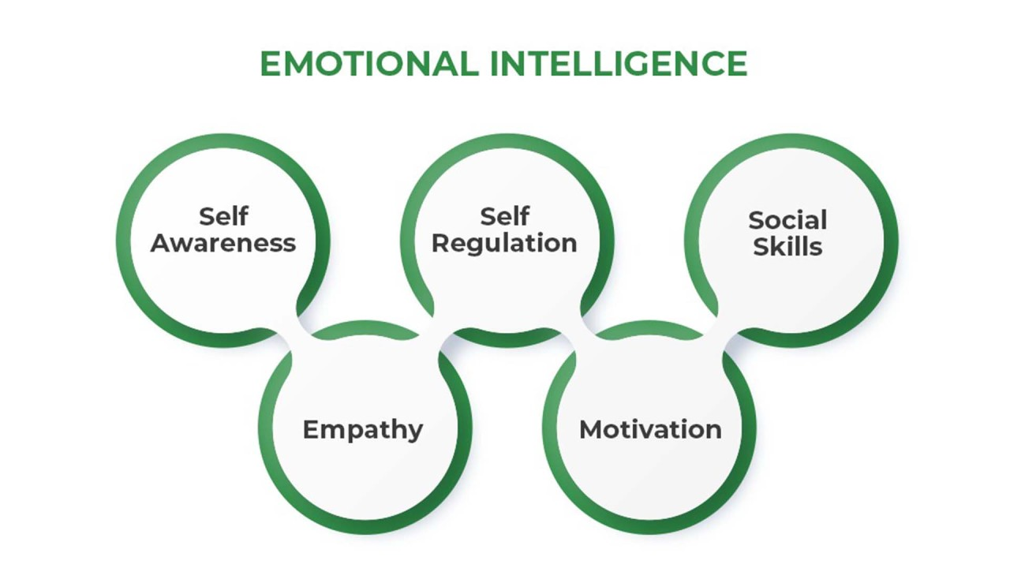
Internet source

Emotional intelligence (EI) is a crucial competency in the workplace, enabling individuals to manage interpersonal relationships effectively, navigate social complexities, and foster a harmonious working environment. It is particularly significant in organisations like FAYE Inc., where cultural diversity and cross-functional collaboration are integral to operations. The attached image succinctly illustrates the five core components of emotional intelligence as outlined by Goleman (1995): self-awareness, self-regulation, motivation, empathy, and social skills. These elements collectively form the foundation for effective communication, conflict resolution, and leadership.
Self-Awareness: This is the ability to recognise and understand one’s emotions and their impact on others. In the context of FAYE Inc., Clarke’s lack of awareness about how his greetings were perceived demonstrates a gap in this competency. Greater self-awareness would enable Clarke to identify and adjust behaviours that might negatively affect employee morale.
Self-Regulation: Refers to the ability to manage and control emotional impulses. Leaders who exhibit self-regulation are better equipped to remain calm under pressure and respond to challenging situations constructively. For instance, Clarke must learn to manage his strict adherence to schedules while considering the relationship-driven work culture of the visiting Chinese team.
Motivation: Emotional intelligence includes the intrinsic drive to achieve goals, aligned with a commitment to the organisation’s values. Leaders who are motivated can inspire their teams to perform better. Clarke’s focus on productivity could benefit from balancing motivation with cultural sensitivity to foster a collaborative atmosphere.

Empathy: Empathy is the ability to understand and share the feelings of others, which is vital in managing diverse teams. By understanding the emotional and cultural perspectives of his colleagues, Clarke can better adapt his leadership style to build trust and respect.
Social Skills: These skills enable leaders to influence, inspire, and build strong connections with others. Effective use of social skills could help Clarke address the concerns of his team, resolve misunderstandings, and create a supportive work environment.
Emotional intelligence is particularly important in managing cultural diversity, as seen in the case of FAYE Inc. For example, the Chinese team values relationships and prefers being addressed by their Chinese names, reflecting their cultural orientation. This highlights the importance of empathy and social skills in bridging cultural differences and fostering inclusivity.
Incorporating the principles depicted in the image into workplace practices at FAYE Inc. could transform leadership dynamics and promote a more emotionally intelligent organisational culture, reducing misunderstandings and enhancing employee satisfaction.

Emotional Intelligence Models to Enhance Clarke’s Workplace Abilities

Emotional intelligence (EI) is a critical leadership skill that enables individuals to manage their own emotions effectively and influence the emotions of others positively. In the context of Clarke’s challenges at FAYE Inc., adopting appropriate EI models can help him improve his communication style, adapt to cultural differences, and foster a supportive and inclusive workplace. Two well-established models of emotional intelligence that are particularly relevant to Clarke’s situation are Goleman’s Emotional Intelligence Model and Salovey and Mayer’s Four-Branch Model.

Goleman’s Emotional Intelligence Model

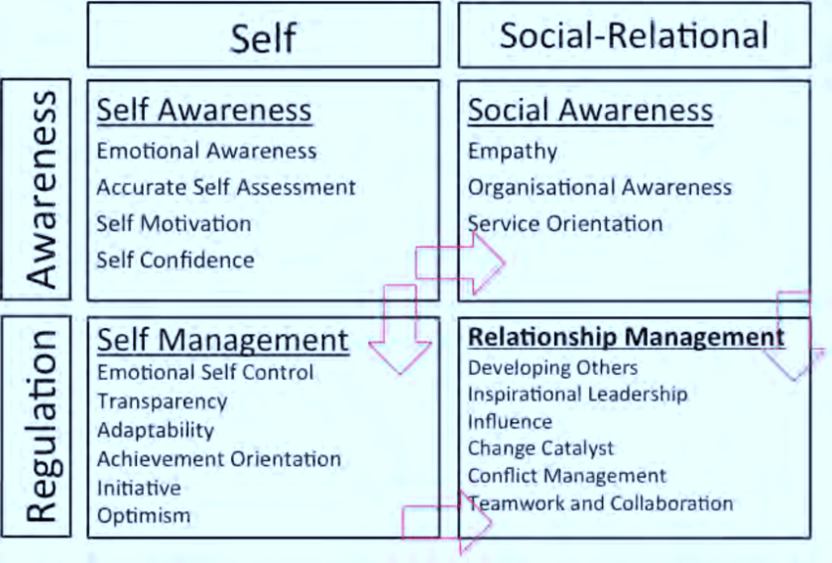
Internet source

Daniel Goleman’s model of emotional intelligence (EI) provides a comprehensive framework for understanding how individuals can effectively manage their emotions and relationships in the workplace. His framework, as depicted in the attached diagram, is structured into four primary domains: Self-Awareness, Self-Management, Social Awareness, and Relationship Management (Goleman, 1995). Each domain encompasses specific competencies that are essential for personal and professional success.
Self-Awareness:
Self-awareness refers to the ability to recognise and understand one’s emotions and how they affect others. This includes emotional awareness, accurate self-assessment, and self-confidence. In a workplace like FAYE Inc., self-awareness is fundamental for leaders like Clarke to reflect on how their behaviours, such as informal greetings, are perceived by colleagues and how such actions impact morale.
Self-Management:
This domain focuses on controlling emotions and impulses, maintaining transparency, and demonstrating adaptability. It includes competencies such as emotional self-control, achievement orientation, and optimism. Clarke’s adherence to strict schedules highlights a need for greater flexibility and adaptability to balance productivity with cultural sensitivity, particularly when working with the visiting Chinese team.
Social Awareness:
Social awareness involves understanding the emotions and needs of others, which includes empathy, organisational awareness, and service orientation. In diverse workplaces, empathy is critical for leaders to appreciate cultural differences. For instance, acknowledging the preferences of the Chinese team to use their native names rather than English names would demonstrate greater social awareness and respect.
Relationship Management:
Relationship management is about developing and maintaining positive interactions, influencing others, and managing conflicts effectively. It includes skills like inspirational leadership, teamwork, and collaboration. Clarke could strengthen his relationship management by fostering a more inclusive and empathetic environment, which would enhance trust and cohesion within his team.

Goleman’s model is particularly relevant for addressing the challenges at FAYE Inc., as it integrates emotional regulation with interpersonal effectiveness. By improving these competencies, Clarke can align his leadership style with the needs of a culturally diverse workforce, fostering a more inclusive and productive organisational culture.

Salovey and Mayer’s Four-Branch Model

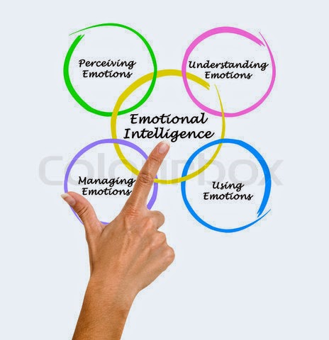
Internet source

The Four-Branch Model, proposed by Salovey and Mayer (1990), breaks down emotional intelligence into four specific skills: perceiving emotions, using emotions to facilitate thinking, understanding emotions, and managing emotions. These branches offer practical steps Clarke can adopt to address the challenges at FAYE Inc.:
Perceiving emotions: This involves accurately recognising emotions in oneself and others. For Clarke, this means becoming more attuned to the discomfort expressed by female employees and the preferences of the Chinese team. Improved emotional perception would allow Clarke to identify and address issues proactively.
Using emotions to facilitate thinking: This branch highlights the role of emotions in enhancing problem-solving and decision-making. For example, Clarke could use his awareness of employee dissatisfaction to rethink his communication strategies and foster a more inclusive approach.
Understanding emotions: Developing a deeper understanding of the emotions behind employees' reactions would help Clarke navigate cultural sensitivities. For instance, recognising that the Chinese team values relationship-building over task orientation could guide him in creating a balance between structure and flexibility.
Managing emotions: The ability to regulate emotions in oneself and others is essential for maintaining workplace harmony. Clarke can manage his frustration with cultural differences or resistance to his leadership style, ensuring that his actions promote respect and collaboration.
Integrating the Models into Practice
Combining insights from both models, Clarke can enhance his workplace abilities by adopting a holistic approach to emotional intelligence. Goleman’s model provides a framework for building core EI competencies, while the Four-Branch Model offers practical tools for implementing these skills in specific workplace scenarios. By focusing on self-awareness, empathy, and cultural sensitivity, Clarke can address the concerns raised by employees and foster a more inclusive and productive work environment.
Adopting Goleman’s and Salovey and Mayer’s EI models can empower Clarke to transform his leadership approach and create a workplace culture that values emotional intelligence. By developing self-awareness, empathy, and the ability to perceive and manage emotions, Clarke can address the concerns at FAYE Inc. effectively, ensuring greater employee satisfaction and team cohesion.

The Bar-On Model of Emotional Intelligence in the Workplace

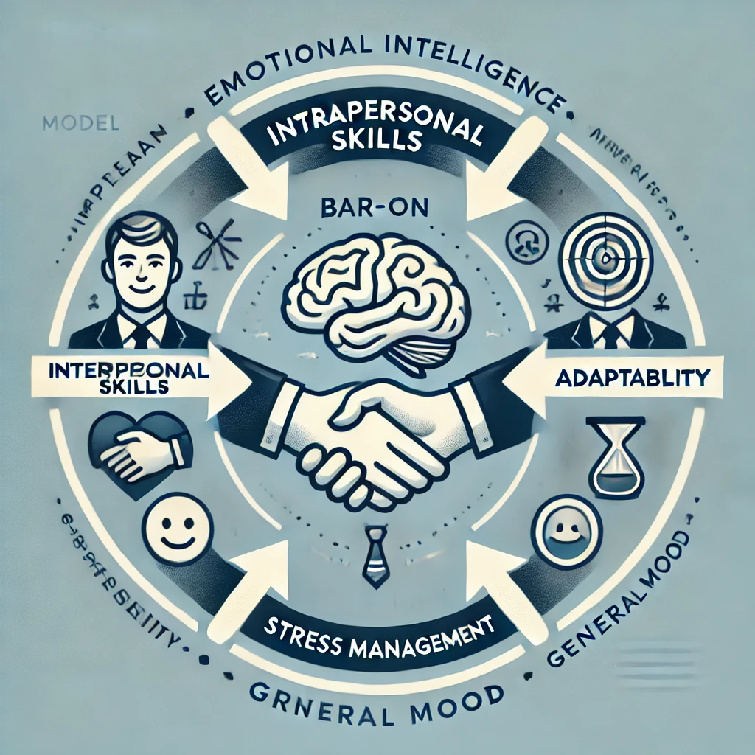
Internet source

Another significant model of emotional intelligence is the Bar-On Model, which defines EI as a set of emotional and social skills that influence how effectively individuals perceive and express themselves, develop and maintain social relationships, cope with challenges, and make decisions (Bar-On, 1997). Unlike Goleman’s framework, which is more leadership-focused, the Bar-On model is comprehensive and encompasses five broad categories of competencies: intrapersonal skills, interpersonal skills, adaptability, stress management, and general mood.
Intrapersonal Skills: These include self-awareness and the ability to express emotions effectively. Employees who are self-aware are better equipped to communicate openly, fostering a transparent and collaborative work environment. For instance, Clarke can enhance his intrapersonal skills to better recognise how his personal leadership style impacts others and adapt accordingly.
Interpersonal Skills: This component emphasises the importance of empathy and social responsibility. In a multicultural workplace like FAYE Inc., interpersonal skills are crucial for understanding and respecting cultural differences. Clarke’s efforts to engage with the visiting Chinese team would benefit from developing these skills, enabling him to build trust and rapport effectively.
Adaptability: Emotional intelligence requires the ability to adjust thinking and behaviours to changing circumstances. Clarke’s rigid approach to schedules may alienate employees and collaborators from different cultural backgrounds. By improving his adaptability, Clarke could better align his leadership approach with the expectations of his culturally diverse team.
Stress Management: This competency involves managing emotions under pressure. Leaders with strong stress management skills can navigate challenging situations calmly and maintain focus. For Clarke, stress management could help him balance the demands of tight deadlines while remaining empathetic to his team’s concerns.
General Mood: The Bar-On model highlights the role of optimism and happiness in promoting a positive workplace environment. A leader’s mood can significantly influence team morale. Clarke’s ability to foster an optimistic atmosphere could counteract the current low morale among his employees.
By integrating the Bar-On model into workplace practices, FAYE Inc. can foster a culture of emotional intelligence, enhancing leadership effectiveness, improving employee satisfaction, and promoting a more resilient and adaptable workforce. This model also complements Goleman’s approach by focusing on both individual and organisational emotional competencies.

The Role of Culture in Understanding EI and Mindfulness of Employees

Culture profoundly influences the way emotional intelligence (EI) is perceived, expressed, and applied in workplace settings. Cultural norms shape communication styles, emotional expressions, and interpersonal interactions, all of which are integral to the practice of EI (Hofstede, 2011). In the case of FAYE Inc., the cultural differences between Clarke’s Western individualistic background and the collectivist orientation of the visiting Chinese team highlight the importance of cultural awareness in fostering mindfulness and emotional intelligence.

Cultural Dimensions and Emotional Intelligence

Hofstede’s (2011) cultural dimensions theory provides a useful framework for understanding how cultural values affect workplace dynamics. For instance, the Chinese team’s collectivist culture prioritises relationships, harmony, and group cohesion. This contrasts with Clarke’s task-oriented approach, which is characteristic of more individualistic cultures, where achieving objectives often takes precedence over personal connections. Such differences can lead to misunderstandings if cultural sensitivities are not considered.
For Clarke to practise EI effectively, he must recognise and respect these cultural values, particularly the concept of guanxi—a cornerstone of Chinese culture that emphasises trust and long-term relationships as the foundation for professional interactions (Chen and Chen, 2004). By demonstrating mindfulness, which involves being fully present and open to others’ thoughts and emotions, Clarke can bridge these cultural differences and create an environment of mutual respect.

Mindfulness and Cross-Cultural Communication

Mindfulness complements EI by encouraging individuals to approach interactions with an open and non-judgemental attitude (Glomb et al., 2011). In cross-cultural settings, mindfulness allows leaders like Clarke to remain attentive to verbal and non-verbal cues, helping them adapt their communication style to suit diverse cultural norms. For instance, rather than suggesting that the Chinese team members adopt English names for convenience, Clarke could make an effort to learn their actual names, which would demonstrate respect for their cultural identity and foster a stronger sense of inclusion.

Cultural Intelligence as an Extension of EI

The concept of cultural intelligence (CQ) is closely related to EI and offers additional insights into managing cultural diversity in the workplace. CQ enables individuals to interpret and respond appropriately to cultural differences, enhancing collaboration and reducing the risk of conflict (Earley and Ang, 2003). For FAYE Inc., promoting cultural intelligence alongside EI training can help employees and leaders alike navigate cultural complexities more effectively.

Implications for FAYE Inc.

Understanding the interplay between culture, EI, and mindfulness is essential for fostering a positive workplace culture at FAYE Inc. Clarke’s ability to adapt his leadership style to accommodate the cultural preferences of his team members will not only enhance employee morale but also strengthen team cohesion and productivity. By prioritising relationship-building and demonstrating cultural sensitivity, Clarke can exemplify the principles of EI and mindfulness, setting a standard for inclusive leadership within the organisation.
Incorporating cultural awareness into the practice of EI and mindfulness is critical for managing diverse teams effectively. By recognising and respecting cultural differences, FAYE Inc. can create a more inclusive and harmonious workplace, where employees feel valued and understood. Mindfulness, as an integral component of EI, serves as a powerful tool for bridging cultural divides and fostering mutual understanding among employees from different backgrounds.

How FAYE Inc. Can Harness the Benefits of EI and Mindfulness

To address the challenges highlighted in the case study and enhance the workplace environment, FAYE Inc. should adopt strategies that promote emotional intelligence (EI) and mindfulness across all levels of the organisation. These initiatives will not only improve individual and team performance but also foster a culture of inclusivity and adaptability. Below is a detailed discussion of key measures the company can take.

Implement Comprehensive EI and Mindfulness Training

Providing training programmes focused on emotional intelligence and mindfulness can equip employees with the tools needed to manage their emotions effectively and engage empathetically with colleagues. Goleman (1998) emphasises that EI skills, such as self-regulation and empathy, can be developed through targeted training, enabling employees to better navigate interpersonal dynamics and cultural differences. For example, training sessions could include role-playing exercises to help participants practise recognising and responding to emotional cues in diverse scenarios. Mindfulness techniques, such as breathing exercises and guided meditation, could also be incorporated to enhance emotional resilience and focus (Dane, 2011).

Foster Open Communication and Feedback Mechanisms

Establishing a culture of open communication is essential for building trust and addressing issues promptly. FAYE Inc. can introduce 360-degree feedback systems that allow employees to provide constructive feedback about their experiences in a safe and non-judgemental environment (Bracken, Rose and Church, 2016). Such systems can help identify areas for improvement in leadership behaviours, such as Clarke’s communication style, and encourage continuous personal development. Regular feedback sessions can also enable leaders to become more self-aware and responsive to the needs of their teams.

Promote Cultural Intelligence and Inclusion

Given the multicultural nature of FAYE Inc., fostering cultural intelligence (CQ) is vital for enhancing workplace harmony and collaboration. Earley and Ang (2003) define CQ as the ability to adapt to different cultural contexts, a skill that complements emotional intelligence. The company can organise workshops that educate employees about cultural norms and values, such as the importance of guanxi (personal relationships) in Chinese culture (Chen and Chen, 2004). Encouraging team-building activities that celebrate cultural diversity can further strengthen intercultural relationships and promote mutual respect.

Encourage Mindfulness Practices in Daily Operations

Incorporating mindfulness into daily routines can help employees maintain focus, regulate emotions, and manage stress effectively. FAYE Inc. could introduce initiatives such as “mindful Mondays,” where employees participate in short mindfulness exercises before starting their workday. Additionally, providing access to mindfulness apps or creating quiet spaces in the office for reflection can support employees in developing their mindfulness practices (Glomb et al., 2011).

Embed EI and Mindfulness in Leadership Development

Leadership development programmes should place a strong emphasis on EI and mindfulness as core competencies. Leaders with high emotional intelligence are better equipped to inspire and motivate their teams, manage conflicts, and drive organisational success (Goleman, 1998). Clarke, for instance, could benefit from one-on-one coaching sessions focused on enhancing his empathy and cultural sensitivity. Embedding EI and mindfulness in leadership training ensures that future leaders are prepared to manage diverse teams effectively.

Monitor and Evaluate

Progress to ensure the effectiveness of these initiatives, FAYE Inc. should establish metrics to measure the impact of EI and mindfulness on employee engagement and performance. Surveys and regular check-ins can provide valuable insights into how employees perceive changes in workplace culture and leadership behaviours. These evaluations can guide further improvements and reinforce a commitment to continuous development. By implementing these strategies, FAYE Inc. can harness the full potential of emotional intelligence and mindfulness to create a supportive, inclusive, and high-performing workplace. These efforts will not only address current challenges but also position the organisation as a leader in fostering emotional and cultural intelligence, enabling it to thrive in a diverse and dynamic global environment.

Conclusion

Emotional intelligence is an indispensable skill for leaders, particularly in culturally diverse organisations like FAYE Inc. Clarke’s challenges in adapting to the expectations of a multicultural workforce underscore the critical need for self-awareness, empathy, and cultural competence. These attributes form the cornerstone of effective leadership and facilitate the development of positive interpersonal relationships, leading to enhanced employee morale and organisational success.
The models of emotional intelligence by Goleman (1995) and Salovey and Mayer (1990) provide practical frameworks that Clarke can adopt to address his current difficulties. Goleman’s emphasis on empathy and social skills and Salovey and Mayer’s focus on emotional perception and management highlight areas for personal growth that could improve Clarke’s effectiveness as a supervisor. Additionally, understanding cultural dimensions and practising mindfulness are essential for navigating the complexities of cross-cultural communication.
FAYE Inc. has a significant opportunity to leverage emotional intelligence as a driver of employee satisfaction, productivity, and inclusivity. By investing in EI training, promoting open communication, fostering cultural awareness, and integrating mindfulness practices into the workplace, the organisation can create a supportive environment that values diversity and enhances collaboration. Such initiatives would not only address the immediate challenges faced by Clarke but also contribute to the long-term success of FAYE Inc. as a global organisation.

References

Bar-On, R. (1997) The Emotional Quotient Inventory (EQ-I): A test of emotional intelligence. Toronto: Multi-Health Systems.
Bracken, D.W., Rose, D.S. and Church, A.H. (2016) The handbook of multi-source feedback. 2nd edn. San Francisco: Wiley.
Cherniss, C. (2001) ‘Emotional intelligence and organisational effectiveness’, in Cherniss, C. and Goleman, D. (eds.) The emotionally intelligent workplace. San Francisco: Jossey-Bass, pp. 3-12.
Chen, X.P. and Chen, C.C. (2004) ‘On the intricacies of the Chinese guanxi: A process model of guanxi development’, Asia Pacific Journal of Management, 21(3), pp. 305-324.
Dane, E. (2011) ‘Paying attention to mindfulness and its effects on task performance in the workplace’, Journal of Management, 37(4), pp. 997-1018.
Earley, P.C. and Ang, S. (2003) Cultural intelligence: Individual interactions across cultures. Stanford: Stanford University Press.
Glomb, T.M., Duffy, M.K., Bono, J.E. and Yang, T. (2011) ‘Mindfulness at work’, Research in Personnel and Human Resources Management, 30, pp. 115-157.
Goleman, D. (1995) Emotional intelligence. New York: Bantam Books.
Goleman, D. (1998) ‘What makes a leader?’, Harvard Business Review, 76(6), pp. 93-102.
Hofstede, G. (2011) Dimensionalizing cultures: The Hofstede model in context. Online Readings in Psychology and Culture, 2(1), pp. 1-26.
Salovey, P. and Mayer, J.D. (1990) ‘Emotional intelligence’, Imagination, Cognition and Personality, 9(3), pp. 185-211.

Appendix

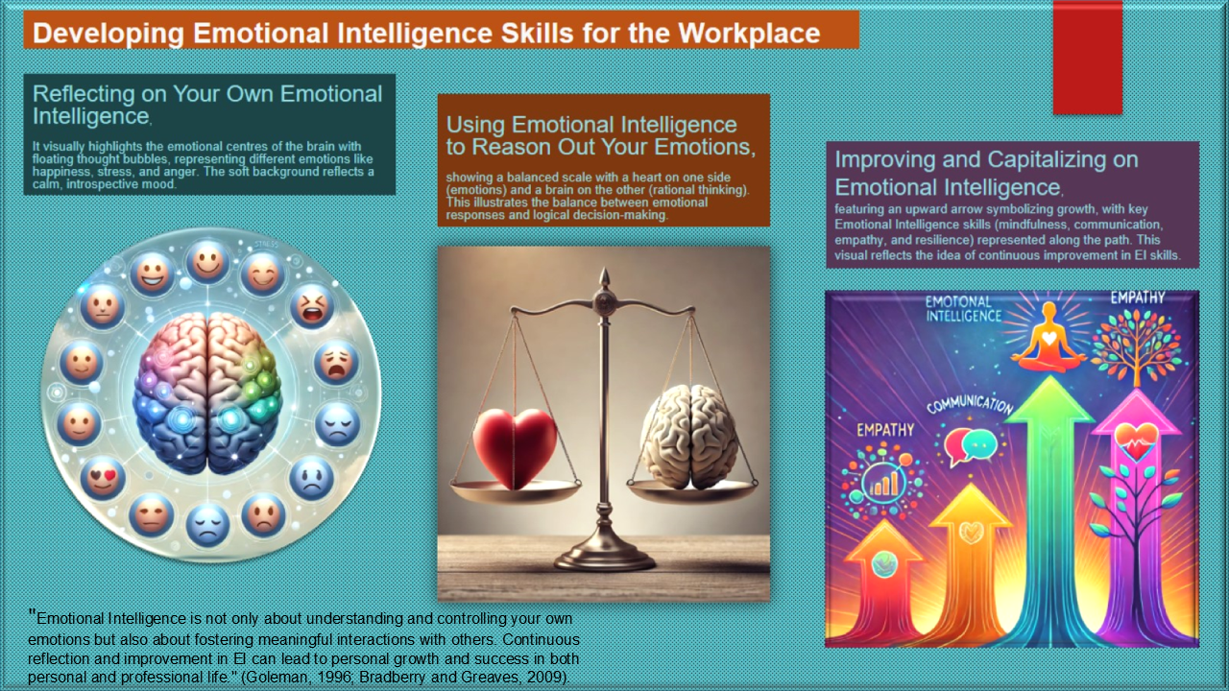

Bar-On, R. (2006). The Bar-On model of emotional-social intelligence (ESI). Psicothema, 18(Suppl.), pp. 13–25.
Boyatzis, R.E. (2018). The behavioural level of emotional and social intelligence. New York: Routledge.
Goleman, D. (1995). Emotional Intelligence: Why it can matter more than IQ. New York: Bantam Books.
Salovey, P., & Mayer, J.D. (1990). Emotional intelligence. Imagination, Cognition and Personality, 9(3), pp. 185–211.

