

LOCATION: Swansea | LLEOLIAD: abertawe
LEVEL 5 | LEFEL 5
EXAMINATION PERIOD | CYFNOD ARHOLIADAU
January 2024 | 2024

MODULE CODE: ACDA5001
Electrical Engineering

TIME: 2 HOURS
Maximum Marks:100
answer All the questions

Equipment or materials required – Calculator, formula sheet
Adnoddau neu ddefnyddiau sydd eu hangen - Cyfrifiannell

ANSWER ALL THE QUESTIONS

Question 1 [25 marks]
- A Pure inductance of $1.273mH$ is connected in series with a pure resistance of 30Ω. If the frequency of the sinusoidal supply is $5KHz$ and the potential difference across the 30$Ω$ is 6V, determine the following.
- Current in the circuit [2 Marks]
- Supply Voltage [3 Marks]
- Voltage across the inductor. [2 Marks]
- Phase angle [2 Marks]
- Draw the phasor diagram [2 Marks]
Solution:
- Current in the circuit
$I=\frac{V_{R}}{R}=\frac{6}{30}=0.20A$ [2 Marks]
- Supply Voltage
Inductive Reactance $X_{L}=2πfL$=2$π×5×1000×1.273×{10}^{-3}=40Ω$ [1 Mark]
Impedance, $Z=\sqrt{R^{2}+X_{L}^{2}}=\sqrt{{30}^{2}+{40}^{2}}=50Ω$ [1 Mark]
Supply voltage= $V=IZ=0.20×50=10V$ [1 Marks]
- Voltage across the inductor.
$V_{L}=IX_{L}=0.2×40=8V$ [2 Marks]
- Phase angle
Φ=$\tan^{-1}\left(\frac{X_{L}}{R}\right)=\tan^{-1}\left(\frac{40}{30}\right)=53.123$ [2 Marks]
- Draw the phasor diagram
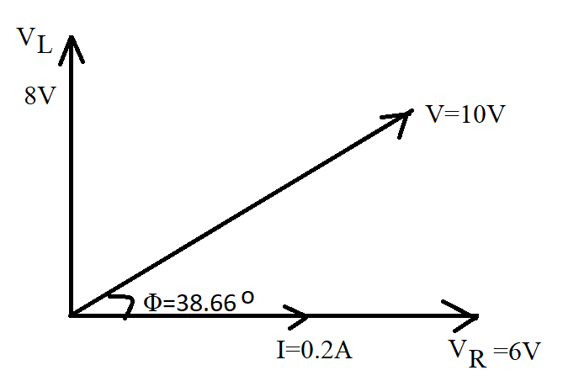 [2 Marks]
- A Transformer has a rated output of 210KVA at a power factor of 0.7. Determine the real power and the reactive power. [5 marks]
Solution:
Power Factor = 0.7=$Cosϕ$
Real power = P=VI $Cosϕ$
Apparent Power = Rated power= 210KVA =VI
P=210×1000×0.7=147000W [2 Marks]
We know that, $Cosϕ=0.7$
$ϕ={Cos}^{-1}\left(0.7\right)={46}^{o}$ [1 Mark]
Reactive power=$VISinϕ$= 210×1000 $Sin({46}^{o})$=210000×0.719=151061.36kVAR [2 Marks]
- An Alternating voltage is given by the equation $V=75Sin (200πt-90)$. Calculate the following.
- The amplitude [1 Mark]
- The peak to peak voltage [2 Marks]
- The RMS voltage [2 Marks]
- The periodic time [2 Marks]
- The Frequency [2 Marks]
Solution:
- Amplitude
$V=V_{m}sin(ωt+ϕ)$
$Given,$ $V=75sin(200πt-0.25)$
$V_{m}=75V$ [1 mark]
- peak to peak voltage
$Peak to Peak Voltage = 2×Amplitude$
$=2×75=150V$ [2 marks]
- RMS value
$V_{RMS}=\frac{V_{m}}{\sqrt{2}}=\frac{75}{\sqrt{2}}=53.03V$ [2 marks]
- the periodic Time
$T=\frac{1}{f}$
We know that $ω=2πf=200π$
$2πf=200π$
$2f=200$
$f=100Hz$
$T=\frac{1}{f}$= $\frac{1}{100}=10ms$ [2 marks]
- frequency
$f=100Hz$ [2 marks]
Question 2 [25 Marks]
- A Coil having an inductance of $1.4H$ and a Resistance $1Ω$ is connected to a$12V$ Supply through a switch. What will be the volume of current after $400msec$ of switching ON the supply? How much time will it take for the steady state current to drop to half its value after the switch is turned ON. [10 Marks]
Solution:
Gn, $L= 1.4H, R=1Ω, V=12V$
To Find Value of current at $t=400msec$
The rise in Current is given by
$i=I_{0}\left(1-e^{-t/τ}\right)$
$i=\frac{V}{R}\left(1-e^{-{Rt}/L}\right)$
$i=\frac{12}{1}\left(1-e^{-{1×t}/{1.4}}\right)$ [1 mark]
$When t=400ms$
$i=12\left(1-e^{\frac{-400×{10}^{-3}}{1.4}}\right)$
$i=12\left(1-e^{-0.286}\right)$ [1 Mark]
$i=12(1-0.751$)
$i=12(0.249$)
$i=3A$ [3 marks]
To find the time taken for the steady state current to drop to half its value (discharging)
$i=I_{0}e^{-t/τ}$
$To drop the steady state value by half$ $I_{0}=\frac{I_{0}}{2}$
$i=\frac{I_{0}}{2}e^{-t/τ}$
$3=\frac{I_{0}}{2}e^{-{Rt}/L}$
$3=\frac{I_{0}}{2}e^{-{1×t}/{1.4}}$ [1 Mark]
$6=I_{0}e^{-t/{1.4}}$
$6=\frac{V}{R}e^{-t/{1.4}}$
$6=\frac{12}{1}e^{-t/{1.4}}$ [1 Mark]
$6=12e^{-t/{1.4}}$
$\frac{6}{12}=e^{-t/{1.4}}$
$0.5=e^{-t/{1.4}}$
$Taking Log on both the side$
$log⁡(0.5)=-t/{1.4}$
$-0.301 ×1.4=-t$
$t=0.421sec$ [3 marks]
- A supply voltage of $V_{1}=10V$ is given to the circuit shown in fig:1. Determine the following
- The load current, [7 marks]
- Value of load resistor, when maximum power is transferred to the load,
[2 marks]
- Simplified circuit diagram for the circuit shown in fig.1 [3 marks]
- The maximum power transferred across the load ($P_{L})$. [3 marks]
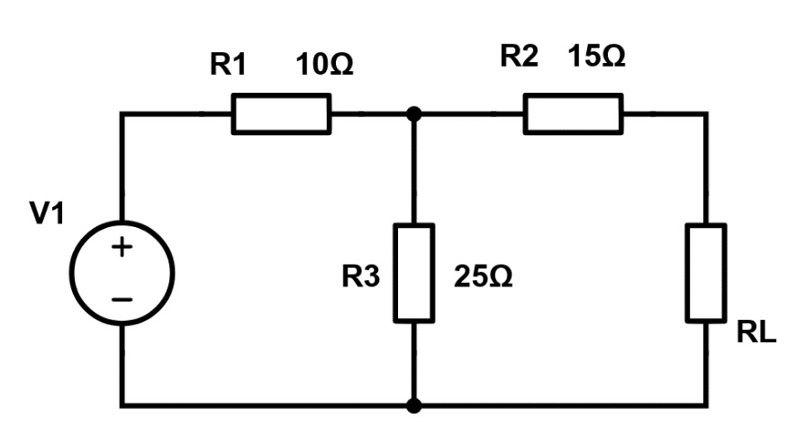
Fig:1
Solution:
- The Load Current,
Voltage across 25$Ω$ resistor,
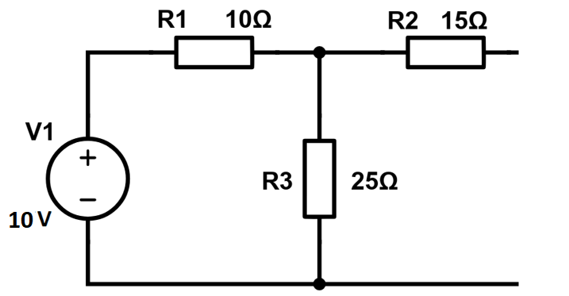
To find current in the loop,$I=\frac{10}{35}=0.286A$
$V_{25Ω}=0.286×25=7.15V=V_{th}$ [3 marks]
To Find $R_{th}$
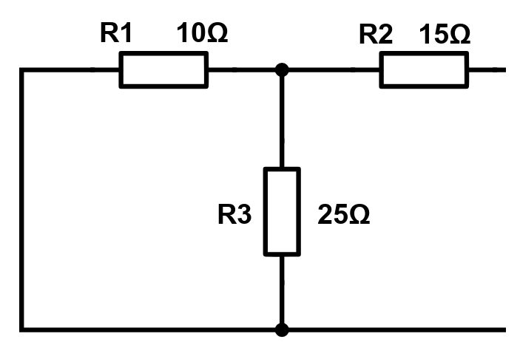
$R_{1}$ parallel to $R_{3}$=7.143Ω
7.143Ω series with $R_{2}$=22.143 Ω
$R_{th}=22.143Ω$ [2 marks]
$I_{L}=\frac{V_{th}}{R_{th}+R_{L}}=\frac{7.15}{22.143+22.143}=0.161A$ [2 marks]
- Value of load resistor, when maximum power is transferred across the load,
According to Maximum power transfer theorem, maximum power will be transferred across the load, when the Load resistor is equal to internal resistance. Hence Internal resistance is $22.143 Ω$ [2 marks]
- Simplified circuit diagram for the circuit shown in fig.1
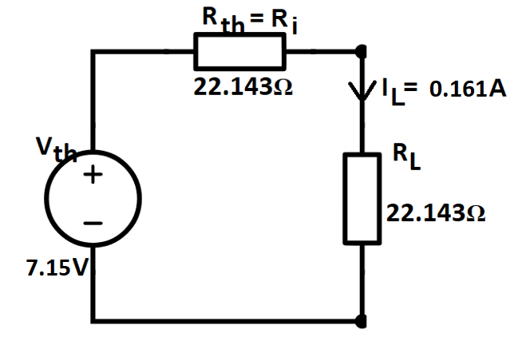 [3 marks]
- The maximum power transferred across the load ($P_{L})$.
$P_{L}=I_{L}^{2}R_{L}={0.161}^{2}×22.143=3.565W$ [3 marks]
$This is the maximum power transfered across the load$.
Question 3 [25 marks]
- The three impedances, resistance of 8Ω; coil of inductance130μH and 5Ω resistor; and10Ω resistor in series with 0.25μF capacitor are connected in series across a 40V, 20KHz supply as shown in fig.2, calculate the following,
- The circuit current [5 Marks]
- Circuit phase angle [2 Marks]
- Voltage drop across each impedance [6 Marks]
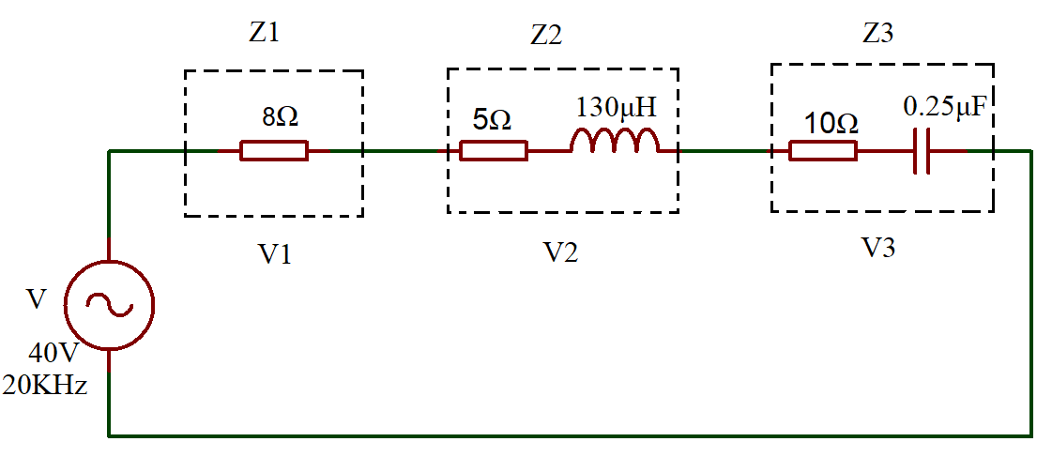
Fig.2
Solution:
- The circuit current
$X_{L}=$2$π×20×1000×130×{10}^{-6}=16.34Ω$ [1 Mark]
$X_{C}=\frac{1}{2πfC}=\frac{1}{2π×20×1000×0.25×{10}^{-6}}=31.83Ω$ [1 Mark]
$X_{C}>X_{L}$, it is a Capacitive circuit.
$X_{C}-X_{L}=31.83-16.34=15.49Ω$
$Z=\sqrt{R^{2}+{{(X}_{C}-X_{L})}^{2}}=\sqrt{{23}^{2}+{15.49}^{2}}=27.73Ω$ [1 Mark]
Circuit Current=$I=\frac{V}{Z}=\frac{40}{27.73}=1.442A$ [2 Marks]
- Circuit phase angle
Φ=$\tan^{-1}\left(\frac{{(X}_{C}-X_{L}}{R}\right)=\tan^{-1}\left(\frac{15.49}{23}\right)={33.96}^{0}$ [2 Marks]
- Voltage drop across each impedance
$V_{1}=IR_{1}=1.442×8=11.54V$ [2 Marks]
$V_{2}=IZ_{2}=I×\sqrt{R^{2}+{X_{L}}^{2}}=1.442×\sqrt{5^{2}+{16.34}^{2}}=24.64V$ [2 Marks]
$V_{3}=IZ_{2}=I×\sqrt{R^{2}+{X_{C}}^{2}}=1.442×\sqrt{{10}^{2}+{31.83}^{2}}=48.11V$ [2 Marks]

- A 415V, three phase AC motor has a power output of 12.75kW and operates at a power factor of 0.77 lagging and with an efficiency of 85%. If the motor is delta-connected, determine the following,
- The Power input [3 Marks]
- The Line current [2 Marks]
- The Phase current [2 Marks]
Solution:
- The Power input
$Efficiency=\frac{Power Output}{Power Input}$
$\frac{85}{100}=\frac{12750}{Power input}$ [1 Mark]
$Power Input=\frac{12750 ×100}{85}=15000W$ [2 Marks]
- The Line current
$I_{L}=\frac{P}{\sqrt{3}(415)(0.77)}=\frac{15000}{\sqrt{3}(415)(0.77)}=27.10A$ [2 Marks]
- The Phase current
$I_{P}=\frac{I_{L}}{\sqrt{3}}=\frac{27.10}{\sqrt{3}}=15.65A$ [2 Marks]
- Voltage of 100sinwt is applied to a 5Ω resistor. Calculate the current and the instantaneous power. [5 Marks]
Solution:
V=100sinwt, R=5Ω
$I=\frac{V}{R}=\frac{100sinwt}{5}$ =20sinwt [2 marks]
P=VI =100sinwt ×20sinwt [2 marks]
P=$2000\sin^{2}ωt$ [1 mark]
Question 4 [25 Marks]
- An ideal transformer has a turns ratio of 8:1 and the primary current is 3A when it is supplied at 240V. Calculate the secondary Voltage. [6 Marks]
Solution:
The Turns Ratio 8:1 means, $\frac{N_{1}}{N_{2}}=\frac{8}{1}, it is step down transformer,$ [2 marks]
$\frac{N_{1}}{N_{2}}=\frac{V_{1}}{V_{2}} or secondary Voltage$ , $V_{2}=V_{1}\left(\frac{N_{2}}{N_{1}}\right)=240(\frac{1}{8})$=30Volts [4 marks]
- Differentiate Active power, and Apparent power [ minimum of two differences] [4 Marks]
Solution:
 | Active power | Apparent Power
Definition | The actual power consumed by a circuits due to the resistive load is called real power. | It is the amount of power delivered to a circuit.
Formula | P=$VI Cos∅$ | S=$VI$
[Each Point 2 marks Maximum of 4 marks]
- List the types of DC Generators. Describe any two types of DC generator with the aid of necessary diagrams. [15 Marks]
Solution:
Types of DC Generators
- Separately Excited DC Generators – Field coils excited by some external source
- Self-Excited DC Generators – Field coils excited by the generator itself
  - Series Wound Generators
  - Shunt Wound Generators
  - Compound Wound Generators [5 Marks]

Series Wound Generator
In these type of generators, the field windings are connected in series with armature conductors, as shown in the figure below.
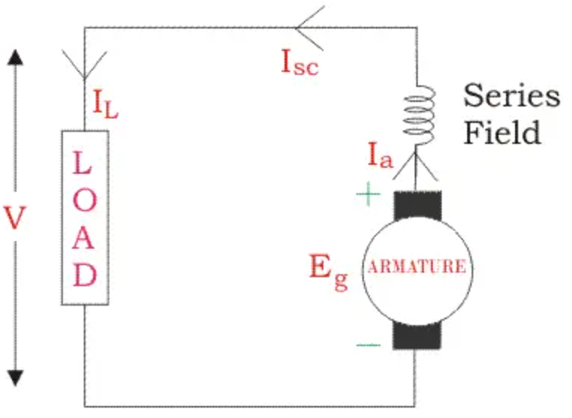
All the currents flows through the field coils as well as the load. As series field winding carries full load current it is designed with relatively few turns of thick wire. The electrical resistance of series field winding is therefore very low (nearly 0.5Ω ).
- R_{sc} = Series winding resistance
- I_{sc} = Current flowing through the series field
- R_{a} = Armature resistance
- I_{a} = Armature current
- I_{L} = Load current
- V = Terminal voltage
- E_{g} = Generated EMF

Then,
$$I_{a}=I_{SC}=I_{L}=I$$

Voltage across the load is equal to,
$$V=E_{g}-I(I_{a}{×R}_{a)}$$
Power generated is equal to,
$$P_{g}=E_{g}×I$$
Power delivered to the load is equal to,
$$P_{L}=V×I$$
[5 Marks]

Shunt Wound DC Generators
In these type of DC generators, the field windings are connected in parallel with armature conductors, as shown in the figure below. The voltage in the field winding is same as the voltage across the terminal.
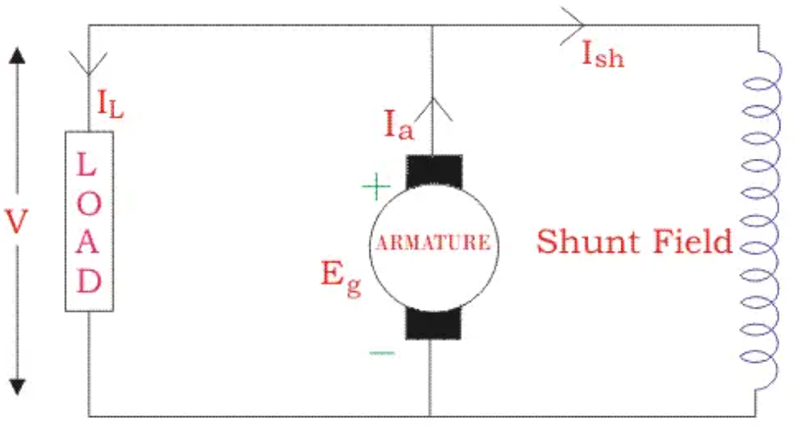
Here:
- R_{sh} = Shunt winding resistance
- I_{sh} = Current flowing through the shunt field
- R_{a} = Armature resistance
- I_{a} = Armature current
- I_{L} = Load current
- V = Terminal voltage
- E_{g} = Generated EMF

Here armature current I_{a} is dividing in two parts – one is shunt field current I_{sh}, and another is load current I_{L}.
So,$I_{a}=I_{Sh}+I_{L}$
The effective power across the load will be maximum when I_{L} is maximum. So, it is required to keep shunt field current as small as possible. For this purpose the resistance of the shunt field winding generally kept high (100 Ω) and large number of turns are used for the desired EMF.
Shunt field current is equal to,
$$I_{Sh}=\frac{V}{R_{Sh}}$$
Voltage across the load is equal to,
$$V=E_{g}-I_{a}R_{a}$$
Power generated is equal to,
$$P_{g}=E_{g}×I_{a}$$
Power Delivered to the load is equal to
$$P_{L}=V×I_{L}$$
[5 Marks]

Diwedd/End

