Name: Rafaqat Khan / 2407945
Module code: BMHP5014
Module Changemakers creativity and value creation
Assignment component 1

Task 1 – Concept Map

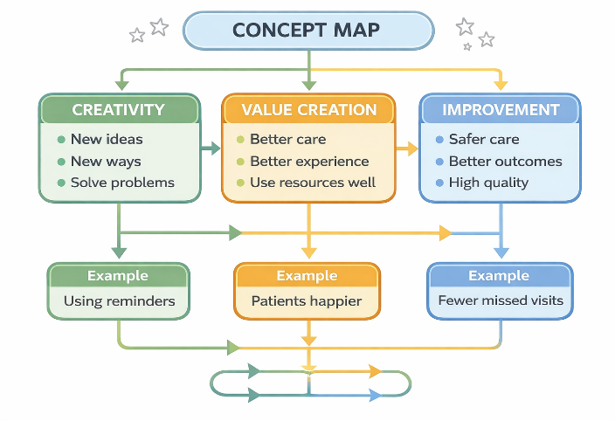

Creativity, value creation, and improvement are connected in health and social care. Creativity means thinking of new ideas or doing things in a different way. Workers use creativity to solve problems and make care better.
When new ideas are used, they create value. Value means something becomes better for patients, families, and staff. For example, better communication, new technology, or personalised care can improve people’s experience. This shows that creativity helps to create value (National Health Service , 2019)
Value creation leads to improvement. Improvement means services become safer, better quality, and more effective. When services create value, they meet people’s needs more and give better outcomes. Patients may feel happier and receive better care. These three ideas work together. Creativity starts with new ideas. Value creation makes sure these ideas are useful. Improvement is the result, where services get better over time (Department of Health and Social Care, 2021)

For example, a care worker may use text reminders for appointments. This is a creative idea. It creates value because patients remember their visits. This leads to improvement because fewer appointments are missed.
In conclusion, creativity, value creation, and improvement are linked. They help health and social care services improve and provide better care for everyone.

Task 2 – Self-Reflection (250 words)

I will use Gibbs Reflective Cycle to reflect on the paperclip activity (Graham Gibbs, 1988)

Description:
In this activity, we had to think of different ways to use a paperclip. This was about convergent and divergent thinking. I made a ring and a bracelet from a paperclip.

Feelings:
At first, I felt unsure because I did not know what to make. After I started, I felt more confident and enjoyed being creative.

Evaluation:
The activity was good because it helped me think in different ways. Making a ring and bracelet showed I could use simple ideas. However, I could have thought of more creative ideas.

Analysis:
This activity showed the difference between convergent and divergent thinking. Divergent thinking helped me come up with ideas like jewellery. Convergent thinking helped me choose the best idea to make. This is important in health and social care because workers need to think of different solutions and then choose the best one.

Conclusion:
I learned that creativity is important and I can improve my thinking skills. I also learned that simple items can be used in many ways.

Action Plan:
Next time, I will try to think of more ideas before choosing one. I will also be more confident in sharing my ideas.

Task 3 – Case Study of a UK Innovation

One example of innovation in the UK is the National Health Service App. This digital service allows patients to book appointments, order prescriptions, and view their health records online. It shows how creativity can improve health and social care services.
Creativity was used by introducing digital technology to make services easier to access. Instead of calling or visiting a GP, patients can use their phones. This is a new and simple way of delivering care. The idea came from the need to reduce pressure on services and make healthcare more convenient. This shows creative thinking because it changes traditional ways of working.
The app creates value for patients and staff. Patients can manage their health more easily and save time. It also helps people feel more in control of their care. For staff, it reduces workload because fewer phone calls and visits are needed. This allows staff to focus on more serious cases. This shows how innovation can create value by improving efficiency and patient experience (National Health Service, 2019).
The innovation also leads to improvement in services. It makes healthcare faster, more organised, and more accessible. For example, patients can quickly check information or book appointments without delays. This can lead to better health outcomes because people can access help sooner. It also supports safer care by keeping records in one place.
However, there are some challenges. Not everyone has access to digital devices or knows how to use them. This may affect older people or vulnerable groups. Despite this, support and training can help reduce this problem.
Overall, the NHS App shows how creativity, value creation, and improvement are linked. A creative idea led to better services and improved patient care. It demonstrates how innovation in the NHS can meet modern needs and improve the quality of care (Health Foundation, 2020).

Task 4 - Mental Health Stigma – Why It Happens

Mental health stigma means that people with mental health problems are treated unfairly or judged negatively. One reason stigma exists is fear and misunderstanding. Many people think that people with mental health conditions are dangerous or unpredictable. For example, Tan et al. (2020) studied public attitudes in Singapore and found that fear of people with mental illness was one of the main reasons for stigma. People also believed mental illness is not a real health problem, which made them avoid or judge those affected (Tan et al., 2020).
Another reason is blame and personal responsibility. Some people think that mental health problems happen because someone is weak or did something wrong in their life. This idea makes others feel that people with mental illness are responsible for their problems, which increases negative attitudes (Corrigan, 2004).
Family and culture also play a role. Tan et al. (2020) found that children learn attitudes from their parents and society. If families or communities talk about mental illness as shameful or bad, children grow up thinking the same way. Media can make this worse by showing people with mental health problems as violent or strange (Corrigan, 2004).
These factors combine to create both public stigma and self-stigma. Public stigma is when society judges people, and self-stigma is when individuals feel ashamed of themselves. Both make it harder for people to get help or support, which affects their health and wellbeing (Tan et al., 2020; Corrigan, 2004).
In summary, mental health stigma happens because of fear, blame, lack of knowledge, family influence, and cultural ideas. Understanding these reasons is important to help reduce stigma and make it easier for people to seek care.

Task 5 – Podcast

Task 6 – Leadership Framework
The NHS Leadership Framework is a guide that explains the important skills and behaviours NHS leaders should have to support high-quality care and better outcomes for patients. It is used across the NHS to help leaders at all levels improve how they lead teams, services and organisations. One key part of the framework is driving high-quality and sustainable outcomes, which means leaders must focus on delivering safe, effective care and continuous improvement for service users and staff (NHS England, 2024). Another important component is setting strategy and delivering long-term transformation; leaders should use evidence and planning to make changes that benefit patients and the wider health system over time (NHS England, 2024).
The framework also emphasises promoting equality and inclusion, ensuring that health and workforce inequalities are reduced and that every person is treated fairly. Leaders are expected to create a compassionate and positive culture where staff feel respected and valued. Building strong relationships with partners and communities is another key component, encouraging collaboration with other health services and the people who use them (NHS England, 2024). Overall, the NHS Leadership Framework helps leaders develop the skills they need to lead effectively, create a positive work culture and improve care for all.

Reference list
Department of Health and Social Care (2021) Health and Social Care Integration. Available at: https://www.gov.uk/government/organisations/department-of-health-and-social-care (Accessed: 15 March 2026)
Health Foundation (2020) Quality Improvement Made Simple. Available at: https://www.health.org.uk/publications/quality-improvement-made-simple (Accessed: 22 March 2026).
National Health Service (2019) The NHS Long Term Plan. Available at: https://www.longtermplan.nhs.uk/ (Accessed: 18 March 2026).
National Health Service (2019) The NHS Long Term Plan. Available at: https://www.longtermplan.nhs.uk/ (Accessed: 22 March 2026).
NHS England, 2024. NHS leadership competency framework for board members. Available at: https://www.england.nhs.uk/long-read/nhs-leadership-competency-framework-for-board-members/ (Accessed 20 March 2026)
NHS England, 2024. NHS leadership competency framework for board members. Summary of key domains.

