Portfolio.
ECIE4012
The Principles of Learning and Teaching.
Ethan Smith.
Student Number: 2311689

Blog 1
What’s the Bobo Doll Theory? Let’s read more to find out!
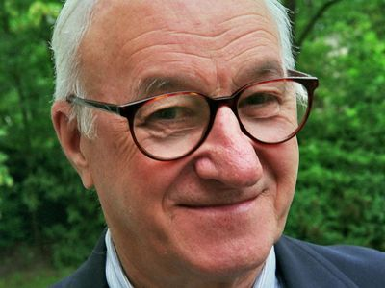
(Association for Psychological Science, 2012)
In 1961 a theory was undertaken by Albert Bandura in Stanford University in California, as this is where Bandura worked as a professor, which was set to gather information about the observation of adult behaviour and how it influences children. Many say that this theory wasn’t made in the most polite and happy way, but many years ago things were different. Nevertheless, the outcome of this theory shows a lot about the links between the way children observe adults and then how children can reinforce behaviours themselves after watching from their adults (Nolan, n.d.).
Bandura and a group of researchers set up 3 groups of children with an allocated adult who had a bobo doll. Each doll had been painted to look as though it was a cartoon character and placed with a weighted bottom, so if the doll was knocked down, it would be able to be up facing automatically. Both groups of children were preschool age (3 to 5 years old) and a mix of males and females, they used this age group of children as they are thought to be still developing and learning at that age, which would give the results found, more of a realistic and fair result. The first group of children watched the adult act kindly towards the bobo doll, caring for the doll and showing happy, wanted behaviour. The second group of children, this group of children observed their adult being very unkind to the bobo doll, both physically and verbally, the adult kicked, punched and threw the doll across the room multiple times. As for the third group, this group of children observed their adult provide no emotional aspects towards the doll (Cherry, 2022).
After the children observed the adult in their group, they were all then split up into sub-groups to see how their observation had affected their behaviour. The groups were now mixed up together from all three original groups. In their new groups they were than all sat down at a table and then all given a bobo doll, Bandura and his team of researchers were wanting to look how the children would then act towards the doll after seeing the behaviour of their adult and little do you know, the results were very interesting. The first group of children who watched their adult provide care and wanted behaviour towards their bobo doll, when watched, the children in the first group also provided their bobo doll with care and wanted behaviour exactly how they observed their adults’ actions towards their bobo doll. These results show the link of how children observe adults in a positive way. The second group, the group of children who watched their adult abuse the bobo doll both physically and verbally, were mostly all found to do the same when each child had their bobo doll. These results show again prove the massive link between how children observe adults and reinforce behaviour as they have seen previously. In this case, this would be seen as a negative impact as the children are not learning and understanding the right concepts needed for life. Lastly, the third group, the group of children who observed their adult provide no emotional behaviour towards their bobo doll, were all seen to not understand how to interact with the doll, not knowing how to play with the bobo doll and some not wanting to play with the bobo doll at all. These findings again show the link as mentioned previously. However, it can be seen as both a positive and negative way of children observing adults, as this group of children didn’t see their adult show any emotional behaviour towards their bobo doll, these children then didn’t understand how to play and interact when it was their turn to play.
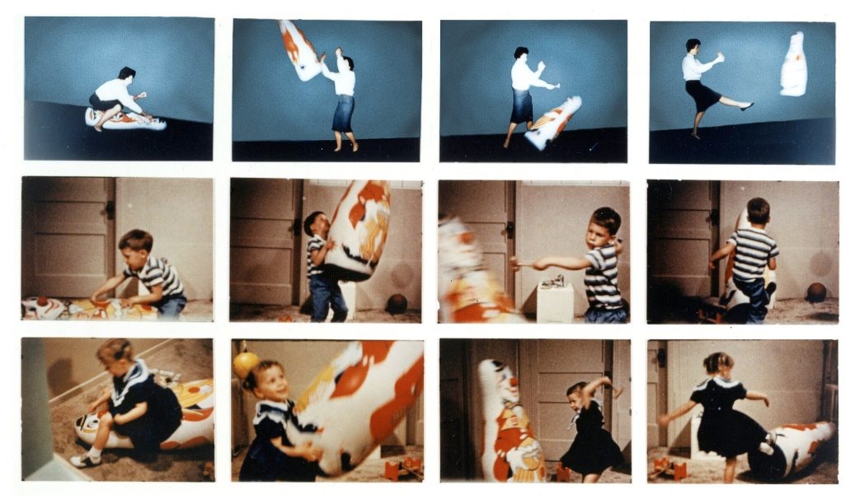
(Tom, 2021).
Just reading this theory and the results find put so much into perspective when it comes to understanding children’s behaviour now days. It shows that children will copy and imitate adults which they see and their behaviour which can be seen as positive and a negative factor when it comes to their development. I agree that this theory was proven to be true and see it daily in the school setting with my pupils in my class. Adults need to understand and take responsibility when it comes to how they act and do things in front of their children or any adults around children, our actions can have a massive impact on our children’s lives, it’s up to us to make that positive effect for them.

Blog 1: Reference list

References
Association for Psychological Science. (2012, September 26). Bandura Honored With Lifetime Achievement Award. Retrieved from Association for Psychological Science: https://www.psychologicalscience.org/observer/bandura-honored-with-lifetime-achievement-award
Cherry, K. (2022, December 8). What the Bobo Doll Experiment Reveals About Kids and Aggression. Retrieved from VerryWellMind: https://www.verywellmind.com/bobo-doll-experiment-2794993
Nolan, J. (n.d.). Britannica. Retrieved from Bobo doll experiment: https://www.britannica.com/event/Bobo-doll-experiment
Tom, S. (2021, August 18). Albert Bandura, 1925-2021: The Social Psychologist Who Transformed How We Think of Learning and Morality. Retrieved from Social Science Space: https://www.socialsciencespace.com/2021/08/albert-bandura-1925-2021-the-social-psychologist-who-transformed-how-we-think-of-learning-and-morality/

Blog 2
B.F. Skinner’s masterplan of the Operant Conditioning theory!
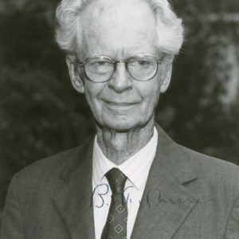
(School of Humanities and Social Sciences, n.d.).
Skinner was known for his Operant Conditioning theory, which he believed that children develop through a method of rewards and punishment of the child’s behaviour. Skinner believes that repetition of reward to children when they display wanted behaviour and punishment when the child shows unwanted behaviour.
Skinner talked a lot about the five components that he researched when researching accordingly to the Operant Conditioning theory, these components he suggested to use to help reinforce positive behaviour in children, these are:
Positive reinforcement – the importance of positive reinforcement being provided when we see wanted behaviour. This gives children a rewarding feeling after they show a desired behaviour. For example, having a point system in the classroom, if a child does something positive, they get a point, which allows them to the link positive behaviour with a positive reward and hopefully encourage the child to continue their behaviour.
Negative reinforcement – Skinner believed that by removing an unwanted feeling that a child might have, it encourages an outcome of positive behaviour. For example, after a PE lesson, each child has to wait for a teacher to put their shoes on to go out to play, which the child doesn’t like, as they just want to go out to play as quickly as they can. By this negative reinforcement, the child learns how to independently put their shoes on, so they don’t have to wait for the teacher’s help. This is using their unwanted feelings to show them a way to overcome it and then shows a positive behaviour.
Positive punishment – Skinner explained that by adding a consequence that causes a unhappy feeling after a child shows a unwanted behaviour, allows them to reduce the amount of times they present that behaviour. For example, if a child takes Lego of another child and won’t give it back, they get taken out of the Lego area. This is giving the child their conscience that they don’t like, allowing them to understand if they don’t do this again, then they won’t have the consequence given to them.
Negative punishment – Skinner believed by taking away a positive feeling from a child when they display negative behaviour, allows the child to understand the link between both. The child learns that when they misbehave, they will then get an unwanted punishment. For example, if a child pushes another child’s blocks down, the teacher moves them to another area they don’t like. The child learns that if they do this again, they will be moved which they don’t like. This allows the child to understand and not present this behaviour again and lessen the frequency of unwanted behaviour.
Extinction – Skinner explained that by taking away a reinforcement that a child seeks when presenting unwanted behaviour, stops the child from then repeating this behaviour again as they are not getting the outcome that they want. For example, if a child makes a mess in the classroom on purpose as they usually get sent out of class and miss tidy up time, by not giving them this reinforcement and keeping them in to tidy up when its time, will stop them from repeating this behaviour as they know they won’t get the usual outcome (Brodie, n.d.).
Skinner researched his theory by conducting an experiment into the different behaviours and the different outcomes when reinforced. Skinner conducted his experiment by placing animals into a box, which he called the ‘Skinner Box’ these animals were small, such as rats and pigeons. Skinner monitored the animals and their behaviour by placing a leaver in the box, if the animal pressed or pecked the leaver they would receive a reward. Skinner found that the animals learnt that when they pressed the leaver, they would gain the reward, so they repeated the behaviour. This is why Skinner spoke about positive reinforcement.
Skinner again experimented by placing another leaver in the box and when the animals pressed/pecked it, their food and water would be dispensed. Skinner found again that the animals were able to link both together and kept repeating the wanted behaviour. This is why Skinner spoke about the importance of reinforcement.
Skinner then looked into unwanted behaviour when the animals were in the box. When skinner saw the animal present an unwanted behaviour he would present the animal with a mild electric shock. He found that after a couple of times, the animals understood that if they presented that behaviour again then they would be punished. This is why skinner spoke about the importance of punishment when unwanted behaviour is shown.
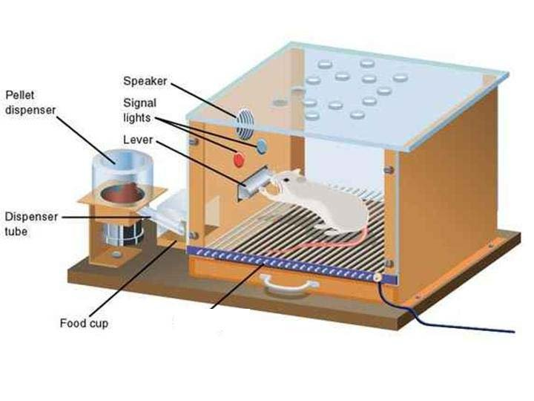
(Mattoli, 2008).
Skinner conducted this experiment to look more in depth about his theory, Skinner researched and provided substantial evidence of his findings to conclude his theory and share to others. This theory provides many people with the understanding and importance of the way to encourage wanted behaviour (McLeod, 2024).

Blog 2: Reference list

References
Brodie, K. (n.d.). B.F. Skinner: Operant Conditioning and Behaviourism Theories. Retrieved from Early Years TV: https://www.earlyyears.tv/b-f-skinner-operant-conditioning-and-behaviourism-theories/
Mattoli, V. (2008, January). Classical Skinner Box experiment II. MATERIALS AND METHODS. Retrieved from ResearchGate: https://www.researchgate.net/figure/Classical-Skinner-Box-experiment-II-MATERIALS-AND-METHODS_fig2_224313225
McLeod, S. (2024, Febuary 2). Operant Conditioning: What It Is, How It Works, and Examples. Retrieved from simplypsychology: https://www.simplypsychology.org/operant-conditioning.html
School of Humanities and Social Sciences. (n.d.). B.F. Skinner. Retrieved from TCNJ The College of New Jersy: https://psychology.tcnj.edu/skinner-2/

Blog 3
The links between Bandura and Skinner’s theories.
To begin, it is worth mention that social learning theories often differ significantly, some more than others, however their research and applications can also be similar. One difference that theories often display is their Sociocultural context. As I have explored in my previous blogs, banduras theory, particularly his bobo doll experiment, displays social learning theory, as his work illustrated how behaviour is influenced by observing others and highlighted the role that role models such as parents and teacher play in children’s development. On the other hand, skinners work was more focused on operant conditioning, learning through reinforcement or punishment, and did not focus on social and cultural contexts (Cherry, What Is Sociocultural Theory?, 2024).
Another difference that theories often display is the stages within the research and the outcome. As Bandura’s theory researches the link between children and the behaviour of role models it doesn’t have many stages within. The only stage that would be seen would be the stage of when the child would repeat the behaviour which the adult had actedt and then the children who were with them at the time then continued repeating the bahviour in different settings. Skinner’s theory would be seen roughly the same as there are not many stages mentioned when reading about his theory, but within the research written about you can see the stage of how the animals understand what is needed from them to be done to retrieve their treat and then the next stage of how the animals would repeat the wanted behaviour to then again benefit them.
Key processes of development and learning would also be s\another factor that we would be considering when looking at comparing different theories, to then understand the difference theories research may have. The key process of development and learning from the research that was undertaken by Bandura, was looking into the process of how children will copy, imitate and repeat the behaviour which they have seen from the adult previously and then, how the children then use this repetitive behaviour themselves. While looking at Skinner’s theory, he was looking more into the process of understanding the wanted behaviour needed to then receive a positive outcome for themselves. Skinner’s theory was undertaken with the use of animals, not children themselves, but is used overall for learning purposes (myenglishpages.com, 2024).
The next aspect looked at would be, the role of language. This is also looked at when looking for difference between theories, as it shows the understanding of how language is used within the research, which then helps form the outcome. Bandura’s theory was more action based when it comes to the research that was undertaken, but did have a little input from language, as one stage in the experiment the adult was verbally abusive to the doll which was then repeated by the children who watched. This is what his experiment resulted. Skinner’s theory didn’t have any role of language as his theory was undertaken by animals. Again, this theory was more action based, with some input from noise. Meaning, there was no language conducted within his theory.
The last aspect that would be looked at when looking for a difference between theories, would be the teaching implications. Teaching implications would be the results from each of the theories research, and what the outcome then recommend and how the use of the theory is taken and then implemented into teaching. As for Bandura, his theory of the Bobo dolls had the teaching implication that adults need to be a positive role model when it comes to being around children, as his research showed the link between how children copy what they see from adults. This allows the children to have a more positive impact in life, when it comes to adults being a positive role models around their children or children that are around them. Skinner’s theory of the Operant Conditioning has the teaching implication that there is a link between learning how to complete a task as such to then gain a personal positive outcome. As Skinner used animals to conduct his research, it wasn’t mainly initiated towards just children. However, us as researches that use his theory when it comes to teaching children because people can see the link between positive action and praise (Emerson, n.d.).

Blog 3: Reference list

References
Cherry, K. (2024, July 12). What Is Sociocultural Theory? Retrieved from verrywellmind: https://www.verywellmind.com/what-is-sociocultural-theory-2795088
Emerson, E. (n.d.). Teaching Insight: Understanding the Educational Implications in Practice. Retrieved from Exquisitive Education: https://exquisitiveeducation.com/what-is-the-meaning-of-educational-implication/#:~:text=It%20involves%20understanding%20the%20educational%20implications%20of%20different,strategies%20and%20their%20potential%20for%20impactful%20learning%20outcomes.
myenglishpages.com (Director). (2024). Schema Theory: How Our Mental Frameworks Shape Learning [Motion Picture]. Retrieved from https://carelearning.org.uk/qualifications/level-3-cypw/cyp-core-31/2-3-explain-how-theories-of-development-and-frameworks-to-support-development-influence-current-practice/

Blog 4
Struggling to implement effective learning and teaching? Well look no further!
As we all know, teaching a classroom full of children isn’t the easiest job that we could’ve picked to do. We all have our own strengths and weaknesses, but if we all work together and help each other along the way, we will be UNSTOPABLE!
As most classrooms are, they are full of teaching, behaviour and children. Some classrooms better in some aspects than others, but we are all still learning. Many of us lack resources that we can use and implement into our everyday routine, well here are some examples that might just help you…
As you can see from Bandura’s Bobo Doll theory and the link it has on the impact of a positive role model for children, we can see that we need to implement this into our teaching. In my setting we have parent engagement days which allows the parents of the children in each class to come Into school to look at the children’s work, but in a fun setting, last year in summer, we had a outdoor picnic parent engagement day, parents came into school on the field, picnic blanket and picnic food and sat with their children to look through their amazing work together. This shows the children a positive role model by their parents coming in, interacting positively with them and others around them, and being positive about their work.
The next strategy that I use myself which works wonders in my classroom is a point system. I use Class Dojo which is an app and website which allows each child to create their profile and gain points for good behaviour, good work etc. this is a massive positive resource to use and is shown to help promote positive behaviour. This strategy links with Skinner’s Operant Conditioning theory and links with the reinforced behaviour, as if children get points for only good behaviour, they are more likely to repeat this behaviour again.
I will insert the link for you to create your own classroom account and promote positive behaviour in your classroom!
 Class Dojo – ClassDojo
(CLASSVR, n.d.)
Another activity that I like to use in my class is an activity used on transition days. There are many activities that can be used of a free website called Twinkl that gives you and the children to learn about each other more. By showing the children in your class a more open and positive aspect of yourself it allows them to feel more connected and trusted by you which can also be liked to Bandura’s theory and the importance of being a positive role model. I will link Twinkl for you to use and implement into your teaching as it has loads of different activates and learning sheets for loads of different topics.
Twinkl - Primary Resources - KS2, KS1, Early Years (EYFS) KS3, KS4, Twinkl

(Purbrook Infant School, n.d.)
The last resource that I will talk about is our pupils themselves! As teachers we always think about how we can be the best positive role model to them in our setting, but it’s not just us adults that can be one for our pupils. What about our older year group children? Why can’t they have some responsibility and be a positive role model to the younger pupils?
In my setting we have playtime buddies and reading buddies. Our playtime buddies are some of the older children from the higher junior side to come down on their playtime to play and interact with the younger children to be a positive role model and show them how to play nicely, how to play with others and how to interact with other children from other classes to all get along together. Our reading buddies come down on story time and either read with our children 1-1 or read a story to the whole class. Both of these times shows our children a positive role model to look up to. Positive role models DON’T have to be just us adults!
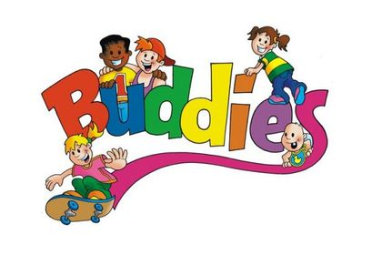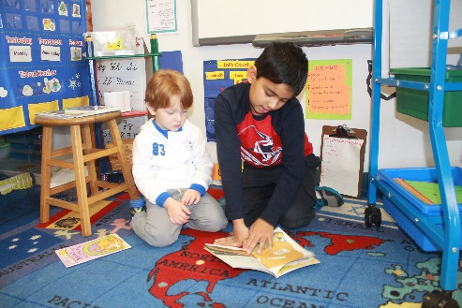
(Luce, 2015) (Independent Day School, n.d.)
As you can see from within my blog. There are many different strategies and resources that us as teachers can use to help implement effective learning into our routines. There are many more that can also help as not everything works the best for everyone, Teaching is all about trial and error, you try and if you don’t see it working for you then you try something else. Theories are a great way of finding resource and strategies as most of the research is already done for you!

Blog 4: Reference list

References
CLASSVR. (n.d.). Virtual reality for schools. Retrieved from CLASSVR: https://www.classvr.com/?msclkid=2240b0f0f7e81f8890c7d77c15808510&utm_source=bing&utm_medium=cpc&utm_campaign=ClassVR%20(UK)&utm_term=immersive%20learning&utm_content=UK%20-%20Brand%20Awareness
Independent Day School. (n.d.). Reading Buddies. Retrieved from Pintrest.
Luce, M. (2015, October 22). Recess buddies~ 2015-2016﻿. Retrieved from Welcome to Ms. Luce's 4K Class: https://msluces4kclass.weebly.com/4k-happenings-blog/recess-buddies-2015-2016

