Student Name: Kristina Masih
Student ID: 2419848
Course Title: BSc Health and Social Care
Module Title: Changemaker: Creativity and value Creation (Component 2)
Module Code: BMHP5014
Lecturer: Zarah Ahmed
Submission date: Sunday 19July 2026
Component 2 – Written Assignment (Poster and Pitch) 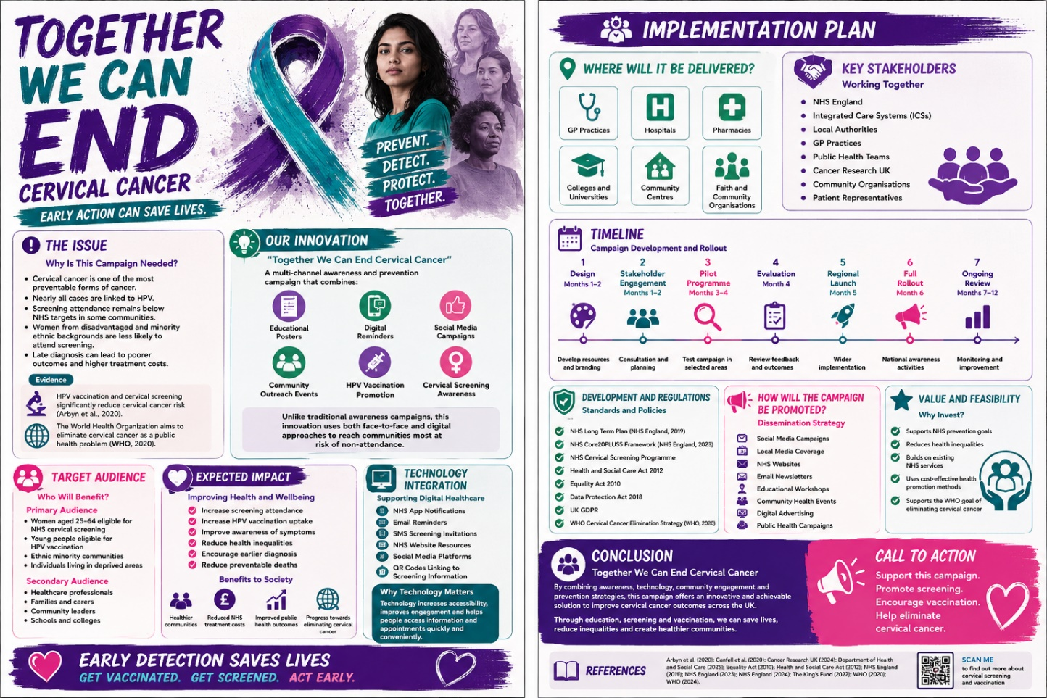
Together We Can End Cervical Cancer Campaign
As a Health and Social Care professional, I am proposing an innovative public health campaign called “Together We Can End Cervical Cancer.” The campaign aims to increase awareness of cervical cancer, improve attendance at cervical screening appointments, encourage HPV vaccination uptake and reduce health inequalities through targeted community engagement.
Although cervical cancer is one of the most preventable forms of cancer, it continues to affect thousands of women across the UK. Almost all cases are linked to persistent infection with high-risk Human Papillomavirus (HPV), and many could be prevented through regular screening and vaccination (Arbyn et al., 2020). However, screening attendance remains below national targets in some communities, particularly among younger women, ethnic minority groups and individuals living in areas of deprivation (Cancer Research UK, 2024). This can result in missed opportunities for early detection and poorer health outcomes.
Building on the educational posters developed for this project, the campaign combines health promotion materials, digital communication, community outreach and partnership working to improve awareness, encourage preventative behaviours and support earlier intervention.
What Makes This Campaign Innovative?
Current approaches to cervical cancer prevention mainly rely on invitation letters, routine health promotion and information provided during healthcare appointments. However, these methods do not always reach individuals facing barriers such as low health literacy, cultural stigma, language differences or anxiety about cervical screening, contributing to health inequalities (Cancer Research UK, 2024).
The proposed campaign adopts a more inclusive approach by combining educational posters, social media, community events, partnership working and digital reminders. Using multiple communication channels helps ensure information is accessible to a wider audience and supports the NHS commitment to reducing inequalities and improving access to preventative healthcare services (NHS England, 2023).
A key strength of the campaign is its focus on community engagement. Working with charities, faith groups and community leaders can build trust and encourage participation, while clear language and inclusive imagery help improve health literacy and support informed decision-making (World Health Organization, 2020).
How the Campaign Will Work
Awareness and Education
Posters, leaflets and digital resources will be displayed in community settings such as GP surgeries, hospitals, pharmacies, colleges and community centres. Information will be provided in different languages and accessible formats to ensure it reaches diverse populations. This supports the principle that healthcare information should be accessible to everyone, regardless of their background or circumstances (NHS England, 2023).
Digital Engagement
Social media platforms, NHS websites, local authority communication channels and the NHS App will be used to share information about cervical cancer prevention. Digital reminders and online booking systems can help reduce practical barriers by making it easier for people to arrange and attend screening appointments. Research suggests that digital communication can improve engagement with health services and support preventative healthcare initiatives (Department of Health and Social Care, 2023).
Community Outreach
Community outreach will play an important role in addressing misconceptions and reducing stigma surrounding cervical screening. Workshops, awareness events and discussions facilitated by trusted community organisations can encourage individuals to seek support and access available services. This approach reflects the importance of partnership working in improving public health outcomes (NHS England, 2019).
Screening and Vaccination Promotion
The campaign will promote existing NHS Cervical Screening and HPV Vaccination Programmes through awareness raising and signposting. By strengthening existing services, it provides a cost-effective approach to prevention. Evidence shows that organised screening and HPV vaccination significantly reduce cervical cancer incidence and mortality rates (Arbyn et al., 2020; Canfell et al., 2020). Together, these activities create a coordinated, person-centred approach that supports prevention, early intervention and improved long-term health outcomes.

Creating Value Through Prevention
A key benefit of this campaign is its ability to create value within health and social care. Porter (2010) suggests that value is achieved when healthcare services improve outcomes while making effective use of resources. Cervical cancer prevention demonstrates this principle because screening and vaccination are considerably less expensive than treating advanced cancer.
By encouraging earlier intervention and increasing participation in preventative services, the campaign has the potential to improve health outcomes, reduce inequalities and lessen future demand on NHS resources. It also supports the priorities outlined in the NHS Long Term Plan, which emphasises prevention, early diagnosis and reducing health inequalities (NHS England, 2019). Furthermore, prevention-focused initiatives are recognised as offering significant long-term benefits for both individuals and healthcare systems by improving population health and reducing avoidable costs (The King's Fund, 2022).
Overall, this campaign provides a practical and sustainable approach to cervical cancer prevention. By combining education, community engagement and partnership working, it has the potential to increase awareness, improve screening uptake and contribute to the wider goal of eliminating cervical cancer as a public health problem (World Health Organization, 2020).

Feasibility and Sustainability
The campaign is highly feasible because it strengthens existing NHS services rather than creating entirely new programmes. It builds upon established cervical screening and HPV vaccination pathways while utilising existing digital platforms and community networks.
Financial sustainability is another advantage. Prevention-focused interventions are widely recognised as generating long-term savings by reducing treatment costs and improving population health (The King's Fund, 2022). Although initial investment would be required for campaign development, community engagement and promotional materials, the long-term benefits are likely to outweigh these costs.
Potential barriers include limited funding, cultural stigma, screening anxiety and digital exclusion. However, these challenges can be addressed through culturally sensitive communication, multilingual resources, community partnerships and alternative non-digital methods of engagement.
Implementation Plan
Phase 1: Planning and Stakeholder Engagement (Months 1–2)
Activities will include developing campaign materials, consulting healthcare professionals and community representatives, ensure cultural sensitivity and establish evaluation measures.
Key stakeholders will include:
- NHS England
- Integrated Care Systems
- Local Public Health Teams
- GP Practices and Primary Care Networks
- Cancer charities
- Community organisations
- Patient representatives
Phase 2: Pilot Programme (Months 3–4)
The campaign will be introduced in selected local authority areas. Feedback will be gathered from service users and healthcare professionals, while engagement and screening attendance data will be monitored.
Phase 3: Full Rollout and Evaluation (Months 5–6)
Following pilot evaluation, campaign materials will be implemented more widely. Community awareness events, digital promotion and targeted messaging will continue alongside ongoing monitoring and evaluation.
Within the first 12 months, the campaign aims to:
- Increase cervical screening attendance by 10%.
- Increase HPV vaccination uptake by 5%.
- Improve public awareness by 15%.
- Increase engagement among underserved communities.

Evaluation and Measuring Success
Campaign effectiveness will be evaluated using quantitative and qualitative measures. Quantitative data will include screening attendance, HPV vaccination uptake, social media engagement, website traffic and event participation. Qualitative feedback from service users, healthcare professionals and community partners will assess accessibility and impact. Findings will inform continuous improvement and future development, with potential adaptation for other public health priorities, including breast and bowel cancer awareness programmes.
Conclusion and Call to Action
I am calling on NHS England, Integrated Care Systems and public health leaders to support the “Together We Can End Cervical Cancer” campaign.
Despite being largely preventable, cervical cancer continues to affect thousands of women each year. This campaign offers an evidence-based and cost-effective approach to increasing awareness, improving screening uptake and reducing health inequalities (Cancer Research UK, 2024). By combining education, community engagement and partnership working, it supports the NHS focus on prevention and contributes to the World Health Organization’s goal of eliminating cervical cancer as a public health problem (NHS England, 2019; World Health Organization, 2020).

References
Arbyn, M., Weiderpass, E., Bruni, L., de Sanjosé, S., Saraiya, M., Ferlay, J. and Bray, F. (2020) ‘Estimates of incidence and mortality of cervical cancer in 2018: A worldwide analysis’, The Lancet Global Health, 8(2), pp. e191–e203.
Cancer Research UK (2024) Cervical cancer statistics. Available at: https://www.cancerresearchuk.org/about-cancer/cervical-cancer (Accessed: 18 July 2026).
Canfell, K., Kim, J.J., Brisson, M., Keane, A., Simms, K.T., Caruana, M., Burger, E.A., Martin, D., Nguyen, D.T.N. and Bénard, É. (2020) ‘Mortality impact of achieving WHO cervical cancer elimination targets: A comparative modelling analysis in 78 low-income and lower-middle-income countries’, The Lancet, 395(10224), pp. 591–603.
Data Protection Act 2018 (2018) Data Protection Act 2018. London: The Stationery Office.
Department of Health and Social Care (2023) Major Conditions Strategy: Case for Change and Strategic Framework. London: Department of Health and Social Care.
Equality Act 2010 (2010) Equality Act 2010. London: The Stationery Office.
Health and Social Care Act 2012 (2012) Health and Social Care Act 2012. London: The Stationery Office.
NHS England (2019) The NHS Long Term Plan. London: NHS England.
NHS England (2023) Core20PLUS5: An Approach to Reducing Healthcare Inequalities. London: NHS England.
NHS England (2024) NHS Cervical Screening Programme Guidance. London: NHS England.
Porter, M.E. (2010) ‘What is value in health care?’, New England Journal of Medicine, 363(26), pp. 2477–2481.
The King's Fund (2022) Prevention and population health. London: The King's Fund.
World Health Organization (2020) Global Strategy to Accelerate the Elimination of Cervical Cancer as a Public Health Problem. Geneva: World Health Organization.
World Health Organization (2024) Cervical cancer. Available at: https://www.who.int/news-room/fact-sheets/detail/cervical-cancer (Accessed: 17 July 2026).

