

Student name: Comfort Bentil-Tumi
Student ID: 2008733

Module name: Living with Care: The Older Person
Module code: (BMHP6009_LON)
Lecturer name: Diola Bijlhout

Contents
Introduction 3
Historical perspectives of Ageing in the UK and Japan 4
Concepts of Loneliness within literature and the relevant theories of loneliness and isolation. 5
Loneliness and Isolation Amongst the ageing Population 5
Prevalence of Loneliness in the UK and Japan amongst the elderly 6
Impact of Loneliness in the UK and Japan in a care setting 7
Legislation and Policies implemented to tackle loneliness and isolation in the UK and Japan 8
Recommendations 9
Future prospects for providing for the elderly 10
Conclusion 10

Introduction
This report will critically evaluate what it means to be elderly in the UK. Further assessing the local, national and global provisions of the health services granted to the elderly with a comparison to Japan. It will examine the current policies within the healthcare system, and how these can be improved in the future to tackle loneliness and social isolation prevalent in the aged.
The World Health Organization (WHO) defined healthy ageing as the process of sustaining functionality to enable good welfare. There is no clear-cut age nor definition as to when a person is considered aged, however, WHO uses the guideline age of 60 throughout their statics with implications that a person is aged at 60 and above.
Specifically in the UK, due to the fact that 65 was the official retirement age as well as the age when people started to receive pensions, this age has traditionally been used to identify people who are elderly (Medicare and Lohr, 2015).
In Japan, the average retirement age for Japanese males is 69.5 years and for females 66.5 years (Ichimura and Shimizutani, 2012). The elderly age in Japan however is also anyone who is 65 years and older (Ouchi et al, 2017).
Additionally, The Japan Gerontological Society and the Japan Geriatrics Society set out on a mission to define the term "elderly" in 2013. Over the course of the three years the select committee spent working on the project, they came up with a number of definitions for the term, and to conclude, they categorized the elderly as follows: those between the ages of 65 and 74 are considered to be pre-old (young-old), and those over the age of 75 are considered to be old age (Koga et al. 2020).
At present in the UK as seen in Figure 1 below 25.10% of the UK’s population is over 60 and this is estimated to only increase in the next coming years. Japan with an even greater ageing population, which at present shown in figure 2 is 34.90% (WHO,2022).
The steep incline of the ageing population in relation to both the UK and Japan is rather astonishing. In 1950 where the ageing population in both countries were lower than 18%. This increase in numbers shows a direct correlation between the improvement of health and social care welfare, public health policies, improvement in technology and the increasing ageing population.

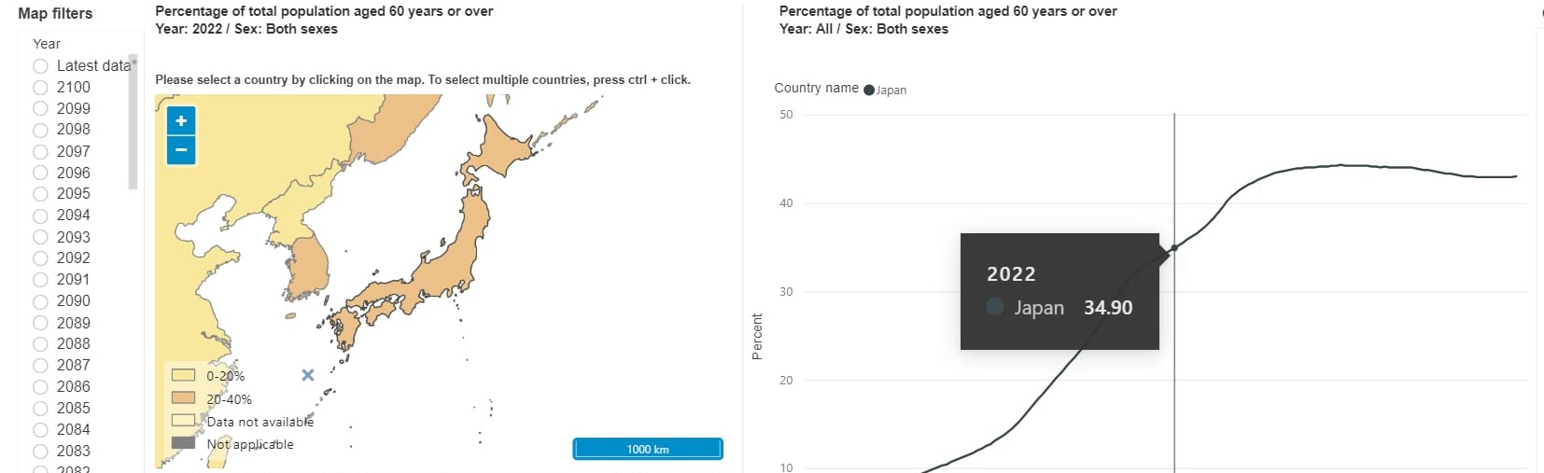

Figure 1
(WHO 2022)

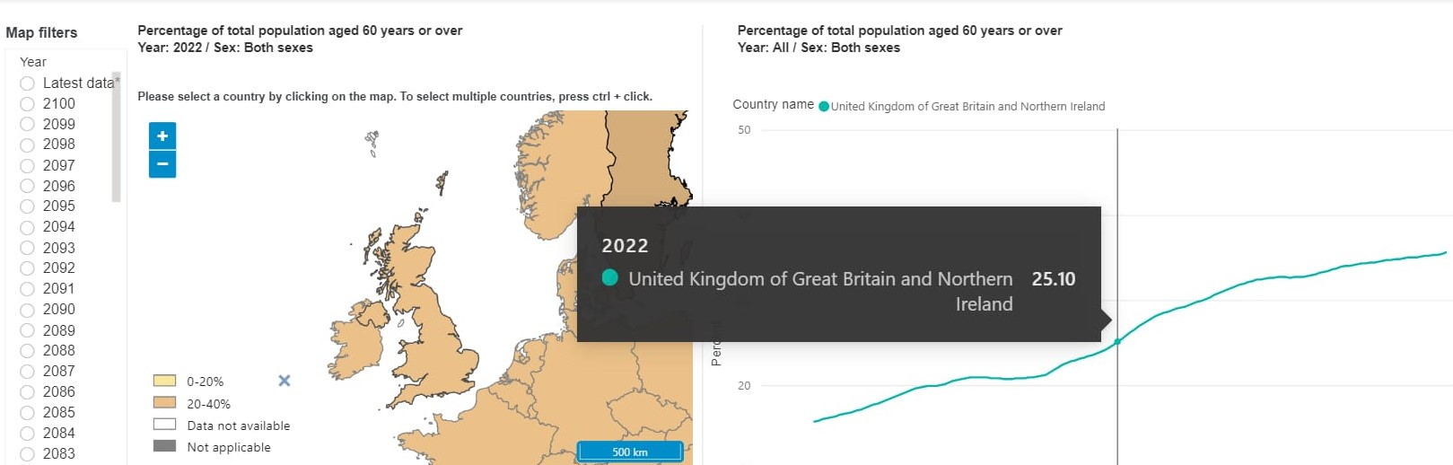

Figure 2
(WHO,2022)

Historical perspectives of Ageing in the UK and Japan
Throughout history, old age has had varying perspectives. The English playwriter Shakespeare makes many correlations of old age as an insult with referenced similarities to it being a disability. Where in his play ‘As you like it’ (Act 3, Scene 2, 80-81) he states “you’re a crooked-pated old cuckoldly ram”. (Covey, 2000, p.171).
Albeit the Japanese concept of ageing in their history is stemmed from Buddhist views. They believe old age is a time of rebirth and celebrate the end of hard work from a period where economic work is an essential part of life. With age, they believe comes wisdom and the term sen-nin (wise sage) is a popular and welcoming ideology of old age and wisdom.
There is deep cultural respect granted to the elderly in Japan where polite age-specific terminology is used when they are addressed. In addition, they celebrate revere day (elder day) where the mayor presents money to those aged over 80 as appreciation and acceptance. (Karasawa, M et al. 2011)
However, the greatest perspective of old age in literature alludes to loneliness and isolation.

Concepts of Loneliness within literature and the relevant theories of loneliness and isolation.
Age is a social construction defined by symbols, in accordance with the symbolic interaction theory. According to the notion, ageing is a biological process that happens naturally throughout time, and as a result, it has no intrinsic value. According to this idea, it is correct to claim that elements affecting the population's biological process have improved, which may explain why the proportion of individuals who are considered old in the UK and Japan now is maybe higher than it was in the past (Population Reference Bureau, 2019).
Disengagement theory provides a compelling argument for why older adults are more likely to reside in rural and coastal parts of the UK than in metropolitan areas (Zhang and Lin, 2021). According to the argument, there comes a point in one's life when they (the elderly) are no longer able to contribute in a meaningful way, maybe through retirement. The claim that contributions to society are made through economic means is most certainly accurate, and the fact that the majority of economic activity occurs in metropolitan centres and other industrialized regions explains why so many elderly people move to rural areas. Ultimately, loneliness and social isolation among the elderly occur.

Loneliness and Isolation Amongst the ageing Population
The concept of loneliness has been described as the lack of desired affection and closeness to a significant person in your life (emotional loneliness). The major important factor to understand in the research on loneliness and its danger is that it is involuntary. (Ong et al.,2016)
There is big evidence that loneliness is a risk factor for morbidity in older ages.
The prevalence of loneliness and isolation has been established to warrant the need for intervention amongst the ageing population. Caioppo undertook a figurative studying showing the impact of the changes in brain behaviour of loneliness resulting in depression and anxiety.
Similarly, a study in Amsterdam showed that there was an increased risk of mortality amongst older men who were isolated and lonely with lowered moods influencing their mental health and physical well-being resulting in suicidal attempts and self-inflicted injuries. (Holwerda et al. 2012)

Prevalence of Loneliness in the UK and Japan amongst the elderly
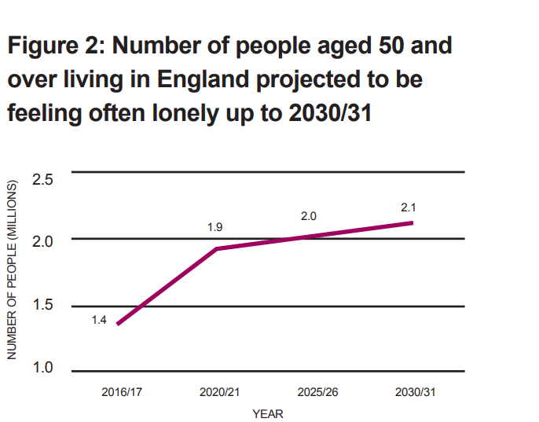
In the UK loneliness amongst adults has been a steadily reoccurring issue. The UK organisation Age UK in 2016 and 2017 recorded that 7% of adults above 50 years old reported loneliness and it is estimated that this percentage is to rise by 2% in 2030/31. (Age UK, 2018)
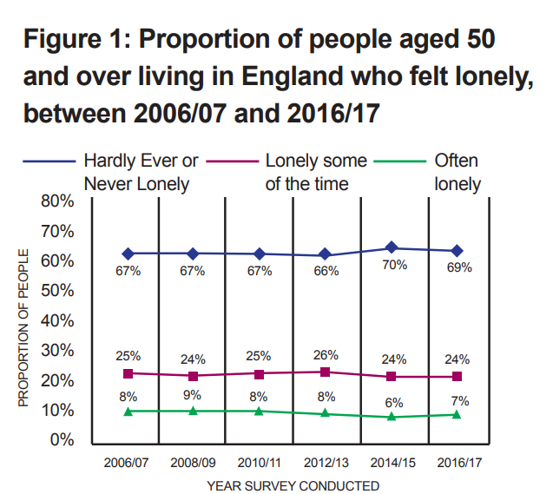
(Age UK, 2018)

Before 2000 the Japanese practice of filial piety resulted in older adults aged 65 years and above living with an adult (usually women) who looked after them. However, between 2000 and 2009 that percentage dropped from 49.1% to 33.1% and more older adults started to live alone. Amongst adults without any intergenerational support, high mortality rates were recorded due to loneliness and the lack of community family support where 37.3% of the participants in the study recorded loneliness from living alone. (Saito and Takagi, 2019, p.156-160)
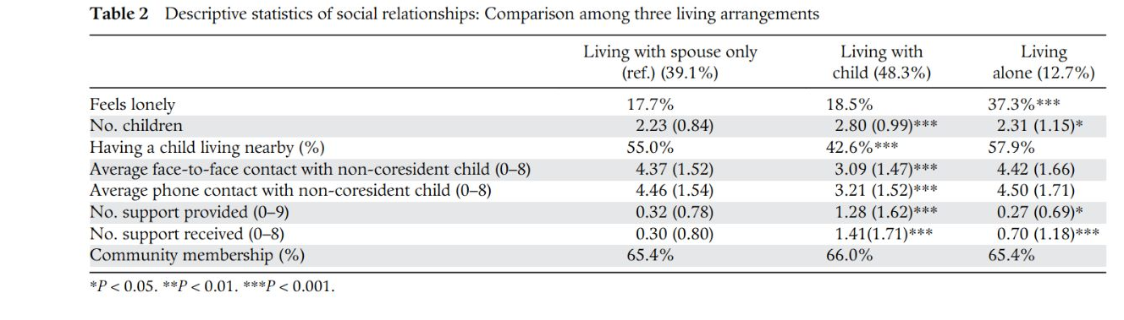

Impact of Loneliness in the UK and Japan in a care setting
Loneliness in the UK has been frequently linked to early death. It shows a greater risk of smoking, risk-taking behaviour and even heart disease, depression, low self-esteem and a decrease in cognition. The extensive research led to the UK taking implemented steps to tackle loneliness (Department for Digital, Culture, Media and Sport, 2018)
The impact of loneliness in the care setting in the UK has encouraged the use of person-centred care. Health and social carers work in collaboration with patients to make decisions on their health.
The importance of this type of care minimises the risk of negative or harmful treatments and the patient feels in control. The Care Act 2014 put person-centred care at its forefront core principle. The impact of this care on the aged is that it can recognise the unique complexity of the aged individual and respects their needs, and preferences and has actively reduced mortality rates. With this close relationship cultivated by the career and the patient, they have someone who is there to listen to their individual needs minimising the feeling of loneliness. (CPD, 2022)
However, there are also negative impacts of loneliness and isolation in care within the UK. One of them is the impact of expenditure on the national health service. Studies have shown that when money is drawn back on certain departments the first to be impacted is older age groups. In comparison to Japan, the cost per capita for those aged 65 and above in the UK only rose by 8% whereas in Japan it rose by 12%. These figures show the reluctance of the UK’s habit to provide the needed service for the aged to reduce loneliness and social isolation. That means many aged do not receive the proper service of care. (Seshmani and Gray, 2002, pp287-294)
One of the main contributors to social isolation and loneliness has been abuse and prejudice. Even more, according to the modernization thesis, the standing of the old in society has deteriorated. Care homes are important to the care that the elderly receive both within the UK and Japan. Given the diversity of the elderly population, a range of services is available to them, including care home services where they receive assistance with daily living activities, services to ensure they receive an equitable share of government benefits (power of attorney), assistance in managing chronic health conditions, and support for their caregivers (Kuluski et al., 2019).
However, the major concern that could worsen the effects of loneliness and isolation is abuse and neglect within care homes. A caregiver may neglect to provide the assistance required for the patient further worsening the impacts of loneliness. Neglect could be intentional or accidental from incompetence. This lack of care can result in behaviours such as drug substance abuse and depression and in extreme cases suicide. (Lacha et al. 1995)
In Japanese care, they aim to incorporate their strong sense of family and culture to enhance their care. They understand the direct impact of community on loneliness. Most aged care facilities were located in urban areas in storey buildings with densely populated areas. Some engaging activities included changing artwork to mimic the change in seasons, including traditional dishes in the food served at the care homes, and celebrating traditional festivals such as the spirit blossom festivals. Such activities allow community and a sense of belonging and minimise the impacts of loneliness among the aged. It is commonly seen that residents at Japanese care homes live longer from their date of admission in comparison to other western countries. Their idea of creating a space for rehabilitation is to provide positive functional changes as adults change with the seasons going by. (Annear et al. 2016)
The negative issue with Japanese care is that there is a qualification process and if you do not meet such requirements, you will not be eligible to receive care. This can have detrimental effects on adults who may live alone in need of care but will be deemed ineligible. This is an issue that the Japanese government have sought to rectify. There are reviews done every 6 months however, this may be an issue that can only be looked at on a local scale. The local government have the power to access individuals in each district to make decisions on eligible persons. (Saito and Yong, 2012, pp.271 -284)

Legislation and Policies implemented to tackle loneliness and isolation in the UK and Japan
In the UK the Care Act 2014 was a legal framework implemented to ensure care services were delivered to tackle specifically loneliness and isolation. The act required local and national authorities to provide and arrange facilities and support. In addition to the implementation of the act, the UK also provided a guide as to how local authorities could tackle loneliness. The UK’s aim is prevention.
Laws like the Equality Act and the Age Discrimination Act 2010 are in place to protect the elderly from being mistreated and discriminated against in any manner, which can help combat loneliness and social isolation (GOV.UK, 2010).
The UK is a leading country at the forefront to tackle loneliness. In 2018 the world’s first Ministerial lead Jo Cox was appointed.
The campaign to end Loneliness in older age aims to provide awareness and provide relevant information about loneliness among the elderly in order to create conversations to prevent loneliness in older with the use of well-being boards and guidance articles. (Department of Health, 2014)
In Japan, they implemented the national long-term care insurance (LTCI) policy. This was implemented in 2000 with various program benefits. The intention is to provide both in-home care and care at institutional facilities. Persons over 65 are all eligible with persons running 40-64 eligible if they have a health-related disability. Eligibility is evaluated every six months. If eligible you will benefit from both in-care and institutional care services.
The major push to Japan finally implementing the LTCI was the social shift from family care where the onus was on women to stay home and care for the elderly. As Japan has modernised, this view has shifted therefore requiring institutional care for lonely elderly which was otherwise not the case in the past. The system not only pays out to the elderly with a monthly expectation of approximately 61,500 Japanese yen. The wide range of services also includes care home institutions where the elderly can gather to promote a community where care managers develop plans and consultation.
The success of the LTCI in Japan is astonishing where a survey conducted by the Ministry is heath and labour and Welfare indicated that 86% of those under the LCTI were satisfied with the services they received. (Saito and Yong, 2012, pp.271 -284)

Recommendations
A study undertaken in Japan showed the effectiveness of an “educational, cognitive and social support program” was highly effective in treating loneliness and social isolation. The study showed that putting together larger socially diverse groups cultivated a sense of protection for one another and this form of intervention was particularly helpful with mental well-being. Tackling depression and anxiety which may develop from loneliness. In addition, the intervention is low cost, tackles loneliness at its root cause and creates long-lasting communities. (Crewdson, 2016, p.6)
As the world’s ageing population grows at exponential rates it would be wise to implement international laws and educational programmes incorporating all the advantages of different methods and policies from different countries to create better care methods. Learning from one another’s weaknesses and strengths may be a major key to the health care management of the aged. For example, the UK may benefit from the use of community care homes as implemented in Japan to cultivate communities within counties.

Future prospects for providing for the elderly
The claim that people live longer now because lifespans have grown is only partially true because most individuals have a variety of requirements as they age, which places a heavy burden on the health and social care systems. Latikka, et al. (2021) have highlighted the necessity to do more with less, which in essence implies integrating technology into the care of the aged, in an effort to address the issue of loneliness and social isolation among the aged while still offering them the necessary freedom and an upholding of self-worth. It is essential that technology be incorporated since it is anticipated that the percentage of the elderly would increase dramatically, which would result in a considerable increase in care requirements and even make it more challenging to provide care.
Japan is in the process of developing AI as a means to provide support to the elderly. The current improvement in robotics has increased the potential use of physical and emotional support among the elderly. Japan’s cooperation program funds the Agile Co-Creation for Robots and Aging Project (ACCRA) proposed to create robots as physical aids (mobility and daily life support) called the Astro Robot and social companions accessible to promote healthy ageing. The approach is in four stages. To conduct a needs analysis, develop robots that fulfil those needs, undertake a wide-scale experiment and sustainability analysis. (D’Onofrio et al. 2018, pp.785-800)
The use of technology, particularly artificial intelligence (AI), in providing care to the elderly is thus anticipated to increase in the future. For instance, there are currently numerous studies and developments related to mechanical companions that could help the elderly “dance, walk, connect socially, remind them to take medication”, and even assist with activities of daily living. The main advantages of using technology to assist for the elderly are that feelings of social isolation and loneliness are likely to disappear, that seniors live more independently and with dignity since their privacy is encouraged, and that they live longer and in better health (Tun et al. 2021).

Conclusion
This report has shown the direct relationship between loneliness and healthy ageing from the UK and Japanese perspectives. Both countries have cultivated different social and cultural ways to tackle loneliness among the aged. However, there is more to be done in the future. The use of robotics and AI show huge promise. In addition, the UK’s person-centred approach also tackles individuality which is effective for every person. Japan and UK do acknowledge that loneliness is a prevalent issue amongst the aged and this will only increase with their continuing growing aged populations unless they are tackled.
References
Age UK (2018) All the Lonely People: Loneliness in Later Life. Available at: loneliness-report_final_2409[1].pdf (Accessed: 14 December 2022)
Annear, M. J (2016) ‘Experiences of Japanese aged care: the pursuit of optimal health and cultural engagement’, Age and Aging, 4(6), pp.753-756. https://doi.org/10.1093/ageing/afw144 (Accessed: 15 December 2022)
Covet, H. (2000) ‘Shakespeare on Old age and disability’, Intl.J Aging and human development, 50(3), p.171 Available: (Accessed: 13 December 2022)
CPD (2022) Why is person-centred care important? Available at: https://cpdonline.co.uk/knowledge-base/care/person-centred-care/ (Accessed: 15 December 2022)
Crewdson, J.A (2016) ‘The Effect of Loneliness in the Elderly Population: A Review’, Healthy ageing & clinical care in the elderly, 8, p.6. Available at: f_5439-HACCE-The-Effect-of-Loneliness-in-the-Elderly-Population-A-Review.pdf_7270.pdf (Accessed: 14 December 2022)
D’Onofrio, G et al (2018) ‘Agile Co-Creation for Robots and Aging (ACCRA) Project: new technological solutions for older people’, European Geriatric Medicine, 9, pp. 795-800. Available at: Agile Co-Creation for Robots and Aging (ACCRA) Project: new technological solutions for older people | SpringerLink (Accessed: 15 December 2022)
Department for Digital, Culture, Media and Sport (2018) A connected society A strategy for tackling loneliness – laying the foundations for change. Available at: DDCMS Loneliness Strategy (publishing.service.gov.uk) (Accessed:10 December 2022)
Department of Health (2014) Care and Support Statutory Guidance. Available: 43380_23902777_Care Act_Book.indb (publishing.service.gov.uk) (Accessed: 15 December 2022)
GOV.UK (2010) Equality Act 2010: guidance. Available at: https://www.gov.uk/guidance/equality-act-2010-guidance.
Holwerda, T. J. (2012) ‘Increased risk of mortality associated with social isolation in older men: only when feeling lonely? Results from the Amsterdam Study of the Elderly (AMSTEL)’, Psychol Med, 42(4):843-63. DOI: 10.1017/S0033291711001772. (Accessed: 13 December 2022)
Ichimura, H. and Shimizutani, S. (2012) ‘Aging in Asia’, National Library of Medicine. Available at: https://www.ncbi.nlm.nih.gov/books/NBK109234/ (Accessed: 13 December 2022)
Karasawa, M. et al. (2011) ‘Cultural Perspectives on Aging and Well-Being: A Comparison of Japan and the U.S.’, Int J Aging Hum Dev, 73(1), pp.73-98. DOI: 10.2190/AG.73.1.d (Accessed: 16 December 2022)
Koga, C. et al. (2020) ‘Elder abuse and social capital in older adults: The Japan Gerontological Evaluation Study’, Gerontology, 66(2), 149-159.
Kuluski, K. et al. (2019) ‘What is important to older people with multimorbidity and their caregivers? Identifying attributes of person centered care from the user perspective.’, International journal of integrated care, 19(3).
Lachs, M. (1995) ‘Abuse and neglect of elderly persons’, The New England journal of medicine, 332(7), pp.437-443. Available at: https://www.proquest.com/docview/223981234?accountid=130472&parentSessionId=IgjxOH9oiXrUVRjtDjVhzsxlAAhen1eCR6AwCUafgo4%3D&pq-origsite=primo (Accessed: 18 December 2022)
Latikka, R., et al (2021) ‘Older adults’ loneliness, social isolation, and physical information and communication technology in the era of ambient assisted living: A systematic literature review’, Journal of medical Internet research, 23(12). DOI: 10.2196/28022. (Accessed:14 December 2022)
Medicare and Lohr, K.N. (2015) The Elderly Population. Available at: https://www.ncbi.nlm.nih.gov/books/NBK235450/. (Accessed: 10 December 2022)
Ong, A.D. (2016) ‘Loneliness and Health in Older Adults: A Mini-Review and Synthesis’, Gerontology, 62:443-449. DOI: https://doi.org/10.1159/000441651. (Accessed: 13 December 2022)
Ouchi, Y. et al. (2017) ‘Redefining the elderly as aged 75 years and older: Proposal from the Joint Committee of Japan Gerontological Society and the Japan Geriatrics Society’, Geriatrics & Gerontology International, 17(7), pp. 1045–1047. Available at: https://doi.org/10.1111/ggi.13118. (Accessed: 18 December 2022)
Population Reference Bureau (2019) Countries with the Oldest Populations in the World. Available at: https://www.prb.org/resources/countries-with-the-oldest-populations-in-the-world/. (Accessed: 11 December 2022)
Saito, Y. and Takagi, E. (2019) ‘Japanese older adults’ loneliness, family relationships and mortality: Does one’s living arrangement make a difference?’, Behavioural and social sciences, pp.156 -160 DOI: 10.1111/ggi.13837 (Accessed: 14 December 2022)
Saito, Y. and Yong, V. (2012) ‘National Long-Term Care Insurance Policy in Japan a Decade after Implementation: Some Lessons for Aging Countries’, Ageing International,37, pp.271-284. Available: https://link.springer.com/article/10.1007/s12126-011-9109-0#Abs1 (Accessed 10 December 2022)
Seshamani, M and Gray, A. (2002) ‘The impact of ageing on expenditures in the National Health Service’, Age and Aging, 31, pp. 287-294.
Tun, S. et al. (2021) ‘Internet of things (IoT) applications for elderly care: a reflective review’, Aging clinical and experimental research, 33(4), 855-867. DOI: 10.1007/s40520-020-01545-9. (Accessed: 14 December 2022)
World Health Organisation (2022) Percentage of total population aged 60 and over. Available at: Percentage of total population aged 60 years or over (who.int) (Accessed: 13 December 2022)
Zhang, X. and Lin, H. (2021) ‘Disengagement Theory’, Encyclopedia of Gerontology and Population Aging, pp. 1471-1476) DOI:10.1007/978-3-030-22009-9_645 (Accessed: 10 December 2022)

