retrofit coordination & management
EnerPHit Assessment

Mark Preston – ID 2223676
HND / BSc Construction Management

Contents Page

Introduction – Page 2
Background – Page 2, 3
Sustainability – Page 3
Existing Site Plans – Page 4, 5
Current Annual Heat Load – Page 6
Passivehaus Key Principles – Page 6
Existing Water Content in Stone Wall – Page 7
Scenario Water Content in Stone Wall with EPS EWI – Page 8
Scenario Water Content in Stone Wall with Woodfibre EWI – Page 9
Scenario Thermal Imagery with EWI applied (Part & Full) – Page 10

Interventions

EWI – Page 11
EWI Rockwool Insulation – Page 11
Cavity Fill Insulation - Page 12
Breathable Render – Page 12
Windows & Doors – Page 13
Ventilation (MVHR) – Page 13
Proposed Ventilation Strategy – Page 14, 15
Ventilation Strategy First Floor Plan – Page 16
Ventilation Strategy Ground Floor Plan – Page 17
Ventilation Strategy Plan Keys – Page 18
Floor – Page 18
Thermal Bridging - Page 18
Air Tightness / Wind Tightness – Page 19
Feasibility Study for Solar Panels – Page 20, 21
Existing & Scenario PHPP Example - Page 22
Comparing Existing and Proposed Intervention’s Heating Demand – Page 23
Conclusion – Page 23
References – Page 24, 25

Introduction

This report outlines an approach to achieving EnerPHit standards and the reasoning behind the choices. Using PHPP (Passive House Planning Package) as a baseline, it is determined that the building does not currently meet EnerPHit requirements. The goal of this report is to provide an honest assessment of how far a building can be improved, even if it doesn’t fully reach EnerPHit standards. In some cases, upgrades can become too costly to justify, meaning there’s a practical limit to what can be achieved within reasonable financial constraints. Achieving EnerPHit certification requires significant investment, although this report will be based on energy performance and not cost.

Background

The Solid Stone building was built 180 years ago as a blacksmith. As per the Swansea council planning website, it was converted in 1900 into a cottage. (2 spaces upstairs and 2 spaces downstairs). 1977 is when the side double storey extension was built (uninsulated block & block) and 1995 for the rear utility room (insulated (50mm) block cavity based on 1995 building regs). Prior to this it was a quarry and a cart shed. The chimneys would have been brought in when it was a blacksmith. Given the deuteriation of the windows it is assumed the windows were changed in 1995 (30 years old). There is currently a solid hardwood door to the front of the property, solid hardwood stable door to the south facing side elevation and PVC French doors (1995) to the north facing side elevation.

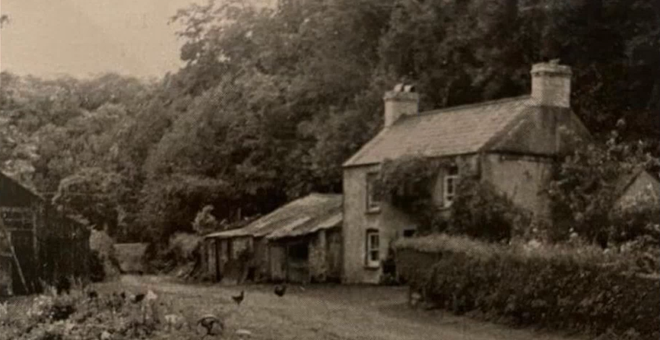
(Brown I, 2025)
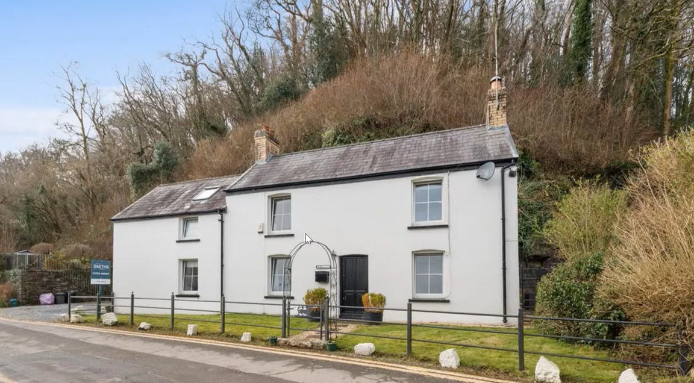
(Zoopla, 2025)

Sustainability

Sustainability isn’t just about the environment; it also includes economic and social factors. The ethical side of it means making sure the people living in a building can do so comfortably. That involves considering health, practicality, and how the design works for daily life. Any changes to a building need to fit the people using it. One example is off-gassing, where certain materials release chemicals over time. PIR insulation, for example, can off-gas for years.
While knocking down and rebuilding might seem like an option, it would come with a much higher carbon footprint and embodied energy compared to keeping the existing structure. Plus, tearing down an older building means losing its historic character, which is an important part of sustainability.

From an environmental perspective, everything should be chosen as sustainably as possible, with a focus on materials and embodied energy. Also bearing in mind this is a conservation area. But in practice, economic factors tend to take priority. Many retrofits are approached with buildings seen as assets rather than homes. This makes it even more important to ensure the right interventions for each building. For example, painting an older solid wall with non-breathable paint or cement-based render would trap moisture, eventually causing serious damage.

Existing Site Plans
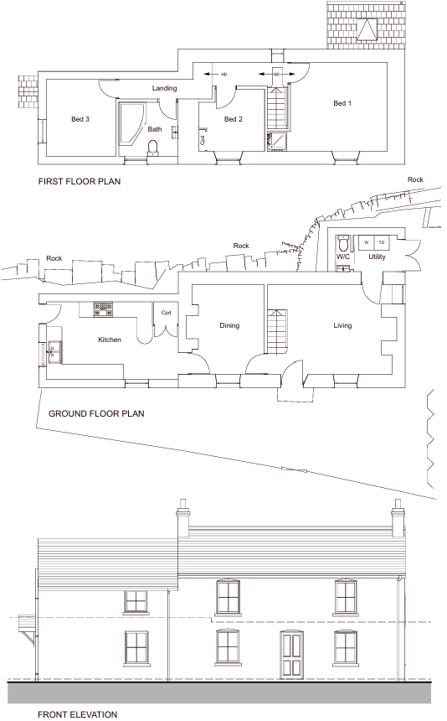
(Brown I, 2025)
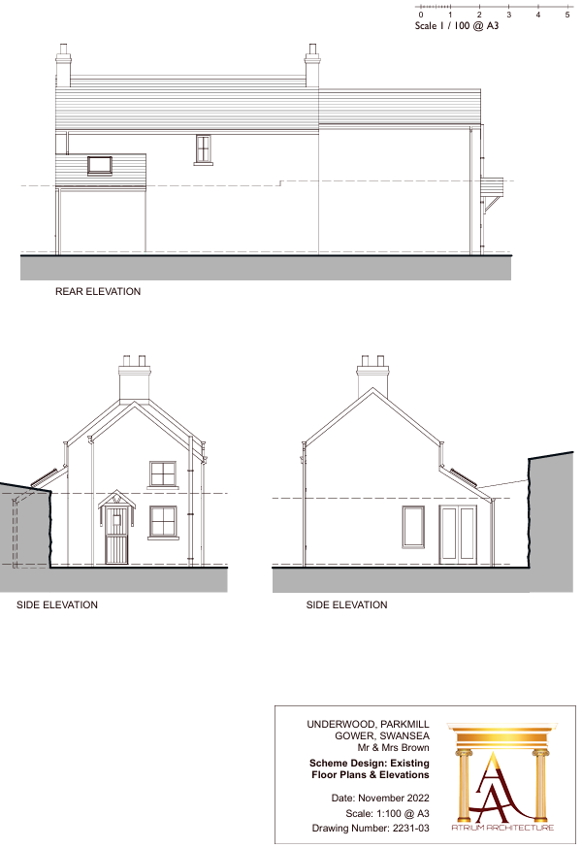

(Brown I, 2025)

Current Annual Heat Load

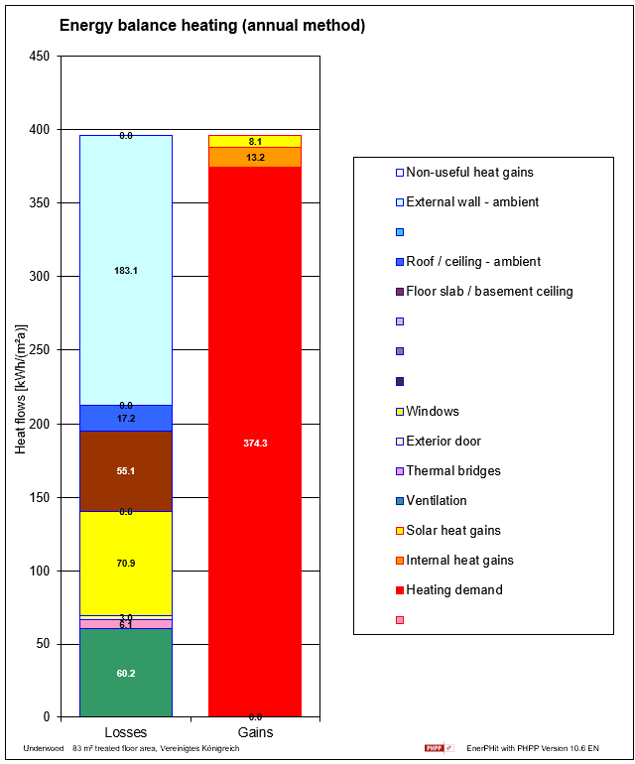
(Brown I, 2025)

As per the diagram above, the biggest heat loss currently is through the external walls, followed by windows, ventilation, then floor slab.

Passivehaus Key Principles

A well-balanced retrofit should focus on key principles from Passivhaus, including:

- Airtightness & wind tightness to control energy loss
- A continuous insulation layer for thermal stability
- Energy-efficient windows and doors to reduce heat loss
- Mechanical ventilation with heat recovery (MVHR) for air quality
- A ventilation strategy & minimizing thermal bridges to prevent issues like condensation

Moisture management also needs to be a priority. If breathability isn’t considered, trapped moisture can lead to long-term problems.

Existing Water Content in Stone Wall

The current wall makeup is gypsum plaster in sections, lime paster everywhere else, stone wall (600m thick), mix of both cement and lime render between stone wall & gypsum plaster (from over the years) and cement base render on the outside. The below diagram shows the moisture level in the limestone itself is slowly increasing overtime. With zero input of external water sources coming in, this shows that moisture levels within the structure is increasing overtime. Since the building was made, moisture from average heating and moisture production in relative humidity is always increasing. The walls are potentially saturated as they are 100+ years old as a property. Even though the building is heated, helping the walls dry out, you’re also forcing moisture back into the wall. As per the client, Summer is the worst time with moisture issues as the heating is not on as much. There is a wood burner in the property which in essence was the original heat source which would have significantly changed the building fabric and would ensure the moisture that is building was pushed down.

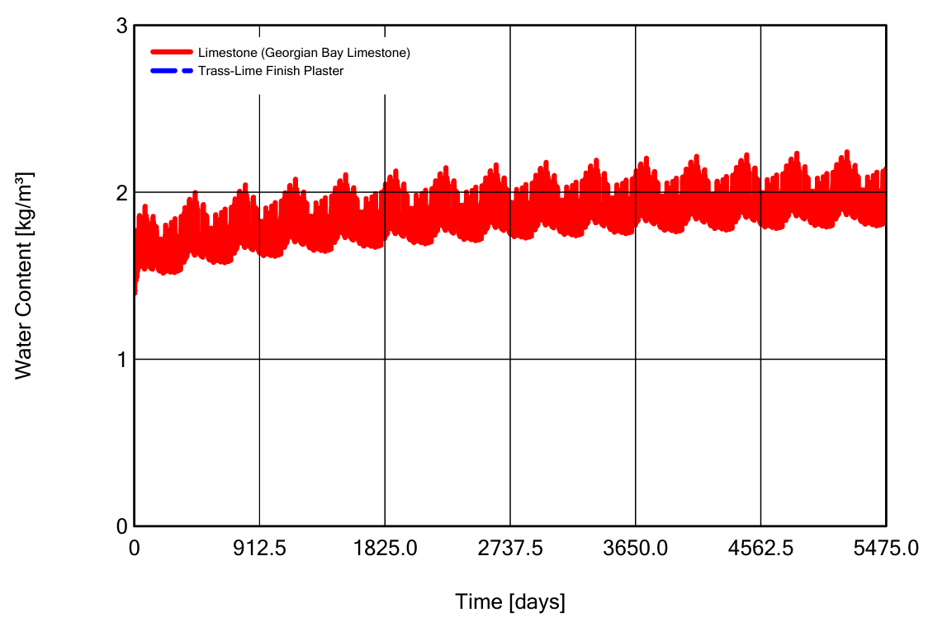
(Brown I, 2025)

Scenario Water Content in Stone Wall with EPS EWI

Below is a diagram if standard 100mm EPS (Expanded polystyrene) non breathable EWI was appplied on the outside. The moisture content remains relatively steady and fairly low and the moisture content for the limestone wall starts to reduce with the cement render still in place.

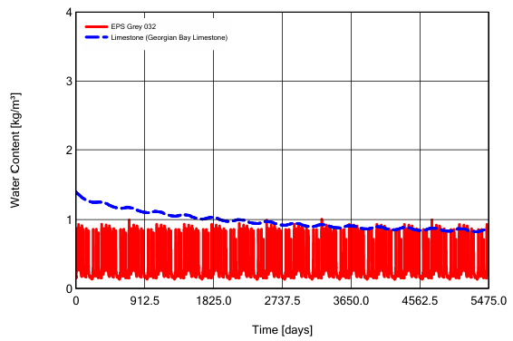
(Brown I, 2025)

Scenario Water Content in Stone Wall with Woodfibre EWI

The diagram below shows if wood fibre board was applied for EWI. Comparing both scenario diagrams, the EPS would perform better than the Woodfibre in this scenario. It shows a better result than the natural insulation. The reason for this it is currently there is a cement render that doesn’t breathe. The idea is to model this with the cement render gone, lime render applied and then compare the differences.

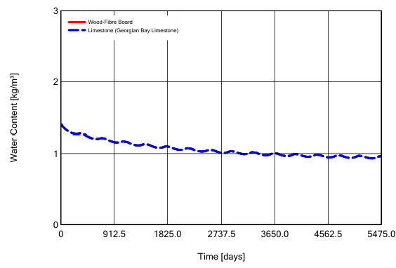
(Brown I, 2025)

Scenario Thermal Imagery with EWI applied (Part & Full)

The diagram below (left) represents the solid floor and solid screed, then the solid wall bearing onto rock with 100mm EPS but it’s not taken below DPC level. The diagram below (right) shows the EWI going down as far as the bottom edge of the slab. For representation, the closer the colours are together, the slower the heat loss is occurring. The red is one solid colour, showing the heat is the same one side to the other. It is losing heat below but as soon as the insulation has been applied, the heat is not being lost.

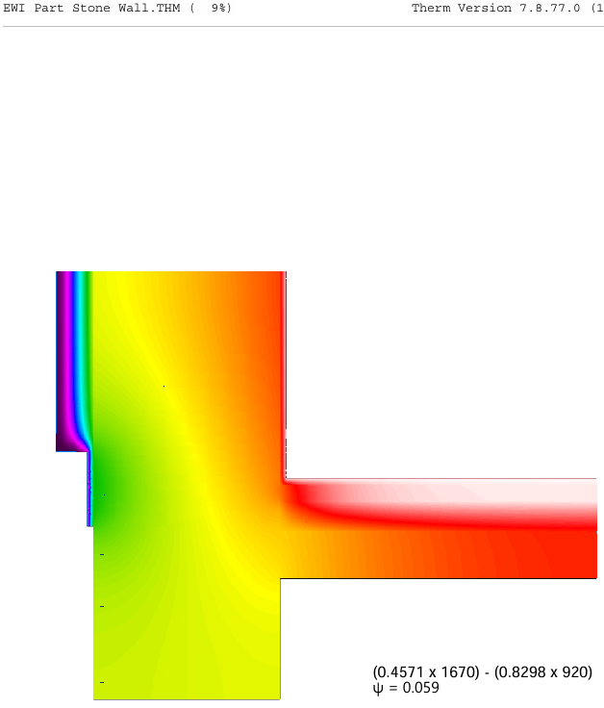
(Brown I, 2025)

Interventions

EWI

To install external wall insulation (EWI), the roof would need to be extended by 2 slates minimum including the verge. This overhang will help with moisture management and would be the perfect time to renew the guttering for wider opening gutters for direct issues such as the trees behind and excessive rainfall. The overhang will mean losing part of the bathroom window as per the site plans. Fortunately, there’s already a roof light, so natural light would not be a major issue.

The cavity walls would need filling with insulation as this becomes part of the building makeup (unvented). As the render around the property is smooth and in good condition, the question is whether EWI can go directly on or not. This is a traditional stone cottage with block sections, so the insulation needs to work across both materials. There are two main options:
Natural insulation to keep breathability, aligning with the building’s traditional character.
High-performance, slimmer insulation, which would be non-breathable as well as the existing cement render and plaster-based paint.

For this scenario, the cement render will be removed (approx 25mm), exposing the stonework, then lime render will be applied to keep breathability before adding the insulation. Internally, lime plaster is already applied which would help maintain moisture balance. This approach would change how moisture moves through the building. It would allow the structure to dry out instead of trapping dampness.
EWI seems like the best option and can be justified as no internal space is lost with potential IWI, and the property is currently occupied, therefore wouldn’t affect this as work is outside.

EWI Rockwool insulation

Rockwool insulation is considered synthetic because it's made from a combination of natural materials (like volcanic rock) that are melted and spun into fibers. While the raw materials are natural, the manufacturing process creates a man-made mineral fiber product. I have chosen this material for the EWI as it has low thermal conductivity and it’s a breathable material. The Psi value is 0.036W/(m2k) so this will be added to the PHPP in the relevant areas at 100mm thick.
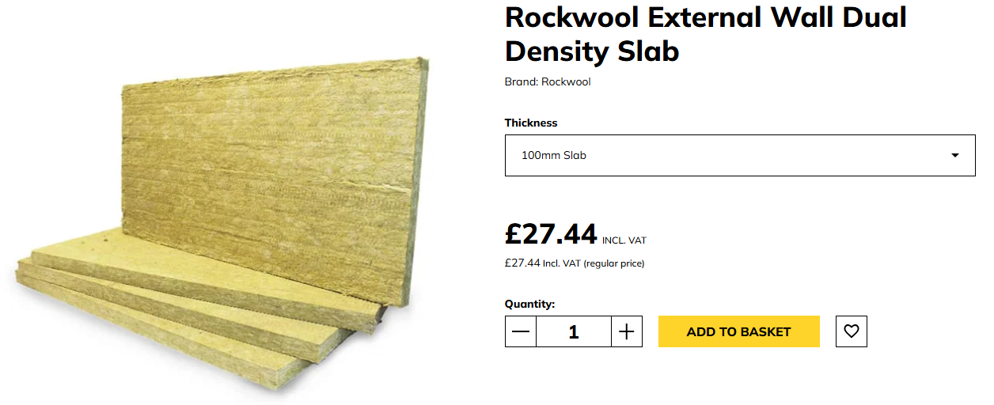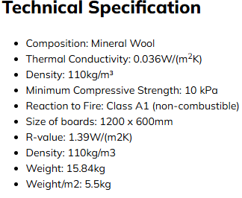
(EWIStore, 2025)

Cavity Fill insulation
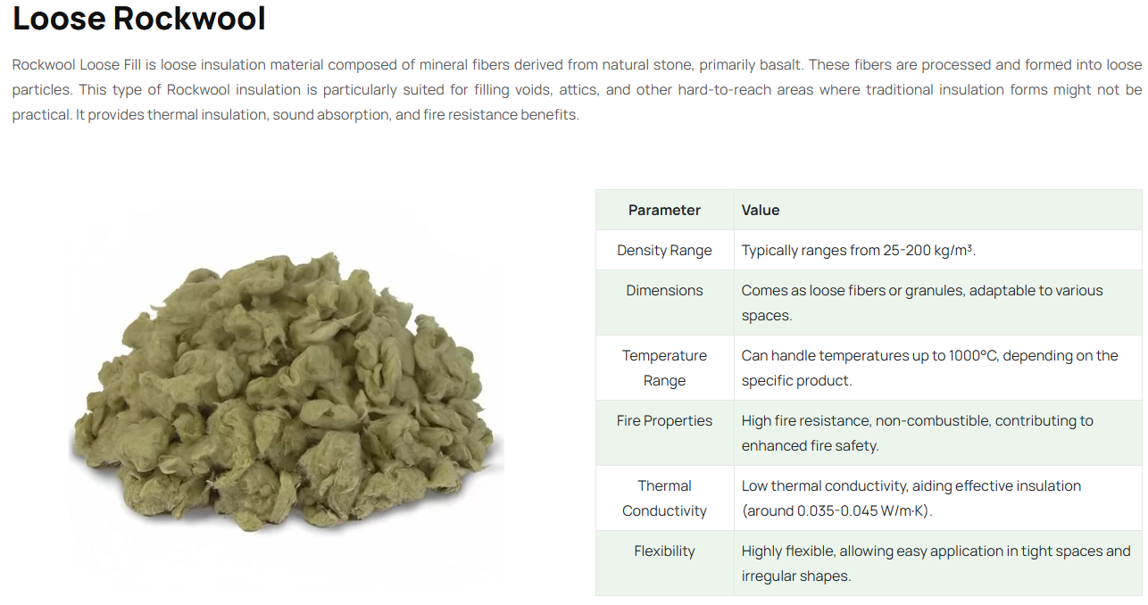
(Shree Gayatri Insulation Pvt Ltd, 2024)

Breathable Render

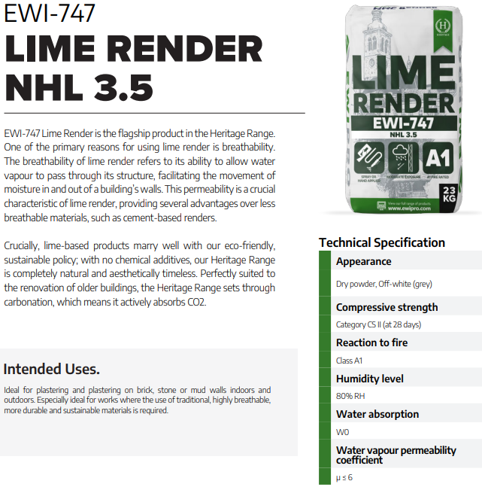
EWIPRO Building Solutions, (2025)
Windows & Doors

The next priority in the project is windows and doors, which are essential for achieving high performance and sustainability. Passivhaus-certified windows and doors will be used to ensure maximum energy efficiency. To maintain airtightness, all windows and doors must be properly taped and sealed. The external and internal doors will also be selected with sustainability in mind. The windows / doors need to be repositioned within the new EWI insulation layer, forming part of the external thermal envelope of the building. For consistency with the area, required is a Passivhaus-standard door with a U-value of 0.8 W/m²K. I’ve found a local company ‘GRM Windows’ that provide triple-glazed windows with a PSI value of up to 0.79 W/m2K. The ‘AGILA’ passivehaus door by Rheau provides a u-value of 0.7 W/m2k. Again, these will be added to the PHPP.

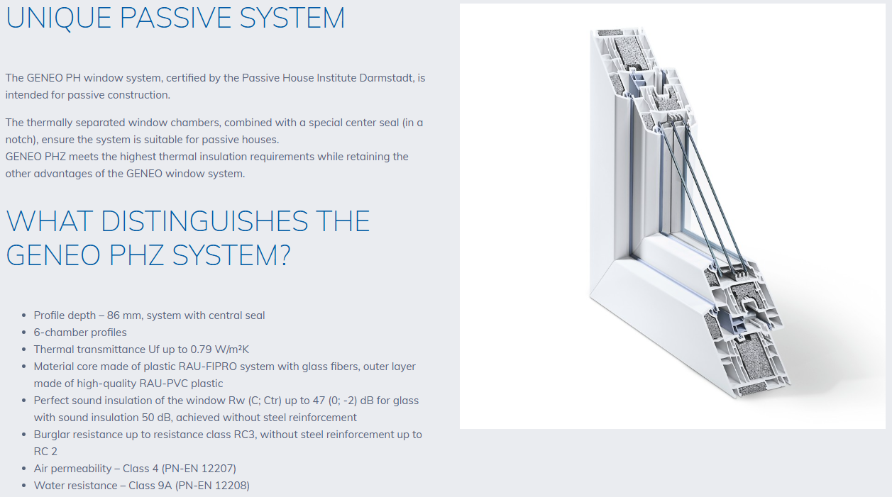
FASADA. (2025).

Ventilation (MVHR)

A Mechanical Ventilation with Heat Recovery (MVHR) system is one of the most effective ways to improve indoor air quality, reduce the risk of moisture ingress, and enhance overall energy efficiency. This can be quantified through tools like the PHPP. Undercutting doors, provide airflow as part of this strategy. MVHR directly benefits occupants' health and contributes to better air quality. While MVHR offers significant advantages, it’s not always viable for older, leaky stone cottages, where airtightness is difficult to achieve. In such cases, building services must be considered secondary to fabric performance, which is catered for in this report).

Proposed Ventilation Strategy

PAUL Heat Recovery have provided a quote for installation on an MVHR System for the existing plans provided. As per the quote below, the preference would be the Passive House MVHR (Zehnder CA 180 LuxePH) as part of the Passive MVHR Range that PAUL supply. Because of the size of the unit, it can potentially fit into a cupboard space. Please refer to referenced data sheet.

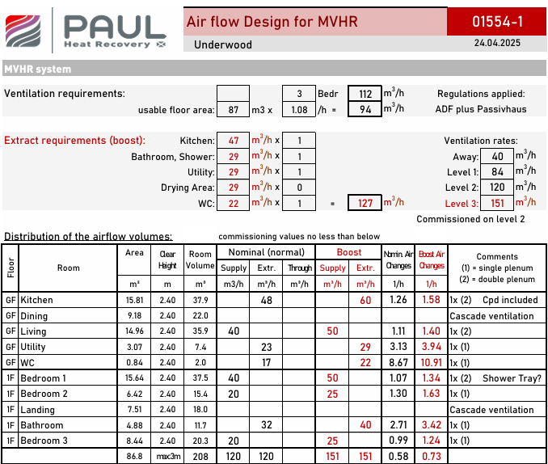
(PAUL Heat Recovery, 2025)
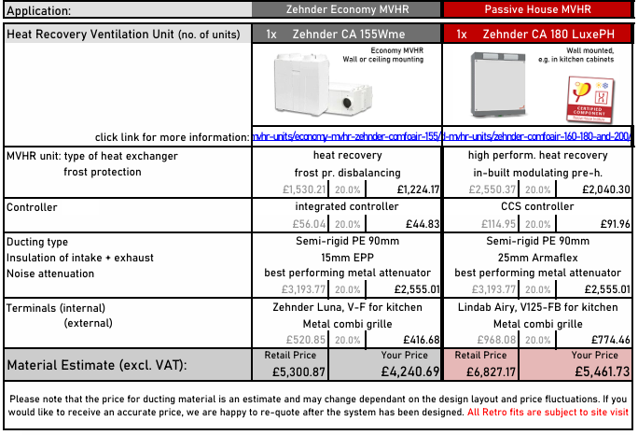

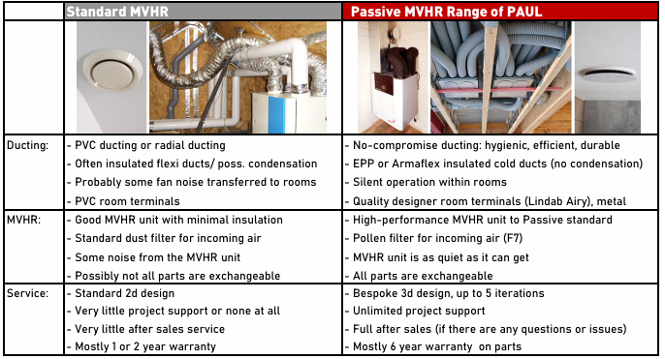
(PAUL Heat Recovery, 2025)

Ventilation strategy drawings have also been provided. The decommissioned fireplace in the dining room has been utilised for the duct riser to take a supply and extract duct down into the ground floor ceiling void to serve the ground floor. Please refer to the ventilation strategy drawings below for the first floor & ground floor including annotations.
Ventilation Strategy First Floor Plan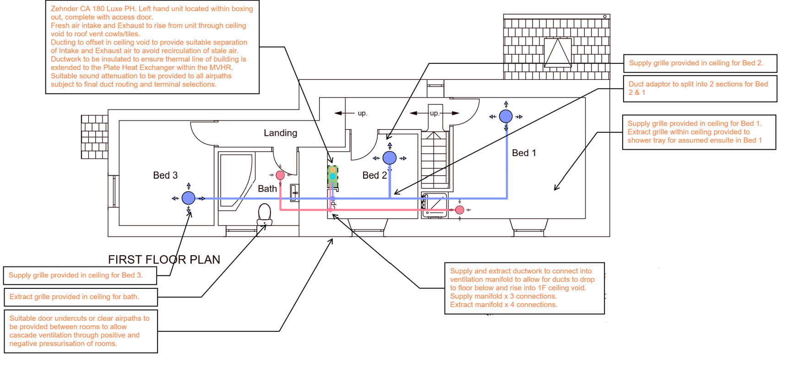
(PAUL Heat Recovery, 2025)
Ventilation Strategy Ground Floor Plan
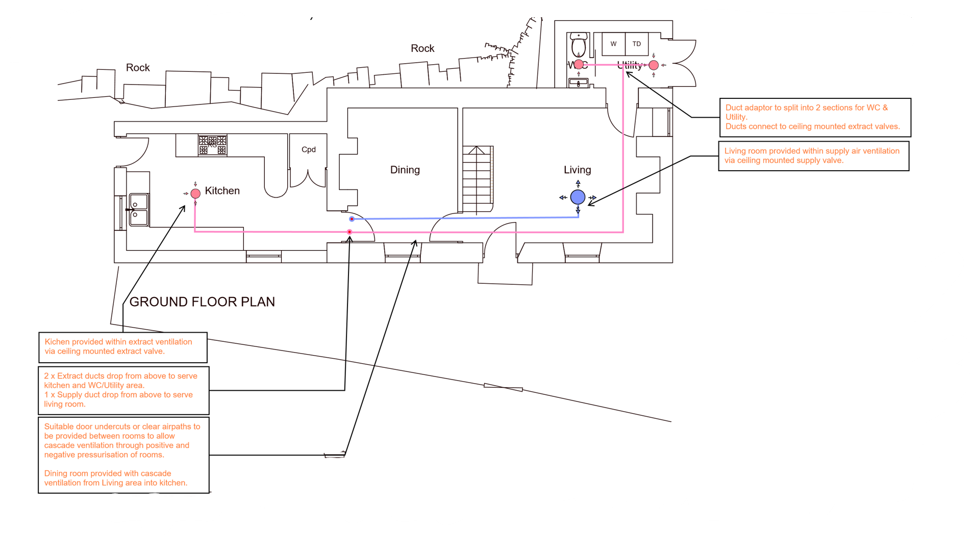
(PAUL Heat Recovery, 2025)

Ventilation Strategy Plan Keys

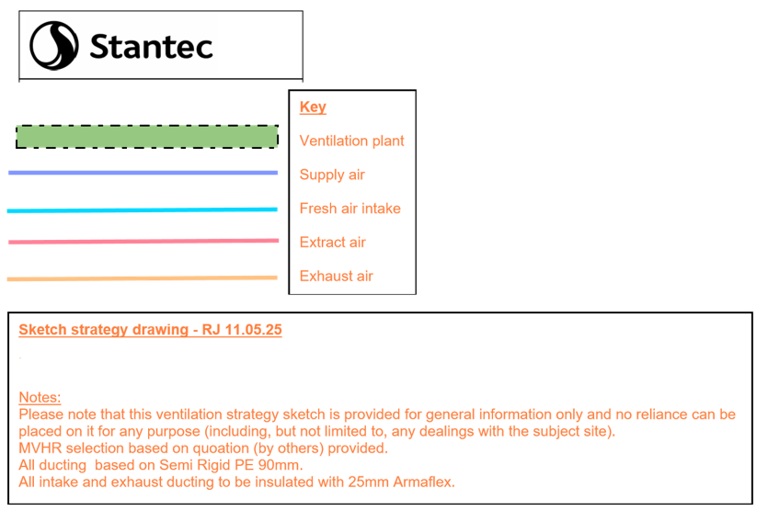
(PAUL Heat Recovery, 2025)

Floor

To improve thermal performance, you should take the insulation down as far as possible. Given the existing model, digging up the floor & slab, then installing insulation, would be a major job, but would significantly reduce heat loss. A lot of heat escapes through the floor as per the current annual heat load diagram shown previously, so addressing this would make a noticeable difference. Currently there is stone below ground, with rubble-filled walls and an old slab. The floor consists of underfloor heating, a screed layer, and stone flooring, but there’s no insulation beneath it. The plan is to install external wall insulation (XPS) below ground and a breathable insulation above ground (rockwool). The challenge is that excavation will be substantial, as the ground is solid rock. It would mean digging up the existing materials, installing new insulation, laying a fresh slab and screed, and then reinstalling the underfloor heating system. Again, the rockwool floor slab insulation would be added to the PHPP.

Thermal bridging

Thermal bridging is one of the trickiest challenges in retrofit projects, especially when dealing with existing structures. Some thermal bridges can be managed, but others, like those below ground, might be unavoidable. If redoing the floor slab, mitigating thermal bridges is difficult because the foundation is already connected to surrounding elements. Even with insulation, heat can still transfer through structural contact points. Perimeter insulation and raising the slab can help, but there are limits. If renewing the roof, this is one of the easier areas to address. You can wrap insulation around structural elements to create a continuous thermal envelope, reducing weak points. Below-ground thermal bridge (stone wall) is something you might have to accept. Since stone holds heat well, the best option is bringing external insulation as far down as possible.

Air Tightness / Wind Tightness

To make the building airtight, a radon barrier will be applied in the floor. The internal walls will be sealed with plaster, creating an airtight layer, while the filled cavity and external render will serve as the wind-tight barrier. Since the roof is not being replace at this time, there won’t be any changes, but when it happens, it’ll be a great chance to improve airtightness and wind tightness. This can be applied especially around the new windows & doors. The plan follows five key principles, ensuring the building is properly sealed is one of them. But since reducing air leakage means less natural air movement, there needs to be a solid ventilation strategy to keep moisture levels in check and prevent mould. Right now, the air permeability of the building is just over 10 cubic metres per square metre of the external envelope per hour. the aim is to bring it down to 0.05, which is a 200% reduction in air leakage.

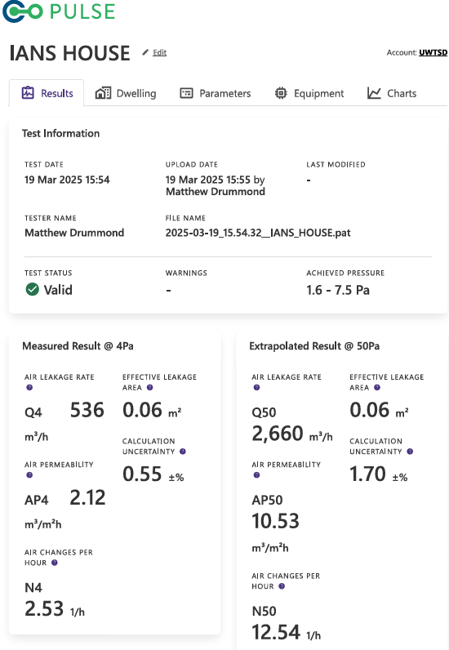
(Brown I, 2025)

Feasibility Study for Solar Panels

Through Open Solar, I have recommended a system option for 13 solar panels to the east of the roof with no inverter. Please below for specification. This would potentially produce 3,368kWh per year, producing 67% of the energy for the house in its existing form.
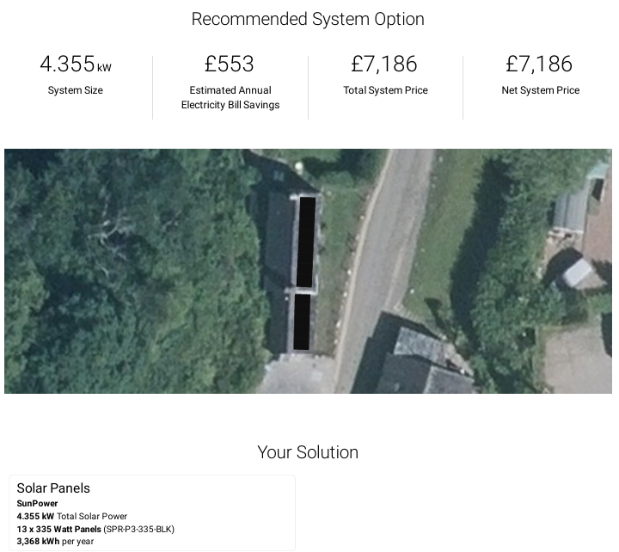
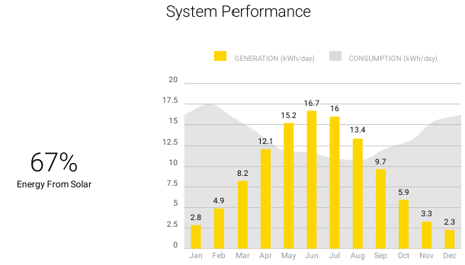
OpenSolar. (2025).
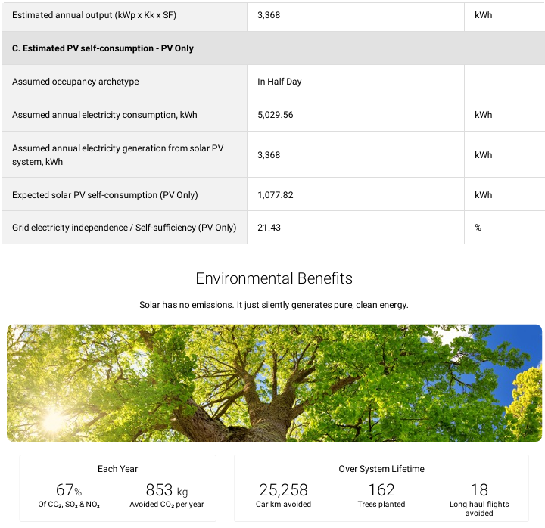
OpenSolar. (2025).

Existing & Scenario PHPP Example

The treated floor area and the heat loss area for the building needs to be calculated for the PHPP. In terms of design of the building, it is approx. 600mm stone wall in most instances. Some of the walls in sections are thicker. The baseline PHPP has been populated prior. An example is shown below for the current solid wall masonry make up.

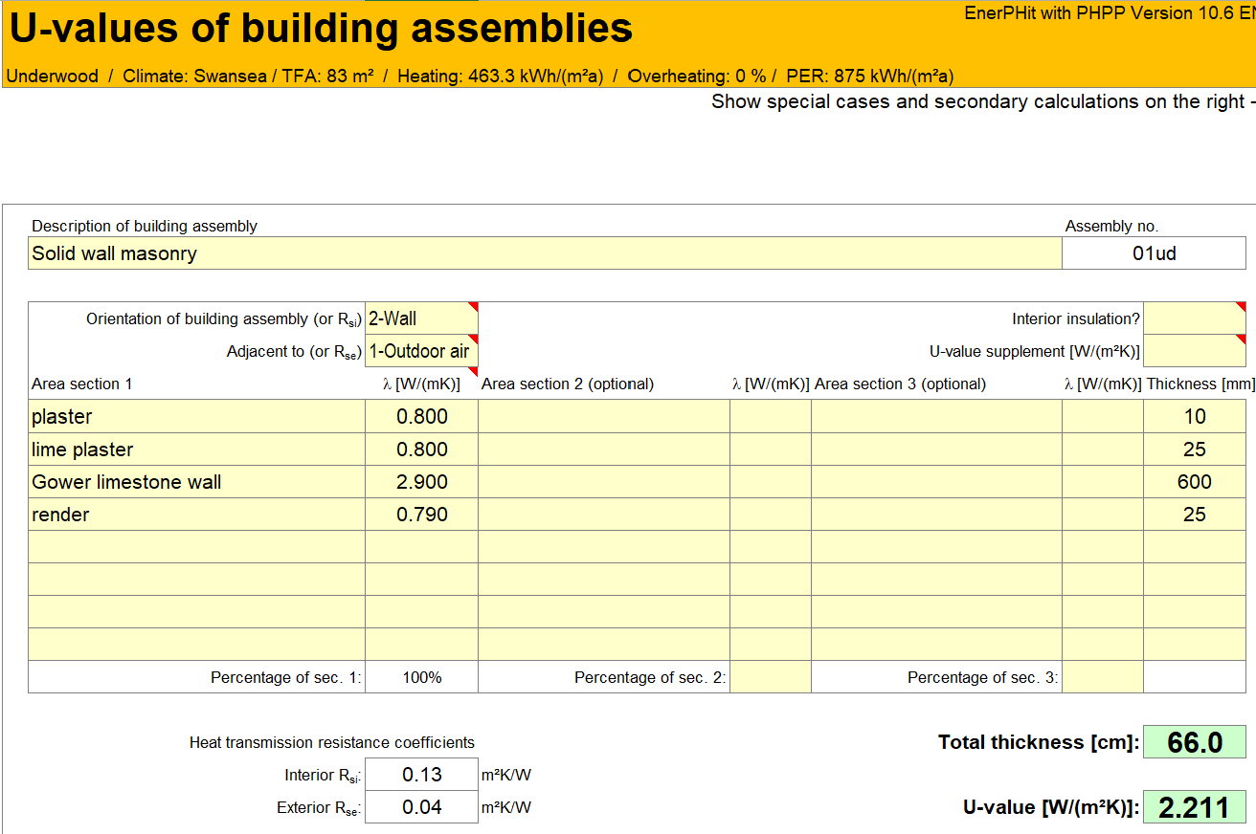
(Brown I, 2025)

The U Value of the current stone wall make up is approximately 2.2 w/(m2k) as per the PHPP above. If insulation is put on, this should drive the u-value down significantly. For an example, EPS EWI at 100mm thick with a lander value of 0.035W/(mK) it gives an approximately 152% reduction as per the below diagram.

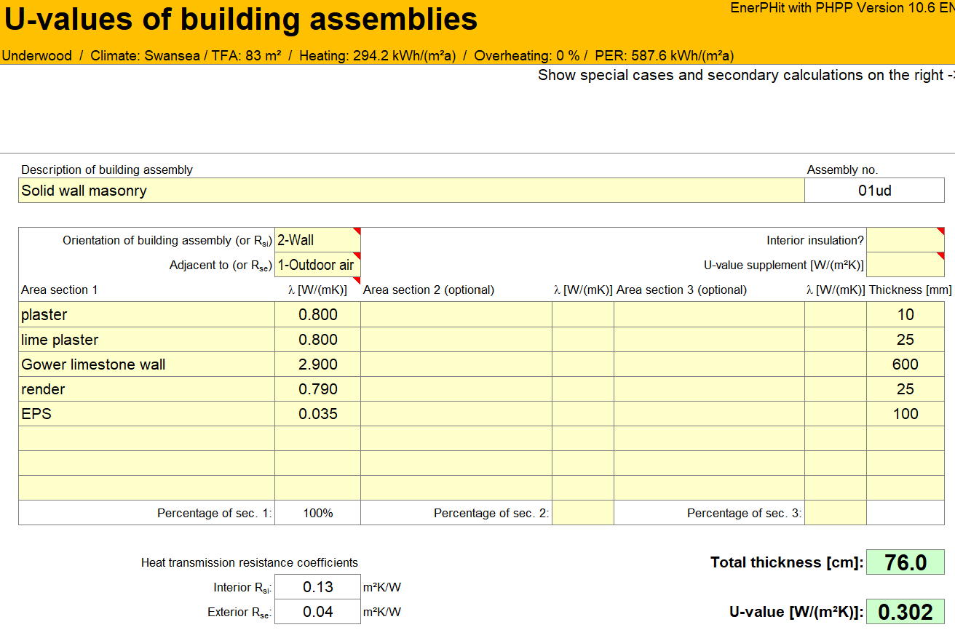

Comparing Existing and Proposed Intervention’s Heating Demand

The interventions of EWI, Windows / Doors and Floor Slab were applied to the PHPP. Although the interventions have been provided for Ventilation, Thermal Bridging, Air permeability, and Solar Panels, they still require to be applied to the PHPP. From the intervention and findings below, the external wall heat loss has reduced from 183.1 kWh/(m2a) to 33.4kWh/(m2a). That is a reduction of 81.76%. The window heat loss as reduced from 70.9 kWh/(m2a) to 15.2 kWh/(m2a). That is a reduction of 78.54%. The floor slab heat loss has reduced from 55.1 kWh/(m2a) to 13.0 kWh/(m2a). That is a reduction of 76.42%. With only the three interventions applied into the PHPP so far, the heating demand and reduced from 374.3 kWh/(m2a) to 151.8 kWh/(m2a). This is a reduction of 59.45%. EnerPhit requires a heating demand of 25 kWh/(m2a) so there is still a long way to go. Once all the interventions are applied to the PHPP, it will get closer to that figure.

Existing Proposed
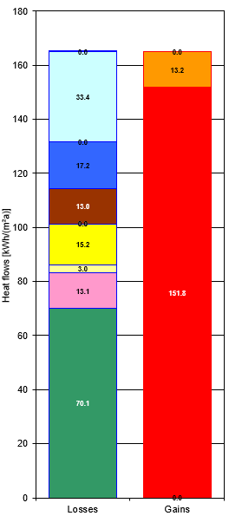

Conclusion

In summary, the most significant source of heat loss identified in this report is the external walls, followed by windows, ventilation, and the floor slab. While various interventions can help reduce energy loss, it's crucial to balance sustainability, environmental impact, economic feasibility, and social considerations. A more precise outcome could be achieved by fully inputting data into the PHPP, given that MVHR plays a vital role in Passive House design and in meeting EnerPHit standards. Key principles such as airtightness and wind-tightness help control energy loss, while a continuous insulation layer ensures thermal stability. Additionally, energy-efficient windows and doors minimize heat loss, and addressing thermal bridges is essential to prevent condensation-related issues and maintain overall performance. If cost was no object, all interventions would be applied. Although it may be feasible to take a staged approach to the interventions.
References

Brown, I. (2025). 16_Case study. [Online]. UWTSD. Available at: https://teams.microsoft.com/v2/ [Accessed 05 May 2025].

Brown, I. (2025). Meeting in "17_assessment_25_03_25". [Online]. UWTSD. Last Updated: 25 March 2025. Available at: https://uowtsd.sharepoint.com/teams/RetrofitCoordinationandManagementACBA5026_GRP/_layouts/15/stream [Accessed 05 May 2025].

BRE. (2025). Passivhaus primer: Designer’s guide A guide for the design team and local authorities. [Online]. BRE. Available at: https://passivehouse-international.org/upload/BRE_Passivhaus_Designers_Guide.pdf [Accessed 05 May 2025].

bsi. (2013). BSI Standards Publication Guide to the conservation of historic buildings. [Online]. bsi. Available at: https://framptons-planning.com/wp-content/uploads/2021/03/CD-H23-BSI-Guide-to-the-Conservation-of-Hi [Accessed 05 May 2025].

Dadevy A, Et al. (2012). The Passivhaus Handbook: A practical guide to constructing and retrofitting buildings for ultra-low energy performance. [Online]. RIBA. Last Updated: 25 October 2012. Available at: https://www.ribabooks.com/the-passivhaus-handbook-a-practical-guide-to-constructing-and-retrofitting [Accessed 05 May 2025].

EWIPRO Building Solutions. (2025). EWI-747 LIME RENDER NHL 3.5. [Online]. EWIStore. Available at: https://ewistore.co.uk/Products/394439/Product%20Data%20Sheet/EWI-747-Lime-Render-3.5.pdf [Accessed 05 May 2025].

EWIStore. (2025). Rockwool External Wall Dual Density Slab. [Online]. EWISTORE. Available at: https://ewistore.co.uk/shop/external-wall-insulation/rockwool-external-wall-dual-density-slab/ [Accessed 05 May 2025].

FASADA. (2025). GENEO PHZ. [Online]. FASADA. Available at: https://fasada.eu/de/product/geneo-rehau/ [Accessed 05 May 2025].

LETI. (2020). Climate Emergency Design Guide. [Online]. LETI. Last Updated: 27 January 2020. Available at: https://www.leti.uk/cedg [Accessed 05 May 2025].

LETI. (2021). LETI Climate Emergency Retrofit Guide How existing homes can be adapted to meet UK climate targets. [Online]. leti.uk. Last Updated: October 2021. Available at: https://www.leti.uk/_files/ugd/252d09_c71428bafc3d42fbac34f9ad0cd6262b.pdf [Accessed 05 May 2025].

Morgan, C. (2018). SUSTAINABLE RENOVATION improving homes for energy, health and environment. [Online]. thepebbletrust.org. Last Updated: 2023. Available at: https://www.thepebbletrust.org/wp-content/uploads/2023/08/230814_SRG-ed2_Digital-V2_compressed.pdf [Accessed 05 May 2025].

NHBC. (2025). 5.2.9 Thermal insulation and thermal bridging. [Online]. NHBC. Available at: https://nhbc-standards.co.uk/welcome/?wppb_referer_url=https%3A%2F%2Fnhbc-standards.co.uk%2F5-substr [Accessed 05 May 2025].

NORRSKEN. (2025). Passive House Windows and Doors The Home of Passive House Windows & Doors. [Online]. NORRSKEN. Available at: https://www.norrsken.co.uk/passive-house/passive-house [Accessed 05 May 2025].

OpenSolar. (2025). Project Online Proposal. [Online]. OpenSolar. Available at: https://app.opensolar.com/#/projects/6946183/proposal [Accessed 05 May 2025].

Passive House Institute. (2023). Criteria for Buildings Passive House – EnerPHit – PHI Low Energy Building. [Online]. Passive House Institute. Last Updated: January 2023. Available at: https://passiv.de/downloads/03_building_criteria_en.pdf [Accessed 05 May 2025].

Passivhaus Trust. (2018). Good Practice Guide MVHR for single dwellings. [Online]. Passivhaus Trust. Last Updated: September 2018. Available at: https://www.passivhaustrust.org.uk/UserFiles/File/Technical%20Papers/2018%20MVHR%20Good%20Practice%2 [Accessed 05 May 2025].

Passivhaus Trust. (2025). How to Build a Passivhaus - Rules of Thumb. [Online]. Passivhaus Trust. Available at: https://www.passivhaustrust.org.uk/UserFiles/File/Technical%20Papers/ROT/How%20to%20build%20a%20Pass [Accessed 05 May 2025].

Passive House Institute. (2016). Step by Step retrofits with Passive House components. [Online]. EuroPhit. Available at: https://europhit.eu/sites/europhit.eu/files/EuroPHit_Handbook_final_Optimized.pdf [Accessed 05 May 2025].

PAUL Heat Recovery. (2025). MVHR Scheme. [Online]. UWTSD. Last Updated: 29 April 2025. Available at: https://teams.microsoft.com/v2/ [Accessed 05 May 2025].

Shree Gayatri Insulation Pvt Ltd. (2024). Loose Rockwool. [Online]. SGIOL. Available at: https://www.shreegayatriinsulation.com/portfolio/loose-rockwool/ [Accessed 05 May 2025].

Swansea Council. (2025). Planning – Results for Application Search. [Online]. Swansea Council. Available at: https://property.swansea.gov.uk/online-applications/simpleSearchResults.do?action=firstPage [Accessed 05 May 2025].

Zoopla. (2025). 3 bed detached house for sale Parkmill, Swansea SA3. [Online]. Zoopla. Available at: https://www.zoopla.co.uk/for-sale/details/69997108/?search_identifier=f8c2600bd3b581089b53cdcb675812 [Accessed 05 May 2025].

