Economics of Sustainability BMSP6007
Matthew Edward Kilgariff
University of Wales, Trinity Saint David
Anthony Burns

Introduction
This report demonstrates that the clothing industry is an example of market failure. The textile industry has been producing high volume fashion at a low cost to the consumer without proper consideration of the environmental impact. The UK’s fashion industry is the most wasteful in Europe (Parliament UK (2019), with 336,000 tonnes of textiles reaching landfill sites in 2018 (WRAP UK. (2019). The general public and media are becoming increasingly aware of this damage so businesses will need to account for their actions in future.
A report by the Global Fashion Agenda (2017) states that 79 billion cubic meters of water, 1715 million tons of CO2 and 92 million tons of waste were used in 2017 for the textile industry. European Parliamentary Research Service (2019) estimate that by 2030 if business continues on this current trajectory that these numbers will increase by at least 50%. This is not sustainable and obviously damaging to the environment.

Environmental Economics.
The current capitalist economic model is unfit for purpose because of the pressure of striving for ongoing growth but with only finite resources. This relentless pursuit of profit is unsustainable. There must be a balance with environmental and social costs.
There is also the belief that individuals are entitled to as much natural resources as their money can buy (Monbiot, G. (2019). This increases inequality and leads to less economically active countries using resources at an unsustainable rate for the benefit of the affluent ones. The textile industry has outsourced most of its production to countries such as India and China where labour is cheaper. This can stress natural resources, threaten water supplies and increase carbon emissions as well as other issues such as poor working conditions and low pay. When a country such as China becomes too expensive , then companies move to cheaper countries such as Myanmar and Ethiopia. Ethiopia’s garment workers are reported to be the lowest paid in the world (Waite, M. (2009).
A more sustainable trajectory is essential. Current systems and models need to align with a respect for the natural environment. The ‘Circular Flow Model (Figure 1.0) is an economic model that presents supply and demand flows through the output and factor markets. The households supply value to the firms in the form of labour, land and resources in exchange for the supply of goods and services (Hussen, A. (2019).
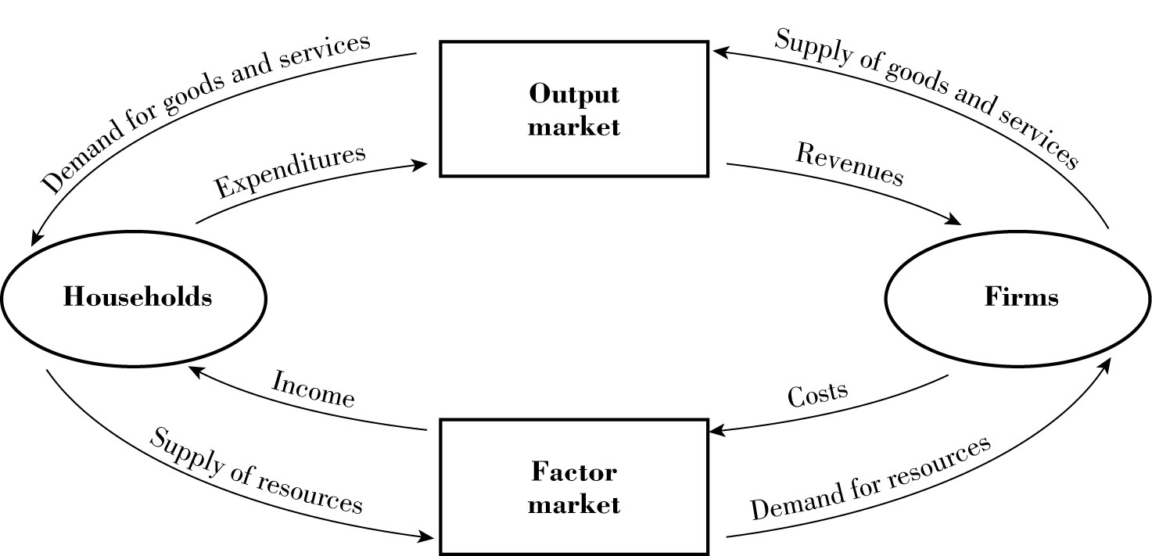

Figure 1.0; Circular Flow Model
However, this model needs to be expanded to include the relationship between the economic activity and natural environment. The Material Balance Model (Figure 1.1) is an adaptation of the Circular Flow Model which does incorporate the interdependence of economic activity and nature (Callan, S. & Thomas, J., (2013). The residuals in this model can be recovered, recycled or re-used to extend the product lifecycle and to reduce the leak of waste back into the natural environment.
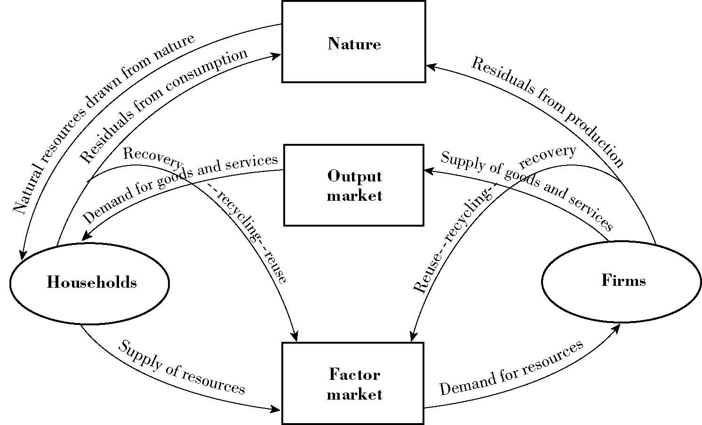
Figure 1.1 Material Balance Model. Source: Kneese, A., Ayres, R. & D'Arge, R. (2015).
At present, disposable consumption of clothing is embedded in our culture with only a fraction being recycled and the rest going to landfill. In the UK 46% of binned textiles could in fact be recycled (Ross, G. (2019). This is wasteful and needs to be addressed for the sake of the environment.
Supply and Demand
The main purpose of the supply and demand model is to determine market conditions. Supply and demand is the amount of a commodity produced and the willingness of consumers to pay. This helps businesses to determine prices and the quantity to produce. The law of demand states there is an inverse relationship between price and quantity demanded which means that if the price of clothing goes down ,the demand will increase.
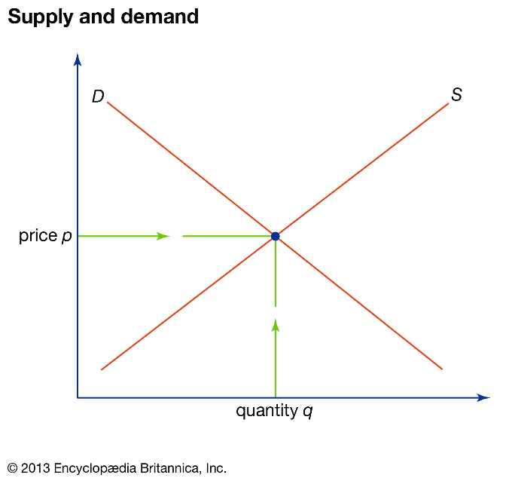
A equilibrium is met when supply and demand are equal within the market (Britannica (2018). Figure 2.0 is a graph showing the relationship between supply and demand. The equilibrium is the point when the supply and demand curves meet and show the equilibrium price (p) and quantity (q). This shows the price at which the product can be sold to reach profit maximization.
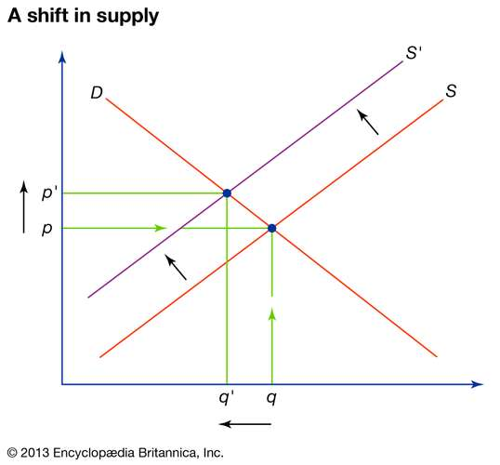
Figure 2.0 Figure 2.1 Image Source: Britannica (2018).

Figure 2.1 shows a shift in supply. Any change in the supply, such as increased production costs, will cause a shift in the supply curve. Taxes produce a shift to the left and a decrease in quantity because it costs producers more to create the product.

Market Failure
Market failure exists when free markets fail to manage resources effectively. Economists have described climate change as a market failure because the people profiting are not the ones who have to pay the environmental costs (Clark, D. (2012).
Environmental conditions cause market failures through both environmental quality or externalities. Publicgoods are nonrival and nonexcludable commodities such as a beach or forest. They are commodities that are often used or affected within the manufacturing of products but are not always factored into the supply and demand model. These types of markets are in contrast to competitive markets.
Allocative efficiency represents an optimal distribution of goods-to-demand and is a characteristic of an efficient market. Allocative efficiency is created when marginal social costs equal marginal social benefits. Achieving allocative efficiency in a public goods market is challenging as the consumers willingness to pay is difficult to define. Public goods have no property rights so there is no incentive for private firms to behave responsibly,therefore the government must act as a third party moderator (Callan, S. & Thomas, J., (2013). Governments depend on policies to reduce market failure.
Externality is the effect that the production or consumption of a product has on its environment. Within the textile industry, negative externalities include water pollution caused by the dying process and pesticides used for growing raw materials. Water and electricity consumption is also needed for consumers to maintain their clothing (Hedge. (2014). Most of the garments sold in Europe and Northern America are manufactured in places such as Bangladesh where there are negative social marginal effects associated with production. The workforce is often women who are poorly paid and with no prospects for advancement.
Private textile retailers often neglect to account for the negative externalities they impose on third parties (Hussen, A. (2019). Dye contaminating a river has an obvious environmental impact but there are social and health costs to the local community too.
Every cotton T-shirt produced requires 1/3 of a pound of agricultural chemicals for its production (Waite, M. (2009). Dichlorodiphenyltrichloroethane, better known as DDT ,was the pesticide previously used in the production of cotton. DDT was banned for agricultural use worldwide in 2001 by the Stockholm Convention on Persistent Organic Pollutants (Pesticide Action Network. (2018). It was associated with unwanted health effects in humans such as endocrine disorders, impaired development of children (Alewu, B., & Nosiri C. (2011) and an increased risk of breast cancer (Cohn, B., La Merrill, M., Krigbaum, & Cirillo, P. (2015). It also detrimentally affected wildlife. Birds ingested DDT by eating contaminated insects which reduced the quality of the eggs they laid. This caused bald eagles and peregrine falcons in North America to become almost extinct (Carson, R. (2002). The Environmental Defence Fund filed lawsuits in New York which resulted in the Federal Government banning its use in the USA in 1972. Bald eagle numbers subsequently increased from 500 in 1972 to 10,000 by 2001 (Moss, D. (2012). By 1975 cotton prices in America had risen by 33%, partly due to the banning of pesticides (United States Environmental Protection Agency (1975).

Figure 3.0 below shows a supply and demand graph of cotton pre and post the ban.

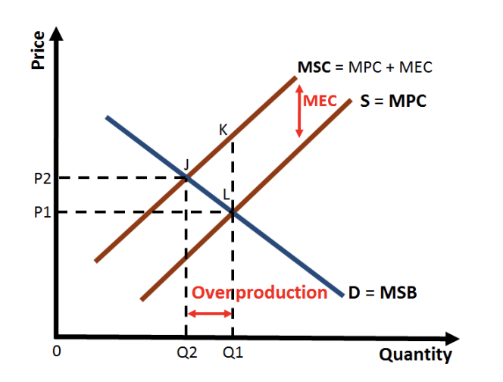
Figure 3.0: Supply and demand of cotton pre and post DDT ban.
Supply curve S shows the marginal private costs (MPC) associated with production of cotton. Curve D represents the demand in the market at different prices i.e the marginal social benefits (MSB). Before the ban, American cotton farmers did not have to absorb the price of the environmental and social effects associated with using DDT. The equilibrium was at Q1.
Marginal external costs (MEC) had not been factored in to the supply (Hussen, A. (2019). . After the ban, marginal private costs rose due to losing the economic benefits of DDT .
When the MEC is included ,there is a new supply curve, labelled marginal social costs (MSC). MSC depicts the true cost of the cotton production. Negative externalities, such as loss of production due to the ban on DDT, impacts MSC and price (Callan, S., & Thomas, J. (2008). The graph (Figure 3.0) demonstrates the fact that the market has been overproducing and under-pricing its products and is therefore failing.

Environmental Standards
In the United States the Environmental Protection Agency (EPA) informs scientific research and provides recommendations on environmental policy. Environmental standards form the basis of most environmental policies. These can be ambient standards, technological-based standards or performance based standards (Hussen, A. (2019).
Ambient standards set a desired quality for an element of the environment. They are often used on air and water quality. They do not offer a physical solution but set an acceptable level that can then be enforced through another standard.
Technological based standards is when the most effective technology needed to prevent a pollutant is selected by a third party such as the EPA. All polluters within the industry must adhere to this and adopt the technology to provide a consistent level of abatement.
Performance based standards set a limit on how much pollution can be produced but is not prescriptive on how this is to be achieved. This allows businesses to create their own solutions to achieve compliance. (Callan, S., & Thomas, J. (2008).

Solutions
Policies aiming to correct the effects of negative externalities rely on direct regulations (Hussen, A. (2019). Garret Hardin (1968) suggests that the only way to resolve problems associated with public goods is through coercive methods. However this may lead to discouraging third parties to find their own creative solutions.
Below are solutions that have been imposed on the textile industry to enable it to become more sustainable and to consider negative externalities.
Solution 1: Registration, Evaluation, Authorisation and Restriction of Chemicals (REACH) is legislation by the European Union to ban the use of irritable chemicals in the production and retailing of clothing within the EU. Companies are compelled to monitor their regulatory obligations within production. This leads to less environmental risks such as chemical leakages and protection of workers’ and consumers’ rights (Anthesis. (2018).
Market based regulation can be achieved by providing incentives or charges so that the businesses within the market can attain a desired social goal. However this method has the risk of unintended negative effects on the market if transaction costs are not also included.

Solution 2: The Federal Environment Agency and the EU set out voluntary guidelines referred to as BREFs (Best Available Techniques Reference documents). The guidelines show firms, in the textile and shoe sectors, how to create technological improvements and provide environmental protection and management solutions. There are ambient and technological standards for the industry so processes can become more sustainable. The standards for air emission, water waste and energy (Figure 4.0) provide a benchmark to manufacturers (Federal Environment Agency (2011).
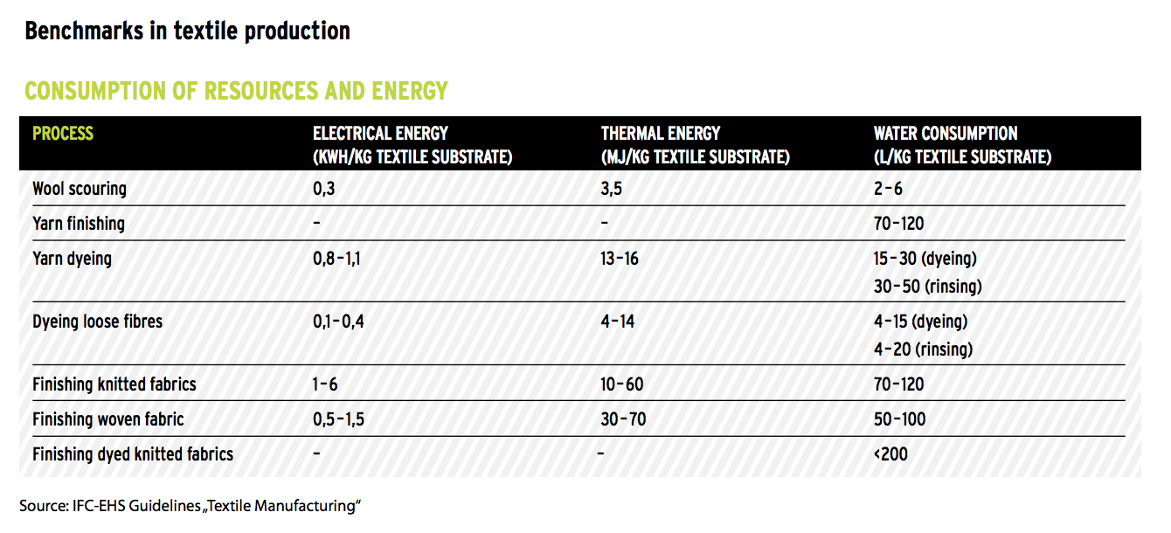
Figure 4.0: EU BREF textile production benchmarks.

These are not yet legal requirements in Europe but they show how to improve efficiency and sustainability. In the UK when applying for an environmental permit you must state whether the associated emissions levels meet the BREF standards (GOV UK. (2020).

Solution 3: In 2019 a bill was rejected by the UK government to charge 1p per garment to prevent clothes going to landfill (Carrington, D. (2019). This bill would have raised 35 million annually but the government’s response was; “We believe that positive approaches are required to find outlets for waste textiles rather than simply imposing a landfill ban.”
Previously clothes were re-sold to developing countries across the world. The volume of disposable textiles has flooded the market and now globally 87% of textiles are sent to landfill or incinerated with only 1% being chemically recycled back to useable raw materials (Ross, G. (2019).
In January 2007 France created legislation so that all domestic textile manufacturers pay a financial contribution (France.Gov (2020). The tax was reduced for textiles that are more environmentally friendly, the same way more eco-friendly cars pay less tax. Figure 5.0 shows the tariff system.
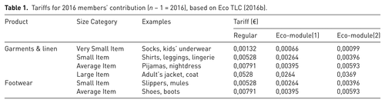

Figure 5.0 Source: Bukhari, A., Carrasco, R., & Ponce-Cueto, E. (2018).
This encourages manufacturers to develop more durable and sustainable products and to devise innovative techniques for recycling (Bukhari, A., et al. (2018). The money raised funds Eco TLC which is an organisation encouraging recycling and revenue from used clothing as well as supporting the collectors and sorters of textiles (Morley, N., Bartlett, C. & McGill, I. (2009).

Conclusion
The current trajectory of the textile industry is unsustainable. Environmental standards need to examine all aspects of the industry from production to collection and recycling (Bukhari, A., et al. (2018). A problem arises when foreign imports do not have the same environmental standards so can provide large quantities of cheap, disposable fashion.

The responsibility lies not only with governments or individual businesses but with consumers. This means choosing to buy wisely and ethically. Consumers must be mindful of the environmental and social costs associated with the choices they make when buying and disposing of clothes. Eighty percent of European consumers now want brands to be more transparent about their supply chains to help them make informed and sustainable decisions (World Economic Forum. (2019).
The unfettered globalised clothing industry creates unacceptable inequalities. Workers are mired in poverty so legislation is needed to enforce acceptable working conditions and wages. The natural world is struggling to cope with the demand from industries like textiles. Customers can lead the change by buying ethical, sustainable garments. If customers do this, the level of consumerism will decrease and factories will produce less clothes and waste.
There needs to be a combination of government intervention, industry innovation and social responsibility to help the textile market maintain a healthier balance with the natural world.

References
Alewu, B., & Nosiri C. (2011). Pesticides in the Modern World – Effects of Pesticides Exposure.

Anthesis. (2018). New EU Restrictions of Hazardous Chemicals in Clothing and Textiles. https://www.anthesisgroup.com/eu-restrictions-hazardous-chemicals-clothing-textiles/

Britannica (2018). Supply and Demand. https://www.britannica.com/topic/supply-and-demand

Britannica (2019). Environmental economics - The Coase theorem. Retrieved 7 April 2020, from https://www.britannica.com/topic/environmental-economics/The-Coase-theorem

Bukhari, A., Carrasco, R., & Ponce-Cueto, E. (2018). Developing a national programme for textiles and clothing recovery. Waste Management & Research, 36(4), 321–331. https://doi.org/10.1177/0734242X18759190

Carrington, D. (2019). Ministers reject plans for 1p per garment levy to tackle fast fashion. The Guardian. https://www.theguardian.com/fashion/2019/jun/18/ministers-reject-charge-of-1p-an-item-to-clean-up-fast-fashion

Carson, R. (2002). Silent Spring. Boston: A Mariner Books.

Clark, D. (2012). Why do economists describe climate change as a 'market failure’? https://www.theguardian.com/environment/2012/may/21/economists-climate-change-market-failure

Callan, S., & Thomas, J. (2008). Resources and learning tools in environmental economics. Mason, OH: Thomson/South-Western.

Callan, S. & Thomas, J., (2013). Environmental Economics and Management. Mason, OH: South-western college Publishing.

Cohn, B., La Merrill, M., Krigbaum, & Cirillo, P. (2015). DDT Exposure in Utero and Breast Cancer. The Journal Of Clinical Endocrinology & Metabolism, 100(8), 2865-2872. doi:10.1210/jc.2015-1841

European Parliamentary Research Service (2019). Environmental Impact of the Textile industry. EPRS.

Federal Environment Agency (2011). Environmental standards in the textile industry. https://www.umweltbundesamt.de/sites/default/files/medien/publikation/long/4289.pdf

France.Gov (2020). Code de l'environnement - Article L541-10-3 | https://www.legifrance.gouv.fr/affichCodeArticle.do;jsessionid=D245F102A49CF9F57990A1419986260B.tplgfr25s_3?idArticle=LEGIARTI000031066466&cidTe

Gaither, B., & Sinclair, J. (2017). Environmental Marketplace Advocacy: Influences and Implications of U.S. Public Response. Journalism & Mass Communication Quarterly, 95(1), 169-191. doi: 10.1177/1077699017710452

Global Fashion Agenda. (2017). A Call to Action for a Circular Fashion System. Copenhagen: Plan Miljo.

GOV UK. (2020). Best available techniques: environmental permits. https://www.gov.uk/guidance/best-available-techniques-environmental-permits#bat-in-your-permit-application

Hardin, G. (1968). The Tragedy of the Commons. Santa Barbara: University of California.

Hedge. (2014). The Economics of Fashion: Externalities https://fashionhedge.com/2014/09/06/the-economics-of-fashion-externalities/

Hussen, A. (2019). Principles of environmental economics and sustainability. New York: Routledge.

Jørgensen, M., & Jensen, C. (2012). The shaping of environmental impacts from Danish production and consumption of clothing. Ecological Economics, 83, 164-173. doi: 10.1016/j.ecolecon.2012.04.002

James, D., Jansen, H., Opschoor, J. & Wakeman, ml’:KR., (2013). Economic Approaches to Environmental Problems. Amsterdam: Elsevier.

Kneese, A., Ayres, R. & D'Arge, R. (2015). Economics and The Environment. Oxford: Routledge.

Monbiot, G. (2019). Dare to declare capitalism dead – before it takes us all down with it. https://www.theguardian.com/commentisfree/2019/apr/25/capitalism-economic-system-survival-earth

Morley, N., Bartlett, C. & McGill, I. (2009). Maximising Reuse and Recycling of UK Clothing and Textiles: A report to the Department for Environment, Food and Rural Affairs. Oakdene Hollins Ltd

Moss, D. (2012). Life after DDT. Blue Ridge Outdoors Magazine. https://www.blueridgeoutdoors.com/go-outside/recovery-after-ddt/

Parliament UK. (2019). Fixing fashion: clothing consumption. House of Commons. https://publications.parliament.uk/pa/cm201719/cmselect/cmenvaud/1952/report-files/195207.htm

Pesticide Action Network. (2018). The DDT Story. https://www.panna.org/resources/ddt-story

Ross, G. (2019). Australia recycles paper and plastics. So why does clothing end up in landfill? The Guardian.://www.theguardian.com/commentisfree/2019/aug/27/australia-recycles-paper-and-plastics-so-why-does-clothing-end-up-in-landfill

United States Environmental Protection Agency. (1975). DDT: a Review of Scientific and Economic Aspects of the Decision to Ban Its Use as a Pesticide. Washington: United States Environmental Protection Agency.

Waite, M. (2009). SUSTAINABLE TEXTILES:. Journal Of Textile And Apparel, Technology And Management, Vol 6. (2).

World Economic Forum. (2019). Ending the era of dirty textiles. https://www.weforum.org/agenda/2019/09/ending-the-era-of-dirty-textiles/

WRAP UK. (2019). Textiles Market Situation report 2019. http://www.wrap.org.uk/content/textiles-market-situation-report-2019-0

