Assessment 1

Marketing Fundamentals Analysis and Evaluation

Module: Marketing Fundamentals
Module code :LCBB4004

Student’s ID: 2019148

Student name: BOTANOIU MARILENA RALUCA
Critical analysis of processes and stages of marketing and the role of marketing mix
The marketing process involves creating customers’ satisfaction by providing value. All the activities are executed by the enterprise itself for satisfying the demand of the customers to achieve the organisational goals. The process of marketing is divided into two broader parts where the foremost one is the activities that create value for customers, which is the prime part of the process and it is divided into further four steps. On the other hand, the second broader part is capturing the value from the customers. Therefore, the marketing process has five steps from creating the value to capturing the value (Kotler and Keller, 2016).
The first step is to identify the customers and their needs and wants. Before adopting other marketing actions, every organisation need to have a close understanding of its market and so it must initiate research for knowing the needs and wants of the customers. Only after researching the marketplace, the organisation can get complete information on which way they should approach the customers.
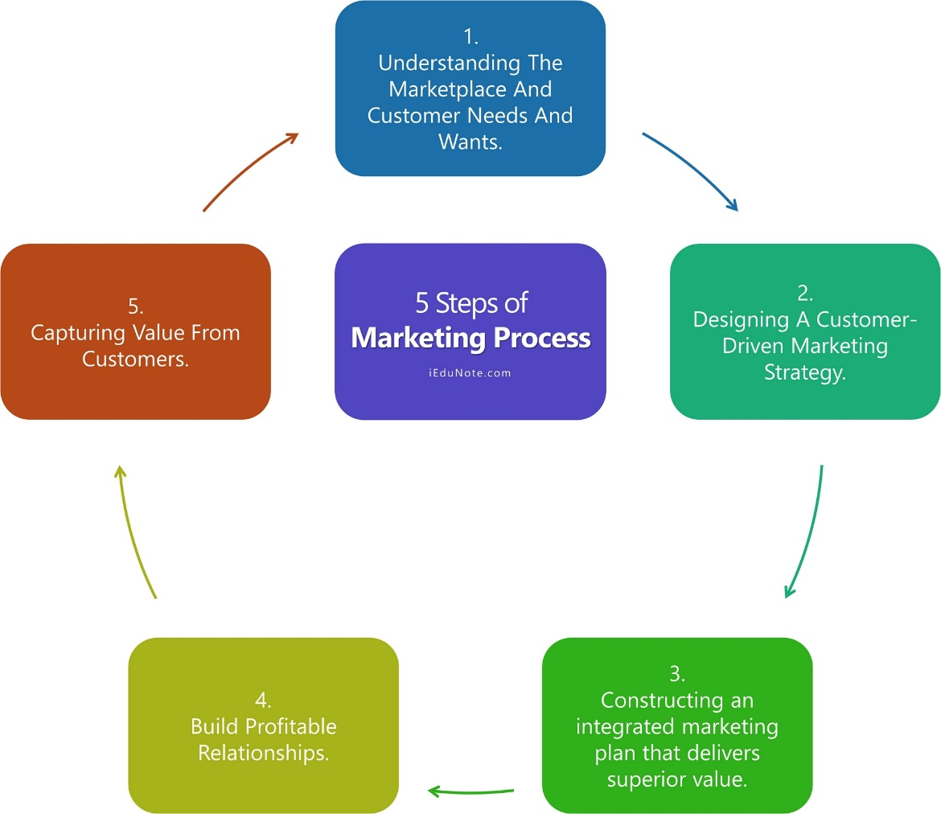
Figure: Marketing Process (Capon, 2016).
The second step includes designing a strategy, which is customer-driven where the company initiates segmentation and targeting strategy for all the available market. The company has to segment the market first and then it has to initiate a plan about which customer segment the company is going to target. Here the question would be ‘what customers do they want to serve? Answering this question, the company can get an actual target customer idea since it cannot serve all the customers. Besides, the company has to further analyse its resources to invest so that it can serve its customers most profitably (Capon, 2016).
When a proper marketing strategy is completed, the organisation can look forward to the third step focusing on constructing an integrated marketing program, which in other word is called the marketing mix. The primary concern of the marketing mix is to turn the strategies into actual customer value and so the marketing mix provides superior value to the customers. The marketing program or the marketing mix is described through the 4Ps of marketing including Product, Price, Place, and Promotion (Elbe and Axelsson, 2015). The Product refers to the design of a product, which is optimal for the previously targeted customers. The product must be priced well so that the customers can feel that it is attractive which will thrive them to purchase it (Piercy and Morgan, 2019). Besides, the product must be distributed taking into consideration that all the targeted customers are getting the product flexibly and therefore, the company need to initiate promotional activities to communicate the value with the targeted customers.
The fourth step is to create value for the customers in order to build customer relationship with target customers. In this process, only providing the value is not enough rather the company has to deliver such value, which will delight the customers, and so they will repeat their buying activities and ultimately become loyal customer for the organisation. This step is the most important since we all know that the customer is the king. Therefore, satisfying their needs and wants and making them loyal to the organisation is the most important part to increase the sell to the existing and potential customers (Tokman and Lemon, 2014).
The final step of the marketing process is to capture the value from the customers in return which refers that the company is capable of creating profits and customer equity. This step is formed with those customers who are delighted, satisfied, and loyal customers and they will repeat their purchasing action coming back repeatedly. The company can even gain long-term customer value, which in other word is called Customer Lifetime Value (CLV).
If any company can execute these steps appropriately, the company will definitely be able to create customer value and capture the value form the customers in return. This process is appropriate for every product and service, which the companies want to market. Here, every step is equally important, for example, if the first four steps are accomplished and the fifth one is incomplete, the company will not get any value from the customers in return which will force the company to initiate the whole marketing process again even for getting the existing customers since they are not loyal (Hartmann and Neely, 2012).
Several stages of marketing are available through which we have got this present customer-focused marketing stage. Each stage has its own characteristics that the businesses followed. Among them, the first one is the Production Oriented Stage, which included the philosophy of increasing the production with proper controlling and cost reduction method and then making a profit with larger sales volume. This was the foremost era that was followed throughout the year of 1940s. In this era, all the efforts were given to the production of goods and services to obtain higher manufacturing efficiency. Since all the companies executed mass production, there was no recognition for understanding the needs and wants of the customers, which means the customers, did not have any choice to make. The customers had to buy the products that were available whether they like them or not (Dawar, 2013).
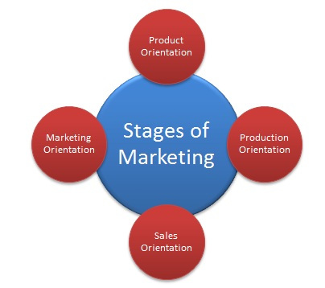
Figure: Marketing Stages (Dawar, 2013).
When all the companies highly focused on mass production, the quality went down and so they certainly became aware of the quality of the product and thus the Product Orientation Stage appeared which had the philosophy to produce quality products. Companies were only concentrating on improving and controlling the quality of the product. During the 1950s to 1960s, across the UK, this product orientation became popular with a famous statement ‘Build a better mousetrap and the world will beat a path to you your door.’ Though this stage was better than the previous one, however, every customer does not want or can afford superior quality products. So the companies lose a higher range of customer segment (Burnett, 2016).
When all the businesses started to produce more quality products, there came the real scenario to sell those with a profit. Thus Sales Oriented Stage became popular in the late 1950s where the philosophy was to clear the stock, aggressive sales and promotion, and making a profit through quick sales. The main problem of this stage was the customers were reluctant to purchase and needed to be forced into purchasing. Still today, some firms are practising this orientation, however, the customers have more power in terms of laws and there is customer movement everywhere (Aemstrong and Kotler, 2016).
The Marketing Orientated Stage includes generating planning and making a decision based on the needs and wants of the targeted customers. Here, customers’ needs and wants are given the most priority so that the customers become delighted and loyal after consuming the product. All the employees of the organisation functions relentlessly to fulfil the customers’ demand and so the organisation as a whole (not only the marketing department) becomes so customer-oriented that the customers hold the perception of buying the product from the same firm repeatedly (Gray and Matheson, 2012).
The marketing mix has four elements that were mentioned in the previous section of the essay and they are product, price, place, and promotion that play an important role in marketing a product so that an organisation can obtain a larger volume of sales. Product for instance is the central element of a marketing plan and the brand is much dependant on the success of the product. In the 21st century where there has been massive competition and simply a quality product can bring about a competitive advantage over the competitors. Otherwise, the product will be lost among the huge crowd of products and there will be no market at all (Kalyanamand and McIntyre, 2017). Apple and Starbucks can be good example of achieving success by delivering a great quality product.
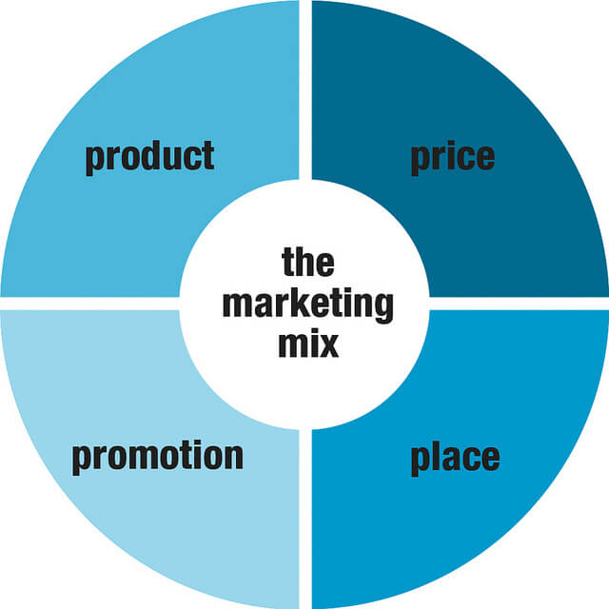
Figure: Marketing Mix (Kalyanamand and McIntyre, 2017).
Placement is also a vital element of marketing a brand. If a company wants to sell its product, it must place it where its targeted customers are. If a brand sells products for urban people, there is no necessity to place them in rural areas. If the company has a product for millennials, then the company has to find out the largest crowd of millennials. Moreover, no company wants its product to become inaccessible and so every company place its product from where the targeted customer segments can easily access it. So, this is why placement is important for the success of a company (Strauss and Ansary, 2019).
Price is the most effective part of the marketing mix. All the customers do not want great quality products since great quality product needs much money to purchase. So, price is the prime factor here to make a purchasing decision from the customer perspective. Walmart can be the most effective example since it is very popular among customers because of its lowest prices. Apple has a higher price for which the people who have a lower level of income cannot afford it and therefore Apple has to position their product to the higher-end segment. So, the company has to keep its customer segment and competition in mind before pricing its product (Kareh, 2016).
After pricing, the Promotional part comes to be executed. If a company delivers good quality products with the best price range and the customers are not aware of that, the product will not be able to bring any success to the company. The company has to reach its targeted customers and assist them to know and understand its brand and product so that they can make a purchasing decision. There is intense competition in the market and so other competitors may get better sales with their better promotional activities even having less quality product. Therefore, the role of the marketing mix to any company is beyond describable since all the success depends on the proper execution of these four elements (Ettenson and Knowles, 2013).

References


