BMSP 5006 - Social Enterprise Business Plan

1802683 – JAMIE MOORMAN Tutor – Jess SHORE
jamie.moorman28@outlook.com
Contents
Introduction: 2
Owner Information: 2
Aims and Objectives: 3
Aim 1 3
Objective 1 3
Objective 2: 3
Aim 2 3
Objective 1: 3
Objective 2 3
Our Mission 3
Our Product 4
Our Target 5
Meeting Client Needs 6
Competition. 7
Finance 7
Marketing/Advertising 8
Physical Location 10
SWOT Analysis 10
Summary 11
Bibliography 11

Introduction:
It is common knowledge that enterprises, particularly social enterprises are vital for the community. Since 2015, the Well-being of Future Generations (Wales) Act has required public bodies in Wales to consider the well-being of future generations when making decisions and operating. The Future Generations Act requires businesses to think sustainably, to make changes and sacrifices, so that we do not live at the expense of future generations. – (Thatcher, 1990) Social enterprises normally fill gaps in existing markets that sometimes cannot be filled by public/private sector businesses. – (Iyengar, 2015), as well as being able to fix many societal issues that other sectors cannot. – (Sheppard., 2018). The idea I have in mind is WeCare, a social enterprise based in Carmarthen with the aim to reduce the number of households living below the poverty line by manufacturing and distributing hygiene boxes. With that said, this business plan will outline how I aim to move WeCare from paper to reality.

Owner Information:
Part ownership. I would not be the only owner and I see this is more advantageous than not as I will be able to share the start-up duties and the onus is not solely on me if there is a problem with the business. I would share the ownership between 3 people and this is because I believe that four people is enough to successfully start up this type of business easily, efficiently, yet there aren’t so many people involved that people become useless due to having nothing to do. Wages are also split easier and I don’t have to credit or share wages between loads of people before I have to give wages to my employees. This social enterprise is a CIC (Community Interest Company), a type of company designed for social enterprises that want to use their profits and assets for the public good. – (debitoor.com, 2019)

Aims and Objectives:
‘WeCare’ has two primary SMART Aims reinforced by two objectives to each aim. Aims and objectives are SMART if they are Specific, Measurable, Achievable, Relevant and Timed.
Aim 1: To distribute a ‘care package’ to hygiene poor houses in Wales, thus decreasing the number of hygiene poor households by 10% in the next 5 years.
Objective 1: Establish a hygiene care package with a ‘MALE’, ‘FEMALE’ or ‘CHILD’ option, within the first three months.
Objective 2: Create a delivery service, enabling a further range of distribution, with the goal of covering all of Wales in at least 5 years.

Aim 2: To expand our services from Carmarthenshire to Wales coverage in the next 3 - 5 years.
Objective 1: Achieve a successful operation in Carmarthenshire, then expand region by region, i.e. The North, Cardiff, etc.
Objective 2: Attain a steady financial status through government funding across the next 3-5 years.

Our Mission
In Wales alone, there are 710,000 people living in poverty, 185,000 of which are children, 405,000 are working age adults, and 120,000 are pensioners, as shown in figure 1.
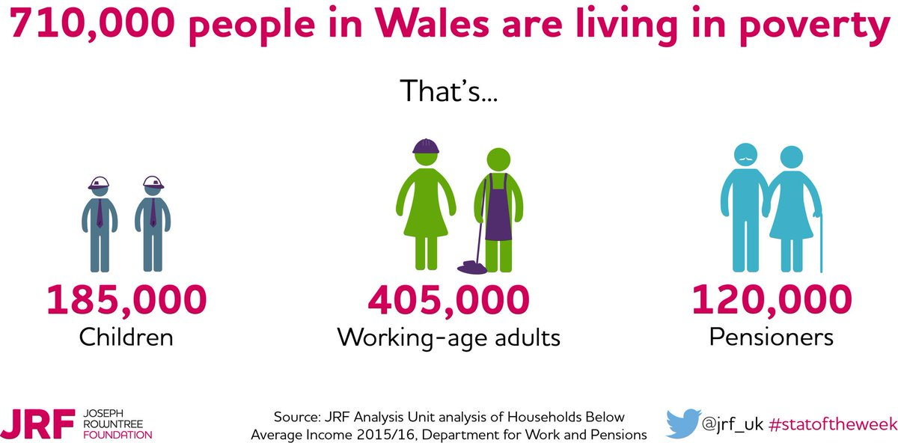
Figure 1 – (Joseph Rowntree Foundation, 2017)

At ‘WeCare’ our mission is simple. We do not want anyone to live in hygiene poverty. WE think it is abhorrent that people like you and I must live without hygiene products and in some extreme cases, the lack of a shower. Therefore, our mission statement is ‘No family deserves poverty. That is why we give welsh families what they deserve.’

Our Product
‘WeCare’ are all about fairness, hygiene and an improved quality of life, and this is included in our product. ‘WeCare’ create a care package. This care package comes in three varieties: ‘MaleCare’, which centres its products around men’s hygiene needs, for example Shower Gels, Soaps, shaving foam, condoms, face wash, moisturize and toothbrushes and toothpaste and smellies. ‘FemCare’, giving female only products, such as razors, feminine hygiene products, shaving cream, toothbrushes, toothpaste, hair conditioner etc. And finally, ‘KidCare’. Men and Women need different things hygiene wise, therefore having different boxes means more for everyone. This is the thinking behind a KidCare box too. Adults need different things to children, such as sexual health items, and children do not need to see this, therefore a separate box maintains their innocence. My product is highly beneficial for them as it allows them to re-enter the workplace and reintegrate into society. This then benefits society on a small scale as my scheme enables more people to work, meaning less people requiring state benefits to support themselves.
The second part of WeCare will be an area set aside for washing machines and a showering area. I believe that the boxes alone are not enough. People who need this service may not have working showers or washing machines, therefore having this utility adds to the service provided. These washing machines and showers are completely free to use.

Our Target
Our target audience has no demographic; however, it does have a psychographic. We tailor our products to those who find themselves below the hygiene poverty line and are in desperate need of care products. It is important however to declare that we do not offer this support to just anyone. This isn’t for people who find themselves a little short on money, these care packages are reserved only for families who really need this support, for example a family whose parents cannot provide the means to clean themselves or practise dental hygiene. This may be whole family units, couples, people of all ages and races, the criteria needed is if you are below the hygiene poverty line, you are eligible to receive help from WeCare. For reference, households below 60% of the median household income are classed as being in general poverty, and household below 50% of the median household are classed as being in severe poverty.
To this extent, I aim to employ disadvantaged people too, those who haven’t had the greatest start in life, such as convicts and educational dropouts. Whilst WeCare will aim to employ people from disadvantaged backgrounds, some of these will be volunteers. The ratio of employee to volunteer will sit somewhere around 75/25 to 50/50. This helps the local community as volunteering gives people who aren’t eligible for employment, the chance to work, to gain experience and move up the employment ladder. WeCare will source its stock from excess stock in storerooms, as well as donations from the local community. This combats the sustainability issues as the leftover stock from suppliers and households will not go to landfill.

Meeting Client Needs
This service provides care products for both men and women. It also provides contraceptives and feminine hygiene products. This will hopefully reduce the amount of hygiene poor families in Wales and will also reduce the number of adults and children who fall ill. This benefits the children massively as they will be able to keep clean, hygienic and well, enabling them to go to school. Contraceptives have been added so that adults can have safe sex, reducing the risk of Sexually Transmitted Diseases (STD’s). Women also benefit from having feminine hygiene products as they can keep clean and keep healthy, allowing them to go about their daily life. I can say that WeCare products more than benefit the needs of my target audience.
This product is needed for the hygiene poor in my opinion, not people who find themselves a little strapped for cash. Why should anyone live in poor hygiene. The fact that anyone must live like this is abhorrent. At WeCare, we want to eliminate this problem. Imagine not being able to work or go to school on the grounds of poor hygiene. It’s wrong, and WeCare aim to eliminate this.
Not only does this idea help people in need, but it also conforms to the Future Generations Act as mentioned earlier. The ‘A Prosperous Wales’ section of the Future Generations Act sets out how the third sector can contribute to helping, via community renewable energy schemes, delivering public services even down to youth/homework clubs. WeCare provides a public service in the way of helping disadvantaged people.

Competition.
In my research, I have found two primary competitors: InKind Direct. InKind are a charity established in 1996 by HRH Prince Charles. – (inkinddircet.org, n.d.) It is a charity created to provide consumer goods donated by companies to UK charities working in the UK and overseas. However, they do not distribute Personal hygiene products and therefore do not operate the same way WeCare does. This gives my idea a unique vibe, making it stand out, and thus more likely to succeed in the long run. I found no charity or Social venture that operates the way WeCare would, and the idea of providing only hygiene products seems to be a new idea on the market. There are commercial businesses that do boxes like this, for example boxes one can get in LUSH or The Body Shop.
My attention must also go to a charity known as The Hygiene Bank, a charity which collects donated toiletries, not unlike what WeCare aims to do. These donations are then distributed to schools, charities and voluntary organisations. (thehygienebank.com, 2020). Whilst this is similar to WeCare, there are differences, such as WeCare donates to those below the poverty line as opposed to donating to organisations.

Finance
Crowdfunding is a good source of raising money. This process asks a large number of small donations – (ukfca, 2017) This is an increasingly popular method of attaining finance as lots of people can donate without spending large amounts. A theoretical example of this is that it would only take 1000 people to donate £10 each and you have £10000 and no one had to spend more than £10. As a social enterprise, WeCare would primarily use donation crowdfunding, where people donate simply because they believe in the idea. Usually the crowdfunder gives an intangible gift to say thank you, but this is not possible for the sort of enterprise I am proposing.
Due to this, I do not want to fully rely on the kindness of others. Another, more reliable way is through a bank loan. Bank loans and grants are a popular way of funding. A bank loan of £10000 is what I would look to secure. However, bank loans must be paid back with interest, and my research does show that many social enterprises fail. The rate at which social enterprises succeed stands at:
Between 1 – 3 years: 45.2%
Between 4 – 6 years: 8.7%
Past 10 years: 5.2% - (Gasca, 2017)
Due to this, I believe the best funding source to be through obtaining a grant. There are a few grant options available, such as the Forward Enterprise Fund, a fund aimed at individuals, charities and social enterprises that prioritise creating employment opportunities for people breaking the cycle of crime and addiction. – (sibgroup.org, n.d.). This fund provides access to loans between £25k - £150k. I do believe that this funding option is good as my social enterprise is about helping disadvantaged people, and that goes for staff as well.
Another appealing grant is the Social Enterprise Assist Fund. Successful applicants of this will receive an interest free loan from 10,000 to 30,000 pounds. – (businesswales, 2020)

Marketing/Advertising
Currently, social media is both the best and cheapest way to advertise your business. Nearly everyone has social media. Facebook advertising can cost anywhere from 0.16 to 1.00 dollars per click, which is dependent on your audience size, industry of your business and even ad quality.
This is initial however, and with more money comes more extensive ways of advertising, such as newspaper advertisements, radio ads, and even collaborations with other business in the third sector and beyond. Having said this, the costs can vary based on factors such as season, day of the week, time of day, target market and demographic, your ad’s relevance to your target market, ad quality and your industry. The image below shows the average price of advertising, based on CPC (Cost Per Click). Note how the average price differs based on industry.
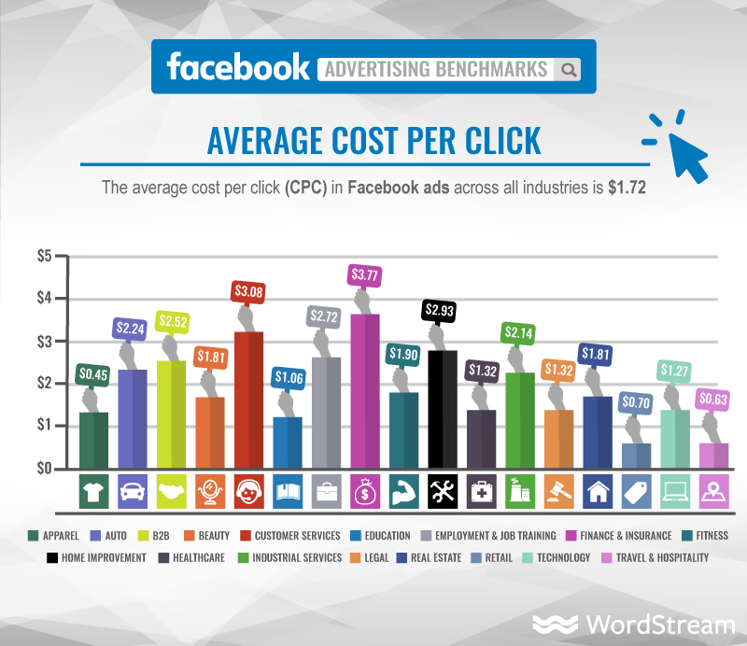 Figure 2 – (Gollin, 2019)
Below is a list of costs for different methods of advertising, with a breakdown of costs. 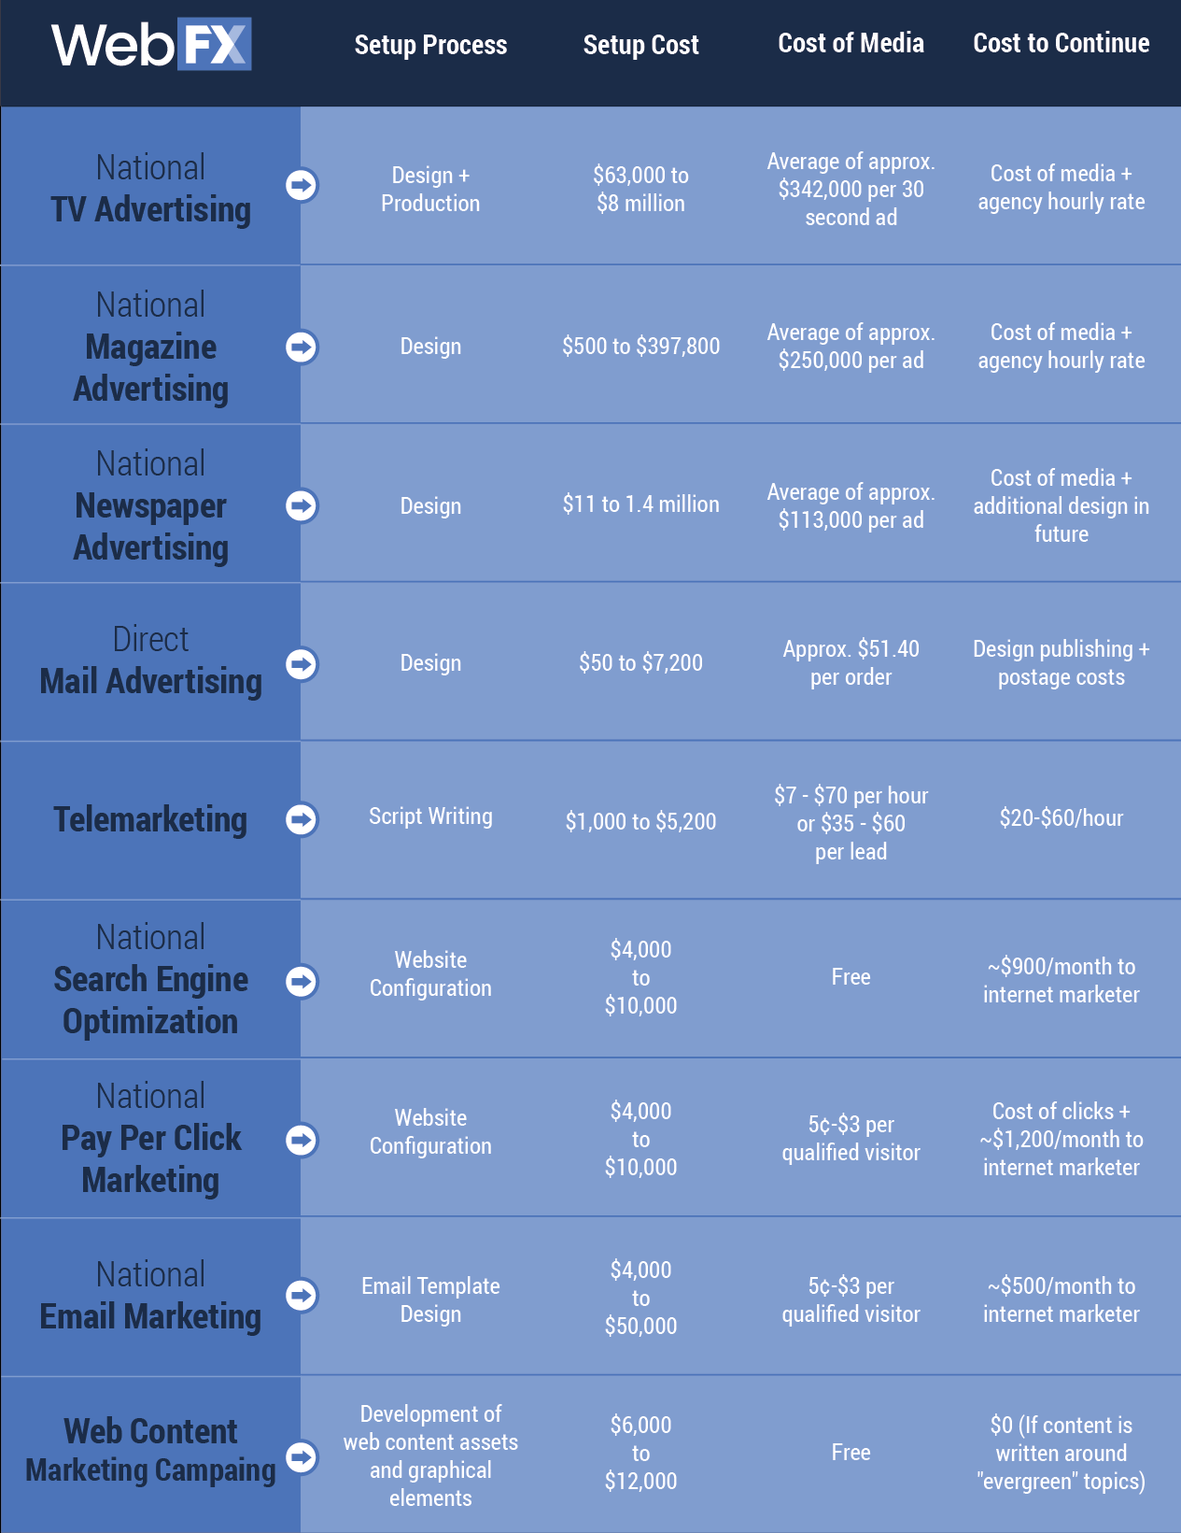
Figure 3 - (WebFX, n.d.)

Physical Location
Being a physical business, WeCare needs a location. Preferably based in Carmarthen in the short term before expansion. The location needs to, ideally, be a warehouse, with an office space, either built into the warehouse space or using a portable office. The ideal property, found on PrimeLocation, is Unit 2.1 Pensarn Trade Park, Myrtle Hill, Pensarn, Carmarthen, Carmarthenshire.
The unit covers an area of 10,545 sq. ft. and sits at £52,500 per annuum (£4.98/sq. ft. pa). The floorplan provided shows more than enough storage space. The floorplan shows how the area can be split into four parts, therefore there is an admin area.
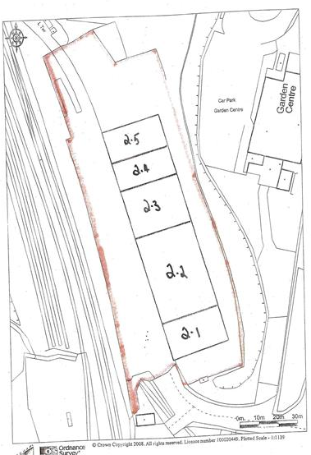
The closeness to the A48 Dual Carriageway and independent car park access.
Figure 4 - (primelocation.com, 2020)

SWOT Analysis
Listed below is a brief SWOR analysis, listing the Strengths, Weaknesses, Opportunities and Threats mentioned above, that may come with WeCare.
Strengths  - Helping the local community.  - Improving the lives of others. | Weaknesses  - No government funding.  - Not for profit, wages could be low.  - No external profits. Harder for to attain support of key players.
Opportunities  - Expansion.  - The rise of social enterprises could help fix many of society’s ills.  - Support from outside sources. | Threats  - Public do not share our vision, no support.  - Cannot meet our costs.

Summary
To surmise, the idea I am proposing to you (WeCare), is, in my opinion, a social enterprise with benefits to the community in more than one way. As mentioned above, social enterprises can fill holes in the market that cannot otherwise be filled by the public and private sectors, and WeCare does exactly this. By providing poor households with hygiene products, shower and washing facilities, WeCare not only gives people what they can’t have, but goes part of the way to helping people find work who originally could not. By employing people at a disadvantage, WeCare goes towards tackling the issue of unemployment, another issue in any community. This plan has outlined my plans in terms of finance, highlighting some areas of funding I can explore, how I plan on advertising, the costs of advertising and other forms I can pursue in the future. I have discussed a physical location in the local area, with easy access to the A48. WeCare does not have many competitors, but the two major ones I have found are national charities, therefore do not directly compete with WeCare, there is even an opportunity to collaborate with The Hygiene Bank. I thought it important to highlight the mission statement of WeCare, as well as a description of the service, and why this meets the needs of our clients. I also thought it important to list some aims and objectives to outline what WeCare wants to achieve in the next few years.

Bibliography
1. Thatcher, M. (1990). Speech at 2nd World Climate Conference. Retrieved 1 May 2020, from https://www.margaretthatcher.org/document/108237
2. Iyengar, A. (2015). The Importance of Social Media. Retrieved 1 May 2020, from https://segreenhouse.org/social-enterprises-importance/
3. Sheppard, E. (2018). 'Social enterprises go bust all the time' - how the sector is tackling its image problem. The Guardian. Retrieved from https://www.theguardian.com/small-business-network/2018/mar/12/social-enterprises-go-bust-all-the-time-how-the-sector-is-tackling-its-image-problem
4. debitoor.com. (2019). Community interest company (CIC) – What is a CIC?. Retrieved 1 May 2020, from https://debitoor.com/dictionary/community-interest-company
5. Joseph Rowntree Foundation. (2017). Analysis Unit analysis of Households Below Average Income 2015/16 - DWP [Image]. Retrieved from https://pbs.twimg.com/media/DXqpl4cXcAAU-e8.jpg
6. inkinddirect.org. About Us | In Kind Direct. Retrieved 1 May 2020, from https://www.inkinddirect.org/about-us/
7. thehygienebank.com. (2020). The Hygiene Bank – The Hygiene Bank. Retrieved 1 May 2020, from https://thehygienebank.com/
8. ukfca. (2017). What Is Crowdfunding. Retrieved 1 May 2020, from https://www.ukcfa.org.uk/
9. Gasca, L. (2017). 3 reasons why social enterprises fail – and what we can learn from them. Retrieved 17 January 2020, from https://www.weforum.org/agenda/2017/06/3-reasons-why-social-enterprises-fail-and-what-we-can-learn-from-them/
10. sibgroup.org. Forward Enterprise Fund. Retrieved 1 May 2020, from https://www.sibgroup.org.uk/forward-enterprise-fund
11. businesswales. (2020). Social Business Wales. Retrieved 1 May 2020, from https://businesswales.gov.wales/socialbusinesswales/
12. Gollin, M. (2019). How Much Do Ads Cost on Instagram, Facebook, Twitter & LinkedIn? | Falcon.io. Retrieved 1 May 2020, from https://www.falcon.io/insights-hub/topics/social-media-roi/how-much-do-ads-cost-on-facebook-instagram-twitter-and-linkedin-in-2018/
13. WebFX. The Cost of Advertising Nationally Broken Down by Medium [Image]. Retrieved from https://www.webfx.com/blog/wp-content/uploads/2016/01/cost-of-advertising-nationally-broken-down-by-medium-02.png
14. primelocation.com. (2020). Check out this property to rent on PrimeLocation!. Retrieved 1 May 2020, from https://www.primelocation.com/to-rent/commercial/details/45512255?search_identifier=1e2394fb2ce511b93b901cfe4cef27fa

