Research Project Proposal – Impact of current challenges on the human resource department
Malik Miah ( 2107169)
Personnel Resourcing and Development (BMIH5005 )
Kathryn Roberts

Content

INTRODUCTION | Page 3
PESTEL | Page 4 -
PESTEL ANALYSIS | Page 5-6
SWOT | Page 6
SWOT ANALYSIS | Page 7
ENGAGEMENT METHODS | Page 7-8
CONCLUSION | Page 8-9
REFERENCES | Page 10-12

Introduction
This project proposal will look at the current state of challenges that are affecting employee retention in the hotel industry, and highlight the solutions. It shall look at engagement methods, the employee life cycle, and how they affect retention. It shall also look at the PESTEL and SWOT analysis of the hotel and find out what can be learnt, to improve employee retention. It shall also look at industry examples to gain better knowledge and understanding, and try to find outcomes that can be used by the HR team to better engage with the employees.
The hotel Marriott in Leeds is a 6-floor building in the heart of Leeds city centre and has 239 rooms, 8 suites and 7 meeting rooms covering 678 sq m of total meeting space (Marriott, 2022). It has a gym and restaurant for its guest and employs around 200 staff to maintain the building and take care of the guests (Linkedin, 2022). With Covid protocols now less intrusive in the hospitality industry, it is still being felt with the loss of experienced workers moving to other industries. The retention of current staff is paramount to the hospitality industry and job security and pay are some of the deciding factors that we shall examine. The pre-Covid environment has been taken over by the surge of inflation, which is starting to affect customers spending and also business spending.

PESTEL:
- Political: Government decision such as Brexit has continued to reduce the pool of future staff recruitment. Also, higher thresholds for low-skilled migrants reduce new foreign workers (Sumption, 2022). Low emission-free zones starting to roll over city by city, further increasing travel costs for outer city employees who travel by car (Bernardo, V, Fageda, X and Fillol, R., 2021).
- Economic: The UK economy has fallen into recession, and employers are reducing new hires (Romei, 2022). Consumers are less likely to stay in hotels and find alternatives that are cheaper. Interest is high and the cost of a loan has increased. The cost of oil and gas is very high, adding to the business’s running cost with less money to divert to other departments.
- Social: Workers are facing burnout and quite quitting their jobs. Using social media to vent their frustration or show a lack of interest in their current job roles (Brandon, 2022)
- Technology: Past decade has seen improvement in technology in all industries. During COVID-19, no contact was needed to book into the hotel, with everything done by app and website interaction, which followed pre-COVID and the reduction of some front-line staff (Kim, S. et al. 2021).
- Environmental: Consumer demanding companies be more ethical can lead to a change of suppliers due to their carbon footprint. Marriott wants to make a positive impact and be sustainable, wherever it does business in the world (Marriott, 2021).
- Legal: Following employment law and paying the minimum wage. Zero-hour contracts are good for the company but not for the employees who are looking for stability in a year of high inflation. Following the working time directive and making sure any under 18 years old do not work more than 8 hours a day or 40 hours a week (Gov.UK, 2022).

PESTEL Analysis:
We can see that actions by the government put a heavy burden on the company to adust and change strategies such as finding new recruits that are none European due to changes in the law and the high wage demand attached to their employment. Impact of low emission zones as part of the government Environmental Bill 2020 (Gov.UK, 2020). Adding extra cost to drivers coming into the city from outside the low emission zones. With high-interest rates and the cost of energy increasing for the foreseeable future, it puts a lot of strain on the company to save money by cutting costs, and employees are one of the ways to reduce operating costs, even though it can have a negative impact on the business.
Staff burnout is another issue facing the hotel industry, with long working hours and different shifts. Employees’ work-life balance might suffer and their interest in work dissipates, leading them to be less productive and less interactive with their colleagues. Such disinterest might be contagious and lead to other employees just winding down till the end of the shift. This will lead to less productivity for the company and a reduction of service to its customers.
Another issue that arises is staff burnout. This is high in the hotel industry and there are a number of reasons for this. One of the reasons is that they feel dissatisfied with the working environment and its long working hours. Staff can disengage from their work and their colleagues, which in turn leads them to be unable to perform well in their tasks. This can negatively impact productivity leading to poor service to the customers of the hotel.
Technological development over the years has made it so no contact is needed for guests to book into the hotel, reducing some staff needs and saving money for the company in the long run, to the detriment of the staff that are no longer required. With consumers are more aware of environmental issues and their impacts on our world. The hotel industry needs to be more ethical and sustainable. This can be done by sourcing local supplies in order to reduce the carbon footprint. This in turn will lead to attracting consumers that care about what impact a hotel makes on the environment. The Marriott has a programme called Serve360, to create an environmentally sustainable world (Serve360, 2022)
The popularity of zero-hour contracts is also beneficial to the company as they can tell staff to come when they are needed and be paid for that time only, therefore reducing some operating costs. On the other hand, the employees with zero-hour contracts will feel more vulnerable in times of high inflation with job uncertainty adding to the stress and impact on performance in their workplace. They would also most likely be looking for a secure job, therefore depriving the company of a worker and the additional cost to hire a replacement.

SWOT :
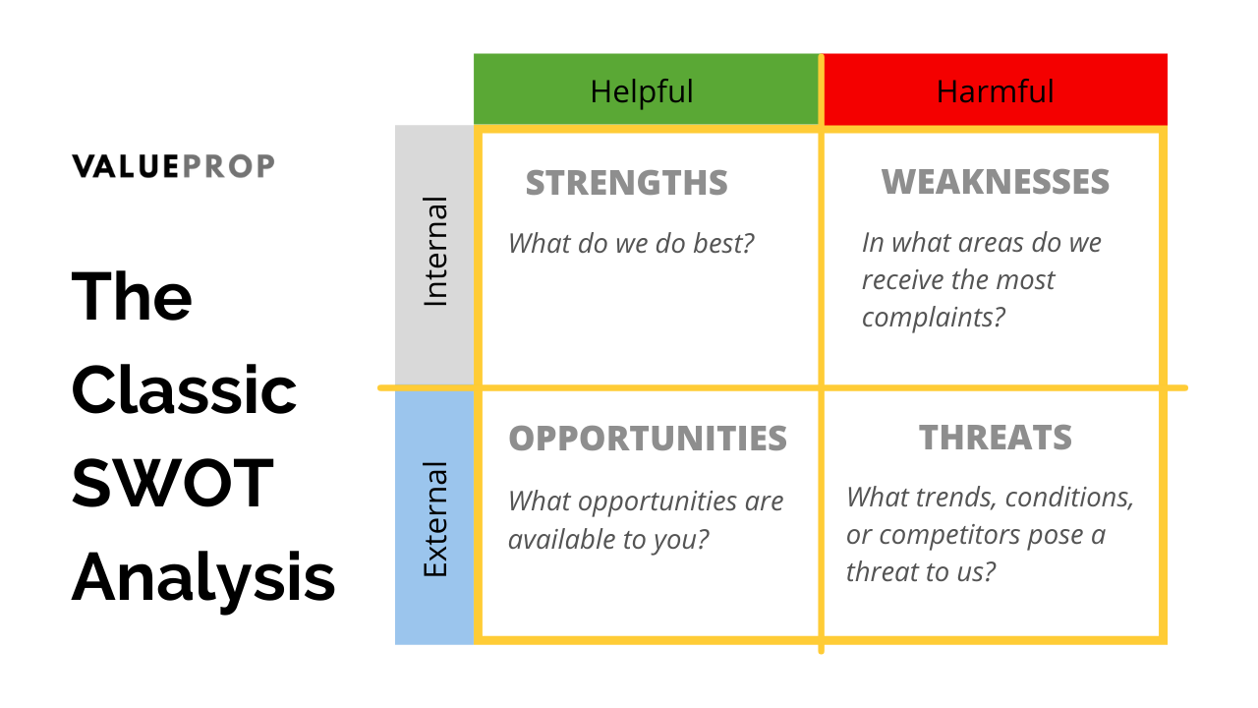
- Losing staff to competitors
- Increase regulation
- Inflation
- Loss of market share
- Demographic shift
- Expansion and growth
- Workforce planning
- Employee turnover
- Strict code of conduct
- Internal promotion
- Budget constraints

- Staf development
- Staff perks and opportunity
- Wellbeing programmes
- Culture and philosophy of the company

SWOT Analysis:
We can see that the organisation has some good strategies in place such as The Marriot Development Academy (MDA). It allows its staff to learn at their own pace and develop new skills (Rasheed, 2022). The organisation is also global so further expansion and growth are possibilities for the future and this will lead to staff having opportunities for promotion or a chance to relocate if they wish. As for the negatives, we can see that staff turnover is high in the industry (Frye et al., 2020). There are many reasons why companies fail to retain their employees, such as a lack of communication between managers and departments. This in turn results in a lack of trust and a reduction in output, affecting performance and morale in the company. High inflation can lead to unemployment (Hayford, 2000), and this might put pressure on current staff to do more for the same pay.

Engagement Methods:
Employees are a big part of the company and in order for them to feel part of it, the same interest has to be given to them as it is given to the business itself (Amstrong and Miller, 2020). Engaging with staff is key to finding out how they are doing in their jobs. Without that engagement, the HR department will be left in the dark as to what their employees’ state of mind and engagement level with the company is. There are several tools to look at staff engagement, one of those tools is called The Gallup survey which can give a glimpse of employee engagement (Gallup, 2022). The other tool can be an internal survey from the company itself to engage with their workforce and implement change if need be from the result of the survey. Work engagement is important for the company because it affects customer service quality and satisfaction (Salanova, Agut., and Peiró, 2005). Another aspect that HR can look into is the employee life cycle as it adds a means to engage with the employee, give them direction to improve performance and also a path to promotion. Managers need to understand how to engage and motivate their staff (Johnson, 2004). When employees are fully engaged with the company, they are more likely to stay within the company.
Workers are considering their overall experience, not just their pay (Franklin, 2022). Their feelings about their job are heavily influenced as to whether their psychological, rather than only material needs are met. Research has found that 60% of employees are thinking of quitting, without new job offers (Allas, 2022). So a disengaged employee is less likely to stay in the company and be productive. The 3-stage model of change by Lewin can help a business to change. In order for a business to adapt to change it first has to strategies and plan, engage with the level of resistance and involve people in the process. And then develop ways to sustain the change by providing support and training for the staff (Rosca, 2020).

Conclusion:
The report here shows that in order to engage with employees, models such as PESTEL and SWOT analysis are useful in finding out the external and internal pressures the company is facing and using them to its advantage. It can use this information to retain employees. In order to retain employees the company must engage and understand the employee’s progression in the company. Using the employee life cycle to check and promote the progression of the employee, while using surveys such as the Gallup survey or an internal survey to see their engagement within the company. Managers also have a role to play, if they do not engage with their employees then they would not know how well an employee is doing, and if they need help or a new challenge.
There are some challenges outside the power of the company such as government decisions that affect the business, in this instance, the company needs to follow the directives and try to minimize the stress of their employees by engaging with them and keeping them up to date with whatever decisions the company is going to explore or make. The high inflation increasing the cost of all goods for business and employees will need to be addressed by the company and they should have a plan moving forward and encourage the employees for their input. If staff reduction needs to be made then the company needs to explain the situation and the reason for the reduction rather than just letting people go and making it uncertain for the rest of the working employees.
It is recommended that the best way to retain employees in a company is to engage with them from the start to finish. Keeping them aware and engaged about decisions that will either affect them or their colleagues. Using industry tools such as PESTEL and SWOT to look at the overall picture affecting the company. If employees are left in the dark then it will breed uncertainty and doubt about their future within the company and more likely for them to jump ship if the chance arises. Also giving employees options for shift change and flexible working hours will be advantageous to the company, as it will encourage the employees to work at their best time and give their best effort at the job they are doing. The more engagement between the company and employees, the better the understanding of the company’s needs and decision-making.

References:

Allas, T (2022) More UK employees are leaving their jobs than ever before: How businesses can respond [Online], Mckinsey & Company, Available at: https://www.mckinsey.com/uk/our-insights/the-mckinsey-uk-blog/more-uk-employees-are-leaving-their-jobs-than-ever-how-businesses-can-respond (Accessed: 21 November 2022)
Armstrong, M and Taylor, S. (2020) Armstrong’s Handbook of Human Resource Management Practice, 15 edn, London: Kogan Page
Bernardo, V., Fageda, X. and Fillol, R. (2021) ‘Pollution and congestion in urban areas: The effects of low emission zones’, Economics of Transportation, 26–27. Available at: https://www.sciencedirect.com/science/article/pii/S2212012221000265 (Accessed 22 November 2022)
Brandon, J (2022) your-employees-might-be-quiet-quitting-on-social-media-here-are-the-signs [Online], Forbes, Available at: https://www.forbes.com/sites/johnbbrandon/2022/11/27/your-employees-might-be-quiet-quitting-on-social-media-here-are-the-signs/?sh=601fcfa34f48 (Accessed: 22 November 2022)
Department of Environment Food & Rural Affairs (2020) 30 January 2020: Environment Bill 2020 policy statement [Online], Gov.UK, Available at: https://www.gov.uk/government/publications/environment-bill-2020/30-january-2020-environment-bill-2020-policy-statement (Accessed: 23 November 2022)
Franklin, N (2022) People are searching for better work, not just more pay [Online], Insight, Available at: https://workplaceinsight.net/people-are-searching-for-better-work-not-just-more-pay/ (Accessed: 21 November 2022)
Gallup Survey (2022) Gallup's Employee Engagement Survey: Ask the Right Questions With the Q12® Survey [Online], Gallup, Available at: https://www.gallup.com/workplace/356063/gallup-q12-employee-engagement-survey.aspx (Accessed: 23 November 2022)
Gov.UK (2022) Maximum weekly working hours [Online], Gov.UK, Available at: https://www.gov.uk/maximum-weekly-working-hours (Accessed: 22 November 2022)
Hayford, M. (2000) ‘Inflation uncertainty, unemployment uncertainty and economic activity, Journal of Macroeconomics, 22 (2), pp. 315-329. Available at: https://www.sciencedirect.com/science/article/pii/S0164070400001348 (Accessed: 23 November 2022)
Johnson M (2004), The new rules of engagement: life‐work balance and employee commitment, The Chartered Institute of Personnel and Development. Europe, Middle East and Africa: McGraw-Hill Education.
Kim, S., et al. (2021) ‘Preference for robot service or human service in hotels? Impacts of the COVID-19 pandemic’, International Journal of Hospitality Management, 93, Available at: https://www.sciencedirect.com/science/article/pii/S0278431920303479 (Accessed: 24 November 2022)
Leeds Marriot Hotel (2022) About us [Online], Linkedin, Available at: https://uk.linkedin.com/company/leeds-marriott-hotel (Accessed: 20 November 2022)
Marriot (2022) Hotel details [Online], Marriot International, Available at: https://www.marriott.co.uk/hotels/fact-sheet/travel/lbadt-leeds-marriott-hotel/ (Accessed: 20 November 2022)
Marriott International (2021) Marriott International Reports on Environmental, Social, and Governance Progress [Online], Marriott International, Available at: https://news.marriott.com/news/2021/09/14/marriott-international-reports-on-environmental-social-and-governance-progress (Accessed: 20 November 2022)
Rasheed, N (2022) Marriott International Serves Up “Life With the Works” to Inspire a New Generation of Hospitality Workers [Online] Linkedin, Available at: https://www.linkedin.com/pulse/marriott-international-serves-up-life-works-inspire-new-rasheed?trk=public_post (Accessed: 20 November 2022)
Romei, V (2022) UK economy has fallen into recession, survey suggests [Online] Financial Times, Avaliable at: https://www.ft.com/content/77a03e89-13c5-4d05-ad71-72a18bd05d7c (Accessed: 20 November 2022)
Roşca V (2020) ‘Implications of Lewin’s Field Theory on Social Change’, Proceedings of the International Conference on Business Excellence, 14, pp. 617-625. Available at: https://sciendo.com/es/article/10.2478/picbe-2020-0058 (Accessed: 23 November 2022)
Salanova, M., Agut, S. and Peiró, J. M. (2005) ‘Linking organizational resources and work engagement to employee performance and customer loyalty: the mediation of service climate, Journal of Applied Psychology, 90, 1217-1227.

Seve360 (2019) Sustainability and Social Impact [Online], Marriot International, Available at: https://serve360.marriott.com/ (Accessed: 21 November 2022)
Sumption, M (2022) ‘Shortages, high-demand occupations, and the post-Brexit UK immigration system’, Oxford Review of Economic Policy, 38 (1), pp. 97–111. Available at: https://academic.oup.com/oxrep/article/38/1/97/6514754 (Accessed: 21 November 2022)
William D. et al. (2020) ‘What factors influence Generation Y’s employee retention in the hospitality industry?: An internal marketing approach’, International Journal of Hospitality Management, 85, Available at: https://www.sciencedirect.com/science/article/pii/S0278431918310910 (Accessed: 21 November 2022)

