Abigail Hall
EDCAD4005
Spaces and Places to learn
‘Choose either ‘the beach’ or ‘the woods’ to plan a visit for a group of children. Describe how visiting this location can support learning.’

Providing children with spaces and places to learn can maximise learning outcomes. The Welsh Assembly Government agree with many that indoor and outdoor spaces are fun, they are engaging and enhance learning. The outdoors is the ideal environment for experiential learning, it offers unique opportunities to be creative, to move around, to be noisy and to take risks. The outdoors is full of special stimuli such as weather, sounds, smells and textures which can enrich and enhance a child’s learning environment. (WAG 2009). Spaces and places can involve more than just an area for children to learn, they can contain lots of different resources and adult roles for further learning of the outside world. Children need more than the standard curriculum learning, they need to develop their creativity, relationships, physical and mental development. Furthermore, providing children with these experiences can make it easier to teach cross curricular subjects supporting Donaldson’s Successful Futures on the new curriculum that the ‘curriculum’s aim is to prepare pupils at the school for the opportunities, responsibilities and experiences of later life.’ (DCELLS 2015). Through cross-curricular teaching and good pedagogy in the classroom and outdoors, he focusses on 4 main purposes to produce ‘ambitious, capable learners, ready to learn throughout their lives, enterprising, creative contributors, ready to play a full part in life and work, ethical, informed citizens of Wales and the world healthy, confident individuals, ready to lead fulfilling lives as valued members of society’. (DCELLS 2015).
For this assignment, I have chosen to take 25 Year 2 children to The Woods on a trip. On this trip, they will learn more about their outdoor environment that they might not already know especially when a lot of children don’t live in rural areas. They will get the chance to explore and investigate the woods and how they might survive a couple of days living in the wild connecting with the theme ‘The Wild’. In this assignment, I will analyse and evaluate why outdoor and indoor spaces and places are beneficial to supporting learning and what risks can arise using the outdoors.
Learning environments are more than just a classroom, learning environments shape a child’s learning. They need to be engaging, safe and secure and encourage independence. A good learning environment will be a positive and influential place that is inclusive and where the child feels equal and comfortable. Teachers are taught to focus on the curriculum, academics and how to teach it effectively, however if the learning environment isn’t engaging or inclusive for everyone, they will not get the best out of all their learners. Winford Montgomery (2001) agrees with this and states many teachers are faced with limited understanding of cultures other than their own and the possibility that this limitation will negatively affect their students’ ability to become success learners. The learning space should include all the children’s interests and fulfil their cognitive, emotional, spiritual and physical needs.
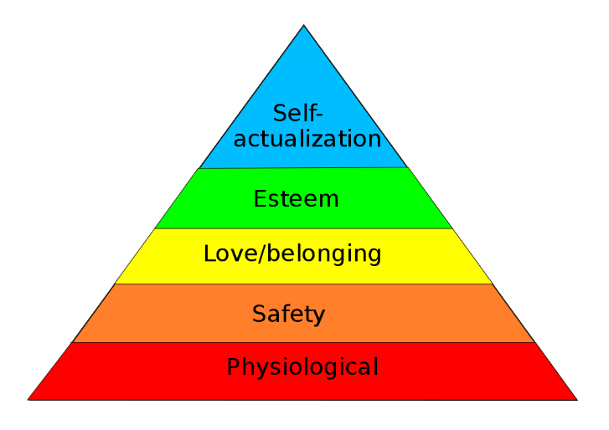
An example of a learning environment emphasising on play is Friedrich Froebel’s ‘Kindergarten system’, ‘he stressed the natural growth of children through play using extraordinary visual materials to reconstruct this successful system, to teach young children about art, design, mathematics, and nature.’ He is widely associated with the words ‘play is a child’s work’. (N. Brosterman 1997). Learning environments can be indoors or outdoors. However, extensive research has found that outdoor learning environments are extremely beneficial for learning. Estyn Report (2011) states in most cases, children benefit from their time outdoors. They display high levels of engagement and enjoyment and their knowledge and understanding of the world and physical development improve. Additionally, the Reggio Emilia schools in Italy approach to learning supports this by stating learning environments replicate their community. Its pedagogy is a constructivist approach and believe that the environment is the third teacher. An example of its philosophy is that ‘Children must have some say over what they learn; additionally, the senses play a big role in the learning process. Children must be able to touch, move, listen, see and hear in order to fully process something.’ (Amanda Rock 2018). Harriman (2006) supports this as she says learning within four walls is an adult concept and agrees we should implement more spaces to learn outdoors. Maslows’s Hiearchy of needs (Appendix A) a humanist pedagogical approach explains how to create a positive learning environment with regards to a child’s basic needs. He believes for a child to move up the hierarchy, each level must be fulfilled by the individual to feel satisfied. A successful positive learning environment should be able to support these needs.
Appendix A

Even though research likes to focus outdoor learning, there are just as engaging learning environments indoors. If we focus on children’s interests, we can plan inside areas for children to learn. They need to be varied, appealing and personalised to the pupils needs and wants. These spaces to learn might include lots of stimulating resources focussing on certain themes such as a stage with a microphone to perform, colourful curtains and backgrounds with lights and peers may watch and record performances with iPads or using cameras with tripods. If teachers plan effectively, indoor areas can enhance learning just as well as outdoor learning. Donaldson (2015) states good teaching and learning sets tasks and selects resources that build on previous knowledge and experience and engage interest. If the teacher has a good pedagogical knowledge and can create engaging resources that are specific to their learners, this can create a positive effective learning environment.
Educational visits are a great way to support learning in the school and bringing learning to life. For children, an educational visit can be an exciting, engaging and fun way of learning skills, experiencing something new and engaging in activities they might never do in school or at home. An example of a popular educational visit is ‘Forest Schools’. ‘The sessions are led by a qualified forest school leader and provide practical, hands on, learning experiences which encourage children to explore and challenge themselves. This leads to the development of confidence and self-esteem as well as a growing appreciation of their natural environment.’ Some school have their own designated Forest Schools area however many go and visit areas in the community. (WAG 2009). In this educational visit, the learners get to experience the natural environment over time and become familiar with the environment and learn to feel a sense of ownership while having fun. If we are teaching our learners to look after our environment, then we are producing more sustainable citizens for the future generation. Educations visits can also help develop knowledge and understanding of the world, creative development, welsh language development, physical development, social and personal development and Literacy and communication. Children are being introduced to the outside world, animals, language and new relationships.
Educational visits are an easy way for a teacher to introduce cross curricular learning. One visit to a museum for example, can cover all the Areas of learning that Donaldson has proposed in the new curriculum. Children can learn a huge variety of different skills and produce a vast amount of work on just one visit. A pedagogical approach to educational visits would be a constructivist approach. Piaget's (1936) theory of cognitive development explains how a child constructs a mental model of the world. Piaget states that children learn skills from doing and construct meaning independently. Being able to physically walk around, see and touch objects in a museum is unique to a child and they are more likely to retain and remember information.
Even though the main purpose of an educational visit is to broaden a child’s learning, introduce them to new experiences and environments and to let them explore as wider community, they are also an opportunity for a child to experience some risks. Children especially at present, are seen to be wrapped in ‘cotton wool’. The Telegraph (2012) states the Cotton Wool Culture, "Play outdoors teaches young people how to deal with risk and without this they are ill-equipped to deal with working life." Children should be exposed to risk so that they can learn how to deal with difficult situations in adult life. Teachers should be able to take pupils on exciting school trips that broaden their horizons. (WG 2013). The Welsh government agree that teachers should introduce children to the outside world and should introduce children to risk but there are policies in place that the government have implemented to keep teachers and children safe.
Another aim of educational visits is to have a break from the classroom and working within four walls and give them something to look forward to. Children know their classmates and teachers in day to day school life, however out on visits or even a residential visit they get to experience people in a different light. They also get to develop their own social skills out of the classroom and find their own self-esteem and resilience. The Guardian (2008) ‘School trips provide a great opportunity for pupils to gain such experience and face a range of challenges that can contribute significantly to their personal development.’ Some children may not open up in the classroom but may shine on an educational visit.
I have chosen to go to The Woods on my educational trip with a Year 2 class of 25 children because I believe there are so many skills that can be learnt in the natural environment and so many experiences to have that some children may never get to explore at home. It can give them a chance to become familiar with their surroundings and become more sustainable citizens if they know the reason behind trying to protect the environment. The University of Tennessee states that ‘all subjects or curriculum can be presented in an outdoor classroom. Outdoor classrooms also provide alternatives for all to gain a better knowledge of what natural resources are and to understand the interconnectedness of these resources.’
The woods I have chosen will be local to the school but will need transport as there are lots of busy roads to get the destination. The woods are a great place for children to explore and get a feel for the outdoor environment as its all natural and there are lots of animals and mini beats along with leaves, trees and water to investigate. They can use many of their senses, touch, smell, see and hear to gather information. This will be extremely engaging for the children and will cover many of the children’s interests and may even spark a few new interests. The woods are also a great place for the teacher as if planned effectively, the woods can cover several subjects and areas of learning in one day and when back at the classroom. Steiner (1919) established his first school and states that learning is cross curricular without subject boundaries and imagination and imitation are nurtured through play. He believes a pupils’ central focus is imagination and creativity. I believe taking a class into the woods gives children the opportunity to venture and play freely but with a learning objective in mind.
Donaldson (2015) wants learning to be a continuum and doesn’t want learning to stop at school. He wants to give children the opportunity to prepare themselves for life beyond school and to learn to be sustainable global citizens. Providing children with learning beyond the classroom such as outdoors and on educational visits, can broaden their learning and open their minds to more than just four walls. However, to provide children with such experience comes with protocols and lots of pre-planning. Before organising an educational visit, you must get permission from the school. You must let them know your plans and the reason for the visit and what the learning outcome will be for the class. Once that has been agreed, if the visit is at a museum or a zoo for example they will need to be contacted and have an agreement from them for the trip to go ahead.
Parents and home life are an important factor on a child’s learning. A significant other at home that encourages learning can make a massive difference to a child’s engagement and success in school life. This supports a behaviourist pedagogical approach from Vygotsky (1978) and his theory of the Zone of proximal development (ZPD), which is best understood as the difference between what a learner can do without help and what he or she can do with help. The concept was developed by Soviet psychologist and social constructivist Lev Vygotsky (1896 – 1934). Parents need to be informed with plenty of notice and given a consent form to provide their permission for their child to attend the visit.
The children will be 6-7 years old and will having been learning through the theme of ‘The Wild’. The children would have been looking at different habitats, different animals and mini beasts that live in the wild and how we can help protect their habitats. They will also have been looking at other things that live and happen in the wild such as plants and the weather and how the time of year affects the plants and animals. The areas of learning that will be developed on this trip will be Language and Literacy, Mathematics, Creative, Personal and social development and Understanding and knowledge of the world. There are skills from the Foundation Phase Framework (2015) that will be developed. From personal and social development skills they will be able to ‘take risks and become confident explorers of their indoor and outdoor environment’, from literacy skills they will be to ‘look for key words to find out what the text is about’, from the mathematics skills they will be able to ‘gather and record data’, from the understanding and knowledge of the world skills they will be able to ‘think creatively and imaginatively’, and lastly the creative skill they will learn will be to ‘mix, shape, arrange and combine materials to create their own images and objects that communicate and express their ideas, feelings and memories creatively’. One or more of the tasks on the visit will cover the LNF and the DCF from the framework. All these skills will be able to be explored with the outdoor educational visit combined with classroom activity prior to and after the visit.
Prior to the visit, I will need to arrange staff to accommodate my 25 children with the ratio 1:5. I will need 1 adult per 5 children which will be arranged into 5 groups of 5. I will have 1 teacher from another class, 3 teaching assistants and one parent I have found suitable to help for the trip. Each adult will have a bag on them to carry any medication and a First Aid kit and will have food supplies ready for the recipe task. A bus service frequently used by the school will be arranged for pick up from school at 9:30am and arrive to the woods at 9:45am and pick up from the woods 2:30pm and arrive back at school for 2:45pm approximately. The bus will cost £3 per child which will be included on the consent form (Appendix B) sent home to parents a week prior to the visit. I will have arranged with the headmaster on a suitable risk assessment of the woods which already has been visited previously by another class and added my own information that I have found suitable when visited the woods prior myself. (Appendix C). Children and parents will have been informed on bringing packed lunch and suitable clothing. Any medical issues such as asthma and allergic reactions will already have been discussed and noted and medication will be brought on the trip. The woods are accessible to any disabilities with wheelchair access available if need be and toilets are in the café in the car park.
In the classroom, the children will have been working on the theme ‘The Wild’ and we will have covered many of the mini beasts and animals that will find on the trip. They will already know what tasks will be set on the visit and what is expected of them in terms of behaviour and learning objectives. The children will have previously learnt the risks and dangers of being out in the wild and research their own information on staying safe. They will also have spent time researching on their tasks and any information they might need to help them out in the wild.
During the visit, there will be 5 different groups, with each group doing 5 activities like a carousel and will all experience the same skills. However, they will all be assigned one specific skill to work on back at the classroom to present to the class the next day. As we arrive, a register will be taken by each adult in each group and feedback back to me and a register will be done lunch time and before entering the bus at the end of the visit. Group one will be assigned instruction writing and will start in a quiet, open section of the woods and required to read a very brief set of instructions to pitch a tent. Group two will have the task of finding specific animals and mini beats they will have already researched themselves and record the data to then make pie charts on J2e back in the classroom. Group three will be assigned a more creative task of collecting all the different types and colours of leaves and shapes they find interesting in the woods to make a collage of the woods back at the classroom. Group four will use the research they have already found to prepare food they think would last them out in the wild for a few days and design suitable recipes to survive. Finally, group five will be able to freely be adventurous and take lots of pictures of things they find out on their ventures to make a PowerPoint presentation on their visit. Each group will have a go at every task and work in a carousel manner spending around 45 minutes per task.
The next day, the children will work straight on the tasks from the visit as the information is fresh. We will have a small discussion and reflection to talk about what they enjoyed, what they didn’t enjoy for example to activate prior knowledge. Each group will then start their assigned task for their group which is instruction writing, Pie charts on J2e, Art collage, recipe writing (on laptops) and PowerPoint. Each group will present to the class what their findings were, explain what they found and present their work.
To conclude, the aim of an educational visit is to support learning in the classroom, engage the children in learning and let them explore skills that they wouldn’t indoors. There are benefits to teaching and learning in a classroom and many times it cannot be avoided. However, there is extensive research and support that outdoor learning and educational visits can enhance education further. I believe the woods is a great example to support learning as I have shown in this assignment that several skills and areas of learning can be covered while the children are having fun and hands on engagement with learning and it can be brought back into the classroom while still being fun and engaging. In the woods they are also being exposed to small risks and dangers that are needed for children to grow and explore to prepare them for the real world after education. ‘Such experiences, from early years to adulthood, will help our children and young people to enter education, employment or training with transferable skills required to meet the opportunities and challenges of a rapidly changing world.’
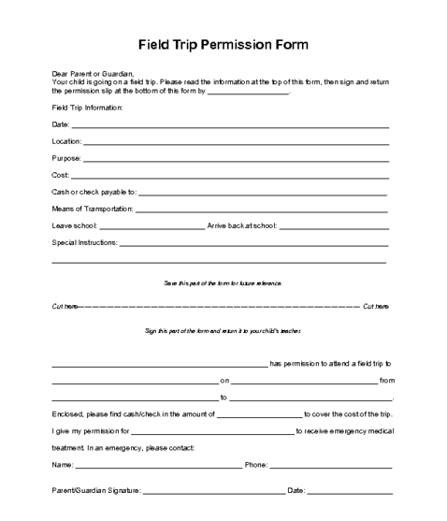

Appendix B

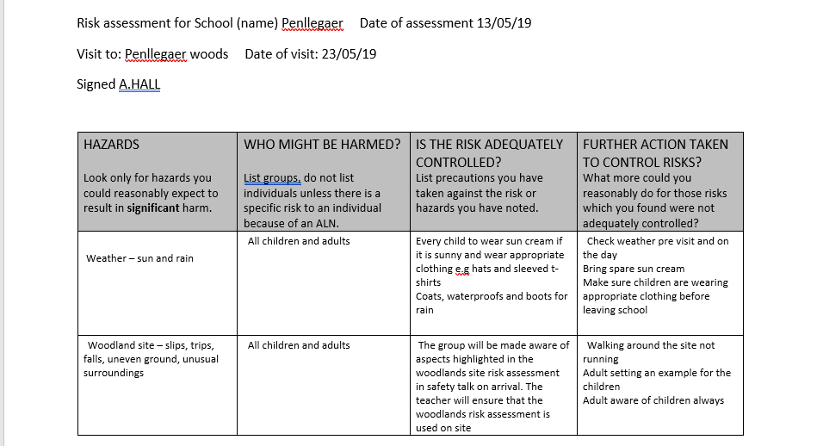
Appendix C

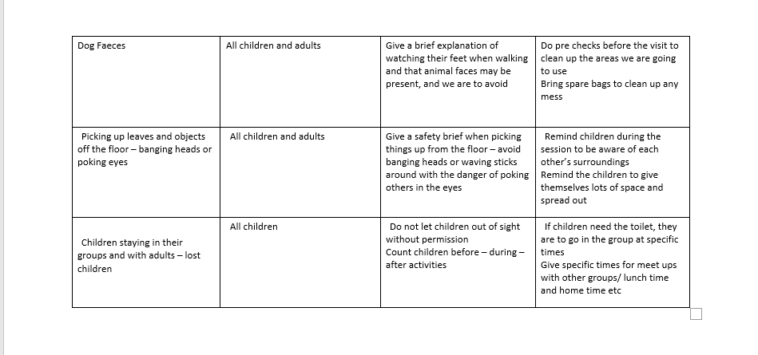

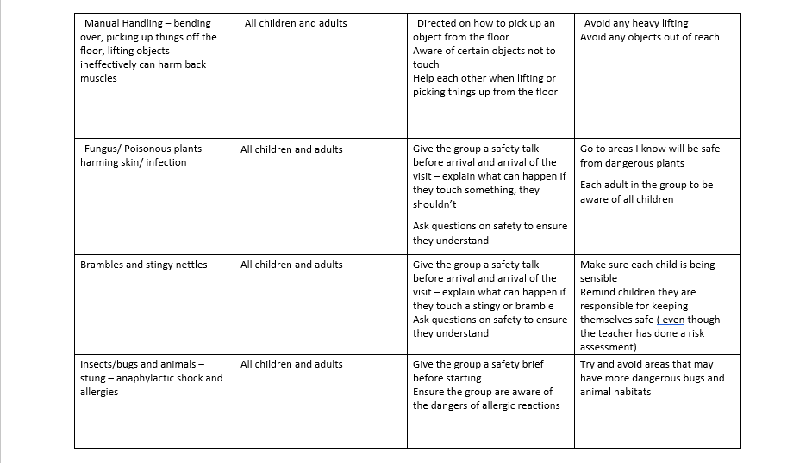

References

A.Rock (2018) The Reggio Emilia Preschool Philosophy. Available at: https://www.verywellfamily.com/reggio-emilia-approach-2764968 Accessed on 11/05/19
Estyn Report (2011) Outdoor Learning: an evaluation of learning in the outdoors for children under five in the Foundation Phase. Available at: https://www.estyn.gov.wales/sites/default/files/documents/Outdoor%20learning%3A%20%20an%20evaluation%20of%20learning%20in%20the%20outdoors%20for%20children%20under%20five%20in%20the%20Foundation%20Phase%20-%20September%202011.pdf Accessed on 11/05/19
Foundation Phase Framework (2015) Curriculum for Wales. Available at: https://learning.gov.wales/docs/learningwales/publications/150803-fp-framework-en.pdf Welsh Government. Accessed on 12/05/19
G.Donaldson (2015) Successful Futures Available at: https://gweddill.gov.wales/docs/dcells/publications/150225-successful-futures-en.pdf Accessed on: 11/05/19
Harriman, H. (2006) The Outdoor Classroom - A place to learn. London: Red Robin Books.
Learning and teaching Scotland (2010) Curriculum for excellence through outdoor learning. Available at: https://education.gov.scot/Documents/cfe-through-outdoor-learning.pdf Accessed on: 12/05/19
Maslow’s Hierarchy of Needs (Appendix A) Available at : https://en.wikipedia.org/wiki/Maslow's_hierarchy_of_needs#cite_note-:0-3 Accessed 11/05/19
N. Brosterman, Harry N. Abrams, Inc. (1997) Inventing Kindergarten. New York.
Piaget (1936) Jean Piaget's Theory of Cognitive Development. Available at: https://www.simplypsychology.org/piaget.html Accessed on 11/05/19
S. Macblain (2014) How Children Learn. SAGE. London
Steiner (1919) How Children Learn. SAGE. London
The Guardian (2008) Benefits far outweigh risks. Available at: https://www.theguardian.com/schooltrips/risk Accessed on 11/05/19
The Telegraph (2012) 'Cotton wool culture' stops children playing. Available at: https://www.telegraph.co.uk/news/health/children/9519175/Cotton-wool-culture-stops-children-playing.html Accessed on 11/05/19
The University of Tennessee (2006) Developing an Outdoor classroom to provide Education Naturally. Available at: https://emmajonesportfolio.weebly.com/uploads/3/1/9/8/3198894/out_door_classrooms.pdf Accessed on 12/05/19
Welsh Government (2013) Health and safety: responsibilities and duties for schools. Available at: https://www.gov.uk/government/publications/health-and-safety-advice-for-schools/responsibilities-and-duties-for-schools Accessed on 11/05/19
Welsh Assembly Government (2009) Foundation Phase Outdoor Learning Handbook. Available at: https://learning.gov.wales/docs/learningwales/publications/140828-foundation-phase-outdoor-learning-handbook-en.pdf WAG. Accessed on 11/05/19
W. Montgomery (2001) Creating, Culturally Responsive Inclusive Classrooms Volume 33. Issue 4. Available at: https://journals.sagepub.com/doi/abs/10.1177/004005990103300401 Accessed on 11/05/19
Vygotsky (1978) Vygotskian Principles on the ZPD and Scaffolding. Available at: http://www.open.edu/openlearncreate/pluginfile.php/5904/mod_resource/content/1/Vygotskian_principles_on_the_ZPD_and_scaffolding.pdf Accessed on 12/05/19

