
Assignment 2:
Operating Systems
CertHE Computing Skills for Workplace

Computer Architecture and Operating Systems. ACCA4022_LON
DR. Redhwan Al-Amri (Lecturer)
University of Wales Trinity Saint David
(London Campus)
Student Name: Mohamed Fofanah
Student Number:2510890
Group: 04
Date: April 29, 2026

Table of Contents
Introduction 1
1. Key functions of general Operating Systems 1
1.1 Process and Processor Management 1
1.2 Memory Management 2
1.3 File System Management 3
1.4 Security and Protection 3
2. Use of Windows OS CLI commands. 4
3. Use of Linux OS CLI commands. 7
4. Use of Windows OS scripts. 9
Script: System Health Check 9
Key Features Demonstrated 10
5. Use of Linux OS scripts. 10
Script: Log File Analyzer 10
Key Features Demonstrated 11
Conclusion 12
References 12
Appendices 13
Tutorial Activity on OS Types from OS Tutorial 1 13
1. LinkedIn Learning course 13
2. Cisco Networking Academy 14
3. Cisco Networking Academy: Operating Systems Basics 15

Introduction
Modern computing relies on a layer of software that most users never directly see: the operating system. It manages CPU time, memory, files, devices, and security, providing an environment in which applications can run reliably and independently of one another [1]. This report examines four core functions of general-purpose operating systems, demonstrates command-line tools on Windows and Linux, and presents two short administrative scripts written in PowerShell and Bash respectively.
The report is organised into five sections. Section 1 covers the core OS functions. Sections 2 and 3 demonstrate essential CLI commands on Windows and Linux. Sections 4 and 5 present a PowerShell system health check and a Bash log file analyser. The appendices document the supporting tutorial activities completed on LinkedIn Learning and the Cisco Networking Academy.

1. Key functions of general Operating Systems

1.1 Process and Processor Management
A process is a program in execution, encapsulating its own memory space, CPU register state, and allocated system resources [1]. Because a physical CPU core can only run one process at a time, the OS scheduler determines which process executes and for how long, carrying out a context switch when work is transferred from one process to another [1]. Modern Windows uses a priority-based pre-emptive scheduler with 32 priority levels, while the Linux kernel has used the Completely Fair Scheduler (CFS) since version 2.6.23 to allocate CPU time proportionally according to each process's weighted share [2]. Threads units of execution that share memory within a single process are more lightweight than processes and enable concurrency within applications [1], [3].
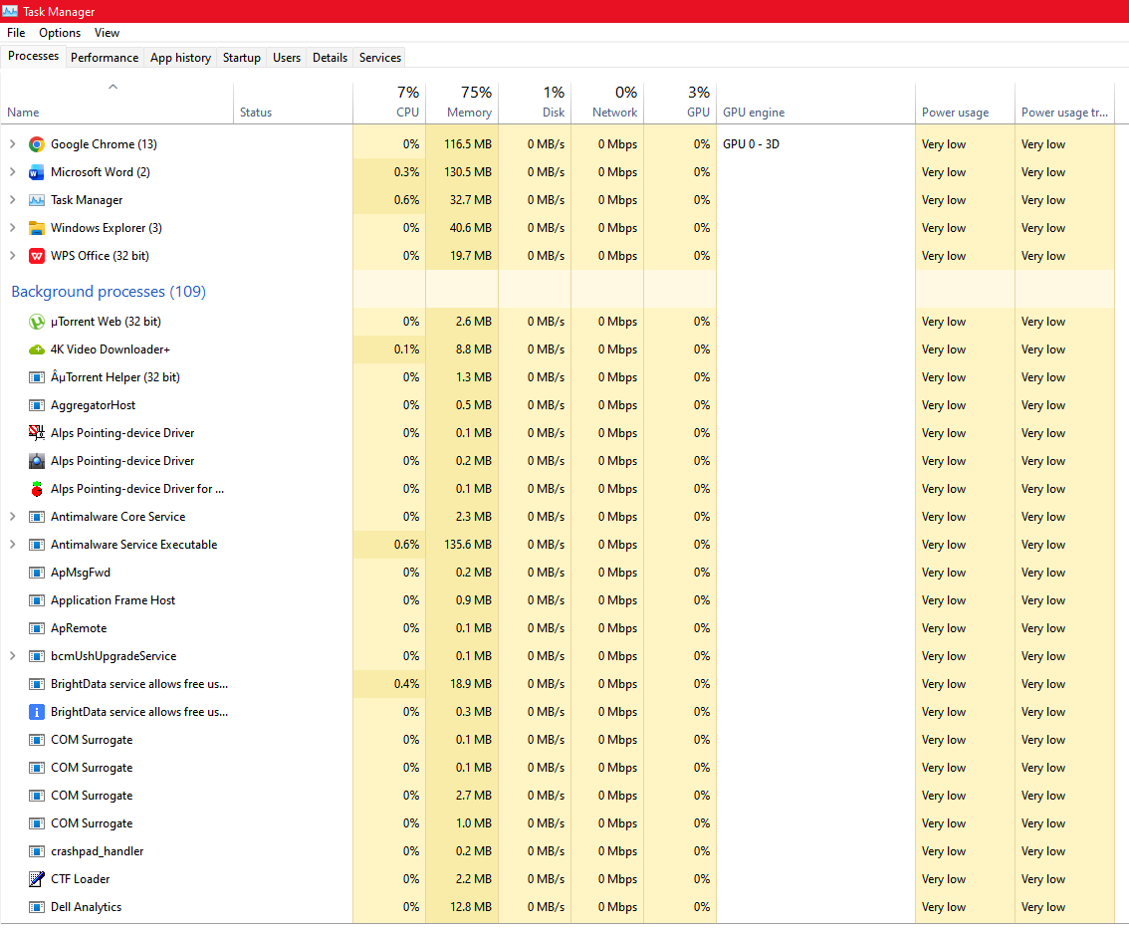
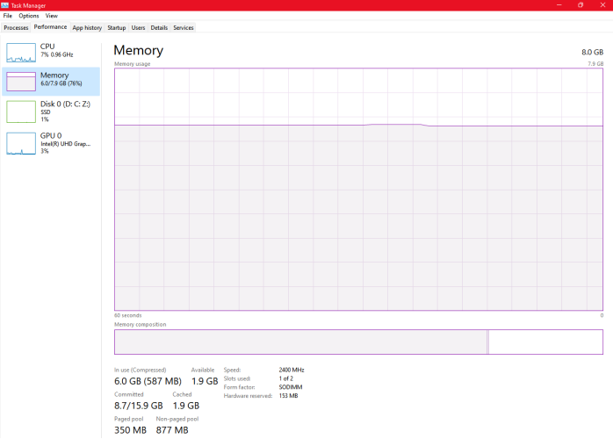
[Screenshot: Windows Task Manager – Processes tab showing CPU and memory columns]

1.2 Memory Management
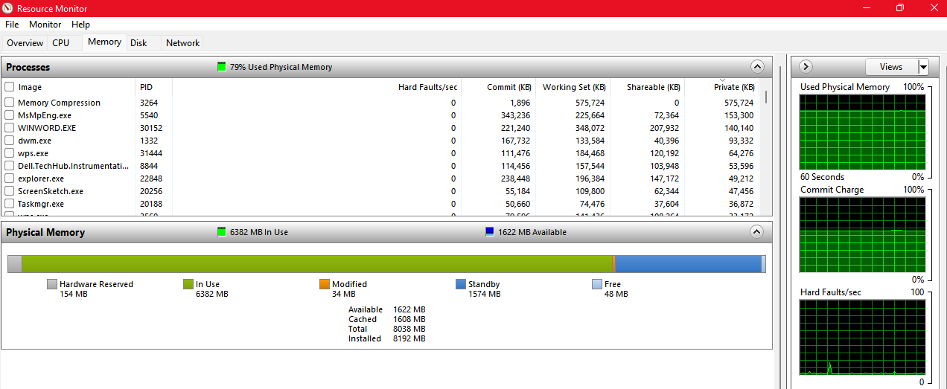
Physical RAM is finite, so the OS extends memory using virtual memory and paging. Each process operates within its own virtual address space that the OS maps onto physical RAM through page tables [1]. When RAM is exhausted, the OS moves less-used pages to secondary storage the page file on Windows or a swap partition on Linux. A page fault occurs when a process accesses a swapped-out page, prompting the OS to retrieve it from disk, an operation several orders of magnitude slower than RAM access. The hardware Memory Management Unit (MMU) enforces memory isolation between processes, a feature critical to both stability and security [3].

[Screenshot: Windows Resource Monitor – Memory tab showing usage breakdown]

1.3 File System Management
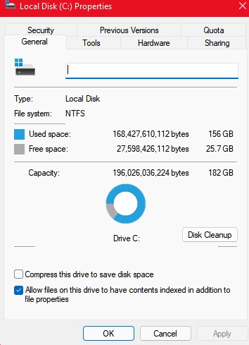
The file system abstracts raw storage blocks into named files arranged within a directory hierarchy [1]. Windows uses NTFS, which supports journaling, file-level permissions via Access Control Lists (ACLs), compression, and large volumes. Linux distributions predominantly use ext4, which similarly supports journaling and efficient handling of large file systems. Older file systems such as FAT32, still commonly used on USB flash drives, lack journaling and cannot handle files exceeding 4GB. Journaling is significant for fault tolerance: following an unexpected shutdown, the file system replays its journal to either complete or roll back pending writes, avoiding the lengthy full-disk scans required by non-journaled systems.
[Screenshot: Windows File Explorer showing C: drive NTFS properties]

1.4 Security and Protection
Operating system security relies on two complementary mechanisms: authentication, which verifies user identity, and authorisation, which enforces permitted actions. Authentication can be implemented via passwords, PINs, biometric data, or hardware tokens, with frameworks such as Windows Hello and Linux PAM providing pluggable support for multiple methods [4]. Authorisation is enforced through user accounts, group membership, and privilege-escalation mechanisms including Windows User Account Control (UAC) and the Linux sudo command. At a lower level, the CPU enforces a distinction between kernel mode and user mode: user-mode code cannot directly access hardware or other processes' memory and must request privileged operations through system calls. Full-disk encryption technologies BitLocker on Windows and LUKS on Linux provide protection for data at rest in the event of device theft.

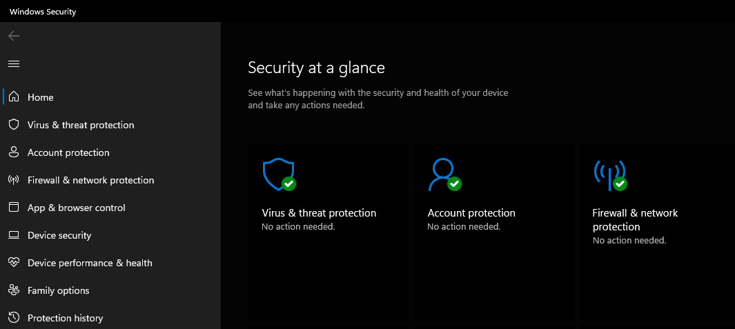
[Screenshot: Windows Security dashboard showing protection status]

2. Use of Windows OS CLI commands.
The Windows Command Prompt provides direct access to operating system functions through a text-based interface, and although PowerShell has largely superseded it for complex automation, the traditional command set remains essential for rapid diagnostics, scripting compatibility, and working with legacy systems [4]. The commands below are grouped by function.
File system navigation and manipulation. The dir command lists directory contents, with /s enabling recursive listing and /a:h revealing hidden files; cd changes directory, with /d permitting cross-drive changes. File operations include mkdir (create directory hierarchies in a single call), copy and move for duplication and relocation, ren for renaming, and del and rmdir /s for deletion. Unlike the File Explorer interface, del bypasses the Recycle Bin, so deleted files cannot be trivially restored.
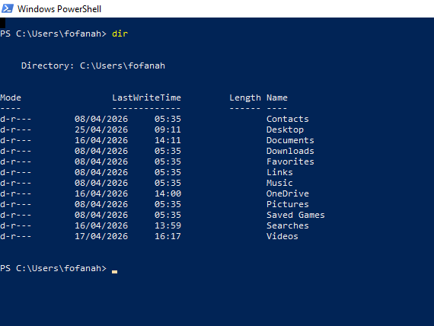

[Screenshot: Output of dir in C:\Users\[username] showing personal folders]
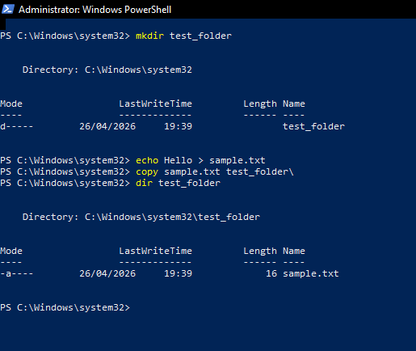
System and user information. The systeminfo command returns a summary of OS version, build number, installation date, available RAM, and BIOS information in a single output, making it valuable for support diagnostics [4]. The hostname and whoami commands identify the machine and current user respectively, and whoami /groups enumerates the security groups to which the user belongs.

[Screenshot: Output of systeminfo showing OS version, RAM, and BIOS details]
Process management. tasklist lists all running processes with their process identifiers (PIDs), while taskkill terminates a process by PID (taskkill /PID 1234) or by image name (taskkill /IM chrome.exe /F); the /F flag forces termination for unresponsive processes.
Network troubleshooting. A small set of commands covers the majority of connectivity diagnostics: ipconfig (with /all for full adapter information and /flushdns to clear the DNS resolver cache), ping for ICMP-based reachability testing, tracert for hop-by-hop route tracing, netstat -ano to enumerate active connections with owning PIDs, and nslookup for direct DNS queries. Together these provide observability across the network, transport, and application layers.
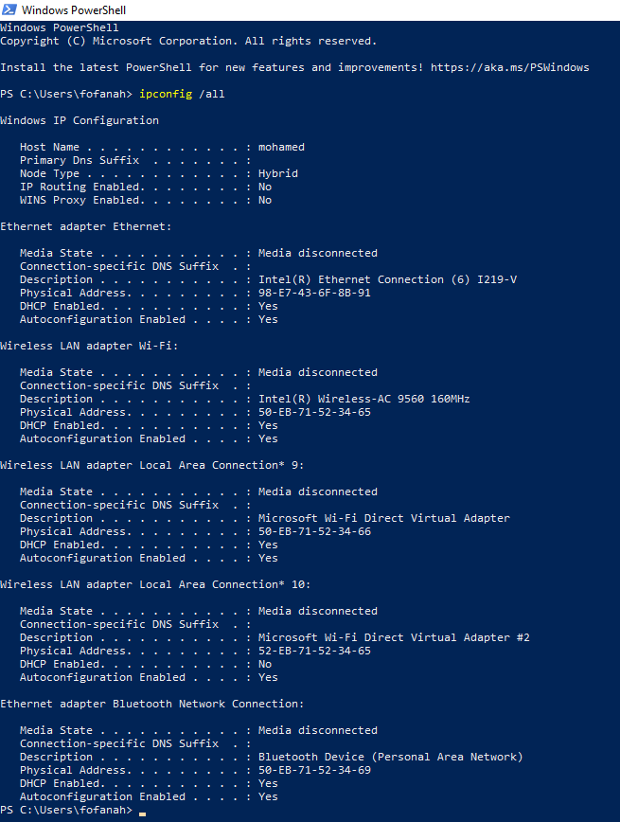
[Screenshot: Output of ipconfig /all showing network adapter details]
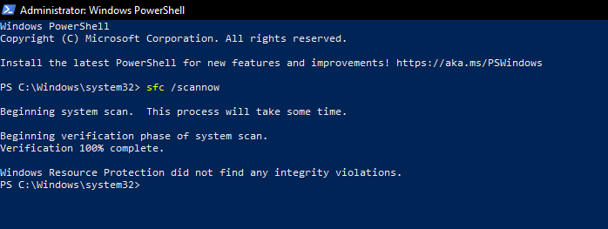
System maintenance. The sfc /scannow command runs the System File Checker, repairing protected system files against a verified cache, while DISM /Online /Cleanup-Image /RestoreHealth repairs the Windows component store; chkdsk /f detects and repairs file system errors on a specified volume. These commands are frequently the first response to symptoms of operating system corruption.

[Screenshot: sfc /scannow running with verification progress]

3. Use of Linux OS CLI commands.
The Linux command-line environment most commonly the Bash shell is the primary interface for Linux system administration, and many operational tasks have no graphical equivalent. Bash's effectiveness derives from composition: small, single-purpose utilities combined through pipes and redirection to produce complex behaviour from simple primitives.
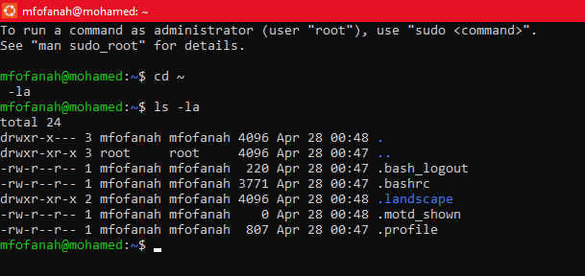
File system navigation and inspection. The ls command lists files, with flags -l for detailed listings, -a for hidden files, and -h for human-readable sizes; pwd prints the working directory, and cd navigates the hierarchy, with ~ and - as shortcuts to the home and previous directories respectively [7]. File operations include cp (with -r for recursion), mv for moving and renaming, and rm for deletion; rm -rf forces recursive removal and should be used with care.

[Screenshot: ls -la output in the home directory]
Viewing and monitoring file content. cat prints file contents directly, less provides paging for long files, and head and tail return the first or last N lines. tail -f continuously follows a file as it grows, a technique widely used for real-time log monitoring.
Permissions and ownership. Linux enforces a discretionary access control model based on owner, group, and world read/write/execute bits, modified using chmod (numeric form: 4 = read, 2 = write, 1 = execute) and chown [8]. A file with permissions -rw-r--r-- grants the owner read and write access and all other users read-only access. Executable files require the execute bit, which is why downloaded shell scripts typically require chmod +x before they can run.
Searching and filtering. grep searches files for patterns, supporting regular expressions and recursive operation; find locates files by name, type, size, or modification time. The pipe operator (|) chains commands so that the output of one becomes the input of the next, enabling expressions such as du -sh * | sort -h to identify the largest subdirectories within a folder.
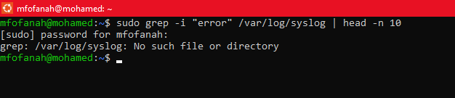
[Screenshot: grep searching a log file for specific keywords]
Process and system monitoring. ps aux captures a snapshot of all running processes, top and htop provide live updating views sorted by resource usage, kill sends signals (with SIGTERM as default and SIGKILL via -9), and uptime and free -h report system load and memory usage.
Networking and package management. The ip a command (which replaces the older ifconfig) reports network interface configuration; ss -tulpn enumerates open ports and owning processes, replacing the deprecated netstat. Package management is distribution-specific: apt on Debian and Ubuntu, dnf on Fedora and RHEL, and pacman on Arch. Privileged operations are performed via sudo, which logs every invocation for audit purposes.
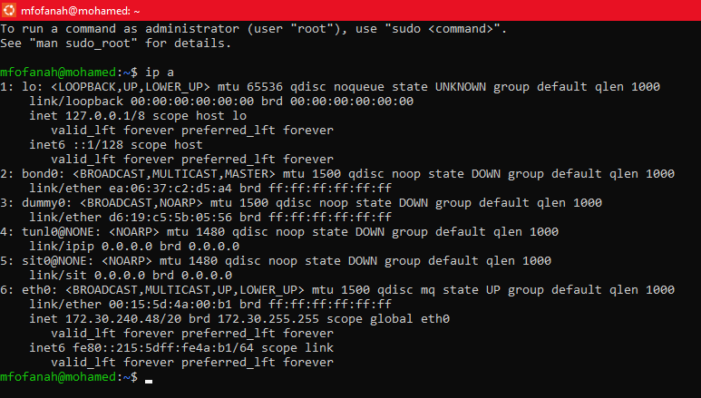
[Screenshot: ip a output showing network interface configuration]

4. Use of Windows OS scripts.

Script: System Health Check
PowerShell is Microsoft's modern scripting and automation language and has largely replaced legacy Batch scripting for Windows system administration [5]. Unlike Batch, which manipulates text streams, PowerShell is object-oriented and built on the .NET runtime, enabling structured data handling through pipelines of .NET objects [5]. The script below uses PowerShell to produce a rapid health summary of a Windows system, covering CPU load, memory utilisation, disk space, the state of selected services, and system uptime.
# System Health Check
# Author: [Student Name]

Write-Host "============================"
Write-Host " SYSTEM HEALTH CHECK"
Write-Host " $(Get-Date)"
Write-Host "============================`n"

$cpu = Get-CimInstance Win32_Processor | Measure-Object -Property LoadPercentage -Average
Write-Host "CPU usage: $([math]::Round($cpu.Average, 1))%"

$os = Get-CimInstance Win32_OperatingSystem
$totalMem = [math]::Round($os.TotalVisibleMemorySize / 1MB, 2)
$freeMem = [math]::Round($os.FreePhysicalMemory / 1MB, 2)
$usedPct = [math]::Round((($totalMem - $freeMem) / $totalMem) * 100, 1)
Write-Host "Memory: $usedPct% used ($freeMem GB free of $totalMem GB)"

Write-Host "`nDisk usage:"
Get-CimInstance Win32_LogicalDisk -Filter "DriveType=3" | ForEach-Object {
$usedGB = [math]::Round(($_.Size - $_.FreeSpace) / 1GB, 1)
$totalGB = [math]::Round($_.Size / 1GB, 1)
$pct = [math]::Round((($_.Size - $_.FreeSpace) / $_.Size) * 100, 1)
Write-Host " $($_.DeviceID) $usedGB GB / $totalGB GB ($pct% used)"
}

$services = @("wuauserv", "WinDefend", "Spooler")
Write-Host "`nKey services:"
foreach ($s in $services) {
$svc = Get-Service -Name $s -ErrorAction SilentlyContinue
if ($svc) { Write-Host " $($svc.Name) - $($svc.Status)" }
else { Write-Host " $s - Not found" }
}

$boot = (Get-CimInstance Win32_OperatingSystem).LastBootUpTime
$up = (Get-Date) - $boot
Write-Host "`nUptime: $($up.Days)d $($up.Hours)h $($up.Minutes)m"

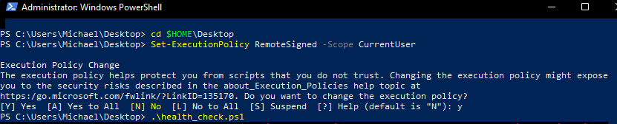

[Screenshot: PowerShell output of the System Health Check script]

Key Features Demonstrated
The script applies several core PowerShell techniques. Get-CimInstance queries WMI, the standard interface for Windows system data in modern PowerShell [5]. Measure-Object summarises collections, a ForEach-Object pipeline iterates through logical disks, and a foreach loop over a service array uses -ErrorAction SilentlyContinue to handle missing services gracefully a recommended defensive pattern in production scripts [9]. Arithmetic and formatted output are achieved through [math]: Round() and subexpression string interpolation ($(...)). The script can be extended with event-log queries (Get-WinEvent) or network-connectivity tests (Test-NetConnection) without structural change [5].

5. Use of Linux OS scripts.

Script: Log File Analyzer
Bash is the dominant scripting language for Linux administration because it is preinstalled on virtually every distribution and offers direct access to the full range of shell utilities. The script below accepts a log-file path as an argument and reports the file's size, last modification time, line count, counts of lines containing the keywords error, warning, and failed, and the five most recent lines containing the word error.
#!/bin/bash
# Log File Analyzer
# Usage: ./log_analyzer.sh /path/to/logfile

LOGFILE="$1"

if [ -z "$LOGFILE" ]; then
echo "Usage: $0 <logfile>"
exit 1
fi

if [ ! -f "$LOGFILE" ]; then
echo "File not found: $LOGFILE"
exit 2
fi

echo "=============================="
echo " LOG FILE ANALYZER"
echo " $(date)"
echo "=============================="
echo "File: $LOGFILE"

SIZE=$(du -h "$LOGFILE" | cut -f1)
MODIFIED=$(stat -c %y "$LOGFILE")
echo "Size: $SIZE"
echo "Last modified: $MODIFIED"
echo

TOTAL=$(wc -l < "$LOGFILE")
echo "Total lines: $TOTAL"

ERRORS=$(grep -ic "error" "$LOGFILE")
WARNINGS=$(grep -ic "warning" "$LOGFILE")
FAILED=$(grep -ic "failed" "$LOGFILE")

echo "Errors: $ERRORS"
echo "Warnings: $WARNINGS"
echo "Failed: $FAILED"

if [ "$ERRORS" -gt 0 ]; then
echo
echo "Most recent error lines:"
grep -i "error" "$LOGFILE" | tail -n 5
fi

[Screenshot: Bash output of the Log File Analyzer against /var/log/syslog]

Key Features Demonstrated
The script applies several fundamental Bash techniques. The shebang (#!/bin/bash) identifies the interpreter, allowing direct execution after chmod +x. The positional parameter $1 handles user input, and the two initial if guards validate that an argument was supplied and that it refers to an existing file a defensive-programming convention in administrative scripting. Analysis uses grep -ic for case-insensitive counts, wc -l for total lines, and du -h together with stat for file metadata. The final pipeline (grep | tail) illustrates classic Bash composition, where specialised tools combine through pipes to achieve a compound result. Extensions such as cron-based scheduling, email notifications, or integration with logrotate can be added without restructuring the script [6].

Conclusion
Operating systems mediate between hardware and application software through four interlocking functions: process scheduling, memory management, file system organisation, and security enforcement. The Windows and Linux command-line interfaces provide direct access to these functions, enabling precise and repeatable system administration that graphical tools cannot match [7]. The two scripts presented in Sections 4 and 5 demonstrate how common administrative tasks health monitoring and log analysis can be automated using PowerShell and Bash once the underlying commands are understood [7], [8].
The research for this report drew on established operating systems textbooks, vendor documentation [9], and online tutorial resources. A consistent finding across these sources is that the apparent simplicity of modern computing to end users is sustained by layered resource management that is invisible unless something fails. Understanding that layered structure is essential for any IT practitioner. [6]

References

[1] | A. Silberschatz, P. B. Galvin and and G. Gagne, Opera, Operating System Concepts, 4th ed. ed., Hoboken, NJ: Wiley, 2018., 2018.
[2] | A. S. Tanenbaum and and H. Bos, Modern Operating Systems, Boston, MA: Pearson, 2015.
[3] | W. Stallings, Operating Systems: Internals and Design Principles, 9th ed. ed., Harlow, U.K: Pearson, 2018.
[4] | Microsoft, "Windows commands," 2024. [Online]. Available: https://learn.microsoft.com/.
[5] | Microsoft, "PowerShell documentation," 2024. [Online]. Available: https://learn.microsoft.com/.
[6] | The Linux Kernel Organization, "The Linux The Linux Kernel documentation," 2024. [Online]. Available: https://www.kernel.org/.
[7] | GNU Project, "Bash Reference Manual, Free Software Foundation," 2024. [Online]. Available: https://www.gnu.org/software/bash/manual/.
[8] | R. Love, "Linux Kernel Development," 3rd ed ed., Upper Saddle River, NJ, Addison-Wesley, 2010.
[9] | M. Russinovich, D. Solomon and and A. Ionescu, "Windows Internals, Part 1," 7th ed. ed., Redmond, WA, Microsoft Press, 2017.
[10] | C. N. Academy, "Operating Systems Basics," NetAcad, 2024. [Online]. Available: https://www.netacad.com.
[11] | J. F. Kurose and and K. W. Ross, "Computer Networking," in A Top-Down Approach, 8th ed ed., Harlow, U.K, Pearson, 2021.

Appendices

Tutorial Activity on OS Types from OS Tutorial 1

1. LinkedIn Learning course
The Operating System Fundamentals course on LinkedIn Learning was completed as part of the tutorial activity. The course covers the role of the operating system, process and memory management, file systems, and device drivers. It complements the textbook-based material covered in Section 1 of this report.
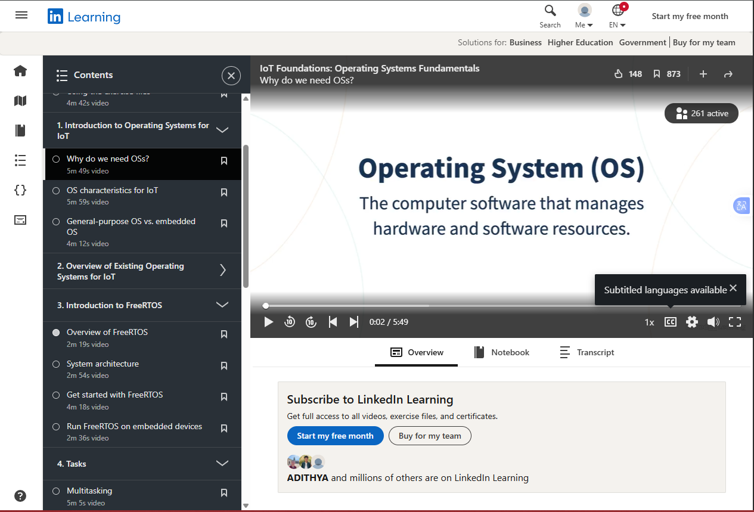

[Screenshot: progress page on LinkedIn Learning]

2. Cisco Networking Academy
The Cisco Networking Academy (NetAcad) module [10] framed operating system concepts from an IT technician and networking perspective. Topics covered included kernel and user modes, operating system categories (real-time, distributed, embedded), and file system fundamentals.

[Screenshot: Cisco Networking Academy progress page]
Notes: [Student to add a short reflection on what was most useful from this module.]

3. Cisco Networking Academy: Operating Systems Basics
The Operating Systems Basics chapter of the NetAcad course [11] introduced four principal categories of operating system: single-user single-task, single-user multi-task, multi-user, and real-time. It also covered the relationship between shells, kernels, and the system call interface material that connects directly to the command-line demonstrations in Sections 2 and 3.
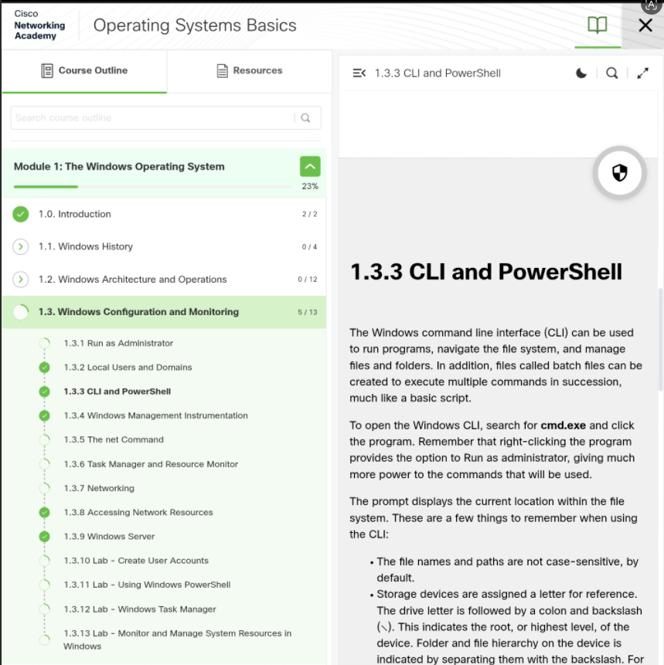
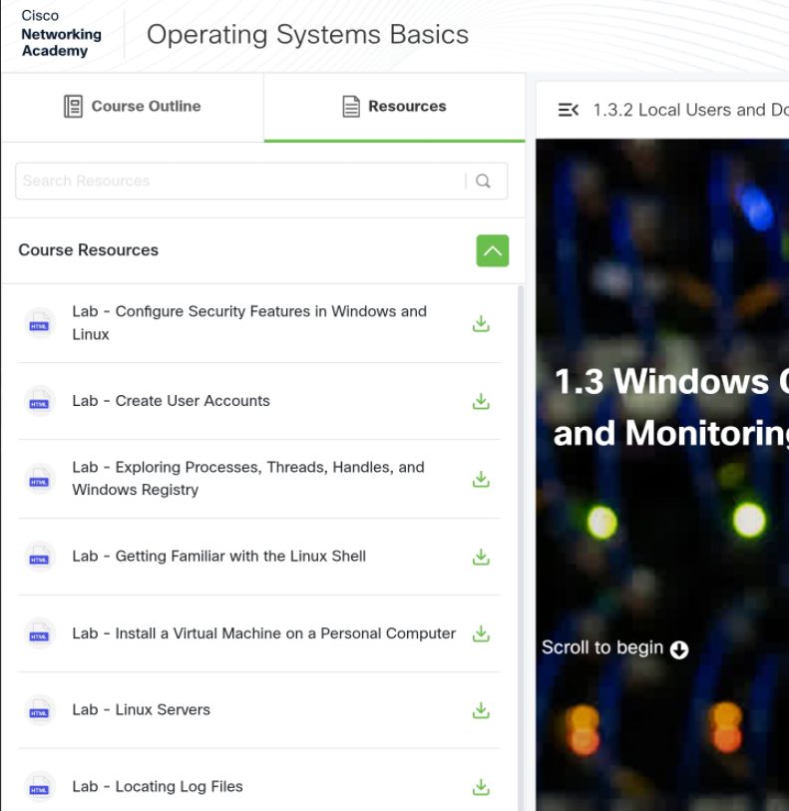


[Screenshot: Completion of the Operating Systems Basics chapter]

