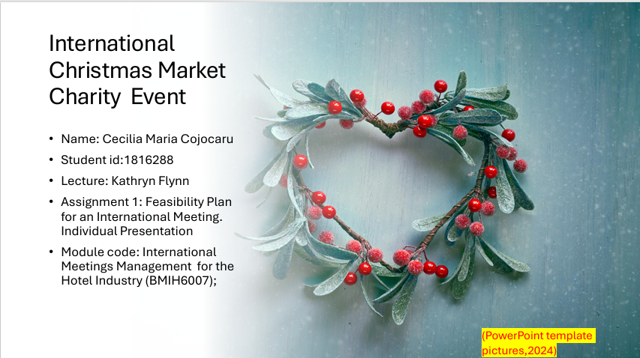

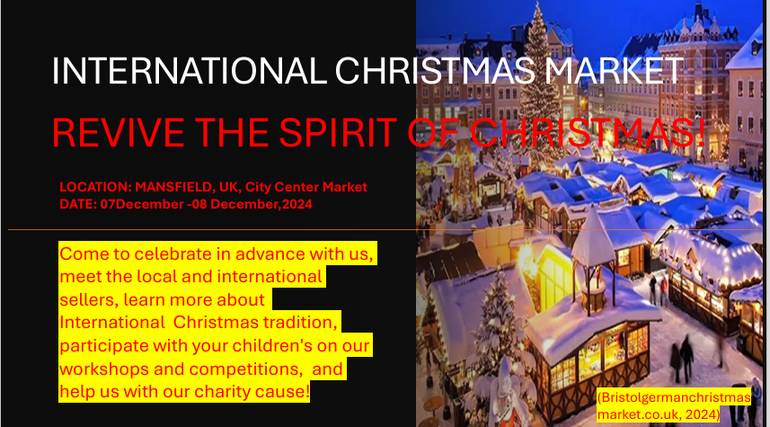

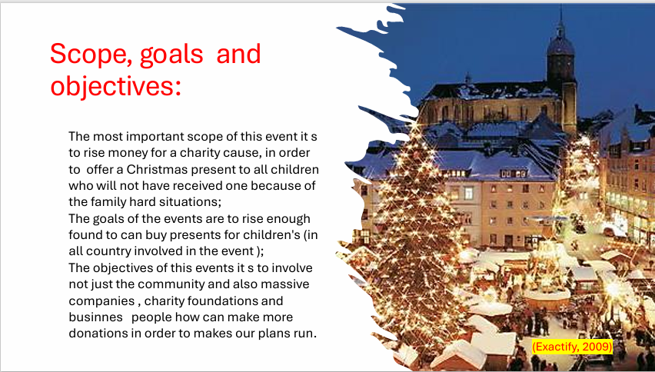

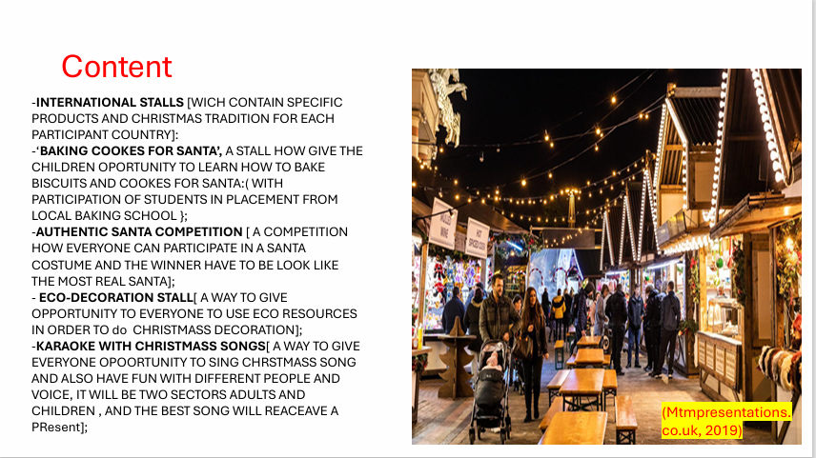

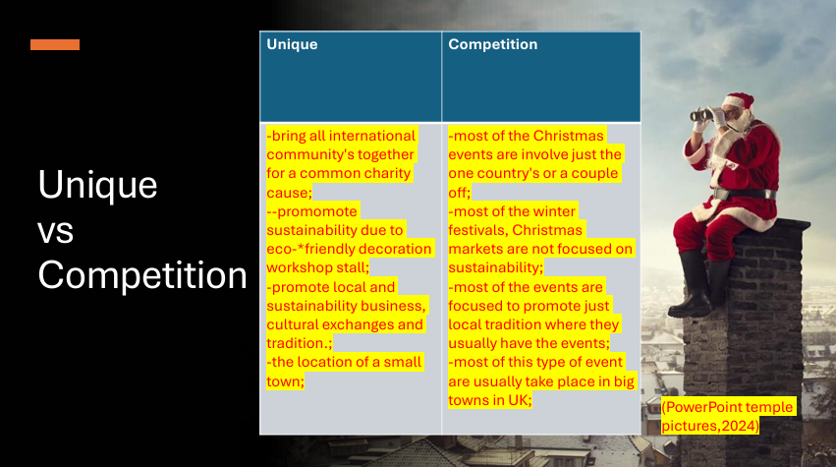

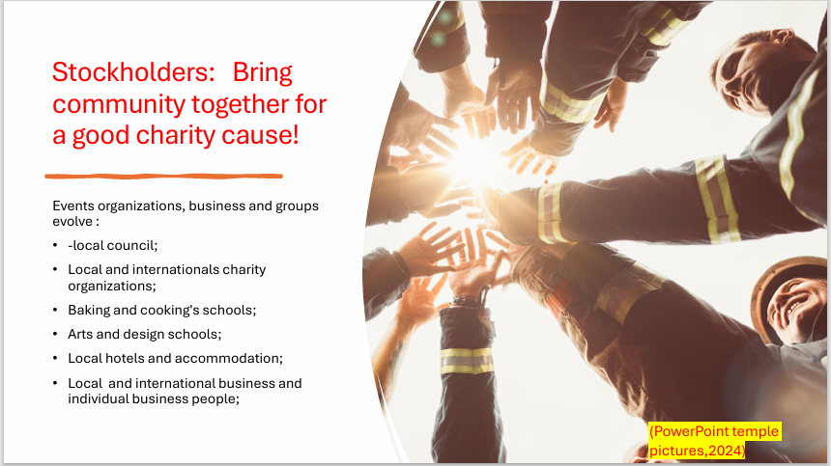

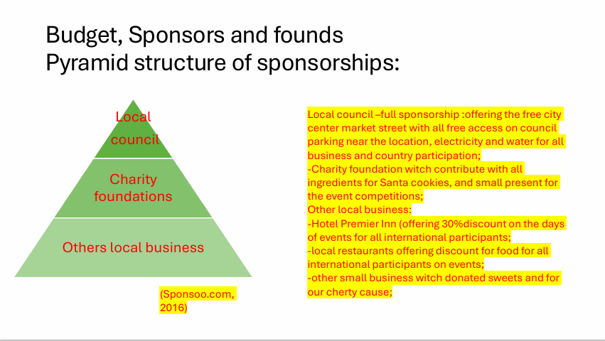

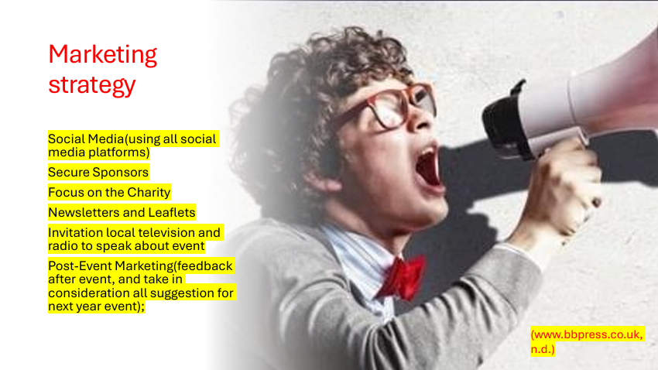



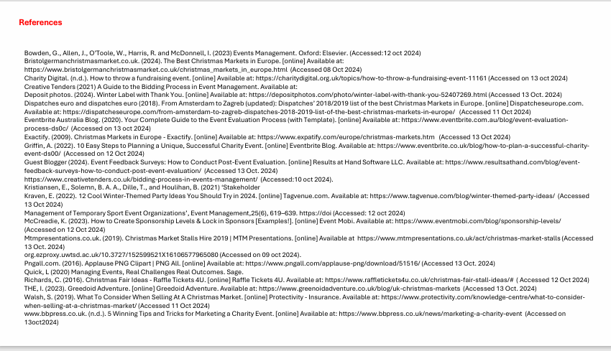

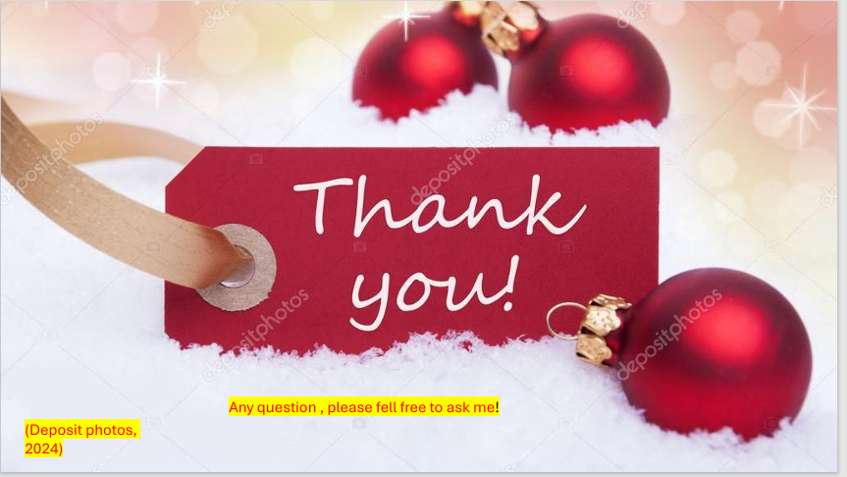

Notes:

Good morning Kattryn, my name is Cecilia Cojocaru and I will present today the presentation of an Winter Event based on the requirements of Assignment 1 for our module. (slide1)
My chosen event is an International Christmas Market which has the main objective of charity cause. “Revive the spirit of the Christmas” (the name of event) will be based in Mansfield market a small and beautiful town in Nottinghamshire, and will be between 07 and 08 December(the Christmas month) on the city center market street, and invite all international community to take part and celebrate with us in order to revive the spirit of the Christmas and help to achieve our goals of charity cause to raise enough money to buy Santa present for children in needs how probably will not have any presents because of the financial difficulties.(slide 2)
The main objective of this event it’s to involve not just the community and also massive companies , charity foundations and business people how can make more donations in order to makes our plans run.(slide3).
If we looking forward to describing the content of the event, I am happy to tell will be plenty of choices for all ages including parents, children, grandparents. Will had:
-INTERNATIONAL STALLS [WICH CONTAIN SPECIFIC PRODUCTS AND CHRISTMAS TRADITION FOR EACH PARTICIPANT COUNTRY]:
-‘BAKING COOKES FOR SANTA’, A STALL HOW GIVE THE CHILDREN OPORTUNITY TO LEARN HOW TO BAKE BISCUITS AND COOKES FOR SANTA:( WITH PARTICIPATION OF STUDENTS IN PLACEMENT FROM LOCAL BAKING SCHOOL };
-AUTHENTIC SANTA COMPETITION [ A COMPETITION HOW EVERYONE CAN PARTICIPATE IN A SANTA COSTUME AND THE WINNER HAVE TO BE LOOK LIKE THE MOST REAL SANTA];
- ECO-DECORATION STALL [A WAY TO GIVE OPPORTUNITY TO EVERYONE TO USE ECO RESOURCES IN ORDER TO CHRISTMASS DECORATION];
-KARAOKE WITH CHRISTMASS SONGS [ A WAY TO GIVE EVERYONE OPOORTUNITY TO SING CHRSTMASS SONG AND ALSO HAVE FUN WITH DIFFERENT PEOPLE AND VOICE, IT WILL BE TWO SECTORS ADULTS AND CHILDREN , AND THE BEST SONG WILL REACEAVE A PRICE];
And a lot of more prices and surprises… (slide 4).
Why a Christmas Market event? Probably you will already put in your mind this question! And I know they are common in December period, but I have find some massive unique prepositions in comparation with competition, For example our event involve all international cultures and it s located in a small town besides the other similar events which involve just the local country which takes place in and they usually take place just in the big city. Another fact which I take in consideration it s our event promote culture exchange, local businesses and also put a lot of accent on sustainability (promote by our eco-friendly decoration stall) beside of other events how just give you the impression of: “HAVE TO BE DONE, IT IS A TRADITION!” (slide 5).
Apart of all the unique phrase created by this event our stockholder’s slogan it’s: “Bring community together for a good charity cause!” and we relied on stockholders which involve local Council; Local and internationals charity organizations; Baking and cooking's schools; Arts and design schools; Local hotels and accommodation; Local business and individual businesspeople. (slide 6)
Of course nothing will be possible to put in practice if we don t think about an bouget, sponsors and founds, and as you see in pyramid structure of sponsors we based on our Local council –full sponsorship :offering the free city center market street with all free access on council parking near the location, light, electricity and water for all business and country participation; charity foundation witch contribute with all ingredients for Santa cookies, and small presents for the event competitions; and we try to attract as many we can Other local business:-Hotel Premier Inn (offering 30%discount on the days of events for all international participants;-local restaurants offering discount for food for all international participants on events; and other small business witch donated sweets for our charity cause. (slide 7)
About our marketing strategy of course we need and have one based on:
Social Media(using all social media platforms).Secure Sponsors
Focus on the Charity, Newsletters and Leaflets, Invitation local television and radio to speak about event, and an Post-Event Marketing(feedback after event, and take in consideration all suggestion for next year event); (slide 8).
And finally, for all things to going well, we prepared a strategy for post event evaluation based on:
-post event feedback: this can be done online on social media platforms or complete and left in a feedback box at the end of your visit on event;
-survey for all participants just with a simple scan of a QR code;(witch contain question in order to develop more improvements for the next events;
-evaluation of the objectives and charity goal setup and improve them by extend the area of activity and find more finable sponsors for the future event;
-after the events will open a suggestion and new ideas forum about the events for all participant who can contribute with new ideas for the next year event;(and also we identify the area witch can be improved);
-extend the marketing and publicity sectors in order to improve and extend the participation on the next events to achieve more goals on our charity cause;

Because I am already struggling of the time, I will end now with my references page and hope I was catch the general information about my event idea, and attract you to take part in our sponsorship team where you will receive more information about this project! (slide9)

Thank you for your attention and hope you enjoy it! Feel free to ask me any question , but I am sure all the answers will be covered in Assigment2 Raport.(slide 10).

