Name:___Joshua Willis____________________

Student Number: _____2405267___________
__________________________________________________________

WORKSHEET 1 – TESTING (Using Variables)

- Original code:
#define _CRT_SECURE_NO_WARNINGS
#include <stdio.h>

void main()
{
char surname[30];
char NINumber[10];
int age = -3;
float weeklyHours = -3;
char choice;

printf("Enter your surname: ");
scanf("%s", &surname);
printf("Enter your national insurance number: ");
scanf("%s", &NINumber);

while (age < 0 || age > 110)
{
printf("Enter your age: ");
scanf("%d", &age);
if (age < 0 || age > 110)
{
printf("This age is invalid, please try again\n");
}
else
{
printf("Thank you\n");
}
}

printf("Enter how many hours you work a week: ");
scanf("%f", &weeklyHours);

while (weeklyHours < 0 || weeklyHours > 168)
{
printf("Enter how many hours you work a week: ");
scanf("%d", &weeklyHours);
if (weeklyHours < 0 || weeklyHours > 110)
{
printf("This input is invalid, please try again\n");
}
else
{
printf("Thank you\n");
}
}
printf("Are all these details correct:\n");
printf("Surname: %s\n", surname);
printf("National Insurance Number: %s\n", NINumber);
printf("Age: %d\n", age);
printf("Hours Worked: %f\n", weeklyHours);
}

- Code Testing

For each test below, run your code and enter the values provided. Present a screenshot of the programme running. Did the programme behave correctly or did it do something unexpected, and if so, why?

Surname:
- Enter JONES
- Leave blank
- Enter A
- Enter 123

National Insurance Number:
- Enter PE534121B
- Leave blank
- Enter AB11223344556677 (ie too long for National Insurance number format)

Age
- Enter 34
- Enter 150
- Enter -4
- Enter a letter

Number of working hours per week:
- Enter 37.5
- Enter 105
- Enter 0
- Enter -2

Fill in a box for each test above. You should present 15 separate boxes, 1 for each test. (Note: the two boxes are provided as a template)

Test:
Surname i. Enter JONES
Screenshot(s) of output:
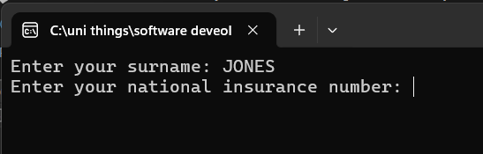
Result: Did the programme behave as expected ie syntactically and logically correct?
YES
The input of JONES worked how I expected in the program with no issue.

Test:
Surname ii Leave blank
Screenshot(s) of output:
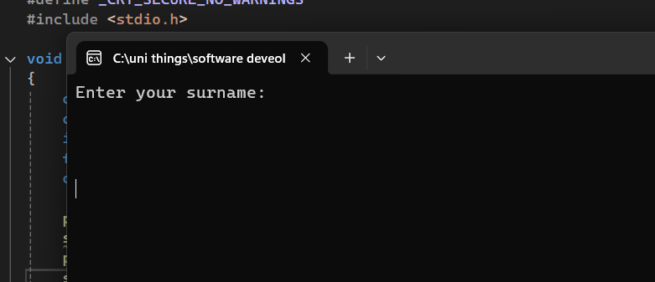
Result: Did the programme behave as expected ie syntactically and logically correct?
NO
what went wrong?
With this test the variable was left blank. However, due to this the program would not continue until it had received an input for the surname variable. fixing this was difficult and the solution that arose was to input validation for the length of the input for a minimum of 2 characters
If YES, comment on what happened

Test:
Surname iii A
Screenshot(s) of output:
Result: Did the programme behave as expected ie syntactically and logically correct?
YES
This test went as expected with having the error and comment to retry the input for the user

Test:
Surname iv 123
Screenshot(s) of output:
Result: Did the programme behave as expected ie syntactically and logically correct?
YES
When putting 123 into the input it came out as expected with an error to retry inputting the data

Test:
National insurance i PE534121B
Screenshot(s) of output:
Result: Did the programme behave as expected ie syntactically and logically correct?
YES
From inputting the test, it behaved exactly as expected with continuing through the rest of the program

Test:
National insurance ii leave blank
Screenshot(s) of output:
Result: Did the programme behave as expected ie syntactically and logically correct?
NO
what went wrong?
This result was not as expected and came out with no result and would not continue through the rest of the program until an input was provided

Test:
National insurance iii AB11223344556677
Screenshot(s) of output:
Result: Did the programme behave as expected ie syntactically and logically correct?
NO
what went wrong?
From entering AB11223344556677 the code continued however the length is to long for an actual national insurance number so to prevent this happening again i will input validation on the length of how long this input can be

Test:
Age i 34
Screenshot(s) of output:
Result: Did the programme behave as expected ie syntactically and logically correct?
YES
This test of 34 went how expected with the result continuing through the program to the next question

Test:
age ii 150
Screenshot(s) of output:
Result: Did the programme behave as expected ie syntactically and logically correct?
YES
Inputting 150 into the age question went how the program should have behaved with producing an error displaying invalid age and prompting to input again

Test:
age iii -4
Screenshot(s) of output:
Result: Did the programme behave as expected ie syntactically and logically correct?
YES
This test result prompts the user to retry the input for a valid age between 0 and 110

Test:
Age iv a letter
Screenshot(s) of output:
Result: Did the programme behave as expected ie syntactically and logically correct?
NO
what went wrong?
Inputting a letter into the age section made the program loop continually

Test:
Working hours i 37.5
Screenshot(s) of output:
Result: Did the programme behave as expected ie syntactically and logically correct?
YES
This input for the first test on the hours worked section worked how it was expected and moving to the completion of the program

Test:
Hours worked ii 105
Screenshot(s) of output:
Result: Did the programme behave as expected ie syntactically and logically correct?
YES
This test behaved as it meant to and continued to complete the program

Test:
Hours worked iii 0
Screenshot(s) of output:
Result: Did the programme behave as expected ie syntactically and logically correct?
YES
From inputting a 0 into this area it completed and progress how it should with no occurring errors

Test:
Hours worked iv -2
Screenshot(s) of output:
Result: Did the programme behave as expected ie syntactically and logically correct?
NO
what went wrong?
This input result was wrong to how it’s expected to progress as it should produce an error and prompt a retry

- Consider the results of the above tests and revisit your code in order to solve the problems. (Note: you may not be able to solve all of them, but solve as many as you can.)

Paste your revised code here:

[Copy and paste your revised code here – note, do not use a screenshot]
#define _CRT_SECURE_NO_WARNINGS #include <stdio.h> #include <string.h>
void main() { char surname[30]; char NINumber[10]; int age = -3; float weeklyHours = -3; char choice;
printf("enter your surname ");
scanf("%s", &surname);
while (strlen(surname) < 4)
{
if (strlen(surname) < 4)
{
printf("please try again and enter your surname\n");
scanf("%s", &surname);
}
else
{
printf("thank you\n");
}
}
printf("Enter your national insurance number: ");
scanf("%s", &NINumber);
while (strlen(NINumber) <= 1 || strlen(NINumber) <= 8 || strlen(NINumber) >9)
{
if (strlen(NINumber) <= 1 || strlen(NINumber) <= 8 || strlen(NINumber) > 9)
{
printf("please try again and enter your national insurance\n");
scanf("%s", &NINumber);
}
else
{
printf("thank you\n");
}
}
while (age < 0 || age > 110)
{
printf("Enter your age: ");
scanf("%d", &age);
if (age < 0 || age > 110)
{
printf("This age is invalid, please try again\n");
scanf("%d", &age);
}
else
{
printf("Thank you\n");
}
}
while (weeklyHours <= 0 || weeklyHours > 168)
{
printf("Enter how many hours you work a week: ");
scanf("%f", &weeklyHours);
if (weeklyHours <= 0 || weeklyHours > 168)
{
printf("This input is invalid, please try again\n");
scanf("%f", &weeklyHours);
}
else
{
printf("Thank you\n");
}
}
printf("Are all these details correct:\n");
printf("Surname: %s\n", surname);
printf("National Insurance Number: %s\n", NINumber);
printf("Age: %d\n", age);
printf("Hours Worked: %f\n", weeklyHours);
}

