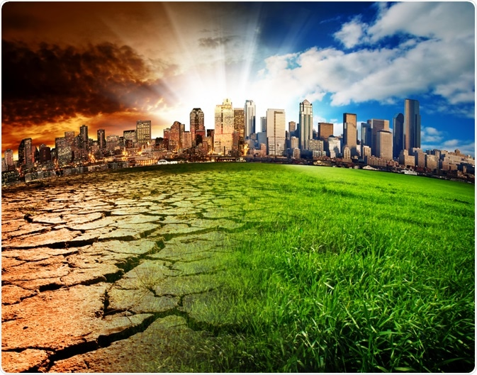  Climate change and its effects on business  Global Business Challenges | Sarah Carr  Student ID - 2107448

We need to act now to stop climate change! It’s a phrase we hear almost every day, but what is climate change? Why do we need to stop it? How can I help? What are you doing to help? Those are some of the questions people are asking.
Every day we are hit with mases of information whether it be from television, newspapers, social media or even our local supermarkets telling us how we can save the planet and become ‘green’. But does buying loose no plastic packaging on our fruit and vegetables or brining your own reusable shopping bags really help the environment or is it something big businesses are telling us just to make a profit?
How does climate change affect business? Does it affect small local businesses the same as global organisations? To find out we need to start at the beginning and ask a simple question, what is climate change?
NASA says, that before you can understand climate change, you need to know the difference between climate and weather. “Weather is the changes we see and feel outside from day to day… Climate is the usual weather of a place” (Green, 2014). For example, a place could be warm and dry in the summer and cold and wet in the winter, this is that areas climate. However, if that same area becomes even warmer and summer months last longer this is climate change.
The United Nations framework convention on climate change (1992), defines climate change as a change of the Earth’s climate which is a result from human activity, whether it be directly or indirectly. They continue to say that climate change is a defining issue of our generation, and we are now at a crucial moment that if we do not act now, we face a very uncertain and costly future. In 2015, a landmark agreement was reached to “Combat climate change and accelerate and intensify the actions and investments needed for sustainable low carbon future” (United Nations, 1992), this is called ‘The Paris Agreement.
Climate change is when the weather we have come to expect in a certain area is changing. In the last twenty years the climate in the United Kingdom has changed. Analysis from the Met office in 2019, says that the ten warmest years on record for the United Kingdom have been since 2002, with 2014 being the warmest year on record dating back to 1884.
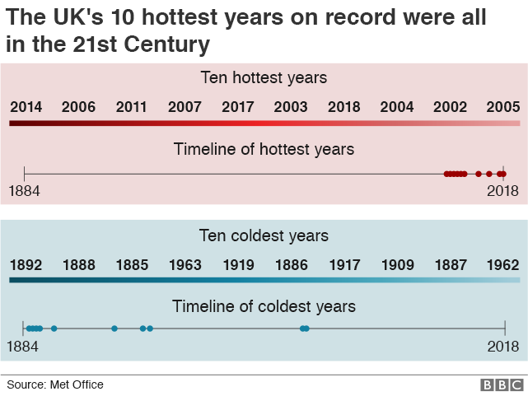
Picture one – Figures from Met Office Ananalys 2019
The Met office continues that the data unmistakably shows that rising temperatures not only in the United Kingdom but globally is driven by the release of harmful gases by human activity.
Our climate has always been changing. A recent study completed by Northern Arizona University’s School of Earth and Sustainability’s Regents’ professor Darrell Kaufman stated that “Before global warming, there was global cooling” (Cockburn, 2020). He goes on to explain that previous studies have shown that our world was naturally cooling for at least one thousand years before the later part of the nineteenth century. We are told that scientist believe that human activity has been influencing the world’s climate since 1830’s, around the time of the beginning of the industrial revolution. During this time the United Kingdom and the rest of the world began burning fossil fuels such as coal, natural gases and oil at a dramatic higher rate which added to the carbon dioxide and other greenhouse gasses in the atmosphere.
There are many studies that attribute the industrial revolution as the ‘start’ of our climate warming. They have proved this by the use of ‘The Greenhouse Theory’. In 1859 Professor John Tyndall, created an experiment to measure how gases in the atmosphere absorb heat and light. From this he discovered that water vapour and carbon dioxide among others, where not only gases that absorbed heat but also radiated it. Put in simple terms when we burn fossil flues such as coal or oil, the harmful gases they release get trapped in our atmosphere. The heat coming from the sun is absorbed by the earth’s atmosphere, due to the increase of greenhouse gases in our atmosphere this heat in unable to pass back through causing our planet to heat up and change our climate.
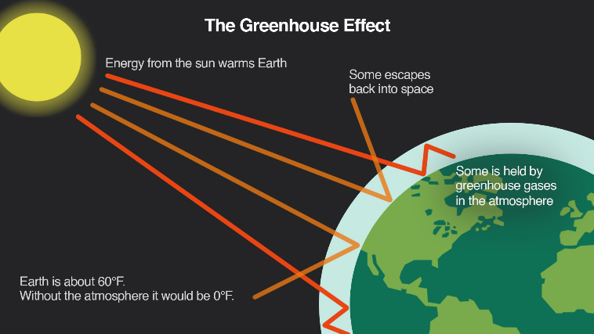
Picture two – diagram of the greenhouse effect
The effects of the greenhouse theory have also been proven by numerous studies showing us that the Earth’s temperature is indeed rising. Data received from the National Centres for Environmental Information shows that since the 1980’s the planets average global surface temperature is rising at a rate of 0.18C per decade.
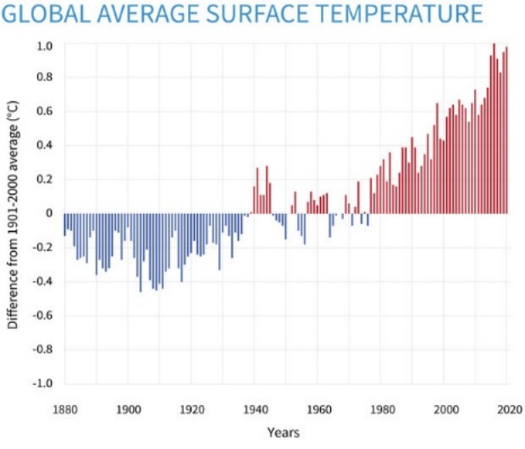
Picture three – Graph showing the surface temperature from 1880-2020 (climate.gov graph, based ondata from the National Centres for Environmental Information).
Who is affected by climate change?
Everyone on this planet is affect by climate change, whether they choose to believe it or not. The most vulnerable people living on our planet arguably those in developing countries feel it the most as they do not have the financial resources in place to cope with the effects. It may be from weather patterns changing causing disastrous storms, water pollution affecting a community’s drinking water or higher temperatures in the North Pole causing glaciers to melt and wildlife to retreat into human populated communities or risk the chance of dying, this is why we are continuously getting told to help save the planet.
How does climate change effect business?
In the same way climate change effects people, business are also affected. Climate change doesn’t discriminate, you can be a global multimillion-dollar company or a small local business it has an effect on how you trade. There are many different effects of climate change, pollution in our water, air or on land, rising sea levels and of course the change of our weather. Each of these effects can have a different effect on how businesses operate and survive.
Many businesses now understand the need to change the way the produce, develop, market, and deliver their products or services. Some may have used business models to help them achieve this such as the PESTLE framework. This framework created by Harvard professor Francis Aguilar in 1967, is a tool used by businesses to assess their political, economic, social, technological, legal, and environmental factors. Using this tool to evaluate the business helps to provide a list of potentially important issues the company could be or could possibly face in the future.
Another way businesses and organisations can help in the fight against climate change is to become more sustainable within their business. The United Nations Brundtland Commission defines sustainability as “development that meets the needs of the present without compromising the ability for future generations to meet their own needs” (Brundtland, 1987)
To help businesses and government become more sustainable in 2015, the United Nations created seventeen sustainable development goals that each can follow. These seventeen goals were adopted by the one hundred and ninety-three member states of the United Nations as part of the fifteen-year plan of the 2030 Agenda for sustainable development. By having these goals in place every business can use them and help meet the target set by the United Nations to help combat the effects of climate change.
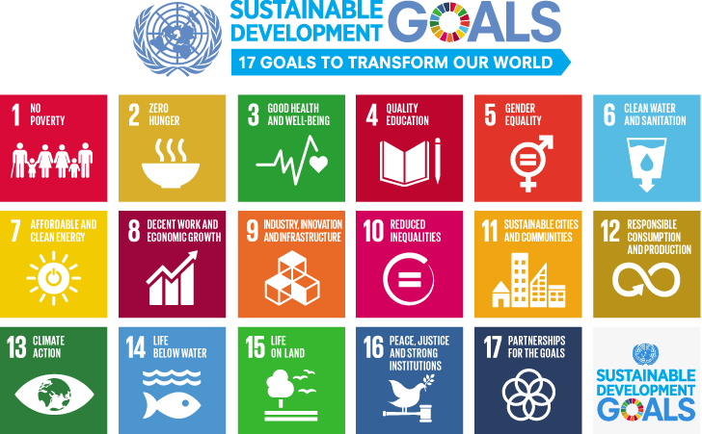
Picture four - The United Nations 17 sustainable development goals
While many businesses are doing everything, they can to be more sustainable and help reduce their carbon footprint in order to help fight climate change there are many challenges that can make this fight difficult for some. The cost of become a sustainable business can be very high especially for businesses that have been trading for years under a business plan that is focussed on a linear economy. A linear economy is a plan that follows the basic steps of take, make, and then waste. Companies are collecting the raw materials needed for their products, making them normally through ways that can cause a high number of carbon emissions before finally discarding them as waste when the no longer become useful. Many businesses use this method as you can create as many products as needed quickly and demand is high.
However, if a company using this method could change to a more sustainable way of producing products the benefits can be felt all round. A way to do this is by using the circular economy concept. This concept unlike the linear economy, is a system of closed loops where raw materials, components and products are reused within the cycle and are made using renewable energy sources. Using this concept in the future offers huge benefits to businesses, by becoming more sustainable they are doing their part to fight the effects of climate change, reducing the need for raw materials, they can appear more attractive to their new and older customers and also boosting their profit in the longer term.
Most companies are starting small by recycling more within their business. This can be done by recycling all plastic, paper and glass or offering a recyclable or refurbishment service for old products. In the United Kingdom, Apple offer a trade in programme to their customers, where you can trade in any old Apple product, no matter the condition. You can take them into their stores or apply online, they asses the condition and either give you money off your next purchase or a gift card to use on apple products. The programme is made easier for customers if they don’t have a store nearby with the online option as they offer a pre-paid trade in kit which is sent to your home for you to return your item. Once they have your device, if it’s in good condition they will refurbish and sell it on to another customer at a reduced rate, and by doing so stopping electronic waste from entering landfills. If it is not in a condition to be refurbished, they work together with a recycling partner to reuse as much of the materials as possible. In the United States and the Netherlands, they have gone one step further and have their own disassembly robots called Daisy and Dave, who ‘take part’ iPhone devices and components “to enable the recovery of materials like rare earth elements, steel and tungsten. These materials make it back to the raw materials marketplace so that we, and others, can use recycled materials for the next generation of products”. (Apple , 2021)
Businesses could also look at their supply chain as a way of cutting their carbon emissions. Many small businesses are looking at using local suppliers and companies to use withing their business. By doing this not only are they helping their local economy to grow and thrive but also significantly reducing the carbon emissions of products they are selling. This to can have a possible negative effect at the beginning for the company as sometimes products that are produced locally can cost more to purchase rather than imported items. But again, with more people becoming aware and acknowledging climate change this can become an important selling point for a business to advertise as locally supplied, grown, or made products. Many local companies use ‘green manufacturing’ as their unique selling point, by introducing these kinds of initiatives in the long term it could boost trade.
A good example of a new sustainable business are zero waste shops. These stores are opening all over the world and are become a huge hit with their customers. Their purpose in providing as many products as possible from local suppliers with many taking into account seasonal produce, organic, and cruelty free products has seen many big chain supermarkets try to follow suit. In October 2021 ASDA became one of the first big supermarkets to open a ‘sustainability’ store in Middleton, Leeds. Taking the basic idea from zero waste shops, they have worked together with some of the UK’s biggest brands to offer refilling stations within their store on products that their customers love. By using this store as a trial, they have already seen great responses from their customers and hope to roll out more stores or possibly introduce the refill stations into their already stablished stores.
One major difference we can see in the UK with regards to climate change is the weather. Over the past five years we have experienced colder winters, hotter summers and intense periods of rain causing serious flooding. This has a massive effect on business. Not only does flood damage cost a great deal to repair in the long run it can cause insurance premium to rise, damage to business premises, loss of saleable stock some of which can be damaged beyond repair. Small change we business can make to their carbon emissions could play a big part in hopefully stopping these types of events, however it is predicted that things may possibly get worse before we see a improvement.
There are many reasons why we all should be doing what we can to help reduce the impacts of climate change. Former UN Secretary- General Ban Ki-moon once said “Climate change does not respect border; it does not respect who you are – rich and poor, small and big. Therefore, this is what we call ‘global challenges’ which requires global solidarity” (Ki-moon, 2011) Climate change is a global challenge, we all need to work together as a giant global team in order to reduce the effects of climate change. Where some may argue that it doesn’t affect them, ‘this isn’t my problem I’ve not got long left’, this is a selfish way of looking at it. We all want our children and our children’s children to be able to life a long and full life, and one way to make sure that is possible is help reduce our carbon footprint. The charity world wildlife foundation offers people the change to see their carbon footprint by answering a questionnaire and then giving suggestions on how they an reduce it.
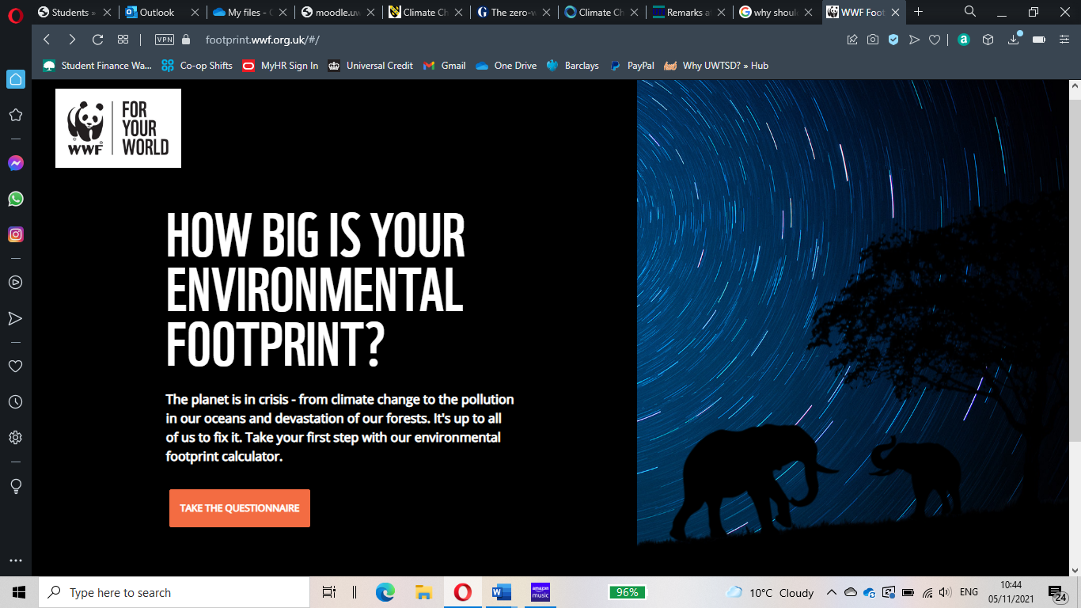
Picture five – Screen shot of WWF carbon footprint calculator
There are so many benefits by taking action against climate change, not only does it provide a better world for future generations, it also can improve our health, growth in new ecologically friendly job market and reduced inequality between countries across the world.

Word Count - 2371 words

References
Apple . (2021). Environment. Retrieved from Apple: https://www.apple.com/uk/environment/
ASDA. (2021, October). Asda Opens New Sustainability Store. Retrieved November 1, 2021, from ASDA: https://corporate.asda.com/newsroom/2020/10/20/asda-opens-new-sustainability-store
Brundtland. (1987). Our Common Future. Oxford: Oxford University Press. Retrieved October 20, 2021, from United Nations: https://www.un.org/en/academic-impact/sustainability
Cockburn, H. (2020, June 30). Climate crisis: 150 years of industrialisation has undone 6,000 years of global cooling. Retrieved October 20, 2021, from The Independent: https://www.independent.co.uk/climate-change/news/climate-change-global-warming-cooling-ice-age-industrialisation-emissions-a9594301.html
Dahlman, R. L. (2021, March 15). Climate change : Global temperature. Retrieved October 22, 2021, from Climate.gov: https://www.climate.gov/news-features/understanding-climate/climate-change-global-temperature
Ellen Macarthur Foundation. (n.d.). What is circular economy? Retrieved from Ellen Macarthur Foundation : https://ellenmacarthurfoundation.org/topics/circular-economy-introduction/overview
Green, D. S. (2014, May 14). What is climate change? Retrieved October 22, 2021 , from NASA: https://www.nasa.gov/audience/forstudents/k-4/stories/nasa-knows/what-is-climate-change-k4.html
Jackson, S. R. (2019, May 17). Who discoverd the Greenhouse effect. Retrieved October 27, 2021, from The Royal Institution: https://www.rigb.org/blog/2019/may/who-discovered-the-greenhouse-effect
Ki-moon, B. (2011, December 6). Remarks at 'Momentum for change'intiative. Retrieved November 3, 2021, from United Nations - Secretary General: https://www.un.org/sg/en/content/sg/speeches/2011-12-06/remarks-momentum-change-initiative
McGrath, M. (2019, July 31). Climate change: UK's 10 warmest years all occurred since 2002. Retrieved October 20, 2021, from BBC News - Science and Environment: https://www.bbc.co.uk/news/science-environment-49167797
Moss, S. (2019, April 21). The zero-waste revolution: how a new wave of shops could end excess packaging. Retrieved November 1, 2021, from The Guardian: https://www.theguardian.com/environment/2019/apr/21/the-zero-waste-revolution-how-a-new-wave-of-shops-could-end-excess-packaging
Post, J. (2018, September 21). What Is a PEST Analysis? Retrieved October 27, 2021, from Business News Daily: https://www.businessnewsdaily.com/5512-pest-analysis-definition-examples-templates.html
United Nations. (1992). United Nations framework convention on climate change.
United Nations. (n.d.). Climate Change. Retrieved October 20, 2021, from United Nations: https://www.un.org/en/global-issues/climate-change

Image References.
Cover Picture
News medical life sciences – The impact of climate change on brain health
https://www.news-medical.net/health/The-Impact-of-Climate-Change-on-Brain-Health.aspx
accessed 5th November 2021

Picture one
BBC News Science and Environment - Climate change: UK's 10 warmest years all occurred since 2002
https://www.bbc.co.uk/news/science-environment-49167797
accessed 20th October 2021

Picture two
Climate Central – The Greenhouse Effect
https://medialibrary.climatecentral.org/resources/the-greenhouse-effect
accessed 3rd November 2021

Picture three
Climate Change: Global Temperature
https://www.climate.gov/news-features/understanding-climate/climate-change-global-temperature
accessed 22nd October 2021

Picture four
United Nations – Sustainable Development Goals
https://www.un.org/sustainabledevelopment/blog/2015/12/sustainable-development-goals-kick-off-with-start-of-new-year/
Accessed 22nd October 2021

Picture five
WWF – How big is your environmental footprint
https://footprint.wwf.org.uk/#/
accessed 3rd November 2021

