Richard Jones 1809132
rojones@gmail.com
Hyper-Fort BYOD Solution
ACCA4018 & Simon Downes

Abstract
The introduction of mobile devices in the work place such as Laptops, Tablets, Smartphones and mobile phones is being driven by the technology consumerism of the public in general. It has poured over in to the work place, and many businesses are now trying to provide staff & clients access to the business IT infrastructure to meet the demands for a mobile workforce using the devices they feel comfortable using to maximise productivity and mobility. There are many challenges with providing a BYOD (Bring your own device) environment in the workplace, these include providing restricted access to data and security of the business networks along with security needs of the BYOD users.

Table of Contents
Abstract 1
Table of Contents 2
Introduction 3
1. Related Work 1
1.1. Overview of the three-tier network design 1
1.2 Brief explanation of VLANS 2
1.3 Network device types and their functions 2
1.4 Server Roles and their uses explained 3
1.5 BYOD Advantages and Disadvantages 4
2. Implementation Overview Network and Office Design 5
2.1 Core Infrastructure (Server Room) 5
2.2 Staff Office 6
2.3 Client Office 6
2.4 Remote Access (Home Users) 6
3. Implementation of BYOD Software 6
3.1 BYOD Solutions Comparison 7
3.1.1 Cisco Meraki 7
3.1.2 Hexnode MDM 7
3.1.3 Soti MobiControl 7
3.1.4 Mobile Iron EMM 7
3.1.5 Citrix XenMobile 7
3.1.6 VMware AirWatch 8
3.2 BYOD Chosen Software Solution 8
3.2.1 Administration 8
3.2.2 Security 8
3.2.3 Applications 9
3.3 BYOD Access/Login Flow Diagram 9
4. Conclusion Hyper-Fort Network & BYOD Design. 10
4.1 Future Recommendations 10
References 11

Introduction
The author of this document will look to meet the needs of a consultancy company “Hyper-fort” in modernizing its I.T. access to staff and clients alike. By detailing a suggested network setup to meet the wireless / mobile nature of its staff and clients, while making sure that business is able to clearly manage and secure the various aspects of its business information while also making sure the staff/client's data is also kept secure but separate. Details on providing access to a BYOD setup for both user bases will also be investigated. Various areas will be addressed in this document, varying from security policy, user access policies, data policies & device management policies. As part of the document various BYOD or MDM (Mobile Device Management) software will be investigated, detailing the pros and cons of industry leading platforms, and suggesting a suitable candidate for use in the “Hyper-fort” I.T. deployment.

Related Work

Overview of the three-tier network design
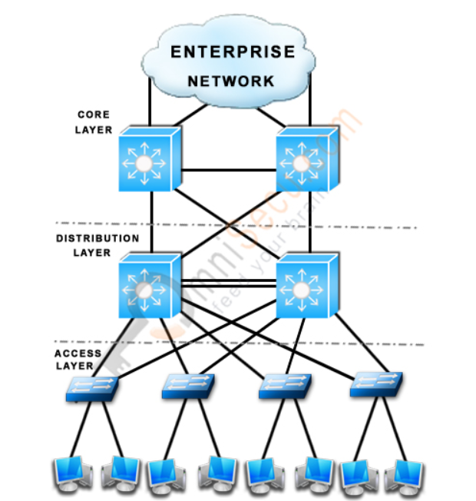
Figure 1. relevant research information[1].

Core Layer
Usually contains the most expensive network equipment. Used to merge internal networks to external networks (I.E Cloud) over separated geographical location. Information at this layer is routed as fast an efficiently as possible.

Distribution Layer
Located between the access and distribution layer. Defines policy attributes for the network layout and access. Its purpose is to provide access & filtering between various subnets & VLANS for connected devices

Access Layer
The access layer can contain numerous device types network & end user. Access layer switches & wireless access points are an example or network types. End user devices such as Desktops, Laptops, Tablets as well as Phones, Printers, Servers etc. are examples of end user devices.

The benefits of a three-layer hierarchical model
Performance – Allows for a tiering of network equipment to provide required performance traits at each level of the network
Management and Performance – Due to the defined areas and roles defined within the tiers, it is easier to identify and troubleshoot where errors may occur
Filtering and policy management – At the relevant layers the filtering and policy of the network can be managed and fine-tuned.
Saleability – Due to its break down in to defined areas, it allows for an easily managed upscale when needed.
Redundancy – in the hierarchical setup it takes in to account for redundancy at each layer. So, in the event of a device failure, other routes are available to continue uptime

1.2 Brief explanation of VLANS
VLAN stands for “virtual LAN” and in its most basic form is a software driven method of segregating ports on a physic switch in to a virtual switch. As referenced[2][3] the benefits of such configuration are as follows:

- Cost effective use of hardware (switches + routers)
- Logical grouping of end-user devices to that may be dispersed across multiple physical locations
- Segregation of traffic across a single network device to improve traffic load/flow.
- Segregation of traffic to provide secured access to specific sections of the network, whilst reducing broadcast of such sensitive information across the entire network.

1.3 Network device types and their functions
There are multiple network device types that would be needed in a possible implementation. Routers and Switches would be the main backbone of any network design. Routers are used to connect two or more networks i.e. an internal network within a business to its external cloud connection[4]. Switches primary use are to connect multiple devices to a single network to allow communication between them[5], both Routers and Switches also utilise VLAN technology as discussed earlier, this allows for more efficient traffic management and security features[2]
Wireless Network devices required in this instance would be in the form of Wireless Access points primarily. Wireless Access points can come in many forms, from basic dumb terminal style wireless access points that simply gain their configuration from a central wireless management console, to wireless access points that are able to hold their own configuration and in some instances act as a router also[6]
To secure the above-mentioned network devices, we would need to have a number of firewalls. Again, depending on the setup as to where they would be located within your network and how many would be needed. But their primary function is to act as a border between networks and/or network devices. They are configured to prevent and allow communication from entering and exiting networks depending on their setup, which helps reduce the traffic load and also provides a security element to unwanted communication whilst also keeping sensitive information from being leaked from a corporate environment[7]

1.4 Server Roles and their uses explained
It is assumed that an active directory is either in place already or will be implemented to reflect the required access and security platform for the forthcoming BYOD deployment.
A brief statement on the basic function of Active Directory.
Active directory (AD) is an installable feature provided by Microsoft for deployment in their network domain environments. The core functions of AD are to gather and store retrievable data on objects that are attached to the domain and setup on the domain. For example user accounts, device objects and security policies[8]. The security policies are primarily dealt with by something called Group Policy Objects (GPO)[9]. These GPO’s are essential a list of set policies that are set and assigned against a group of AD containers (user or devices). These GPO’s usually contain information such as customising the appearance or behaviour of the operating system, and restricting user access and control over aspects of the operating system.

AAA radius server: As referenced[10] the purpose of the radius server is to provide Authentication, Authorization and Accounting for the end user login/access to the corporate network.

Web hosting services server: A web hosting services server[11] in this instance would be used to host the local intranet[12] of the hyper-fort company, as well as being utilized for a providing a Web front end for the external internet site for public consumption and business interaction (Client orders etc.). Also, to promote and publicise the businesses social media presence.

Email server: This will provide an email service within the hyper-fort network for its staff[13]. It will also be able to provide access to corporate email with the interaction with the chosen BYOD product.

DHCP&DNS server: The DHCP & DNS server will provide access for clients within the corporate environment to connect to the network by providing a leased ip address for the end user devices. DHCP essentially manages the leasing of IP addresses across the network[14]. The DNS aspect of the server will allow devices to resolve their device names to their underlying address to allow for communication between devices[15]

File Server: The File server will provide a shared network connected area for user and department files. Utilising active directory[16] to secure user shared areas to their specific accounts and also utilise active directory groups for shared drive access.

1.5 BYOD Advantages and Disadvantages
Introduction to BYOD

BYOD (Bring Your Own Device) has been growing in workplaces. It essentially allows employees, clients, guests to bring their own devices ranging from laptops to smartphones and more and connect to the corporate network to carry out their work. From being able to simply access corporate intranets, accessing corporate documents to fully utilising corporate systems and applications[17].

Advantages
Reduce costs to the business by not having to purchase devices for staff and guests alike. Improve employee satisfaction and productivity by allowing employees to use their own devices to which they are familiar and more comfortable with[18]. Flexible and mobile workforce as ow employees can work from any location within the business and depending on the BYOD implementation can work remotely also.

Disadvantages
Scalability issues can arise as employees potentially having multiple devices, they can now utilise at any given time which can put increased pressure on corporate networks. Security issues as noted[18] are also now more prevalent as devices are not owned by the business therefore harder to maintain control and security over devices that potentially now have sensitive corporate data on them. Supporting the numerous types of devices can also be an issue, when the business purchased devices, they would often be able to standardise on a specific model etc. But with depending on your BYOD policy you now may have numerous models and software OS types to support.

Deploying a Successful BYOD

As already discussed, BYOD brings as many new challenges to the corporate workplace as it does advantages. To implement a successful BYOD strategy some of the basic practises need to be thought through. A clear BYOD policy needs to be put in to place to define the supported device types and access methods, along with having a clear security policy in place. In some instances, again depending on the deployment type the security aspect can either be a shared responsibility between the business and the employee, or it can be a more forced policy approach within a BYOD software implementation.

IT Resources and the underlying infrastructure need to be addresses before implementing a BYOD deployment. As support staff will need to be able to support employee device to a set level, and the infrastructure that will now handle the connectivity and security of these devices will need to be planned ahead of time to be able to cope with a possibly increased demand in network resources as well as device types.

Implementation Overview Network and Office Design
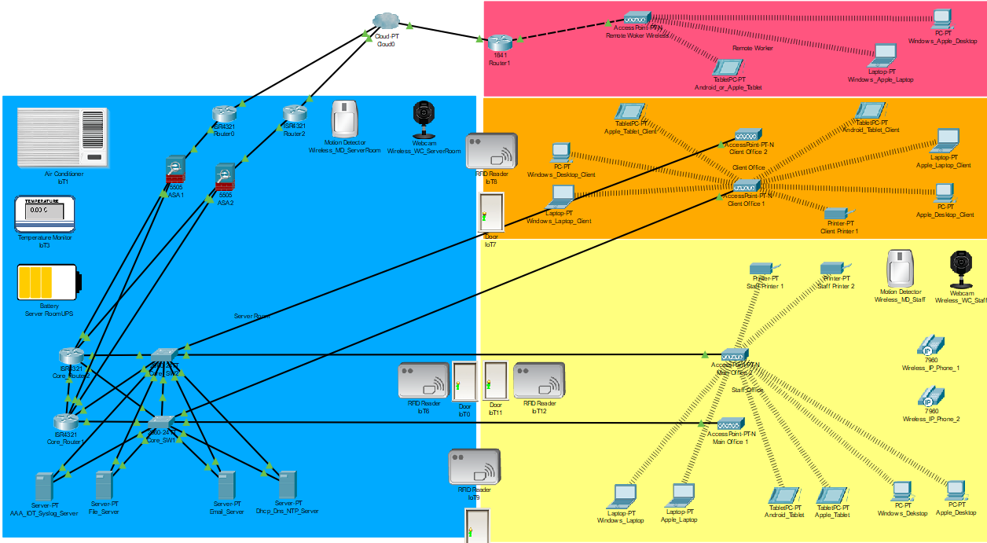
Figure 2. a network/device overview from the Cisco Packet Tracer suggested Hyper-Fort deployment. (Using Cisco Packet Tracer 7.2.0.0225)

2.1 Core Infrastructure (Server Room)
All network routers and switches will be locked down on all interfaces with login passwords and enable passwords (login password: cisco123 and enable password: cisco098), passwords are set to simple phrases for demonstration purposes only and would need to be more complex in real world deployment. Along with a policy for regular password changes, the same login procedure would also be set on the firewalls, but due to the limitations of packet tracer we are unable to demonstrate this.
In a secure access room (controlled by PIN access & RFID readers), this is where the core infrastructure for the “hyper-fort” network will reside. There will be a redundant core 2 x router configuration, which will be the link between the internal network infrastructure and the external cloud access (via firewalls). VLANS will be setup to segregate internal & external traffic.
Connecting to the core routers heading out to the cloud will be redundant network links to 2 x firewalls (for security/policy), followed by 2 x routers to provide routed access out to the cloud. The specific VLANS required at this level will be set for the external cloud access.
Connecting to the core routers for internal network access whilst also providing a link to external cloud access to the required servers internally, will be 2 x switches in a redundant setup. These two switches will provide internal connection to the servers (in a dual honed teaming NIC setup on each server for redundancy)[19], also network connectivity to the on-site offices (both staff and client). The VLAN configuration at this level will reflect what was setup in the core routers. There will be specific VLANS for server infrastructure, staff office infrastructure and client office infrastructure.
As detailed in section 1.4 there are also the required servers in the server room, further information on the requirement reason and users are detailed in section 1.4. But to confirm there will be the following services provided on the servers. AAA Server, File Server, Email Server, Web Hosting Services Server, DHCP & DNS Servers (Active Directory services also)

2.2 Staff Office
The staff office will also be secured in a similar manor to the server room. There will be PIN & RFID reader access to allow the relevant authorised staff to gain access to the office. Again, Motion detector alarms and security cameras will also be in place. In this room there will be multiple wireless access points (however many are required to provide a suitable coverage along with backup capacity). These wireless access points will be cabled back to the core switches for connectivity. In the staff office they will be configure for a specific SSID to be broadcast and locked down for staff access only, utilising WPA-PSK. All devices used in the staff office including end user devices, IP Phones and printers will be configured for wireless access.

2.3 Client Office
The client office will again be secured in the same fashion as the staff office, by utilising a PIN & RFID reader. Access to this office will be administered by hyper-forts admin staff to allow all clients accessibility to this area. As setup in the staff office, the client office will have multiple wireless access points (however many are required to provide a suitable coverage along with backup capacity). These wireless access points will be cabled back to the core switches for connectivity. In the client office a separate SSID will be broadcast to allow access to clients. This network will also be locked down utilising WPA-PSK. There will also be a shared access printer for client staff utilisation.

2.4 Remote Access (Home Users)
There will be provision for remote access via the user’s cloud / internet access, which will link in to the BYOD/MDM software utilised by “hyper-fort”. Staff and Clients alike will be able to access their specific secured area’s (documents etc.) from the BYOD product in the same fashion they would be able as if they were on site.

Implementation of BYOD Software
As discussed in section 1.5 an outline of what BYOD refers to and some advantages and disadvantages associated with BYOD. Taking this information in to account we now look to discuss the BYOD software packages/solutions that are available in the market place.

3.1 BYOD Solutions Comparison
There are a vast array of BYOD software solutions available, as with any other type of product there are more well-known market leaders which hold a larger share of the market place. Some examples or such software and their pros and cons are detailed[20]. Looking in to these industry leaders we can see that they all have their advantages and disadvantages and to detail those we can discuss here in relation to what would be needed for our Hyper-Fort deployment.

3.1.1 Cisco Meraki
- Able to manage multiple Operating Systems (Windows, IOS, Linux, ChromeOS and Android).
- Management consoles also have remote apps to manage devices remotely.
- Device Security policy enforcement.
- Application and software deployment management (including device specific management over user specific).
- Remote management & troubleshooting.

3.1.2 Hexnode MDM
- User accessible portal for device management with integrated Active directory support.
- Remote management & troubleshooting.
- Manage mobile applications (including App Store Whitelist/Blacklist functionality).
- Enforce and manage security compliance and Remote lock/wipe function.

3.1.3 Soti MobiControl
- Able to manage multiple Operating Systems (Windows, IOS and Android).
- Provides a device lifecycle feature, managing devices from initial deployment to retirement.
- Can be installed on premise or deployed via the cloud.
- Allows for over the air deployment of policies for pre-provisioned devices.

3.1.4 Mobile Iron EMM
- Devices can be managed from a single console.
- Allows for Data and Security policies to be implemented.
- Install or Manage applications and services on a per device basis.
- Remote wipe/restore function available on demand.
- Mobile Iron client comes with its on Mobile@Work app, which allows for enforced corporate email, Wi-Fi, VPN and Security policies.
- Features a mobile application management tool which allows for a corporate app/software storefront for employees.

3.1.5 Citrix XenMobile
- Provides containerisation of applications and personal application on devices.
- Centralised console for management of devices.
- Specifically adds support for a multi-user single device environment.
- Devices can also be secured and even prevented from working depending on location.

3.1.6 VMware AirWatch
- Airwatch MDM caters for all end user device Operation System types.
- Utilises an App Catalogue to provide end users with their applications.
- Security can be tailored to a granular level based on user, endpoint device, data type and network.
- Airwatch offers a streamlined device provisioning process which can reduce the work load on the IT staff administering the system.

3.2 BYOD Chosen Software Solution
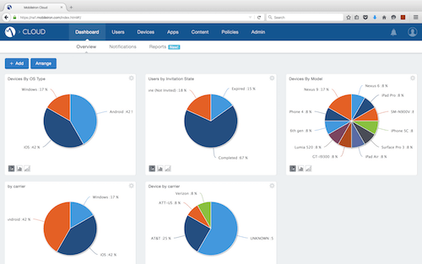
Figure 3. An example or Mobile Iron EMM management console[20].

After researching the BYOD software implementations available and matching that up with the needs for the hyper-fort deployment, it is suggested that the Mobile Iron EMM software be utilised for this environment. The reasons that Mobile Iron EMM would be best suited for the hyper-fort deployment can be broken down in to the following key areas.

3.2.1 Administration
Mobile Iron allows for a single pain of glass approach to the managing of the end user devices and all its associated functions. This would allow for the IT staff to have less of an overhead in managing the deployment of device management, security policies, software/application deployment etc. It also supports a multitude of operating system types. So in the case of Hyper-fort all of the consumer based operating systems can be managed, whether it be Windows, IOS, Android or macOS[21]

3.2.2 Security
Hyper-Fort would require specific security assurances for its documents and devices access whilst users are accessing corporate sensitive information remotely. Mobile Iron EMM provides assurances in its ability to set and deploy specific security policies tailored to what the end user requires. So for example utilising its Mobile@Work client, corporate email and documents etc. are encrypted to prevent malicious access and use of the information while out of the corporate environment, also Specific policy templates can be set to dictate Wi-Fi Access for example, meaning pre-determined SSID and related Security keys can be profiled down to the end device depending on what access it requires. Another added security function is the ability to remote wipe/restore devices if the need occurs. So for example if a staff member has a device stolen, IT Staff would be able to put a remote wipe set for the device which will clear the device or all information

3.2.3 Applications
As mentioned in 3.2.2 the Mobile@Work client can provide governed access to documents emails etc. from behind firewall accessed resources. This means Staff and Clients are able to access any required web resources or documents they are deemed to have access to (utilising active directory) remotely while not being on site. Mobile Iron EMM also allows for Whitelisting/Black listing of applications on various OS platform app stores whilst also being able to create its own corporate storefront interface for those applications. This means specific policies can be tailored to individual or groups of users to only be allowed access to specific required applications.

3.3 BYOD Access/Login Flow Diagram
Below is an example of the process flow associated with a Staff/Client member bringing in a device for the first time in to the enrolment/access process for Hyper-Fort BYOD.

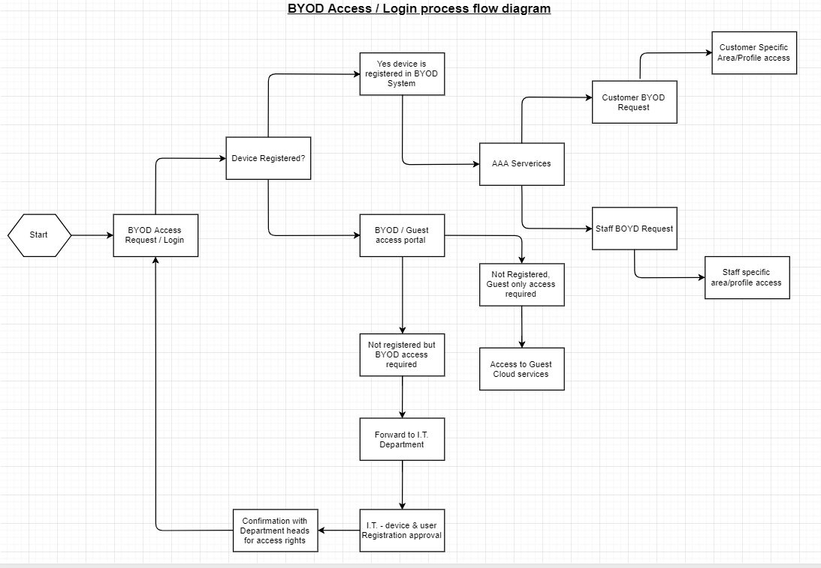
Figure 4. BYOD Access/Login Flow diagram.

Conclusion Hyper-Fort Network & BYOD Design.
To conclude the suggestions of the previous chapters, it was clear in the outline that Hyper-Fort would be looking for a network design that would accommodate a mobile work force that would still require all the access to resources that would be needed in a traditional corporate office environment. To achieve this we looked to provide a “wireless” only network within all of the staff / client areas. It was key to make sure that in such an environment security was taken as a high priority, this is why the highest level of Wireless security was utilised (WPA2-PSK). To tie in with the Security elements it was also suggested that all areas within the corporate estate be locked down with RFID and PIN code locks, this would add an extra layer of security to the physical access of the estate. The other on-site security measures where addressed with making sure a security policy is formalised and adhered to, not only by the staff and clients (via the BYOD, Active Directory and Access to premise) but by IT admin staff in relation to password policies for the Networking and Server infrastructure, by this we mean a good rolling password change policy across the estate.
In relation to the BYOD Software itself, it was also clear from the outset of the needs of hyper-fort in relation to its staff and clients. The business required a BYOD product that would be able to deal with an array of personal and corporate owned devices along with the differing types of Operating systems & Manufacturer brands that would come along with this. As well as being able to provide staff with access to the required applications for their work and personal needs on these devices. This is why Mobile Iron EMM[20] was a good product for their needs, it had the ability to be deployed and managed across the various operating systems and not only secure and managed the device, but managed the applications and their stores (including the ability to provide a customised corporate store) while also providing access to their corporate email and document needs in an encrypted environment.
That last need tied in to the BYOD security aspect. Devices needed to be secure whilst off-site. Mobile Iron EMM was one of the clear industry leaders in this area. By providing access to the previously mentioned Mobile@Work client which encrypted email and document access on a per user basis (tied in to Active Directory user permissions). Also the Mobile@Work client allowed for a remote wipe/restore function for lost or stolen device out in the field. This is a key security function that should be a must have in any BYOD deployment.

4.1 Future Recommendations
The author would also recommend some future recommendations for the improvement of security in the deployment of the network design and BYOD deployment at hyper-fort. This would include investigating the deployment of the WPA3 wireless security standard once the hardware and software was available to support it. This should be a major consideration for Hyper-Fort IT staff, as the majority of their network is wireless based to accommodate the roaming BYOD approach. WPA3 is set to improve upon WPA2 in key areas such as further advanced encryption, and reducing the success of potential attacks by implementing security polices around the previously widely adopted WPA2 model[22]

References

[1] Thomas Jajish, “Cisco Three Layer / Three-tier Hierarchical Network Model,” Omnisecu.com. [Online]. Available: http://www.omnisecu.com/cisco-certified-network-associate-ccna/three-tier-hierarchical-network-model.php. [Accessed: 17-Dec-2018].
[2] J. Langemak, “Introduction to Cisco VLANs.” [Online]. Available: http://techhead.co/introduction-to-cisco-vlans/. [Accessed: 19-Dec-2018].
[3] I. NetApp, “Advantages of VLANs.” [Online]. Available: https://library.netapp.com/ecmdocs/ECMP1401193/html/GUID-C9DA920B-F414-4017-8DD1-D77D7FD3CC8C.html. [Accessed: 19-Dec-2018].
[4] B. Mitchell, “What Is a Router for Computer Networks?,” 2018. [Online]. Available: https://www.lifewire.com/how-routers-work-816456. [Accessed: 19-Dec-2018].
[5] B. Mitchell, “What Is a Computer Network Switch?,” 2018. [Online]. Available: https://www.lifewire.com/definition-of-network-switch-817588. [Accessed: 19-Dec-2018].
[6] K. Rajesh, “Types and features of wireless Access Points – excITingIP.com,” 2009. [Online]. Available: http://www.excitingip.com/53/types-and-features-of-wireless-access-points/. [Accessed: 19-Dec-2018].
[7] M. Anicas, “What is a Firewall and How Does It Work? | DigitalOcean,” 2015. [Online]. Available: https://www.digitalocean.com/community/tutorials/what-is-a-firewall-and-how-does-it-work. [Accessed: 19-Dec-2018].
[8] M. Tanvit, “Microsoft Active Directory Explained - Simple and Easy,” 2017. [Online]. Available: https://www.logitrain.com.au/blog/microsoft-active-directory-explained.html. [Accessed: 28-Dec-2018].
[9] Dummies.com, “Network Administration: Windows Group Policy Basics.” [Online]. Available: https://www.dummies.com/programming/networking/network-administration-windows-group-policy-basics/. [Accessed: 28-Dec-2018].
[10] C. Systems, “How Does RADIUS Work? - Cisco,” 2006. [Online]. Available: https://www.cisco.com/c/en/us/support/docs/security-vpn/remote-authentication-dial-user-service-radius/12433-32.html. [Accessed: 19-Dec-2018].
[11] T. Terms, “Web Server Definition,” 2011. [Online]. Available: https://techterms.com/definition/web_server. [Accessed: 19-Dec-2018].
[12] B. Hall, “What is an Intranet? | Interact software,” Interact-Intranet, 2017. [Online]. Available: https://www.interact-intranet.com/blog/what-is-an-intranet/. [Accessed: 19-Dec-2018].
[13] T. Terms, “Mail Server Definition,” 2015. [Online]. Available: https://techterms.com/definition/mail_server. [Accessed: 19-Dec-2018].
[14] T. Terms, “DHCP (Dynamic Host Configuration Protocol) Definition,” 2014. [Online]. Available: https://techterms.com/definition/dhcp. [Accessed: 19-Dec-2018].
[15] T. Terms, “DNS (Domain Name System) Definition,” 2014. [Online]. Available: https://techterms.com/definition/dns. [Accessed: 19-Dec-2018].
[16] Microsoft.com, “Understanding Active Directory for Beginners – Part 1 – Ashwin’s Blog,” 2012. [Online]. Available: https://blogs.technet.microsoft.com/ashwinexchange/2012/12/18/understanding-active-directory-for-beginners-part-1/. [Accessed: 28-Dec-2018].
[17] R. Team, “The Advantages &amp; Disadvantages of BYOD | Riverside Technologies, Inc. (RTI),” 2018. [Online]. Available: https://www.1rti.com/the-advantages-disadvantages-of-byod/. [Accessed: 19-Dec-2018].
[18] M. Olalere, M. T. Abdullah, R. Mahmod, and A. Abdullah, “A Review of Bring Your Own Device on Security Issues,” SAGE Open, vol. 5, no. 2, p. 215824401558037, Jun. 2015.
[19] Dell.com, “What is network teaming? | Dell UK,” 2014. [Online]. Available: https://www.dell.com/support/article/uk/en/ukbsdt1/sln289328/what-is-network-teaming-?lang=en. [Accessed: 28-Dec-2018].
[20] C. Hopping and B. Hellard, “Best MDM solutions 2018: Take the hassle out of BYOD | IT PRO,” 2018. [Online]. Available: https://www.itpro.co.uk/mobile/29775/best-mdm-solutions. [Accessed: 28-Dec-2018].
[21] MobileIron.com, “Operating Systems | MobileIron.com.” [Online]. Available: https://www.mobileiron.com/en/unified-endpoint-management/operating-systems. [Accessed: 28-Dec-2018].
[22] eWeek Staff, “WPA3 Launches, Providing Next-Gen WiFi Security Capabilities: EBSCOhost,” 2018.

marking criteria and Student FEEDBACK

This section details the assessment criteria. The extent to which these are demonstrated by you determines your mark. The marks available for each criterion are shown. Lecturers will use the space provided to comment on the achievement of the task(s), including those areas in which you have performed well and areas that would benefit from development/improvement.

Common Assessment Criteria Applied (Assignment 1) | Marks available | Marks  awarded
1. Research-informed Literature
Extent of research and/or own reading, selection of credible sources, application of appropriate referencing conventions.
The research utilised within the report come from mainly online sources, try to utilise conference, white papers and journal articles. The correct IEEE referencing throughout for images and text based sources. To demonstrate good practice the amount of references you have should contain articles, the use of some sites is acceptable but try to avoid. (Grade mark: 80.00%) | 15 | 12
2. Knowledge and Understanding of Subject
Extent of knowledge and understanding of concepts and underlying principles associated with the discipline.
The report has been structured to identify the concerns around the BYOD. The depth of research is okay and is demonstrated throughout the report. The layout is complemented by logical titles for each section. (Grade mark: 93.33%) | 15 | 14
3. Analysis
Analysis, evaluation and synthesis; logic, argument and judgement; analytical reflection; organisation of ideas and evidence
The extent of report demonstrates good knowledge of the subject this mark would have been greater had the sources have been from IEEE sources. The breakdown of the contents guides the reader around the document. (Grade mark: 80.00%) | 40 | 32
4. Practical Application and Deployment
Deployment of methods, materials, tools and techniques; application of concepts; formulation of innovative and creative solutions to solve problems.
The simulation is well thought out, however the basic security measures of banner, encryption and SSH are not deployed. (Grade mark: 80.00%) | 20 | 16
5. Skills for Professional Practice
Attributes in professional practice: individual and collaborative working; deployment of appropriate media; presentation and organisation.
The report looks very professional and well presented, this allows the reader to follow the document. Very minor corrections would have given full marks for this section see comments within document for advice. (Grade mark: 90.00%) | 10 | 9

Assignment Mark (Assessment marks are subject to ratification at the Exam Board. These comments and marks are to give feedback on module work and are for guidance only until they are confirmed. ) | Late Submission Penalties (tick if appropriate) |  | 83%
 | Up to four weeks late |  | 83%
 | First Attempt? |  | 83%

