Research Proposal
Ryan Durston, Cieran Griffiths, Nathan Edwards, Taylor Morgan, Ben Cheley
Title (Ryan)
To evaluate the proposal to abolish contact rugby for ages 6-16.
Aim; (Cieran)
A critical evaluation of the proposal to abolish contact rugby from ages to 6-16.
Objectives; (Ryan)
To examine the proposal to abolish contact rugby.
To undertake secondary research into advantages and disadvantages.
Using a local school or team under taking primary research to collect.
Views on proposal conclude and more recommendations on visibility of the proposal
Rationale (Taylor)
The implications for young players not having the required skill levels when they progress to senior teams, the research team is interested in this area as they are future rugby coaches.
Background (Cieran)

The sport of rugby originated in 1823 by a man named William Web Ellis who took a football in his arms and started running with it. Rugby’s rules were created that same year and since the game started it has always been predominantly a contact sport these rules have been around since the game’s creation alongside the offside rule. Currently there are many different formats of rugby such as seven-a-side rugby and rugby league, although the majority of these types of rugby include contact. Contact in rugby has been a tradition since the beginning of rugby and can be safe if the players know how to tackle and fall correctly.
[Information found online at Centurion Rugby]

Literature review (Ben)

The Rugby Football Union made a report on injury risk in the English youth rugby union. The report found that the incidence of match injuries was lower in schools than in academy rugby. It was found that there were 35 injuries within 1000 hours of play time within school rugby matches whilst, academy rugby had 44 injuries within 1000 hours. These results are interestingly half that of the incidence of injuries within premiership level rugby as shown in the table below.
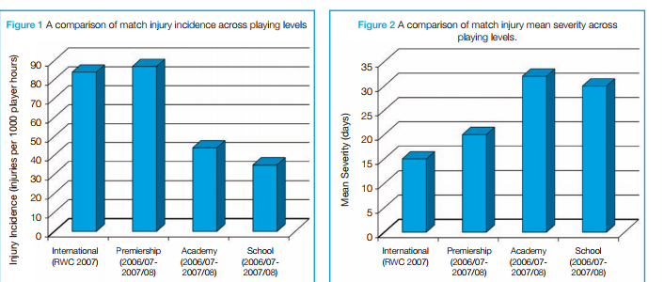

[Allyson Pollock and Graham Kirkwood: Tackle and scrum should be banned in school rugby:]

This report written on the proposed tackling ban compares injury rates in rugby to injuries in other sports. The report then goes on to say how changing rules in contact sport can make a difference to injury rates for example how the rules of ice hockey have changed over recent years.

Wales online posted a news article on the proposed tackling ban and the article reveals that banning tackling could cause serious impacts on the number of rugby injuries sustained in youth and professional rugby. More injuries could be caused as young children will not be trained to fall correctly or tackle correctly which could potentially lead to more serious rugby injuries for players who will have only just moved onto contact rugby.

3 Resource ; (Nathan)
- Sam Evans level 2 referee, Kieran Hooper level 2 qualified, increasing to level 3.
- Wales online.
- World rugby board.

Access to resources (Taylor)

I would go to Cwmcarn high school and interview the PE/rugby teacher and interview them. I would interview him about his views/opinions on contact being banned from rugby up until the age of 16. This could be Geraint Thomas who is head of PE and coaches currently. He also played for a number of years at a high level of rugby. His email is ‘gthomas@cwmcarnhigh.co.uk.’ I would ask him what he thinks about this matter as he has experience playing rugby for many of years. He also coaches and referees so has a lot of knowledge on the game itself.
Finally, I could interview John Schropfer a university lecturer. He has played for a number of years and also coached national teams such as Wales’s u16’s. His email address is ‘john.schropfer@uwtsd.ac.uk.’

Timeline (Nathan)
Task Name | Start | Finish | Who?
Research Topics | 10/10/17 | 17/10/17 | All
Choose a Topic | 17/10/17 | 24/10/17 | All
Identify Research Question | 24/11/17 | 14/11/17 | Ryan
Establish contact with referees/players | 24/11/17 | 7/11/17 | Nathan + Taylor
Preparation of presentation | 24/11/17 | 14/11/17 | Cieran + Ryan
Research Literature | 17/10/17 | 24/10/17 | Ben + Cieran
Research Methodology | 24/11/17 | 14/11/17 | Taylor + Nathan
Construction of Questionnaire | 24/11/17 | 7/11/17 | Nathan + Ben
Completion of Questionnaire | 24/11/17 | 14/11/17 | Taylor
Arrange and hold interview | 15/11/17 | 20/11/17 | Ryan + Ben
Analysis of Data | 15/11/17 | 20/11/17 | Cieran
Create Graphs | 20/11/17 | 30/11/17 | Ryan
Conclusion | 31/11/17 | 08/12/17 | Nathan + Ryan
Identify recommendations | 31/11/17 | 08/12/17 | Cieran + Ben

 | October | November | December

Research Topics

Pick a Topic

Identify Research Question

Establish contact with referees/players

Preparation of presentation

Research Literature

Research Methodology

Construction of Questionnaire

Completion of Questionnaire

Arrange and hold interview

Analysis of Data

Create Graphs

Conclusion

Identify recommendations

References (Ben)

Rugby Football Union. Report on injury risk in youth rugby union. [Online] Available at: http://www.englandrugby.com/mm/Document/MyRugby/Headcase/01/30/49/62/110510youthinjurygamewidehighres_Neutral.pdf. [Accessed 3rd November 2017].
Allyson Pollock and Graham Kirkwood. 2017. Tackle and scrum should be banned in school rugby. [ONLINE] Available at: http://blogs.bmj.com/bmj/2017/09/25/allyson-pollock-and-graham-kirkwood-tackle-and-scrum-should-be-banned-in-school-rugby/ . [Accessed 3rd November 2017].
Wales online. 2017. Banning tackling in schools rugby could INCREASE risk of serious injury, study reveals. [ONLINE] Available at: http://www.walesonline.co.uk/sport/rugby/rugby-news/banning-tackling-schools-rugby-could-11521693. [Accessed 3rd November 2017].
Centurion Rugby. 2017. A Brief History Of Rugby. [ONLINE] Available at: https://www.centurion-rugby.com/blogs/rugby/77546177-a-brief-history-of-rugby. [Accessed 4th November 2017]

