Effective Teamwork and Communication

Student name : Silvia Mita
Student ID number: 2310673
TABLE OF CONTENTS
Introduction 3
Main body 3
One 3
Ways through which application of teamwork theories can enhance teamwork in the organisation 3
Two 5
Importance of 2-way communication at the organisation 5
Importance of effective communication for the continued success of the organisation 7
Conclusion 8
References 9

Introduction
Effective teamwork and communication are significant aspects of achieving success in any organisation operating in the modern business environment. Effective teamwork is important because it leads to enhanced efficiency and productivity, improved problem-solving, increased innovation and boosted engagement and employee morale (Oteshova et.al 2021). Similarly, in the case of effective communication is important because it leads to enhanced decision-making, improved customer service, stronger relationships and reduced errors and misunderstandings. The further assessment will evaluate different aspects of teamwork and communication in relation to the ladies’ fashion store owned by Janet Williams.

Main body

Ways through which application of teamwork theories can enhance teamwork in the organisation
The fashion store of Janet has already experienced rapid growth, and with it, the business has also faced numerous challenges related to collaboration and communication. Theories on team development and individual roles can provide valuable insights for addressing these concerns.
Tuckman’s stages of team development
This framework for team building progresses in a manner that is both organic and adaptable. Each following stage is constructed atop the preceding one, and there are instances where it revisits a preceding stage prior to progressing to the subsequent one. The subsequent section will offer a comprehensive elucidation of this matter.
The five stages of team development are:
- Forming
- Storming
- Norming
- Performing
- Adjourning

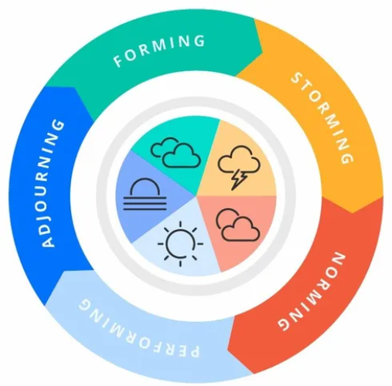
Figure 1 Tuckman's 5 Stages of Team Development
(Source: Jaga, 2024)
Forming
Currently, the workforce of the fashion store lacks behind formal teams, and when the new staff members join loosely defined groups, they enter the forming stage. This stage is particularly characterised by uncertainty regarding roles, focus on knowing about one another and politeness (Bourgault and Goforth, 2021). In order to ease the comprehensive transition, Janet can focus on implementing structured onboarding programs with clear role definitions and team introductions.
Storming
As the teams solidify, the differences in working styles, opinions and personalities become more visible and can also lead to conflicts. This is considered to be a natural part of the overall procedure, but it also has the capability of hindering progress if not managed properly. Janet can focus on encouraging open communication in order to address the conflicts in a constructive manner. The establishment of ground rules related to respectful interactions and team-building exercises can support fostering a healthy and productive storming phase.
Norming
Through conflict resolution and effective communication, the teams enter the norming stage, and in this stage, the roles become clearer, collaboration increases, and members also tend to develop trust (Chowdhury and Murzi, 2020). This stage can be solidified by using tools such as Microsoft Teams for conducting regular team meetings. Janet can also encourage active listening and open communication for the solidification of the team norms.
Performing
This is the ideal state where the teams function in an efficient manner, solve problems collaboratively and are also considered to be highly motivated. Through fostering a productive and supportive environment through the prior phases, Janet can focus on creating the team's data dedicated towards high performance. The solidification of this stage can be done by recognition of team achievements and regular performance reviews (Kapur, 2020).
Adjourning
This stage particularly focuses on the period when the team members are ready to leave or is related to course termination. In the case of the fashion store, this stage is not considered to be of major relevance.
Belbin’s team roles
The nine team positions were classified by Belbin into three categories: Action, People, and Thought Oriented. The jobs within a team exhibit shared behavioural and interpersonal competencies. Belbin also noticed deficiencies in team roles. His "permissible" shortcomings were weaknesses in his job within the squad. It is imperative to acknowledge and enhance these behavioural deficiencies.
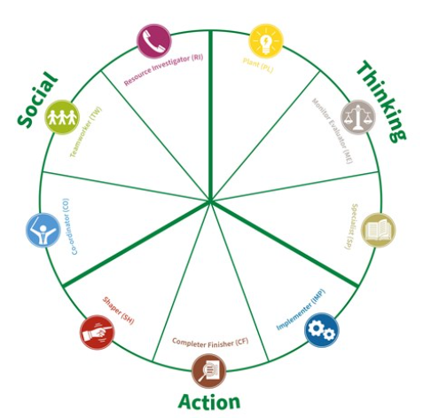
Figure 2 Belbin Team Roles
(Source: Belbin, 2024)
Belbin specifically identified nine significant team roles that individuals naturally gravitate towards (Belbin, 2024). Understanding these roles can support Janet in building well rounded teams with essential skills for succeeding.
Plant
This is the creative who comes up with new and innovative ideas and is ideal for the marketing and promotions team.
Resource investigator
This is someone who is outgoing, has the capability of building external relationships, and is ideal for collaborating with influencers or suppliers (Chowdhury and Murzi, 2020).
Coordinator
An individual who is organised and ensures that the tasks are completed on time and is ideal for a team leader role.
Shaper
Someone who challenges the status quo is driven for improvement and is valuable in any team to offer constructive criticism (Oteshova et.al 2021).
Monitor evaluator
Someone who is able to make sound decisions and is analytical as well and is important for the operations team.
Teamwork
Someone who has the capability of building team harmony, is diplomatic and is significant for all the team members.
Implementer
The capability of turning ideas into action and discipline and is essential across all the teams (Belbin, 2024).
Completer
Someone who ensures that the deadlines are met and the details are not missed. These aspects are also valuable to all the teams.
Specialist
An individual who offers deep expertise in a particular area and this role can be present in any team according to the particular task.

Importance of 2-way communication at the organisation
2-way communication is the type of communication in which information flows seamlessly and freely in both directions and is important for the success of any organisation (Kapur, 2020). In the rapidly growing fashion store owned by Janet, consistent and precise communication is significant in bridging the gaps between different departments, both virtual and physical.

Schramm’s model of communication
As to Schramm's approach, communication follows a cyclical pattern. The concept of circularity entails the sharing of communication roles between the sender and recipient. Linear communication models are distinct from this. This model particularly focuses on depicting communication as a circular procedure with various major elements.
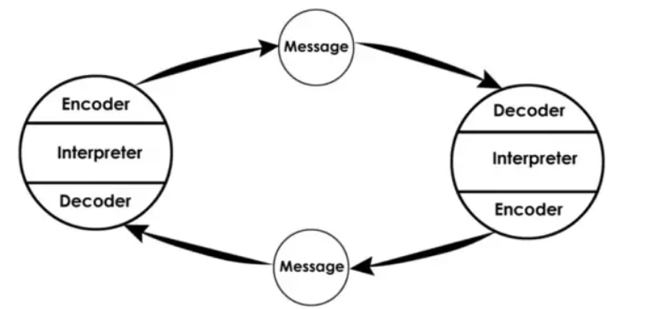
Source
Information is considered to originate from several sources, including sales representatives, managers, marketing team and other sources (Wiradharma et.al 2022).
Encoder
The sender focuses on translating the information into a precise message through written reports or verbal instructions.
Channel
The message is further transmitted through several channels by Microsoft Teams messages, in person meetings or emails.
Decoder
The receiver focuses on interpreting the message, for example, managers reading the reports or employees listening to the instructions (Maneerutt, 2021).
Destination
The message particularly reaches the intended recipient or recipients.
Feedback
The receiver offers feedback to the sender by highlighting any misunderstandings or indicating a comprehensive understanding.

Currently, communication at the fashion store of Janet is inclined towards a one-way model, which highlights that managers might deliver appropriate instructions, but these are delivered without any feedback mechanisms. This makes it unclear whether the message is understood or received by the recipients (Musheke and Phiri, 2021). This can lead to inefficiencies, frustration and errors. 2-way communication can address this gap. Feedback focuses on allowing the sender to adjust the overall message if required and further leads to avoidance of misunderstandings and also ensures clarity. For example, if a manager emails instructions regarding the new product launch, due to 2-way communication, the sales representatives can further ask any clarifying questions or even suggest enhancements before the implementation of the plan.

There are several benefits of 2-way communication at the fashion store owned by Janet. Firstly, it can improve decision-making as by incorporating diverse perspectives through feedback, the teams can make more appropriate and informed decisions (Kapur, 2020). Furthermore, it can also increase employee engagement as feeling valued and heard through 2-way communication can motivate the employees and also foster a sense of ownership. Not only this, but it can also enhance problem-solving as open communication can allow for early identification of any errors and further offer collaborative solutions to the concerns.

Another relevant model is the sender-receiver model, which focuses on the interaction between the receiver and the sender and emphasises the significance of clear communication and active listening for effective message transmission (Chowdhury and Murzi, 2020). First is the aspect of this is active listening, and in the context of the story of Janet, active listening specifically involves asking clarifying questions, paying close attention and providing feedback. Moreover, in terms of clear communication the team leaders and managers can enhance communication through encouraging open dialogue, using concise and clear language and tailoring messages.

Importance of effective communication for the continued success of the organisation

In the rapidly expanding fashion store of Janet, the aspect of effective and clear communication, both nonverbal and verbal, is considered to act as the lifeblood for achieving continued success. One significant reason why effective communication is important for the fashion store is because it supports building cohesion and trust (Wiradharma et.al 2022). In terms of verbal communication, timely updates, clear instructions, and open discussions regarding any challenges support Infosys's strong trust between the management and team members. On the other hand, in terms of nonverbal communication, active listening and positive body language, such as eye contact during conversations, can demonstrate respect and also build rapport. Therefore, without effective communication, there can be the presence of frustration and misunderstandings, which might lead to a less cohesive and disjointed team. This might hinder collaboration and ultimately influence customer service and comprehensive organisational success.

Another relevant reason is improved customer service, as verbal communication can allow the sales representatives to improve their clear communication skills for understanding customer requirements, handling inquiries and effectively recommending products (Musheke and Phiri, 2021). Not only this, but nonverbal communication, including positive body language, genuine enthusiasm, and a welcoming smile, can also project a professional image and further improve the overall customer experience. Poor communication in such interactions can lead to lost sales and frustrated customers. In contrast, effective communication ensures a seamless customer journey, which drives positive word-of-mouth marketing and also fosters brand loyalty.

Streamlined operations and decreased errors are also significant reasons to implement effective communication. Verbal communication can ensure precise instructions during project briefings and training sessions, which can further minimise any confusion and ensure that everyone has the capability of understanding their roles and responsibilities. This can also lead to a reduction in misunderstandings and conflicts (Maneerutt, 2021). On the other hand, nonverbal communication, such as avoiding distractions and maintaining a focus on tasks during meetings, can focus on the promotion of task completion with accuracy. A lack of precise and understandable communication can lead to hindrances or errors in stock levels, marketing campaigns and order processing. However effective communication can streamline operations, ensure that all the departments work together in an efficient manner and also minimise errors.

Lastly, the reason related to managing a diverse workforce is verbal communication, including catering to the communication styles of individuals belonging to different backgrounds and of different personalities, ensuring that everyone feels comfortable in expressing their perspectives and ideas (Bourgault and Goforth, 2021). Similarly, nonverbal communication, like being mindful of cultural nuances and avoiding any offensive or discriminatory body language, also leads to the creation of a more inclusive and welcoming workplace environment. In a diversified workforce with different levels of experience, the aspect of communication can be difficult. However effective and appropriate communication has the capability of bridging these gaps by ensuring that everyone feels valued and also empowered to contribute towards the organisation. This leads to the development and maintenance of a successful and productive team (Kapur, 2020). Therefore, effective communication is the cornerstone of a thriving and consistently developing organisation.

Conclusion
Through the overall analysis, it can be concluded that the fashion store owned by Janet has experienced impressive growth, but this growth comes with the challenge of maintaining a positive work environment and efficient operations. The report examined various major areas for addressing these issues, including team structures, teamwork theories, 2-way communication and effective communication. Through appropriate implementation of these recommendations, Janet can particularly create a collaborative and well-structured environment. This will also allow them to empower their team to innovate, tackle challenges and be propelled towards long-term success.

References
Belbin, (2024). Belbin Team Roles. [Online]. <Accessed through: https://www.belbin.com/resources/articles-directory/thinking-social-action>. [Accessed on: 9th March, 2024].
Bourgault, A. M., and Goforth, C. (2021). Embrace teamwork to create and maintain a positive workplace culture. Critical care nurse, 41(3), 8-10.
Chowdhury, T. M., and Murzi, H. (2020, June). The evolution of teamwork in the engineering workplace from the first industrial revolution to industry 4.0: A literature review. In 2020 ASEE Virtual Annual Conference Content Access.
Jaga, (2024). Tuckman's 5 Stages of Team Development. [Online]. <Accessed through: https://www.jaga.com.au/tuckman-stages-of-team-development>. [Accessed on: 9th March, 2024].
Kapur, R. (2020). Communication skills for workplace success. ResearchGate, November.
Maneerutt, G. (2021). Miscommunication at the Workplace: Causes and Ways to Improve Internal Communication. AU-GSB e-JOURNAL, 14(2), 155-166.
Musheke, M. M., and Phiri, J. (2021). The effects of effective communication on organizational performance based on the systems theory. Open Journal of Business and Management, 9(2), 659-671.
Oteshova, A. K., Niyazbayeva, A. A., Prodanova, N. A., Sabirova, R. K., and Zayed, N. M. (2021). The effect of teamwork on employee productivity. Academy of Strategic Management Journal, 20, 1-8.
Wiradharma, G., Sediyaningsih, S., Arisanty, M., and Dewi, D. K. (2022). Development of Moocs Effective Communication Skill In Professional Workplace. In Proceeding of The International Conference on Innovation In Open And Distance Learning (Vol. 3).

