University of Wales Trinity Saint David
Wales Institute of Science and Art
Flywheel Experiment
Further Science (ACHA4007)

Aidan Samuel Moore
2404386
05/2025
Contents

List Of Figures ii
1.Introduction 1
2.Experiment 2
3.Results 3
4.Analysis 4
5.Conclusion 5
6.Evaluation 6
7.Further Work 7
8.Referance List 8
References 8

List Of Figures
Table 1 Raw Data Collected 3
Table 2, First half of Calculated Data Points 4
Table 3, Second half of Calculated Data Points 4

1.Introduction
A flywheel is a rotating disc used to store rotational energy. It is a vital part of the internal combustion engine, being mechanically attached to the end of the crankshaft it has the potential to significantly change the behaviour of the engine. A heavier flywheel requires more energy to move due to its increased moment of inertia, however this also means it can store more kinetic energy relative to a lighter flywheel.
This is useful in applications where there are large gaps in power delivery such as in the Fiat 500 0.9 Twin air-as the Twin-Air has two cylinders power is delivered every 360 degrees of crank rotation, making the engine inherently uneven and rough running. The heavier flywheel gives the engine the momentum required to keep the engine running smoothly to even out torque delivery, along with making the engine lower the rate at which it drops its revolutions per minute making it easier to change gear for the driver: however this makes the engine less responsive.
In contrast to this in performance applications, typically the number of cylinders used in the vehicle increases, as in the case of the Aston Martin DBR9 GT1 with a 6.0 V12 where torque is delivered every time the crank rotates 60 degrees. So, the torque is delivered in a much smoother manner relative to the 2 cylinders. Meaning, that less weight is required to compensate for the smaller distance between power strokes. It also allows for weight saving and with less inertia it allows the engine to rev faster and reach peak power/torque sooner.
The aim of this experiment is to prove that a flywheel acts as an energy store that converts potential energy of a falling mass into rotational kinetic energy in the context of the experiment. This mirrors how a flywheel stores rotational kinetic energy between power strokes in an engine to smoothen the power strokes.

2.Experiment
The experiment was setup with a steel pegboard, a pulley block is mounted to the top of the board. With the flywheel (mass of 330g, radius of 0.0065m) on one side of the pulley block, a shaft goes straight through the block allowing for it to rotate freely, where a piece of string is winded round the shaft. The piece of string is tied onto a small platform that holds the weights. With a magnetic ruler adjacent to the platform as seen in fig.1. The initial height of the platform reads 280mm. Whilst holding the flywheel in position a weight of 0.1kg is added. With a timer at the ready, the weight is then released with the time to fall/rise being recorded. Whilst looking at the ruler to measure the rebound height.
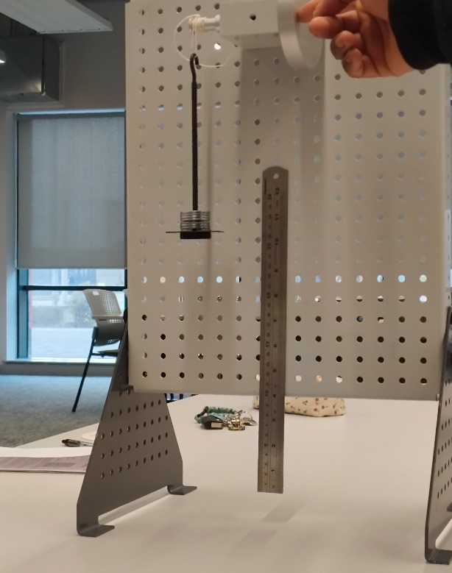

Figure 1 The experiment setup
Repeating the process as many times as possible for accuracy. After which more weight can be added in 0.1kg increments until half a kilo is reached, where all the data can be put into a table.

3.Results
The following data table shows the raw data collected during the experiment. 3 measurements were taken for each weight respectively. The data is as shown in table 1:

Table 1 Raw Data Collected
Mass in kg | Fall/Rise Time 1 in S - (Rebound height 1 in mm) | Fall/Rise Time 2 in S - (Rebound height 2 in mm) | Fall/Rise Time 3 in S - (rebound height 3 in mm)
0.1 | 4.16 (248) | 3.71(250) | 4.23(255)
0.2 | 2.85(255) | 2.72(260) | 2.66(265)
0.3 | 2.41(265) | 2.34(267) | 2.53(260.5)
0.4 | 2.01(255) | 2.07(245) | 2.27(255)
0.5 | 2.13(247) | 1.68(247) | 2.20(240)

The values shown display the raw data collected from each rendition of the experiment including mass, time to fall/rise and rebound height. This data was the basis for further analysis including for velocities, energies, and accelerations.

4.Analysis
The data calculated from the data found in table 1 is as follows in table 2/3:
Table 2, First half of Calculated Data Points
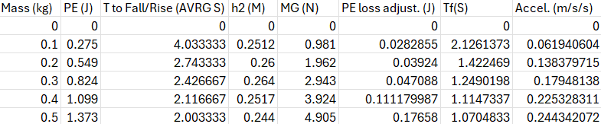
Table 3, Second half of Calculated Data Points
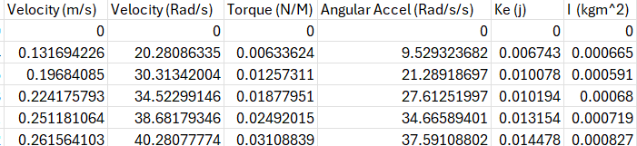

To calculate the Kinetic Energy stored in the flywheel from the raw data collected the first step is to calculate the mean average between the 3 different figures collected for total time to rise/fall and the rebound height. This means that all three renditions of the experiment can be easily represented within the analysis.
At the start of the experiment, the flywheel is stationary-Meaning potential energy is being held because of the mass. When the flywheel is released, it changes the Potential Energy Store (PE) into Kinetic Energy (KE). When the weight rebounds the transfer reverses from KE to PE. However, due to frictional losses like bearings and air resistance etc. the weights will not return to their original height of 280mm. To adjust for this the equation:
$$PEloss=(mgh1)-(mgh2)$$
This calculates the loss of energy in the downward and upward movement. For it to be comparable with KE, only the downward movement is required. Hence the PEloss for the mass of 0.3kg was 0.047J. Thus the height ratio is required to account for this, with the equation:
$PEloss adjusted=PEloss x h1 (h1+h2)$.
This would be 0.00097J for the Mass of 0.3kg in its downward movement.
To calculate the acceleration and velocity of the mass which is proportional to that of the flywheel; to calculate the rotational acceleration with an adjustment to make “fall time” more accurate:
$$a=\frac{h1}{(t ×\left(\frac{h1}{h1+h2}\right))²}$$
With 1.249s from the mass of 0.3kg for example. From there it is easy to calculate the linear Vmax of the falling mass through:
$$V=atF$$
With 0.22m/s coming out for 0.3kg. To convert the linear values relating to the mass so they are directly compatible with the rotational values required for the flywheel. To do this for velocity the equation is:
$$ω= \frac{2 π v}{c}$$
With the value of C already known as 0.0408m as it is the circumference of the pulley. Which would make 34.52 rad/s the outcome for 0.3 kilos. As
$ω= \frac{2 π × 0.22}{0.0408}=34.52 rad/s$.
To calculate inertia, it can be assumed that the force experienced by the chord is equal to the difference of mg, the force from acceleration due to gravity and the force from ma. Which gives:
$$F=mg-ma$$
Provided the chord doesn’t stretch the simple momentum theory can be used, meaning the torque would be equal to the force in the chord at the radius of the pulley. And considering that the torque from the turning flywheel’s angular acceleration and the moment of inertia relative to the flywheel is:
$t=Iα$
means that the angular acceleration is equal to the acceleration of the mass moving divided by the radius of the pulley. Which means
$$α=\frac{a}{r}$$
Which allows for:
$$\left(mg-ma\right)r=I\frac{a}{r}$$
From this the following graph can be created to help find an average value for inertia using a trendline.

Figure 2, The graph showing the relationship between Torque, Acceleration and Inertia
Using Y = MX+C the average inertia came out to be 0.00078kgm^2.

5.Conclusion
This experiment successfully demonstrated that a flywheel can store and release rotational kinetic energy. With the mass being used to initiate the transfers of energy, it showed that despite losses in energy to air resistance etc., the relationship between torque and acceleration was proved as the results in the graph align with those in the table. Confirming its moment of inertia, which is why flywheels are used to store energy in Internal Combustion Engines and why “[much] of the FESS research work in aerospace focus on replacing lion batteries with astronautical FESSs.” (Palazzolo,2021) So if a energy storage system as well established as lithium ion batteries is under threat in an aerospace application then Flywheel Energy Storage Systems could be the optimal choice for energy storage solutions in all sorts of contexts other than within the engine.

6.Evaluation
Whilst the experiment did prove successful there was the odd outlier within the raw data collected. Repeating the experiment did improve with accuracy however 3 is quite a limited amount and in retrospect 5 repetitions may have been the wiser choice to average out the data, as that is the best way to counteract outliers without changing anything to do with the set up of the experiment. There are a lot of things to take into consideration with the way the experiment was conducted that could have lead to inaccuracy. A lot of it relied on the accuracy of a person’s reaction time, or the perspective at which they were sat at whilst looking for the rebound height of the weights etc. There are also other possibilities such as the string may have stretched when it was under its maximum load. To an extent even the temperature of the room where the experiment was conducted also played a part as the temperature could’ve been cooler meaning the air would have been denser, creating more air resistance.

7.Further Work
A way to improve the experiment would be to have the board fastened securely bolted to the floor to ensure there is no movement within the board, a thicker string, and with the experiment to be done in a vacuum to eliminate a few possible variables. A solenoid hold the flywheel in position with a button that when pressed will return the solenoid allowing the mass to fall with a motion sensor there to trigger when it detects movement which initiates a timer linked to a computer, with a slow motion camera filming the mass as it reaches h2. The computer would then be able to sync the moment the timer went off and the footage together. With the synced footage and time, a software would then be able to indicate when the mass reached h2. With the experiment to be repeated much more with more variety in masses.

8.Referance List

References
Alan Palazzolo, X. L. (2021). A review of flywheel energy storage systems : state of the art and oppertunities. Fremont: Gotion Inc.

