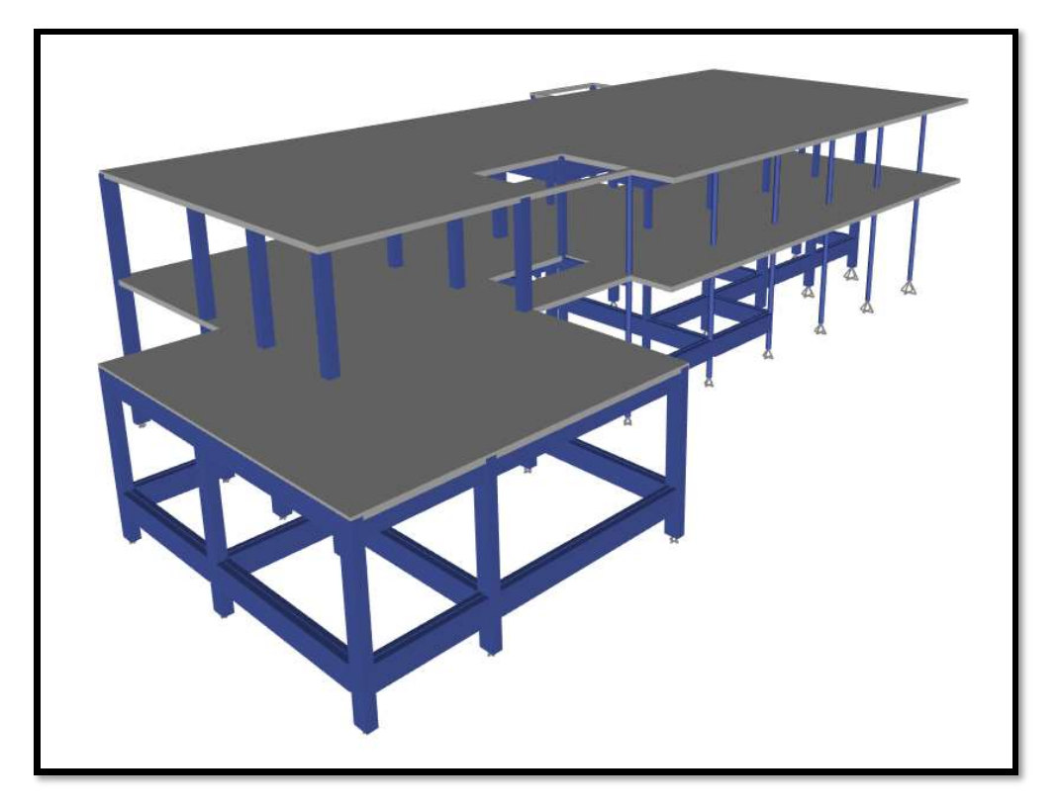

Student ID number: 2113837
Module: Engineering Mathematics and Structure
Module code: ACBA4007
Assignment Title: Structural Analysis & Design
Lecturer: Dr Jamiu A. Dauda

Table of Contents

Structural design processes……..…………………………………………………………………………………………………………..1-2
Loads that should be considered when designing a building project……………………………….……………………3-4
Structural Analysis……………………………………………………………………………………………………………………………..5-10
References…………………………………………………………………………………………………………………………………………….11

INTRODUCTION
The primary goal of this structural investigation and analysis is to determine the internal actions and support response of a structure that has been subjected to mechanical load, imposed deformations, and support settlements, as well as to discuss briefly the process involved in structural design and to identify and discuss the various types of loads that should be considered when designing a building project.. In civil engineering, a structure is a system of interconnected parts used to sustain external loads. The prediction of the reaction of structures to specified arbitrary external loads is known as structural analysis. The possible external load of a structure is assessed during the preliminary structural design stage, and the size of the structure's linked elements is determined based on the expected load. To meet the safety and serviceability requirements of the local building code and specifications of the area where the structure is located, structural analysis established the relationship between a structural member's expected external load and the structures corresponding to develop internal stresses and displacements that occur within the members.

structural design processes
The entire process of structural planning and design requires not just imagination and intellectual thought, but also a thorough understanding of practical concerns like current design regulations and byelaws, as well as considerable experience, knowledge, and judgement. It is stressed that any construction must meet the efficiency requirements while also being durable for the stipulated life span.
There are currently five (5) processes of a structural design, they are:
- Structural scheming
Following the selection of a structure type, the structural design process begins. Structural design is an art and science that focuses on understanding physical load-bearing behavioural components and building them with economy and dignity to produce a safe, usable, and long-lasting framework.
- Loading schedule
The engineer starts the element engineering phase by assuring proper dimensions for various parts of the building project using geometry coordination software (either 2D or 3D). The engineer will begin detailed member analysis for the given spans, such as calculating roof loads transmitted to external and interior bearing walls, assuming the measurements are accurate. When combined with window and door perforations, which need headers and beams, lateral force resisting systems often take the greatest engineering time. Gravity, wind uplift, and lateral load routes are all included in this approach. This load path analysis will also be done to the floor system and foundations, providing the engineer a basic picture of the different types of loads that exist within the structural parts and where further attention is needed.
- Durability design
Engineers refine the numerous aspects into final structural element designs through an iterative process. Consider this to be repeated in nature, with the end objective of an efficient design that fulfils the diversity of criteria that the structure's arrangement sets on the path that the applied load must follow to reach the ground. Starting with a broad knowledge of the loads on various parts, the engineer narrows the emphasis until each element, and the complete structure, is built to safely transmit all loads, fulfil code requirements, and produce an acceptable solution that can be signed and sealed.
- Structural element design
Deferred submittals apply to certain items, such as roof trusses. This implies the engineer permits others to generate the drawings, which are then sealed by a specialist or delegated engineer. The EOR examines the sealed designs and either approves them for fabrication or sends them back for changes. Engineers will also monitor construction progress on behalf of the customer and will frequently conduct site inspections to ensure that the construction process is moving smoothly and that product installation is error-free.

- Structural detailing.
Structural detailing is the process of drafting a design Ota structural system in a form that a builder may utilise for construction and simple installation. Furthermore, structural drawings are the primary mechanism through which the designer conveys his needs to the builder in a clear manner.

Different type of loads that should be considered when designing a building project.
Loads operating on buildings and other structures are generically classed as vertical loads, horizontal loads, and longitudinal loads. Vertical loads include dead load, active load, and impact load. Wind and earthquake loads are examples of horizontal loads. Safety and economics are two significant considerations in building construction. The economy suffers if the burdens are assessed and taken higher. When cost is considered and weights are reduced, safety is compromised. As a result, the assessment of various loads operating must be correct.
Building and Other Structures Minimum Design Loads defines different design loads for constructions and buildings. Loads operating on a structure include:
- Dead load
The dead load is the first vertical load to consider. The term "dead loads" refers to loads that remain constant or stable throughout the life of a construction. The self-weight of structural parts, permanent partition walls, fixed permanent equipment, and the weight of various materials account for the majority of the dead load. It mostly comprises of the weight of roofs, beams, walls, and columns, among other structural elements.
- Imposed load
Imposed loads, also known as living loads, are the second type of vertical load to consider while designing a building. Live loads are mobile or moving loads that do not experience any acceleration or impact. The weights of moveable partitions or furniture, among other things, are supposed to be created by the building's planned usage or occupancy. The live load fluctuates.
- Wind load
The horizontal load induced by air movement relative to the earth is known as wind load. When the heath of the building exceeds two times the dimensions transverse to the exposed wind surface, wind load must be addressed in structural design. The wind load is not significant in low-rise buildings of four to five stories because the moment of resistance supplied by the continuity of the floor system to column connection and the walls provided between columns is adequate to handle the influence of these forces.
- Snow load
Snow load is the downward strain exerted on a building's roof by the weight of accumulated snow and ice. If the snow load exceeds the weight capacity of the structure, the roof or the entire structure may fail. Or if the structure was badly designed or built. It does not need a snowstorm to cause difficulties.
- Earthquake load
The building is subjected to both vertical and horizontal earthquake stresses. An earthquake's overall vibration may be divided into three mutually perpendicular directions, typically referred to as vertical and two horizontal directions. Vertical movement does not result in considerable pressures in the superstructure. However, the horizontal displacement of the building during an earthquake must be taken into account while planning. The composition of the foundation soil, the size and manner of construction, and the length and severity of ground motion all influence the structure's response to ground vibration.

Structural Analysis
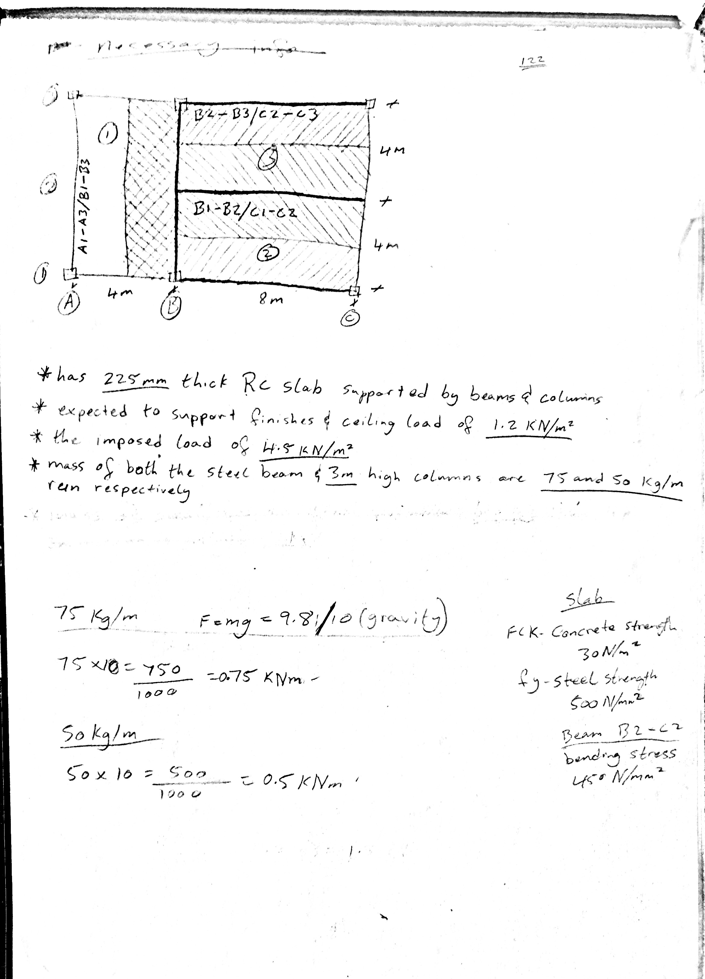
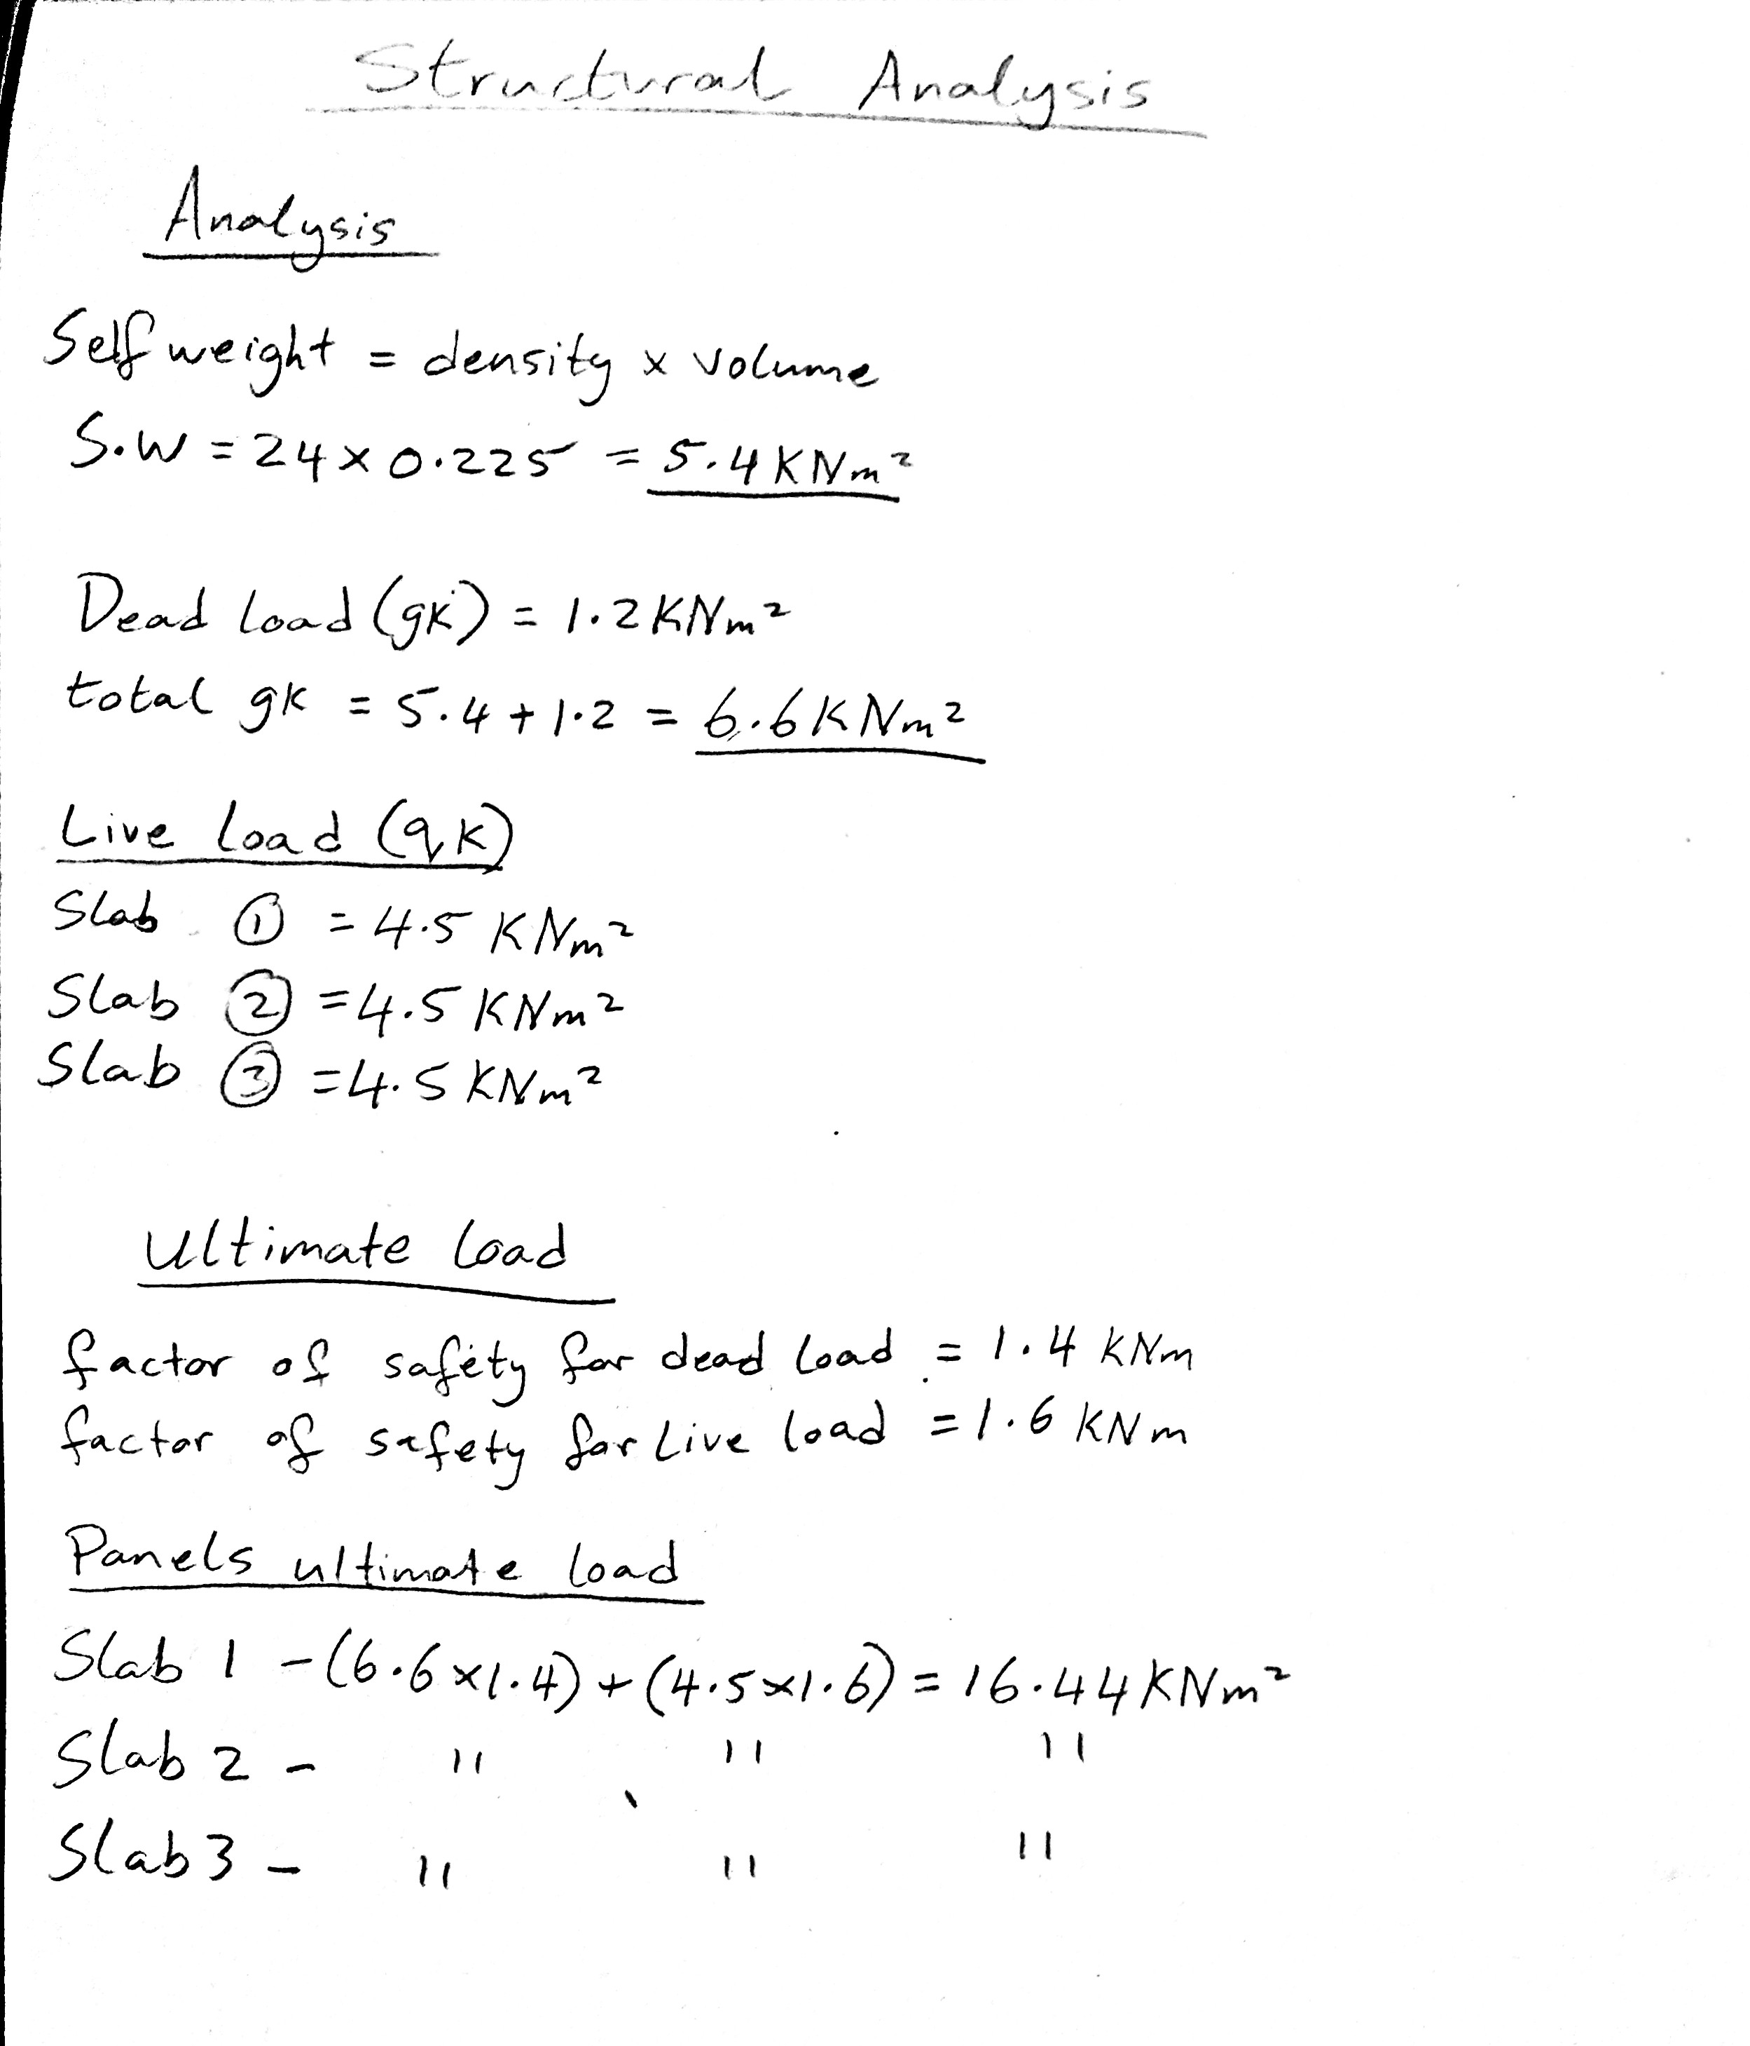

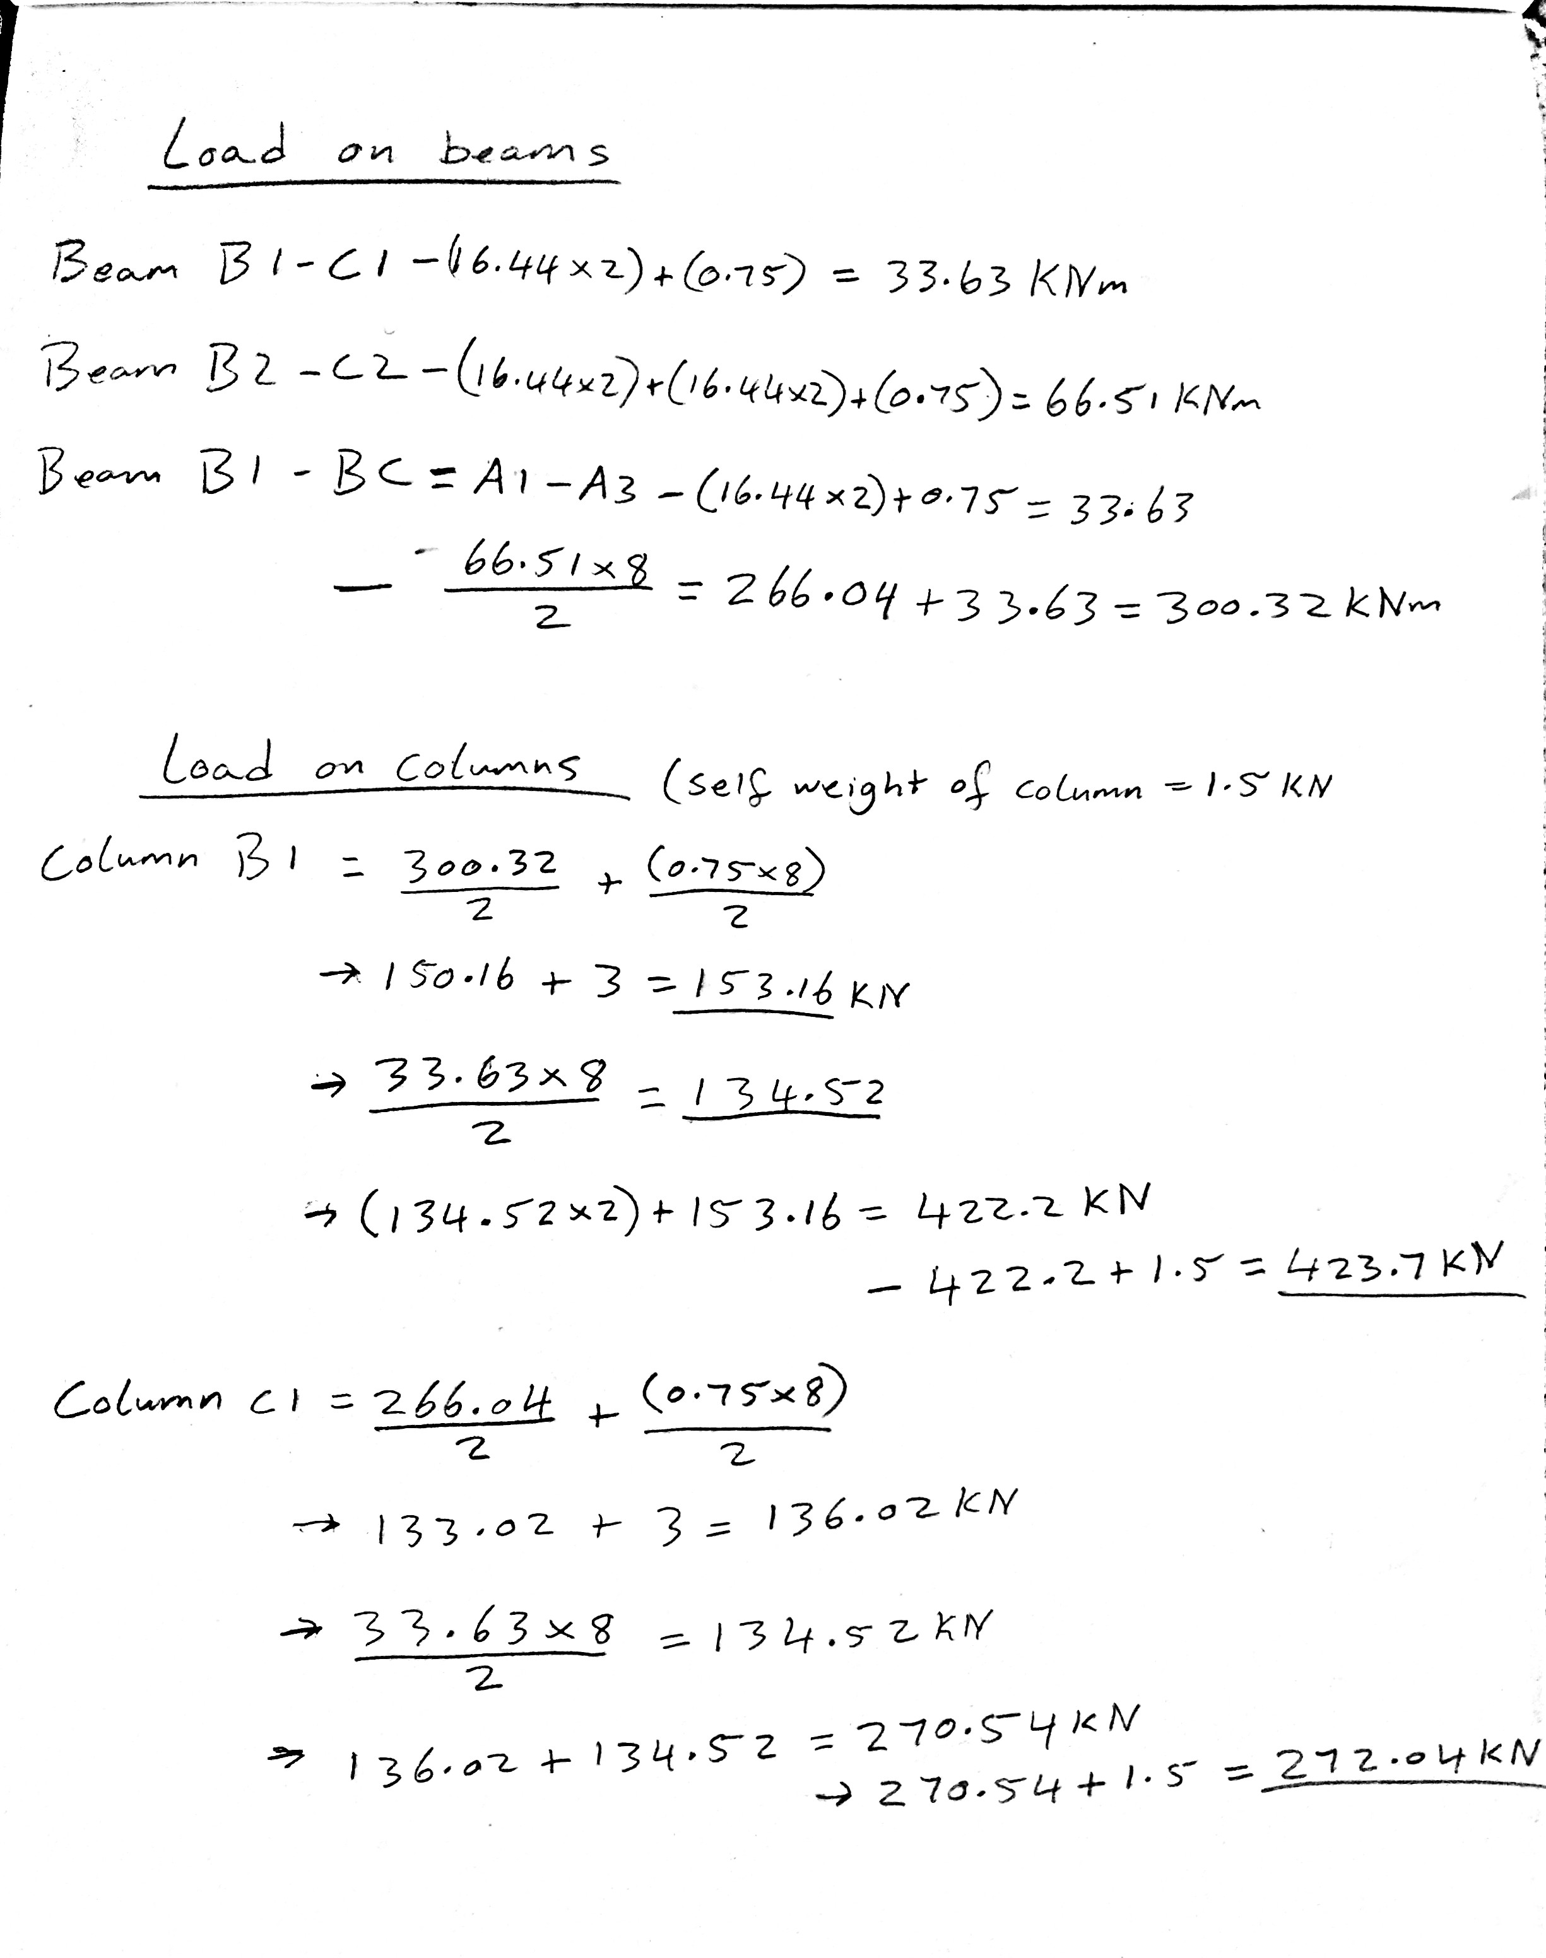

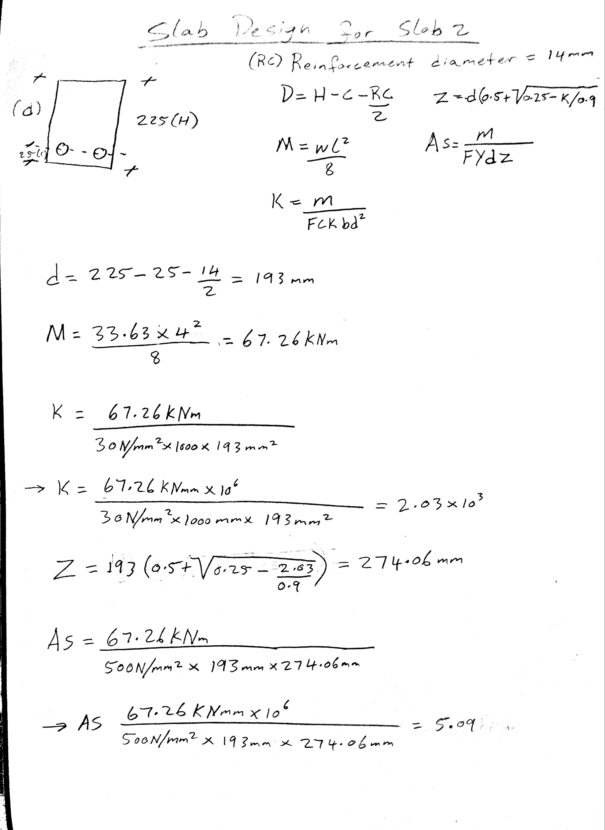
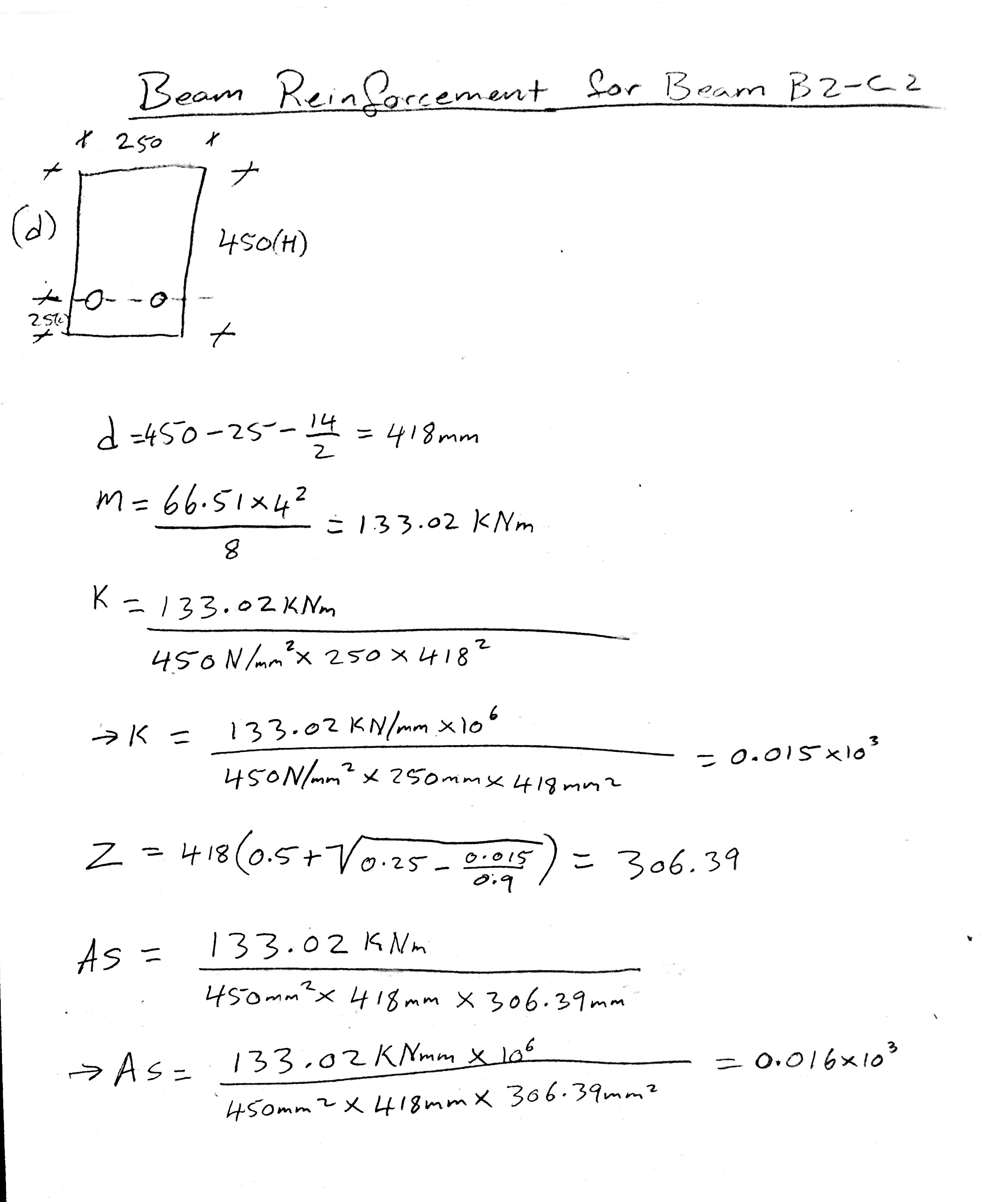

References
Anon, (n.d.). Basic Procedure of Structural Design | The Structural World. [online] Available at: https://www.thestructuralworld.com/2019/06/07/6-basic-procedure-of-a-structural-design/.
civilengineer-online.com. (2019). Structural Design: Types and Stages. [online] Available at: https://civilengineer-online.com/structural-design-types-and-stages/#The_action_of_Forces_and_Computation_of_Loads [Accessed 12 May 2022].
The Constructor. (2017). Types of Loads on Structures - Buildings and Other Structures. [online] Available at: https://theconstructor.org/structural-engg/types-of-loads-on-structure/1698/.
www.nationwide.com. (n.d.). Calculate Roof Snow Load for Your Barn - Nationwide. [online] Available at: https://www.nationwide.com/lc/resources/farm-and-agribusiness/articles/snow-load-barn-collapse#:~:text=Snow%20load%20is%20the%20downward.

