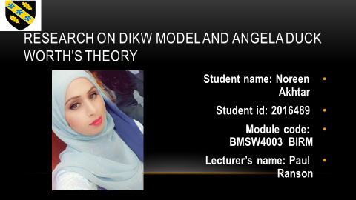


Good day ladies and gentlemen, my name is Noreen Akhtar and I am an understudy at University of Wales Trinity David. Today, the topic of the research I have conducted in my University is that Angela’s Duckworth theory of GRIT passes the CRAAP test and I will be presenting a short presentation on the research that is based on the work of Angela Duckworth's GRIT model.
I would like to start off with the basic understanding of GRIT, what is GRIT; how it affects the lives of common man and what are the features of it. To have Grit implies having the inspiration, strength, endurance and a 'stay with it disposition' to accomplish long haul objectives and to eventually be fruitful. It is a tool considered for the development in school going adolescents’. (Duckworth, 2009)
My examination is relies on the crafted by Angela Duckworth, she has made it approach for assessing individuals as she entitlements can be foresee in what way effective such people can be seen in the forthcoming scholastically
Angela has developed a kind of measure per say in which we are able to quantify their GRIT, named the Angela’s Duckworth Grit Scale. Angela’s Duckworth is PhD in the domain of psychology furthermore she has also worked in university of Pennsylvania as a professor. Miss Angela Duckworth is the founder and developer of the skills called grit. The scale grit is primarily developed to induce or check the enthusiasm, determinations and somewhat a prediction about the future upholding for the long term goals respectively, disregarding the short term goals' perspective in mind.
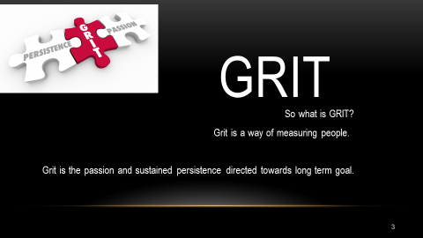
GRIT can be defined as a method of measuring individuals. It can be seen as a combination of energy and tirelessness. This scale is not just a measure it's about having the potential to attain to prolong goals and keeping up with the short term goals as well. Its actually about the long term prediction of behavior and focus, short term goals are bit and pieces of the long way process.
Angela supports a notion that it is not always the talent of an individual but the realistic nature, grasping tendency and courageous attitude that set them apart from the crowd and like mentioned before help in the long term goal. Duckworth has established a ten question based scale that processes aforementioned nature and tendencies. The elements of the scale rely on one's commitment and persistence that indicates if the person is determined towards the long term goals and objectives.
After taking up the test and answering all ten questions, it provides with a concrete result from 0 to 5 as 0 being the least and 5 being the highest in such tendencies as being committed, persistence or realistic in nature.
Angela has also made researches about her work and has made sure that her work is accurate and approved by others too.
Theory suggest that it is the incompetency of an individual if they study a research and validate it as it is without studying about it further. So, what I have done here is applied CRAAP test to Angela Duckworth’s theory to see if the work is really relevant and passes the test. (Blakeslee, S., 2004)
CRAAP is the method of assessing data, it stands for;
Currency: How current the information is, the timeline of the research. Angela has presented her GRIT in 2006 which we can say is not a decade back, so it makes it timely. Also, upon research I have noticed that academics and scholars are conducting further research on GRIT which makes it pass the ‘C’ ach of CRAAP test.
Relevance: How correlated it is to the need of hour. While searching it over the internet, you can clearly observe that the GRIT theory is published over a number of known platforms.
Authority: This ach asks to check the authenticity of an author. Not anyone can be an author, they have to be qualified enough to write on a certain topic. Angela is a Professor in University of Pennsylvania and has well develop her name, which makes her a credible author.
Accuracy: How correct the information is, who is the publisher. The theory is published by some renowned publishers.
Purpose: This states whether the author is able to communicate her research clearly.

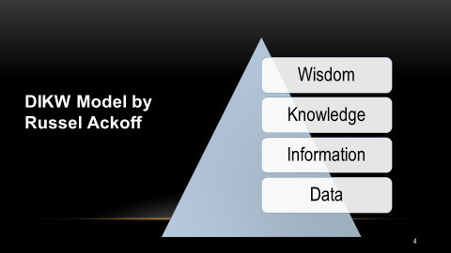
DIKW Model has been used by me in the following research and it is presented by Russel Ackwoff (1989) to go ahead with my research further. Russel can be defined as a systemic theorist, a teacher of organizational change. The big triangle presented above is known as the pyramid of relationship between data, knowledge and wisdom is known as information processing model. (Pretorius, J.G, 2019)
In this model Russel has presented a hierarchy as to how data can be processed into wisdom. This model consists of four stages;
- Data
- Information
- Knowledge
- Wisdom
Data: Data is the beginning point of any research. These are the numbers which are gathered through survey or questionnaire.
Information: the processed data takes the form of information. This can be represented in the system of number or graphs.
Knowledge: When if the information had being accumulated and prepared, it now needs to be associated to check the accuracy.
Wisdom: This is the stage where decision making takes place.


Information, agreeing to the (Oxford Word reference) are realities and insights collected together for reference or examination. For this reason, I begin with the first step of DIKW model which is to gather essential data utilizing the Microsoft Survey Form. I made a questionnaire reflecting Angela’s Duckworth Grit questionnaire, (www.angela Duckworth Grit Scale).
This was the primary data that I collected. I then asked my fellow class mates to fill it and examine or compare the United Kingdom prerequisite evaluation graph in understanding their exact academic level. Part of the research requires to fill Grit Questionnaire to know their GRIT Score.
Based on these two things, I concluded the following two queries;
- What was your Angela Duckworth Grit score
- What was the academic level based on the UK qualifications
In Upcoming pages I have prepares with MS forms, gathers information through inquiring undergrad students or colleagues of mine during the course to total it and the real comes about from Angela Duckworth's GRIT study.
I have also made and include the video explaining the footsteps I have taken to form the questionnaire and gather the information.
https://web.microsoftstream.com/studio/videos

This is the screenshot of the Microsoft Form I have created (using MS Word) in the class only with the help of the instructor and my other fellow students.

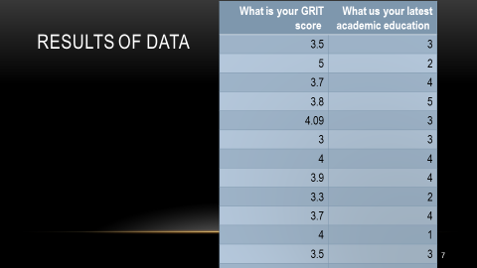
The above table is the conclusion of the responses I have received, the result that I gotten on my research. I at this point have taken this information and have presented it in the form of graph.

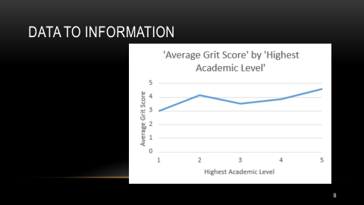
With the initial data accumulated I was able to convert it into the data for making the above graph. I profoundly had 13 questionnaire complete responses with a cut down of 11when I have expurgated down the incomplete or rejected forms, or eliminated for being irregular, or unacceptable.
This illustrates what Ackoff was suggesting, you have to scrutinize the data before using it. I will now show you how I turned the data to turn it into information: -
Furthermore, I then started with using Microsoft excel spreadsheet to group all the academic level from 1 to 5. Moreover as mentioned their responses respectively making sure that it became easy for anyone reading the research and for me to further calculate the averages of each group.
Then I have used the scatter diagram tool to represent this data in the graph form to see a relation between GRIT score and academic levels. The graph shows up to go broadly upwards, and If we look at Angela’s Duckworth research it also showed a rising line; this shows that we can agree to Duckworth's hypothesis in which individuals with advanced educational heights as compare to the lower education stages seems more grittier or in other words more realistic and consistent.
As per Ackoff, information's reliable once it is compared with already published data i.e., secondary data. The further refined data or information I had utilized to associate Angela Duckworth's hypothesis comes from the Wednesday group data 2020. This data was collected in 2020 in University of Wales Trinity St David.

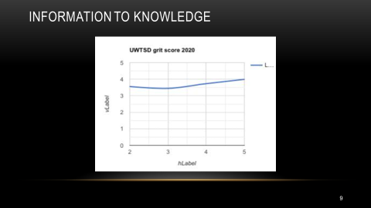
- This is the information existed and created in 2020 and is collected from 171 reactions. This clearly indicate an upward rising line as it was with our Thursday Group GRIT chart. This demonstrates Angela’s Duckworth theory that individuals with higher academic levels leads to higher GRIT score.
Angela Duckworth recommends that as the advanced the GRIT mark the advanced the educational stage will be; this has quite already have been demonstrated as both graphs seems to be elevated from obliquely from bottom to the top. A pattern can be notice that this outline emerges uniform within the exceptionally little data I composed of everybody among my colleagues and it can too remain understood within the chart from UWTSD January 2020 test of 170 individuals. In spite of the fact that here exist comparative contrasts prepared among the two graphs, there are a few strong matters along with the quality in the information provided.

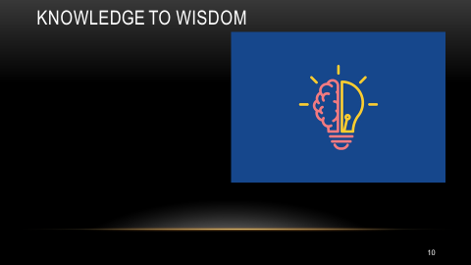
As per Ackoff, now that we have on knowledge in hand we are able to take decisions. So, here we can draw the conclusion do we agree with Angela’s Duckworth theory or not. With my graphs and research, I can conclude that my research gives the result which we have seen with Duckworth theory. Hence, I can say that I agree with Angela’s theory.
Now that we have our conclusion that higher academic levels lead to high grit score, the question becomes how can we develop GRIT in individuals. This kept me wondering about the question and it lead me towards the growth mindset theory presents by carol dweck. Teacher of brain research in Stanford college, American analyst Carol Dweck . Proposed a notion that personalities ought to have development intellect usually manages to be fruitful in their lives. Victory be contingent to period, exertion instead of through natal abilities. Individuals with a settled intellect established, who admit that they are born with certain abilities, insights and aptitudes and those are sufficient to agree the worlds are not right. (Carol S. Dweck, 2007).
This completes Angela’s hypothesis, we ought to enjoy extra in expanding our information instead of depending on our gifts. Learn modern aptitudes; soak knowledge as much as possible, exposed to change that offer assistance us into suitable best into world also gotten to be effective at the same time. Thank you.

BIBLIOGRAPHY
- Duckworth, A.L, & Quinn, P.D, 2009., Development and validation of the Short Grit Scale (Grit-S)," Journal of Personality Assessment, pp. 166
- Angela Duckworth.com/ grit-scale
- Russell L. Ackoff., Blakeslee, S., 2004. Loex Quarterly, [31(3)], p.4., Available at: https://commons.emich.edu/cgi/viewcontent.cgi?article=1009&context=loexquarterly
- Pretorius, J.G., Mathews, M.J., Maré, P., Kleingeld, M. and Van Rensburg, J., 2019. Implementing a DIKW model on a deep mine cooling system. [International Journal of Mining Science and Technology, 29(2)], pp.319. Available at: https://link.springer.com/chapter/10.1007/978-3-642-39928-2_1
- UK qualification comparison chart, paragon publication UK
Available at: paragon-publication.uk
- DIKW pyramid- Wikipedia
Available at: https://en.wikipedia.org/wiki/DIKW_pyramid
- Carol Deweck, 2014 ‘The power of believing that you can improve, ‘ted talk, YouTube
Available at: https://www.youtube.com/watch?v=hiiEeMN7vbQ

Carol S. Dweck, 2007, Mindset: The New Psychology of Success

