Care Home Clover

Business Plan 

By Ina Stancheva 2010542
Entrepreneurship
Lecturer: Vasilios Tavlaridis

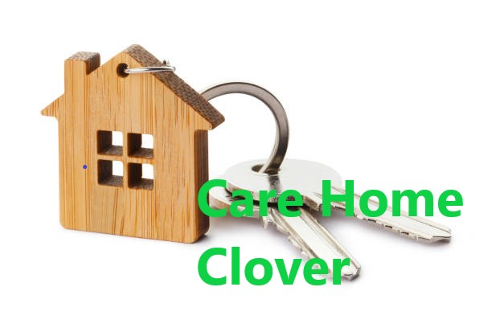

All about our business

Table of Contents
Introduction 3
Business overview 4
Vision for my Business 4
SWOT, PESTEL analysis 4
Target market and market research 7
Marketing plan 9
My business plan's financial section 10
Conclusion 10
References 10

Introduction
While an entrepreneur may be a 'innovator,' it is more accurate to call them a 'organisation builder,' meaning someone who has the ability to create an organisation while also utilising the fresh ideas of other innovators (Garg, n.d.). My job and expertise as a leader will ensure the success of my business idea because I will apply what I have learnt in the construction of my own business. With the right team in place and the ability to recruit effectively, the workflow will be simple and successful.

Business overview

My name is Ina Stancheva and I will present a business plan for a senior living home in Evesham, Worcestershire. This business plan's objective is to showcase my vision for the home, which will be completed by the end of 2023. I'd create a new Limited Liability Company. I've chosen to do so in order to be legally registered with the Company House in the United Kingdom. The business will be known as Care Home Clover. In December 2023, this business will commence operations. The business plan's objective is to transform the current care facility into a profitable business during the following two years, up to and including 2023. This will be done through administrative and personnel reorganisation, as well as by expanding the number of residential apartments from 25 to 45. While I recognise that residential development will take longer given the current circumstances surrounding the Covid-19, my goal is to finish residential construction by September 2023. In this industry, I see a gap between the private sector and the government. The reason for this gap is that in the United Kingdom, private sector providers run the majority of the care homes (CMA, 2017). This gap should be felt by working together with the government. With communication and different types of benefits, the government could give more flexibility and opportunities to those who have ideas for the entire care home industry.

Vision for my Business
Providing the finest environment for the satisfaction of the elderly and / or lonely people would be a key component of the overall offering. Quality services, clean accommodations, the greatest organic multinational cuisine menu, and enticing entertainment are what I and my team will provide our customers. Clients' needs will be met by our team at all hours of the day and night.

SWOT, PESTEL analysis
SWOT analysis is a tool for evaluating a company's resources and capabilities (weaknesses and strengths) as well as the state of the external market (opportunities and threats). Several research studies have revealed. One of the most extensively utilised strategic tools among managers is SWOT analysis (Madsen, 2016). This section is to present SWOT done to Care Home Clover
Strengthens | Weaknesses
- A large number of activities  - Highly skilled clinic staff  - Salon de coiffure  - Spa and wellness facilities are available  - There's plenty space for table games  - Outdoor areas ,large garden  - Pets friendly | - Not enough time is spent by staff planning additional events  - Nurses are not accessible to visit with patients on a regular basis because of the COVID 19  - It is not possible to have food delivered from a restaurant outside of the building.
Opportunities | Threats
- External elements that are likely to have a beneficial impact on reaching and exceeding the care home objectives or goals that were not previously considered  - High demand for care home placements in the local area  - In many facilities, improvements are can be made that will help care leavers feel more confident and joyful. | - Not many professionals and specialist care staff on the market

PESTEL analyze - Political, Economic, Social, Technological, Environmental, and Legal factors are abbreviations. By evaluating these six areas (the external environment), the strategic planning process becomes more precise and provides more aspects to consider when developing the company's strategy (Albu, 2014). This section is intended to provide Care Home Clover with an overview of the PESTEL framework.
Political factors
Care Home Clover can thoroughly examine the following factors before entering or investing in a particular market:
- The government's bureaucracy and meddling in the Home Health Care industry are problematic.
- Contracts are enforced under a legal framework.
- Pricing rules and regulations
- Employment regulations, including minimum wage and overtime pay
- Home health care work week restrictions

Economic Factors
Care Home Clover should consider some economic factors like inflation, interest rate, etc.
- The level of skill of the personnel in the home health care profession.
- In the economy, the level of education is important.
- The rate of economic expansion
- Unemployment rate is a percentage of the workforce.
- The rate of inflation
- Rates of interest
Social Factors
In order for marketers at Care Home Clover to understand their clients in a given market and build marketing messages for consumers in the Home Health Care industry, it is essential that they have a common set of beliefs and attitudes among the general public.
- The population's demographics and skill level are detailed here.
- Social structures such as class, hierarchy, and power are all present in society.
- The level of education, as well as the standard of education, in the Culture (gender roles, social conventions etc.)
- Interests in leisure activities
Technological factors
Companies should not only conduct technological analyses of their industries, but also evaluate the rate at which technology disrupts such industries. Slower technological disruption will offer a firm more time to adapt and remain profitable, whereas faster technological disruption may provide a firm little time to adapt and remain profitable.
- Affects of global warming
- Environmental contamination is governed by laws.
- The Home Health Care industry is subject to air and water pollution rules.
- Recycling
- In the healthcare industry, waste management is important.
- Views on environmentally friendly or ecologically friendly goods and services
- Animals that are endangered
- Support for and attitudes toward renewable energy are on the rise.
Legal factors
Some of the legal considerations that Care Home Clover management should keep in mind when entering a new market are as follows:
- Discrimination is prohibited under the law.
- Intellectual property law (copyright, patents, etc.)
- Consumer protection and the Internet of Things
- Employer-employee relations
- Laws governing health and safety
- Protection of Personal Data

These evaluations will assist my company in determining areas for improvement.

Target market and market research

Ascertain that the target market is an appropriate fit for the individuals to whom the products or services are being given. When recruiting new residents, my primary focus will be on the elderly and lonely residents of Evesham.
In the event that Care Home Clover uses important information before starting operations, both marketing primary and secondary research was conducted. According to secondary research, 18.7% of Evesham's population is 65 years old or older. (population, 2020). Secondary study in that area indicates that the over 65-year-old population in Evesham was estimated to be 18.3 %, implying a fourprocent rise in the senior population over the last three years. The secondary study on the care home services market indicates that Care Home Clover has a good future. A primary research study was conducted on 50 people over the age of 65 who live in Evesham, Worcestershire. The three questions below are intended to ascertain the need for care home services in Evesham:
In your care home, what kind of recreational activities would you like to find?

Do you think the services provided by the care homes are adequate for a higher quality of life?

Is there anything you'd like to see different from what's provided by care homes?

As a result of answering the questions listed above, my team and I have discovered ways to better organise services in order to better satisfy our clients while also discovering our marketing plan.

Marketing plan
Our marketing plan entails the development of a functional website, the publication of advertisements in the Evesham Journal, and the use of social media platforms such as Facebook and Twitter. By utilising a marketing strategy, businesses may keep their customers at the forefront of their minds. Marketing strategy is the rationale by which a business seeks to create value for its customers and establish a profitable connection ( (Kotler, 2013). The following is the marketing strategy established for Care Home Clover utilising the marketing mix (Kotler, 2013) :
Product- Our business provides products and services of the highest quality
Price- When it comes to pricing, we provide our clients the best value since we offer the lowest rates
Promotion- To raise awareness about our business, we'll run ads on social media and create a website
Place- Clover Care Home is located in a quiet and serene area of Worcestershire. Our clients will enjoy a peaceful and relaxing environment at this location

My business plan's financial section

Expenses for supplies and labour

Product | Amount | Cost.
Vehicle employed by the company | 1 | £ 15,000
Apparatus for treating disease | 1 | £ 7,000
Staff training Employee education and development | 1 | £ 8,000
Facilities for recreation and amusement | 1 | £20,000
Total |  | £ 50,000

Expenses for supplies and labour – Care Home Clover

Requirements for transport:
We will acquire a company vehicle to meet the transport demands of Care Home Clover.

Obligations legales:
Prior to opening for operation, Care Home Clover must comply with a number of legal criteria, including:
- Registration of a company
- Insurance for a company
- HM Revenue & Customs registration
Requirements in terms of insurance:
Due to the vast size of our care home's facilities, building insurance for Care Home Clover costs roughly £1000 per year. The annual cost of company insurance will be around 500 pounds.

Additional Certifications Required:
- All staff must be certified on a fundamental level
- Certificates of training for all key personnel
- Permission to work in the UK for non-UK citizens
Monthly Costs that are Predictable Based on Cash Flow

Items | Cost
Insurance | £ 130
Interest Loan | £ 90
Utilities/Gas/Elec | £ 500
Legal | £ 45
Loan repayment | £ 333
Accountant | £ 95
Promotion | £ 185
Transport | £ 235
Salaries | £ 22,000
Maintenance | £ 100
Website | £ 45
Rent | £ 2,000
Total monthly fixed costs | £ 25,758
Monthly Costs that are Predictable Based on Cash Flow of Care Home Clover

Product and service costs
Name of the product or service | Typical facility for home health care services
The cost for one unit | 1600 monthly
The cost for one unit | 2000 monthly
Profit margin (£) | 400 monthly
Profit margin (%)  (Profit / Price x 100 = Profit margin) | 20.00%
Mark up (%)  (Profit / Cost x 100 = Mark Up) | 25.00%

Care Home Clover's profits will be put toward quality enhancement and business expansion.

Cash flow forecasting that is realistic Forecasting sales and costs
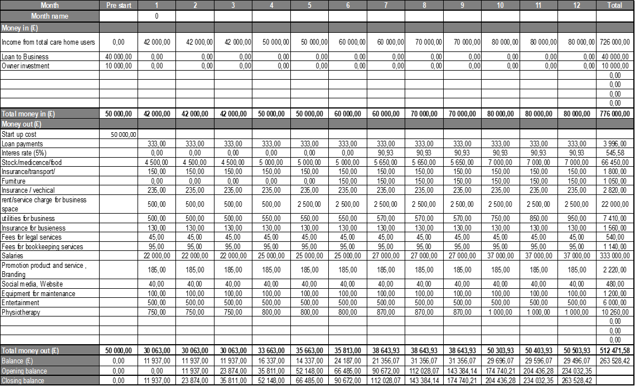

Items | Year 1
Annual Income from total care home users | £ 776 000
Direct expenses | £ 512 471.68
Net profit | £ 213 528.42
1 Year forecast for Care Home Clover
The forecasts above assume a 26.1% growth in Care Home Clover's sales. Profits are expected to increase by 14.1% as a result of this.

Conclusion
To summarise, Care Home Clover will be a financially sound business. The business is expected to have a balanced cash position at the conclusion of the first year and a very strong chance of continuing to do so for the next two years.

References
(CMA), T. C. a. M. A., 2017. Care homes market study. [Online]
Available at: https://assets.publishing.service.gov.uk/media/59b2bb0ae5274a5cfcda2d18/financial_analysis_working_paper.pdf
[Accessed october 2021].
Albu, P., 2014. A strategic management framework: PESTEL.
Garg, D. M., n.d. Entrepreneurial Development. [Online]
Available at: https://www.ddegjust.ac.in/studymaterial/mba/cp-401.pdf
[Accessed 03/10 October 2021].
Kotler, P., 2013. Principles of Marketing. 6th ed. Harlow: Pearson Education Limited.
Madsen, D. Ø., 2016. SWOT Analysis: A Management Fashion Perspective. SWOT Analysis: A Management Fashion Perspective, 16(1), pp. 39-56.
population, C., 2020. https://www.citypopulation.de/en/uk/westmidlands/worcestershire/E34004292__evesham/. [Online]
Available at: https://www.citypopulation.de/en/uk/westmidlands/worcestershire/E34004292__evesham/
[Accessed 17 October 2021].

