
MASTER OF BUSINESS ADMINISTRATION

HUMAN CAPITAL MANAGEMENT
LCMB7023
ASSESSMENT COMPONENT 1: INDIVIDUAL REPORT – HR STRATEGY

Student name: Kunjal Ghanshyambhai Amreliya
Student ID: 2531260
Lecturer name: Dr Anupam Mazumdar

Word count: 2572
Date of submission: 20th March 2026
Table of Contents

1. Introduction 4
Part 1: Building a Culture of Innovation & Future Work Practices 4
1.1. Current Innovation and Work Practices in Tech Companies 4
1.2. Building an Innovation Culture at Aether Innovations 6
1.3. Designing a Future of Work Model 8
1.4. Impact on Employee Motivation and Organisational Performance 10
Part 2: Reflective account 12
2.1 Reflection Using Gibbs’ Reflective Cycle 12
2.2. AI and Future Career Relevance 14
3. Conclusion 15
References 17

List of figures

Figure 1: Agile cultural development matrix 5
Figure 2: Agile Innovation Process 6
Figure 3: Statistics of preferences for hybrid work 8
Figure 4: Improved communication and collaboration through social technologies 9

1. Introduction
Human capital strategy is the practice of applying and aligning people management in line with the organisational objectives in order to improve performance and competitiveness. Aether Innovations is a mid-sized technological corporation that is experiencing a number of problems, among which are high employee turnover, poor organisational growth and decreased customer satisfaction. The above problems emphasise the necessity of a better way of handling and involving employees. The creation of a culture of innovation and future work practice in present-day technology companies is necessary to enhance creativity, cooperation, and productivity. Thus, the purpose of this report is to suggest the strategic HR initiatives that help build an innovation-oriented culture and a model of the future of work so that employee engagement and organisational performance at Aether Innovations can be improved.

Part 1: Building a Culture of Innovation & Future Work Practices

1.1. Current Innovation and Work Practices in Tech Companies
Innovation-driven cultures and flexible work practices have become the pivots of technology companies in the contemporary world to stay competitive due to the fast-changing environment. A lot of the top companies actively facilitate innovation through the empowerment of employees and experimentation. As an example, the famous Google policy of 20% time permits any employee to devote one day or so out of a weekly job to experience independent innovations, resulting in Google items like Gmail and Google News (Sekar, 2025). Similarly, Uwasomba et al. (2025) added that agile team organisational structures facilitate cross-functional teams, quick problem-solving and sustained product development to bring organisational learning and knowledge sharing.
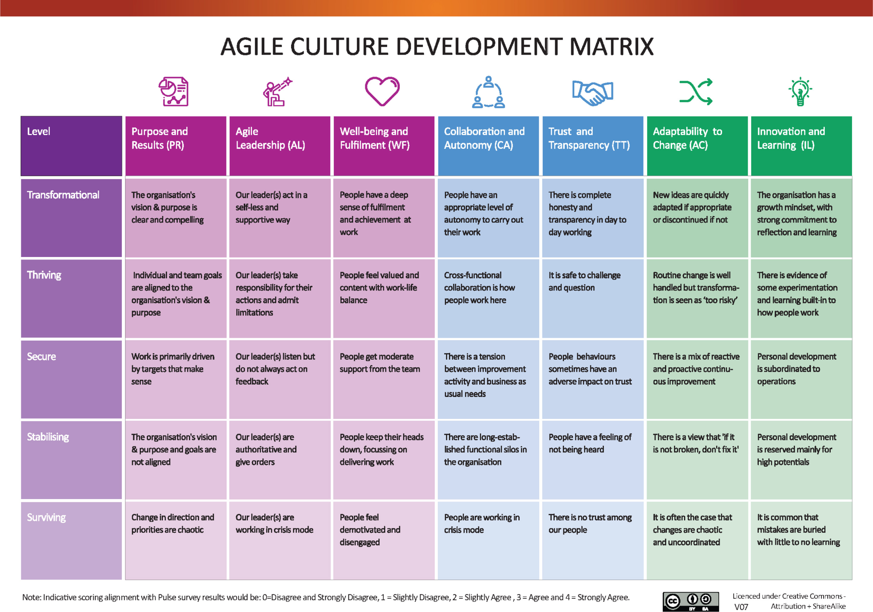

Figure 1: Agile cultural development matrix
(Source: Inspired by the ideas of Uwasomba et al. 2025)
Organisations that have integrated modern technologies are found to embrace the practice of flexible work, such as the hybrid and distance work model, with the assistance of the digital collaboration platform. It is analysed that 83-84% of workers claim to be more productive under hybrid or remote learning with the help of proper technology and communication technology (Zoom, 2024). These productions fit with the Organisational Culture Theory in which Schein lays more emphasis on shared values and open communication as a form of innovation, and with the High-Performance Work Systems (HPWS). From the perspectives of Bhardwaj et al. (2025), this facilitates the integration of HR practices like collaboration, training, and empowerment to drive organisational performance.
Moreover, digital knowledge-sharing tools help to facilitate sharing of ideas and development of creative solutions among employees. These altogether plays a vital role in the innovation process in knowledge-intensive sectors. Nevertheless, the issues faced by Aether Innovations, including high turnover, stagnant growth, and customer dissatisfaction with their service, indicates that the practice of innovation-based activities is either non-existent or implemented poorly. The absence of such collaborative culture, flexible work arrangements and mechanisms of sharing knowledge could, therefore, hamper creativity and involvement of employees. As per Probosari (2025), under such circumstances, overall performance of the organisation and its competitive advantage are affected.

1.2. Building an Innovation Culture at Aether Innovations
Progressing towards an innovation-oriented culture is a key step to enhancing creativity, involvement, and performance in the organisation at Aether Innovations. The HR practices promoting experimentation, teamwork, and empowering employees can considerably expand the level of innovativeness.
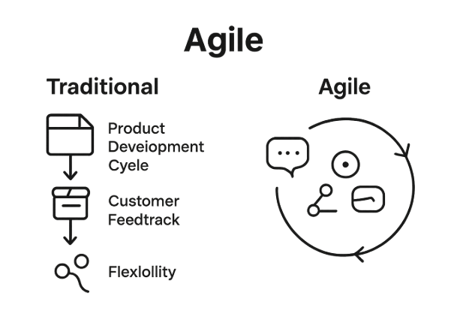

Figure 2: Agile Innovation Process
(Source: Inspired by the ideas of Skipso, 2025)
One of the methods of increasing creativity and idea generation speed is innovation sprints. Innovation sprints are brief, highly organised development sprints in which a cross-functional team quickly designs and tests ideas within a constrained time. This strategy is common among technology companies since it encourages swift decision-making as well as collaborative problem-solving. It is believed that the organisations that employ agile innovation technologies can increase the development speed of the products by up to 30% when compared to the classic models of product development (Skipso, 2025). Another idea that innovation sprints can bring to employees is creativity, since it gives the staff the opportunity to play around with new ideas without bureaucracy. Since this theory is based conceptually, it falls under Self-Determination Theory that underlines autonomy and competence as major sources of intrinsic motivation (Grenier et al. 2024).
The second critical strategy will be the setup of intrapreneurship programmes that will motivate their workers to come up with new ideas in the organisation. Examples of intrapreneurship programs can be internal idea incubators, internal innovation laboratories, and experimental projects funded by the company. Research shows that those companies that utilise professional intrapreneurship programmes have increased employee engagement rates and rates of innovation. For example, around 70% of companies worldwide have seen their innovation performance improve once they have instituted internal entrepreneurship programmes (Weforum, 2024). This is motivated through such programmes because they give a chance to employees to be creative and get their ideas heard. Moreover, Kumar et al. (2022) stated that intrapreneurship fosters the theory of employee empowerment. It, however, argues that when individuals are given powers to make decisions, it increases commitment and organisational performance.
The other essential approach is the condition of cross-functional teams where workers of various departments work together on common projects of the innovations. Cross- functional teamwork helps in the sharing of knowledge, diversification and more efficient problem solving. Organisations that facilitate cross-department cooperation have a higher likelihood of beating competition in terms of innovation outcomes by a factor of 1.5 (Mckinsey, 2023). In human resource perspective, cross-functional teams reinforce organisational learning and allow employees to integrate specialised knowledge in producing new solutions. In general, the introduction of innovation sprints, intrapreneurship programmes, and cross-functional teams would empower the workers, improve cooperation, and make a great contribution to the innovation capacity of Aether Innovations. These human resources are in line with modern motivation and empowerment theory, and thus generates conducive organisational culture to promote creativity, knowledge sharing and sustainable competitive advantage.

1.3. Designing a Future of Work Model
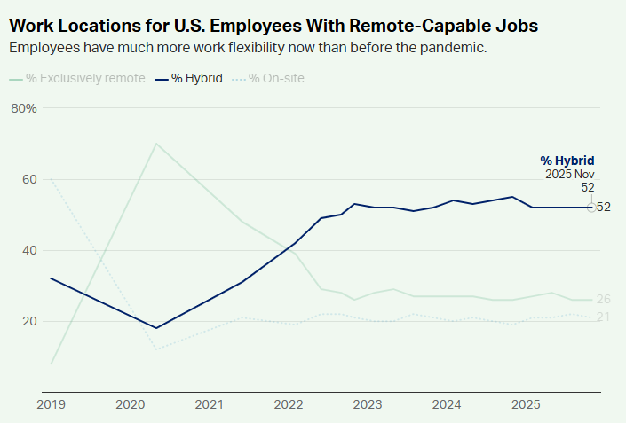

Figure 3: Statistics of preferences for hybrid work
(Source: Gallup, 2025)
In current technological companies, the future-oriented work model should be designed to enhance employee engagement, productivity, and organisational performance. Among the possible options, the hybrid work system is one of the most effective, as employees spend a certain amount of time working on a remote basis and some working in the office. Hybrid work creates freedom, and employees are able to balance their professional and personal lives more efficiently. Significantly, 52% employees who work remotely with the option of working hybrid, prefer the latter type, whereas organisations where hybrid models are applied report higher productivity and lower turnover rates (Gallup, 2025). Increased freedom of location choice also increases employee health and job satisfaction, and these two variables are major determinants of long-term organisational performance.
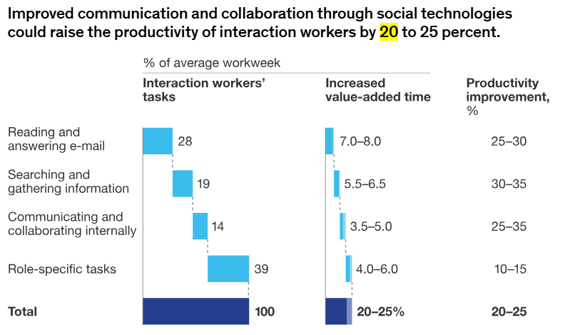

Figure 4: Improved communication and collaboration through social technologies
(Source: McKinsey, 2022)
The use of digital collaboration tools assisting in the communication and teamwork of distributed settings is another significant element of the future of work. Slack, Microsoft Teams, and cloud-based systems like Google Workspace allow sharing of information and coordination of projects, as well as real-time communication between employees, irrespective of their location. Through these technologies, there is a sharing of knowledge and ongoing collaboration that is critical in the industry that is knowledge-intensive, like technology. The effectiveness of organisations to implement digital collaboration technologies may help companies to achieve 2025 productivity improvements by 20 to 25% due to rapid communication and better access to information (McKinsey, 2025). Moreover, agile project management in digital platforms can help teams to optimise coordination, monitor progress and develop ideas more effectively.
Flexible work policies are a primary factor in the transformation of future work alongside hybrid work and digital technologies. Flexible schedules, remote working plans and output-based performance mechanisms are amongst the policies that concentrate on employee performance, but not necessarily on the number of working hours. Such a method is in line with the current trends in HR practices, where autonomy and trust are valued. According to the opinion of Gupta and Nagariya (2025), workers who feel high levels of flexibility are more engaged and committed to their work, and flexible work setups lower burnout and increase retention rates. In addition, such flexibility provides the employees with the opportunity to manage their time effectively to boost morale and work output.

1.4. Impact on Employee Motivation and Organisational Performance
The HR strategies, innovation sprints, intrapreneurship programme, cross-functional teams and flexible work practices that are proposed can go a long way in boosting employee motivation and organisational performance at Aether Innovations. Self-Determination theory states that employees feel more motivated when they feel that they have a sense of autonomy, competence, and relatedness in their job (Gagné et al. 2022). Flexible work models and innovation initiatives grant the employees more freedom and chances to acquire new skills, which enhances the intrinsic motivation and engagement. Moreover, the Two-Factor Motivation Theory by Herzberg emphasises that recognition, achievement, and meaningful work are the key motivators that contribute towards increased job satisfaction and performance. According to Jaffar et al. (2024), innovation projects and intrapreneurship programmes enable the employee to share new ideas and reward them for their efforts, which enhances commitment and motivation. Such programs are also effective in increasing the results of innovation; more specifically, organizations which encourage employee innovation actively are able to develop innovative ideas and new products.
Employee turnover can also be lowered with better motivation and interest. Fatigue indicates that the turnover rates in organisations that have an effective engagement culture are as low as 43% (Gallup, 2025). The reduced turnover leads to organisational stability and retention of useful knowledge and experience. Moreover, highly motivated employees are more likely to provide quality services and products, which has a positive impact on customer satisfaction and organisational reputation.

Part 2: Reflective account

2.1 Reflection Using Gibbs’ Reflective Cycle
Description
The experience during the Human Capital Management module enabled me to better understand the role of the human resource strategies in organisational success. Strategic human resource management, employee engagement, talent development and innovation-based organisational culture are also some of the important concepts that the module addressed. I received lectures, case studies, and academic readings that taught me how HR practices go in line with business objectives to improve the performance of organisations. Specifically, the module pointed out the need to establish new working environments and flexible working arrangements that may contribute to the creativity and productivity of employees. According to Osman et al. (2024), good HR practices can yield a great impact on organisational performance through enhanced employee motivation and performance. The learning opportunity was a practical experience into the ways HR professionals can develop systems that can guide the employee as well as business development.
Feelings
My initial interpretation of HR was only as administrative activities, such as recruitment and employee management. Nevertheless, during the course of the module, I have changed my stance greatly. I started to understand HR as a strategic activity which is important in determining organisational culture and competitive advantage. Personally, I was most interested in discussions about innovation culture and employee empowerment since these two topics showed how HR strategies help organisations evolve a culture of creativity and flexibility. This change of mindset has enabled me to recognise the bigger picture in HR decisions in terms of their organisational implications.

Evaluation
A number of the concepts presented in the module were especially useful to my learning. To begin with, the HR strategy alignment concept enabled me to realise that the HR policies should focus on supporting organisational goals to ensure sustainable performance. Second, the culture of innovation emphasised the role played by organisational culture in promoting innovation and knowledge to be shared among employees. Third, the talent development and employee engagement discussion has shown how organisations can save on talented employees and enhance productivity. Parabakarana and Lasib (2021) demonstrated that when organisations have effective HR practices, the engagement of employees and the organisation perform better. The lessons were particularly applicable to the problem of employee turnover and performance decreases in companies, and how they can be dealt with.
Analysis
Analytically, the module revealed that HR strategies are important in enhancing organisational performance. The motivation of employees and innovation is improved through strategic HR practices that include employee empowerment, learning and development programmes and joint work environments. The strategic human resource management theory argues that organisations operating under high-performance work systems are relatively better in terms of productivity and financial performance (Subramony et al. 2022). Indicatively, knowledge sharing and enhancing problem-solving can be promoted by urging cross-functional working and innovation projects. Additionally, intrinsic motivation is encouraged with the help of employee empowerment and flexible working, and this increases engagement and dedication. Such HR strategies consequently foster good organisational culture, favouring innovation and organisational success, which is sustainable.
Conclusion
In general, this module enabled me to build a more developed perspective on the strategic significance of human capital management. I was able to determine that administrative duties are not the sole responsibilities of HR, but HR is also instrumental in supporting innovation, worker involvement, and organisational productivity.
Action Plan
Development Area | Key Actions (Keywords) | Expected Outcome | Timeframe
HR Strategy Knowledge | HRM research, journals, courses | Strategic HR understanding | 6–12 months
Organisational Culture | Innovation culture, best practices | Collaborative work environment | 6 months
Leadership & Decision Making | Leadership training, strategic thinking | Better HR decisions | 1 year
Communication & Engagement | Communication skills, teamwork | Higher employee engagement | Ongoing
Professional Development | Workshops, HR certifications, networking | Career growth, updated HR knowledge | Continuous

2.2. AI and Future Career Relevance
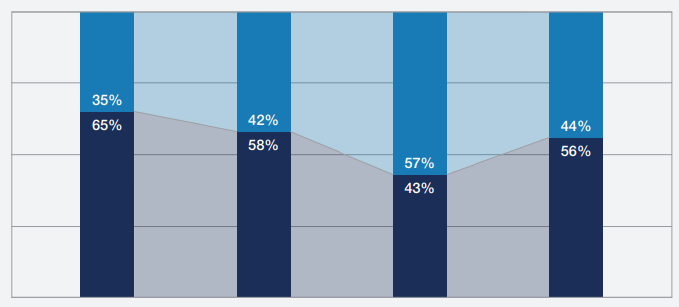
Figure 5: Disrupted Workers’ Skills
(Source: Weforum, 2023)
The AI is turning the business processes and human resource management into an automated routine with the ability to screen job seekers before recruiting them, conduct data analysis, and monitor the performance of the employees. Most organisations are currently relying on AI-based HR analytics to enhance decision-making and workforce planning. As shown in figure 5, AI and automation will disrupt around 44% of the workers' skills in the next five years (Weforum, 2023). This, in turn, explains reasons behind professionals requiring to constantly change and acquire new skills. Nevertheless, even though AI can promote efficiency, human professionals will still be required in the sphere of tasks which presuppose strategic thinking, leadership, and decision-making of a complex nature. Hence, experts need to be concerned with acquiring distinctively human capabilities that do not substitute AI technologies. I will apply AI as an assistant to enhance productivity, decision-making, and preserve my worth as a professional in my future career. As an illustration, AI will be helpful in analysing the workforce data and determining HR trends, and I will be able to concentrate on the strategic plan and organisational growth. Simultaneously, I will also focus more on developing such skills as leadership, creative problem-solving, and human-centred decision-making. With technology, critical thinking, and people skills, I will establish myself as a flexible, useful employee in a more AI-focused environment as time goes by.

3. Conclusion
This report suggested a number of HR practices that can be aimed at enhancing innovation and organisational performance at Aether Innovations. The most significant ones are the introduction of innovation sprints, intrapreneurship programmes, cross-functional teams, and a hybrid future-of-work model with the assistance of digital collaboration tools and flexible work policies. Strong innovation culture provides employees with an opportunity to get ideas across, work together and get creative towards organisational objectives. Combined, these strategies raise the motivation of the employees, the productivity, minimise the turnover, and eventually contribute to the sustainability of organisational development and customer satisfaction.

References
Bhardwaj, S., Choudhary, P., Chopra, R. and Chakraborty, D., (2025). High-performance workplace system: a literature review. International Journal of Organizational Analysis, 33(8), pp.2853-2880. https://www.researchgate.net/profile/Seema-Bhardwaj-2/publication/389131991_High-performance_workplace_system_a_literature_review/links/67b85f2c8311ce680c6ee487/High-performance-workplace-system-a-literature-review.pdf
Gagné, M., Parker, S.K., Griffin, M.A., Dunlop, P.D., Knight, C., Klonek, F.E. and Parent-Rocheleau, X., (2022). Understanding and shaping the future of work with self-determination theory. Nature reviews psychology, 1(7), pp.378-392. https://www.nature.com/articles/s44159-022-00056-w.pdf
Gallup, (2025). Employee Engagement vs. Employee Satisfaction and Organizational Culture. Available at: https://www.gallup.com/workplace/236366/right-culture-not-employee-satisfaction.aspx [Accessed on: 10.03.2026]
Gallup, (2025). Hybrid Work. Available at: https://www.gallup.com/401384/indicator-hybrid-work.aspx [Accessed on: 10.03.2026]
Grenier, S., Gagné, M. and O'Neill, T., (2024). Self‐determination theory and its implications for team motivation. Applied Psychology, 73(4), pp.1833-1865. https://iaap-journals.onlinelibrary.wiley.com/doi/pdfdirect/10.1111/apps.12526
Gupta, I. and Nagariya, R., (2025). The impact of flexible work policies on employee well-being and retention in modern organizations. In Prioritizing employee mental health and well-being for organizational success (pp. 185-218). IGI Global Scientific Publishing. https://www.researchgate.net/profile/Uday-Ghosh-9/publication/391489203_Prioritizing_Employee_Health_and_Well-Being_for_Organizational_Success/links/681a7609bd3f1930dd6d34d9/Prioritizing-Employee-Health-and-Well-Being-for-Organizational-Success.pdf#page=201
Jaffar, H., Munir, A.J. and Waqas, M.M., (2024). Assessing the impact of Herzberg’s two-factor motivation theory on job satisfaction: A study of employees in the Punjab Healthcare Commission. Sustainable Business and Society in Emerging Economies, 6(3), pp.469-480. https://publishing.globalcsrc.org/ojs/index.php/sbsee/article/download/3148/1798
Kumar, N., Liu, Z. and Jin, Y., (2022). Evaluation of employee empowerment on taking charge behaviour: an application of perceived organizational support as a moderator. Psychology Research and Behavior Management, pp.1055-1066. https://www.tandfonline.com/doi/pdf/10.2147/prbm.s355326
Mckinsey, (2022). Improved communication and collaboration through social technologies could raise the productivity of interaction workers by 20 to 25 percent. Available at: https://www.mckinsey.com/industries/technology-media-and-telecommunications/our-insights/the-social-economy [Accessed on: 07.03.2026]
Mckinsey, (2023). Performance through people. Available at: https://www.mckinsey.com/~/media/mckinsey/mckinsey%20global%20institute/our%20research/performance%20through%20people%20transforming%20human%20capital%20into%20competitive%20advantage/mgi-performance-through-people-full-report-vf.pdf [Accessed on: 07.03.2026]
Sekar, N. (2025). Google’s “20% Time” Policy. Available at: https://medium.com/@nareshnavinash/googles-20-time-policy-60d5706084be [Accessed on: 10.03.2026]
Osman, A., Opoku, V. and Kyeraa, A., (2024). The impact of performance appraisal systems on employee motivation and organizational success: A comprehensive review of best practices and challenges. Convergence Chronicles, 5(5), pp.83-92. https://scholarindexing.com/uploads/files/lhn_omk86iqyv01.pdf
Parabakarana, D. and Lasib, M.B.A., (2021). Human resource management practices and its impact on employee engagement and performance in an organization a study on labour force in malaysia. Malaysian E Commerce Journal, 5(1), pp.29-35.
Probosari, N., 2025. The Impact of Knowledge Sharing Culture on Employee Innovation in Remote Work Era. The Journal of Academic Science, 2(6), pp.1657-1665. http://thejoas.com/index.php/thejoas/article/download/420/423
Skipso, (2025). Understanding the Agile Innovation Process for Success. Available at: https://www.skipso.com/resources/understanding-agile-innovation-process-en [Accessed on: 05.03.2026]
Subramony, M., Guthrie, J.P. and Dooney, J., (2022). Investing in HR? Human resource function investments and labor productivity in US organizations. In Strategic Human Resource Management and Organizational Effectiveness (pp. 83-106). Routledge. https://www.researchgate.net/profile/Mahesh-Subramony/publication/365045956_Investing_in_HR_Human_resource_function_investments_and_labor_productivity_in_US_organizations/links/63e66c87dea61217579bf4c1/Investing-in-HR-Human-resource-function-investments-and-labor-productivity-in-US-organizations.pdf
Uwasomba, C., Deshpande, A., Sharp, H., Gregory, P., Willis, R., Barroca, L., Uwadi, M. and Taylor, K., (2025). Data-driven agility: Assessing agile culture transformation in a technology organisation. Information and Software Technology, 183, p.107729.
Zoom, (2024). Zoom survey reveals hybrid work reigns supreme and delivers unexpected value to global organizations. https://news.zoom.com/zoom-survey-reveals-hybrid-work-reigns-supreme-and-delivers-unexpected-value-to-global-organizations/
Weforum, (2023). The Future of Jobs Report 2023. Available at: https://www.weforum.org/publications/the-future-of-jobs-report-2023/digest/ [Accessed on: 05.03.2026]
Weforum, (2024). Future Readiness of SMEs and Mid-Sized Companies. Available at: https://www3.weforum.org/docs/WEF_Future_Readiness_of_SMEs_and_Mid_Sized_Companies_A_Year_On_2022.pdf [Accessed on: 07.03 2026]

