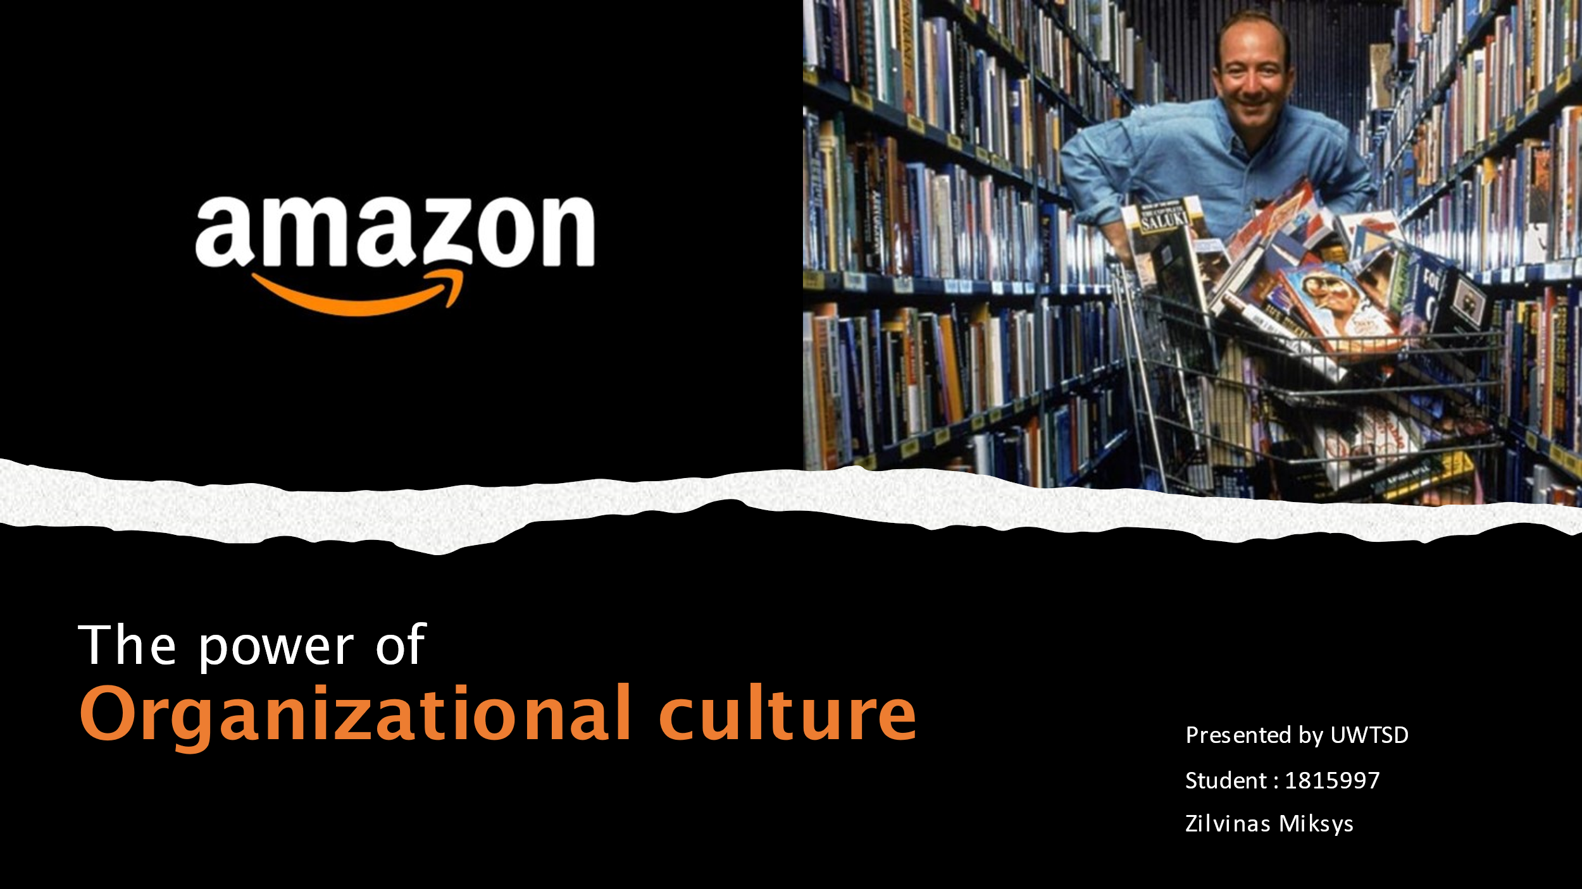

Video link:
https://web.microsoftstream.com/video/d3d57408-f26c-462a-bb69-ed1e4b644889

References

Anitha, J., 2016. Role of organizational Culture and Employee Commitment in Employee
Retention. ASBM Journal of Management, 9(1).
Gilani, H. and Cunningham, L., 2017. Employer branding and its influence on employee retention: A literature review. The Marketing Review, 17(2), pp. 239-256.
Harney, B. and Dundon, T., 2020. Amazon: HRM and change in the house of neo-liberalism. In Case Studies in Work, Employment and Human Resource Management. Edward Elgar Publishing.
Jenkins, H., Ford, S. and Green, J., 2018. Spreadable media: Creating value and meaning in a networked culture (Vol. 15). NYU press.
Johnson, G., 2015. Cultural Web. Wiley Encyclopedia of Management, pp.1-2.
Kantor, J. and Streitfeld, D., 2015. Inside Amazon: Wrestling big ideas in a bruising workplace. The New York Times, 15(08).
Kwon, Y., Marzec, M.L. and Edington, D.W., 2015. Development and validity of a scale to measure workplace culture of health. Journal of International Migration and Integration, 18(3), pp. 937-959.
Lauerwald, R., Regnier, P., Camino-Serrano, M., Guenet, B., Guimberteau, M., Ducharne, A., Polcher, J. and Ciais, P., 2017.ORCHILEAK (revision 3875): a new model branch to simulate carbon transfers along the terrestrial-aquatic continuum of the Amazon basin. Geoscientific Model Development, 10(10), pp. 3821-3859.
Morris, J.P., 2020. Is this the culture of academies? Utilising the cultural web to investigate the organizational culture of an academy case study. Educational Management Administration & Leadership, 48(1), pp. 164-185.
Onyusheva, I. and Seenalasataporn, T., 2018 Strategic Analysis of Global E-Commerce And Diversification Technology: The Case Of Amazon. Com INC. The EUrASEANs: journal on global socio-economic dynamics, (1(8)), pp.48-63.
Ortega, R.G., Rodriguez, M.D.O., Vazquez, M.L., Ricardo, J.E., Figueiredo, J.A.S. and Smarandache, F., 2019. Pestel analysis based on neutrosophic cognitive maps and neutrosophic numbers for the sinos river basin management. Infinite Study.
Spurk, D. and Straub, C., 2020. Flexible employment relationships and careers in times of the COVID-19 pandemic.
Wittig. M., Wittig, A. and Whaley, B., 2018. Amazon web services in action. Manning.

