Assessment 1: A detailed field journal
This past module, ‘into the field’, we went on a 10-day archaeological dig in the Aeron Valley at Llanllyr, Talsarn in mid Wales. For these 10 days we stayed at Lampeter accommodation. Which I found to be a lot nicer than I was expecting. The reason for the dig in Talsarn was that we were looking for shards of flint, and anything else we could get our hands on, but flint was the main object that we were looking for. This excavation happened from the 4th to the 13th of May this year, I was hoping the weather would be on our side since its mid spring but as its Wales you can never be too sure. I think this excavation was extremely challenging and I underestimated how much physical and mental strength I would need for it. I think this experience taught me the importance of patience and teamwork. As at first I expected to find artifacts quite quickly but we as a team faced a lot of distressing issues along the way.
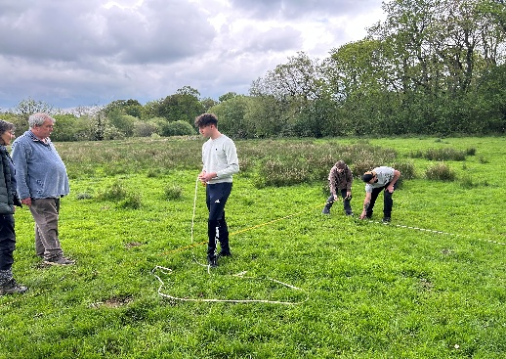
On the days leading up to the excavation we had 2 lectures to attend to which told us all about what we were going to be doing at this dig. At this point I was feeling excited to finally be doing something physical on this course instead of only lectures. Although I did find it difficult to figure out what I had to bring and did end up forgetting a few things. My friend who does outdoor education (meaning he has all the necessary equipment for anything outdoorsy) let me borrow a sit mat, which stopped my bottom getting wet while sitting on the grass. A big water bottle, as I didn’t have one that would carry enough water. And some gloves, which I found the most useful out of anything as I found it stopped my hands from hurting as much, and I got a lot less bruises and blisters then everyone else. So, I am very grateful for my friend for lending those to me. I didn’t look forward to waking up so early as I don’t sleep very well, so having to wake up at 8 everyday was not my cup of tea.
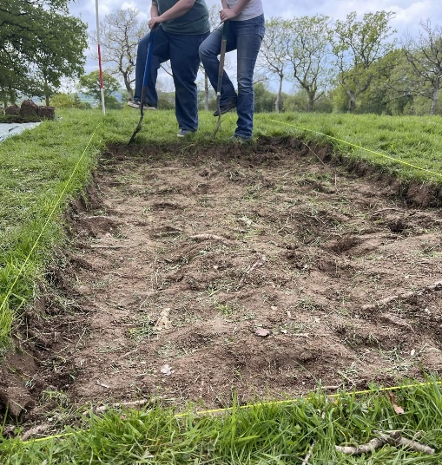
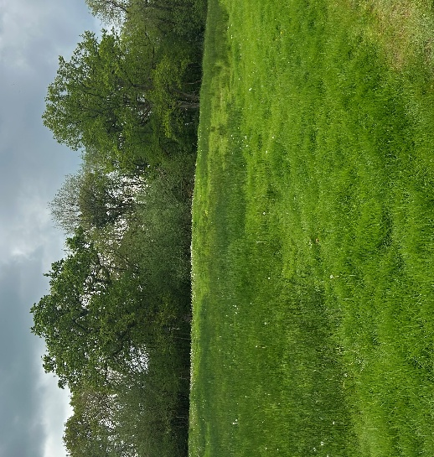
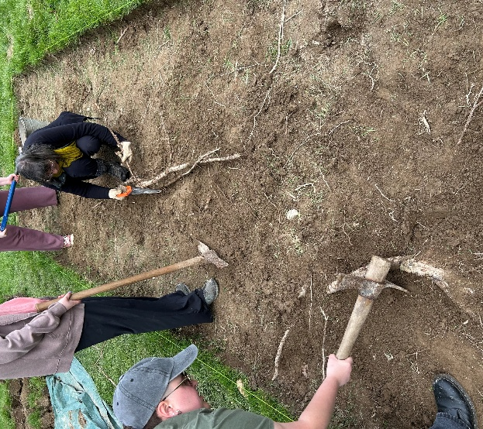
I was feeling energised going into the first day, I was ready to get into what there was to offer. On the bus ride over I noticed how much the flowers had bloomed and the trees were green, and it’s hard not to notice the terrain changing as you travel through Wales, I find there is a lot more hills in the midlands then the south. Another thing I noticed a lot of were the little lambs and their mothers, that made me happy. The first step was to make the trenches that we were going to be digging in. we were taught to use Pythagoras’ theorem rules to get the 90° angles that we needed to measure the dimensions of the trenches, the rule was to measure 3m by 6m for the length and width of the trench, and then to measure 4m down the 6m line and connect it to the 3m line and the length between the 2 spaces should be 5m. we did this for all the right angles of the trench to make sure that everything would end up being even and we would have a nice solid area to dig from. We used 6-inch nails to secure the rope down which we would use as our guidelines for the outer edges of the trench. A pole was also placed in the corner that we would label (1). The area of our trench was placed on an old lake, however ours was slightly on a mound which is where we believed there might have been a little island. As the land around was slightly boggy and all covered in reeds. But our trench had none of that. It was around 1pm at this point and I was starting to feel tired out from all the digging we had to do, we also discovered that we had enormous amounts of tree roots in our trench. Which would also lead to be our biggest downfall. With a few small finds of quartz, a bottle cap and some nuts the first day was over.
De-turfing (me and Kayla)
5m
4m
3m
The terrain around our trench
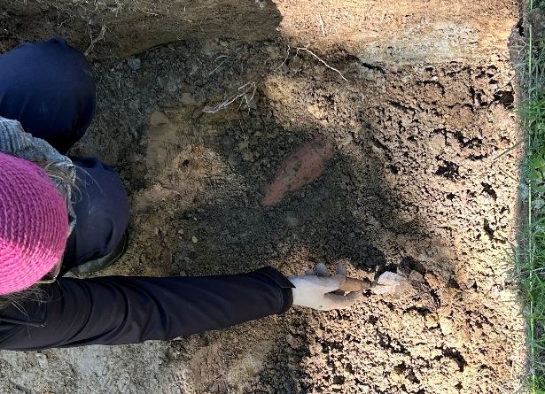
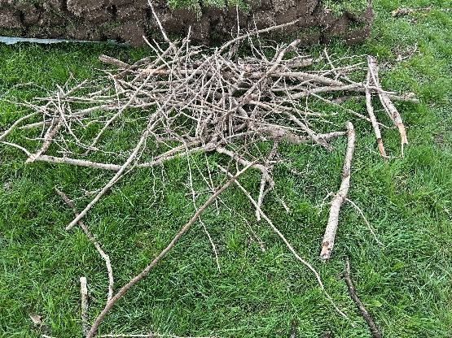
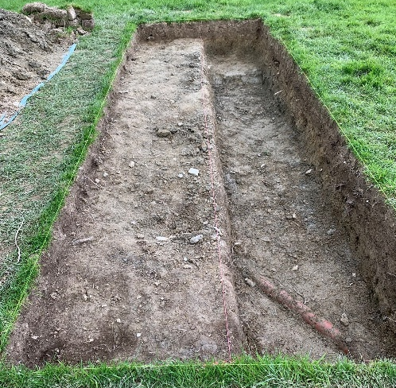
The second day was all about trying to get the roots out, as they were everywhere. We used mattocks, shovels, saws, anything and everything we could to try and get them out. I was finding this part quite difficult and took a lot of patience to get them out correctly, we spent hours trying to uncover the roots that were on the top only to then find more and more roots the further down we went, this took a lot out of us as a team. This day we made quite a lot more finds then before we found fragments of pottery, although they were modern (19th-20th century) it was still exciting to be able to find something like that for myself in such a random location as well. We found chunks of iron, quartz, charcoal, nuts – which to me seemed like they had bite marks taken out of them which let us as a group to think there could’ve possibly been rats around where we dug, as we also found small hollow tunnels in our hole. Parts of clay, and seeds. As the textures of our trench were too different, we split the trench in half so we could go deeper and find out what was under there, and as it was too deep, we had to create a sort of step to get in and out. This is when we ran into a pipe which didn’t look to be in use anymore but that kind of told us that this area had been dug up before, so it was interesting for me to see how much the tree roots had taken over considering.
Uncovering the pipe
Most of the roots we had to get out of the trench
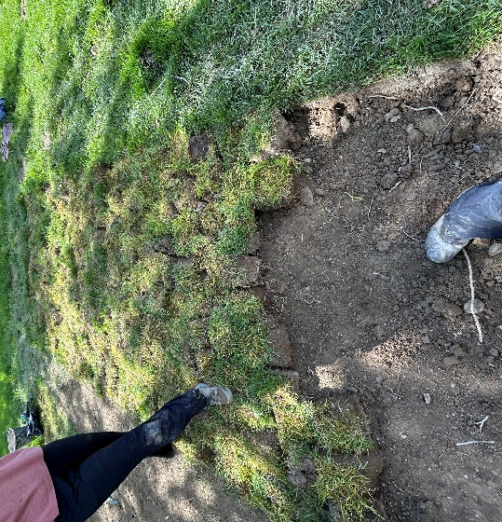
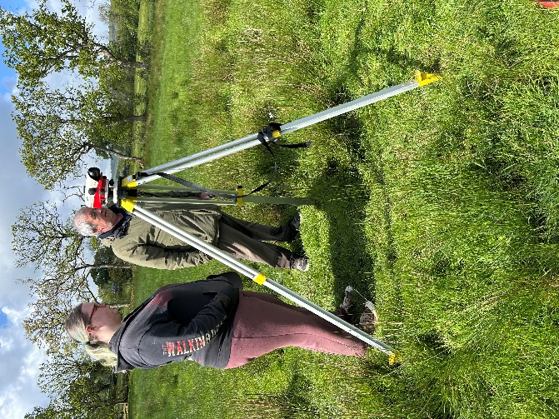
Being taught how to do the levelling was interesting, we had to find out the rough estimate of our trench above sea level. Luckily for us there were 2 posts on site that we could easily measure to get our first numbers, the post was 71.87m above sea level, which led us to work out the leveller was 72.02m above sea level. In the end we had 13 different level points in our trench and had to measure them all which was an easy enough job. I think the backfilling day is the day that took the most out of me, as me and Kayla started the day helping to backfill another trench for an hour or 2 whilst the rest of our team did some more levelling so we could find out the depth of every area of our trench. The rain was so heavy this day we ended up sitting in the tent for about an hour too, I think it was nice to have that as a break. The rain made it freeze however so I found if I didn’t stop working id be way too cold. I would say the backfilling took us about 3-4 hours and the re-turfing took us around 1. The staff were very helpful, and I felt very grateful that they offered to help us with parts of it.
The final product of our trench, with the step and pipe
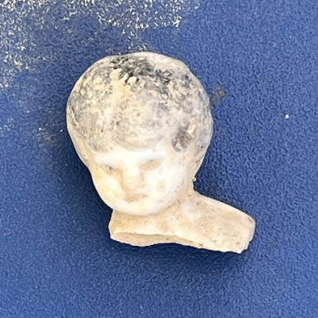
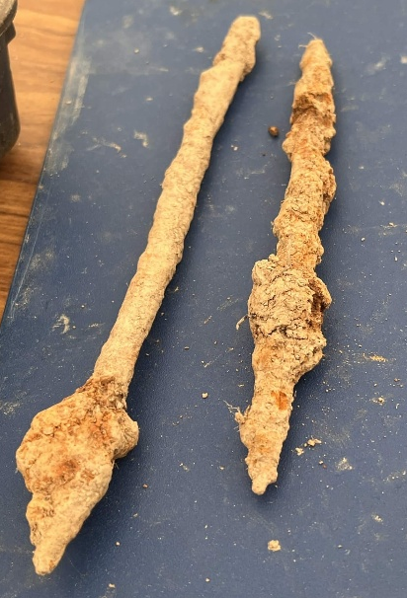
One of my most exciting finds from the dig was this little ceramic girl dolls head, I found that this showed us proof of domestication, and it let me to ask the question what it is doing by an old river. Unless there was some sort of building nearby. Another thing we found that contradicts my point was a harrow, which shows proof of agriculture, a harrow is part of a surface tillage tool, used to break up the soil and level the ground. So, in our trench we found both domestic and agriculture proof. this means that there was proof of past human activities and settlement, the presence of these objects suggests that the inhabitants were engaged in farming, processing food and even storing goods. Which helps us as archaeologists understand deeper the daily lives of the people who lived in the wetland area and how they interacted with it. I was over the moon when I found this piece of ceramic as it made me believe that in the difficulty of our trench there were objects worth it inside.
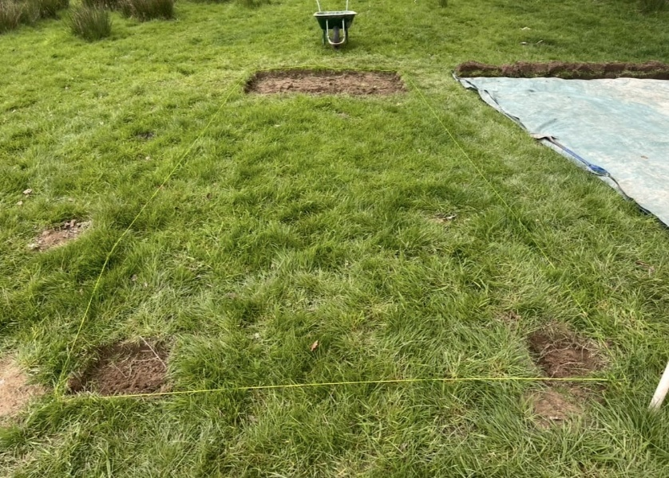
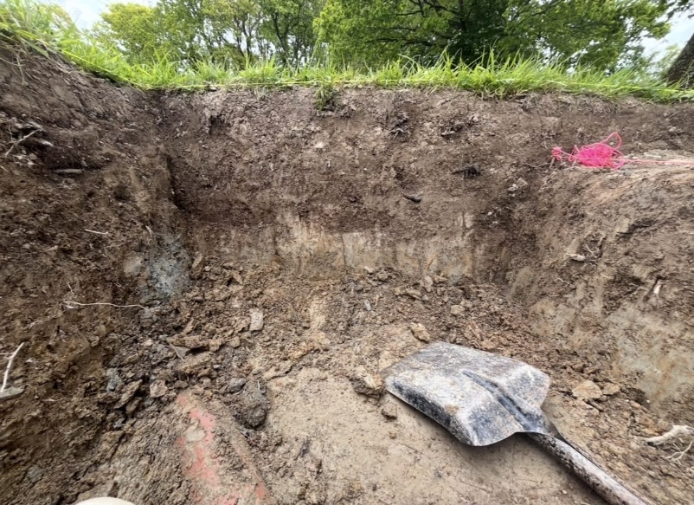
In conclusion, I really enjoyed my time at Talsarn but I do think it was a very big mental and physical work out, I learnt how important it was to work as a team In a time like this so that we all don’t get too tired too quickly, and to work together to face tough scenarios such as the tree roots we faced in the beginning, this also took a lot of patience and observation skills. As it was important we all looked out for little things in case someone missed something interesting or important.
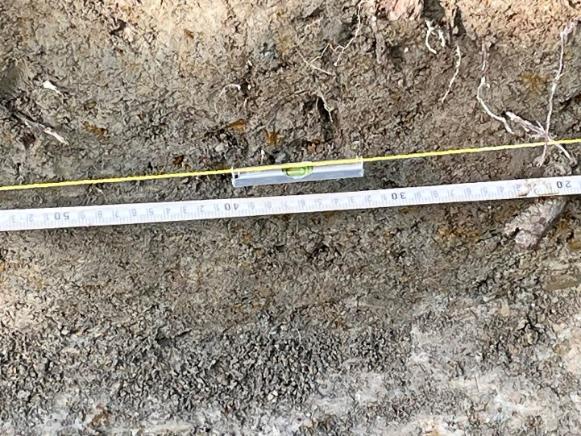
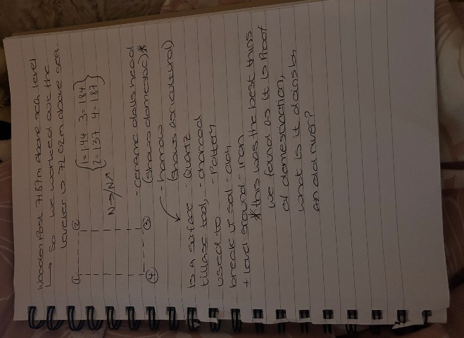
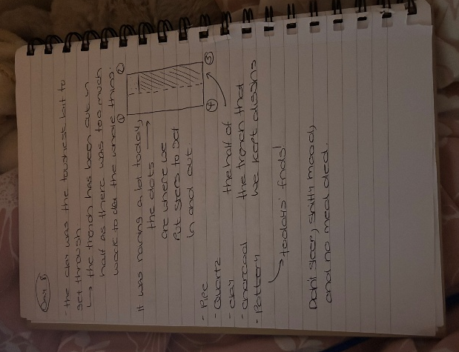
These are some extra pictures showing the different textures of the layers we dug through, our trench before any work and more levelling and some of my notes throughout the dig.

