

Project Proposal Title - Is the external challenge good or bad? Analyse the impacts of the external environment on employee recruitment and retention
Student Name: Andreea Catalina Mecic
Student number: 2215573
Assessment 2
Module Title: Personnel Resourcing and Development
Module Number: BMIH5005
Lecturer’s Name: Helen Lee

Contents
1 Introduction 4
1.1 Background of the Hotel 4
1.2 Current Challenges in the Hotel Industry 4
1.3 Factors Affecting Employee Retention 5
2 Discussion - Literature 5
2.1 Importance of Employee Retention 5
2.2 PESTLE Analysis 5
2.2.1 Political Factors 5
2.2.2 Economic Factors 6
2.2.3 Social Factors 6
2.2.4 Technological Factors 7
2.2.5 Legal Factors 8
2.2.6 Environmental Factors 8
3 SWOT Analysis 9
3.1 SWOT Summary 10
4 Industry Examples 10
5 Influence of Specific External Challenges 11
5.1 AI Advancement 11
5.2 Retirement Tide 11
5.3 Brexit 12
5.4 Covid-19 12
5.5 Inflation 12
5.6 Economic Downturns 12
6 Potential Solutions 12
7 Evaluation of Findings 13
7.1 Recommendations 13
7.2 Conclusion 14
8 References 15

Introduction
The hotel sector is crucial in the larger service business since it caters to those looking for overnight housing (Serra et al., 2018). Despite clear differences in size, it retains secure links to the travel and hospitality industries. The main goal of this research proposal is to thoroughly examine the challenges brought on by the outside world. It aims to discover more about how these challenges affect hiring and retention practices in the hotel sector.

Background of the Hotel
With an extensive portfolio of more than 578 hotels and more than 40,000 rooms, Premier Inn is the largest hotel chain in the UK (Ghandour et al., 2015). Particularly, when Premier Inn was established in 1987, it first ran under the name "Travel Inn". It is owned by Whitbread, a business with a long history of providing eating, hotel, and beverage services as part of its main mission. When Premier Inn first opened, its goal was to compete with Lord Forte's Travelodge brand. As a well-known, award-winning organisation, Premier Inn remains the UK's biggest and fastest-growing hotel brand (Bower, 2018). The main goal of this research proposal is to thoroughly examine the complex challenges brought on by the outside world. It aims to discover more about how these challenges affect hiring and retention practices in the hotel sector.

Current Challenges in the Hotel Industry
Nevertheless, despite the progress made, the hotel industry still confronts intrinsic challenges that make managing hotel operations more challenging, prompting an examination of their implications on staff recruitment and retention (Nam et al., 2021). The constant difficulties of hiring and keeping workers are still significant in the hospitality sector. In addition, a key barrier in the hotel business is the lack of skills among new graduates from academic institutions, exacerbating the sector's difficulties (Willie et al., 2017). The responsibilities in the sector have also increased due to the recent dramatic rise in the cost of food, supplies, and other products that are needed daily. Incorporating artificial intelligence (AI) in the hotel industry may also have certain hazards (Nam et al., 2021). One of these concerns is the possibility of job displacement since automation of some jobs, like check-ins or housekeeping, might result in job losses for some employees in the hospitality industry.

Factors Affecting Employee Retention
Staff Shortage: An issue that surfaced during the pandemic is the continued global scarcity of workers in the hotel and tourist sector (Choy et al., 2021). The seriousness of this problem is highlighted by figures from the European Union, where more than 1.2 million jobs in the tourist industry are still unfilled (Da Vet et al., 2021). Premier Inn Hotel has faced considerable challenges due to the lack of qualified hospitality workers.
Operational Issues: There are several operational issues in the hotel sector. These include handling reservations, providing guest services, carrying out different front desk duties, maintaining cleanliness in hotel rooms and public spaces, and more (Frye et al., 2020). Premier Inn hotel customers are usually dissatisfied and distressed when hotel departments can't effectively coordinate their actions.

Discussion - Literature

Importance of Employee Retention
The importance of staff retention in the hotel sector is crucial. Retention not only guarantees the continued existence of employees inside the hotel but also boosts productivity and encourages higher levels of engagement, which boosts income (Singh, 2019). Contrarily, a high turnover rate can negatively impact customer satisfaction, resulting in the loss of knowledgeable staff familiar with the complexities of the hotel and its processes. Customer satisfaction and service quality deterioration can be directly linked to this turnover.

PESTLE Analysis

Political Factors
The government has a strong hold on the hotel industry. For instance, when the government enacted a travel ban, it negatively impacted the Premier Inn hotels and caused a labour shortage. Political unrest in the form of the post-Brexist era added uncertainty to the labour market in the hotel industry, which in turn affected decisions about hiring within the hotel industry, including the Premier Inn hotels (Davern, 2021).

Economic Factors
Economic conditions like inflation, joblessness, economic downturn, and financial instability substantially impact the hotel business and, in turn, directly impact how the budget is allocated for hiring. According to Statista (2023), the average weekly wage for all employees in the United Kingdom increased by 8.5 percent in 2023. The UK is experiencing an increase in labour conflicts, including strikes, as a result of the convergence of high inflation and slow pay growth.

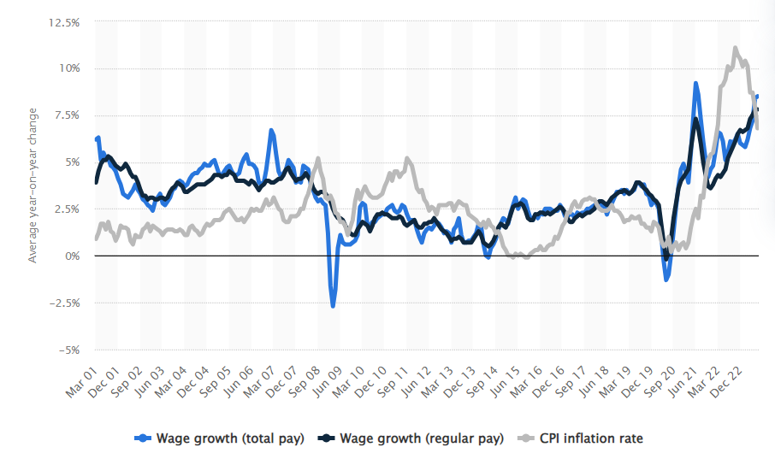
Figure 1: Average Wage Growth. Source: Statista (2023)

Social Factors
According to Statista (2022), customer decisions are greatly influenced by online customer reviews and online ratings in the intensely competitive world of the modern hotel sector. Premier Inn prioritises employee retention because it realises a prepared workforce's critical role in providing excellent guest experiences. Reservations are directly and positively impacted by the positive evaluations and positive reviews left by satisfied customers, highlighting the significance of staff retention in maintaining a strong position in this competitive environment.
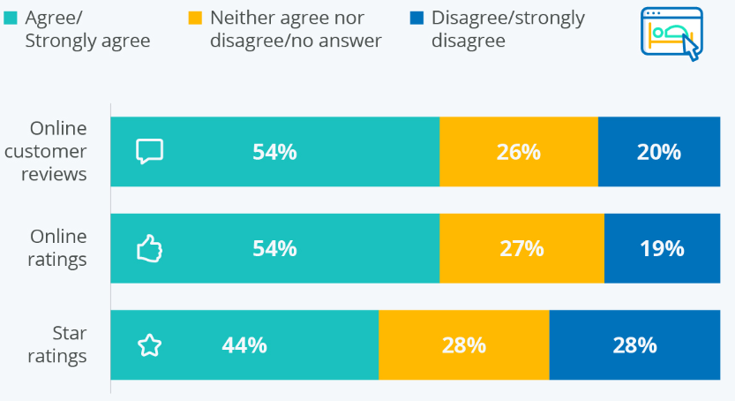
Figure 2: Online Customer Review. Source: Statista (2022).

Technological Factors
The advent of AI innovations in the hotel industry is a challenge for Premier Inn since they threaten employment stability by replicating human cognitive processes. Concerns regarding staff turnover and job instability have increased due to the rising automation and increased installation of robots. According to research, by 2030, automation may displace more than 30 million industrial jobs worldwide (Parschau et al., 2020).

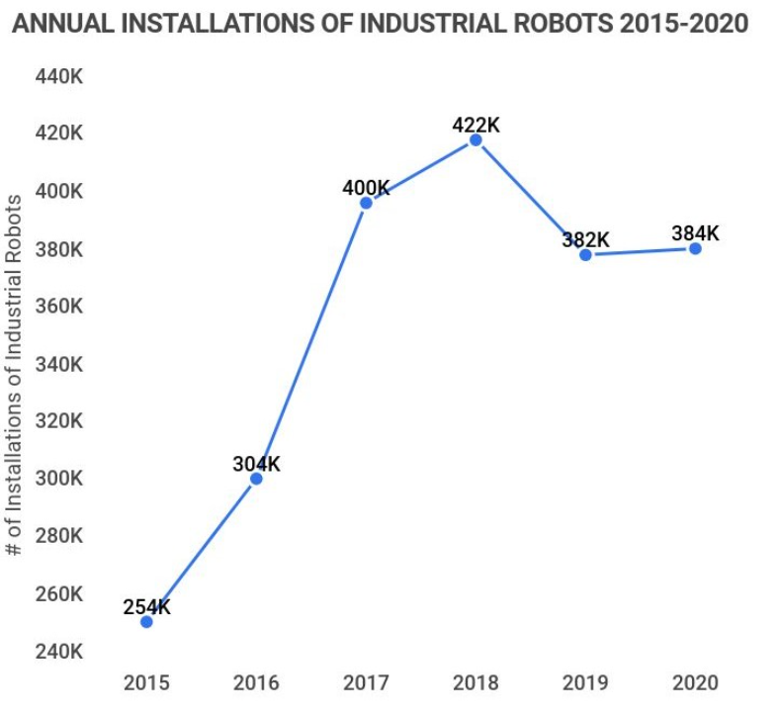
Figure 3: Annual Installations of Robots. Source: Parschau et al. (2020).

Legal Factors
Compliance with labour laws is crucial for achieving legal compliance and ensuring employee satisfaction. For instance, the National Minimum Wage Act in the UK creates fair compensation rules, ensuring that workers are paid in line with their job functions and responsibilities (Reeves et al., 2017). The Premier Inn Hotel places a high priority on strictly adhering to UK labour laws as a way to ensure complete legal compliance.

Environmental Factors
Hotels are increasingly emphasising environmental sustainability because they understand that such efforts may increase employee satisfaction and attract potential employees who share and resonate with the hotel's basic values (Shakeel et al., 2015). The Premier Inn puts great emphasis on sustainable practices within its operations, which ensures the well-being of its staff and the environment.

SWOT Analysis
Strengths  The hotels of Premier Limited are ideal locations, increasing their attractiveness to visitors and business travellers. Building a solid brand reputation resulted in consumer loyalty and good feedback. Premier Limited's hotels are distinguished by providing excellent customer service and using well-trained employees.  Offering a variety of amenities such as restaurants, spas, and conference facilities will help you reach a wider audience.  Using technology to make reservations check-ins, and provide tailored services can help to simplify operations. | Weaknesses  High operating costs, particularly in luxury hotels, may influence profitability.  In the hotel sector, intense rivalry necessitates ongoing innovation and marketing initiatives.  Staff Turnover: High turnover rates can have an impact on service consistency and training costs.  Upkeep and upgrading older hotels may be expensive and time-consuming. Demand fluctuations caused by seasons and economic situations might be difficult to manage.
Opportunities  Customers can be increased by entering new markets or expanding existing ones.  Eco-friendly projects can attract ecologically aware visitors. Smart room technologies and Internet booking systems can improve visitor experiences. Collaborations with travel agents or internet platforms can increase exposure. As travel resumes following the COVID-19 outbreak, there may be pent-up demand for hotel accommodations. | Threats  Economic downturns can impact travel and occupancy rates.  Negative internet reviews can have a negative impact on your reputation and bookings. Changing legislation concerning travel, safety, and health can have an impact on operations. Hotel operations in disaster-prone locations may be disrupted and property damaged. Market share may be impacted by increased competition from new hotels and accommodation choices.

SWOT Summary
Premier Limited's strengths in the hotel sector include ideal sites, a solid reputation, exceptional service, various facilities, and successful technological integration (Ramadhani, 2017). However, it has a number of obstacles, including high operational expenses, severe competition, significant personnel turnover, aged infrastructure, and seasonal demand changes. Premier Limited should investigate prospects such as market expansion, sustainable practices, technological integration, collaborations, and the recovery of post-pandemic tourism to flourish in this field. On the other hand, potential hazards include economic downturns, unfavourable internet reviews, legislative changes, natural disasters, and greater competition from new entrants (George, 2021). Premier Limited's hotel industry performance will depend on a strategy focusing on exploiting strengths, fixing weaknesses, capitalising on opportunities, and reducing risks.

Industry Examples
In recent years, the Radisson Hotel, like many others in the hotel business, has encountered a slew of external obstacles, including the COVID-19 epidemic and altering client preferences. They executed a number of strategic measures in order to adapt and prosper. The Radisson Hotel prioritised the protection of its guests and employees by instituting stringent health and safety measures. This includes improved cleaning procedures, contactless check-in/check-out, and recommendations for social distancing in public places. Radisson implemented flexible booking arrangements in response to the unpredictability of travel plans during the pandemic. This allowed guests to change or cancel bookings without incurring charges, giving them peace of mind. To improve the guest experience, the hotel invested in technology. To decrease physical touch, these include smartphone check-in, keyless room entrance, and digital concierge services (Joshi and Gupta, 2021). Radisson created advertising campaigns emphasising their dedication to cleanliness and safety. This increased potential visitors' trust and underscored their commitment to a safe stay. Because travel restrictions were affecting occupancy rates, some Radisson sites looked into alternate revenue streams. This includes providing temporary office space in the form of day-use rooms and catering to local clients for meals and events. Recognising the rising importance of sustainability, Radisson has continued to invest in environmentally friendly measures such as energy-efficient systems and waste reduction programs (Lama and Rai, 2021). The Radisson Hotel intended to assure visitor happiness, staff well-being, and long-term success in the competitive hospitality business by embracing these tactics and keeping adaptive in the face of external obstacles.

Influence of Specific External Challenges
In recent years, a number of external issues have had a substantial influence on staff recruitment and retention. Each of these external challenges necessitates flexibility and creative HR tactics. To remain competitive in an ever-changing market, successful firms proactively alter their recruiting and retention strategies (Hámornik and Krasznay, 2017).

AI Advancement
With automated screening and chatbots, the emergence of artificial intelligence has revolutionised recruiting procedures. Companies such as Unilever, for example, utilise AI to evaluate video interviews, expediting their employment process (Loureiro et al., 2021).

Retirement Tide
Organisations will suffer knowledge shortages when Baby Boomers retire. To address this, firms such as IBM have created mentoring programs in which experienced employees pass on their knowledge to their younger counterparts (Losekoot and Theresa, 2018)

Brexit
Brexit has created uncertainty in job markets. Firms operating in the United Kingdom, such as Jaguar Land Rover, had to plan ahead of time to ensure the availability of skilled workers following Brexit, which impacted their recruitment efforts (Sheel, 2017).

Covid-19
The pandemic altered work dynamics, with remote work becoming more widespread. Companies such as Twitter and Shopify are implementing permanent remote work possibilities, which is influencing talent recruitment beyond geographical limits (Hao et al., 2020).

Inflation
Salary expectations are affected by inflation. To deal with this, some businesses provide more flexible remuneration packages, such as profit-sharing, in order to retain talent while controlling expenses (Huy, 2019).

Economic Downturns
Economic downturns may restrict employment and result in layoffs. General Electric suspended recruiting and used voluntary layoffs to handle economic hurdles during the 2008 financial crisis.

Potential Solutions
Prioritise Employee Training: Premier Inn has to provide extensive training and skill development programmes to address the lack of qualified workers in the hospitality industry (Ashton, 2018). The service quality at Premier Inn may be improved, employee satisfaction can be increased, and turnover rates can be reduced by investing in a well-trained team.
Embracing Advanced Technology: The development of AI and automation may bring difficulties, but Premier Inn can deliberately incorporate technology to complement rather than replace the responsibilities played by humans (Nam et al., 2021). For instance, AI may be used for data analysis to customise visitor experiences, freeing staff members to focus on providing first-rate service.
Implement Benefits Packages: Premier Inn should constantly assess and improve its pay packages to be competitive in a changing economic environment. The hotel can maintain its present staff and attract new talent by giving competitive compensation and complete perks like healthcare and retirement plans.

Evaluation of Findings
The findings on staff recruitment and retention in the UK hotel business have far-reaching ramifications for a variety of stakeholders. To begin, hotel owners and managers must address these issues since high turnover rates can lead to greater operating expenses and poor service quality. Improved retention may lead to more stable and experienced personnel, which improves visitor happiness and loyalty. Furthermore, the reported repercussions have larger economic implications. A steady and contented hotel staff benefits local economies by increasing customer spending and tax revenues. It also helps boost the tourist industry, an important part of the UK economy (Oukil, 2016). Finally, the findings emphasise the critical significance of good recruiting and retention tactics in sustaining the profitability and expansion of the UK hotel sector, with far-reaching implications for both enterprises and the wider economy.

Recommendations
The recognised effects of staff recruitment and retention in the UK hotel business are quite important. First and foremost, a professional and steady team improves visitor satisfaction, resulting in great ratings and repeat business. Reduced turnover also reduces recruitment expenses and minimises service disruption. Furthermore, experienced employees can give greater customer service, which helps the hotel's reputation and competitiveness in a congested industry. Furthermore, enhanced employee morale and job security increase production and teamwork, eventually leading to a higher bottom line (Lu and Tabari, 2019). In conclusion, efficient recruiting and retention procedures are critical in the UK hotel business for guaranteeing operational efficiency, profitability, and a great guest experience.

Conclusion
The effects of staff recruitment and retention for Premier Inn Limited Hotel are critical. A strong recruiting strategy assures a pool of talented and devoted employees, which improves service quality and visitor happiness. Retaining these personnel results in lower turnover costs, a more stable staff, cheaper recruiting costs, and increased operational efficiency. Furthermore, long-tenured employees frequently have substantial institutional knowledge, which aids in smooth operations and customer interactions (Haynes, 2016). Finally, these techniques help build Premier Inn's reputation for exceptional hospitality, which leads to repeat business and favourable word-of-mouth marketing, which are significant advantages in the highly competitive hotel sector. Premier Inn's long-term performance is based on excellent recruiting and retention techniques.

References
Ashton, A.S., 2018. How human resources management best practices influence employee satisfaction and job retention in the Thai hotel industry. Journal of Human Resources in Hospitality & Tourism, 17(2), pp.175-199.
Bower, J., 2018. Whitbread: Routines and resource building on the path from brewer to retailer. Management & Organizational History, 13(1), pp.1-23.
Choy, M.W. and Kamoche, K., 2021. Identifying stabilising and destabilising factors of job change: A qualitative study of employee retention in the Hong Kong travel agency industry. Current Issues in Tourism, 24(10), pp.1375-1388.
Davern, D., 2021. Talent management, the employer brand, and employee retention: evidence from the Irish hotel sector. In Talent management innovations in the international hospitality industry (pp. 79-98). Emerald Publishing Limited.
De Vet, J.M., Nigohosyan, D., Ferrer, J.N., Gross, A.K., Kuehl, S. and Flickenschild, M., 2021. Impacts of the COVID-19 pandemic on EU industries (pp. 1-86). Strasbourg, France: European Parliament.
Frye, W.D., Kang, S., Huh, C. and Lee, M.J.M., 2020. What factors influence Generation Y’s employee retention in the hospitality industry?: An internal marketing approach. International Journal of Hospitality Management, 85, p.102.
George, R., 2021. Tourism and Hospitality Marketing Planning. In Marketing Tourism and Hospitality: Concepts and Cases (pp. 149-182). Cham: Springer International Publishing.
Ghandour, R., Bilal, J. and Mudassar, H., 2015. Relationship between Service Quality, Customer Retention and the Role of Social Media-Case study Premier Inn Hotel (UK). Journal of Organizational Studies and Innovation, 2(4), pp.1-12.
Hámornik, B.P. and Krasznay, C., 2017. Prerequisites of virtual teamwork in security operations centres: Knowledge, skills, abilities and other characteristics. Academic and Applied Research in Military and Public Management Science, 16(3), pp.73-92.
Hao, F., Xiao, Q. and Chon, K., 2020. COVID-19 and China’s hotel industry: Impacts, a disaster management framework, and post-pandemic agenda. International journal of hospitality management, 90, p.102636.
Haynes, N., 2016. The evolution of competitor data collection in the hotel industry and its application to revenue management and pricing. Journal of Revenue and Pricing Management, 15, pp.258-263.
Huy, D.T.N., 2019. The Analysis of Volatility of Viet Nam Hotel Industry Market Risk after the Low Inflation Period 2015-2017. Medcave J Bus Manag, 2, p.109.
Joshi, V.A. and Gupta, I., 2021. Assessing the impact of the COVID-19 pandemic on hospitality and tourism education in India and preparing for the new normal. Worldwide Hospitality and Tourism Themes, 13(5), pp.622-635.
Lama, R. and Rai, A., 2021. Challenges in developing sustainable tourism post COVID-19 pandemic. In Tourism Destination Management in a Post-Pandemic Context: Global Issues and Destination Management Solutions (pp. 233-244). Emerald Publishing Limited.
Losekoot, E. and Theresa, Z., 2018. Retirement villages: hospitals or hospitality operations–management attributes and traits. Journal of Hospitality and Tourism Management, 34, pp.75-81.
Loureiro, S.M.C., Ashfaq, M. and Rodrigues, M.O.B., 2021. AI Meaning and Applications in the Consumer Sector of Retailing, Hospitality, and Tourism. In Handbook of Research on Applied Data Science and Artificial Intelligence in Business and Industry (pp. 291-303). IGI Global.
Lu, L. and Tabari, S., 2019. Impact of Airbnb on customers' behaviour in the UK hotel industry. Tourism Analysis, 24(1), pp.13-26.
Nam, K., Dutt, C.S., Chathoth, P., Daghfous, A. and Khan, M.S., 2021. Adopting artificial intelligence and robotics in the hotel industry: prospects and challenges. Electronic Markets, 31, pp.553-574.
Oukil, A., Channouf, N. and Al-Zaidi, A., 2016. Performance evaluation of the hotel industry in an emerging tourism destination: The case of Oman. Journal of Hospitality and Tourism Management, 29, pp.60-68.
Parschau, C. and Hauge, J., 2020. Is automation stealing manufacturing jobs? Evidence from South Africa’s apparel industry. Geoforum, 115, pp.120-131.
Ramadhani, F., Raka, I.G.P. and Tavio, T., 2017. Desain Modifikasi Struktur Gedung Hotel Premier Inn Surabaya dengan Menggunakan Beton Prategang dan Sistem Rangka Pemikul Momen Khusus (SRPMK). Jurnal Teknik ITS, 6(2), pp.D309-D314.
Reeves, A., McKee, M., Mackenbach, J., Whitehead, M. and Stuckler, D., 2017. Introduction of a national minimum wage reduced depressive symptoms in low‐wage workers: a quasi‐natural experiment in the UK. Health economics, 26(5), pp.639-655.
Serra-Cantallops, A., Peña-Miranda, D.D., Ramón-Cardona, J. and Martorell-Cunill, O., 2018. Progress in research on CSR and the hotel industry (2006-2015). Cornell Hospitality Quarterly, 59(1), pp.15-38.
Shakeel, N. and But, S., 2015. Factors influencing employee retention: An integrated perspective. Journal of Resources Development and Management, 6(1), pp.32-49.
Sheel, A., 2017. Hotel industry performance in 2016–2017 and the JHFM index. The Journal of Hospitality Financial Management, 25(2), pp.75-76.
Singh, D., 2019. A literature review on employee retention with a focus on recent trends. International Journal of Scientific Research in Science and Technology, 6(1), pp.425-431.
Statista Infographics. (2022). Infographic: Online hotel reviews are more important to consumers than star classification. [online] Available at: https://www.statista.com/chart/28992/influenceing-factors-in-accommodation-booking-online/.
Statista. (2023). UK wage growth vs inflation 2023. [online] Available at: https://www.statista.com/statistics/1272447/uk-wage-growth-vs-inflation.
Willie, P.A., Connor, D., Sole, J., Forgacs, G., Grieve, R. and Mueller, J., 2017. Human capital challenges in the hotel industry of Canada: finding innovative solutions. Worldwide Hospitality and Tourism Themes, 9(4), pp.402-410.

