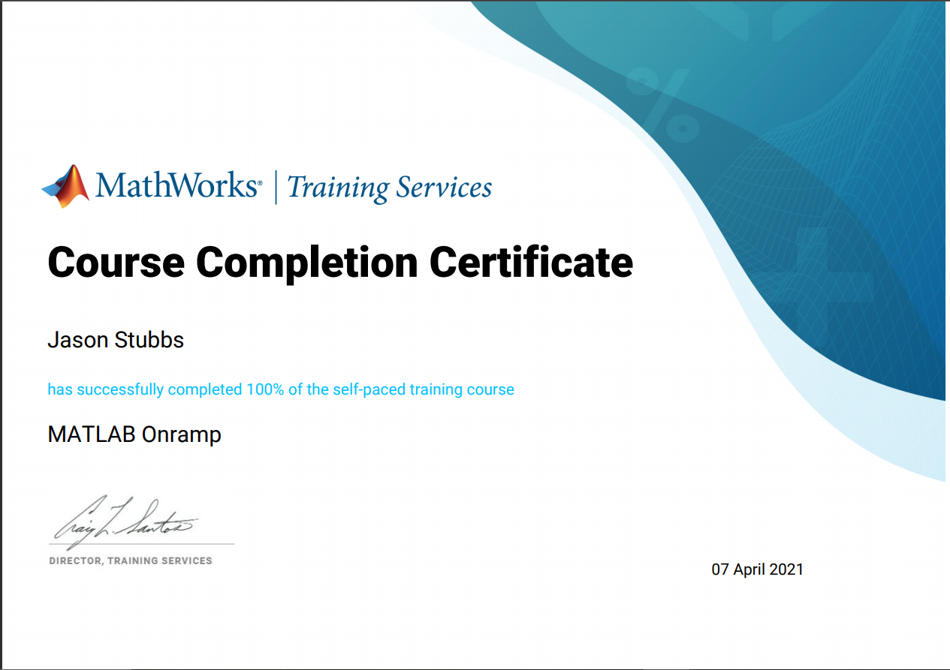
Monty Pithon Assignment
(Top secret, classified)

Scene: A cafe. One table is occupied by a group of Vikings with horned helmets on. A man and his wife enter.
Man (Eric Idle): You sit here, dear.
Wife (Graham Chapman in drag): All right.
Man (to Waitress): Morning!
Waitress (Terry Jones, in drag as a bit of a rat-bag): Morning!
Man: Well what’ve you got?
Waitress: Well, there's egg and bacon; egg sausage and bacon; egg and spam; egg bacon and spam; egg bacon sausage and spam; spam bacon sausage and spam; spam egg spam spam bacon and spam; spam sausage spam spam bacon spam tomato and spam;
Vikings (starting to chant): Spam spam spam spam...
Waitress: ...spam spam spam egg and spam; spam spam spam spam spam spam baked beans spam spam spam...
Vikings (singing): Spam! Lovely spam! Lovely spam!
Waitress: ...or Lobster Thermidor au Crevette with a Mornay sauce served in a Provencale manner with shallots and aubergines garnished with truffle pate, brandy and with a fried egg on top and spam.
Wife: Have you got anything without spam?
Waitress: Well, there's spam egg sausage and spam, that's not got much spam in it.
Wife: I don't want ANY spam!
Man: Why can't she have egg bacon spam and sausage?
Wife: THAT'S got spam in it!
Man: Hasn't got as much spam in it as spam egg sausage and spam, has it?
Vikings: Spam spam spam spam (crescendo through next few lines)
Wife: Could you do the egg bacon spam and sausage without the spam then?
Waitress: Urgghh!
Wife: What do you mean 'Urgghh'? I don't like spam!
Vikings: Lovely spam! Wonderful spam!
Waitress: Shut up!
Vikings: Lovely spam! Wonderful spam!
Waitress: Shut up! (Vikings stop) Bloody Vikings! You can't have egg bacon spam and sausage without the spam.
Wife (shrieks): I don’t like spam!
Man: Sshh, dear, don't cause a fuss. I'll have your spam. I love it. I'm having spam spam spam spam spam spam spam beaked beans spam spam spam and spam!
Vikings (singing): Spam spam spam spam. Lovely spam! Wonderful spam!
Waitress: Shut up!! Baked beans are off.
Man: Well could I have her spam instead of the baked beans then?
Waitress: You mean spam spam spam spam spam spam... (but it is too late and the Vikings drown her words)
Vikings (singing elaborately): Spam spam spam spam. Lovely spam! Wonderful spam! Spam spa-a-a-a-a-am spam spa-a-a-a-a-am spam. Lovely spam! Lovely spam! Lovely spam! Lovely spam! Lovely spam! Spam spam spam spam!

