
Skills for the Workplace
Module Assignment Submission
Student Name: | ANGEL BRAZIER-LEWIS
Student Number: | 1702844
Module No: | BMSK4004
Module Title: | Problem Solving and Decision Making

Statement of Confirmation of Authenticity
By the act of making this submission, the student declares that this is the work of the student named above. The work has not, in whole or in part, been knowingly presented elsewhere for assessment, or where assessment has been built on a previous assessment, this has been identified. Where materials have been used from other sources it has been properly acknowledged. If this statement is untrue, the student acknowledges that an assessment offence has been committed.
Attention is drawn to the plagiarism and unfair practice policies of UWTSD.

Contents
Define a complex problem in the workplace, including its scope and impact 3
Analyse information on the identified problem, to help inform the decision-making process 4
Brainstorming 4
Mind Mapping 6
Root Cause Analysis 7
Cause and Effect 8
Propose a range of alternative solutions to the problem 9
Using a decision-making technique, evaluate a range of solutions to identify the most appropriate option 10
Grid Analysis 10
Cost Benefit Analysis 10
Develop a detailed plan for implementing the solution 12
Gantt Chart 13
Communicate the plan to relevant stakeholders 13
Assess appropriate monitoring and review techniques to ensure successful implementation of solution 15
References 15

Define a complex problem in the workplace, including its scope and impact

The business is experiencing high test failure rates on medical devices due to Electrostatic Discharge, also known as ESD. ESD damage can happen where there is a difference in power in between objects. PCB’s and their components are extremely sensitive, if they are in contact with conductive items, this will result in a discharge which in turn damages the product, rendering it useless. (Static Safe Environments, 2022)
This is a Strategic Problem. Significant consequences will arise from this issue which will affect the organisation. Test procedures have indicated that 27% of all medical devices have failed due to ESD damage. This is a considerable proportion of materials and requires immediate attention to minimise disruption to sales, cash flow and the consumer.
The solution needs to be found quickly and efficiently. As time goes on, more damage will occur resulting in higher production and material costs. Resource is needed to solve the problem; however, this is challenging due to the lack of staff in all departments. The problem should be solved utilising as little resource as possible. The business is also suffering financial hardship due to falling profits, which impacts the available budget for the resolution of this issue.
The actual situation is that customers are not receiving their medical devices as laid out in their product service contracts. Their devices are failing the test procedures due to ESD damage. The desired situation is one where most, if not all devices are passing test procedures with no evidenced of ESD damage.
The owner of this problem-solving project will be the Quality Manager. Four other members of staff across four different departments will need to work together as a team alongside the Quality Manager to solve this problem. The project will require the assistance of the Production Supervisor, a Quality Engineer, and a Senior Electronic Engineer. These members of staff have the knowledge, capability, and skills to resolve the issue. Many are affected by this problem, and this ‘trickles’ down to other departments as shown in the flow chart below.

This problem impacts the entire business structure. The consequences of not solving this problem are far greater than the short-term investment needed to solve this. If the business continues to produce in this way, there will be severe financial implications as so many components and PCBs are wasted in the process. The business’ reputation is at stake as the customers are becoming increasingly frustrated with product delays and unavailability of ‘off the shelf’ products.

Analyse information on the identified problem, to help inform the decision-making process
Analysing the information at hand will inform the decision process.

Brainstorming
A focus group of employees including those already involved in the project were brought together to ‘Brainstorm’ to generate ideas to solve the identified problem. ‘Brainstorming’ is a creative problem-solving approach to analyse ideas that may be overlooked. (Proctor, 2018) Each member of the focus group was from a different department within the business such as quality, finance, supply chain, production, stores, test, service, research, and development. Having many members with different learning and thinking styles can be advantageous.
The focus group was given a description of the issue and were asked to generate as many ideas as possible to solve the problem. Post-it notes were used to display ideas on a whiteboard in the meeting room. Participants of the group were welcomed to write their ideas down and affix them to the board, taking it in turns. An administrator was involved and solely responsible for collating the ideas generated during the session. (MindTools, 2022)
The project team began a group discussion once others had started generating ideas, this brought forward more ideas and built on existing ones.
The ideas generated in the session are listed below. Each point has been marked with categories for considering their suitability to solve the problem.
Key
Y = Will be considered.
N = Will not be an option.
M = May be worth looking at further
Results
Increase the ESD Safety Area on the premises – M
Improve ESD procedures at Goods Inwards – Y
Test components and boards before they reach the production floor – Y
Increase ESD Footwear testing frequency – Y
Review ESD equipment on site – Y
Buy all new ESD equipment – N
All staff to be issued ESD footwear – Y
Ban of temporary ESD straps – M
‘ESD free’ zone for office staff – Y
Review ESD tooling – Y
Review handling of ESD components in stores – Y
Visitors banned from production floor and ESD critical zones – M
Provide ‘back up’ ESD straps for forgotten ones to all staff – Y
Consequences for not wearing suitable ESD protection – Y
Educational sessions with R&D to show impact of ESD damage to new employees – Y
Use components that are not ESD sensitive – N
Use ESD Safe storage for components and boards – Y

Feedback from this brainstorming session was positive. Participants enjoyed the activity and felt it was productive. However, brainstorming in a group like this alone is not enough to find a solution to the problem. In a group like this, people must share their ‘talking time’ with other members of the group. While group members wait for others to discuss their ideas, others may have forgotten their points, or decided that what they had to say is no longer relevant. This is called ‘Production Blocking.’ Brainwriting may have worked better in this group scenario, where everyone writes their ideas on post it notes, but they do not display or discuss these until the end of the session. This way, any ideas that may have been quashed or forgotten, would still have been considered. (Kenworthy & Paulus, 2019)
Following this exercise, it is important to discuss the outcomes, and choose the preferred options from the list to explore.
All proposed ideas marked as ‘Y’
Improve ESD procedures at Goods Inwards – Y
Test components and boards before they reach the production floor – Y
Increase ESD Footwear testing frequency – Y
Review ESD equipment on site – Y
All staff to be issued ESD footwear – Y
‘ESD free’ zone for office staff – Y
Review ESD tooling – Y
Review handling of ESD components in stores – Y
Provide ‘back up’ ESD straps for forgotten ones to all staff – Y
Consequences for not wearing suitable ESD protection – Y
Educational sessions with R&D to show impact of ESD damage to new employees – Y
Use ESD Safe storage for components and boards – Y

Preferred Options
Increase ESD Footwear testing frequency – Y - This can easily be changed and does not cost the company any more money or resource.
All staff to be issued ESD footwear – Y – This can be factored into the budget easily, with an allowance for all staff yearly.
Provide ‘back up’ ESD straps for forgotten ones to all staff – Y – This can be factored into the budget easily also.
Educational sessions with R&D to show impact of ESD damage to new employees – Y – This can be done as part of the induction process. All inductions currently include an hour with the R&D Director so this can be factored into the session to teach the importance of ESD Protection.
Test components and boards before they reach the production floor – Y – This can be done as part of the goods in procedure. It will consume more resource, but can prevent ESD damage, and any non-conforming materials, components or parts can be returned to the supplier for an exchange before it causes any issues in the warehouse or on the production floor.

Mind Mapping
Mind Mapping is a concept chart. They are a visual way of seeing ideas and the links and relationships between them. The construction relies on nodes and links. Nodes are the ideas and information typically added within shapes, and the links are the lines showing the relationship between the ideas and information. (Cohen, 2015) A spider chart was used to map out ideas to overcome this problem.
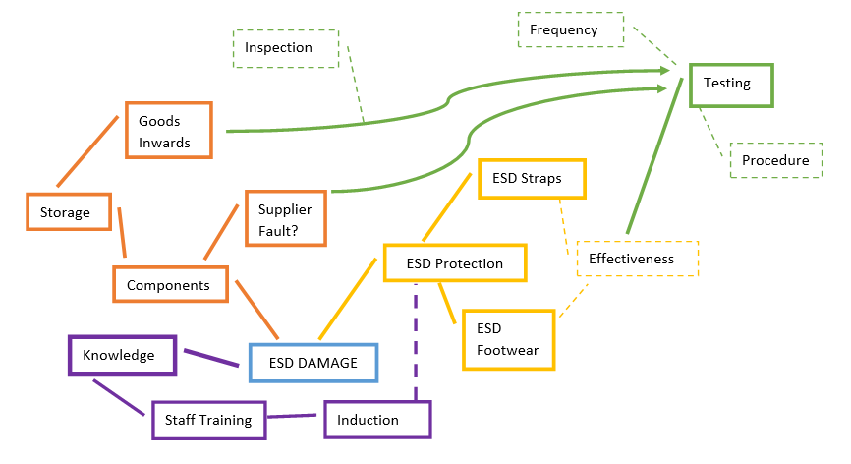
Above, you can see the links between ideas and processes relating to the problem. The information gathered is relevant to the problem. There are some links that feed into each other, such as where the induction process could include sessions about ESD protection. There are no points in this mind map where the information is irrelevant.

Root Cause Analysis
Root Cause Analysis is used to discover the underlying cause of a problem. In identifying the root cause, you can identify the solutions. The core principles of root cause analysis focus on finding a corrective action and remedying the cause, rather than the symptoms. Sometimes, there are multiple root causes. The analysis should consider how the root cause can be prevented in future. A comprehensive approach, met with holistic methods will result in an actionable analysis. (Tableau, 2022)
The most familiar approach to root cause analysis is using the ‘5 W’s’ method. There can be many outcomes to these questions, however the cause can be found by extensively answering the questions.
- Who is experiencing the problem?
Many stakeholders within the business are experiencing the problem. Staff are experiencing the problem first hand. They are unable to pass goods as the testing is failing. In turn, this effects the Management team, as they need to prioritise the orders going to the customer. The end user is the most effected by the problem, as they will not receive their product.
- What are the impacts, effects, and symptoms? What is the scope of the problem?
The impact and scope of this problem is business wide. The problem effects production and getting the product to the customer. The symptoms are slower production times, slower lead times for our distributors and customers, poor cash flow due to delayed or lost sales. This is costing the business significantly in revenue and in damages to reputation.
- When does the problem occur or when did it start happening?
The problem occurs when the devices are going through the final testing procedure at the testing facility within the factory. It has been happening for 6 months.
- Where does the problem occur?
The problem occurs on all the business’s medical devices containing ESD sensitive materials or components. It occurs within the test department at the factory.
- Why does the problem occur?
The problem occurs because there has been ESD damage to the components or materials within the devices.

Cause and Effect
The cause-and-effect relationship is where one or more things happen, because of something else happening. The cause is the stimulus, or an action that brings about a response. The effect is the result or results, generated by the cause. (Prowritingaid, 2022)
A fishbone diagram, also known as an Ishikawa diagram, is a visual way of showing cause and effect, using branched paths to identify potential causes of the issue.
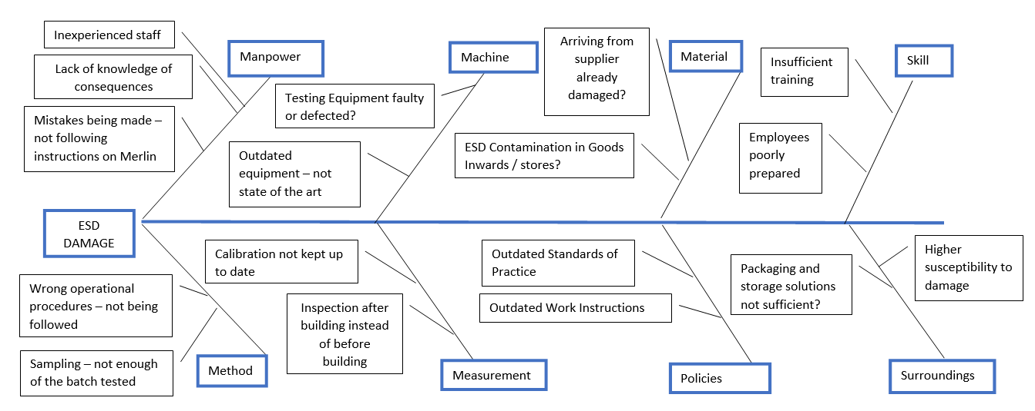
This identifies causes that can be actioned. Circled below are causes that can be resolved.
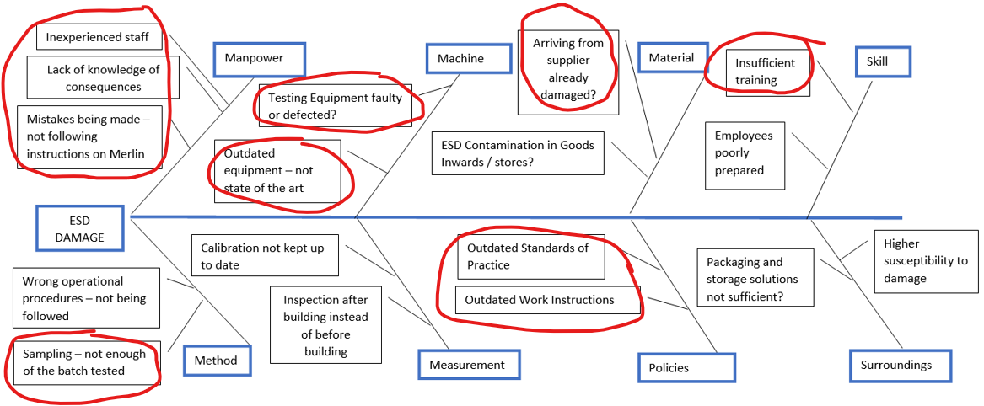
Many actions can be taken for these above causes.
There is a focus within the causes on staff training and experience. This can easily be resolved by improving training plans, procedures, work instructions and Standards of Practice. Sessions with R&D can reduce staff non-compliance with manufacturing instructions on Merlin (company database for blueprints and building instructions.) Resource can be reorganised to sample a higher percentage of components during the inspection process, to identify and resolve issues before they enter the factory. This will allow for supplier evaluation, returning defected components and materials. Equipment can be calibrated and replaced to ensure they are up to standard for ESD testing. Results of testing may be skewed if the equipment is not calibrated regularly enough. These options are all feasible and reasonable in terms of cost.

Propose a range of alternative solutions to the problem
There are diverse options to decide upon to resolve the problem as identified as part of the root cause analysis.
The recurring solution is to improve the induction and onboarding of fresh staff, whether they work in the offices or on the production floor. By including information about ESD safety, awareness and prevention, staff are aware of the potential impact ESD damage has on the business. This is a cost-effective solution. All staff spend 1 hour as part of their induction with the R&D department and Quality department. R&D can adjust their induction session to include an overview of ESD, what it is and how this can be prevented. Quality can also adjust their induction to include the impact of ESD on the business and safety aspects. As part of the induction process with HR, a pair of ESD shoes or boots should be purchased for the member of staff as this is the most effective preventative method against ESD. This will improve employee engagement and performance. With more knowledge, staff can share their knowledge and protect others from making mistakes.
Work Instructions can be introduced for operators and office staff for visiting and using the factory areas that are impacted by ESD. The work instructions can include effective prevention methods such as how to use ESD bootstraps and wrist straps. The work instruction can include information as described in sessions with quality and R&D to reinforce the importance of following these instructions. Work Instructions feed into company policies, so the Employee Handbook should detail what will happen if the instruction is not followed, especially in instances where damage is caused. This is another cost-effective solution, as it can be done with the yearly review and update of Work Instructions and Policies.
Changing the goods inwards and inspection work instructions to introduce ESD testing on all components before acceptance can help identify where components or materials are non-conforming before they enter the warehouse and factory. This can minimise costs as any non-conforming material can be returned and exchanged with the supplier. The cost of resource can be balanced with the cost savings by conducting this activity. Increasing inspection batch percentages can also be beneficial with suppliers that often produce or send non-conforming materials. This increases profitability and quality of product.
The company’s assets used for assessing the medical devices are calibrated once a year. Calibrating the equipment on a more frequent basis may result in fewer failures, as the equipment will be in better working order. This is a costly option, as the equipment calibration costs range from £45 to £500 on average. With at least seventy pieces of equipment to be assessed over the course of a year, increasing this frequency will impact the budget massively. However, by doing this, it is reassuring that is not the equipment that is faulty.
Providing adequate ESD protection to staff, the factory and warehouses can improve the problem. If all staff are issued ESD shoes or boots upon induction there is instant protection against discharge. Staff can be issued a spare pair of antistatic bootstraps and wrist straps if the shoes are forgotten. Temporary bootstraps will be made available at all entry points to the factory so that visitors can be protected if they do not have ESD shoes.
Adequate antistatic storage can be reviewed, all boxes and storage solutions such as bags, crates or wrap need to be assessed to conform to antistatic standards. Any equipment that does not meet the standards will need to be replaced. This is another costly solution as some of the equipment in the warehouse such as crates and racking, will need to be brought out of the warehouse and assessed individually, which will render the warehouse inoperative while this is undertaken.

Using a decision-making technique, evaluate a range of solutions to identify the most appropriate option

Grid Analysis
Grid analysis has been used below to compare the solutions to aid in making a decision. Each factor is weighted by relative importance. Each factor has been scored by numbers zero to three (three being very good, zero being poor.) In the first grid, this shows the score. In the second grid, this score has been multiplied by its relative importance and then the total score has been calculated. (Mind Tools Content Team, 2022)
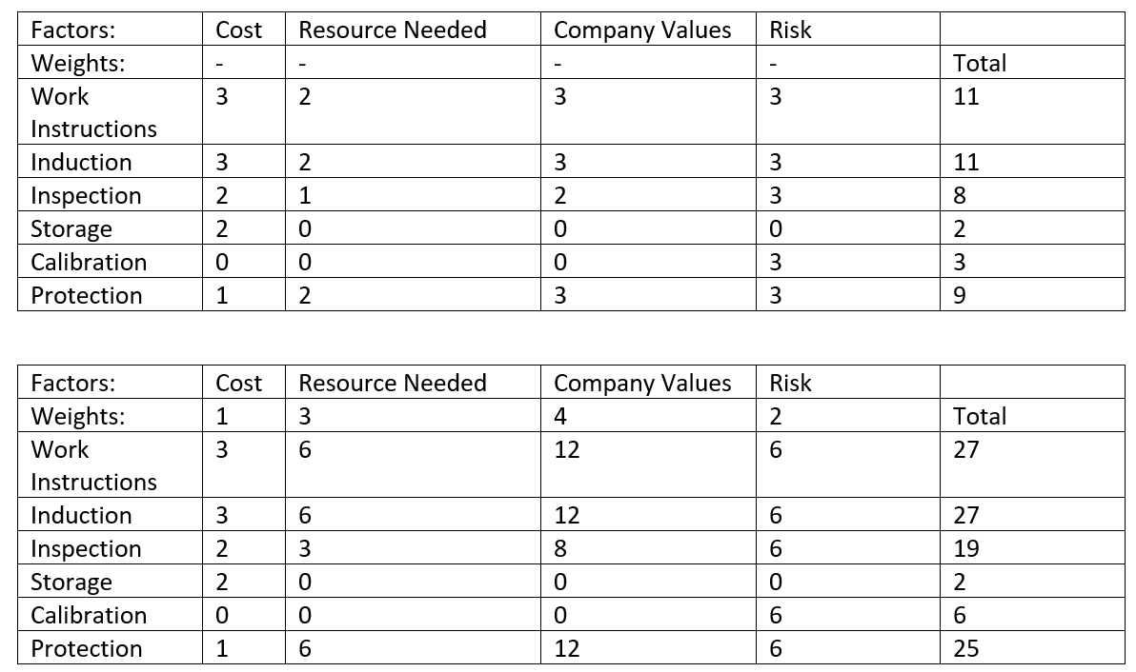
This grid analysis identifies the most suitable decisions based on their relative importance. The three best options are Work Instructions, Induction and Protection.

Cost Benefit Analysis

Cost Benefit Analysis for Work Instructions
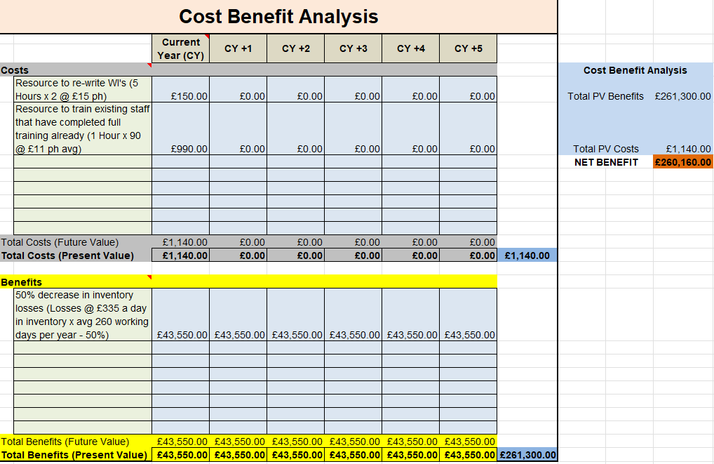
Cost Benefit Analysis for Induction
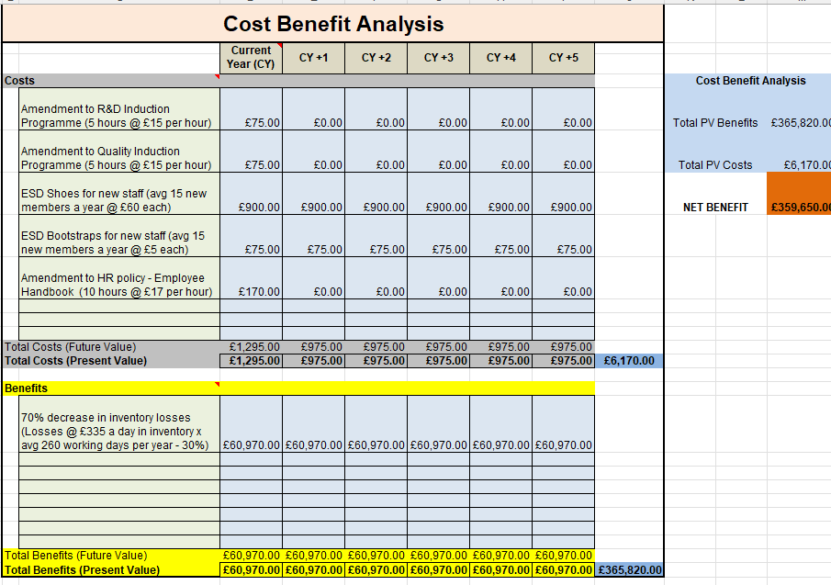
Cost Benefit Analysis Protection
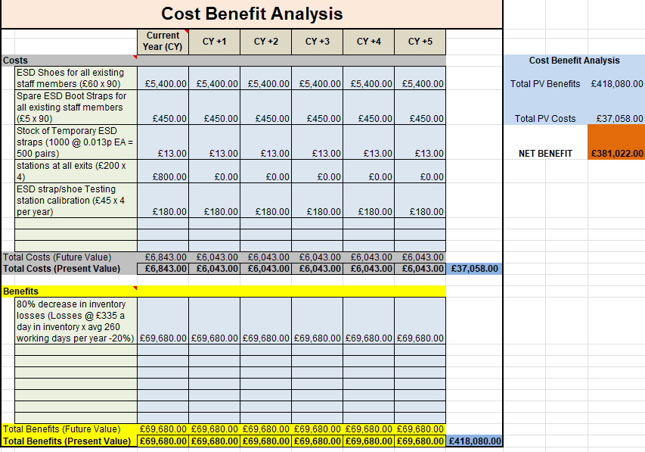
All three cost benefit analysis’ give their own benefit to the business. All increase profit in the long term. Protection and Induction reap the most financial benefit, whereas the Work Instruction has a lower financial cost benefit.
The best option from a business point of view would be to combine both Protection and Induction to solve the problem from the root. Continuous systematic improvement is a core business value, to stay competitive and profitable. The work instructions can be amended later, they are reviewed annually in April, so it is not cost effective to make changes now because they will be changed anyway in the next 8 months. The profit loss for only amending the work instructions is too great to ignore.

Develop a detailed plan for implementing the solution
Gantt Charts are helpful in detailing critical deadlines and their interdependencies. (Croft, 2015) This chart has been developed for the implementation of the proposed solution. This highlights key stages of the project, who is responsible for each part and when this should be completed. The order is important, as selected stages need to be sequential, not overlapping, or parallel. There are tasks that can be completed in parallel, for example writing the new induction plan, as there are three departments, each can work on their plan at once.
This chart makes best use of each team’s resource. One week has been spared towards the end of the project in case of any delays or final adjustments before communicating the changes to stakeholders.

Gantt Chart
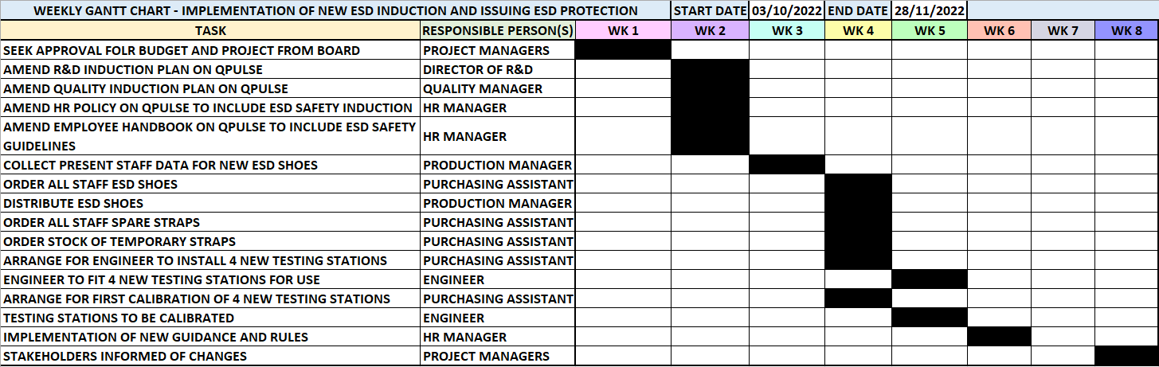
All responsible persons can identify their responsibilities in the project, with clear, defined goals and deadlines. If this project is successful, all the above actions will have been completed by their deadline. The targets are SMART, Specific, Measurable, Attainable, Relevant and Timely. SMART targets help to keep the team motivated, as the goal is clear. It is important to encourage the project team and stay focussed on the end goal. This plan also provides guidance and direction for the team. (Kristenson, 2022)

Communicate the plan to relevant stakeholders
Key stakeholders need to be informed about this plan. Identifying the key stakeholders create the basis for planning communication.
Investors are stakeholders that need to be aware of this plan. The business investors regularly analyse business profitability, and this plan aims to improve the issues with stock loss. They can offer advice and support with this project, as it is in their best business interests to do so. The investors do not have influence on decision making, this is left to the board of directors and CEO, who are also key stakeholders. The board of directors and CEO can provide financial support for the project and need to be aware of any organisational changes to the business.
Employees and distributors are also key stakeholders in the project. The employees need to be aware of any changes to their working day and can help smoothly implement the action plan in place. Employees will also report any issues that may arise during the project when they are identified. Distributors are important stakeholders as they will be directly repairing the relationship with the customer following the delays the problem has caused. They will be instrumental in feeding back information to clientele.
The senior management team are stakeholders in this project as their departments will be directly working on the tasks. They need to be made aware of any changes to their team members’ schedules. Their support comes in the form of redistributing work to the team members that are not participating in the project to ensure the business is still operational.
Suppliers will need to provide equipment and make arrangements with the business to deliver goods and services for this plan. Customers are also stakeholders as they will benefit from the implementation of this plan. It is imperative to build back trust and communication, following months of interruption.
To create the communication plan for this project, all stakeholders need to be classified. One way to do this is to use an Influence and Interest matrix. This matrix suggests that there are four distinct categories in which stakeholders fit into.
High power and those who are highly interested, fall into the manage closely category. These are the most important stakeholders; communication is of paramount importance to them. High power but less interested stakeholders need to be informed, but do not need to be inundated by the details. Low power, but highly interested stakeholders need to be informed, as they will be instrumental in ensuring that no issues arise. The final category is low power, less interested stakeholders. These stakeholders should be monitored lightly, but not inundated with excessive communication. (Mitchell et al., 1997)
Considering each stakeholders interests and responsibilities, they have been filtered into the matrix below.
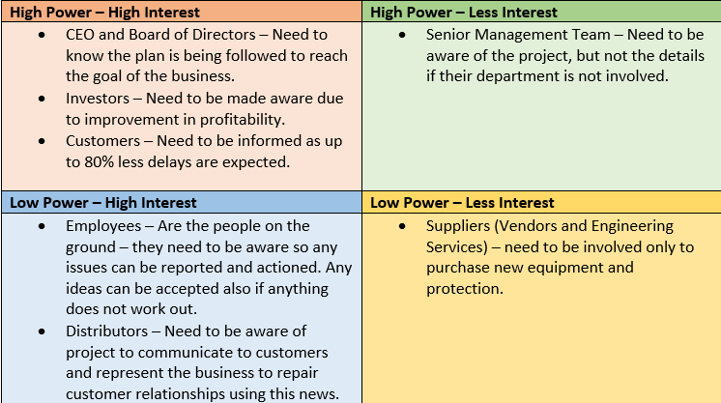
Stakeholders’ positions within this matrix can change during the project, and this should be monitored and updated.
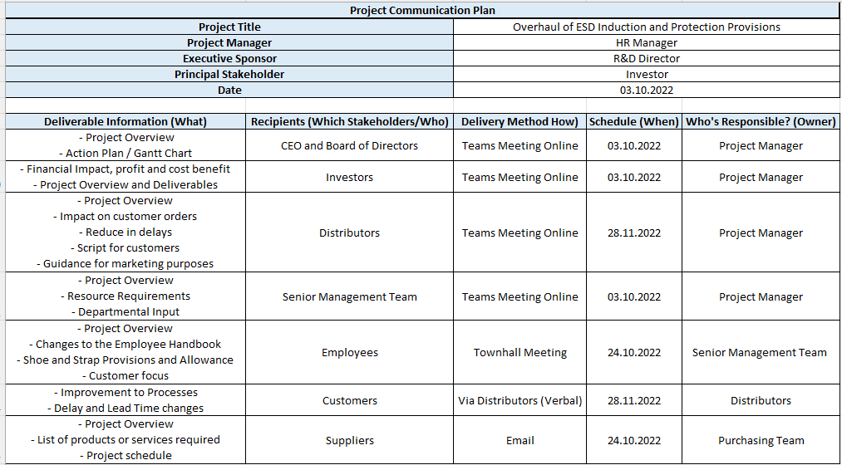
The communication plan above outlines who should be contacted, when, and what information should be given. This is a clear instruction to ensure that the stakeholders are informed accordingly.

Assess appropriate monitoring and review techniques to ensure successful implementation of solution
“Just because there is a plan does not mean the project is under control. Just because someone says the project is under control doesn’t mean they are right.” (Jones, 2007)
All the tools used throughout the planning process can be used to measure progress. The Gantt chart will show where the plan is and what progress is being achieved any given point. The project manager can meet with the project team during the plan to ensure everything is running as per the chart, and that it reflects reality.
A weekly project meeting is a terrific way of ensuring that the team are coping with the tasks and goals. This is also an effective way of encouraging feedback from the team and internal stakeholders. Wellbeing checks can also be made to ensure that teammates are not feeling stressed or under pressure. The wellbeing of the team should be a priority, after all these are the people that will ensure the overall success. This can also identify skills gaps and gives an opportunity to draw other essential departmental figures into the project where necessary. Consistency is key, so if meetings are to be held, these should be respected and not rearranged or cancelled at the cost of the project.
If there are changes or to the project, the chart can always be reviewed and redistributed so long as the budget and resource allows. If the chart needs to be changed, for better or worse, this is an important way of reflecting and recording what went wrong, or what was successful, and what can be improved or replicated for the next project.
There are milestones within the plan which are a visual way of tracking progress, for example once the induction plans have been updated, these can be seen on the online database. The stakeholders can also see milestones, such as receiving their ESD shoes and straps. These milestones are a good indication of where the project is and how it is progressing.
The communication plan will show who has been contacted and who is yet to be contacted. Contact can also be delayed or progressed depending on the progress of the project plan.

References
Cohen, M. (2015). Critical Thinking Skills For Dummies. Wiley.
Learning Gantt Charts. Croft, C. (Director). (2015).[Video/DVD] Carpenteria, CA: linkedin.com.
Jones, R. (2007). Project management survival a practical guide to leading, managing & delivering challenging projects. Kogan Page.
Kenworthy, J. B., & Paulus, P. B. (2019). Effective Brainstorming. (). Oxford University Press. 10.1093/oxfordhb/9780190648077.013.17
Kristenson, S. (2022). 7 Benefits of Setting & Achieving SMART Goals. https://www.developgoodhabits.com/. https://www.developgoodhabits.com/benefits-smart-goals/
Mind Tools Content Team. (2022). Decision Matrix Analysis: Making a Decision by Weighing Up Different Factors. https://www.mindtools.com/. https://www.mindtools.com/pages/article/newTED_03.htm
MindTools. (2022). Brainstorming . https://www.mindtools.com/. https://www.mindtools.com/brainstm.html
Mitchell, R. K., Agle, B. R., & Wood, D. J. (1997). Toward a Theory of Stakeholder Identification and Salience: Defining the Principle of Who and What Really Counts. The Academy of Management Review, 22(4), 853-886. 10.2307/259247
Proctor, T. (2018). Creative Problem Solving for Managers : Developing Skills for Decision Making and Innovation. Routledge.
Prowritingaid. (2022). Cause and Effect: Definition, Meaning, and Examples. https://prowritingaid.com/. https://prowritingaid.com/cause-and-effect
Static Safe Environments. (2022). What is ESD? . https://www.staticsafe.co.uk/. https://www.staticsafe.co.uk/what-is-esd/
Tableau. (2022). Root Cause Analysis Explained: Definition, Examples, and Methods. https://www.tableau.com/. https://www.tableau.com/learn/articles/root-cause-analysis

