8 - For Loops in Python

As we know, loops have a set number of iterations (number of times the loop is run)

There are two categories of loop in Python – for and while

For loops are usually used when the number of loop iterations is known in advance.
(iterations = times around the loop)

Let's start with a loop to print a sequence of numbers. By default, Python, like many programming languages, starts counting from 0 by default.

The 3 numbers on a for loop set the range of the loop count:

Start counting here Exit here Count up by one each time around the loop
(increment)
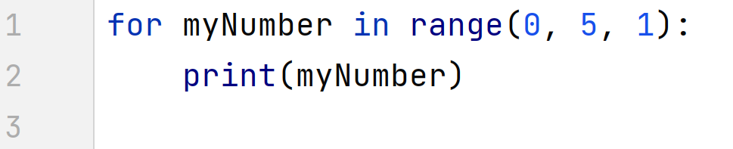

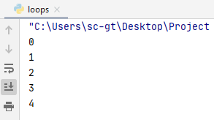

As we can see above, Python has counted around the loop 5 times, starting from 0, so 0-4.

The syntax is similar to if/else. The contents of the loop in Python is always tabbed in. When you untab, you are out of the loop and into the regular program.

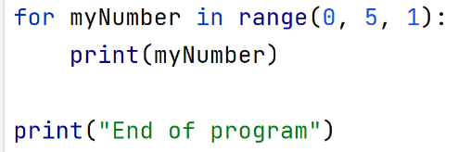
tabbed in
loop content

outside loop,
back to normal
program flow

loops 5 times

We can do this for any number, here's one with 10:

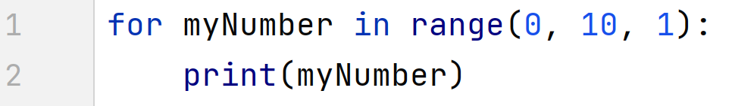

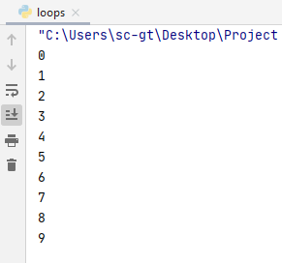

As you can see, Python starts counting at 0 and counts up to 9 (10 total)

We can also set the start of the range, in this case between 5 and 10:

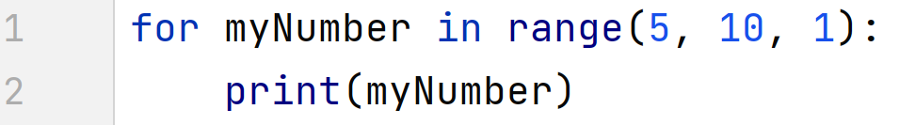

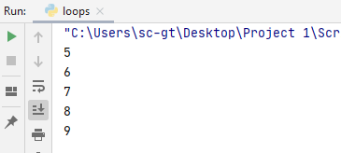

This may seem a tiny bit weird, as it only counts up to 9, not 10. Think of 10 as the exit value. When the program gets to 10, it stops running the loop.

Shorter syntax

NB You may see Python for loops written a shorter way.

We wrote our first example this way:

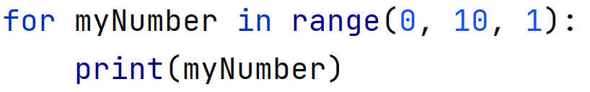

We could also have written it this way and got the same result:

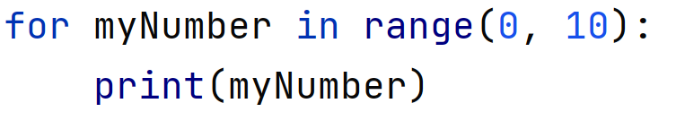

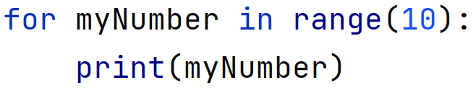

If we do not include the last number (increment), Python will assume it is +1.

If we do not include the first number (start), Python will assume we’re starting from 0.

It is entirely your choice which style of code you use, however I would advise using all 3 numbers if you are new to for loops, until you get used to the way they work.

Increments (1 by default)

We have already mentioned that by default, Python counts up in increments of 1.

You can set your own increment as follows:

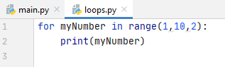

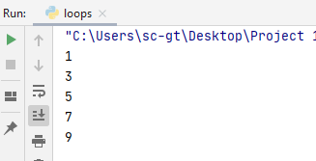
Start at 1, exit on 10, count up in 2s

Counting down

It is less common, but we can also count down:

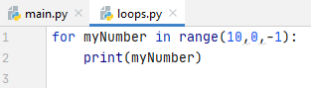

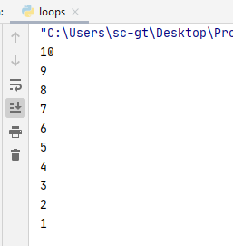

Note that the loop has exited when it reached 0

Using variables in the range
It is fine to use variables in the range for the loop. In the program below, I've asked the user to decide which number they want the program to count to:
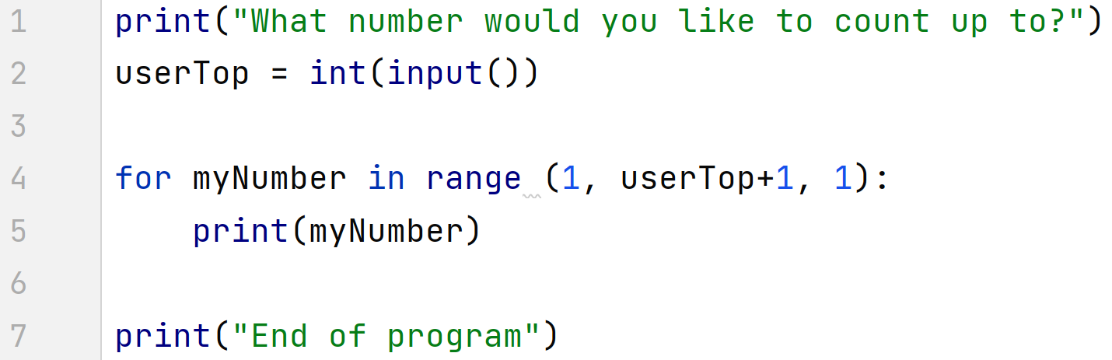
As the program will exit at userTop I've put a +1 on, as the user is expecting to see up to the number they specified (natural language vs computer language!)

Some output examples:
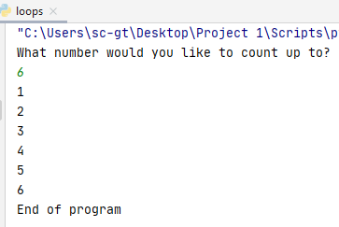
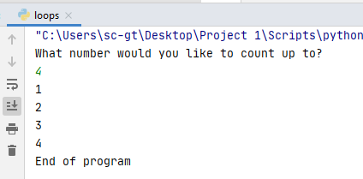

Calculations with for loops
For example if I wanted to print out the 7 times table in primary school style, I know it traditionally starts at 1 and ends at 12.

In the following example, I have done a calculation using myNumber. Remember that myNumber changes as Python moves through the range: 1, then 2, then 3 and so on.

exit at 13, so 12 will be the last
in the range

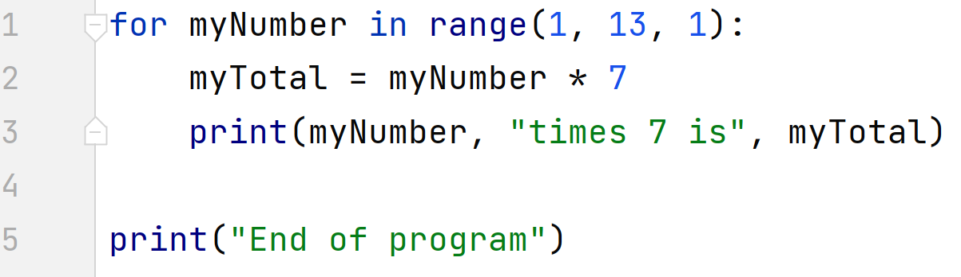
1*7, then 2*7, then 3*7
and so on up to 12*7

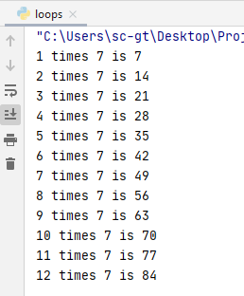

We could also extend this to allow the user to dictate the range:

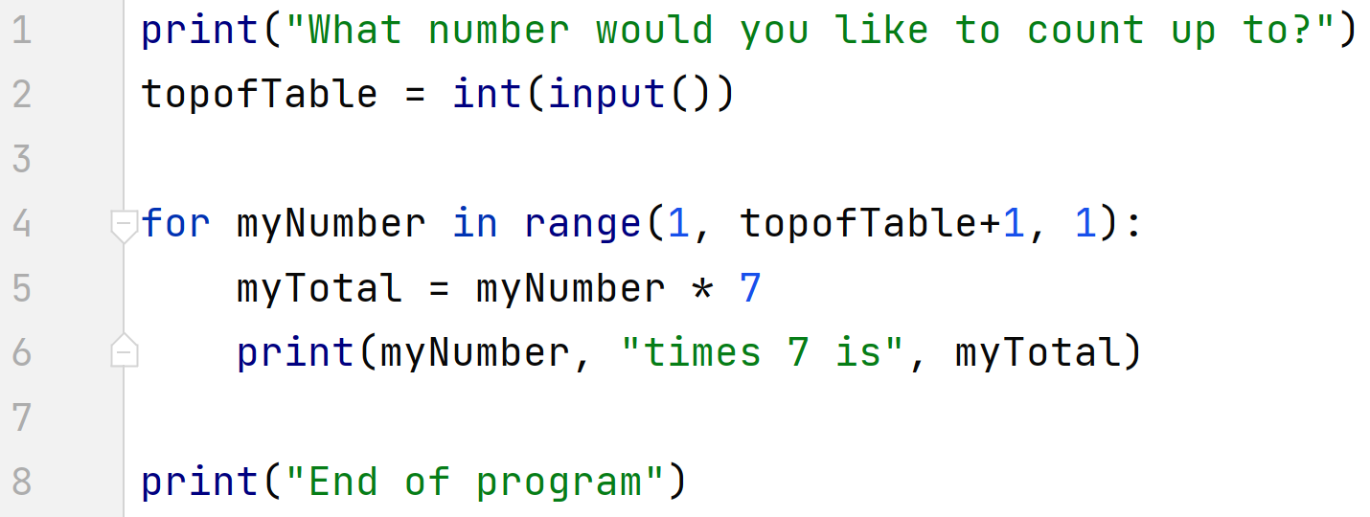

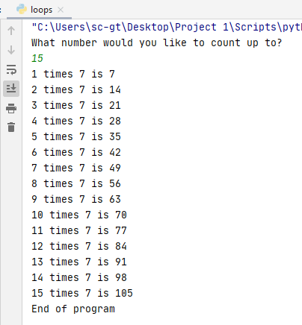

Note: Python for loops are also useful for use with Python lists (arrays in other languages). We will look at lists in a future class.

