
Learning in the Digital Era: Assessment 1

ACCA 4025
E-Portfolio Link: Click Here
University of Wales Trinity Saint David
London campus
Name: Kim Harry Lee Cleto
ID Number: 2517289
Group Number: 1

Professor: Koushik Modak

Table of Contents
Introduction 2
Main Body 3
Task 1: Essential Academic and Employment Skills for Future Career Paths 3
Task 1 (a): Reports on Essential Academic and Employment Skills 3
Task 1 (b): Evaluation of Task 1 (a) based on Turnitin similarity report 6
Task 2: Mind Mapping collaboration and Individual Poster 8
Mind Map (Collaborative) 8
Poster (Individual) 8
Task 3: Virtual Collaborations and RefWorks 9
Report on Virtual Collaboration 10
Step-by-step process using RefWorks with visuals 12
Task 4: E-Portfolio Creation and Evaluation 16
Task 4 (a): E-Portfolio Creation 16
Task 4 (b): Illustrative Review of E-Portfolio tool selection 16
Conclusion 19
References 20
Task 1 References: 20
Works Cited 20
Task 3 References: 21

Introduction

The advancement of modern technology not only affects your academic life but also your professional career. The adaptation of modern technology within universities and companies across the globe has increase and this affects the global industries where displacement within labour jobs significantly shows. With the current advancement of digital tool in today’s age, learning how to utilise digital software and hardware shows how beneficial it is for different individual and organisation. Utilisation of digital tools proves to increase efficiency and productivity within different aspect of day-to-day activities [1], [2], [3].
Universities and companies’ utilisation of virtual teams show “the good, the bad, and the ugly [1]” side of virtual collaboration. Although virtual collaboration has the benefits of having multiple individuals from different parts of the world or from the comforts of their own home, conflict within virtual collaboration often arises due to a lack of face-to-face interaction and misunderstanding due to lack of verbal ques. Emotional intelligence and empathy plays a big role in virtual collaboration as it help individual understand different aspect and roles within a virtual team [1],[2],[3],[4].

Main Body

Task 1: Essential Academic and Employment Skills for Future Career Paths

Task 1 (a): Reports on Essential Academic and Employment Skills

Understanding the use of modern technology helps not only in my academic journey but also in my chosen career path [1]. Analytical skills and understanding of digital infrastructure, along with proactive data collection and adaptability to new information, are essential for software development [2], [3], [4]. Having excellent communication, punctuality, problem-solving, and writing proficiency skills is needed to provide accurate solutions that enhance productivity and workflow [1], [5], [6]. The increasing demand for these qualifications is beneficial to my future career development [2], [3], [4].
Figure 1. Academic and employment skills for a successful digital career. Adapted from [1], [5].
With increased demand for cloud technology, data analytics, Artificial Intelligence (AI), cybersecurity, and software engineering skills. Millions of people are adapting to modern technology and utilizing it to increase productivity [2], [3].
Learning in the Digital Era: Assessment 1
E-Portfolio
Digital skill demands
Labour displacement
AI and Robotics adaptation
Figure 2. Technological advancement and digital skill demand. Adapted from [2], [3].

Although these skills rely on strong work ethics, communication, collaboration, and efficient management of data [2], [3], [4]. With the advancing development of technology at present, the demand for this skillset has increased throughout the years, emphasizing the importance of analytical skills in the present day, which still requires clarification based on different job categories [2], [6].
Having a good understanding of this skillset proves to be beneficial for both future academic and career paths, with a comprehensive understanding of evolving technologies and digital data. Continuously adapting to new information and implementing it into my day-to-day activities, and being able to collaborate with different individuals to achieve an efficient and productive workflow [3], [4], [6].
All these skills are beneficial to my academic and career path in software development and Information Technology. Allowing me to understand the importance of collaborating with different individuals, proficiently conveying information with accuracy to increase workflow productivity, understanding the importance of punctuality to deliver information when required, the ability to detect, understand, and deliver a solution to a problem, and adapting to new information that is beneficial for software development [4], [5], [6].

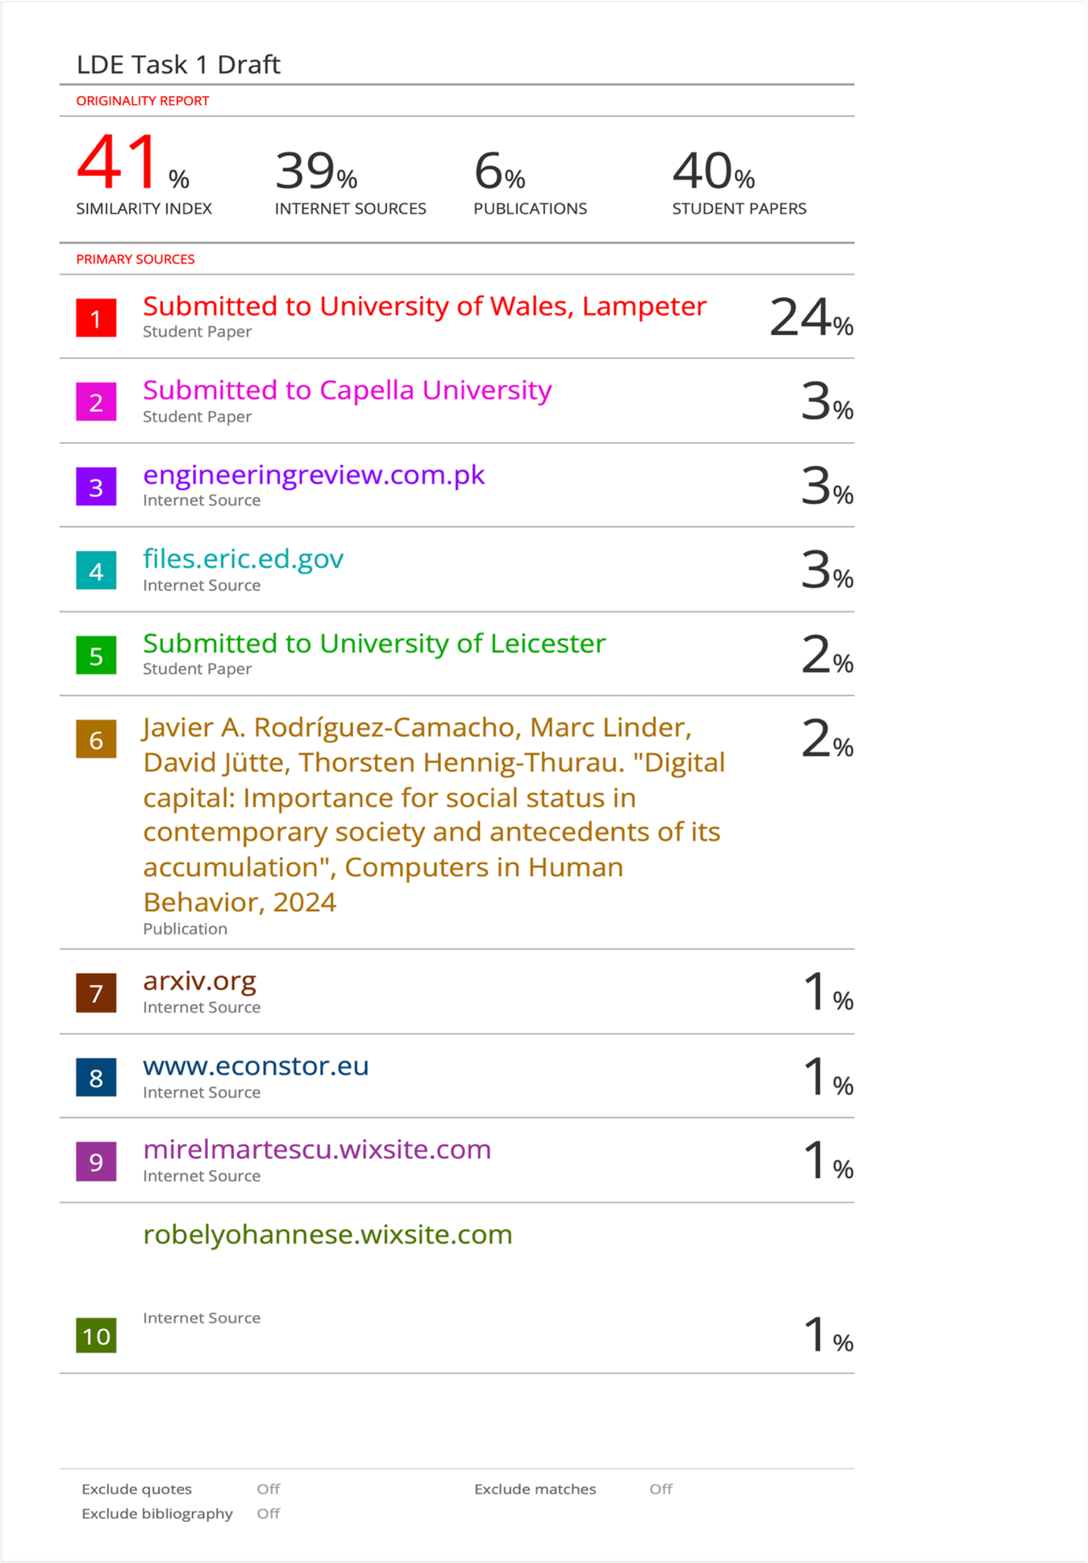
Task 1 (b): Evaluation of Task 1 (a) based on Turnitin similarity report

Based on Turnitin similarity index of 41%, this can be easily justified due to common use of template provided by the university and detailed information provided in the citation reference.
Although my work on the given task is good, there are still some areas that need to be polished. Paraphrasing and choosing words correctly to get a lower to no similarity score, correct use of citation and bibliographies to provide more detailed, accurate information, and avoiding plagiarism. Creatively providing a more accurate illustration or correct referencing of the illustration used directly from the source. Furthermore, I aim to improve my writing skills to be more concise, highlighting key points, using correct grammatical structures, and using different writing styles or tones (e.g., friendly, casual, formal, and academic). Regular proofreading ensures the correct use of spaces and punctuation throughout my work.
Having a good understanding of the given task, I’m giving myself a 65% mark based on the comprehensive concept of my writing, providing different kinds of sources from books, websites, articles, and reports. Having a good understanding of hardware, software, and different kinds of resources will benefit me in my academic and professional career.

Task 2: Mind Mapping collaboration and Individual Poster

Mind Map (Collaborative)
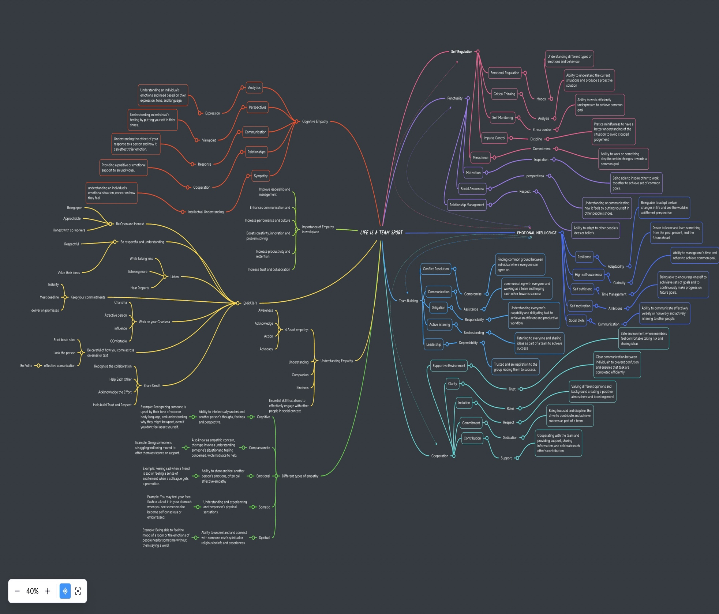
Mind Map Link: Click Here

Poster (Individual)
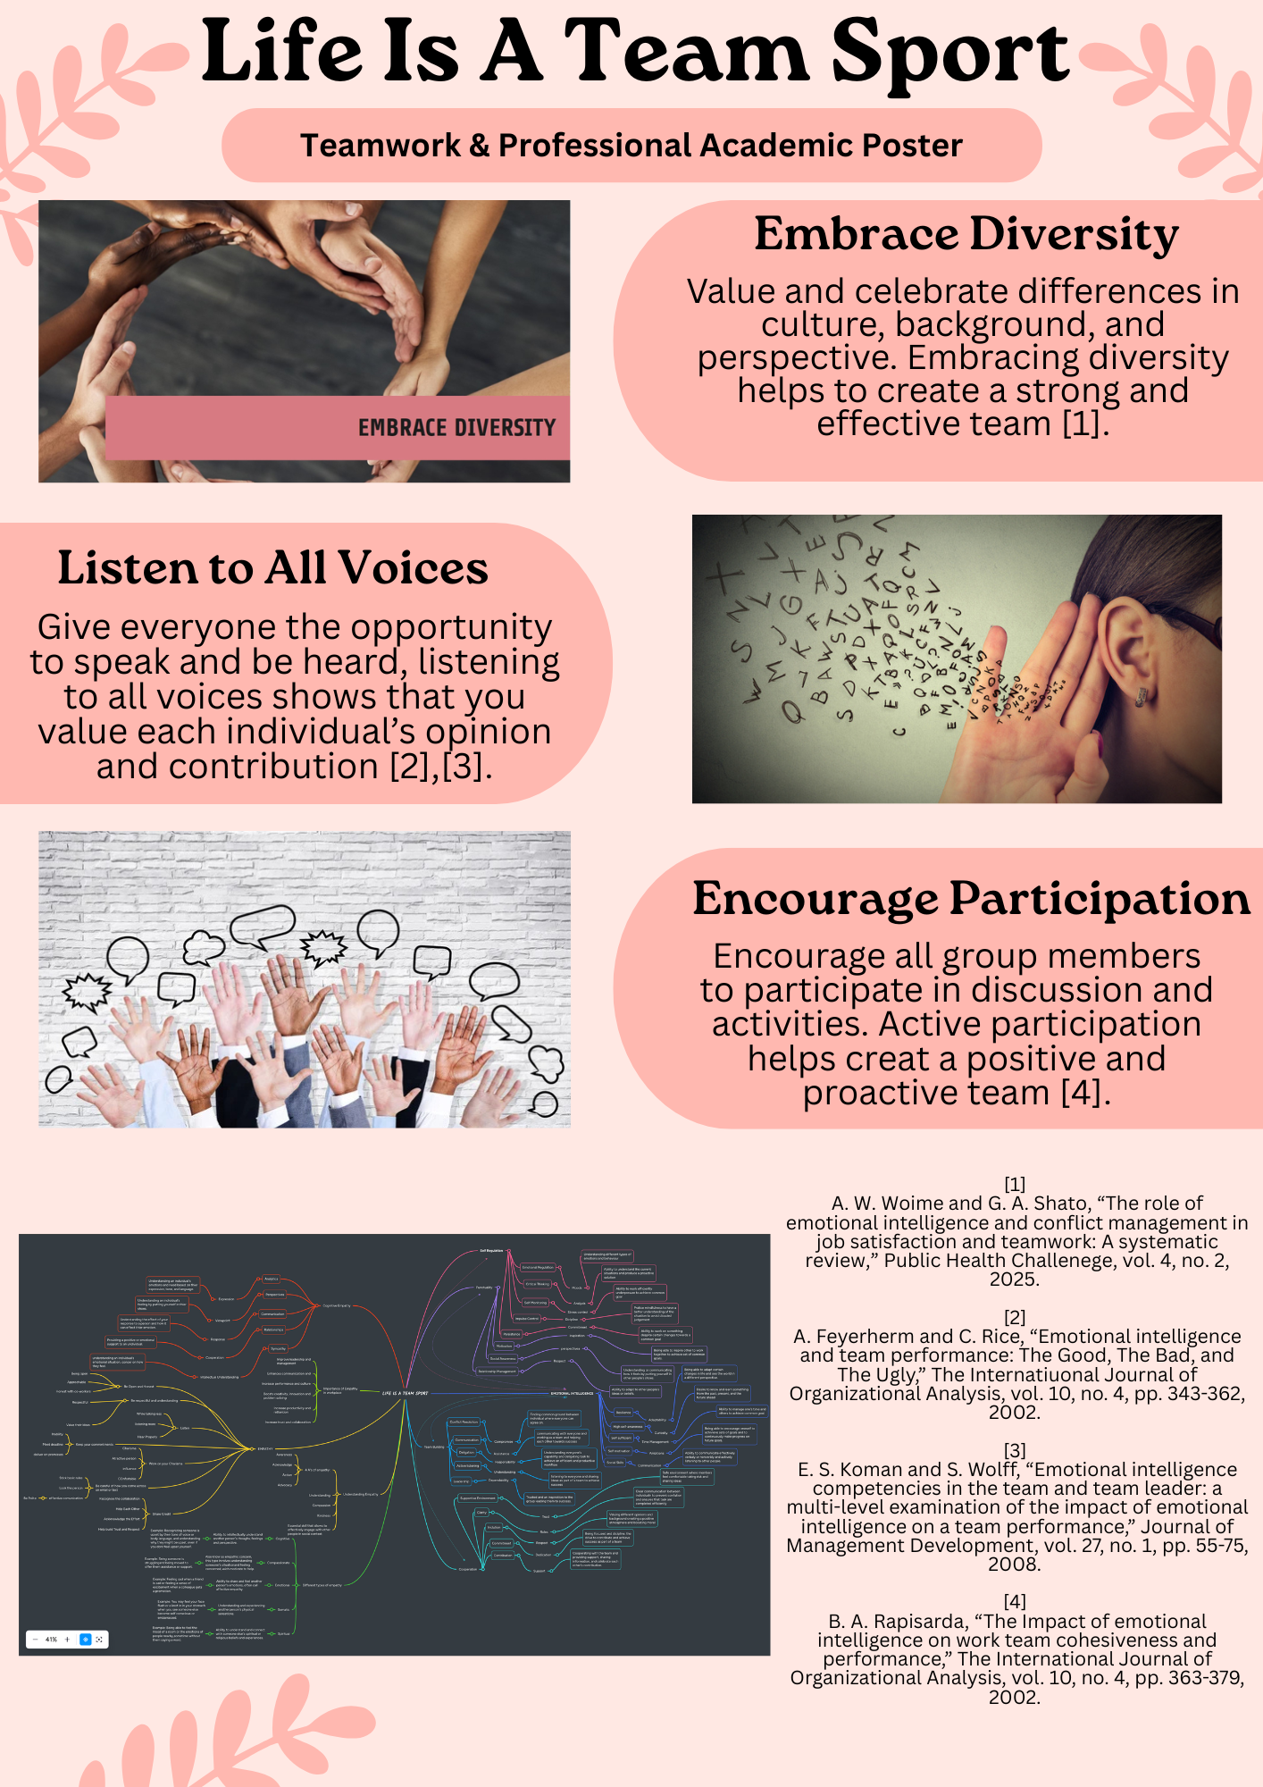
Academic A3 Poster Link: Click Here

Task 3: Virtual Collaborations and RefWorks

Report on Virtual Collaboration
Unit 3 Topic 2: Riding the Storm summary
In today’s age, where technologies are being adapted by individual and global industry, virtual collaboration has become an essential part of how organisations work on their day-to-day activities. Teams now operate in different cities and cultures, using digital tools to share ideas and work together to complete task. While this opens opportunities for individuals and companies, it also introduces new challenges that can impact the efficiency and productivity of individual within a virtual team. Conflict within virtual collaboration arises due to number of reasons, an outcome of working remotely where communication depends solely on digital device and software rather than a face-to-face interaction [4].
Conflict within virtual teams often begin with a simply misunderstanding. Due to lack of face-to-face interaction, team members can easily misinterpret tone, intentions, or feedback. Difference in perspective, methodologies, and unclear roles or responsibilities can easily turn minor misunderstanding into a major issue. Studies shows when virtual communications lack social presence, it often leads to confusion and frustration between individuals [4].
Here are several types of conflicts that often arises within virtual collaboration:
- Perspective conflict - Disagreement between individual occurs due different opinion and views.
- Management conflict - Disagreement between individuals regarding leadership and decision-making.
- Informal resolution - unable to resolve issue or disagreement due to lack of face-to-face discussion.
- Technology conflict - issues within software, hardware, and network that causes significant delays
- Pressure conflict - Increase stress level due to volume of workload and deadlines
- Role and Task conflict - Uneven distribution of workload and duties resulting to expectations now being met
- Behavioural conflict – Dealing with different individual personalities or misconducts.
Handling these challenges requires clear communication and trust-building. Having a regular virtual meeting and check-ups, definitive roles, and transparency during decision-making helps to avoid misunderstanding. Documentations suggest that shared goals and active conflict management can improve both performance and satisfactions of individual within a virtual team [3]. Recent studies also emphasises that the future of virtual collaborations relies on strong emotional intelligence, empathy, and deep understanding of modern technology. These are factors that helps to shape virtual teams adapt to complex, and hybrid work environments [2],[1].

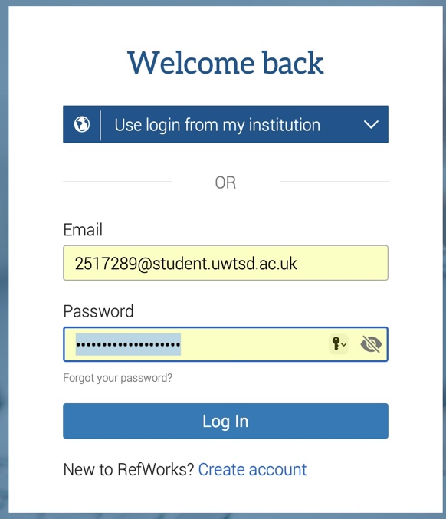
Step-by-step process using RefWorks with visuals
Register and log in using Student university e-mail
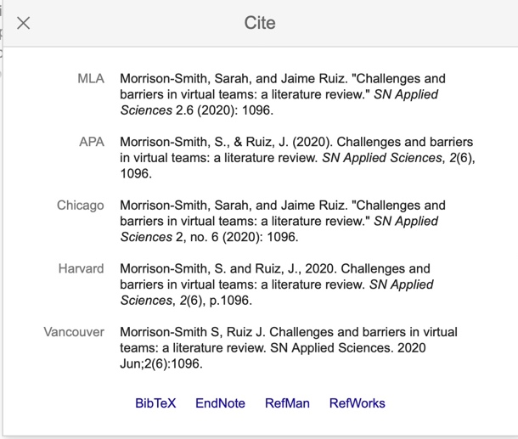
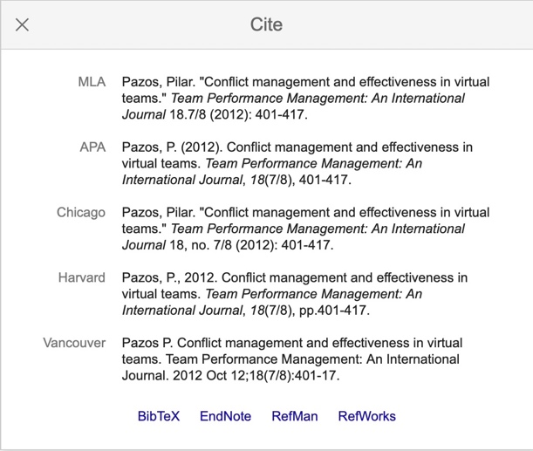
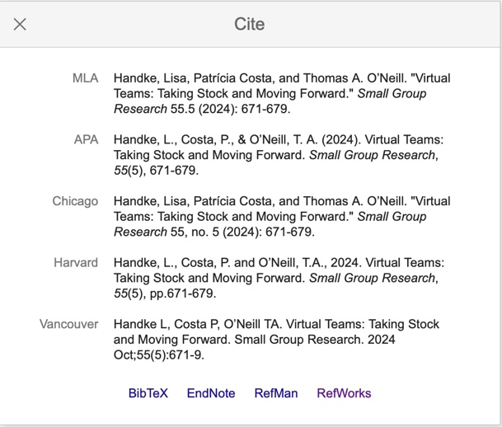
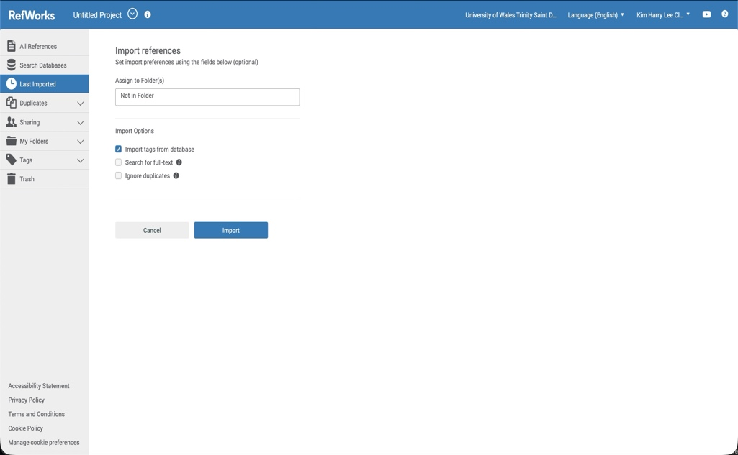
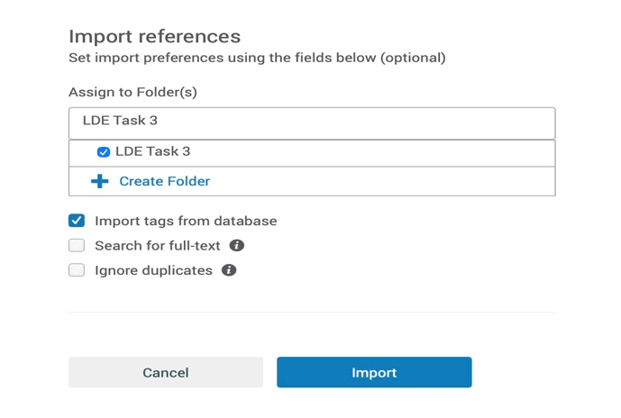
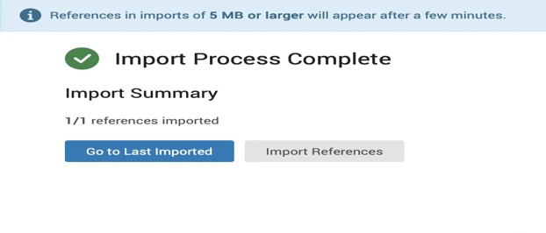
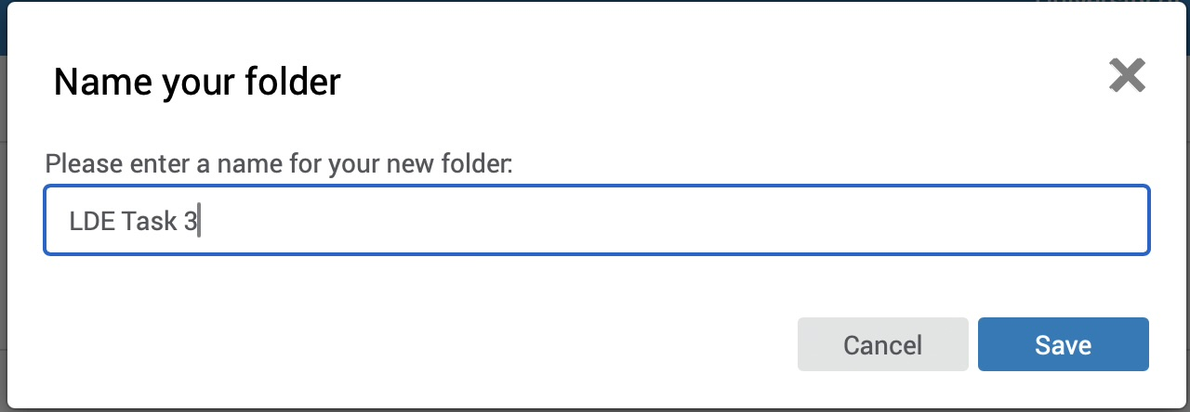
Find sources using google scholar and choose papers applicable to task and cite using RefWorks
Import sources to designated folder keeping citations organised and accessible
Create citation folder for specific task keeping things organised
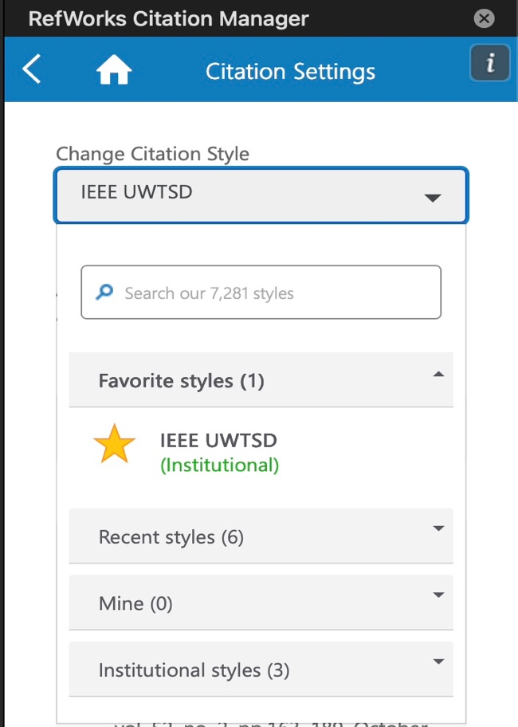
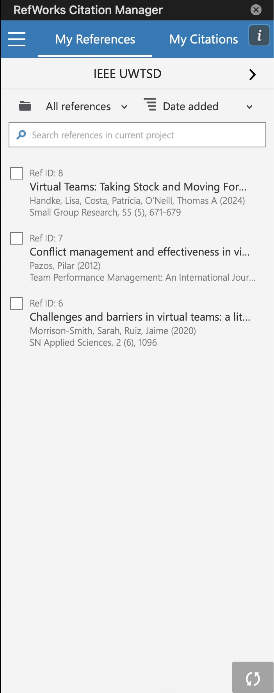
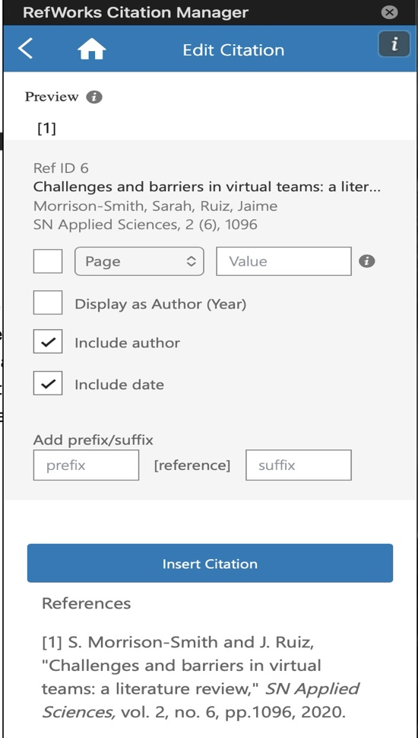
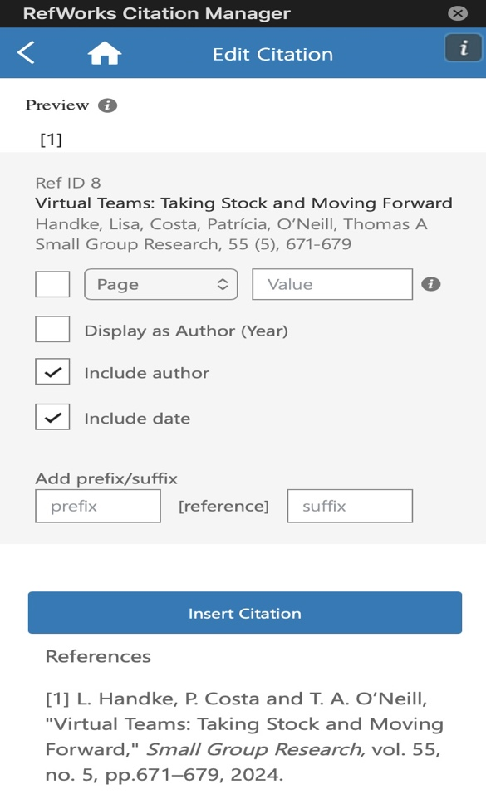
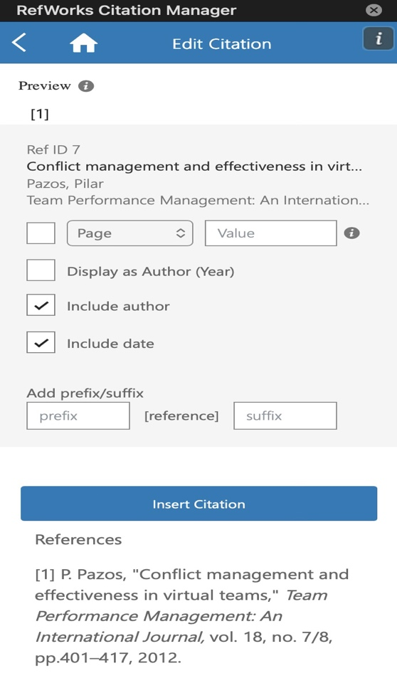
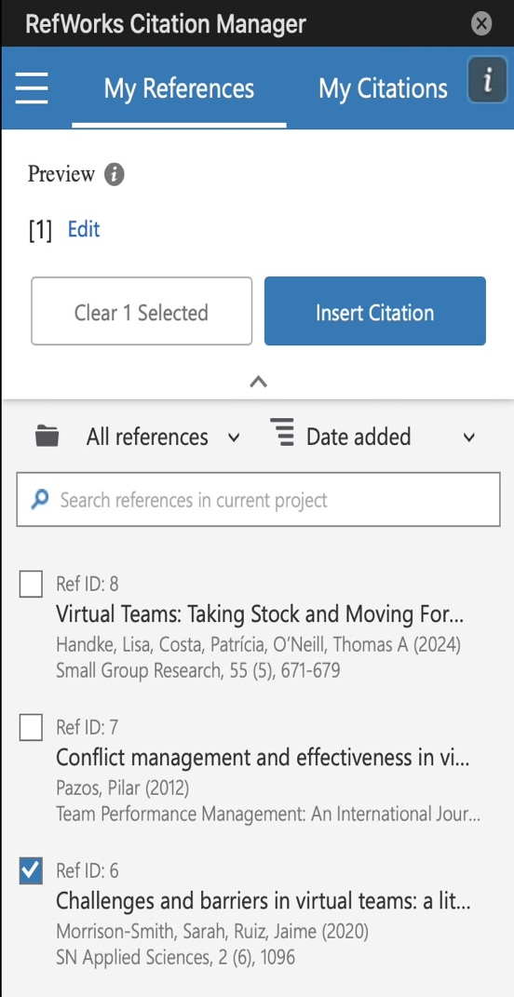
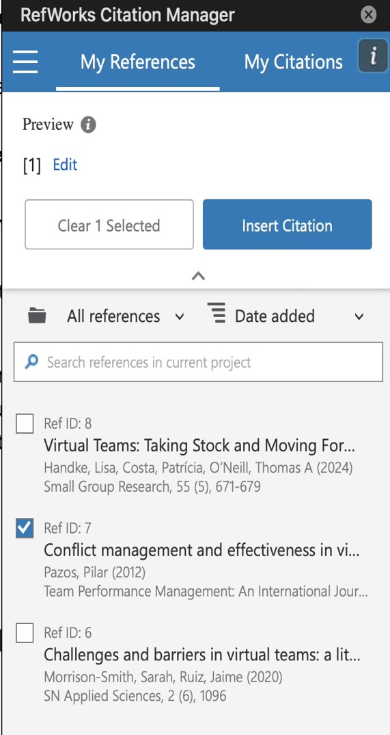
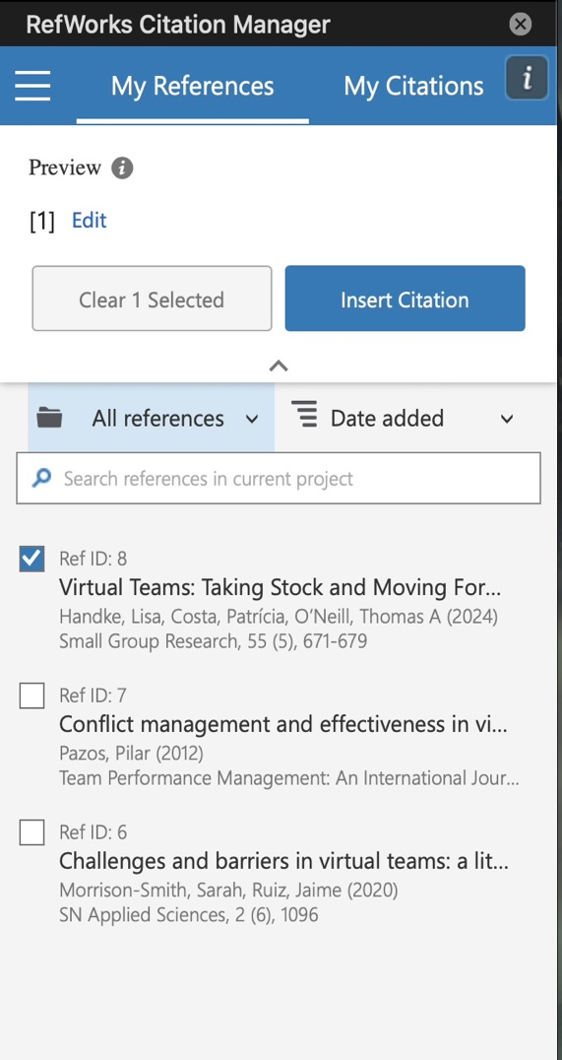
Check citation settings and use academic IEEE UWTSD (institutional) that is required by the university
Insert intext citation using RefWorks in research paper to provide information on where the summary was based on.
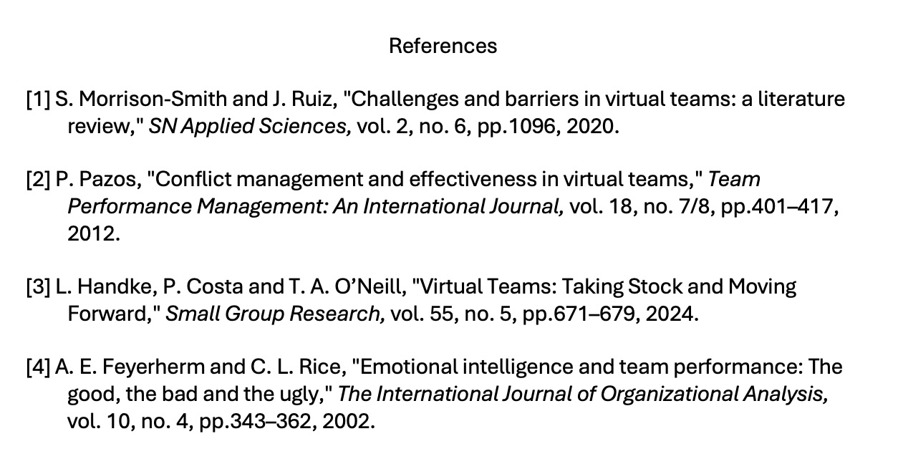
Check intext citation bibliography to make sure that correct citation information is displayed and following the academic format IEEE UWTSD (institutional)

Task 4: E-Portfolio Creation and Evaluation

Task 4 (a): E-Portfolio Creation

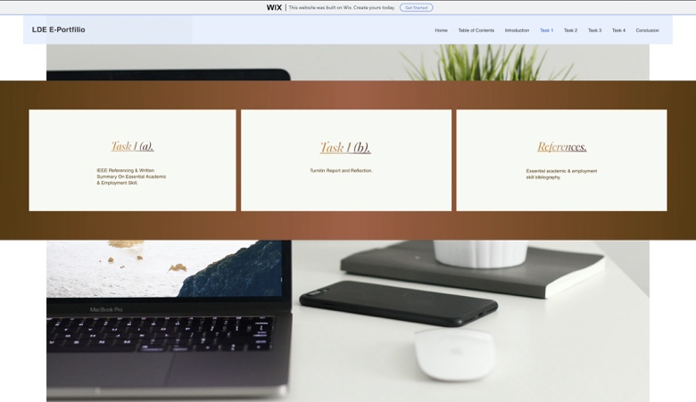
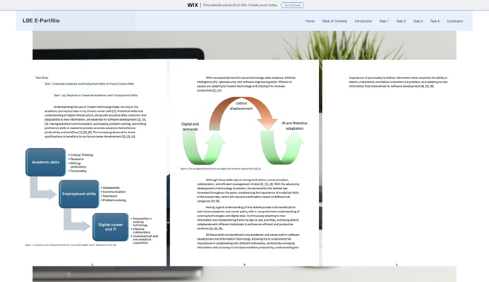
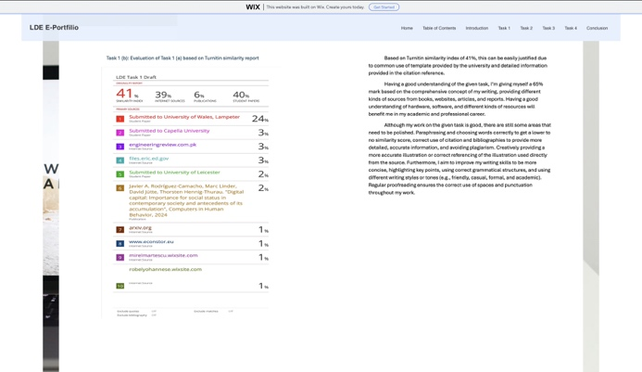
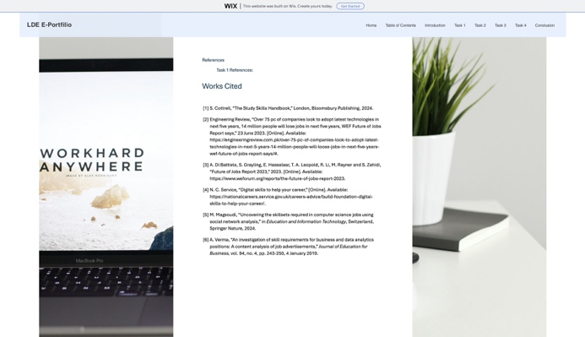
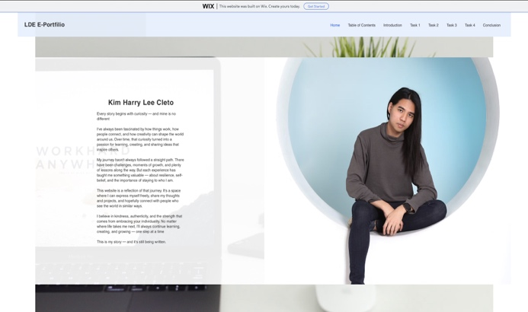
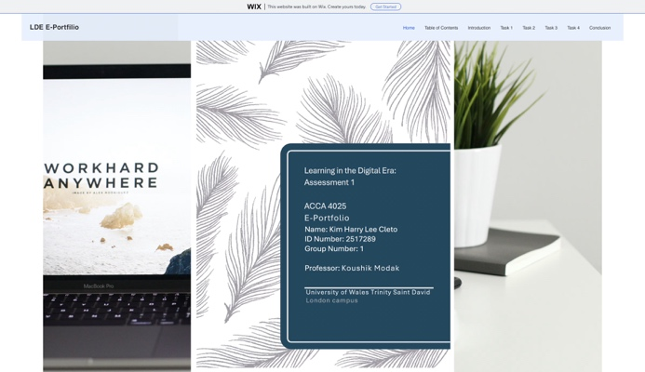
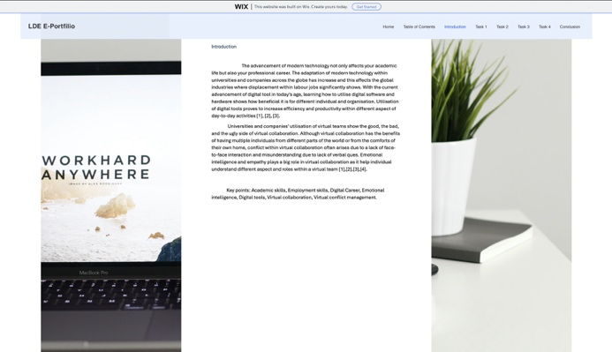
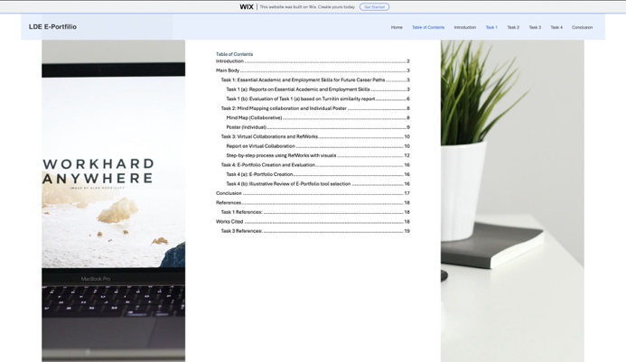
Task 4 (b): Illustrative Review of E-Portfolio tool selection

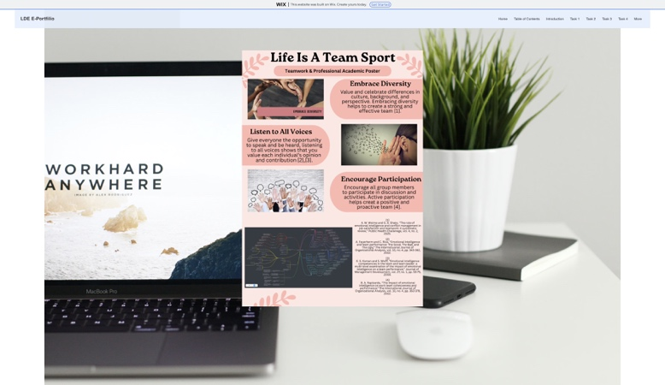
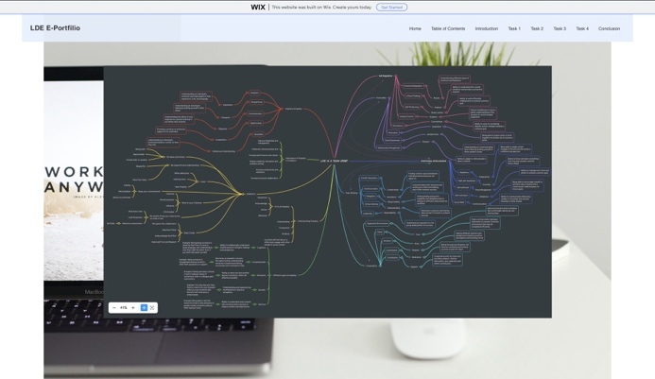
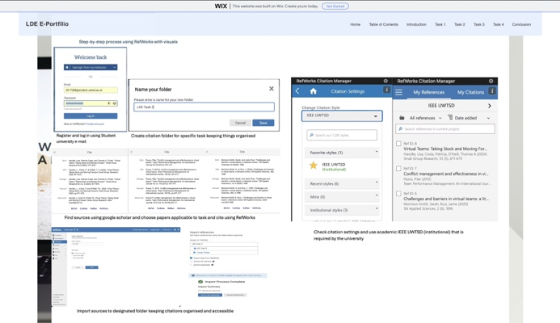
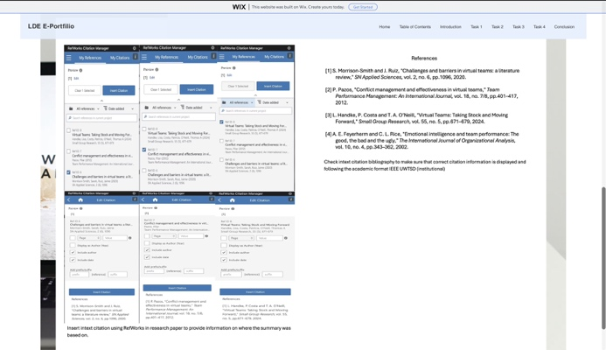
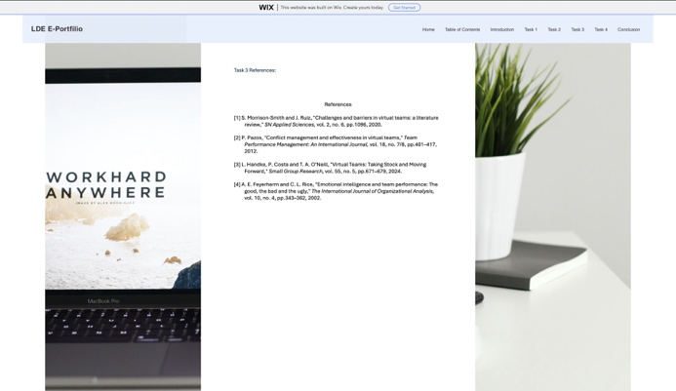
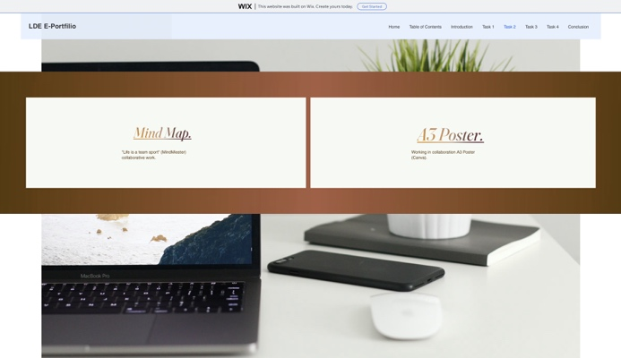
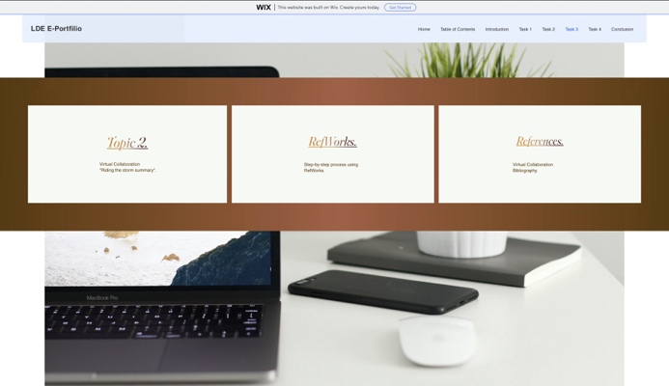
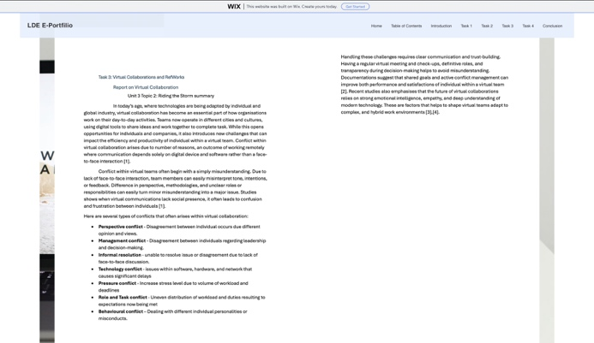

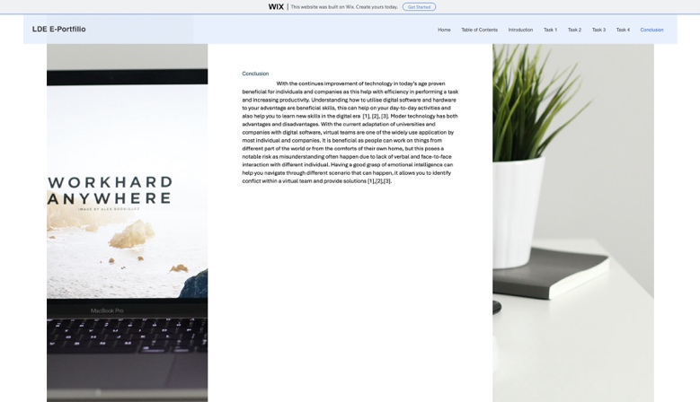
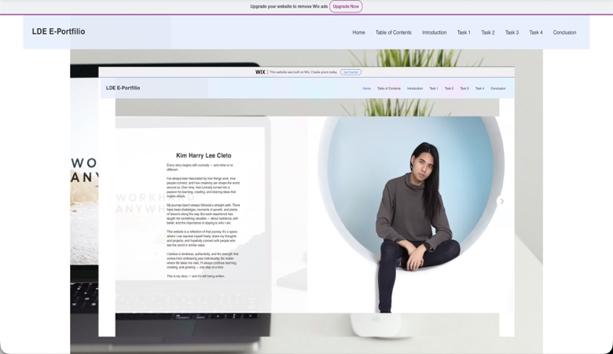
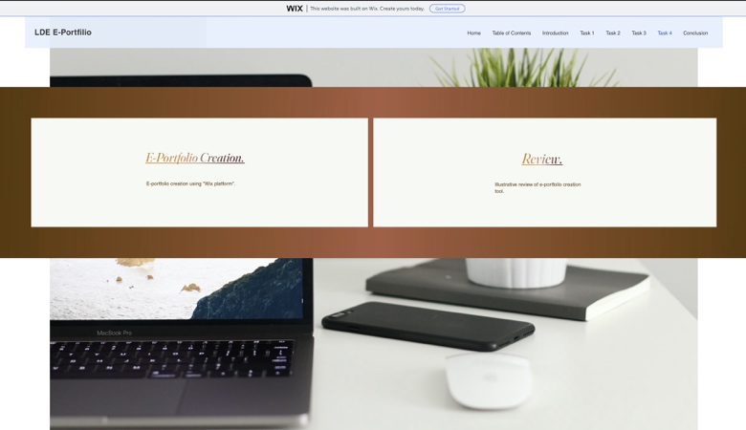
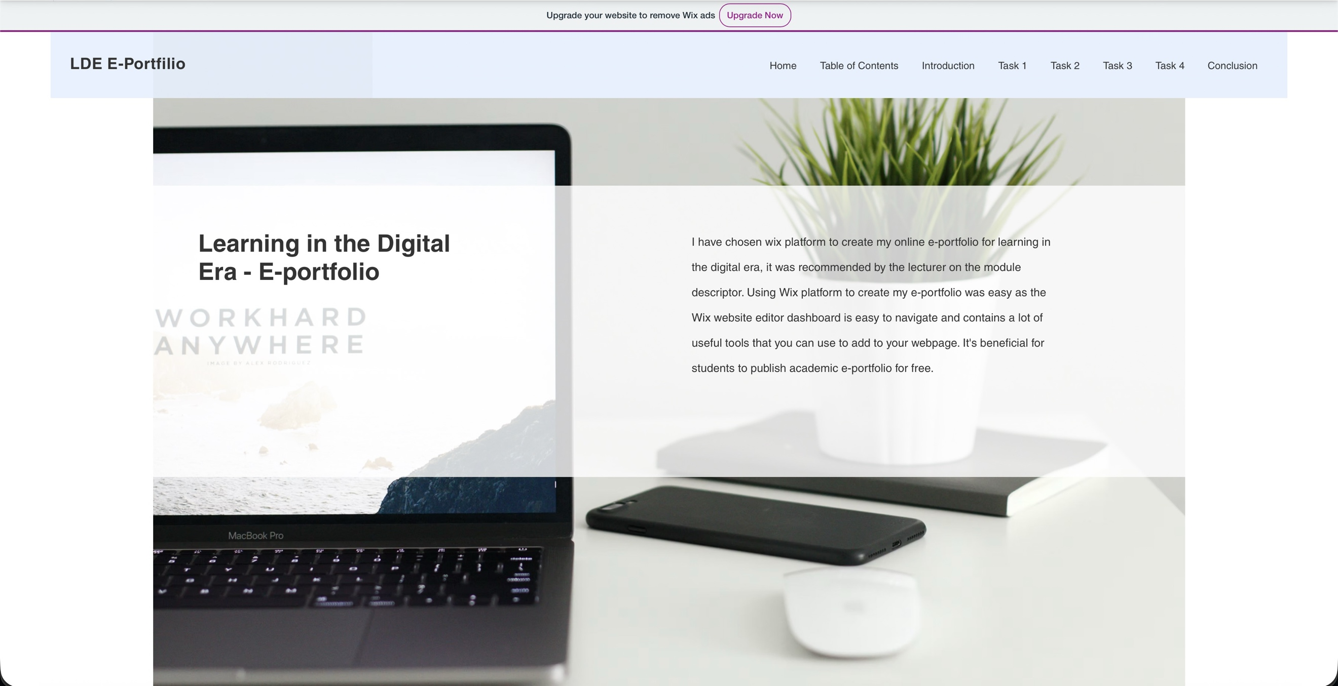
Illustrative Review:
I have chosen Wix platform to create my online e-portfolio for learning in the digital era, it was recommended by the lecturer on the module descriptor. Using Wix platform to create my e-portfolio was easy as the Wix website editor dashboard is easy to navigate and contains a lot of useful tools that you can use to add to your webpage. It's beneficial for students to publish academic e-portfolio for free.

Conclusion
With the continues improvement of technology in today’s age proven beneficial for individuals and companies as this help with efficiency in performing a task and increasing productivity. Understanding how to utilise digital software and hardware to your advantage are beneficial skills, this can help on your day-to-day activities and also help you to learn new skills in the digital era [1], [2], [3]. Moder technology has both advantages and disadvantages. With the current adaptation of universities and companies with digital software, virtual teams are one of the widely use application by most individual and companies. It is beneficial as people can work on things from different part of the world or from the comforts of their own home, but this poses a notable risk as misunderstanding often happen due to lack of verbal and face-to-face interaction with different individual. Having a good grasp of emotional intelligence can help you navigate through different scenario that can happen, it allows you to identify conflict within a virtual team and provide solutions [4],[3],[2].

References

Task 1 References:

[1] | S. Cottrell, “The Study Skills Handbook,” London, Bloomsbury Publishing, 2024.
[2] | Engineering Review, “Over 75 pc of companies look to adopt latest technologies in next five years, 14 million people will lose jobs in next five years, WEF Future of Jobs Report says,” 23 June 2023. [Online]. Available: https://engineeringreview.com.pk/over-75-pc-of-companies-look-to-adopt-latest-technologies-in-next-5-years-14-million-people-will-loose-jobs-in-next-five-years-wef-future-of-jobs-report-says/#.
[3] | A. Di Battista, S. Grayling, E. Hasselaar, T. A. Leopold, R. Li, M. Rayner and S. Zahidi, “Future of Jobs Report 2023,” 2023. [Online]. Available: https://www.weforum.org/reports/the-future-of-jobs-report-2023.
[4] | N. C. Service, “Digital skills to help your career,” [Online]. Available: https://nationalcareers.service.gov.uk/careers-advice/build-foundation-digital-skills-to-help-your-career/.
[5] | M. Magsoudi, “Uncovering the skillsets required in computer science jobs using social network analysis,” in Education and Information Technology, Switzerland, Springer Nature, 2024.
[6] | A. Verma, “An investigation of skill requirements for business and data analytics positions: A content analysis of job advertisements,” Journal of Education for Business, vol. 94, no. 4, pp. 243-250, 4 January 2019.

Task 3 References:

References
[1] A. E. Feyerherm and C. L. Rice, "Emotional intelligence and team performance: The good, the bad and the ugly," The International Journal of Organizational Analysis, vol. 10, no. 4, pp.343–362, 2002.
[2] L. Handke, P. Costa and T. A. O’Neill, "Virtual Teams: Taking Stock and Moving Forward," Small Group Research, vol. 55, no. 5, pp.671–679, 2024.
[3] P. Pazos, "Conflict management and effectiveness in virtual teams," Team Performance Management: An International Journal, vol. 18, no. 7/8, pp.401–417, 2012.
[4] S. Morrison-Smith and J. Ruiz, "Challenges and barriers in virtual teams: a literature review," SN Applied Sciences, vol. 2, no. 6, pp.1096, 2020.

