Ben Harris 2102992

A critical essay about a piece of Welsh Contemporary architecture

The Pierhead building in Cardiff could be described as a contemporary piece of Welsh architecture.
This essay will research the building's role throughout history and how, why, and when it has changed in time. This essay will then explore how the building has had to adapt to its ever-changing surroundings and evaluate the buildings role and relevance in its current state.

Buildings History
There are many examples of leading architecture in Wales, but one that has been in the eyes of many as a staple, is the Pierhead building in Cardiff. The building has been in the public eye due to the role that it has played and more importantly, still plays. The Pierhead was built in 1897 as a replacement for the original Bute Dock Companies Building which was ruined by fire in 1892. The new Cardiff Railway Company (formerly known as the Bute Docks Company) Pierhead Building was commissioned by the Marquess of Bute (Akthar, 2019) and designed by the notorious Welsh architect William Frame, which was then built by William Thomas and Co. (Senedd Cymru, 2022). William Frame was infamous for working on many Welsh architectural landmarks which included the refurbishment of Cardiff Castle and reconstruction of Castell Coch, while he worked as an assistant for William Burges (Hilling, 2018).

Buildings Architecture
The design of the Pierhead is one of several examples of 'Red Brick' buildings constructed in this era, such as Roath Park Primary School, Designed by E M Corbett in 1894 (Senedd Cymru, 2022). Hilling described the Pierhead as a 'Spiky French Gothic Landmark' in 'Architectural Fancy Dress' amongst a number of other features which have taken inspiration from far and wide (Hilling, 2018).

Sketch of Plans

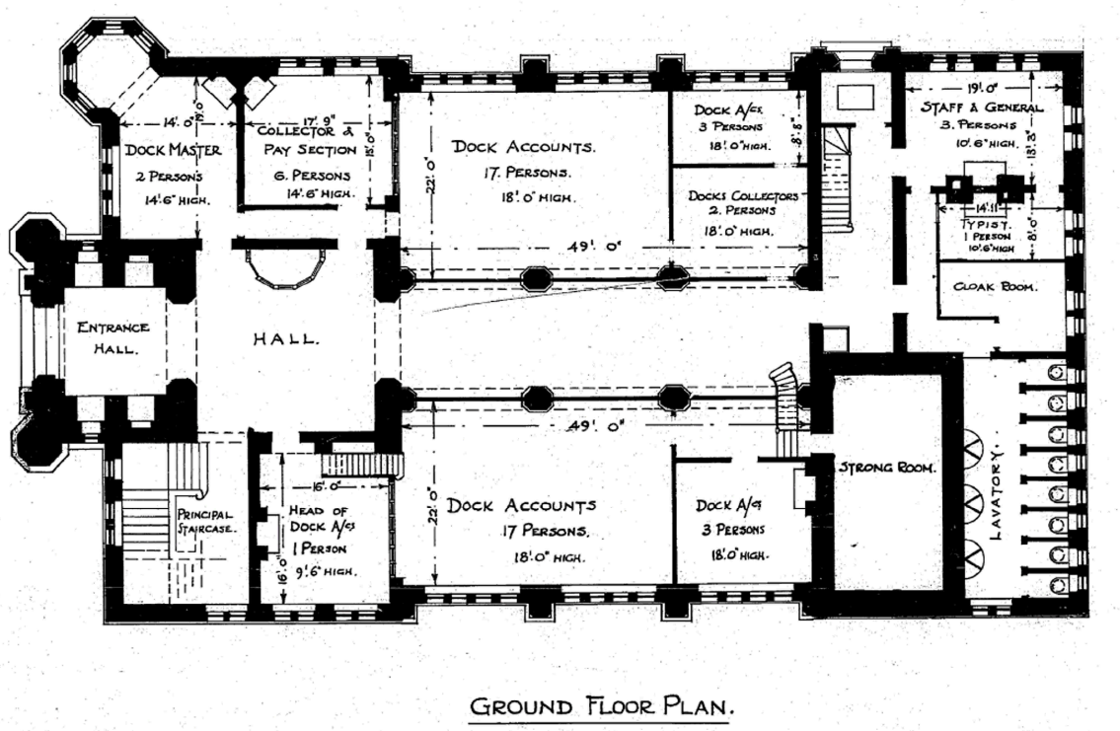

Figure 1 GWR Chief Engineer’s Office drawing of the Ground Floor Plan on 16th June 1926 (courtesy of Network Rail records office York)

Figure 2 GWR Chief Engineer’s Office drawing of the first floor on 16th June 1926 (courtesy of Network Rail records office York)

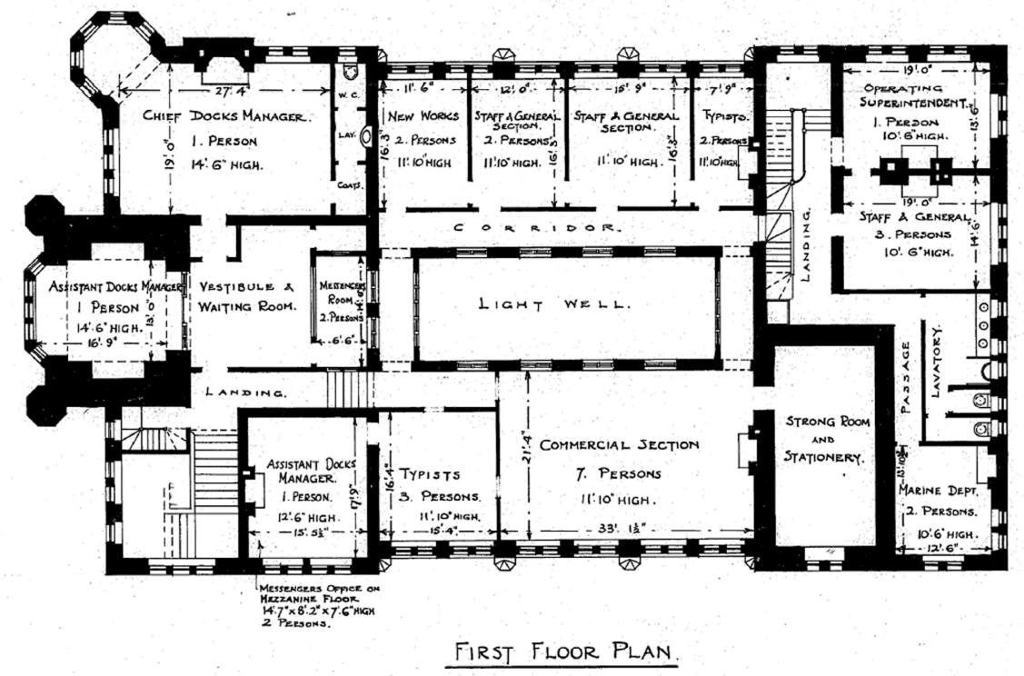

Figure 2 GWR Chief Engineer’s Office drawing of the First Floor Plan on 16th June 1926 (courtesy of Network Rail records office York)

The main feature which has been used in excess across the whole of the design is the use of red terracotta. This gives the now notorious landmark its identity which it is now known for and shares with Roath Park Primary School. The plans show the rectangular interior layout of the Pierhead, with a small extrusion for an entrance hall and semi-circular tower on the ground floor and an assistant
docks manager office on the first floor. A central piece of the whole design is the clock tower, wrapped in the same terracotta red. It acts as a landmark that sailors and merchants would associate with Cardiff as they entered the docks. The mechanism used when the Pierhead was originally built was done by William Potts and Sons, overseen by the designer of Big Ben, Edmund Beckett Dension (Senedd Cymru, 2022). With the port being used at all hours, the clock was visible both during the day and night. This was done through gas lighting at the rear of the dials which would automatically light the clock at night (Senedd Cymru, 2022).

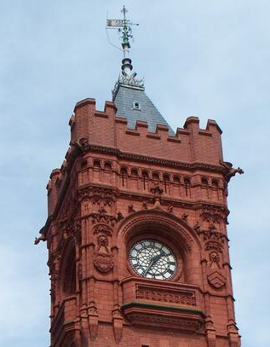

Figure 3 Photograph of the South Facade taken by Stephen R. Hughes (2008)
Vertical Windows and Semi Circular Arches have been used in abundance across the whole of the design. These allow light to flood into the interior spaces of the Pierhead. Along with the wealth of windows, there is also intricate decoration on the exterior of the building. This is shown in the gargoyles which dress the crenelated parapets (Donald Insall Associates Ltd, 2009). This decoration shows the vast amounts of wealth that were coming through the port and which could then be spent on the new architecture. Due to the historical significance of the Pierhead, it gained its grade 1 listing on the 19th May 1975, as described by Coflein, this was especially due to the domination of the 2-stage clock tower as previously mentioned, the clock faces which can be seen from afar are set back beneath semi-circular arches decorated with flanking lions and coats of arms (Donald Insall Associates Ltd, 2009).

Buildings Original Use
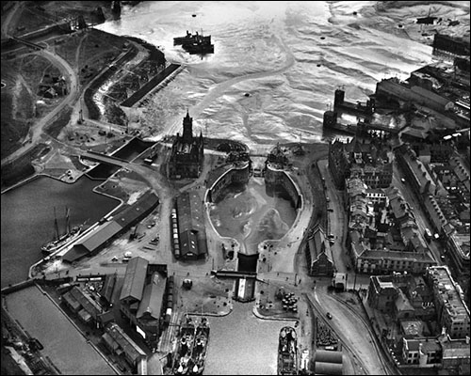

Figure 4 Aerial Photo taken by Aerofilms LTD (1929)

When the gothic revival design Pierhead was originally built for the marquess of Bute it was to serve the role of the administrative office for the South Wales Ports (Senedd Cymru, 2022). At the time of construction the port at Cardiff was a hub for the export of coal all over the world, with an average of 9 million and a peak of 13 million tonnes leaving per year. Due to the enormous quantity of coal, the Pierhead was the location where the first £1 million check was signed (Cardiff Harbour Authority, 2022). Showing that this was the financial centre for business during the time that coal was a major export and financial dependency for South Wales. The Pierhead acted as both a headquarters for the Cardiff Railway Company and also as a show of wealth for the Marquess of Bute and all that he had achieved and still was achieving. The Pierhead was the centre for all operations of the port and it was there, that the Dock Master oversaw operations. A place where engineers drew up plans and where the accounts were managed (Senedd Cymru, 2022). But throughout time and with the everchanging layout and usage of the Bay, the role of the Pierhead has had to change to adapt to the regeneration of the Bay ever since the drastic decrease in the production of coal. The Pierhead remained as the dock offices for over a hundred years until it was taken over by the national assembly for Wales in 1999. Its uses changed to offices and a visitor and educational centre for the use of the public (Donald Insall Associates Ltd, 2009).
Since the changing of hands of the Pierhead, there has been a range of activities and events in which the building has been used to maintain the amounts of usage which pay for the upkeep of the building. For example, this has been done through holding plays, in 2011 Shakespeare's ‘Much Ado About Nothing’ was held at the Pierhead (Roberts, 2012). Also held at the coal exchange in 2013, was an opera named Orpheus in the Underworld, with a review of the play described as a 'glorious ensemble piece that was populated with a rich pantheon of characters all delivered with relish by the cast' (Smith, 2013). By the Pierhead hosting plays and musical performances, it shows the building has much more potential than some may preserve and still has a purpose in the Cardiff Bay. The building would now become an education resource to explain its history to the public, whilst also showcasing art in the Futures Gallery which was formerly an office for staff (Akthar, 2019). The now National Assembly owned building is described as having the aim to ‘inform, involve, and inspire a new generation to forge a Wales for the future’ (Visit Wales, 2022). To do this, the building sets out to be a unique centre for the public to visit from far and wide to attend events and conferences. The Pierhead intends to act as a space for the people of Wales to express opinions and give a voice on issues that matter to them as individuals (Senedd Cymru, 2020).
But as a staple of architecture in Cardiff and Wales, the Pierhead has an important role to play in reflecting the history of which the Cardiff dock once was and still is. But with the dockland no longer being functional, it has to serve a new purpose that will maintain its upkeep. A design and access statement for alterations to the Pierhead is shown in a document from Coflein (DCA Consultants, No Date ). A plan for the future includes an open reception area that will showcase the building's architecture. An orientation gallery will open, which will include a video installation of the Bay, tactile displays on the buildings features, graphic wallpaper displays, and an audio information post (DCA Consultants, No Date ). The plans also aim to develop the buildings advertisement to the wider public, increasing its sense of arrival, which will bring in passers-by who would otherwise be lost.
To conclude, the Pierhead building was the pinacol of the Welsh coal exporting industry, to accommodate the Marquess of Bute's growing business. However, in recent times, with the coal industry plummeting, and its use at the lowest rate in hundreds of years, the building has had to adapt to the current economic climate and find an alternative use to ensure it gets the attention it deserves, since its takeover in 1999. As discussed, the plans set out will help to enable the maintenance of the building, allowing the public to develop and enrich their knowledge of the Welsh coal history, along with the regeneration of Cardiff Bay. It could be argued that although the Pierhead is not used for what it once was, its change in purpose corresponds to its change in time. Therefore, this Welsh piece of contemporary architecture with the help from its adaptations, is still fit for purpose at the heart of the Welsh capital city.

References
Aerofilms LTD (1929) Aerial Photo. Available at: Cardiff Docks, Cardiff | Coflein (Accessed: 2 December 2022).
Akthar, F. (2019, October 25th). Pierhead: The building that defeats the modern architecture around it. Retrieved December 04, 2022, from Cardiff Journalism: https://cardiffjournalism.co.uk/intercardiff/business-culture/pierhead-the-building-that-defeats-the-modern-architecture-around-it
Cardiff Harbour Authority. (2022). History. Retrieved December 04, 2022, from Cardiff Harbour: https://www.cardiffharbour.com/history/
Coflein. (2009). Pierhead Building, Cardiff. Retrieved December 06, 2022, from Coflein: https://coflein.gov.uk/en/site/34241/
DCA Consultants. (No Date ). Brief Historical Analysis. Retrieved December 05 , 2022, from Coflein: https://coflein.gov.uk/media/163/900/erc2012_016_002.pdf
Donald Insall Associates Ltd. (2009). Pierhead Building, Cardiff Brief Historical Analysis for National Assembely for Wales. Retrieved December 2, 2022, from Coflein: https://coflein.gov.uk/media/163/900/erc2012_016_002.pdf
Hilling, J. (2018). The Architecture of Wales. In J. Hilling, The Architecture of Wales (pp. 157-173). Cardiff: University of Wales Press. Retrieved December 03, 2022
Hughes, R. (2008) Photograph of the South Façade. Available: DS2008_057_002 - Coflein Digital Asset Management (ibase.media) (Accessed : 2 December 2022).
Network Rail records office York (1926). GWR Chief Engineer’s Office drawing of the Ground Floor Plan. Available at: Microsoft Word - PBC4 historical 6feb09.doc (coflein.gov.uk) (Accessed: 2 December 2022).
Network Rail records office York (1926). GWR Chief Engineer’s Office drawing of the First Floor Plan. Available at: Microsoft Word - PBC4 historical 6feb09.doc (coflein.gov.uk) (Accessed: 2 December 2022).
Roberts, B. (2012). Review of Shakespeare's Much Ado About Nothing (directed by Richard Nichols for Mappa Mundi/Theatr Mwldan) at the Coal Exchange, Cardiff, 19 October 2011. Shakespear, 8(4), 447-450. Retrieved December 07, 2022, from https://www-tandfonline-com.ezproxy.uwtsd.ac.uk/doi/full/10.1080/17450918.2012.705878
Senedd Cymru. (2020). The Pierhead Today. Retrieved December 07, 2022, from Senedd Cymru: https://senedd.wales/visit/our-estate/the-pierhead/the-pierhead-today/
Senedd Cymru. (2022, May 23). History of the Pierhead. Retrieved December 03, 2022, from Senedd Cymru: https://senedd.wales/visit/our-estate/the-pierhead/history-of-the-pierhead/
Smith, M. (2013). Opera'r Ddraig: Orpheus in the Underworld: The Coal Exchange, Cardiff. Musical Opinion, 136(1494), 43-44. Retrieved December 7, 2022, from https://www.proquest.com/docview/1349793998/fulltext/534496450BF94DA9PQ/1?accountid=130472
Visit Wales. (2022). The Pierhead. Retrieved December 6, 2022, from Visit Cardiff: https://www.visitcardiff.com/highlights/pierhead/

