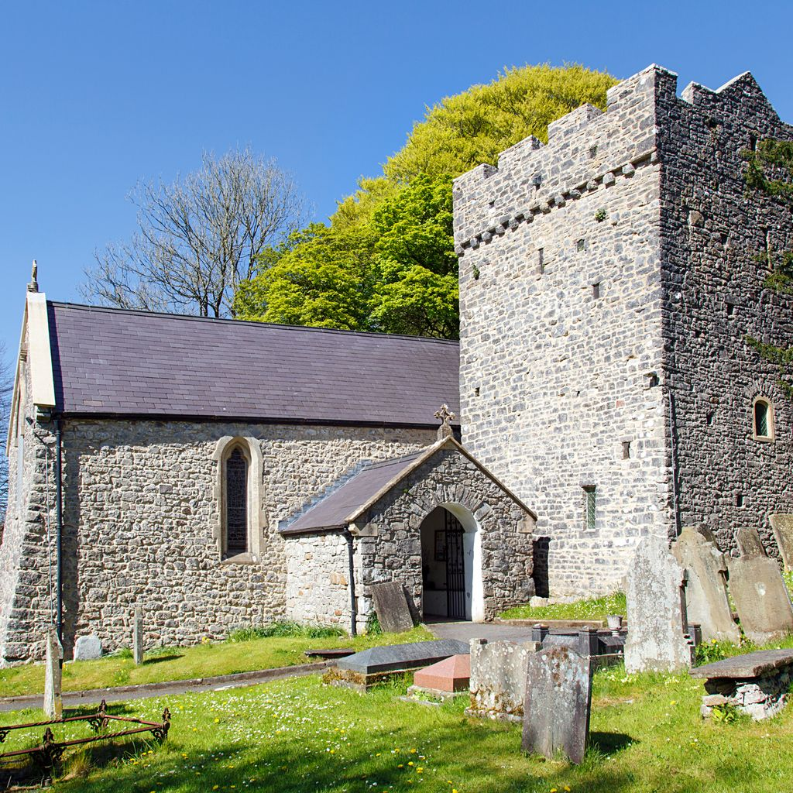
Conservation management plan
Building Conservation, Asset and Facilities Management
Sean Bamber | 2320765 | ACBA6012

Table of Contents
Introduction 2
History 2
Location 2
Architecture / Construction 2
Use and Community Interest 2
Stakeholders (Owners and Users) 2
Aspirations for Site 2
Identification of Building Significance 3
Assessment of the Building's Structure / Decoration / Design and Use 3
Historical 3
Aesthetic 3
Communal 3
Evidential 3
Challenges and Opportunities 4
Funding Available / Restrictions / Risks from Environment / Risks from People 4
Risks 4
Engagement 4
Improving Access 5
Climate Change / Future Proof 5
Managing Significance / Interventions 5
Considerations for C&O Intervention Need to be Appropriate 5
Risk Management 6
Action Plan 6
Material Symbiosis 6
Maintenance and Compliance 6
Surrounding Landscape Survey 7
Appendices 7
HIA (Heritage Impact Assessment) 7
Legislation 7
BS7913 (British Standard 7913) 8
Conservation and Planning 8
Final 8
References 9

Introduction
St Illtyd's Church in Ilston is a Grade II* listed edifice that embodies centuries of architectural, cultural, and religious heritage. Maintained by dedicated volunteers, it offers insight into previous spiritual and social life. Its status as a centre of the community and a place of worship will be preserved for future generations thanks to this conservation strategy. It discusses the historical significance, present state, and preservation tactics of the church.

History
Dedicated to the Welsh saint St Illtyd, who lived in the fifth century, St Illtyd's Church dates back to the early mediaeval era. A combination of Norman, mediaeval, and Victorian architectural elements may be seen in the contemporary building. One important element is the Norman gateway with its Romanesque patterns, and the mediaeval wall paintings that were discovered beneath subsequent plaster provide information about early religious and artistic customs. The church's distinctive profile is enhanced by a tower from the 15th century that was constructed during a major enlargement, reflecting the goals of the mediaeval parish community. Sir George Gilbert Scott oversaw the Victorian renovation, which ensured the church's continued significance by preserving its historic character while incorporating contemporary features.

Location
Encircled by a tranquil churchyard and with boundary walls made of local rubble stone, St Illtyd's Church in Ilston, Swansea, adds to its mediaeval beauty. You can get a better look at its architectural elements and picturesque environment by using online images and mapping programs.

Current Condition
Concerns have been raised recently about a number of aspects of the church's preservation and structural soundness. The church's crucially important slate roof has weathered and several tiles are missing, which raises concerns about water intrusion. To avoid more harm to the inside and timber framework, damaged slates must be evaluated and replaced right away.
The external walls exhibit evidence of mortar deterioration, which increases moisture absorption and reduces their durability. The problem is made worse by biological growth, such as moss and ivy, which traps moisture and further deteriorates the mortar. In order to address these problems, controlled vegetation clearance and lime mortar repointing are crucial procedures.
One of the church's main features, the tower from the 15th century, has small structural flaws that need to be watched to make sure they don't get worse over time. Lead fatigue and deterioration are causing the stained-glass windows, particularly the east window, to deteriorate. Immediate restoration is essential to stabilize the brittle panes and repair the leading to maintain their historical and artistic value.
The stone slab flooring, an important historical feature, has grown uneven, causing safety issues. While maintaining the authenticity of the floor, a thorough evaluation and realignment of the slabs will aid increase safety.

Architecture/Construction
This traditional ecclesiastical design shows careful attention to craftsmanship, especially in the stonework. The church is constructed with random coursed stonework with Bath stone detailing, and its walls lean outward, especially at the northeast corner of the chancel, which is probably due to historic roof spread.

Use and Community Interest
St. Illtyd's Church is still a hub for community events and a place of worship. Volunteers play a key role in its upkeep and conservation, and programs like the 2023 Access Audit seek to increase accessibility and guarantee inclusivity for all community members.

Stakeholders
The church wardens and the Diocese of Swansea and Brecon, represented by Vicar Peter Brooks, oversee the day-to-day operations and ongoing upkeep of the church. To maintain its ongoing significance to the community, volunteers and locals are also essential in supporting its operations and maintenance.

Aspirations for the Site
Future goals include preserving the historical integrity of the church, enhancing physical and informational accessibility, encouraging increased community involvement through events and activities, and looking into funding options for preservation and restoration work.

Building Significance
St. Illtyd's Church's Grade II* classification, which guarantees the preservation of its distinctive elements, highlights its historical and architectural significance. By confirming its significance as a heritage site, this classification protects its legacy for coming generations.

Assessment of Structure/Decoration/Design and Use

Historical
Documents from 1119 and 1221 mention the church's history, which extends at least to the 12th century. It has undergone multiple repairs to maintain its integrity and displays changing religious design.

Aesthetic
The church's design consists of a nave, chancel, and vestry, all of which are adorned with ornamental masonry and have conventional stone construction with Bath stone ornamentation. Its calm, contemplative surroundings are enhanced by the churchyard.

Communal
By holding services and programs, the church acts as a gathering place for the community. Its social significance is reinforced by volunteers, who are essential to its upkeep.

Evidential
The church provides important proof of traditional architectural techniques. In order to comprehend its status and direct future preservation efforts, inspection reports highlight problems like structural faults and damp infiltration.

Challenges and Opportunities
St Illtyd's Church faces challenges related to funding, environmental risks, and preservation, but also opportunities for proactive action.
Funding Available: There are funding options from heritage organizations, CADW grants, and community fundraising, but these are competitive and require detailed proposals.
Restrictions: The Grade II* listing limits alterations and repairs, necessitating compliance with conservation guidelines, which may increase costs and complexity.
Environmental Risks: Damp ingress, worsened by rainfall and poor drainage, threatens the church’s structure, requiring urgent remedial work.
Risks from People: Vandalism and neglect pose preservation risks. Engaging the community is key to preventing these issues and ensuring the church is respected and maintained.
Risks
The church faces several risks that must be addressed to preserve its future.
Structural Risks: Dampness and moisture issues threaten the building’s fabric, requiring immediate action.
Financial Risks: Limited funding may hinder repairs, causing further deterioration.
Community Engagement Risks: Lack of community involvement could weaken support for the church and its ability to secure funding.

Engagement
The church's viability depends on community involvement, and programs like events, workshops, and volunteer opportunities may strengthen ties and guarantee continued support.
Improving Access
Improving access following the 2023 Access Audit is a priority. Enhancements may include:
Physical Access: Installing ramps and improving pathways to ensure full accessibility.
Information Access: Clear signage and information will attract visitors and broaden participation.

Climate Change / Future Proofing
To safeguard the church’s future, climate change must be addressed through proactive strategies:
Sustainable Practices: Using breathable coatings and eco-friendly maintenance to combat dampness.
Resilience Planning: Developing a long-term plan to address risks like flooding and extreme weather.
Community Education: Educating the community on climate change impacts and sustainable preservation practices.

Managing Significance / Interventions

Considerations for C&O Intervention Need to be Appropriate
When planning conservation and operational (C&O) interventions at St Illtyd's Church, it is necessary to ensure that all measures are appropriate to the building's historical and architectural value. This contains:
o Preserving Historical Integrity: Any renovations must respect the church's historic architectural elements and character while following the rules established by CADW and other heritage organisations.
o Use of Conventional Materials: To stop additional damage to the structure, repairs and maintenance should make use of materials that can be used with the original construction, such as breathable coatings and mortars based on lime.

Risk Management

St. Illtyd's Church preservation depends on effective risk management techniques. Important things to think about include:

o Identifying hazards: Regular evaluations should be undertaken to identify potential hazards, such as structural issues, environmental factors, and community engagement challenges.

o Mitigation Strategies: Long-term preservation will depend on creating and putting into practice plans to reduce hazards that have been identified, such as enhancing drainage systems to deal with moisture and enlisting community participation.

Action Plan
An action plan should be developed to outline specific steps for addressing the church's maintenance and preservation needs. This plan may include:
  - Prioritization of Repairs: Identifying urgent repairs, such as addressing damp ingress and drainage issues, and scheduling them for prompt action.
  - Funding Applications: Seeking funding opportunities to support necessary repairs and maintenance, including grants and community fundraising efforts.
  - Community Engagement Initiatives: Organizing events and outreach programs to raise awareness and encourage local involvement in the church's upkeep.

Material Symbiosis
Material symbiosis refers to the harmonious relationship between the building's materials and its environment. In the context of St Illtyd's Church, this involves:
  - Compatibility of Materials: Ensuring that any new materials used in repairs are compatible with the existing structure to prevent damage and maintain aesthetic coherence.
  - Sustainable Practices: Incorporating sustainable materials and practices in maintenance efforts to enhance the building's resilience against environmental challenges.

Maintenance and Compliance
Ongoing maintenance and compliance with heritage regulations are vital for the church's preservation. This includes:
  - Regular Inspections: Conducting routine inspections to monitor the condition of the building and identify maintenance needs promptly.
  - Compliance with Regulations: Ensuring that all maintenance and repair work complies with local and national heritage regulations, including obtaining necessary permissions for alterations.
  - Documentation: Keeping detailed records of maintenance activities, repairs, and inspections to support compliance and inform future interventions.

Surrounding Landscape Survey
A survey of the surrounding landscape is essential for understanding the context in which St Illtyd's Church exists. Key considerations include:
  - Landscape Assessment: Evaluating the condition of the churchyard, boundary walls, and pathways to identify areas needing improvement or restoration.
  - Integration with Environment: Ensuring that any interventions in the landscape complement the church's historical significance and enhance its visual appeal.
  - Biodiversity Considerations: Considering the local ecology and biodiversity when planning landscape interventions, such as maintaining native plant species and managing overgrowth.

Appendices

HIA (Heritage Impact Assessment)
A Heritage Impact Assessment (HIA) is crucial for understanding the potential effects of proposed changes or interventions on the historical significance of St Illtyd's Church. Key components include:
- Assessment of Significance: Evaluating the church's historical, architectural, and cultural significance to inform decision-making regarding any proposed works.
- Impact Analysis: Analysing how proposed interventions may affect the church's character and fabric, ensuring that any changes are justifiable and necessary.
- Mitigation Strategies: Recommending measures to mitigate any adverse impacts identified during the assessment, ensuring that the church's heritage value is preserved.

Legislation
Understanding the relevant legislation is essential for compliance and effective management of St Illtyd's Church. Important legislative frameworks include:
- Planning (Listed Buildings and Conservation Areas) Act 1990: This act provides the legal framework for the protection of listed buildings and conservation areas in the UK, ensuring that any alterations to St Illtyd's Church are conducted in accordance with legal requirements.
- The Ancient Monuments and Archaeological Areas Act 1979: This legislation protects scheduled monuments and archaeological sites, which may be relevant if any excavation or significant alterations are planned around the church.
- The Regulatory Reform (Fire Safety) Order 2005: Ensures that fire safety measures are in place for public buildings, including places of worship, to protect both the structure and its users.

BS7913 (British Standard 7913)
BS7913 provides guidance on the conservation of historic buildings and is a valuable resource for managing St Illtyd's Church. Key aspects include:
- Conservation Principles: Outlining best practices for the conservation of historic buildings, including the importance of understanding the building's significance before undertaking any work.
- Decision-Making Framework: Offering a structured approach to decision-making regarding repairs, alterations, and maintenance, ensuring that interventions are appropriate and respectful of the building's heritage.
- Sustainability Considerations: Emphasizing the need for sustainable practices in conservation efforts, which can enhance the longevity and resilience of the church.

Conservation and Planning
Conservation and planning are integral to the management of St Illtyd's Church, ensuring that its historical significance is preserved while accommodating modern needs. Key considerations include:
- Conservation Policies: Developing and implementing conservation policies that align with local and national guidelines, ensuring that all work on the church is conducted with respect for its heritage.
- Planning Applications: Understanding the process for submitting planning applications for any proposed works, including the need for listed building consent for alterations that may affect the church's character.
- Community Involvement: Engaging with the local community and stakeholders in the planning process to foster support for conservation efforts and ensure that the church remains a valued part of the community.
In summary, the appendices related to St Illtyd's Church encompass essential elements such as Heritage Impact Assessments, relevant legislation, British Standards for conservation, and the principles of conservation and planning. These components are vital for ensuring the church's preservation and effective management in the context of its historical significance.

Final
In conclusion, the conservation plan for St Illtyd's Church is a vital step towards addressing the pressing issues of damp ingress and maintenance while preserving the church's historical and architectural integrity. By implementing the proposed interventions, such as improving ventilation and establishing a routine maintenance schedule, we can mitigate the risks of further deterioration. Engaging the local community in these efforts will not only enhance the church's role as a community hub but also foster a sense of shared responsibility for its preservation. Ultimately, this plan ensures that St Illtyd's Church remains a cherished landmark and a place of worship for future generations.

References

