Shader Development

Luke James Webb
2021
Table of Contents
User Guide 2
Controls 2
User-Interface 2
Shader concepts used. 4
Post Processing 4
Physically Based Rendering - PBR 7
Lighting 9
Directional light 9
Point Light 10
Spotlight 10
Emerging shader treads 11
procedural textures 11
Texture Blending 11
Testing Plan 12
References 15

User Guide

Controls
When the window first opens, it will default to being focused so the user is free to move around the camera, using W, S, A, D, Q and E for forward, backward, left, right and up and down, to unfocused the window the user can press the left alt key, after the window is unfocused the cursor will become visible allowing the user to move around the GUI, clicking on any of the GUI elements will cause the drop down headers to expand showing the options that they hold, to interact with any of the GUI elements the user can simply click or drag on the element to change their values.

User-Interface
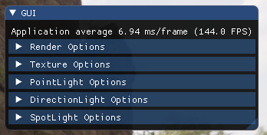
For the user interface I used Dear Imgui a “bloat-free graphical user interface library for C++.” That you can download for free on Github, I put the options for into five sections, these are collapsible headers, the headers are Render Options, Texture Options, Point light Options, Spotlight Options and Directional light Options.
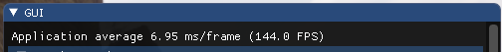
At the top of the GUI, I set some information for the user including frame times and frames per second.
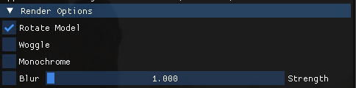
Under Render Options the user will have some tick boxes to select if the user wants to enable the model rotation as well as enable as disable post-processing effects like wobble, monochrome and blur as well as the strength of the blur.
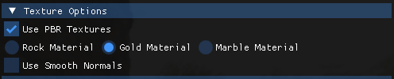
Under the Texture Options the user will have some more tick boxes to click on to enable and disable effects, here the user can select if they would like to use PBR texture that will also allow them to select what material they want to use from Rock, Gold or Marble if the user unticks the use Use PBR tick box then the options will change to this:
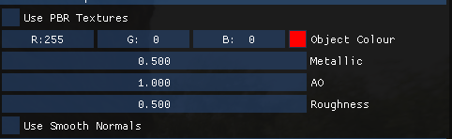
Now the user will be able to pick the colour and change the values of the metallic, ambient occlusion and the roughness of the model, and at the end of header the user can choice if they would want the model to use smooth normals making the model making it softer with less flat edges and over all-rounder.
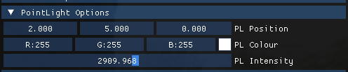
On the point light headers, the user will be able to drag on the light position components to move it around, if the user clicks on the colour it will open another small window that will allow the user to drag around a selection point on a colour map.
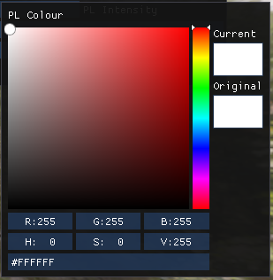
The options also have a slider for controlling the intensity.
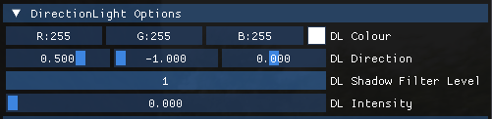
For the directional light, the user will have similar options to the point light but instead of a position component the directional light has a direction component as well as a drag slider to change the filtering on the shadows and then another slider for intensity.
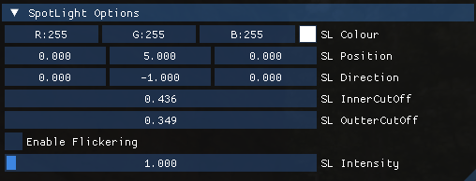
For the spotlight, the user can select the colour like the other light and drag the spot lights position and direction, the user can also change the radius of the light, the user will also have the option to enable a flickering effect with the intensity of the light.

Shader concepts used.

Post Processing
for my post-processing effects, I choice to add 3 different types, I implemented a wobble, blur and monochrome effects, the wobble effect takes the framebuffer texture and creates these rippling effects down the image like so:
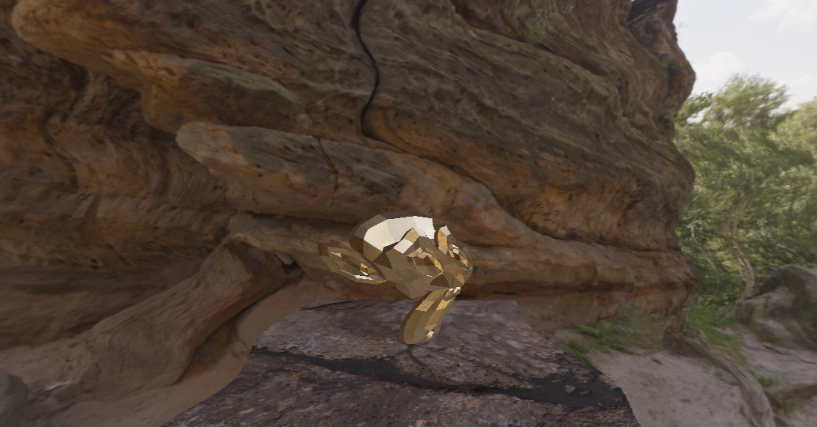
This is effect was done by taking the framebuffer texture and changing the texture coordinates like this in my shader:
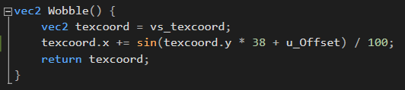
On the first line I take the texture coordinates coming in from the vertex shader and assign them to a new variable so that I can do operations on them, I then take x component and make the addition of a sine of an angle of the y component multiplied by 38 and an uniform offset or time that I get from glfw in main.cpp then I just return the texture coordinates and use them instead of the normal ones if the user selects the option in the GUI.
The next post processing effect I added was a simple monochrome effect that looks like this:
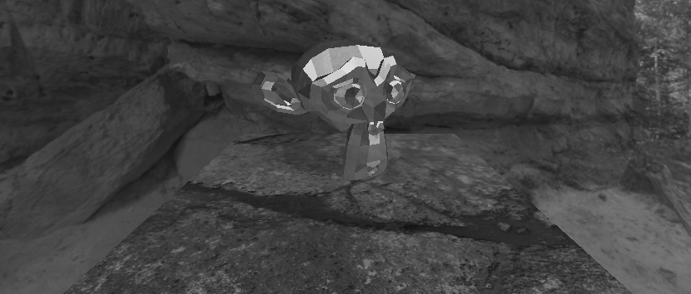
And here is the code that I used to achieve this effect:
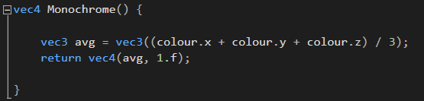
This is by far the simplest effect that I added to my application, here I just take the colour of the outgoing pixel colour and I take each colour red, green and blue and add them together and then I just divide by the number of components so 3 and this will then create this nice monochrome effect then I just return the colour.
The last effect I added to my application is a blur effect and that looks like this:
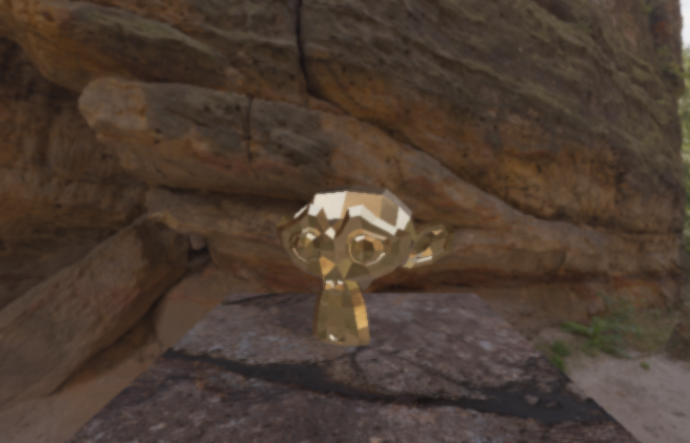
And the code for this effect looks like this:
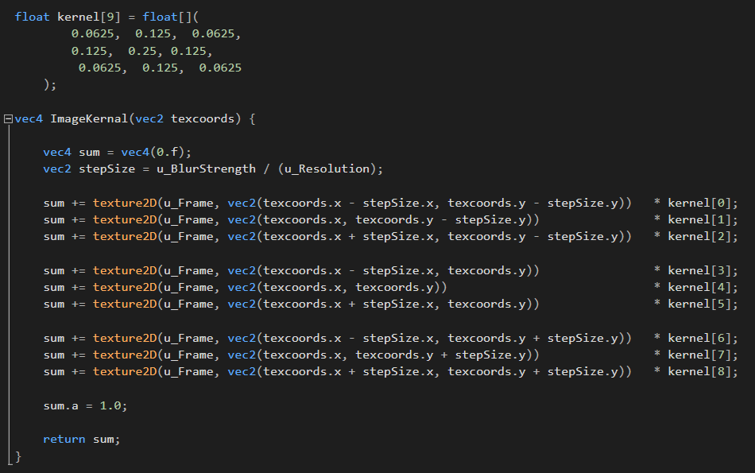
This is the most complex effect that I have added to my application, to achieve this effect I used an Image Kernel to weight different pixels around the current pixel in the fragment shader and sample them to get this effect, you can see at the top of the function I have an array of 9 floats, this is my kernel that I used and in the function you can see multiple texture2D calls for the texture sampler “u_Frame” so that I can sample all the neighbouring pixels, to calculate the stepSize variable I used the window resolution and sent it into the GPU as the “u_Resolution” uniform then I have another uniform called “u_BlurStrength” to adjust how many pixels the kernel with step over to get the pixel to sample, by default this value is set to one so the strength is not very strong but this can be adjusted in the GUI.

Physically Based Rendering - PBR
Instead of implantation Blinn-Phong illumination I choice to add an implantation of physically based rendering, this is a collection of techniques that are used to simulate properties of the real world, this is so we can get more realistic visual results using global illumination and material system that will use multiple textures for different properties of objects so we can control the albedo, roughness, metal-ness and ambient occlusion, using this we can emulate many different types of material properties from plastic to, metal or reflective and non-reflective with very good visual quality,
I choice to do this because It is a much newer model of rendering materials and lighting that give much more realistic visual, using this model I will be able to change multiple properties of a given object, these parameters allow for some amazing results that can look like so:
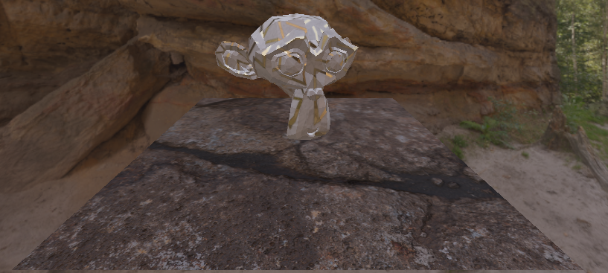
Here is an example of a semi-gloss surface material this is a marble you can see that reflective gold strips and the glossy white marble are treating light differently from each other.
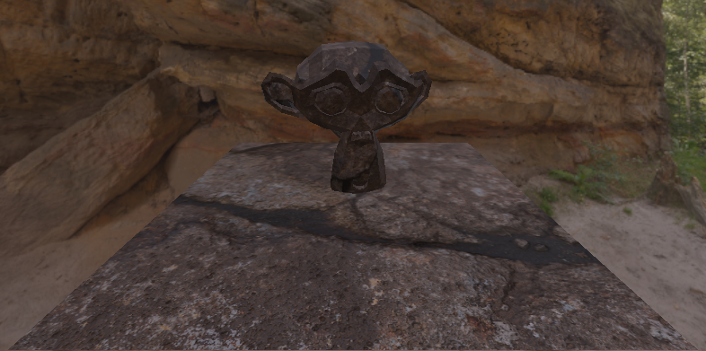
Here you can see that the blender monkey is now using the same material as the quad I used for the floor and it now reacts completely different from the marble material that it using before.
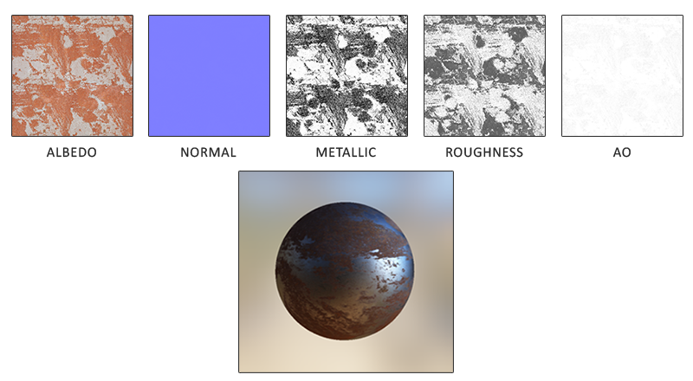
Here is an example of a PBR material where we use different textures to set the values of each parameter in the shader to get vastly different types of material, but we do not need to use texture and we could set them manual, so in my project I added user interface option to allow the user to change the values of the albedo, ambient occlusion, metal-ness and roughness of the object.
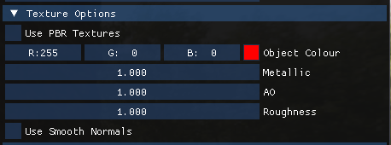
Here are the dropdown options that the user can change in real-time, the user will be able to toggle the PRB textures, if the textures are not in use, they will get the option for the albedo, ambient occlusion, metal-ness and roughness as well as the option for using smoothed normal making the model seem much smoother.
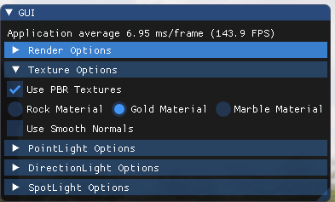
The user will also be able to choose one of three different textures that load with the program in real time.

Lighting

For Lighting I added the three basic types of light, point, spot and directional for each of the light types I added one into the scene and gave each GUI option for the user to change around the parameters to show the lights working together with the material system, here is the options the user can change for each light.

Directional light
For the directional light, the user can change the colour of the light, the direction of the light, the filter level of the shadow so they can change the softness of shadow and the intensity of the light, here is an example of the light in use.
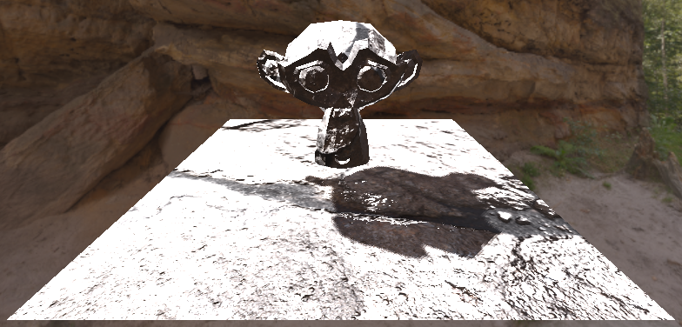

Point Light
For the point light the options are the lights position, colour and intensity since a point light is omni-directional there is no need to give it a direction option, here is an example of the light in use.
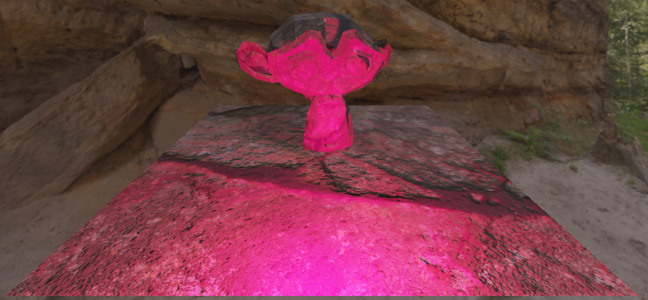

Spotlight
The spotlight has the most GUI options of all lights, it has a colour and position like the point light but it also has a direction and it has two extra parameters for controlling the sharpness of the light around the radius of the edge light moving the outer cut-off closer to the inner cut-off will cause the light to have a sharper radius, I also added an extra parameter for enabling the light to flicker randomly with a slider for speed, here Is an example of the light in use.
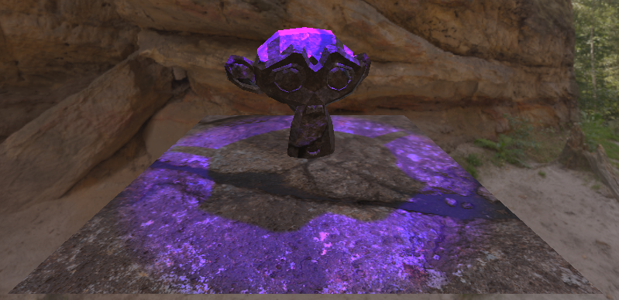

Emerging shader treads

procedural textures
An emerging trend I’ve notice in recent years in shader are the use of procedural textures, artist will use procedural textures to mix up patterns and stop reparation in places where they would have to use the same texture multiple times, for example they would use this tread for shading something like a large land mass like a field using a single seamless repeatable texture would lead to an obvious tilting of the textures and would be extremely easy to see where one texture starts and end, but using the shaders we can add small differences to the texture each time we use it, adding small amounts of rotation and some noise we can make each tile in the texture unique to the last making it look like its one big texture instead of the same texture tiled, for my project I could of used this to generate a texture to shade the monkey with or I could of used it to generate my own rock texture for the ground plane so each time the application is ran it would generate a new texture for the ground.

Texture Blending
Another emerging trend is to use multiple textures of similar styles and use blending and vertex painting to mix and blend the textures based on some variable like height if we use the land mass example like I did for procedural textures, say we were trying to add a small hill to some land made of sand and we wanted to go from a sand texture to a dirt texture and then at the top of the hill we wanted to add grass, we could easily set these parameters to mix between these textures as the height as the land changes, compared to my program I don’t have this type of blending to go between textures but If I did add this technique I could make the quad under the blender monkey blend between different types of rock to match the background of the skybox better.

Testing Plan
Test | Discretion | Pass/Fail | Fix (if needed) | Notes
Blender Monkey | Check that models load and render correctly | Pass | N/A | N/A
Floor Quad | Check that model loads and renders correctly | Pass | N/A | N/A
Gold Material | Check to see that all texture for material load and render | Pass | N/A | N/A
Rock Material | Check to see that all texture for material load and render | Pass | N/A | N/A
Marble Material | Check to see that all texture for material load and render | Pass | N/A | N/A
Skybox | Check to see that skybox renders with correct texture | Pass | N/A | N/A
GUI Render Option Check boxes | Check each tick boxes are working and applying effects | Pass | N/A | N/A
GUI Render Option Slider | Testing that float slider applies slider blur as slider goes up | Pass | N/A | N/A
GUI Texture Option Check boxes | Testing the user can change the value of the check box by clicking | Pass | N/A | N/A
GUI Texture Option Draggable floats | Testing the user can change the value of the variable by dragging on the GUI | Pass | N/A | N/A
GUI Texture Option Colour select | Testing the user can select a new colour using the pop out window | Pass | N/A | N/A
GUI Texture Options Radio Buttons | Testing that the radio buttons change the material | Pass | N/A | N/A
GUI Point Light Options draggable float | Testing the user can move the point light by dragging the GUI option | Pass | N/A | N/A
GUI Point Light Options Colour select | Testing if the user can change the colour of the light using the popout window | Pass | N/A | N/A
GUI Point Light Options Intensity Slider | Testing the user can change the intensity of the light using the slider | Pass | N/A | N/A
GUI Directional light Colour Select | Testing if the user can change the colour of the light using the pop out window | Pass | N/A | N/A
GUI Directional light Directional Slider | Testing the user can change the direction of the light using the slider | Pass | N/A | N/A
GUI Directional light draggable int | Testing the user can change the shadow filtering using the GUI | Pass | N/A | N/A
GUI Directional light Intensity slider | Testing that the user can change the intensity of the light via the slider | Pass | N/A | N/A
GUI Spotlight Colour select | Testing the user can change the colour of the light using the pop out window | Pass | N/A | N/A
GUI spotlight Draggable position | Testing the user can change the position of the light using the draggable slider | Pass | N/A | N/A
GUI Spotlight Draggable Direction | Testing the user can change the direction of the light using the draggable slider | Pass | N/A | N/A
GUI Spotlight draggable inner cut-off | Testing if the user can change the radius of the inner cut off the light | Pass | N/A | N/A
GUI Spotlight draggable outer cut-off | Testing if the user can change the radius of the outer cut off the light | Pass | N/A | N/A
GUI Spotlight checkbox | Testing that the user can enable flickering | Pass | N/A | N/A
GUI Spotlight intensity slider | Testing the user can change the intensity slider | Pass | N/A | N/A
GUI Spotlight flickering speed slider | Testing that the user can change the speed slider for the spotlight | Pass | N/A | N/A

Code Appendix

Due to the overall size of my project, I have decided to link it externally using GitHub:
https://github.com/LukeWebb99/PostProcessing

References

- Physically based rendering - https://en.wikipedia.org/wiki/Physically_based_rendering
- LearnOpenGL Theory - https://learnopengl.com/PBR/Theory
- LearnOpenGL Lighting - https://learnopengl.com/PBR/Lighting
- LearnOpenGL Image Based Light –
- https://learnopengl.com/PBR/IBL/Diffuse-irradiance
- https://learnopengl.com/PBR/IBL/Specular-IBL
- Setosa.io Image Kernal - https://setosa.io/ev/image-kernels/
- Wikibooks.org OpenGL Post-Processing - https://en.wikibooks.org/wiki/OpenGL_Programming/Post-Processing
- LearnOpenGL Framebuffers - https://learnopengl.com/Advanced-OpenGL/Framebuffers
- Dear Imgui - https://github.com/ocornut/imgui
- Assimp Asset Importer - https://www.assimp.org/
- Stb_Image Image Loader - https://github.com/nothings/stb
- Quixel Bridge Ttextures
- Gold https://quixel.com/assets/schvfgwp
- Marble https://quixel.com/assets/vdfjbfvv
- Cracked Rock https://quixel.com/assets/vclnajuew

