Design & Analysis of Extended Surfaces
Advanced Thermofluid Mechanics ACMA6011
Mark Watson
2116466

Contents
Task A 2
Task B 6
Task C 7
Bibliography 14

Task A

Extended surfaces, also commonly referred to as extended fins are methods for increasing a plate or an objects surface area, to improve the rate and efficiency of heat transfer between the fluid and its surface. (Frank P Incropera, 2007). Some of the key applications of extended fins are Industrial Heat exchangers such as radiators in automotive vehicles, electronic devices such as heat sinks attached to, microchip processors (Kraus, 1983).
Uses Within the Automotive industry
As discussed, the primary use for heat fins is in the dissipation of heat energy, there are various applications within a vehicles system where Heat or Cooling fins are used.
During a vehicles journey traveling around 80kmh approximately 4000 controlled explosions take place per minute from the ignition of fuel via the spark plugs. These explosions power the cylinders causing them to propel and rotate the crank shaft (Gogineni Prudvhi, 2013) These temperatures can reach around 2300--2500°C, and this temperature can burn oil causing parts to seize. Temperatures must be reduced to that of around 150-200°C to allow the engine to operate “efficiently” (Gogineni Prudvhi, 2013). However not all power generated from internal combustion engines is used efficiently. It’s estimated that 30% of the total figure of energy produced though combustion is converted into work on crank shaft. Around 70% is lost to the environment through exhaustion, whilst the heat energy created from the engine processes is dissipated by the fins into the atmosphere (D.Srinivas, 2022)
During the early years (early 20th century) of fin use in automotive design, engines and engine blocks had fins designed onto them externally, which relied on “air cooling” with developed blowers through convection heat detraction seen in fig 1 (Huntington, 1964). Included alongside Air cooling was liquid cooling methods used pre-World War II, however they routinely overheated especially when venturing up hills and mountain climbs requiring regular fixing and maintenance (Vemula Chandra, 2019). Liquid based cooling systems involve heat energy being transferred to the fluid that flows through the fins / piping before traveling the vehicles radiator where the heat is passed from the liquid into the air (Huntington, 1964). The forward motion of the car pulls in sufficient air through the grill and vents through the radiator, however fans are needed to boost the volume and for when the car is traveling slower or stationary. Many of today’s engines are water cooled with a mixture of coolant, the use of water pumps and hoses that circulate the mixture through the engine. Finally, the coolant is cooled in the radiator before traveling through the system again. The coolant ensures the engine does not freeze or boil over due to the mixture of water and glycol as seen in fig 3.0 (Mobil, 2024)
The materials used for engine fins must have good thermal conductivity, which is the ability to conduct or move heat energy from once position to another location (Stewart, 2024). Fins for air cooled engines were positioned externally of the engine. During the beginning years of automotive engine fins, they were predominantly manufactured from cast iron and was basic in shape and design, then due to the heavy nature of the cast iron it was soon replaced by Aluminium. In the later years the fins were manufactured from a material considerably lighter (Cast iron 7.8g/cm3 vs Aluminium 2.7g/cm3) with a much greater rate of thermal conductivity (Cast iron 52W/Mk vs Aluminium 100W/MK) (metals, 2023). In conjunction to improved material properties the geometry of the fins also improved. With the evolvement of engine sizes and power output during the later years of the 20th century, the complexity of the heat fins improved drastically to improve the rate of heat diffusion. (Yunus A cengel, 2015). Further into technological and computerise power advancement of the 21st century methods of flow analysis such as CFD and SolidWorks were used in conjunction with physical models to further enhance fins geometry, optimizing designs for their suited uses. Materials such as composite were used above Aluminium alone due to the much greater heat energy absorption (Vadhilingham, 2020) (Ponangi BR, 2018).
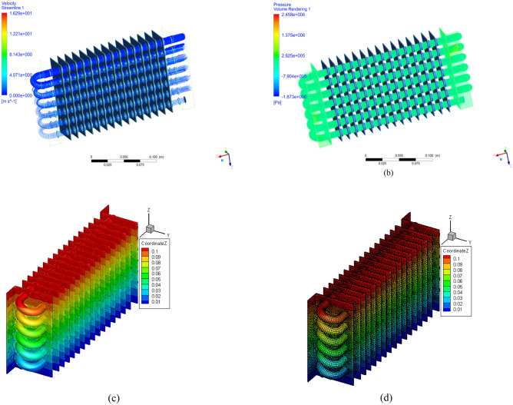

Fig 1.0; Images highlighting examples of CFD analysis for velocity streams, pressure volume readings, and heat transfer rate of fins (R.Ramesh Kumar, 2024)
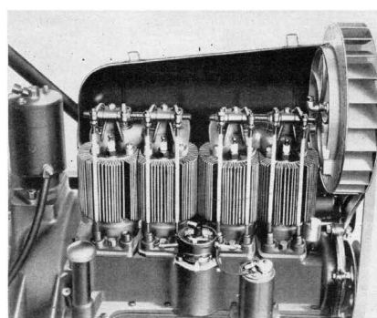

Fig 2; Image demonstrating a Chevrolets air cooling systems, with vertical copper fins welded to the steel cylinder barrel circa 1923 (Huntington, 1964)
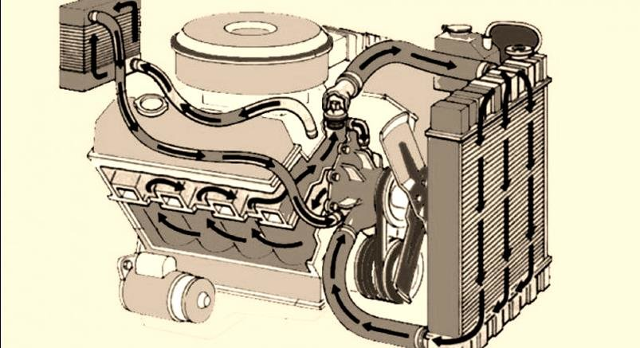

Fig 3; Example of liquid cooled engines used in modern cars (Mukesh, 2020)
Micro processors
With the desire for increases in computer microprocessor performance, this had led to an increase in power which provides additional heat. Extended surfaces and fins were used in the early years of microprocessor development, via aluminium fins. However initially power use and consumption was low. With the evolvement of technological demand heat sinks with inclusion of fans were used, including more thermally conductive materials such as copper in combination with aluminium. The increase in heap dissipation has consequently decreased the lifeline and longevity of processors.
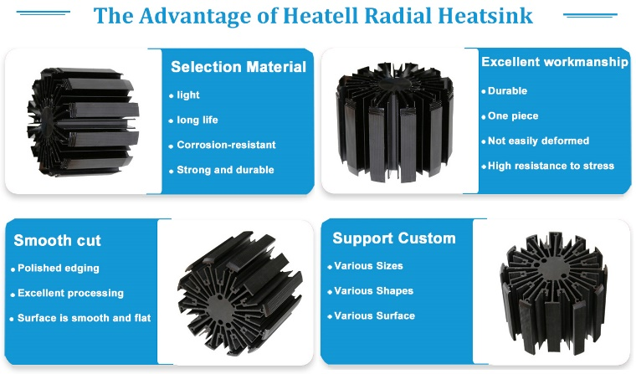
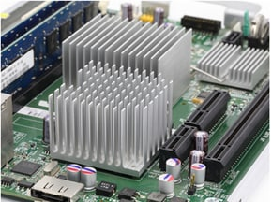
(Arrow, 2019) (Heatell, 2024)

The manufacturing methods have improved greatly, from methods such as “skiving” where the metal block is carved via a bladed tool that produces the sins as seen in fig 6 below. This method provided good thermal conductivity due to the carved fins are all in contact from the single piece of metal block (adafruit, 2022).Other methods of manufacturing heat sinks are casting and milling both costing considerable money when the sizes and quantities are increased (Ye, 2021). Heat sinks are fixed to processors via thermal paste, this layer aids in the conduction of heat away from the unit.
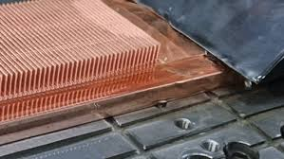

Fig 6: Skiving a method of forming fins from a solid block of conductive material (adafruit, 2022)
Additive manufacturing provides the advantage of producing geometries of complex networks and shapes, not easily done though conventional machining methods. The complex shapes allow for a reduction in manufacturing costs, for greater air flow though the fins, along with enhanced heat transfer. Additive manufacturing allows for various number of materials to be used from polymers to thermally conductive metals, with the ability to combine many (Martin Sarap, 2022). Some of these methods pose disadvantages such as weight (copper) and requiring additional support from fans. The modern methods used are heat pipes and vacuum chambers (including fans). Vacuum chambers use a fluid that will evaporate once heated, thus acting as the conducting agent for the heat. Heat pipes carry the heated fluid to other cooling areas within the circuit. These methods are used extensively, however for uses in high performance computers such as gaming pcs Liquid heat transport and heat pumps are implemented similar to a car cooling system. A heated fluid is transported via a pump to a radiator unit for cooling. Advancing on from this method, for extreme performances liquid immersion cooling is used. Systematically submerging the electronics into cooling fluids such as mineral oils. However this poses great limitations, the oil can evaporate and become contaminated (Arrow, The Best CPU cooling solutions: from minimal to extreme , 2024). Considering some of these more advanced methods, having both natural and forced convection in systems using fans to increase the rate of heat transfer remains popular due to its reliability (Axsom, 2022). The fin and pin designs remain the most efficient methods due to maximizing surface area, this can be improved further by making the pins out of materials with improved thermal conductivity, with addition of fans that force the boundary layer of air to break (Dagan, 2009). Design considerations when evaluating the performance of heat exchangers in relation to any methods used are velocity of the coolant, thermal conductivity of the material used, the mode of attachment to the interface. Any gaps or rough surfaces between the heat sink and processor can increase the thermal contact resistance reducing the overall effectiveness. Minimizing the thermal contact area as much as possible is important. Thermal interface resistance as discussed is the indicator of how heat is transferred across the interface of connecting parts, that is the sink and the unit. Reducing any peaks or roughness of the face can help improve contact pressure, whilst increasing the area of contact (J.P Gwinn, 2003).

Task B
Boundary condition at the base of the fin is seen as:
Ɵ (0) = $Ɵ/b$ = Tb - T$∞$

Infinitely long tip: Ɵ (c) = T (c) - T$∞$ = 0 as L→ $∞$

For an adiabatic tip, that has negligible heat loss the condition at the tip of the fin can be shown as the following: $\frac{dƟ}{dx} ǀ x=l=0$
For and Adiabatic fin tip $\frac{T\left(x\right)-T∞}{Tb-T∞}$ = $\frac{Coshm(L-x)}{Cosh(ml)}$
(A.J Ghajar, 2015)
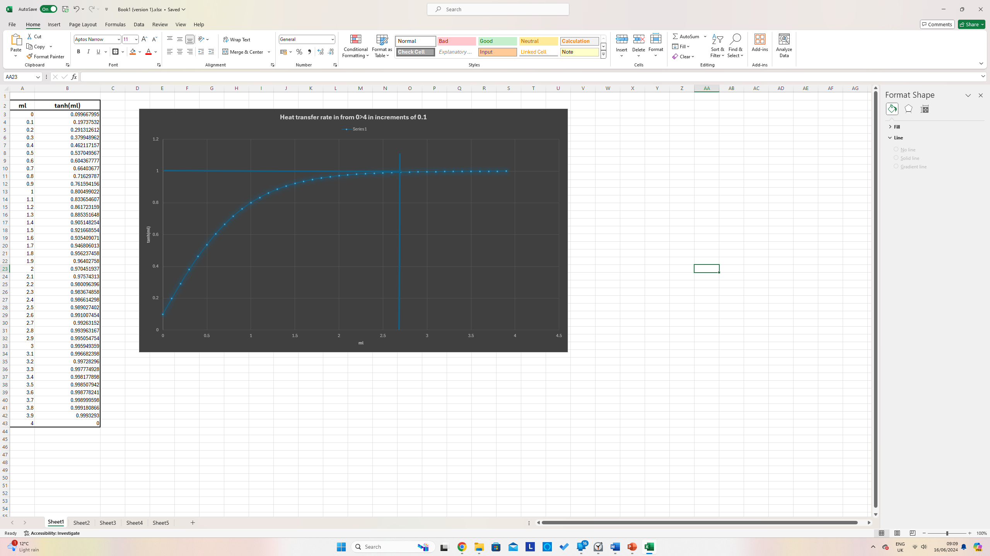

Table 1: Table including increments of ml used in plotting the graph following.
From the excel table above each increment from 0.1 from 0>4 was multiplied using tanh(ml). As highlighted in the graph for increasing values of (ml) there is very little heat transfer increase past the value 2.65. After 2.65 the values remain stable and flatten off, demonstrating the cap to the value. This suggests that fins that are longer in length are less suitable for service, where extra length carries no additional benefit, remain withing 2.65 will prove optimal.

Task C

1)
Length of rods = infinite, calculate up to 400m in increments of 10mm
Diameter of rod = 4,76mm = 0.00476m
m = $√\frac{hp}{ka}$ need to calculate for each material.
Tb = Base temperature = 120°C
T$∞$ = Ambient temperature = 20°C
Tx = temperature from the base at distance x (increments of 0.010mm to be plotted)
A= cross-sectional area of the fin = $\frac{πd^{2}}{4}$ = 0.0000177m
P = perimeter of fin = $πd=$0.0149m

Material properties:
Heat transfer coefficient Thermal Conductivity
2024 Aluminium alloy: h = 30 W/m² K and, k = 186 W/m K
Brass (70 Cu/30 Zn): h = 30 W/m² K and, k = 99 W/m K
Copper: h = 15 W/m² K and, k = 398 W/m K
304 Stainless Steel: h = 7.5 W/m² K and, k = 16 W/m K

Firstly, we need to fin the values of m for each of the four given materials that allow us to use the temperature distribution equation:
Aluminium 2024 = m =$\sqrt{\frac{30Wm^{2}K x 0.0149 m}{186W mk x 0.0000177m}}$ = 11.65$m^{-1}$

Brass (70 Cu/30Zn) =m = $\sqrt{\frac{30Wm^{2}K x 0.0149 m}{99W mk x 0.0000177m}}$ = 15.97$m^{-1}$
Copper = m = $\sqrt{\frac{15Wm^{2}K x 0.0149 m}{398W mk x 0.0000177m}}$ = 5.63$m^{-1}$
304 Stainless Steel = m = $\sqrt{\frac{7.5Wm^{2}K x 0.0149 m}{16W mk x 0.0000177m}}$ = 19.86$m^{-1}$
Now that the value m is established for each material, we can use the equation below and insert each increment of 10mm from 0-400m. The conversion from mm to metres will be included in the equation as seen below:

Temperature distribution along the fin can be calculated using:
$T\left(x\right)=T∞+\left(Tb-T∞\right)e^{-mx}/1000$ (to convert to meters)
Table 2: Temperature distribution along the fin, from 0>400mm in increments of 10mm.

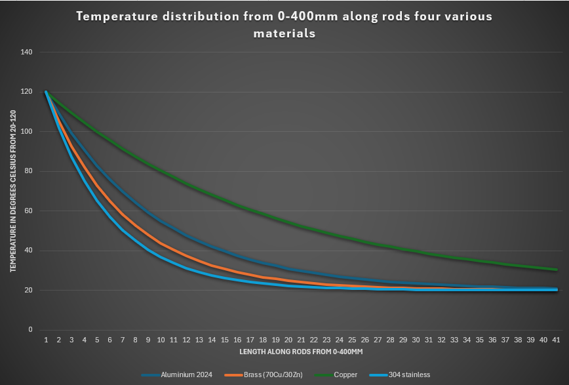
Graph 2: Displaying temperature distribution of all four materials from 0>400mm.
The excel table shows that copper has the greatest thermal conductivity, with its ability to absorb and retain heat. At the length set at 400mm copper is on average 10°C warmer that the other rods. 304 stainless steel begins to lose temperature rapidly, reaching near ambient temperature conditions at around 240mm. This result was expected as 304 Stainless steel has the lowest Heat transfer coefficient and lowest thermal conductivity respectively. Many of the rods achieved near enough ambient temperatures, as mentioned copper retained more heat remaining higher on the graph above highlighted green. For this reason, copper is used vastly for conducting heat and coatings in engineering as central heating pipes and as heat fins in heat sinks of CPU boards.
2)
Calculate the heat loss values for the long rods of the varied materials. For this the equation for heat loss below will be used:
For non-Adiabatic fin tip
Very long fin: $-kA\frac{dT}{dX} ǀ x=0= \sqrt{hpkAc(Tb-T∞)}$
(A.J Ghajar, 2015)

For the length of fin and under an adiabatic boundary condition we would use the following equation:
$$\dot{Q}= \sqrt{hPkA_{c}} \left(T_{b}- T_{∞}\right)tanh⁡(mL)$$

Aluminium 2024
$$\dot{Q}= \sqrt{30x0.0149x186x0.0000177} \left(100\right)tanh⁡(11.65)$$
$$\dot{Q}= 3.84W$$

Brass(70Cu/30Zn)
$$\dot{Q}= \sqrt{30x0.0149x99x0.0000177} \left(100\right)tanh⁡(15.97)$$
$$\dot{Q}= 2.79W$$

Copper
$$\dot{Q}= \sqrt{15x0.0149x398x0.0000177} \left(100\right)tanh⁡(5.63)$$
$$\dot{Q}= 3.96W$$
304StainlessSteel
$$\dot{Q}= \sqrt{7.5x0.0149x16x0.0000177} \left(100\right)tanh⁡(19.86)$$
$$\dot{Q}= 0.563W$$

3)
Determine length of each rod based upon optimum fin length to provide an estimated heat loss. Compare the results with those in part 2. Finding the optimum length for the purpose of presenting the fin length that allows for the greatest heat transfer.
To find the optimum length first we must re – arrange to fin l:
mL = $≥$ 2.65 where L = $\frac{2.65}{m}$

For Aluminium 2024:
L = $\frac{2.65}{11.65}=0.23m$
Comparing to part 2:

$$\dot{Q}= \sqrt{30x0.0149x186x0.0000177} \left(100\right)tanh⁡(11.65x 0.23)$$
$$\dot{Q}= 3.8W$$
For Brass (70 Cu/30Zn):
L = $\frac{2.65}{15.97}=0.165m$
Comparing to part 2:
$$\dot{Q}= \sqrt{30x0.0149x99x0.0000177} \left(100\right)tanh⁡(15.97x 0.165)$$
$$\dot{Q}= 2.68W$$
For Copper:
L = $\frac{2.65}{5.63}=0.470m$

Comparing to part 2:
$$\dot{Q}= \sqrt{15x0.0149x398x0.0000177} \left(100\right)tanh⁡(11.65x 0.470)$$
$$\dot{Q}= 3.967W$$

For 304 Stainless Steel:
L = $\frac{2.65}{19.86}=0.133m$

Comparing to part 2:
$$\dot{Q}= \sqrt{7.5x0.0149x16x0.0000177} \left(100\right)tanh⁡(11.65x 0.133)$$
$$\dot{Q}= 0.514W$$


Full table of results:
Table 3: Comparing heat transfer from part 2 and currently once finding the optimum length.
The results from part 2 and by calculating the optimum length are very close in results as seen in the excel table above. However, there is still room for error with respect to temperature distribution. By calculating the optimum rod length, the heat transfer is slightly better, this is due to the balance of rod length / area.

4)
Now that the optimal lengths of each fin have been calculated, that is we now know the maximum length of each fin based upon its geometry and material properties provided for providing maximum heat transfer. Using the temperature distribution equations from part 1, ‘L’ is substituted into the equation replacing m:
$$T\left(x\right)=T∞+\left(Tb-T∞\right)e^{-mx}$$
Using this equation the table below includes the temperature distribution of each material, each figure is in degrees Celsius.


Table 4: Showing information of temperatures at each optimum length of rod.

Aluminium:
$T\left(x\right)=20+\left(120-20\right)e^{-0.23}$ = 99.5°C
Brass:
$T\left(x\right)=20+\left(120-20\right)e^{-0.165}$ = 104.8°C
Copper:
$T\left(x\right)=20+\left(120-20\right)e^{-0.47}$ = 85.5°C
304 Stainless:
$T\left(x\right)=20+\left(120-20\right)e^{-0.133}$ = 107.5°C

5)

Bibliography
A.J Ghajar, Y. C. (2015). Heat and Mass transfer: Fundementals and applications . In Y. C. A.J Ghajar, Heat and Mass transfer: Fundementals and applications (pp. 163-169). new york. Retrieved 06 15, 2024
adafruit. (2022, 04 20). How heat sinks are made by skiving # computers. Retrieved 06 13, 2024, from blog.adafruit.com: https://blog.adafruit.com/2022/04/20/how-heatsinks-are-made-by-skiving-computers/
Arrow. (2019, 10 31). Understanding Heat sinks: Functions, Types, & more. Retrieved 6 12, 2024, from arrow.com: https://www.arrow.com/en/research-and-events/articles/understanding-heat-sinks-functions-types-and-more
Arrow. (2024, 02 9). The Best CPU cooling solutions: from minimal to extreme . Retrieved from arrow.com: https://www.arrow.com/en/research-and-events/articles/best-cpu-cooling-solutions
Axsom, T. (2022, 2 23). Heat sink and Design considerations. Mechanical design tips. Retrieved 06 13, 2024, from https://www.fictiv.com/articles/heat-sink-design-guide#:~:text=Main%20Takeaways&text=The%20most%20efficient%20heat%20sink,has%20a%20high%20thermal%20conductivity.
D.Srinivas, T. S. (2022). Heat transfer enhancement of a stirling engine by using fins attachement in an energy recovery system. Energy, 239, 404-415. doi:10.1063/1.5141181.
Dagan, B. (2009, 06 08). Pin fin heat sinks point the way to more efficient cooling. Retrieved 06 13, 2024, from newelectroncis.co.uk: https://www.newelectronics.co.uk/content/features/pin-fin-heat-sinks-point-the-way-to-more-efficient-cooling/
Frank P Incropera, D. P. (2007). Fundementals of Heat and Mass Transfer (Sixth Edition ed.). United Satate of America: John Wiley & Sons Inc. Retrieved 06 03, 2024
Gogineni Prudvhi, G. V. (2013, 04). Cooling systems in Automobiles & Cars. International Journal of Engineering and Advanced Technology (IJEAT), 2(4), 688. Retrieved 06 04, 2024, from https://www.ijeat.org/wp-content/uploads/papers/v2i4/D1447042413.pdf
Heatell. (2024, 006 13). radial heat sink. Retrieved from heatell.com: https://www.heatell.com/radial-heatsink/
Huntington, R. (1964, 03). Air cooling for Cars? In which we try to dispel some of the Hot air surrounding certain claims. Retrieved 06 10, 2024, from autohistorypreservationsociety.org: https://autohistorypreservationsociety.org/wp-content/uploads/1964-03-CL-Air-Cooling-For-CARS-1-4.pdf
J.P Gwinn, R. W. (2003, 03). Performance and testing of thermal interface materials. Microelectrics journal, 34(2), 215-222. doi:https://doi.org/10.1016/S0026-2692(02)00191-X
Kraus, A. (1983). Cooling electronic Equipment. Thermal Analysis and Control of Electronic Equipment. New York, United State of America: MGraw - Hill. Retrieved 06 04, 2024
Martin Sarap, A. K. (2022). Utilization of Additive Manufacturing in the Thermal Design of Electrical Machines: A Review. Machines. doi://doi.org/10.3390/machines10040251
metals, S. (2023, 04 12). Cast aluminium vs Cast iron. Retrieved 06 11, 2024, from sunrise-metal.com: https://www.sunrise-metal.com/cast-aluminium-vs-cast-iron/#:~:text=Weight%20is%20one%20of%20the,it's%20difficult%20to%20transport%20iron.
Mobil. (2024). Vehicle maintance. Retrieved 06 14, 2024, from mobil.com: https://www.mobil.com/en/sap/personal-vehicles/car/vehicle-maintenance/importance-of-engine-coolants
Mukesh, S. (2020, 09 04). A review of ubterbak combustion engine fins. International Journal of Engineering reseach . doi:10.17577/IJERTV9IS080311
Ponangi BR, S. S. (2018). Performance analysis of automobile radiator using carboxyl grapheneNano fluids. Conference service material science and engineering. doi:10.1088/1757-899x/346/1/012031
R.Ramesh Kumar, K. K. (2024, 02 13). Enhancing automotive cooling systems: composite fins and nanoparticles analysis in radiators. (14). doi:10.1038/s41598-024-52141-0
Stewart, K. (2024, 04 10). Thermal conductivity. Retrieved 06 10, 2024, from https://www.britannica.com/science/thermal-conductivit
Vadhilingham, D. (2020, 04 12). Computational and numerical analysis of radiator usinf different nano fluids as coolant with different structure of radiator tube. Int Journal of Engineering Applied science and Tehcnology, 250-256. doi:10.33564/ijeast.2020.v04i12.040.
Vemula Chandra, D. V. (2019, 12 12). HEAT TRANSFER ANALYSIS OF IC ENGINE FINS AND THEIR OPTIMISATION BY VARYING MATERIAL AND GEOMETRY. Journal of Engineering Sciences, 10(12), 311-316. Retrieved 06 09, 2024
Ye, R. (2021, 9 11). What are heat sinks and how are they made. Retrieved 06 14, 2024, from 3erp.com: https://www.3erp.com/blog/what-are-heat-sinks-and-how-are-they-made/
Yunus A cengel, A. J. (2015). Heat and mass Trasnfer. In A. J. Yunus A cengel. new york, United states of america: Mc Graw Hill. Retrieved 06 10, 2024

