Encyclopedia Entry: Ffynnon Fair (St Mary’s Well) Penrhys, Rhondda Valley
Evan Davies

Medicine and Miracles: Health, Illness, and Cure
HPHI5019, HPHI6019
Anne Bevan, Jane Cartwright
University of Wales Trinity Saint David
Nov 3, 2024

This Encyclopaedia Entry will be dedicated to Ffynnon Fair (St Mary’s Well) in the Rhondda Valley, Penrhys. The main resource that will be used to give this well a fleshed out encyclopaedia will be primary sources, which are the poems (cerddi) on the specfic well itself and similar poems dedicated to the virgin Mary in general to give a wider context on the holy wells healing powers and its history. The history of the holy well and its surrounding area, from its construction to the areas near destruction.
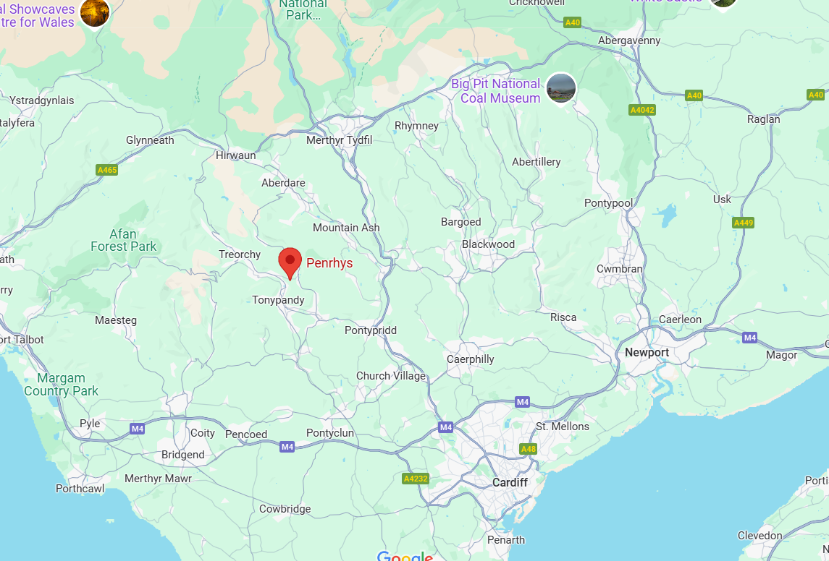
Figure 1, Map of of South Wales pointing out Penrhys (Googlemaps, no date)
To begin, it would be best to get an understanding of the location of Ffynnon Fair. It is in the modern local authority of the Rhondda Cynon Taf(f) (RCT), Specifically in the Rhondda Valley inbetween Rhondda Fawr and Rhondda Fach in a village called Penrhys (see fig 1). Before the dissolution of the Monastaries from c. 1536 – c. 1541 AD, there may have been a Christian establishment that belong to the Cistercian Llantarnam Abbey (Cartwright, 2010, p. 127). However, there is a conflicting documentation that says it was established by Henry I of England or his son Robert 1st Earl of Gloucster (Ward, 1914, p. 382). The land was then transferred to the Crown and became property of John Parker of the Royal Stables (Fynhonnau Cymru). Despite these not being 100% trustworthy, an early documentation of the area which is a land grant from 1203 AD, distinguishes the site of Penrhys as a Manor (Hurlock, 2018, p. 29). Now the monastary is dismissed through historicity. Although, Rhisiart ap Rhys’s elegy to Elspeth Matthew of Radur claims “Parlwr gan fãr niferoedd, I fêls draw fal ostri oedd” (Jones et all, 2022, p. 107), there is no specfic translation. However, this does prove a less formal establishment at Penrhys (Jones et all, 2022, p. 107). The holy well at Penrhys (see fig 2) was also important for pilgramiges, and it was most important during the Medieval period and after (Fynhonnau Cymru). the virgin Mary was also very important in Wales as it was even believed that she had visited Wales (Hurlock, 2018, p. 94). Which is another reason why her cult was so large in Wales. The site also had a statue of the virgin Mary (see fig 3), that sprung from “the hollow of an oak tree” (Cartweight, 2010, p. 134). However, Thomas Cromwell would take the statue to London and destroy it during the dissolution of the Monastaries in the 16th century (Cartwright, 2010, p. 128). The site is also to have said 2 more buildings a chapel and a hostelry to accommodate for the pilgrims (Hurlock, 2018, p. 62). There is also a small vaulted stone building that is heavily restored and built of local Pennant Sandstone (see fig 4)(Fynhonnau Cymru). It is also said that the Lord Rhys (Rhys ap Tewdwr c. 1040 – c. 1093) was beheaded by the Normans at the site, although this has generally been disproven, despite many books holding the tale as fact, and the village being named after him (Fynhonnau Cyrmu). Before the virgin Mary became a large cult in Wales, there was little light shed on the saint (Cartwright, 2010, p. 124). As the Welsh rulers
“clung to the cults of native saints in an attempt to reaffrim Welsh identity ‘under pressure’”
(Cartwright, 2010, p. 124).
However, eventually Christianity in Wales began to accept the virgin Mary more due to her association with Christ (Cartwright, 2010, p. 124). This is suggested in nit guorgnim molin map meir, which is an Old Welsh poem praising the Trinity. The site of Penrhys was also referred to as an island, and this suggests its seperation and elevation (Hurlock, 2018, p. 98). Focusing on its natural setting on locating the holy well/pilgrimage site.
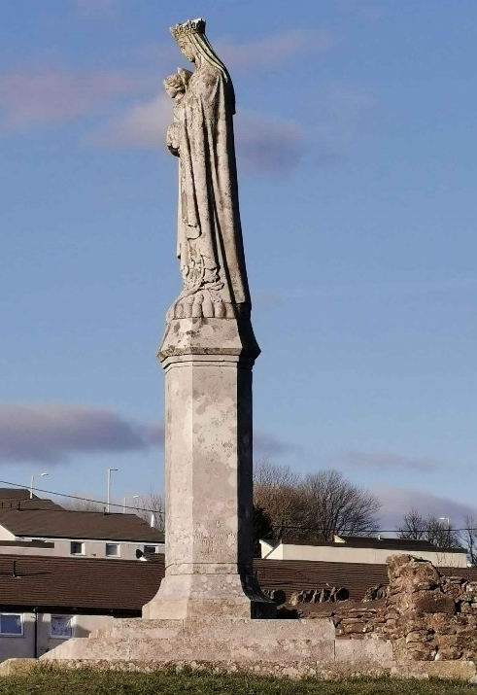
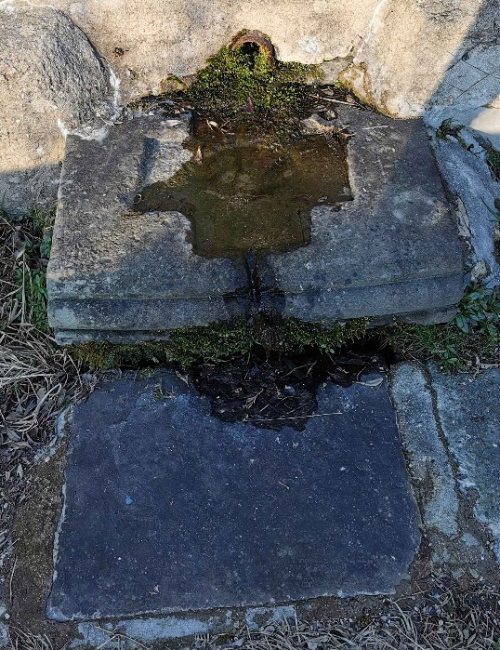
Figure 2, Ffynnon Fair (St Mary’s Well), Penrhys (Davies, 2021).

Figure 3, Modern Our Lady Penrhys Statue (Davies, 2021).

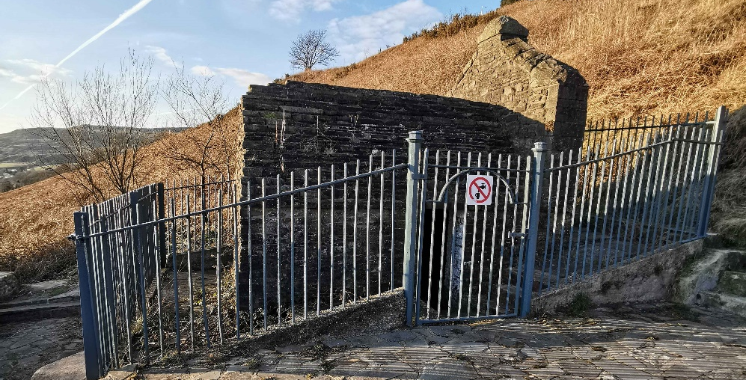
Figure 4, Heavily restored Pennant Sandstone building built on top of Ffynnon Fair (Davies, 2021).

Ffynnon Fair is on the slope of the Penrhys mountain, the stone building stands over the well which is roughly 7 feet in width and 12 feet in length (Fynhonnau Cyrmu). There are 2 baths, a hand bath and a bath for feet (Fynhonnau Cymru). There is another bath which is much larger oppostite the left wall, it is about 3 feet in width and 5 feet in length (Fynhonnau Cyrmu). There are also plaques in the building one saying “BAPTIZE HOLY SPIRIT FIRE” and another saying “YOU ARE STANDING ON THE ASK GROUND” (Fynhonnau Cymru). These are not medieval but modern plaques. There is also another bath outside of the building for hands in the shape of a cross (Fynhonnau Cymru). In the last days of the medieval period many churches, chapels and ecclectical locations were dedicated to the virgin Mary (Cartwright, 2010, p. 119). In ‘Identity and Alterity in hagiography and the cults of saints’ chapter dedicated to Jane Cartwrights section of the book Cartwright mentions “Glanmor Williams notes that at least 143 medieval churches and chapels honoured her name”. This shows how important the virgin Mary was in Wales during this period (Cartwright, 2010, p. 119). There are also 76 holy wells associated with the virgin Mary (Cartwright, 2010, p. 119). Specficially, in Wales, Ffynnon Fair (see fig 2) was a very important pilgrimage site, but only 9 poems were written in regards to the site (Cartwright, 2010, p. 126). In many of the poems that are written on the virgin Mary are mostly written by Gwilym Tew and Lewys Morgannwg (James, 1995). Gwilym Tew in one of the poems described the virgin Mary as a harp (James, 1995). Quoted in James Gairdner’s Lollardy and the Reformation in England, a poet writes;
“Ronnyng hyther and thyther,
We cannot tell whithe
In offryng candels and pence
To stones and stockes,
And to olde rotten blockes,
That came we know not from whense,

To Walsyngham a gaddyng,
To Canterbury a maddyng,
As men distraught of mynde;
With fewe clothes on our backes,
But an image of waxe
For the lame and for the blynde;

To hampton, to Ipswyche,
To Haforth, to Shordcyhe,
With many mo places of pryce,
As to our Lady of Worcester,
And the swete Rode of Chester,
With the blessed Lady of Penryce.”
From reading this poem, it gives some evidence that the holy well of the virgin Mary (see fig 2) was indeed at Penrhys. Also that it was not only celebrated by Welsh pilgrims, but by many from Great Britain (James, 1995). It is one of the few poems in English that mentions the well. Another poems on the virgin Mary at Penrhys is composed by Lewys Morgannwg and gives more evidence of her being a important figure at the site (Cartwright, 2010, p. 126);
“Yna deathost, fendithfawr,
I’r lle hwn o’r nef I’r llawr.
Dy ddelw bob dydd a welynt
Yn fyw a gad o nef gynt”
In one of the poems by Llywelyn ap Hywel ab Ieuan ap Gronw (15th century), he describes the healing powers of the holy well of both physical and spritual afflication (James, 1995, p. 52 – 53).
“Dwyn enaid pob dyn uniawn
A wna, a chorff, yn iach iawn.
Rhoi clywed a dywedyd,
Y mae i fyddar a mud.
Aet dall i gyty â hon,
O’i phlegid caiff olygon.
Synied ar y pum synnwyr
A’u dwyn I ynfyd a wyr.
Cad, wen iach o’r clwyf yna.
Carcharor cur a cherydd,
Gwirion y bair hon yn rhydd”.
In this poem it shows the healing powers of the virgin Mary. By using the well a blind man gains his sight (Cartwright, 2010, p. 127). Not only that but the virgin Mary causes the body and soul of righteous man of all to become healthy (Cartwright, 2010, p. 127). In this specfic poem, it focus on sensory disabilities such as blindness and deafness, although the virgin Mary generally cures most if not all ailments. The virgin Mary also helps men (Cartwright, 1999, p. 68). The saint wins battles for the men, ensures they get jobs, ensures the mens family get their debts, heals them, and makes sure that the men are buried in scared ground (Cartwright, 1999, p. 68). At the end of one of Lewys Morgannwgs poems, he gives his own motive of going to Penrhys, Ffynnon Fair (James, 1995, p. 52);
“Mawr yw ‘maich, Mair, am iechyd,
Mwy na baich mwya’n y byd;
Dyn y ddaliwyd dan ddolur
Fu’n dwyn poen wyf, yn dân pur”.
Another poem that shows the power the virgin Mary with those that are deaf is done by Lewys Morgannwg. He writes (Jones et all, 2022, p. 110);
“O daw byddar at arall
Fe glyw llef o glwyf y llall,”
Lewys Morgannwg also mentions in one of his poems how important the virgin Mary is to him through personal concern (Jones et al, 2022, p. 108). This can be dissected to see how important the virgin Mary was to all of Wales during the period overall;
“Mair, mam, unair am enaid,
Mair, wrthfawr air wrth fy raid!”
Penrhys was not only important to the Welsh population or the English but more. Lewys Morgannwg claims that the piligrams came to the site “hyd môr a thir” (over see and land) (Jones et all, 2022, p. 109). Penrhys may have also been a stopping ground for those on pilgrimages to St Davids, as it was usually on the path towards the city (Jones et all, 2022, p. 109). Due to Lewys Morgannwgs constant mention of deaf men in his poems, it is possible that the story was based on specfic account of miracles from the shrine that has been recorded (Jones et all, 2022, p. 110). Rhisiart ap Rhys mentions that pilgrims would travel to Ffynnon Fair, Penrhys to cure their “ague” (malaria) a common disease in the medieval period (Hurlock, 2018, p. 64).
The holy well, Ffynnon Fair in Penrhys, Rhondda is a very important site for pilgrimages from the medieval to later. Looking at the history of the well gives context on how it became so important despite the welsh identity pride during the medieval period with local saints. But also looking at personal poetry from Lewys Morgannwg and Gwilym Tew more specfically. Showing the power the holy well had by curing ailment such as deafness and blindness. Also, looking at the other curing abilities such as its potential power to cure “ague” (malaria). Using the poetry composed on the holy well gives much to learn on the site despite the little primary sources available. The importance of the holy well with the Welsh and others is truly communicated through these poems.

Reference list
Davies, E. (2021). Figure 2, Ffynnon Fair (St Mary’s Well), Penrhys.
Davies, E. (2021). Figure 3, Modern Our Lady Penrhys Statue.
Davies, E. (2021). Figure 4, Heavily restored Pennant Sandstone building built on top of Ffynnon Fair
Edwards, H.T. (1995) Cwm Rhondda. Llandysul: Gomer. pp. 27 – 71.
Marinković, A., Vedriš, T. and Csepregi, I. (2010). ‘Identity and alterity in hagiography and the cult of saints’. in. Zagreb: Hagiotheca. pp. 119 – 136.
Cartwright, J. And Bwrdd Gwybodau Celtaidd Prifysgol Cymru, P.I. a L. (1999). Y forwyn fair: santesau a lleianod : agweddau ar wyryfdod a diweirdeb yng Nghymru’r Oesoedd Canol. Caerdydd: Gwasg Prifysgol Cymru. pp. 15 – 70.
Ceri, JD, J., LB, Gray, M, & Morgan, DD. (2022). A History of Christianity in Wales, Gwasg Prifysgol Cymru / University of Wales Press, La Vergne. Available from: ProQuest Ebook Central. [25 October 2024].
Googlemap. (no date). Figure 1, Map of South Wales pointing out Penrhys
K, Hurlock. (2018). Medieval Welsh Pilgrimage, C.1100–1500. New York, NY: Palgrave Macmillan. Available at: https://research-ebsco-com.ezproxy.uwtsd.ac.uk/linkprocessor/plink?id=31572e29-a752-306e-8629-89e5c925bf9c (Accessed: 25 October 2024).
Lewis, D. E. (no date). Pen-rhys, Rhondda, Ffynnon Fair, Pen-rhys. [online] fynhonnaucymru.org.uk. Available at: http://www.ffynhonnaucymru.org.uk/pen-rhys.htm. [accessed 1 Nov, 2024]
Ward, J (1914). 'Our Lady of Penrhys', Glamorganshire Volume 69 (1914) pp. 382. Archaeologia Cambrensis.

