sCIENCE OF MATERIALS iN THE BUILT ENVIRONMENT

Assignment: 1

University of Wales Trinity Saint David’s
Student: Ryan Tillman Davies
Student ID: 191404
Course Title: HND Architectural Technology
Email address Ry4ntdavies@gmail.com


Table of Contents
University of Wales Trinity Saint David’s 1
1.0 - Introduction 3
1.1 - Appendix 1 3
1.2 - Appendix 2 3
2.0 - Building A - Burj Khalifa, Dubai (Concrete Framed) 4
2.1 - Appendix 3 4
2.2 - Appendix 4 4
2.3 - High Performance Concrete Frame 5
2.4 - Appendix 5 5
3.0 - Building B The Empire State Building, New York City (Steel Framed) 6
3.1 - Appendix 6 6
3.2 - Appendix 6 7
3.3 - Steel Frame Construction 7
3.4 - Appendix 7 7
4.0 - Environmental Impact and Resistance to Climate 9
4.1 - Building A 9
4.2 - Appendix 8 9
4.3 - Building B 10
4.4 - Appendix 9 10
4.5 - Appendix 10 11
4.6 - Embodied Energy Comparison 12
4.7 - Appendix 11 12
4.8 - Recyclability 12
5.0 Material Characteristics 13
5.1 - Comparison Summary 13
5.2 - Conclusion 16
6.0 References 16
6.1 - References 16
6.2 - Appendixes 17

A1 - Concrete Frame vs Steel Frame Construction Comparison Essay

1.0 - Introduction

In this essay, I will Investigate and evaluate the characteristics and properties of two habitable commercial buildings. The two buildings I have chosen are the ‘Empire State Building’ in New York City which was constructed of a steel frame and I will be comparing and contrasting this with the ‘Burj Khalifa’ in Dubai that was constructed of a concrete frame. This essay will delve into how the building’s framing material chosen has impacted the design & construction and how efficiently it has adapted to defend against the existing environment. The properties of concrete and steel will be evaluated on the environmental impact posed during the production and entire lifecycle.

1.1 - Appendix 1
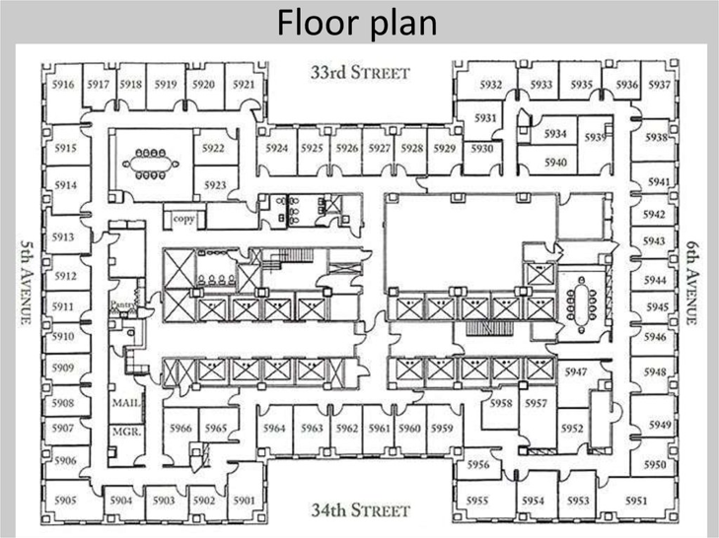

The Empire State Building (No Date)
https://en.ppt-online.org/122751

1.2 - Appendix 2


https://theconstructor.org/structures/structural-details-burj-khalifa-concrete-grade-foundations/20512/

Firstly, both of these buildings chosen are classed as high rise multipurpose commercial buildings. They are constructed by different framing methods and formed of different materials being concrete and steel. The shapes contrast with the Burj Khalifa having a hexagonal shape with a more fluid floor plan being ‘Y’ shaped compared to the Empire State building having a ‘H’ shape which leaves a more rectangular footprint as an area. Burj Khalifa Facts and Figures (accessed 04/01/20) (No Date) https://www.burjkhalifa.ae/en/the-tower/facts-figures/

Additionally, the buildings are both tall however the Burj Khalifa reaches a greater height than the Empire State building being 828m (2,716.5 feet) tall while the Empire State Building reaches 443m to the tip. Burj Khalifa Facts and Figures (accessed 04/01/20) (No Date) https://www.burjkhalifa.ae/en/the-tower/facts-figures/

2.0 - Building A - Burj Khalifa, Dubai (Concrete Framed)

2.1 - Appendix 3
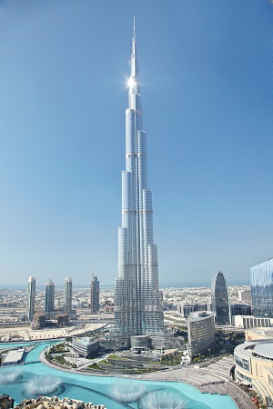

Burj Khalifa Facts and Figures (accessed 04/01/20) (No Date) https://www.burjkhalifa.ae/en/the-tower/facts-figures/

The Burj Khalifa is the tallest building in the world with a height of 828m tall. It was revolutionary after 6 years of construction, the building was inaugurated 4th of January 2010 when it was constructed higher than any other building in the world Burj Khalifa Facts and Figures (accessed 04/01/20) (No Date) https://www.burjkhalifa.ae/en/the-tower/facts-figures/

The tower in total contains 700 residential apartments. Impressively the estimated total project cost is $20 billion with the Tower construction cost estimated at $4.2 billion. Burj Khalifa Facts and Figures (accessed 04/01/20) (No Date) https://www.burjkhalifa.ae/en/the-tower/facts-figures/

2.2 - Appendix 4
The Burj Khalifa was constructed of a concrete frame. The Architectural and Structural Designer was Adrian Smith who designed the hexagonal shape that is illustrated in diagram x which forms as the floor plan shape for an aesthetically pleasing finish while providing greater views of the Persian gulf desert. Furthermore, the hexagonal shape not only provides better views of scenery the shape supports the building’s structure and resists the strong wind loadings of the open desert with the aid of the structural system L. Cohen Blatter, Mansion Global article: ‘For Adrian Smith, An Architect Known for Sky-High Towers, Beauty is a ‘Priority’
(Accessed 04/01/20) (Published 26/09/14) https://www.mansionglobal.com/articles/for-adrian-smith-an-architect-known-for-sky-high-towers-beauty-is-a-priority-40764

2.3 - High Performance Concrete Frame

2.4 - Appendix 5
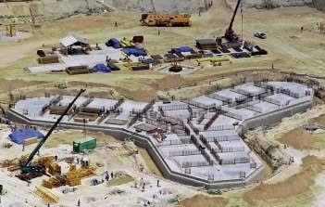
The Constructor (Accessed 04/01/19) (2019) https://theconstructor.org/structures/structural-details-burj-khalifa-concrete-grade-foundations/20512/

The structural system designed for the Burj Khalifa can be illustrated in diagram x by the internal hexagonal center shape named the ‘Buttressed Core System’. Working in unison with the reinforced concrete walls that follow from the core down each of the wings’s corridors to the end are thickened through ‘Hammer Walls’ that aid the resistance to wind shears and moments through acting as a form web and flanges to the connecting columns.

The columns surrounding the perimeter connected to the mechanical floors have installed connection between the floor and column which is provided by the ‘Out Trigger’ walls. The purpose of the outrigger walls provide support and aid the resistance of higher wind loads laterally. Mansion Global article: ‘For Adrian Smith, An Architect Known for Sky-High Towers, Beauty is a ‘Priority’
(Accessed 04/01/20) (Published 26/09/14) https://www.mansionglobal.com/articles/for-adrian-smith-an-architect-known-for-sky-high-towers-beauty-is-a-priority-40764

‘330,00 cubic meters of concrete; 39,000 tonnes of steel reinforcement, was used to construct the building.
The decision to utilise high performance concrete provides a guarantee of low permeability with an increased durability to the end product’s construction quality. The project used C80 and C60 Graded concrete cube strength that incorporated fly ash, portland cement and local aggregates. The C80 Graded concrete granted a Young’s Modulus of 43800N/mm2. This aided the construction that would require to reach great height that needed to not only withstand shear wind loads but also lateral loadings from the pressure and weight caused by the gravitational loads. Khalifa Facts and Figures (accessed 04/01/20) (No Date) https://www.burjkhalifa.ae/en/the-tower/facts-figures/

Concrete that has high compressive strength as a construction material and can be beneficial when needing to transfer heavy loading. However, as a material concrete is weak in reacting to loading caused by tension, therefore the requirement of steel in order to reinforce is needed. As steel has a superior tensile strength compared to concrete it can be incorporated as steel wires or ‘mesh’ that can be pre/post tensioned to bond the materials as one strong unit. Designing Buildings (Accessed: 12/01/20) (Published 26/09/18) https://www.designingbuildings.co.uk/wiki/Concrete_frame

Concrete can be considered as a flexible material in some circumstances depending on the application of the material. If the concrete is applied as an in-situ method the concrete mix will be in more of a liquid form that can be moulded to any shape and finish on-site. This can allow for changes to be made in the construction process if any obstacles are encountered or if the client would make changes after the design stage i.e changes to the finishes of the concrete. Designing Buildings (Accessed: 12/01/20) (Published 26/09/18) https://www.designingbuildings.co.uk/wiki/Concrete_frame

Both concrete and steel can be pre-fabricated off-site, similarly to the construction of the Empire State Building. These benefits although they reduce flexibility to make changes during construction phase they can reduce costs of labour of hiring tradesmen to form the in-situ concrete. On a perspective the prefabrication offsite can maintain quality of the products, being assembled in a controlled environment. but also reduce the environmental impact. The Constructor (Accessed 06/01/20) https://theconstructor.org/structures/structural-details-burj-khalifa-concrete-grade-foundations/20512/

3.0 - Building B The Empire State Building, New York City (Steel Framed)

3.1 - Appendix 6
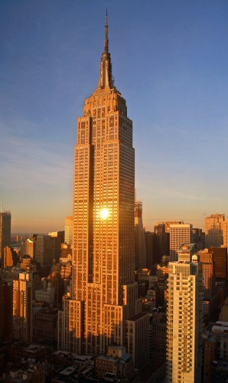

Design Book Magazine (Accessed 06/01/20) ttp://www.designbookmag.com/empirestatebuilding.htm

On the 1st of May 1931, The Empire State building completed construction and was named the tallest building in the world at the time. It achieved a height of 1,250 feet tall with 448m (1,472 feet) in total when including the spire. The construction duration was approximately one year and forty five days that required over 60 different trades.. The title of the world’s tallest building would be held until the completion of the World Trade Center in New York City in 1972.
How Stuff Works - Empire State Building Completed (Accessed 06/01/20) (No Date) https://science.howstuffworks.com/engineering/structural/empire-state-building.htm

3.2 - Appendix 6

How Stuff Works - Empire State Building Completed (Accessed 06/01/20) (No Date) https://science.howstuffworks.com/engineering/structural/empire-state-building.htm

The project for its time was innovative for its time for the speed of construction considering a building was never constructed that high before. Despite adversities the project came in under budget due to the Great Depression reduced labour costs drastically making the cost of the building only $40,948,900 which it was originally estimated to reach $50,000,000. In comparison to the Burj Khalifa the cost of construction was much cheaper although the major saving was the cost of labour reduced by the economy of the 1930s which highlights the difference in time in which the Empire State Building and the Burj Khalifa were built 79 years apart. Additionally, the duration of construction required by the Empire State Building was far lower only taking a year and 45 days compared to Burj Khalifa taking a total of six years to open in from 2004 - 2010. Thought-Co (Accessed 06/01/20) (Updated 26/06/19) https://www.thoughtco.com/the-empire-state-building-1779281

3.3 - Steel Frame Construction

The construction of the steel frame began on the 17th of March 1930, where it required 210 steel columns which made up the vertical frame 12 of these columns ran the entire height of the building where others ranged 6-8 stories. As a high rise building the steel girders at the time could not be raised more than 30 stories at a time by the large cranes. Thought-Co (Accessed 06/01/20) (Updated 26/06/19) https://www.thoughtco.com/the-empire-state-building-1779281

The type of steel frame was a Hot Riveted Steel Frame, which means the joints are stronger than any weld or bolt due the hot rivets applying pressure between the two surfaces.

3.4 - Appendix 7

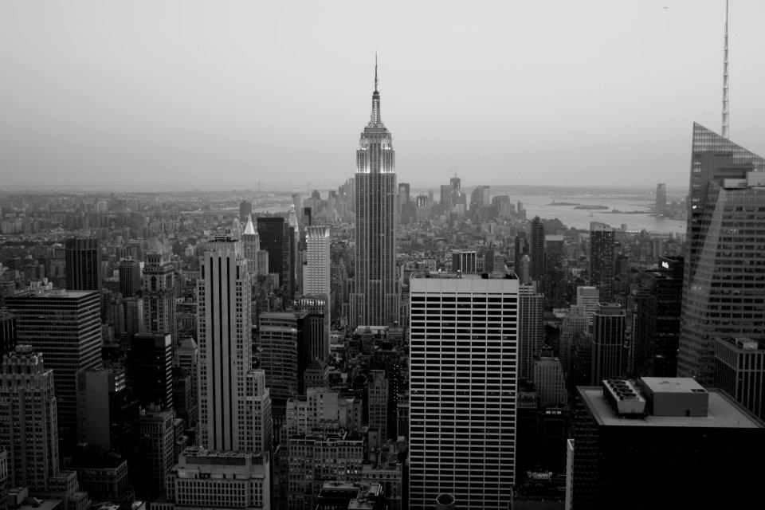

Thought-Co (Accessed 06/01/20) (Updated 26/06/19) https://www.thoughtco.com/the-empire-state-building-1779281

Considering the time, the Empire State Building was constructed the steel frame construction was an innovative method in the 1930s that allowed the building to support greater weights which allowed the structure to reach taller heights. How Stuff Works - Empire State Building Completed (Accessed 06/01/20) (No Date) https://science.howstuffworks.com/engineering/structural/empire-state-building.htm

Furthermore, the steel sections were prefabricated and manufactured off-site in a steel mill which were transported to site. The beneficial factor of steel is the quality assurance having it prefabricated can be designed to specific tolerances which for the Empire State Building was 2mm. The steel sections were prepared to either be bolted or joined via rivets. This process of prefabrication would have potentially influenced the decision to use a steel frame with the increased speed of construction being of importance to investors. The prefabrication process and the convenience of local manufacturers that could access the railway allowed for simpler delivery of the elements to site. How Stuff Works - Empire State Building Completed (Accessed 06/01/20) (No Date) https://science.howstuffworks.com/engineering/structural/empire-state-building.htm

The characteristic of steel is its tensile strength that allows the frame to reach longer clear spans, resulting in a more flexible building with potential for re-use. This allows for more potential for larger and varied construction options for architectural innovation. On a molecular scale steel offers one of the greatest compliance in vibration performance across long spans making it ideal for large buildings that can be considered delicate and strict in regulation compliance such as hospitals with exacting vibration standard demands. Steel Construction - Case for Steel (Accessed 05/01/20) (No date) https://www.steelconstruction.info/The_case_for_steel

4.0 - Environmental Impact and Resistance to Climate

4.1 - Building A

The architectural design of the building with the shape that reduces width as the structure rises incorporates the wind engineering principles of spiralling into the sky, reducing the wind dynamics and force on the building taming the open winds that target the building. Semantic Scholar, (Accessed 07/01/20) (2010)https://pdfs.semanticscholar.org/7a75/b596caa8b47375e520936a1320ba1af8eae4.pdf

The average desert temperature in Dubai is 41°c, as opposed to retaining heat the design of the Burj Khalifa revolves around maintaining a cool temperature. One of the methods is the use of ice chilled water that is supplied by three plants that create an ice slurry that is transported to the heat exchangers on three different levels. Once the water has aided the air conditioners it is pumped back for re-use. At Night, temperature lowers to -4°c where concrete naturally retains heat through the cold night. The concrete was poured at night in order to avoid cracking caused when the temperatures accelerate the hardening process. (Accessed 07/01/20) (2010)https://pdfs.semanticscholar.org/7a75/b596caa8b47375e520936a1320ba1af8eae4.pdf

4.2 - Appendix 8
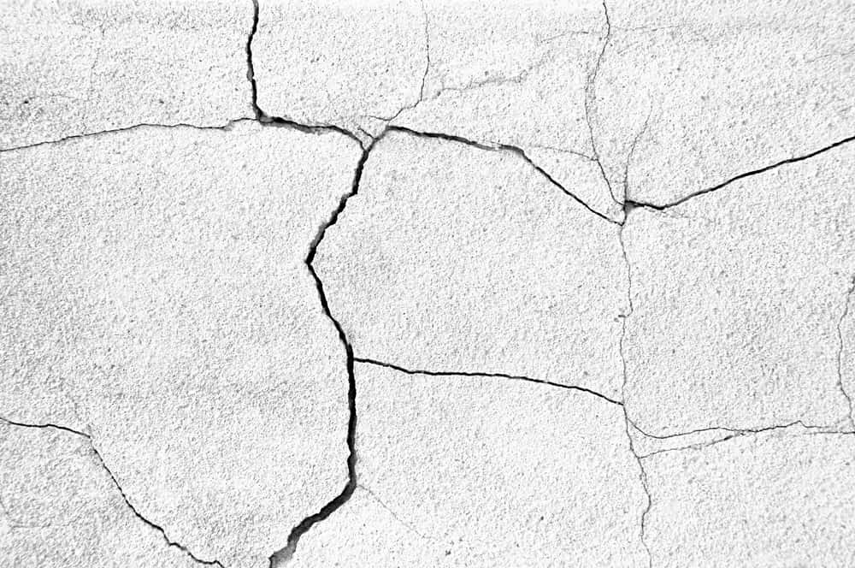
https://gharpedia.com/blog/low-heat-cement-less-susceptible-to-cracks/

According to an article made by the Guardian, ‘After water, concrete is the most widely used substance on Earth. If the cement industry were a country, it would be the third largest carbon dioxide emitter in the world with up to 2.8bn tonnes.’ Considering this information concrete produces a large amount of carbon dioxide due to the common use of the material within the construction industry resulting in a large amount of pollution approximately ‘4-8% of the world’s CO2’. The Guardian - ‘The most destructive material on earth’ (Accessed 08/01/20) (Published 25/02/19) https://www.theguardian.com/cities/2019/feb/25/concrete-the-most-destructive-material-on-earth

4.3 - Building B

As the building was constructed a long time ago the energy efficiency of the building is far less advanced than the Burj Khalifa, estimated in one day Building B consumes the equivalent energy required to power 40,000 family homes. According to C40 Cities Blog, after the energy retrofit Building B will reduce 105,000 tons of greenhouse gas emissions over the next 15 years. C40 Blog (Accessed 05/01/20) (Published 08/05/13) https://www.c40.org/blog_posts/how-the-empire-state-building-is-redefining-sustainability-and-supporting-the-economy-in-new-york-city

The Empire State Building’s energy efficiency retrofit to reduce its impact on the environment which has allowed for 38% energy saving that will generate an additional $4.4 million annually. A major adaptations is the upgrade of the lights to be computer driven LED system, replacement of 6,514 windows that will reduce winter heat losses. The Climate Group (Accessed 06/01/19) (Published 18/09/16) https://www.theclimategroup.org/news/empire-state-building-turning-green-mark-beginning-climate-week-nyc

As comparatively older building to the Burj Khalifa, the retrofit has will benefit the function of the building to reduce heat escaping to the external colder environment in New York. The climate can be considered very cold during winter and humid in summer.

4.4 - Appendix 9
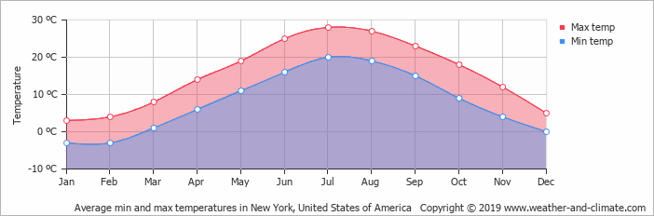
Climate and Weather (Accessed 06/01/20) (No Date) https://weather-and-climate.com/average-monthly-Rainfall-Temperature-Sunshine,New-York,United-States-of-America

As seen in the graph, the highest temperatures the climate can reach nearly 30°c in July at a maximum while the minimum temperature it falls below 0°c roughly -3°c during winter. With the aid of the retrofitting can defend against the heat loss during winter while being to retain more heat during summer. Considering, it is common for snow to fall in New York the steel frame can withstand the additional imposed snow loads and wind loads.

Steel | Comparison to concrete | 4.5 - Appendix 10 - (Accessed 08/01/20) (No Date) https ://www. worldsteel.org/publications/position-papers/steel-s-contribution-to-a-low-carbon-future.html
As stated in the graph, the indexed global energy consumption / tonne of crude steel production in 1960 had 100% capacity utilisation. Compared to 2017, it reduced to 38.7% capacity utilisation demonstrating 61.3% improvement in efficiency in the production of steel. | In 2017, approximately 1.83 tonnes of CO2 were emitted for every tonne of steel produced. Responsible for 7%-9% of direct emissions globally. Which is more than concrete with a global emission similar to concrete which has a lower range of 4-8% as stated by the Guardian. | 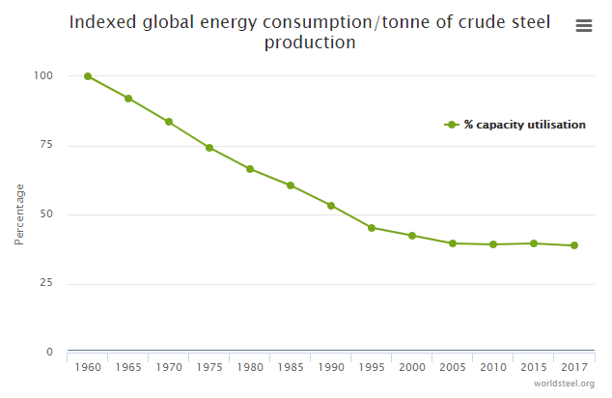

The Guardian - ‘The most destructive material on earth’ (Accessed 08/01/20) (Published 25/02/19) https://www.theguardian.com/cities/2019/feb/25/concrete-the-most-destructive-material-on-earth

4.6 - Embodied Energy Comparison
The meaning of embodied energy is the total energy calculated that has been needed to be consumed across all processes during production of the product or material i.e from initial sourcing of the natural material, manufacturing and transport.

This graph will demonstrate initially how sustainable concrete and steel are to produce considering how much embodied energy is required. Your Home (Accessed: 12/01/19) (Updated 2013) https://www.yourhome.gov.au/materials/embodied-energy
Concrete | Steel | 4.7 - Appendix 11
As shown in the diagram, the embodied energy required for concrete is far more than steel and stainless steel passing over 200(GJ). This demonstrates concrete to use more energy to produce as a material. Furthermore, if this material costs more embodied energy it can be suggested that the manufacturing process of concrete creates more CO2 emissions than steel. | Comparatively, steel has a lower embodied energy according to the graph. This demonstrates it requires less energy to produce and less fossil fuels needed to be consumed for energy. This suggests steel is more favourable from a sustainability standpoint. | 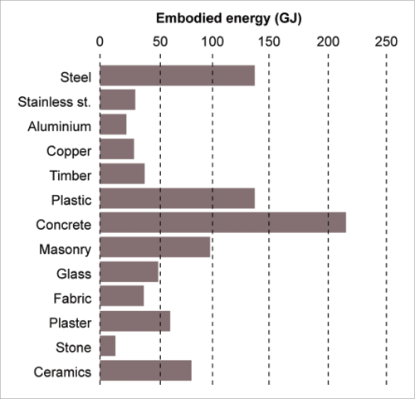

As highlighted in an article made by the Guardian that in the 1950s cement and steel production were equal in terms of industry demand. However, the demand of cement production has increased ‘25-fold, more than three times as fast as its metallic construction partner’. The Guardian - ‘The most destructive material on earth’ (Accessed 08/01/20) (Published 25/02/19) https://www.theguardian.com/cities/2019/feb/25/concrete-the-most-destructive-material-on-earth

4.8 - Recyclability
Although steel has a larger range of CO2 emissions, it combats this issue with its scope for a recyclability which can be multi-cycled endlessly. In the UK, 96% of steel is recovered this way. This argument can redeem steel as being less sustainable than concrete with recycled steel accounting for 50% of new steel manufactured globally. Suggesting half of new steel made has used recycled steel that is 100% recyclable, even at the end of its life 85% of steel can be recycled with its magnetic properties making it easier than concrete to salvage from other useless debris. Whirlwind Steel (Accessed 10/01/20) (Published 12/02/16) https://www.whirlwindsteel.com/blog/bid/407758/steel-construction-versus-concrete

On the other hand, concrete has less recyclable capabilities than steel. This resulted in the variation of different concrete compound mixtures it is difficult to reuse some mixtures when certain mixtures are too specific that would fall into the 10% of concrete waste that goes to landfill. It has a brittle texture and likely to crumble during demolition that would account for 40% to be gathered, crushed and reused for hard-core. Whirlwind Steel (Accessed 10/01/20) (Published 12/02/16) https://www.whirlwindsteel.com/blog/bid/407758/steel-construction-versus-concrete

However concrete will gain strength as time passes with little requirement of maintenance. This can suggest concrete frames are less likely to require demolition, resulting in less waste produced with a higher lifespan. On the same argument, during construction concrete in situ can be responsible for more wastage on site with defects caused by human error and weather dependent. Steel with aid of Building Information Modelling (BIM) can be prefabricated precisely in factory conditions off site reducing wastage and potential of human error with clash detection technologies that increase the construction efficiency. With its ductile properties it is more resistant to damages than concrete. Whirlwind Steel (Accessed 10/01/20) (Published 12/02/16) https://www.whirlwindsteel.com/blog/bid/407758/steel-construction-versus-concrete

5.0 Material Characteristics

5.1 - Comparison Summary
Material Property | Concrete | Steel | Reference
Material Qualities | Composite material that is a combination of cement, gravel, sand and water | Naturally ductile as a material considered solid and malleable with enough force.  As a material, steel is classed a ferrous, which is a metal that contains iron, making it a ferrous alloy of Iron and Carbon sourced from Iron Carbide or cementite. | The Constructor (Accessed 04/01/19) (2019) https  ://theconstructor.  org/structures/structural-  details-burj-  khalifa-concrete-  grade-foundations/20512/  Swanton Weld, (Accessed 11/01/20) (No Date) https  ://blog.swantonweld.  com/steel-vs.-concrete-  which-comes-out-on-top
Availability | Both materials are non-renewable and created from a natural resource. Concrete requires the component called cement which binds the composite together. In the early 2000’s, there was a shortage in cement that resulted in a spike in costs and unreliability of sourcing it. It continues to suffer during times of natural disasters to supply. | Steel is also a non-renewable material. However, currently there is no shortage in its production with countries like the United States of America who produced 86 million tonnes in 2014. | Whirlwind Steel (Accessed 10/01/20)  (Published 12/02/16)  https://www.whirlwindsteel.com/  blog/bid/407758/  steel-construction  -versus-concrete
Fire Resistance | Concrete is inherently fire resistant and does not require additional costs of applying intumescent paint/board to comply with building regulations. | Steel is not an inherently fire resistant material and requires the additional cost of fire resistant paint to comply with the building regulations | Whirlwind Steel (Accessed 10/01/20) (Published 12/02/16) https://www.whirlwindsteel .com/blog/bid/  407758/  steel-construction-versus-concrete
Compressive Strength | Concrete has a high compressive strength when transmitting shear loads. | Steel has a low compressive strength when transferring shear loads. | Whirlwind Steel (Accessed 10/01/20) (Published 12/02/16) https://www. whirlwindsteel. com/blog/bid/ 407758/steel-construction-versus-concrete
Tensile Strength | Concrete has a low tensile strength. This requires additional steel reinforcement to be incorporated into design. This will need a structural engineer to calculate the amount of steel needed which can be an additional cost. Without steel concrete would fail under tensile pressure causing crumbling or cracking. | Steel has a high tensile strength that will not fail under tensile pressure. This feature is utilised in construction for concrete frames as a form of reinforcement. Steel can be incorporated to increase spans of buildings allowing for more efficient bending moments to transfer the loads. | Whirlwind Steel (Accessed 10/01/20) (Published 12/02/16) https://www .whirlwindsteel.com/blog/bid/ 407758/steel-construction-versus-concrete  Whirlwind Steel (Accessed 10/01/20) (Published 12/02/16) https://www. whirlwindsteel.com/blog/ bid/407758/steel-construction-versus-concrete
Speed of Erection | Concrete can be a relatively fast method of construction, however compared to steel frame concrete is considered weather dependant. This dependence can result in delays and loss of quality. If temperature is too humid it can cause cracking and failures during the setting of the in-situ concrete. | Steel can be erected arguably faster than concrete on site however it will require more plant hire during the construction phase that is an extra cost compared to concrete. Steel is not weather dependant for construction. | Whirlwind Steel (Accessed 10/01/20) (Published 12/02/16) https  ://www.whirlwindsteel.com  /blog/bid/407758/steel-  construction-versus-concrete
Transportation | Concrete can be assembled and allowed to set on site. If the method chosen was in-situ then there is less needed to be transported. Concrete can be prefabricated and will similarly have the same requirements of steel. | Steel if prefabricated is heavier and costlier to transport to site. This can suggest site traffic would be increased and the size of the carbon footprint the project will leave. | The Constructor (Accessed 04/01/19) (2019) https  ://theconstructor.org/structures/  structural-details-  burj-khalifa-concrete-  grade-foundations/20512/
Durability | Concrete buildings require less maintenance than steel buildings and fair comparatively better to natural disasters. It can maintain its performance across its lifetime requiring less demolition. Compared to steel it does not rust or rot and immune to vermin. Concrete can be adapted with additives such as freeze/thaw cycles chemicals if required. The inherent alkalinity of concrete protects the reinforced steel within. | Steel framed buildings require more maintenance than concrete. As a material, it is susceptible to corrosion and rust when exposed to the elements. | Whirlwind Steel (Accessed 10/01/20) (Published 12/02/16) https://www.  whirlwindsteel.com/  blog/bid/407758/steel-  construction-versus-concrete
Pre-Fabrication Potential | Can be pre-fabricated off site | Can be prefabricated off site
Cost Comparison | Concrete has a lower scope to be recycled, resulting in the cost of concrete to remain consistent. However, if not prefabricated and poured in situ on site can result in increased labour costs with added time to project. The risk of human error and weather dependence suggests likely more wastage of material on site. | As a majority of new steel is of recycled origin causes the material to be cheaper, however the price of steel can fluctuate with different economic climates. Pre-fabricated aspects can infer lower costs of labour on site, with increased speed of erection of the frame on site along with the added saving of a reduced waste margin, lower costs of exporting unneeded items after construction. | Swanton Weld (Accessed 02/01/20) (No Date) https://blog.swantonweld  .com/steel-vs.-concrete-which  -comes-out-on-top
Water Resistance | Naturally resistant to water if constructed to a standard. Steel reinforcement should not be exposed as it will result in the structural integrity to diminish. | Steel is not naturally resistant to water, if water contacts steel it can cause corrosion. Steel can be treated with water resistant seals and paint. | Swanton Weld (Accessed 02/01/20) (No Date) https://blog.  swantonweld.com/steel-vs.  -concrete-which-comes-out-on-top
Versatility and Aesthetic value | Concrete can achieve a selection of finishes and aesthetics with combinations of additives and aggregates. On the other hand, it is difficult to compete with steel in terms of structural clear spans. It can be moulded but not to the extent steel can be utilised. | Large potential for a variety of designs making it a very flexible material. ‘The strength-to-weight ratio of steel is much higher when compared to other affordable materials.’ This quotation suggests that the feasibility of the material on a project is more durable to withstand loadings compared to its own weight. | Swanton Weld (Accessed 02/01/20) (No Date) https://blog.  swantonweld.com/steel-vs.-  concrete-which-comes-out-on-top

5.2 - Conclusion
In essence, from consideration of both concrete and steel frames as methods of construction. Both have a large environmental impact yet steel despite the carbon produced to manufacture it is more sustainable than concrete due to its recyclability potential and efficiency. Although, concrete has many characteristics that aid in defence of harsh environments and events of emergency, steel possesses more scope for innovation aesthetically for the construction industry that go hand in hand with new technologies entering the modern industry.

6.0 References

6.1 - References

Burj Khalifa Facts and Figures (accessed 04/01/20) (No Date)
https://www.burjkhalifa.ae/en/the-tower/facts-figures/

C40 Blog (Accessed 05/01/20) (Published 08/05/13)
https://www.c40.org/blog_posts/how-the-empire-state-building-is-redefining-sustainability-and-supporting-the-economy-in-new-york-city

Climate and Weather (Accessed 06/01/20) (No Date)
https://weather-and-climate.com/average-monthly-Rainfall-Temperature-Sunshine,New-York,United-States-of-America

Designing Buildings (Accessed: 12/01/20) (Published 26/09/18) https://www.designingbuildings.co.uk/wiki/Concrete_frame

Design Book Magazine (Accessed 06/01/20)
http://www.designbookmag.com/empirestatebuilding.htm

The Constructor (Accessed 04/01/19) (2019)
https://theconstructor.org/structures/structural-details-burj-khalifa-concrete-grade-foundations/20512/

Khalifa Facts and Figures (accessed 04/01/20) (No Date)
https://www.burjkhalifa.ae/en/the-tower/facts-figures/

Mansion Global article: ‘For Adrian Smith, An Architect Known for Sky-High Towers, Beauty is a ‘Priority’
(Accessed 04/01/20) (Published 26/09/14) https://www.mansionglobal.com/articles/for-adrian-smith-an-architect-known-for-sky-high-towers-beauty-is-a-priority-40764

How Stuff Works - Empire State Building Completed (Accessed 06/01/20) (No Date) https://science.howstuffworks.com/engineering/structural/empire-state-building.htm

Thought-Co (Accessed 06/01/20) (Updated 26/06/19) https://www.thoughtco.com/the-empire-state-building-1779281

Steel Construction - Case for Steel (Accessed 05/01/20) (No date) https://www.steelconstruction.info/The_case_for_steel

Semantic Scholar, (Accessed 07/01/20) (2010)https://pdfs.semanticscholar.org/7a75/b596caa8b47375e520936a1320ba1af8eae4.pdf

The Guardian - ‘The most destructive material on earth’ (Accessed 08/01/20) (Published 25/02/19) https://www.theguardian.com/cities/2019/feb/25/concrete-the-most-destructive-material-on-earth

The Climate Group (Accessed 06/01/19) (Published 18/09/16) https://www.theclimategroup.org/news/empire-state-building-turning-green-mark-beginning-climate-week-nyc

Your Home (Accessed: 12/01/19) (Updated 2013) https://www.yourhome.gov.au/materials/embodied-energy

Whirlwind Steel (Accessed 10/01/20) (Published 12/02/16) https://www.whirlwindsteel.com/blog/bid/407758/steel-construction-versus-concrete

The Constructor (Accessed 04/01/19) (2019) https://theconstructor.org/structures/structural-details-burj-khalifa-concrete-grade-foundations/20512/
Swanton Weld (Accessed 02/01/20) (No Date) https://blog.swantonweld.com/steel-vs.-concrete-which-comes-out-on-top

6.2 - Appendixes

Appendix 1 - The Empire State Building (No Date) https://en.ppt-online.org/122751

Appendix 2 - The Constructor (Accessed 04/01/19) (2019) https://theconstructor.org/structures/structural-details-burj-khalifa-concrete-grade-foundations/20512/

Appendix 3 - Burj Khalifa Facts and Figures (accessed 04/01/20) (No Date) https://www.burjkhalifa.ae/en/the-tower/facts-figures/

Appendix 4 - The Constructor (Accessed 04/01/19) (2019)
https://theconstructor.org/structures/structural-details-burj-khalifa-concrete-grade-foundations/20512/

Appendix 5 - The Constructor (Accessed 04/01/19) (2019)
https://theconstructor.org/structures/structural-details-burj-khalifa-concrete-grade-foundations/20512/

Appendix 6 - Design Book Magazine (Accessed 06/01/20) ttp://www.designbookmag.com/empirestatebuilding.htm

Appendix 7 - Thought-Co (Accessed 06/01/20) (Updated 26/06/19)
https://www.thoughtco.com/the-empire-state-building-1779281

Appendix 8 - (Accessed 07/01/20) (2010)https://pdfs.semanticscholar.org/7a75/b596caa8b47375e520936a1320ba1af8eae4.pdf
Appendix 9 - Climate and Weather (Accessed 06/01/20) (No Date)
https://weather-and-climate.com/average-monthly-Rainfall-Temperature-Sunshine,New-York,United-States-of-America

Appendix 10 - Appendix 9 - (Accessed 08/01/20) (No Date) https://www.worldsteel.org/publications/position-papers/steel-s-contribution-to-a-low-carbon-future.htm

Appendix 11 - Your Home (Accessed: 12/01/19) (Updated 2013) https://www.yourhome.gov.au/materials/embodied-energy

