Student Name : Eugen-Adrian Morie
Id:2114303

Managing People LCBB5004
Assignment 2
Lecturer: Nishi Ramsurrun
22 November 2022

Introduction
Professionals in human resources and training in the public, private, and non-profit sectors of the United Kingdom are expected to have degrees conferred by the Chartered Institute of Personnel and Development (CIPD). Regarding human resources (HR) certifications, the Chartered Institute of Personnel Development (CIPD) is the gold standard. Experts in human resources and training in the public, corporate, and non-profit sectors of the United Kingdom all agree that the CIPD's credentials set the gold standard. Despite a high unemployment rate in the United Kingdom, the public sector is experiencing skills shortages, as discussed in this paper. Furthermore, identify structural changes in the labour market that will help the UK healthcare industry fill the gaps in its workforce.
Task 1
Referring to the current CIPD Profession Map:
- Explain how important these behaviours are for effective HR professionals working in the UK.
Market study commissioned by the CIPD last year provided dramatic proof of the shifting business climate. Around 4,500 employees participated in one of the largest HR surveys ever conducted, providing in-depth responses concerning their current roles, future goals, and professional demands (Cattell, 2006). As a result, HR professionals must have an in-depth understanding of their organizations, including what "drivers of sustainable business performance, and the barriers to achieving it," as stated by Orme; be aware of the most fruitful areas in which HR expertise can be applied; be able to go above and beyond in their roles; and have the behavioural skills necessary to translate their knowledge into effective action.
All these behaviour sills involving Valuing people, working inclusively, Passionate for learning, Insight focused, Professional courage and influence, commercial drive, ethical practice and Situational decision making all these behaviours are important for an HR. On the other hand, human resources managers have to deal with people who might be unexpected at times and ultimately cannot be controlled or owned. They must be led rather than merely managed, so they must accord authority figures the utmost deference. Given this context, HR managers' behaviour becomes a crucial professional aspect, particularly given HR's recurring role in establishing norms for employee conduct. Human resource professionals are expected to have a flawed moral character. The very thought of such is absurd. The implication is that they must be honest and trustworthy individuals who, within reason, exhibit the same behaviour at home as they do in the public eye.
Learning these actions is crucial for anybody hoping to make a career change into human resources. Having them is also crucial for a smooth entry into the workforce after completing an undergraduate or secondary education program. To be successful in human resources, HR needs to have a sound mind, heart, and hands while dealing with people. This decision is just one example among many as professionals, and we may take heart from the fact that this behaviour prompts us to ponder. The plot and ultimately make nearly entirely data-driven choices. Because of the potential long-term consequences, it also motivates us to act swiftly when making decisions that affect a co-worker or an employee. Someone might ask for time off to visit their parents or other relatives or attend to urgent matters. However, their manager or supervisor might be out of the office or dealing with the possibility of being absent, which can be very stressful and have severe consequences if anything goes wrong. Therefore, decisive thinking and swift decision-making in the people space are crucial; they distinguish HR as someone who can shift paradigms and appreciate the effects of their decisions or the indecision of superiors and managers.

- Explain to what extent that this map could be applied to HR professionals working on a global scale regardless of sectors and sizes of organisations
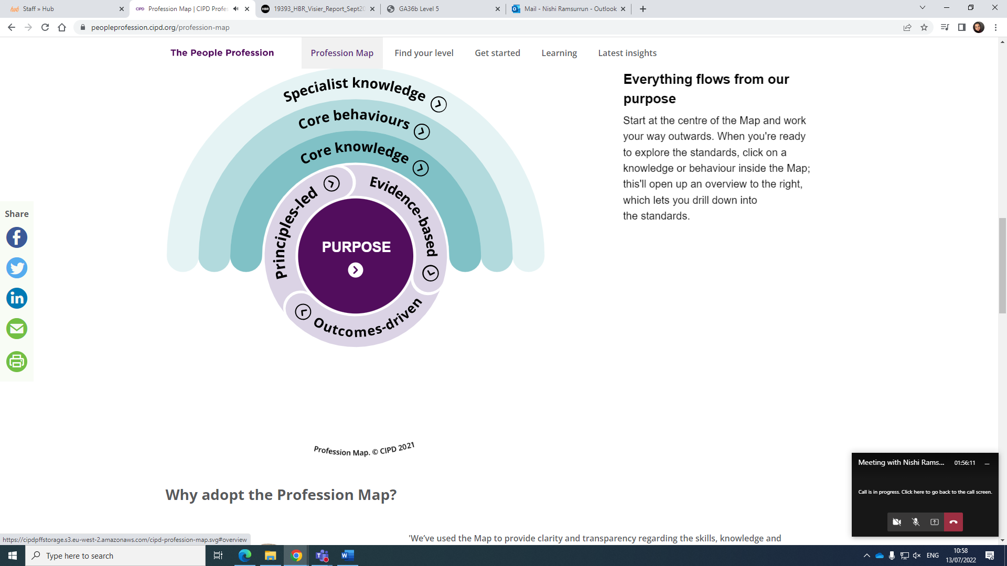
The above given map could be applied to HR professionals working on a global scale regardless of sectors and sizes of organisations in several ways;
- To consider Organisational objectives
A company's long-term goals inspire its short- and medium-term ambitions. A company's performance, business strategy, and productivity can all be gauged in light of these goals. This map gives an excellent illustration of how to think about corporate goals by demonstrating how to apply knowledge and how to establish shared values.
- Providing training and development
Training and development programs help businesses shape their workforce to meet their needs better. Employees' output can be boosted through training and development programs by learning new skills or receiving updates to existing ones. Training and development programs help businesses attract and keep the best employees, boost morale and output in the workplace, and increase bottom-line profits. In addition, absenteeism drops by 41%, and productivity rises by 17% when workers are invested in their work. Additionally, this map can shed light on potential methods of training.
- Review gap of the organisation
An organization's performance may always be enhanced by doing a gap analysis to determine what areas need the most work. The term refers to the difference in results between the current state of affairs and an idealized gold standard established by an analogous group. Each company has its own unique set of methods for making comparisons. The process of doing a gap analysis is simple. Establish the scope of the evaluation and the desired conclusion before proceeding. Step two is a thorough evaluation of the existing situation. Evaluate the outcomes and how they stack up against the ideal. And this map provides insight of gap.
- Explore talent & Individual performance related pay
Paying workers more or less on how successfully they do their tasks is the central premise of this system. To do this, one should reward workers financially whenever they meet or surpass their performance targets. It might be accomplished via a variable compensation plan or a merit pay system. It is a method of compensation management in which an employee's pay rises or falls based on how well they have performed relative to a set of goals. Individual PRP is sometimes referred to as merit pay. This map can be feasible for talent explore. Along with Performance related pay.
- Implement flexible working arrangements
Strike a balance between employee wants and the company's requirements. Make sure your workers are being paid and treated in accordance with the terms of their contemporary award. It is the responsibility of the company to guarantee that all workers, regardless of their working situation, have equal access to learning, advancement, and pay raises. Employees will be happier and more satisfied in their personal lives and will have a far greater appreciation for their job if they are given more freedom to create a balance between their work and personal lives. Happier, more invested, and more morale-filled workers are more productive workers.
Task 2
- Explain why do public sector in the UK is facing skills shortages despite the high unemployment rate.
It is the worst labour shortfall in the United Kingdom since the late 1990s. Recent research found that 91 per cent of UK businesses have trouble finding qualified employees over a year. Consequently, there are more than a million unfilled positions in the labour force (Benderly, 2014). Many people's livelihoods in sectors including production, shipping, and even housekeeping have been impacted. However, the need for more available talent remains the most pressing issue (Benderly, 2014). It is because of several different things, such as the COVID-19 epidemic, Brexit, the lack of wage growth, Poor handling of recruits, Unfavourable salary/terms and conditions of employment, Low morale, High hygiene factors (demotivating factors), lack of equipment to complete work, Poor working conditions such as long working hours or no holidays and No job security.
For example, Brexit is a significant issue that has altered the equilibrium between supply and demand in the United Kingdom's labour market. With the end of the free movement of labour, British businesses will no longer be able to hire EU citizens to fill open positions. A recent poll found that 38% of UK firms blamed a lack of regional talent for difficulties recruiting qualified workers and that this scarcity was directly attributable to Brexit (Stevovic, 2018). EU nationals are finding it more challenging to enter the country and seek jobs due to new visa regulations. It includes innovative programs like a points-based system that requires potential employees to fulfil specific requirements before they can begin their job search. Consequently, many EU job-seekers are now less interested in looking for work in the UK and are instead exploring employment options in other countries. These numbers show that, as the difficulty of recruiting EU citizens grows, UK businesses will have to look to the domestic and non-EU job market for solutions (Stevovic, 2018).
Moreover, there is the COVID-19 issue to consider. The global economy and the UK labour market are both feeling the effects of this uncertainty. A record number of jobs are open in the United Kingdom, while the unemployment rate per job opening is at a record low (Skills Shortages in the UK, 2021). The present skills deficit may be attributed to lockdowns, border closures, and high redundancy rates, with firms reporting a gap between the skillsets of people leaving their employment and those required. Some estimates put the number of migrants who fled the nation due to the epidemic at over a million, with many opting not to return to their responsibilities. Social isolation policies have made it difficult for firms in particular sectors to fill open positions. It is so because they need more resources to give the necessary training for entry into specific occupations.
The widening of the talent gap is also a significant contributor to these shortages. A decade from now, the UK's Industrial Strategy Council predicts, the country will face a severe lack of skilled workers (Skills Shortages in the UK, 2021). As a result, companies need help to fill open positions with qualified candidates. Companies in the United Kingdom spent an estimated £4.4 billion on contract workers, recruiting fees, and wage increases during the last year due to a shortage of workers with the necessary skills (Skills Shortages in the UK, 2021). This shift has highlighted the need to commit to lifelong learning, providing enough training for workers, and seeking out and recruiting talented individuals. Organizing the workforce and hiring the right people requires a skills map.

- Identify and discuss long-term labour market developments to address the skills shortages in healthcare sector professions in the UK
Following labour market developments needs to be done to address skill shortage in healthcare sector in UK;
- Reward and recognition
One of the essential things that can be done to reduce the current rate of the scarcity of skilled workers is to provide incentives and recognition for those who show exceptional performance. For instance, starting pay for new hires has increased at the quickest pace in almost a quarter of a century. Referral programs inside companies are gaining popularity. To guarantee that their shelves are always filled, supermarkets give truck drivers extraordinary incomes. Industries with low pay, such as cleaning, social care, food and hospitality, are seeing the most severe shortages and highest wage increases.
- Concrete communication
Concrete communication with employees is another factor in promoting less skill shortage. Asking people about what they are struggling with and what things they are lacking will eventually decrease the skill shortage.
- Invest in Training and development
By investing in high investment and development, skills can rise. Since many people have the spark but strong guidance so, guiding correctly will eventually solve the problem.
- Empower staff
An empowered workforce is one in which workers are trusted with significant autonomy within defined parameters and provided with the tools, training, and support necessary to make decisions for themselves while being held responsible for the outcomes of those choices. When workers are given greater responsibility, they take it more seriously, produce better results, and develop stronger loyalty to the organization. The results of their delegated decisions are usually quicker, better, and more efficiently carried out. Both managers and workers will require extensive assistance to become more accepting of setbacks.
- Review the way staff are recruited
Employers may evaluate and hire applicants based on their performance in an experiential recruiting initiative. More and more companies are opting for this recruitment strategy since it reduces potential hazards. Candidates may demonstrate the essential soft skills, technical abilities, and cultural fit needed for long-term success in the job and the organization as a whole by taking examinations that have been thoughtfully designed around the difficulties of the sector and the role.
- Review HR workforce planning within the organisation
Companies increasingly rely on supply chain recruiting partners to help them employ more people as it becomes more challenging to fill open positions internally. No matter how many positions need to fill, working with a supply chain recruiting partner with the necessary expertise will save time and money. However, before choosing a supply chain recruitment partner, there are a few things to remember. Among them are:
- Business Groups
- Classification of Employment Agency
- Budget
These are only some of the options for overcoming the difficulties, however. However, other approaches, from international recruiting to financial incentives, will be needed to meet the challenges of the workplace of the future.
- Focus on staff retention and morale
Management aimed at retaining employees entails taking deliberate steps to ensure that workers remain enthusiastic about their jobs and committed to giving their all to the company. Attracting and retaining key employees, as well as decreasing turnover and its associated costs, can be significantly aided by a thorough employee retention program. All of these factors influence the efficiency and success of a company. It is more cost-effective to keep a valuable employee rather than to find, hire, train, and orient a new one.
Conclusion
To conclude the whole discussion, Human resource and training professionals in the government, business, and non-profit sectors of the United Kingdom are unanimous in their praise for the CIPD's certifications. This article discusses the paradox that the public sector in the United Kingdom is facing a skills shortage despite the country's high unemployment rate. Moreover, labour market reforms can assist the UK healthcare sector fill its vacant positions. Results reveal that It is the worst labour shortfall in the United Kingdom since the late 1990s. It is because of several different things, such as the COVID-19 epidemic, Brexit, the lack of wage growth, Poor handling of recruits, Unfavourable salary/terms and conditions of employment, Low morale, High hygiene factors (demotivating factors), lack of equipment to complete work, Poor working conditions such as long working hours or no holidays and No job security. Also, CIPD Profession Map provide behaviours that Hr should adapt along with.
References
Cattell, A. (2006). Learning and Development20061Rosemary Harrison. Learning and Development. London: CIPD 2005. 389 pp. £36.99 (paperback) with additional discounts for CIPD Members and students, ISBN: 1843980509. Industrial and Commercial Training, 38(1), 53–54. https://doi.org/10.1108/00197850610646061
‌ Stevovic, M. (2018). Impact of Brexit to Security and Key Areas in the EU and UK. Account and Financial Management Journal. https://doi.org/10.18535/afmj/v3i1.04
Skills Shortages in the UK. (2021). Www.kingdom.co.uk. https://www.kingdom.co.uk/assessing-skills-shortages-in-the-uk#a1
‌

