Shakera Akthar
Sustainability in Hospitality and Tourism Management (Case study informed essay)
The term “Sustainability” within the context of hospitality and tourism defines that natural ecosystems can continue to develop and support life and provide resources to meet the needs of the present and future generations. In relation to the hotel sector, it puts increased pressure on the environment and is demanding on the natural resources. The industry also relies on the same natural environment such as unspoilt landscapes, sandy beaches, turquoise waters, glaciers, waterfalls, coral reefs and fresh air and these are all of which that serve great tourist attractions, these are key factors into gaining more tourists. There is also a fundamental danger that we may harm the very basis on which hospitality is built. Other business-related concerns, such as rising costs, increased government pressures and competitors’ actions have only encouraged hoteliers to incorporate sustainability and make it an essential part of the corporate agenda. Tourists personally themselves progressively are aware of the issues of sustainability, expecting hotels to presume responsibility and operate their business sustainably. The industry has been quick to make immediate changes and is progressively turning “green”. Policies and regulations have also been put into action in order to recycle, re-use grey water, prevent waste, reduce energy use and lower carbon footprints. All key competitors within the hotel sector such as Hilton Worldwide, Intercontinental Hotel Group, Marriott, Starwood and Carlson Rezidor have regularly published their sustainability reports, whilst reporting initiatives undertaken to reduce negative impacts on the environment. Sustainability is way more than environmental management; it is also about economic progress and social development. Social concerns such as inclusivity, promoting work-life balance, promoting employees’ health and well-being, sourcing supplies locally and stimulating entrepreneurship are all part of the sustainability plan. Sustainability compares with just not being cost-effective, but also as good business sense. Research has shown that more and more customers are willing to reward businesses seen as sustainable by buying products and services from them. Many governments and international agencies for example the EU, offer tax rewards and other monetary enticements in order to promote this cause. There is no uncertainty that the organization of hospitality is built on customer experience, but the need of the hour is that this be grounded within sustainable philosophy. Over the years, hoteliers have started to focus on the importance of sustainability within the hospitality industry as it links to hotel development and operations including the environmental, economic, and social impact. Sustainability is one of the most essential issues facing this world. The hospitality sector has generally had a dramatic environmental impact through energy and water consumption, use of consumable and durable goods, and solid and hazardous waste creation. Hotels consume energy for HVAC operations, lighting, fuel, and other power needs. Water is used for the bathrooms, F&B, and laundry, as well as other general operations such as irrigation, cleaning and maintenance. Waste is generated by the disposal of paper, batteries, bulbs, furniture, equipment, appliances and many more. Economically, fictions include the ideas that green operation is more expensive and that guests are not interested in sustainability. On the social side, there has been a significant shift in recent times, as demonstrated by corporate social responsibility in other words CSR programs, as well as the green buildings for new development projects. Hoteliers also start to realise that they can provide an augmented guest experience by combining natural elements, there has been a growth in “green thought” in the community which is inspired by the following factors:
- Cost savings have always been a leading factor and reducing operating costs provides a powerful inducement for hoteliers. Cost reduction and efficiency strategies can be achieved by capitalizing in better operational procedures and evolving environmental technologies. A various number of hoteliers now employ a number of strategies to stop, reuse, and recycle waste. Other developing areas include sustainable attaining, indoor environmental quality which focuses on air quality and chemical or cleaning product items and staff training programs which can also enable improved outcomes of performance and higher levels of employee satisfaction.
- Economic Inducements- the government has legislated a variety of economic inducements to enhance the development of environmental retrofits and the construction of “green” buildings. These subsidies include tax write-offs, financial grants, insurance premium discounts and accelerated monitoring allowing.
- Regulatory affairs- the recent current environmental regulations targeted towards the hotel sector are increasingly focused on facility operations such as storm-water management, hazardous materials handling, and environmental health and safety. On the other hand, a wide range of present and future legislative activities will influence hotel design, construction methods and operational approaches.
- Guest experience- a superior number of hoteliers understand that ventures in environmental technology have a direct beneficial impact on guest experience. Guests are extremely focused upon the experience that they get. Guests want to stay at properties that do not feel like hotels as they want an “at-home” feeling. Lighting, furnishings, cleaners, and other front-of-house products allow to leave an impression with the customer, which can affect both occupancy and ADR.
- Corporate brand image- having a sustainable corporate culture can provide a clear advantage in context with attracting and retaining talent.
- Brand image- the most key hotel brands have merged some what of sustainability platform into their brand definition. Many brands have been repositioned to cater to a younger generation of more environmentally and socially active customers. But companies must put plans into process. Having sustainable business practises will mean enhanced reputation and brand image which then also leads to exceptional hotel profits in the long term.
Hospitality and tourism are a substantial force around the globe. The industry is debatably the largest and most dynamic of all the other sectors. Due to the factor of globalization and technological innovations, this industry now has broader international standards. As they are the largest firms it has many responsibilities for our ecosystem. Sustainable tourism development has been the most prickling fear of the tourism industry recently. The principles of sustainability are to make sure a non-declining progression of resources through frugality within the economy, to articulate an accounting system that cues the economy and associates with the ecological process and to preserve every forms of life in the environment and secure the diversity of gene pool through rejuvenation ability. Sustainability is to also meet the current demands and needs of the customers without acknowledging the rights of the future generation. Simply sustainability is the capacity to endure or continue.
The impacts of tourism in the environment:
Tourism development can put pressure on natural resources when it increases consumption in areas where resources are already limited.
Negatives:
- Water resources- the tourism industry generally overuses water resources for hotels, swimming pools, golf courses, and personal use of water by tourists. This can result in short of water and deprivation of water supplies, as well as generating a larger volume of wastewater.
- Land degradation- important land resources include fertile soil, forests, wetlands and wildlife. Tourism often contributes to the degradation of said resources. Increased construction of tourism facilities has increased the pressure on these resources and on scenic landscapes. Forests often suffer negative impacts of tourism due to deforestation.
- Local resources- tourism can create immense pressure on local essentials such as food, energy and other raw materials that may be in short supply. Greater abstraction and transfer of these resources aggravates the physical impacts associated with their mistreatment.
Positives:
The most commonly positive impact is raised awareness. Many places promote ecotourism and sustainable tourism, and this can help to educate people about the environmental impacts of tourism.
The effects of tourism are leading in the modern society, their impact can be classified into three contribution to the economy, influence on the environment and enabling the growth of the destined communities.
Critical evaluation of the concept of good practice within the sustainable tourism and hospitality industry:
- Marriott’s sustainable operations are to reduce our environmental impact, build and operate sustainable hotels and source responsibly. This is where they minimize their environmental footprint by sustainably managing their energy and water use, reducing their waste and carbon emissions and increasing the use of renewable energy. They employ innovative technologies to plan, implement, track and communicate how they operate responsibly to mitigate climate-related risk, benefiting their business as well as the community in the way they operate.
- They also build and operate sustainable hotels they collaborate with their associates, hotel owners, franchisees, brands, suppliers, business partners and guests to actively reduce the environmental impact of and risk to their business by constructing and operating sustainable hotels.
- In addition to this they source responsibly, this is where they are committed to integrating leading environmental and social practices into their supply chain and partnering with like-minded suppliers. Their aim is to reduce the negative environmental and social impact of our business activities by focusing on sustainable, responsible and local sourcing.
Their impacts led to in 2018- 36% of properties certified to a recognized sustainability standard, 225 LEED (or equivalent) certified or registered hotels, 155 open adaptive reuse hotels.
Marriott’s goals:
- By 2025, 100% of hotels will be certified to a recognized sustainability standard
- By 2025, 650 open or pipeline hotels will pursue LEED certification or equivalent
- Sustainable Building Standards:
- By 2020, LEED certification or equivalent will be incorporated into building design and renovation standards, including select service prototype solutions for high growth markets
- By 2020, 100% of all prototypes will be designed for LEED certification
- By 2025, partner with owners to develop 250 adaptive reuse projects
- MI’s new global HQ will achieve LEED Gold certification
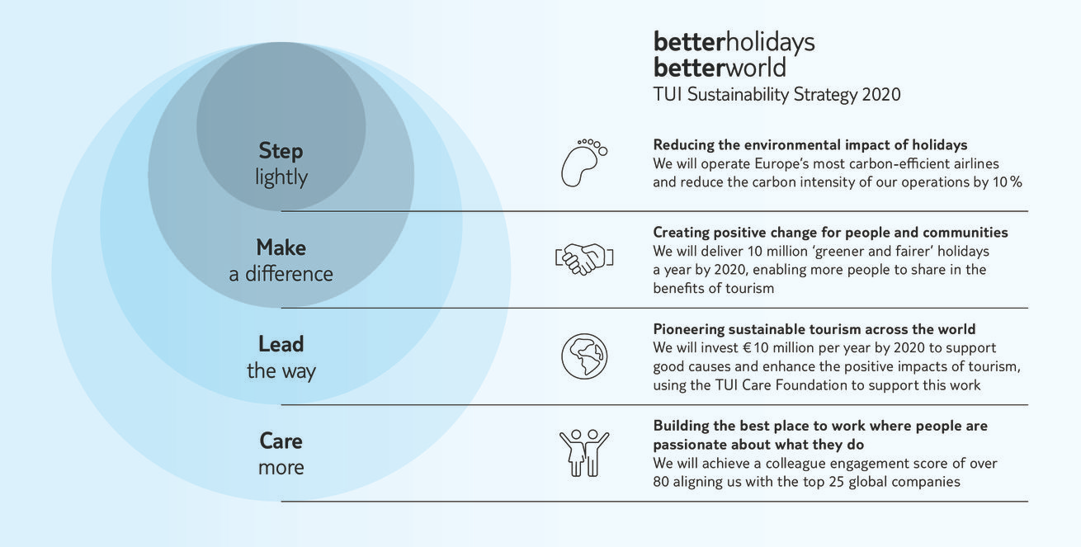
- By 2020, all properties will have a Serve 360 section on the m.com website with hotel impact metrics
Tui group’s sustainability strategy 2015-2020:
TUI Group is committed to making our sector more sustainable. Their Better Holidays, Better World strategy is built around four core pillars. These are areas where they aim to make a positive impact to create change at scale – in their own operations, through their value chain and customers, and across the wider industry and beyond.
Tui group’s sustainable goals:
- Tourism and the SDGs- The tourism value chain connects closely with many sectors and through these industries we have the opportunity to accelerate progress towards all 17 SDGs, however three goals focus in particular on sustainable tourism – SDG 8 on decent work and economic growth, SDG 12 on responsible Consumption and production, and SDG 14 on life below water.
- Leadership opportunity- TUI Group is committed to make our sector more sustainable and support the UN Sustainable Development Goals. As a global operator and the world’s leading tourism business, they believe they can drive change for the better – they also have a responsibility to tackle shared global challenges like climate change.
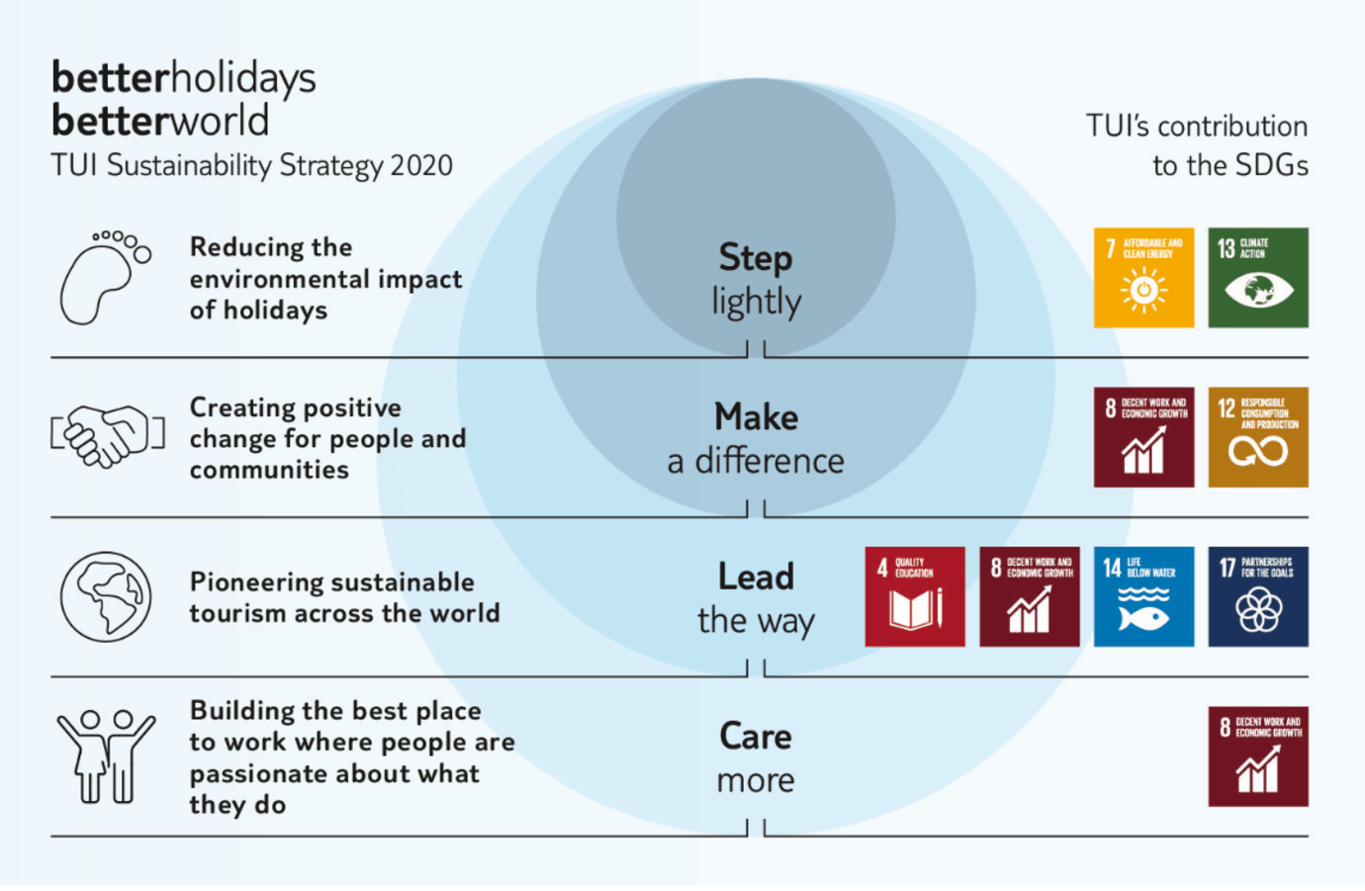
- Their Better Holidays, Better World strategy aims to address key industry challenges and maximise their positive impact. It is built around four core pillars where in which they aim to create change at scale – in their own operations, through their value chain and customers, and across the wider industry and beyond.

Conclusion:
Tui’s environmental management systems are based on acknowledged standards and they are systematically improving our environmental accomplishment. Many authorizations also improve the intelligibility of targets, measures, and the general performance by the company. Tui’s individual companies are also all certified by the international standard ISO 14001. These factors allow customers want to book with them. Tourists are now becoming more environmentally well prepared due to the FTSE4Good. Sustainability is a difficult perception which is hard to distinguish, in search of sustainability there will be a time where there is need to limit development to some pre-determined threshold. There is also a need to amend the behaviour of the stakeholders in tourism. Ecotourism is not a solution to sustainability and there is immediate need for shared responsibility by the private sector combined with a fully engaged public participation in the planning of tourism. in order to make a sustainable livelihoods the following factors allow this such as, tourism can create jobs, increases the demands of locally produced products and services, reduces poverty, helps traditional businesses diversify into tourism, developing and improving tourism products, builds resilience to climate change and brings in change to policies and procedures for long-term success.
References:
https://www.southwales.ac.uk/courses/ba-hons-hotel-and-hospitality-management/2484/why-sustainability-is-key-for-the-future-of-the-hospitality-industry/
https://www.danacommunications.com/importance-of-sustainability-in-the-hospitality-industry/
https://www.youtube.com/watch?v=rmQby7adocM
http://www.uneptie.org/scp/
https://serve360.marriott.com/sustain/
https://www.tuigroup.com/en-en/responsibility/strategy/SDGs
https://uwtsd.hosted.panopto.com/Panopto/Pages/Viewer.aspx?id=9b59c846-3e0b-40e1-897d-abb400fd159c
https://uwtsd.hosted.panopto.com/Panopto/Pages/Viewer.aspx?id=f32c21ce-a9fc-413d-9789-abbc00e0d968

