Abstract
Effective communication is an essential aspect to get the job done. It is ensuring the employees have attained the information that is needed to get the job done in most effective manner. This report aims to provide Tuckman and Belbin's and communication models- Berlo, Shannon-Weaver, and Schram to be applied for improving communication within teamwork. This study showed that both theories Tuckman and Belbin helps in forming of the team in an inclusive manner. Communication models can help the HR and Andrea to fill all the social worker
positions to stabilise the teams.
Skills for the Workplace
Case study of social services
1920088
Irina Tanase

Table of Contents
Introduction 2
Main findings 2
Team Dynamics 2
Team formation & Communication 3
Conclusion 9
Recommendations 9

Introduction
Communication within workplace is the means in which the employees interchange the ideas and information with one another (Harris and Sherblom, 2018). Therefore, this report is based on the case study of communication within workplace in which people professional is facing communication and human management issues. Hence, this report will provide Tuckman and Belbin's explanation and how these can be applied in order to improve teamwork in the organisation. A detailed account of the specific issues and challenges will be provided that have been faced by Andrea Jones and her team. Communication models include Berlo, Shannon-Weaver, and Schram will be discussed along with a series of recommendations to address and cope the addressed key issues.

Main findings
The main findings aim to bring the solution in order to curtail the issues faced by Andrea Jones and the HR team. The analysis of Tuckman's theory and Belbin's theory will serve as a measure to put in practice in order to help employees work in a holistic manner, which was a major issue derived in the case study. However, the way implement cohesiveness will be analysed through models of communication, including Berlo, Shannon-Weaver, and Schram.

Team Dynamics
The team structure of the case study is following a hierarchical structure. This team structure is designed in the form of a pyramid which includes directors, executives, managers as well as employees to create a high level to the lowest in the chain (Guttenberg, 2020).

Tuckman's Theory
In 1965, Tuckman's theory was formulated by Bruce Tuckman, who was a psychologist. The theory presented 5 stages of development, including forming, storming, norming, performing and adjourning. These stages involve the start to the end of the project (Cornelissen, 2020).
Following are the five steps followed by Tuckman's theory that can be applied by Andrea Jones:

Forming
This step of the theory comes in the first phase where teams meet first. Introduction to the team should be facilitated by the managers and highlight the skills of each individual and their career background. Andrea Jones using this stage of Tuckman theory can avail the opportunity by giving project details to each member and providing them with an opportunity to organise their own responsibilities. Avoiding conflict and "playing nice" can influence a highly effective team which can be facilitated by Tuckman's theory of forming effective relations among people at work. Because, in this essence, they can accept each other with open arms (Kuznar and Yager, 2020).
In this way, the team, Andrea Jones, will learn about the goals and objectives by getting a feel for the work that needs to be done together. The teams can focus on practical details like when, who, what and where. In this way, the team will learn where they and others fit in the team.

Storming
Team members in this stage share their ideas and attain an opportunity to stand out as well as be accepted by team members. In this stage, leaders aid a plan to manage competition and make communication accessible and easy to make sure that the projects stay on track (Elleström, 2018).
This step of the Tuckman model can serve the HR management teams and Andrea John in improving social service teamwork. The team leader and supervisor can prepare group decisions which tends to improve the clarity of the purpose among teams.

Norming
Until now, the team has become capable of figuring out how to work collaboratively by excluding competition among them with clear goals and objectives. Thus, every individual puts their full effort as they have learned the ideas to be shared and how to concentrate on feedback while working for a common and shared goal (Delice et al., 2019).
The team, Andrea Jones, can make sure that every important decision should include the team agreement. This will ensure strong unity between them in order to provide their client base. Thus, the team will not feel the new procedures 'being a surprise.

Performing
At this point, conflicts might arise, but the theory has entailed that at this stage, the teams will have approaches for resolving difficulties without negotiating progress and timelines. It is because a high level of cohesion and trust will exist among members (Georgiadis, 2015).
This step can help Andrea Jones and the HR team to improve and enhance the strategic awareness of the team. They can implement this step for the team supervisors that should focus on the organisation's goals.

Belbin Theory
This theory says that each of us attains a specific behavioural pattern which features the behaviour of one person in relation to other to facilitate team progress. In sum, the theory advocates a tendency to contribute, behave, and interrelate with one another in a specific way (Smith et al., 2017).
The HR team and Andrea Jones, when filling manager positions and social work positions, can use Belbin's model to create balanced teams balancing a mix of skills and characters to achieve the different roles described.

Action Oriented-Roles
This role can be fulfilled by HR and Andrea Jones with extroverts who would be confident in challenging other team members. Thus, these will be the shapers who won’t mind questioning the status quo to implement the best possible problem solutions at work by taking risks (Okocha et al., 2022).

People-Oriented Roles
This role will be filled by the executives that are said to be as traditional leaders with a grasp of talent for completing the task correctly. Andrea Jones in filling the managerial position will have to hire the people that guide and coordinate his/her team towards a common goal and in a controlled way as well (Couchman, 2015).

Thought-Oriented Roles
HR and Andrea Jones, when filling the executive position, will have to bring into action this concept of Belbin theory which highlights that the "Plants” produce original and interesting ideas for the benefit of the team. These are the personnel that are typically introverted and prefer to work alone whilst evolving new thoughts and coming up with solutions to complications (Harris and Sherblom, 2018).

Team Formation & Communication
This case study highlights the issues of a social service team that is facing day-to-day complexities in its operations. Staff members in post-pandemic are not willing to get back to work and willing to work from home. On the contrary, the communication gap prevailed among teams because they were working with separate buildings and new procedures were resulting as a surprise for them. This was bringing the absence and turnover ratio of employees to be high. Shortage of staff and new team member dealing was creating stress among management and the team as well. Thus, new employees without proper training were given caseloads straight away.
Communication with email was taken place. However, it was a one-way communication and not entering into a discussion with staff. No mechanisms to communicate these ideas to senior management was the main issue which was highly needed as the employees grumbled to their team managers that they had lots of great ideas to improve performance.

1. Berlo’s Model of Communication
This model of communication involves the emotional aspects of communication. SMCR model has been followed by Berlo’s model of communication, which stands for
S – Source
M - Message
C - Channel
R – Receiver
The source in this model of communication is the sender, who originally contains the idea and thoughts that transfer the information to another person (receiver). Second element is message, the conversion of opinions into words is the message which defines the process of encoding. Third element is channel, it is the medium via which the message has to be conveyed. It allows the medium using which a message can be communicated effectively (Elleström, 2018). Forth element is receiver, that target person to whom the message is to be sent. The receiver receives the message with the aim of listening in order to respond the according to the message being conveyed (Okocha et al., 2022). Figure 1 shows Berlo’s Model of Communication.
On the basis of this theory, he Andrea Jones should assure to incorporate communication skills, Attitude, Knowledge, Social System and Culture within the talent pool of organisation. The channel of communication should be intranet and extranet technologies that can record incoming and outgoing of a message.


Figure 1 Berlo’s Model of Communication
Source: (Guttenberg, 2020).

2. Shannon-Weaver Model of Communication
The Shannon-Weaver Model of Communication aims to communicate effectively between sender and receiver. The theory says “noise” might be the factor that affects the process of communication.


Figure 2 Shannon-Weaver Model of Communication
Source: (Okocha et al., 2022).

1. Information Source
Senders possess information by selecting a message to transmit and a channel to deliver the message (Cornelissen, 2020). Second element of this model is Encoding (Transmitter). The encoder is the person or equipment that converts the message of the sender into signals and communicates to the target receiver. The third element of this model is channel that is used as medium that converts the data from sender to transmitter to decode and receive is termed a channel of communication (Harris and Sherblom, 2018).
Fourth is noise, the transmitter and receiver are unable to communicate in the presence of noise (Elleström, 2018). Decoder is fifth element that is the reverse of encoding. The theory designed this paradigm regarding communication that happens via devices like phones (Guttenberg, 2020). In Recipient (Destination) phase, the recipients, when receiving the message after the noise and distractions are taken into consideration in the message, reach to destination (Georgiadis, 2015). Finally, Feedback happens once the receiver responds to the correspondent to close the message loop (Okocha et al., 2022).
In consideration of this theory, Andrea Jones needs to remove all the noise barriers in order to implement the process of communication effectively. Management by objective and formative feedback can be used by the Andrea Jones to improve and motivate the productivity at work.

3. Schram's Model of Communication
This model says that messages can flow in two directions, i.e., decoding and encoding. Once a person decodes the message, then they encode it and send it back to the sender. This is termed a circular model because it can continue encoding and decoding in circular form in a continuous manner. The theory argues that personal experiences, backgrounds, and knowledge of a person can impact the message interpretation (Guttenberg, 2020).

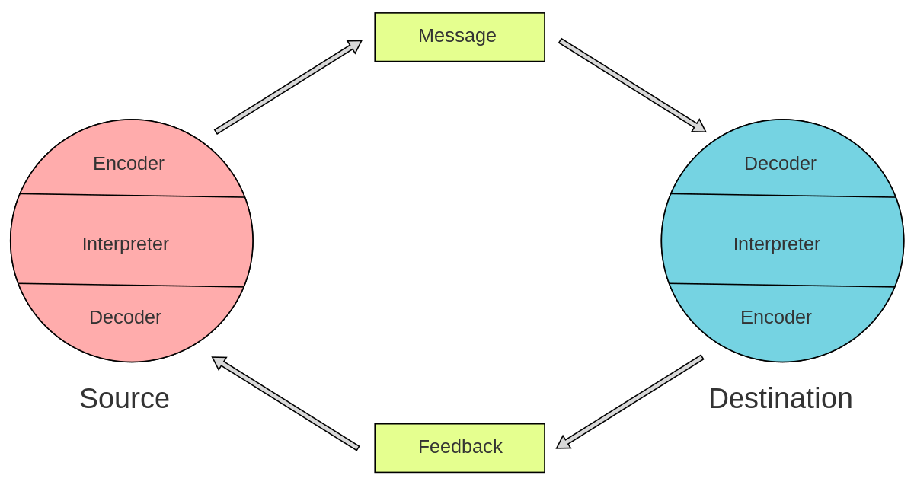
Figure 3 Schram's Model of Communication
Source: (Delice et al., 2019).
The diversity and inclusiveness by removing all sort of stereotyping can be effective by Andrea Jones in order to implement Schram's Model of Communication effectively.

Conclusion
It can be concluded that the good aspects of the organisational approach embrace the study of emotions based on theories which help in understanding emotions based on inter and intra-personal behaviours. The Tuckman theory helps the forming of the team in an inclusive manner, which calls to share ideas in a collective and holistic manner. This open up the way of communication and sharing ideas in the stage of norming by having a common goal. Cohesiveness and trust by Belbin theory implementation in the team of Andrea Jones are highly needed. Belbin's theory serves as an organisational approach that can put in place the executives that can run the business in an effective manner using action-oriented roles, people-oriented roles, and though-oriented roles. Communication models can positively influence the organisation. In this essence, Berlo’s Model of Communication, Schram's model of communication and Shannon-Weaver Model of Communication can serve the aim of communicating the aim of the receiver in the most effective manner towards the target receipt with feedback to implement the words effectively.

Recommendations
- Teamwork and interpersonal relationship can be boosted by placing motivation at work. The moral value at the workplace is crucial to be boosted, which brings the concept of a reward system to be implemented along with using Belbin and tuck man theory at work. The reward system will cut the high level of inner competition to attain a shared goal by the employees (Kuznar and Yager, 2020).
- Communication models with the use of Artificial intelligence like ERP and CRM can help the team of Andrea Jones to break internal communication gaps.
- Post-hire strategy to fulfil the positions of the job should be implemented in a way that pre-training should be provided to new hires.

References
Butchibabu, A., Sparano-Huiban, C., Sonenberg, L. and Shah, J., 2016. Implicit coordination strategies for effective team communication. Human factors, 58(4), pp.595-610.
Cornelissen, J.P., 2020. Corporate communication: A guide to theory and practice. Corporate communication, pp.1-336.
Couchman, M.R., 2015. Tuckman's theory of group development in small nonprofit organisations and group efficacy (Doctoral dissertation, Capella University).
Delice, F., Rousseau, M. and Feitosa, J., 2019. Advancing teams research: What, when, and how to measure team dynamics over time. Frontiers in psychology, 10, p.1324.
Elleström, L., 2018. A medium-centered model of communication. Semiotica, 2018(224), pp.269-293.
Georgiadis, G., 2015. Projects and team dynamics. The Review of Economic Studies, 82(1), pp.187-218.
Guttenberg, J.L., 2020. Group development model and Lean Six Sigma project team outcomes. International Journal of Lean Six Sigma.
Harris, T.E. and Sherblom, J.C., 2018. Small group and team communication. Waveland Press.
Kuznar, L.A. and Yager, M., 2020. The Development of Communication Models, Quick Look. Joint Staff J39, Strategic Multi-layer Assessment Washington, DC United States.
Okocha, P.O., Emeyazia, G.C. and Osakwe, C., 2022. Appraising employee performance through a reward management system in the organisation. Journal of Global Social Sciences, 3(11), pp.211-226.
Smith, M., Polglase, G. and Parry, C., 2017. Construction of student groups using Belbin: Supporting group work in environmental management. In Pedagogic Research in Geography Higher Education (pp. 143-159). Routledge.

