How to acknowledge your use of AI

I confirm that I have not used any AI tools in the research and creation of this assignment. I confirm that I have not presented any AI generated materials as my own work. I confirm I have copies of my drafts, notes, and other resources I used, which I may be asked to provide in evidence.

The limitations of the Little Albert experiment

1.The study is too small

This experiment is too small as a sample. There was only one child in the experiment (Albert), so comparing the results to a control group was impossible, suggesting that the study cannot provide any meaningful data.

2. Poor Methodology
The laboratory was not well designed. A laboratory is an artificial environment, was this taken into consideration as an influence on Albert’s reactions? Perhaps the laboratory have been distressing to Albert.

3. Poorly designed, unscientific procedure
Watson and Rayner used dubious metrics to measure fear, for example rather than measuring important vital signs like heartrate or breathing, they relied solely on observational measurements such as crying.

4.Albert’s health condition
We do not know if Albert was healthy at the time of the study. It is possible that he was suffering from an underlying condition, which would have potentially influenced the outcome of the study.

5. Repeating the study remains impossible
Because of modern ethical requirements, no study to replicate or check the findings of the Little Albert experiment would be designed. This means that it is impossible to compare the experiment with a modern, better-designed equivalent.

Summary
The Little Albert experiment is important to study as the first time it was shown that the fear response can be conditioned, but due to its cruelty, unscientific method, and limited study range (only one subject), the results we can draw are limited in scope and of limited value in the context of today.

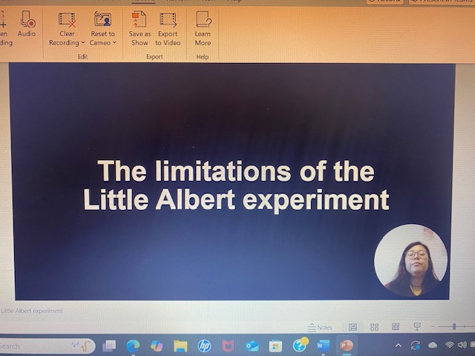
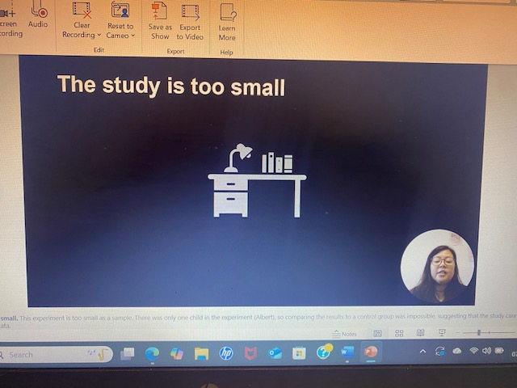
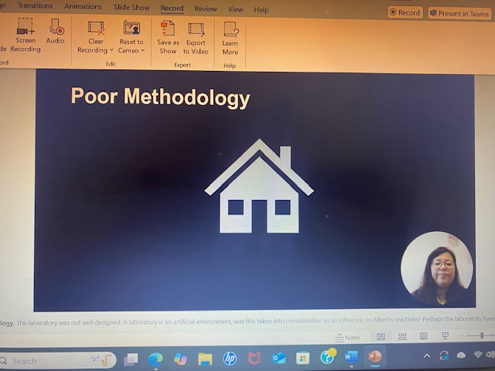
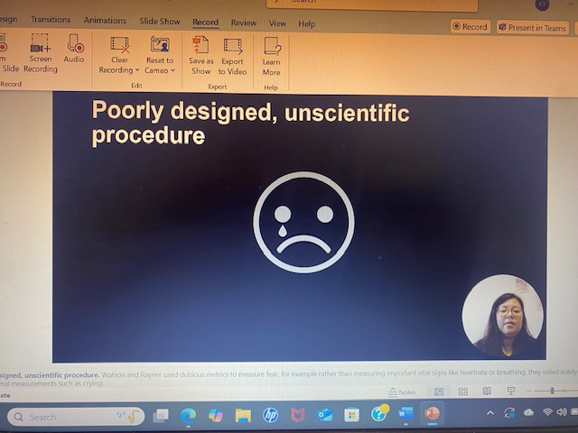
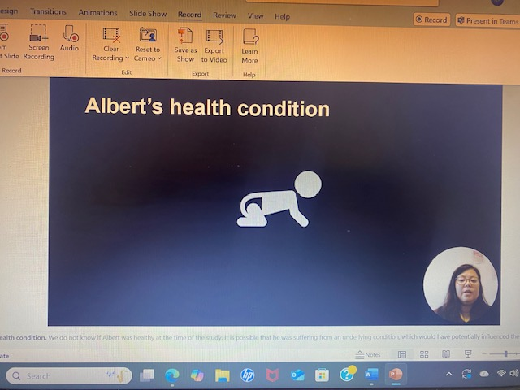
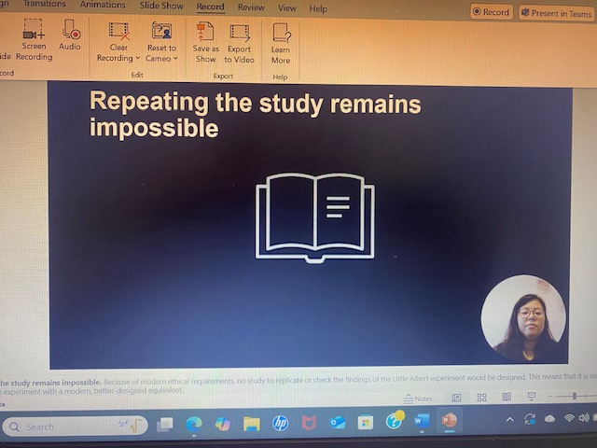
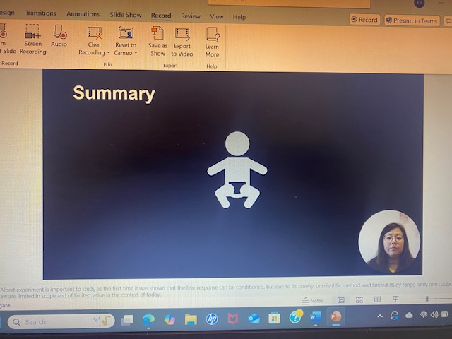
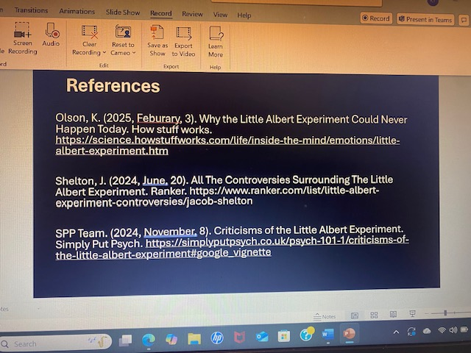
References

Olson, K. (2025, Feburary, 3). Why the Little Albert Experiment Could Never Happen Today. How stuff works. https://science.howstuffworks.com/life/inside-the-mind/emotions/little-albert-experiment.htm

Shelton, J. (2024, June, 20). All The Controversies Surrounding The Little Albert Experiment. Ranker. https://www.ranker.com/list/little-albert-experiment-controversies/jacob-shelton

SPP Team. (2024, November, 8). Criticisms of the Little Albert Experiment. Simply Put Psych. https://simplyputpsych.co.uk/psych-101-1/criticisms-of-the-little-albert-experiment#google_vignette

