

Assessment 2

Student name:​Olivette Mildred Cole
Student ID: ​2022097
Module name: Mental Disorders and Psychopathology​
Module code: BMHP6006
Lecturer name: Bianca Sanfilippo ​
Date: 05/05/2023

Contents
1. Introduction 3
2.0 General anxiety disorder 4
2.1 Definition of General Anxiety Disorder (GAD) 4
2.2 Classification of GAD within ICD-10 4
2.3 Main Causes of Anxiety 5
2.4 Signs and Symptoms of Anxiety 5
2.5 Diagnosis 5
2.6 Treatments and Rehabilitation 6
2.7 Recommendations for improving anxiety disorder. 6
2.8 Principles of care for people experiencing a generalised anxiety disorder 6
2.9 Types of mental health problems/Anxiety and Panic Attacks 6
3.0 Schizophrenia 7
3.1 Definition of Schizophrenia 7
3.2 Classification of Schizophrenia within the ICD–10 7
3.3 Data on the Gender of people suffering from Schizophrenia 7
3.4 Causes (Aetiology) 7
3.5 Signs and Symptoms of Schizophrenia 8
3.6 Diagnosis of Schizophrenia 8
3.7 Treatments for Schizophrenia 8
3.8 Guidance and Principle of Care NICE 9
3.8 Recommendations for improvement of Schizophrenia 9
4.0 Autism 10
4.1 Definition of autism 10
4.2 Classification 10
4.3 Data relating to children and adults with autism within the UK and around the world 10
4.4 Causes (Aetiology) 10
4.5 Signs and symptoms 11
4.6 Diagnosis 11
4.7 Current treatments 12
4.8 Recommendations for improvement of AUTISM 12
4.9 Guidance and principle of care - NICE 12
4.10 Conclusion 12
5 References 14

1. Introduction
Within this review, there will be a critical discussion regarding the ICD (2010) Chapter 5. There will also be a critical examination of the classification, diagnosis, treatment, and measurements of rehabilitation of the following three mental disorder conditions such as
general anxiety disorder
schizophrenia,
autism.

2.0 General anxiety disorder

2.1 Definition of General Anxiety Disorder (GAD)
General anxiety disorder also known as (GAD) this condition lasts a long time, anxiety leaves individuals to develop an anxious feeling about several issues instead of just one problem. Going through anxiety disorder makes an individual feel extremely anxious for the rest of their daily life making it harder for them to relax and stay focused and at ease. As they try to resolve one situation another accuses making it more difficult to overcome feelings of anxiety.

2.2 Classification of GAD within ICD-10
GAD is classified within ‘F40-F48 Neurotic, stress-related, and or somatoform disorders. Gad is under F41.1
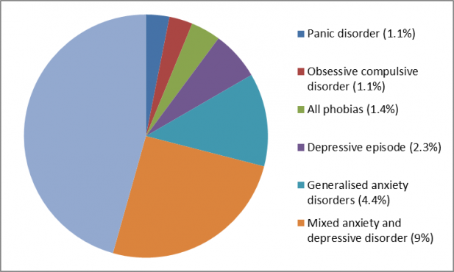
Data on Individual’s going through general anxiety disorder (GAD)

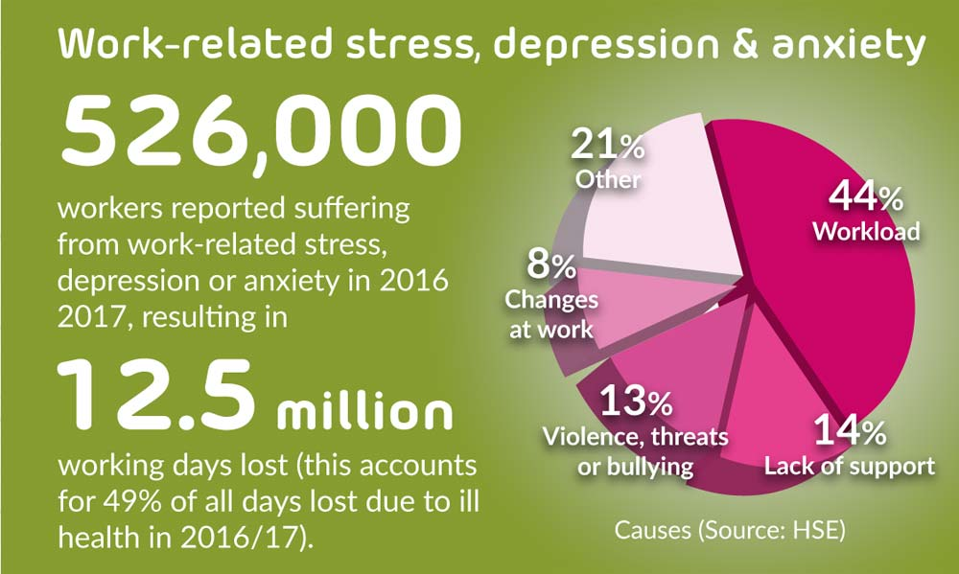

2.3 Main Causes of Anxiety
Anxiety has no particular causes for anxiety however, several combinations can build up an individual anxiety level such as the way our brain chemicals changes and the way its functions, experiencing environmental stress, and depression, it could also be a disorder that runs in the family history as well as experiencing traumatic life-threatening events such as going through a divorce, bereavement and medical history, for example, heart conditions, diabetes drugs or alcohol abuse (2023).

2.4 Signs and Symptoms of Anxiety
Everyone goes through anxiety at an unspecified time for instants experiencing an examination, or going through a job interview these feelings can last for a while it can then be seen as anxiety disorder and the symptoms that build up anxiety are being restless, feeling panicky and fearful, the feeling of uneasiness, feeling nausea and experiencing cramps, having sleepless nights, having cold feet and hands and having numbness in their hands and feet. Other symptoms individuals experience includes difficulties in breathing, increasing heart level, developing chest ach, dryness of mouth, and dizziness ( 2023).

2.5 Diagnosis
A physical assessment and a review of the patient's medical history are used to make a diagnosis. To rule out any other medical conditions causing the symptoms, laboratory and imaging testing may be performed. Mental health can be assessed using psychological questionnaires. When experiencing anxiety individuals are more to be diagnosed with GAD if they have been experiencing the condition for longer than 6 months or more. It can be difficult to be able to maintain your feelings of anxiety this is also a way for people to be able to indicate they are having signs of anxiety.
According to NHS, 2023, states that to be diagnosed properly with anxiety GP will have to conduct a thorough physical examination or a blood test This helps to rule out other medical disorders that may be interfering with the symptoms, such as anaemia. This is due to a lack of iron, vitamin B12, and folate, or an overactive thyroid gland hyperthyroidism (NHS, 2023).

2.6 Treatments and Rehabilitation
There are treatments out there to help individuals’ anxiety conditions such as psychological therapies for GAD, self-helped and cognitive behaviour therapy, applied relaxation, medication, and many more. Before the right treatment and assessing the effectiveness of treatment it can be helpful to be able to know the importance of rehabilitation the reason for this is because if the treatment is not effective depending on how server the condition is, it is always better to reassess the medical treatments and change the treatment to best suit the individual into them maintain their anxiety disorder. Generalise Generalized disorder also known as (GAD) is part of the measurement of rehabilitation using a questionnaire (GAD-7) can be a great assessment tool to help measure how long a person has developed Anxiety over a period of two weeks.

2.7 Recommendations for improving anxiety disorder.
There are several recommendations to help maintain anxiety disorder such as complementary therapies. Shohani et al. (2018) indicate that the effectiveness of yoga helps to reduce anxiety in women, this has proven to have a positive impact the reason for circumstance is that it reduces the drug use and any side effects the treatments may cause. There should be fully written information within the person’s language of understanding as well as providing an audio format of ways of communication due to language barriers, another way of breaking a language barrier is by having an independent interpreter on standby. If professionals end up getting families or carers involve in a patient’s health condition it is very important, they provide the right information such as their contact details, information on support groups and voluntary organisations as well as give them ways of accessing these sources of support (NICE, 2023).

2.8 Principles of care for people experiencing a generalised anxiety disorder
The principles of care for people experiencing generalised anxiety disorder are building positive relationships where they can feel welcome to share their feelings without being judged, to be able to explore the individual struggles and understand the effect having GAD has had on their mental well-being, there are treatments professionals can work together with the patients understand that deciding is a two-way agreement, A discussion should take place in a private and confidential environment where the personalities being respected (NICE, 2011). When helping individuals dealing with GAD, proving the right information and treatments that are available to them and explaining to their level of understanding on the nature of their condition (NICE, 2023).

2.9 Types of mental health problems/Anxiety and Panic Attacks
Types of mental health problems such as Anger issues, anxiety and panic attacks, bipolar disorder, body dysmorphic disorder (BDD), borderline personality disorder (BPD), depression, dissociation and dissociative disorders, eating disorder, hearing voices, hoarding, hypomania and mania, loneliness, mental health problems - introduction, obsessive-compulsive disorder (OCD), Panic attacks, paranoia, personality disorders, phobias, postnatal depression and perinatal mental health problems (Mind, 2023). People experience panic attacks at different times. Others may experience it once whilst others experience theirs regularly or several times in a short time. panic attacks can last at least 5 to 20 minutes (Mind, 2023).

3.0 Schizophrenia

3.1 Definition of Schizophrenia
Schizophrenia is described as a long-lasting health condition according to the NHS, schizophrenia is caused by different types of psychological symptoms. Health professionals also described schizophrenia as a psychosis which means people suffering from this condition are unable to tell the difference between their thoughts or their ideas from reality (NHS, 2023).

3.2 Classification of Schizophrenia within the ICD–10
Classification of Schizophrenia within the ICD–10 is classified as schizotypal and delusional disorders (F20-F29),

3.3 Data on the Gender of people suffering from Schizophrenia
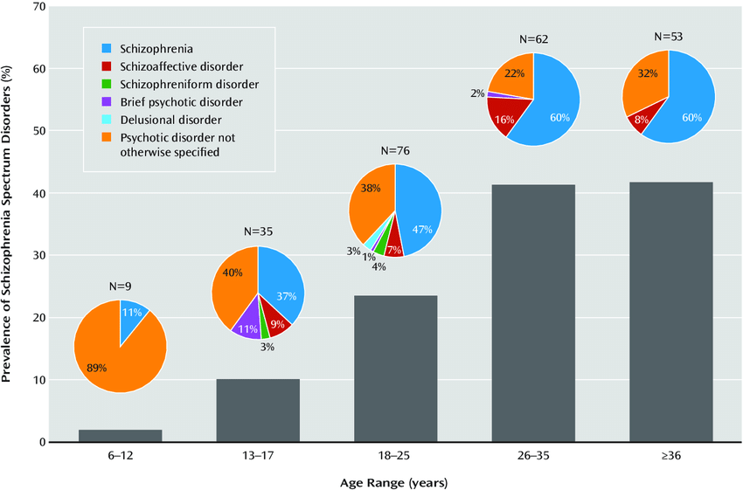

https://www.researchgate.net/figure/Prevalence-of-Schizophrenia-Spectrum-Disorders-and-Distribution-of-Specific-Disorders-by_fig2_262046412
Data taken from (WHO, 2023), indicates that 24 million individual suffers from the condition of schizophrenia worldwide. This means 1 in 222 people are among adults with the condition. This type of condition is not commonly compared to other conditions. Schizophrenia takes place during late adolescence and twenties and tends to reassure earlier in men than in women. Individuals with schizophrenia disorder are 2-3 times more likely to experience death earlier in their life than those that are not going through the experience. This life change is because of physical health conditions for example cardiovascular, metabolic, and infectious diseases (WHO, 2023).
https://www.who.int/news-room/fact-sheets/detail/schizophrenia

3.4 Causes (Aetiology)
Schizophrenia can be caused by a variety of factors. There are still a lot of experts who don't know, and it's most likely caused by a combination of genetic, personal, and environmental factors. These criteria will vary from person to person, but they may include:
- Stressful Life situations
- Drug and alcohol usage
- Genetic inheritance
- Differences in brain chemistry

There are other several causes related to schizophrenia that can cause psychosis and this can relate to other disabilities, therefore, can impact a person, for example, family life, educational life, individual social life as well as job. There have been many stigmas related to the views of how people see those way suffering from schizophrenia condition which is quite common in our everyday life. The NHS mentioned that there are more than 2 out of 3 individuals experiencing psychosis in the universe who tend not to get specialist mental health treatment. Several supports are proven to be effective for people going through schizophrenia and 1 in 3 people with schizophrenia will have a full recovery.

3.5 Signs and Symptoms of Schizophrenia
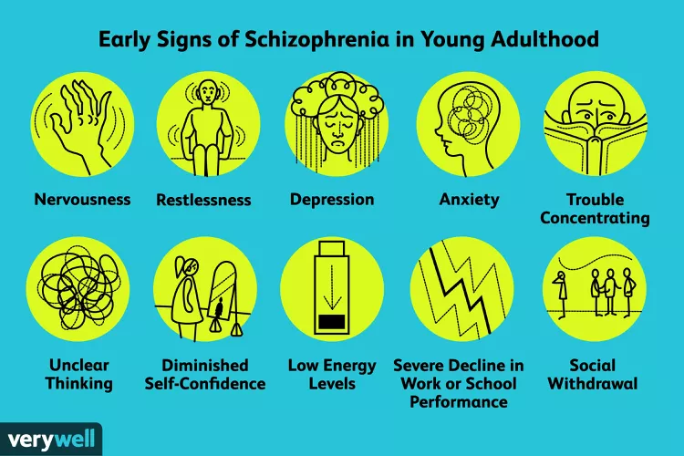
The symptom of schizophrenia depends on how severe it may be. It may involve experiencing a delusion, such as hallucinations and illusions, thinking, and behaving differently such as having less emotional expression, feeling agitated, and having an inappropriate reaction to certain saturations. Another symptom that occurs is developing different phobias, you will seem to have less interest in social activities or motivation to participate in doing anything.

3.6 Diagnosis of Schizophrenia
There is no test to diagnose someone with schizophrenia however, a mental health specialist will usually diagnose a patient with schizophrenia after conducting an assessment. A GP is one of the professionals that need to be seen if a person feels like they are showing systems of schizophrenia the earlier you see a specialist the better for treatments to commence. A blood test is usually taken to rule out other symptoms and to be able to rule out drug abuse this is done by taking a urine test. A CT scan can be suggested to identify what changes the patient is developing so other disorders can be ruled out such as neurological disorders.

3.7 Treatments for Schizophrenia
The best treatments for dealing with schizophrenia are medications and psychotherapy. The health provider will provide you with a care plan suitable for the patient and the right treatment to overcome their condition. There is also a measurement of rehabilitation, when dealing with this condition professionals can measure the quality of care and treatments that’s been prescribed to the individual and the effectiveness of the treatment including ways to control and manage their conditions and help them avoid dangerous choices such as self-harm, substance abuse, neglect lack of dignity and violation of their human right and suicide. Mental health professionals understand that measuring the quality of life indicates that a mental disorder can be a long-term condition if it is not dealt with on time and in the right way.
There is a tool called quality indicator for rehabilitative care this is used to manage and indicate a specific type of condition. Since schizophrenia has been confirmed to be a long-term health condition, it is extremally important to be able to provide patients with the right care support for them to have a positive quality of life. Healthcare professionals can use this measure for them to be able to rehabilitative care which can apply to all long-term mental health conditions.
https://quirc.eu/quirc-sa/

3.8 Guidance and Principle of Care NICE
Rehabilitation services for individuals going through complex psychosis should:
- Establish a community-based comprehensive mental health service.

- offer a recovery-focused strategy with a common philosophy and agreed-upon goals, as well as a sense of optimism and hope, to reduce stigmatized.

- Stigmatized on-centered, personalized care through cooperation and shared decision-making with service users and their caretakers involved

- be provided in the least restrictive environment possible, to assist people in progressing from more intensive support to greater independence via the rehabilitation pathway.

- acknowledge that not everyone regains their previous level of independence and may require long-term supported accommodation (such as residential care, supported housing, or floating outreach) (NICE, 2023).

3.8 Recommendations for improvement of Schizophrenia
Recommendations related to schizophrenia are following the NICE guideline, this has been proven to be effective based on evidence. Professionals, as well as practitioners, need to follow the guideline to consider their judgments, additionally, as the needs of patients or service users need, their preferences, and values. The recommendation is not something that is mandatory applied, meaning the guideline ceases to overrule authority in making choices that are beneficial to the patient’s health condition, in discussion accompanied by families and carer providers or their guardians.
If there have been issues related to devices used for meditational treatment, this needs to be reported as part of a procedure and needs to be reported through the yellow card procedure to the pharmaceuticals and healthcare products regulatory agency. It is the responsibility of local commissioners and health care professionals to be able to follow as well as applied the guideline and encourage service users to use them regularly.
Following the guideline should be done by applying the set of local and national urgencies for services that are developing effectively and put first in funding their services, in consideration of obligation directed towards eliminating unlawful discrimination, and building an advanced system where equal opportunity as well as helping to reduce health inequalities. It is not recommended for the guideline to be interpreted differently it must be consistent so that it complies with the duties discussed above. it is recommended that all commissioners as well as health care providers need to be able to encourage an environmentally non-consumptive health and social care system, they must also help provide ways in which they would be able to prevent an environmental impact in implementing NICE recommendations when possible.

4.0 Autism

4.1 Definition of autism
Autism is a spectrum condition that affects individuals differently meaning everyone surfing from autism is different. Having autism doesn’t mean you are unable to do things for yourself it simply means some people may require more or no help than others. Autistic individual acts differently from other people for example communication becomes hard as well as socializing with others, they may also find it difficult to understand things around them or even understand other’s feelings, bright lights, and noises can be over warming for them and this can be stressful for them to handle which then makes them feel uncomfortable and anxious.

4.2 Classification
classification of autism within the ICD–10 is classified as a Disorder of psychological development (F80-F89).

4.3 Data relating to children and adults with autism within the UK and around the world
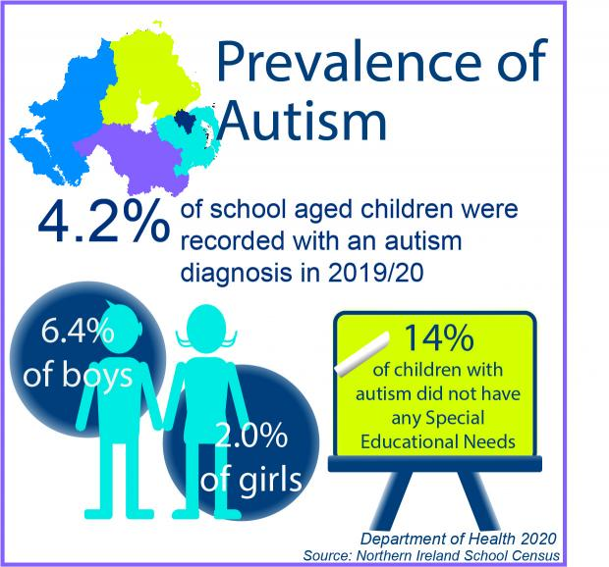

Data on the percentage of autistic children and adults worldwide and in the United Kingdom is that there are 6.2 percent of school children that was recorded with autism from 2019 to 2020. 6.4 percent of boys were diagnosed with autism and 2.0 percent of girls that are diagnosed with autism however research shows that children that have been diagnosed with autism have proven not to have any special educational needs (Department of Health, 2020).

4.4 Causes (Aetiology)
There hasn’t been a specific cause of autism, there has been a few professionals that believe autism is caused by genetic factors and evidence that suggests information however, research has been conducted to find the right cause of autism. There has been an investigation to figure out which jeans are connected, and which are not, to their understanding and scientific research found out that there are a lot of genes connected to forming autism instead of one gene. Autism is not caused by emotional deprivation or the way a person has been brought up as some individuals believe.

4.5 Signs and symptoms
Children with autism exhibit signs and symptoms such as lack of eye contact, poor sensory responsiveness, inability to respond to their name, repetitive behaviors, or movements such as flapping and repeating the same terms. They also have few interactions with other youngsters and exhibit few emotional responses such as smiling.
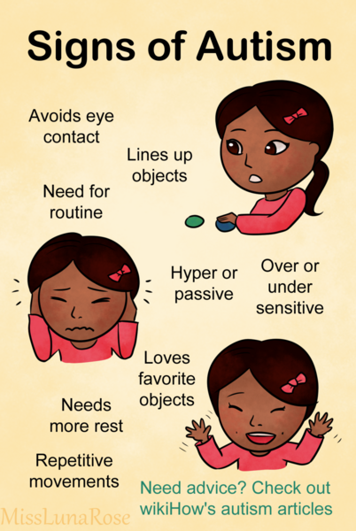

4.6 Diagnosis
When an adult or child is experiencing signs of autism the next step to take to be diagnosed accordingly would be to book an appointment to speak to their GP and children aged 5 and under should be seen by a health visitor. If a child is seen by another health professional such as a doctor or a therapist, special educational needs also known as (SENCO) it would be good to ask for a referral for an autism assessment this is done by a professional that only deals with children showing signs of autism. An autism assessment is performed by an organization of autism specialists to determine whether you or a child is autistic. The examination staff can inquire regarding any issues that you or your child are experiencing, observe how you or your infant engages with others, and communicate with people who are familiar with you or your child, such as relatives, friends, your doctor, or your child's teachers. You might face multiple appointments with a team consisting of various professionals during an autism assessment so that your diagnosis is credible and correct.
When a child is being assessed they will ask the parents about the child’s development such as when the child started talking, they will assess the way the parent will interact for example how their child plays. This information will be recorded and sent by their GP practice or the nursery or school in which the child attends. After receiving the report, a member of the professional team may choose to visit the child in their school so they can assess them during school hours to see how they are intact with other children and adults around them. When the assessment is over the parent will then be reported the outcome indicating if the child is autistic or not. Diagnostic measures include The Autism Diagnostic Interview-Revised (ADI-R).
Adults with autism exhibit difficulties in understanding and interpreting social cues, difficulties in understanding the emotions of others, preferring to be alone, challenges in expressing emotions, information may be perceived literally, and rigidity in routine.
https://www.nhs.uk/conditions/autism/getting-diagnosed/how-to-get-diagnosed/

4.7 Current treatments
There is no cure for autism spectrum condition and no one-size-fits-all treatment. Therapy aims to improve the capacity of your kid to function by minimizing symptoms of autism spectrum disorder and promoting growth and intellect. Intervention at an early age within your child's early childhood years to assist children to gain important social, linguistic, effective, and behavioral skills.
Treatments involve behavioral therapies that attempt to change certain behavior and assist patients in developing abilities. This method typically employs traditional behavior tactics for example rewarding good or acceptable behaviors while ignoring or discouraging incorrect or unacceptable behaviors. Occupational therapy focuses on the adaptive abilities required for everyday routines (ADLs).
Sensory therapy: a variety of sensory treatments have been created to assist with sensory challenges. Speech therapy is used to help pre-schoolers develop their comprehension as well as their language. Physiotherapy: to aid in the improvement of physical and cognitive abilities. Animal therapy, art therapy, music therapy, and relaxation therapies are examples of complementary and alternative treatments for individuals experiencing ASD. Antipsychotic drugs for repetitive behavior patterns/aggressiveness serotonin reuptake inhibitors (SSRIs) stimulants, and other antipsychotics for troublesome behaviors (including aggression) may be used to treat ASD symptoms.

4.8 Recommendations for improvement of AUTISM
Seeks to promote the individual's autonomy, active participation in care decisions, and self-management whenever possible, take care of the continuity of individual relationships making sure that full information regarding the nature of their challenges, as well as solutions and assistance supporting them, can be accessed within a suitable dialect or format (such as numerous visual, verbal, and aural, clear read, and color and print styles). Analyse if the individual would benefit from considering having access to a professionally qualified advocate. Most importantly many studies have demonstrated the effectiveness of complementary therapies, such as yoga, within behavioral treatment among kids with autism.

4.9 Guidance and principle of care - NICE
The general principles of care for children with autism are to guarantee that every single person is autistic especially children and young people, no matter their intellectual capacity or other coinciding diagnosis, have full access to health and social care services, including mental health services. A local autism multi-agency strategy group (for autistic people of all ages) should coordinate the overall configuration and development of local services (including health, mental health, learning disability, education, and social care services) for autistic children and young people, by the NICE guidelines on autism in children and young people (covering identification and diagnosis) and autism in adults.

4.10 Conclusion
Person-centered means focusing on the requirements of each individual going through a mental disorder. Making clinical judgments based on the preferences of the patient’s needs, and values, and providing treatment that is respectful of and sensitive to them. Individuals and members of the workforce must collaborate to achieve health and well-being outcomes, with evidence indicating that this improves patient experiences while costing health and care systems less.
The following provisions of the Equality Act went into effect on October 1, 2010: the fundamental protection framework regarding both direct and indirect discrimination, harassment, and victimization within services and government operations, premi, job, schooling, organizations, and transportation removing the need for medical supervision from the notion of gender reassignment, offering protection to those who are subjected to discrimination because they are thought to have, or are linked with, a protected feature more clear protection for breastfeeding moms by using a uniform definition of indirect discrimination to all protected features and harmonising clauses that allow for voluntary positive action.

5 References

Autism (2023). The causes of autism were undefined. Available at: https://www.autism.org.uk/advice-and-guidance/what-is-autism/the-causes-of-autism (Accessed: 02 May 2023).

Correll, C.U. et al. (2022). Systematic literature review of schizophrenia clinical practice guidelines on acute and maintenance management with antipsychotics, Nature News. Available at: https://www.nature.com/articles/s41537-021-00192-x (Accessed: 02 May 2023).

Edwards, R. (2022) What are the early signs of schizophrenia? Verywell Health. Available at: https://www.verywellhealth.com/early-signs-schizophrenia-5101519 (Accessed: 02 May 2023).

NHS (2021) Anxiety and panic attacks. Available at: Anxiety and panic attacks - NHS (www.nhs.uk) (Accessed: 05 November 2021).

NHS Choices (2013). Personal Centered Care Plan. Available at: https://www.hee.nhs.uk/our-work/person-centred-care (Accessed: 02 May 2023).

NHS choices (2023). Mental health conditions, general anxiety disorder diagnosis. Available at: https://www.nhs.uk/mental-health/conditions/generalised-anxiety-disorder/diagnosis (Accessed: 02 May 2023).

NHS choices (2023). Autism condition. Available at: https://www.nhs.uk/conditions/autism/what-is-autism/ (Accessed: 02 May 2023).

NHS choices (2023). Mental health schizophrenia and diagnosis Available at: https://www.nhs.uk/mental-health/conditions/schizophrenia/diagnosis (Accessed: 02 May 2023).

NICE (2023). Recommendations autism spectrum disorder in adults: Diagnosis and management: Guidance Available at: https://www.nice.org.uk/guidance/cg142/chapter/Recommendations (Accessed: 02 May 2023).

NICE (2023). Recommendations: Generalised anxiety disorder and panic disorder in adults: Management: Guidance Available at: https://www.nice.org.uk/guidance/cg113/chapter/Recommendations#principles-of-care-for-people-with-generalised-anxiety-disorder-gad
(Accessed: 02 May 2023).

NICE (2023). Recommendations: Generalised anxiety disorder and panic disorder in adults: Management: Guidance. Available at: https://www.nice.org.uk/guidance/cg113/chapter/Recommendations#principles-of-care-for-people-with-generalised-anxiety-disorder-gad (Accessed: 02 May 2023).

NICE (2023). Recommendations: Rehabilitation for adults with complex psychosis: Guidance Available at: https://www.nice.org.uk/guidance/NG181/chapter/Recommendations#overarching-principles-of-rehabilitation (Accessed: 02 May 2023).

Mind (2023). Information on Anxiety and panic attacks. Available at: https://www.mind.org.uk/information-support/types-of-mental-health-problems/anxiety-and-panic-attacks/about-anxiety/ (Accessed: 02 May 2023).

Mayo Clinic (2020). Schizophrenia Available at: https://www.mayoclinic.org/diseases-conditions/schizophrenia/diagnosis-treatment. (Accessed: 02 May 2023).

Mind (2023). What is a panic attack? Available at: https://www.mind.org.uk/information-support/types-of-mental-health-problems/anxiety-and-panic-attacks/panic-attacks/ (Accessed: 02 May 2023).

World Health Organisation, WHO (2010) ICD-10 VERSION. Available at: https://icd.who.int/browse10/2010/en#/F30-F39 (Accessed: 16 December 2021).

Appendix A: Generalised Anxiety Disorder Questionnaire GAD –7.

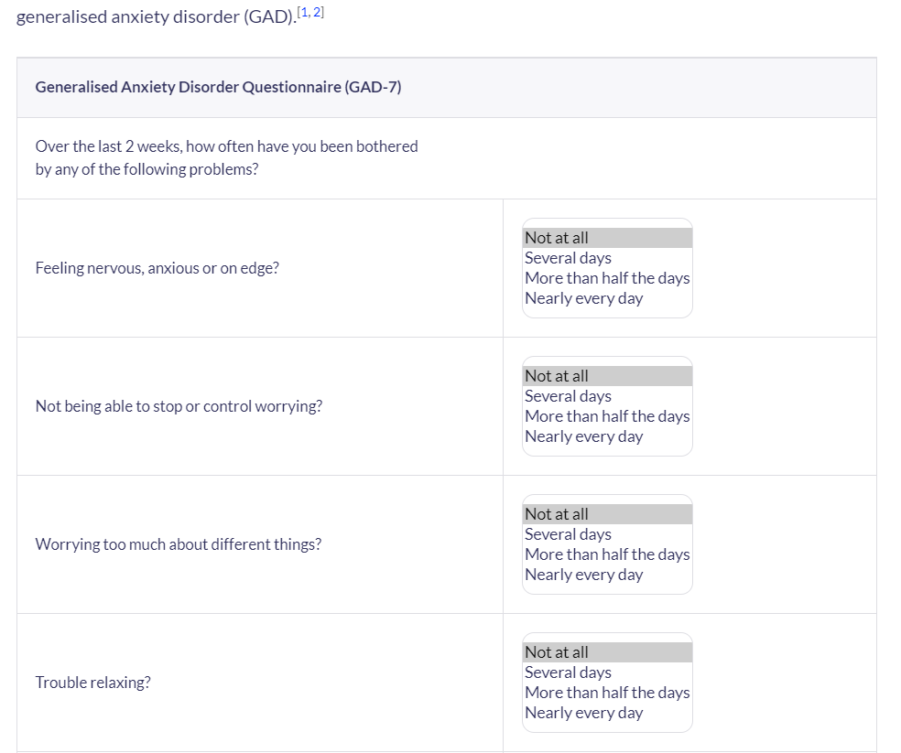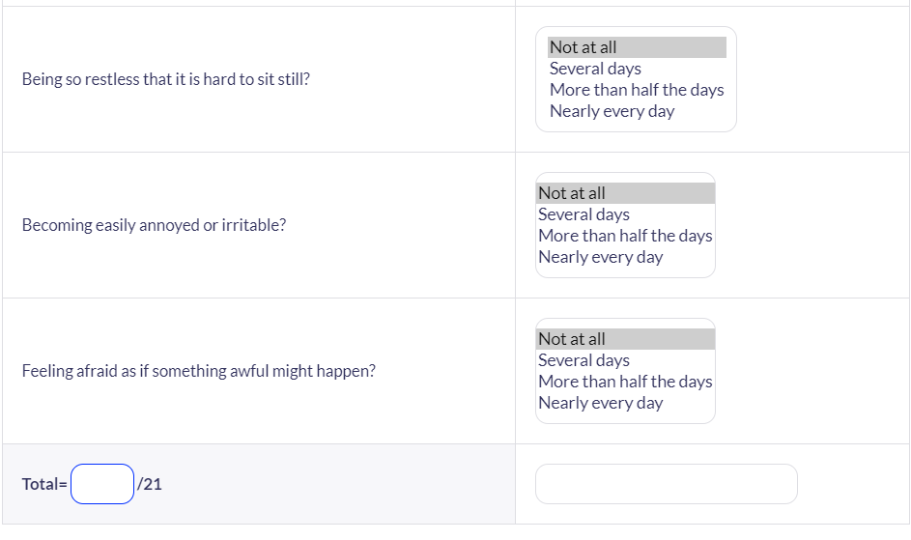

Appendix B: Indicators for rehabilitative care:

‘Quality Indicator for Rehabilitative Care (QuIRC-SA)’
The indicators to be considered are these:
‘Living Environment’,
‘Therapeutic Environment’,
Treatments and Interventions,
Self-Management and Autonomy,
Social Interface,
Human Rights
Recovery Based Practice.

