FUNDAMENTALS OF CONSTRUCTION TECHNOLOGY
REVIEW 5

- You need to build a pitched roof to cover a span of 7m. The perimeter is built with load-bearing brick walls. Design your solution without the need to use a king-post truss. Define all elements of the structure frame, the cover and the connection with the walls. You should design a warm roof.
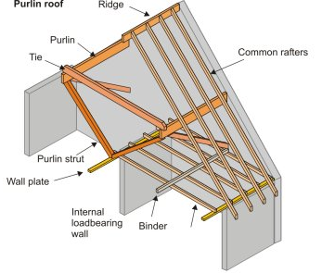
For the assignment, it is very important to consider that you need to leave a habitable empty space on the roof (a loft). For this reason, you will need to use queen-post trusses. Here there is a detail attached with a king-post truss.
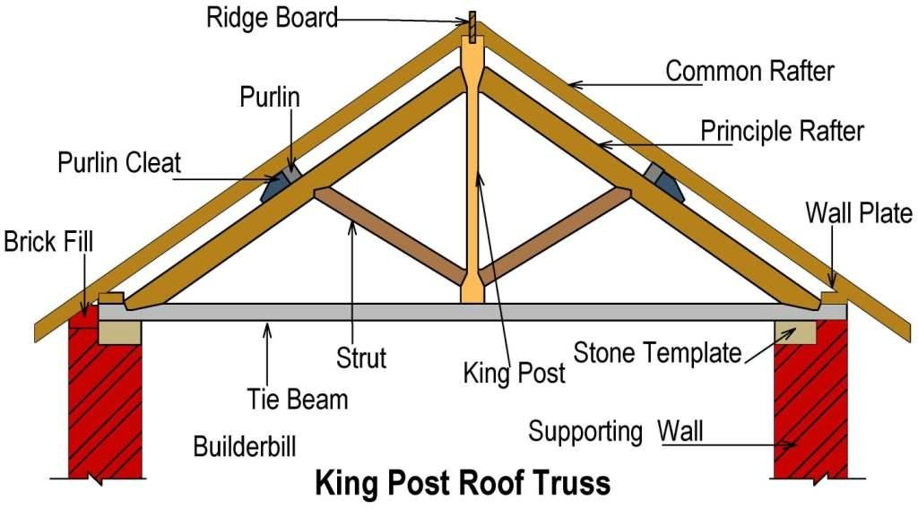
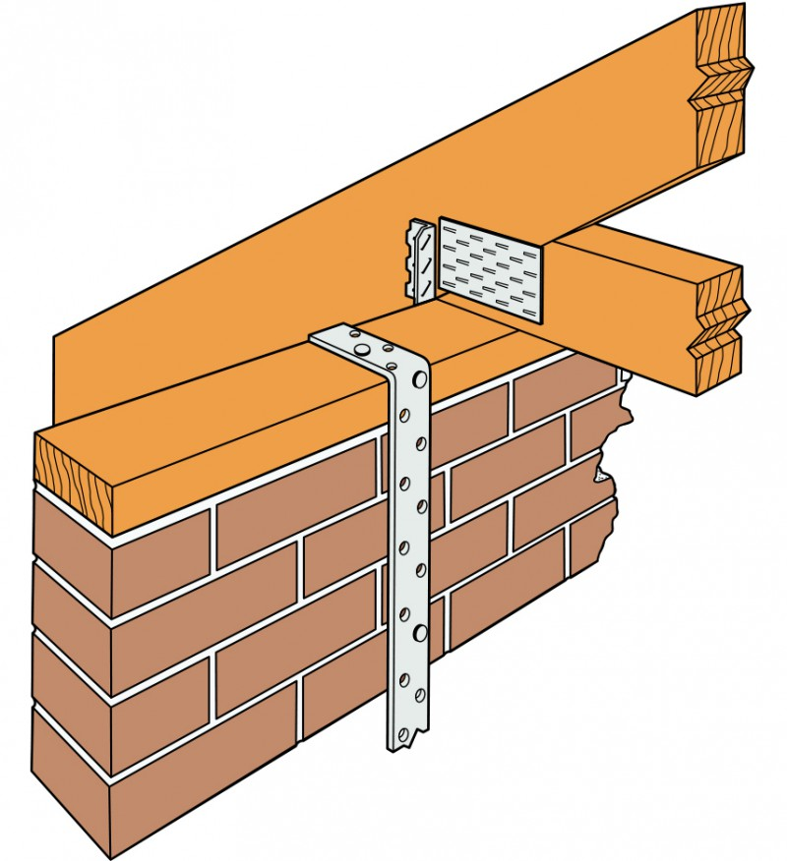
Wall plate
Restrain strap
Rafter (or truss supported by wall plate)

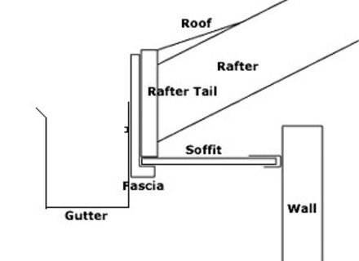

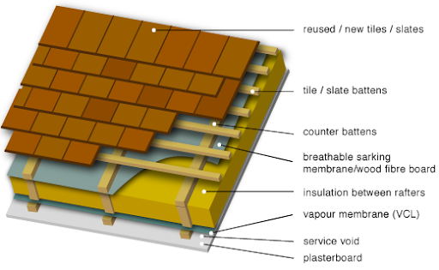

BE CAREFUL! THIS IS NOT A WARM ROOF. Insulation should be on top of the rafters, not between.

- Define the details of a suspended timber floor and a level floor for this building.



