Workplace Culture and Efficiency

Parvez Ahmed 1708935
Lecturer: Eric Osei

Executive summary

The purpose of this piece of writing is to look at a UK based fast food and restaurant organisation, in relation to the external and internal factors of this organisation. The reason for looking at such factors is to ensure that the chosen organisation has a good and positive workplace culture. Workplace culture or environment contributes drastically to the functioning and operation of the chosen business. The results which will be delivered in this writing is from the chosen company called Dixy Chicken, a popular takeaway, with the company establishing its name in several areas throughout Birmingham. There are several bases named after Dixy chicken, but the organisation will be analysed collectively. Dixy chicken has been available to the public since its establishment in 1986. It is one of the fastest growing chicken takeaway/restaurant in Europe, with currently over 100 stores scattered across the UK and stores in countries such as Pakistan, Brunei, UAE and India. The high rate of attraction of a number of customers is due to the provision of Halal chicken.

Contents
Introduction 3
External analysis of Dixy Chicken 4
What is PESTLE analysis? 4
PESTLE analysis of Dixy 4
Porter five forces: 6
What are Porters five forces? 6
Internal analysis of Dixy Chicken 7
McKinsey 7S 7
What is McKinsey 7S? 7
Source: (van Kleef, van Trijp and Luning, 2006). 8
McKinsey 7S of Dixy Chicken 8
Comparison between Dixy and Big John’s 11
Recommendations 11
Conclusion 12
References 12

Introduction

The chosen business called Dixy chicken; a popular take away site in Birmingham will be assessed and focused on, especially on the workplace culture this organisation promotes. By gaining a further understanding on the workplace culture of this business, understanding the implications this has on the efficiency of operations and functions in the organisation is valuable for the development of this organisation. By conducting the various assessments where the workplace culture of this company will be looked at, making judgments on what further actions would be required for the benefit of the organisation will be possible. For Dixy Chicken to have a good workplace environment and culture, placing importance on certain aspects in the performance of a member of the organisation is needed for example high levels of team working skills, high alignment of organisational goals, higher level of productivity est.

External analysis of Dixy Chicken

What is PESTLE analysis?

Pestle is a framework which is used to identify the external factors which impacts the organisation under analysis (Academy, 2019). This is an excellent way for excellent management strategies to be developed in a business. The framework is divided into six macro factors which will be briefly described: The political factors involve the role in which government contribute in a particular industries industry. The economic factors are on basis of things which affect the economical position of a certain organisation. The social factors consist of things in the environment which include the customers of a population and the norms of the community which a company is surrounded by. The technological factors display the potential or current technology used in a business. The environmental factors involve the environmental aspects and the actions performed by a company which affects the environment. Finally the last factor is legal factors and these include specific laws which a company needs to abide to.

PESTLE analysis of Dixy
Political:
The food industry including organisations such as Dixy Chicken, see that on public health articles and policies, the wider public and health cares are assuring individuals to eat healthier (Janet, 2013). Therefore Dixy has been more concerned about providing products which have lower sugar intakes and lower sodium. Some new products have been introduced for this although it is very little compared to the other items on the menu. The current policies which have been introduced have been making citizens much more aware of buying healthy foods.
Economical:
Due to many people being unemployed and financially unstable, this has affected the food industry. For people to purchase healthier options, it is slightly more expensive compared to purchasing food which is ready made in fast food restaurants. This means that more people find purchasing from ready-made food places more convenient. Therefore this allows fast food restaurants such as Dixy to expand its business further.
Sociological:
The trends which fast food organisations are affected by are not only just related the government but the expectations of consumers as well (Baraniuk, 2017). From analysis made, it can be suggested in most places, healthiness is the focus and deepest concern. For this reason it has been identified that there has been a change in the lifestyle people adopt such as becoming a vegetarian or vegan. Therefore companies like Dixy are evolving their menu in order to suit the needs of such consumers or else such customers will be lost. However Dixy is still far behind in offering a wide range of products to suit the needs of such people.
Technological:
The food labels, production of food, packaging which is created using technology provide organisations like Dixy with a competitive advantage. Many companies are installing big screens for their customers to see. Here information of offers and promotional drinks are provided. Dixy should implement the use of this type of technology. With technology advancing, Dixy is able to have their takeaway ordered and delivered to the customer’s home.
Legal:
This is slightly referred to in the political section of PESTLE; however in the eyes of the law, the food industry must have really high standards for safety purposes. Here are certain rules in every country including the UK, which focuses on how food is stored, prepared and transported. This can be included in the legal section because if any of the rules and regulations are breached then there can be issues (Booth and Melling, 2017). Therefore companies like Dixy, has to make sure and be very careful when preparing and cleaning the food because if food is not handled within the legal bounds then the company could face lawsuits.
Environment:
Towards some particular foods eaten there are some environmental repercussions. This type of food is meat and this is an issue because a few of the food items provided by Dixy are meat based. The reason for this is because red meat uses a lot of water and carbon footprint. Also for the space to be created for farms, large amount of forests are being cut down. For this reason a lot of people are moving on to plant based diets.

Porter five forces:

What are Porters five forces?
The framework of the Porters five force, acts as tool for a company to assess its competition (Garber, 2010). The five forces drive out information regarding the intensity of a company’s competition. It also shows how a company is highly likely to attract profitability.
Porter’s five forces analysis of Dixy
Competitive rivalry or competition (High level)
This force involves the intensity of the competition which the company suffers from. The companies which Dixy competes with is Peri Peri, Big Johns and Subway, however the names of the companies which Dixy competes with can differ depending on the area which the business is based in. However in areas where Dixy is based in and for example McDonalds, is there and this also makes the level of competition extremely high.
Bargaining power of buyers (Moderate level)
The buyers can affect the prices in an organization. Customers have the opportunity to purchase their food elsewhere if necessary when local takeaways and small businesses which are located in the neighboring area of Dixy. Such stores have larger portion of food available for a much cheaper cost, however the standard of food can arguably be questioned. However when comparing the quality of Dixy food it can be noted that their food quality is very high, but some customers prefer to go to the more branded companies such as McDonald’s.

Bargaining power of suppliers (weak level)
The bargaining power of suppliers identifies what level of powers suppliers have on the organization. The suppliers whom provide their products to Dixy also provide and deliver the products with other firms, but Dixy have several suppliers involved in the business. If Dixy does not purchase from a particular supplier, there are plenty of other organizations whom are willing to sell their products to Dixy and because Dixy does not take bulk purchases of several items from one supplier, but different suppliers the bargaining powers is low. .

Threat of substitutes (High level)
Substitutes are alternative options which customers have where they receive the same product and services. Customers can very easily transfer from Dixy to any other substitute such as Big John’s. There are plenty of other places where a customer can go in order to eat food at an even higher quality in a better environment. Most of the substitutes which Dixy has have good taste offers and prices. This therefore shows that the fact that Dixy can easily be substituted, it means that Dixy is at a very high risk.

Threats of new entrants (Moderate level)
According to O'Connor, (2008) if there was a new entrant in the industry would not be much of an issue, because Dixy benefits from many profit and money which other organizations and firms cannot make. However the cost of establishing and starting as business in this industry is an overwhelming amount of money.

Internal analysis of Dixy Chicken

McKinsey 7S

What is McKinsey 7S?
This framework was a management model developed by business individuals. The 7S stand for the strategy, system, style, skill, shared values, structure and staff the chosen company is comprised of (Demir and Kocaoglu, 2019).
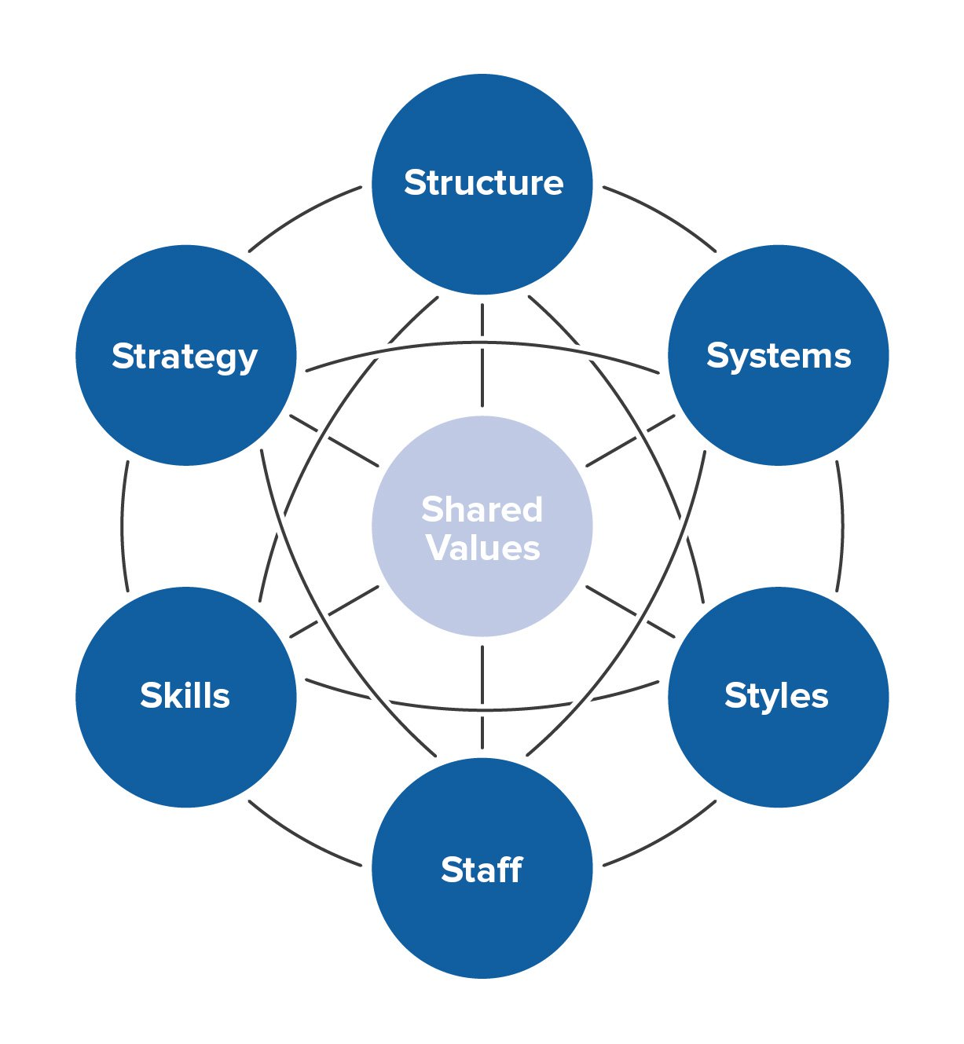

Source: (van Kleef, van Trijp and Luning, 2006).

McKinsey 7S of Dixy Chicken
Strategy:
The strategy which Dixy implements is to make sure that the food that they offer their customers is of high quality and high standard so that the regular customer are satisfied and continuously visit the organisation by becoming regular customers. Also by doing so more customers become attracted to come to the takeaway restaurant because of the positive reviews they receive. There are certain times during the year where Dixy Chicken provides great offers where several items are sold at a lower price, or items are sold as bundles are low prices. Such days consist of Mothers Day and the Islamic religious day called Eid. By doing so, the company receives large amount of customers on such days and this provides the business with lots of profits and more customers. Many offers on these days have been extremely successful. However such strategies have been proven to become much harder to implement because of the increase number of similar fast food restaurants being established in the surrounding area (Cadle, Paul and Yeates, 2014).
Structure:
The structure of this company follows the format of the hierarchy, which means that each member of the organisation is part of a certain level. Also in accordance to what the managers say and decide on, only then can any action be taken forward. Any suggestions have to be taken to the manager and only based upon his best of knowledge he will decide to implement changes or not. This has proven to be a highly inflexible structure for the workforce as they cannot directly speak to their manager regarding their concerns. Compared to a flat structure, the hierarchy structure means that the communication which takes place between different departments and levels of the business is less effective. By having this division within the business, there is an increased rivalry between workers to have decisions made by the manager which suits their department and benefits their own interests. Due to the divisions which the restaurant is consisted of, it means that higher level job roles have a higher salary compared to other workers and this therefore contributes in increasing the organisations costs (Ubereats.com, 2019).
System:
The system which is used in the business is very strict on making sure that the correct and qualified employees should be in the right place in order to allow the company to function adequately (Dixychicken.com, 2019). However in relation to the communication system put in place in Dixy, it is very weak, and this is mainly due to the organisational structure which has been put into place. Also in relation to product development system, Dixy is failing to offer customers with alternative and unique products which other businesses are not offering. However by doing so the company would stand out in the restaurant fast food industry. By doing regular market analysis and creating new and outstanding tastes which appeal to the liking of the customers. Therefore needs to work on their product development system.
Shared values:
The workers of Dixy’s are from all kinds of cultures and backgrounds. For this reason employees are encouraged to share their values as well as respect each individual’s values. Also through training the employees are made aware of the organisational value, so that their values can be aligned with their personal values. This ensures high level of productivity and performance.
Style:
The business style in which the company operates in is not too strict but rather friendly and lenient. This would enable the workers to work really hard. The schedule for the employees are flexible on basis of the requirements of the employees however not every employee can have their requirements fulfilled because it goes beyond the limits of the manager. However due to the system of hierarchy, the manager is unable to fulfil the needs of the staff by having an effective communication system.
Staff:
The staffs of the company are the workers whom allow the business to function (Business environment, 2009). The staffs are treated with high level of respect and are ensured to have the employee rights they deserve.
Skills:
The skills which the staffs have are usually subject to the roles that they perform, however general skills are required such as teamwork skills, communication skills, leadership skills etc (Ravanfar, 2015).
Type of culture of Dixy Chicken
With the use of the Deal and Kennedy’s model, the out of the four defined cultures Dixy is mostly comparable with the Work Hard/ Play hard culture type. The reason for this is because this type of culture recognises that an organisation is not only reliant on one individual for all the success, but rather every single individual in the organisation as with the efforts the position of a company can be attained. With the presentation of team effort and the communication between workers is tasks successful to be performed. Nonetheless, Dixy does not represent the ideal organisation for this culture, such as not every individual works in the organisation with high level of energy. However it can be said that Dixy places certain individuals in the business as role models for new recruits and the ideal employee the company is searching for (Tang, 2014).
Ethical Elements of Dixy Chicken
There are several ethical actions performed by Dixy chicken, though some could be criticised by certain types of people. The managers consider that they way that they treat their employees are fair and the resources they are provided are within the capacity of the business. However it could be mentioned that the communication system used is not helpful for the workers. Furthermore, the animals which are killed for the meat and chicken provided for the food are done so in an ethical manner, from a far where the animals are not locked up but living in their natural environment. This displays animal welfare and the method used to kill the animal is the most ethical way possible. Finally there are several complaints regarding the ethical choices involved in the products and materials used in the organisation. Dixy is progressively decreasing their uptake of plastic base materials as well as other harmful items, and are providing recycles cardboards boxes, paper bags and paper cups are offered.

Comparison between Dixy and Big John’s

The type of culture Big John has is also Work Hard/Play Hard, but there are still some differences in their corporate culture. Using the tool of Deal and Kennedy’s the organisational position is in will be included. The creators of this tool incorporated six elements on which corporate culture is developed from. The history of Dixy starts from 1986, whereas the history of Big Johns started from. The values and beliefs of Dixy consist of providing the best and freshest chicken to its customers. They value their source from which their get their chicken from which are animal welfare farms, and they believe that this contributes greatly to the wonderful taste of the chicken. Big John places high value in the customer service they provide with their comfortable interior design and the satisfaction of customers. Dixy Chicken is widely known for the weekly ritual the company is engaged in on Fridays, during Lunch period where there employees are given food and drinks to enjoy and have some social time with employees for about 30 – 40 minutes. Big John has a ritual which happens every day before the workers begin to work where they are offered tea, coffee and biscuits before they start their long shift. Most of the information obtained about both of this organisation is through the story tellers whom provide information about what working in Dixy or Big Johns in really like (Business environment, 2009).

Recommendations

There are few recommendations of things which Dixy Chicken could do to improve their corporate culture:
- A lot of the firms of Dixy needs to be adjusted with drive thrus
- The company needs to improve its marketing technique in order to become much more popular amongst the wider public of the UK
- Should offer much more healthy options in the menus in order to suit the needs of customers whom only eat healthy
- Cut down on using products which affect the environment as much as possible e.g. fizzy drink cans

Conclusion
To conclude, this internal and external analysis of Dixy has shown how the company is making profits and factors which is limiting the company to expand further and become highly recognized. The suggested recommendations are based upon the knowledge derived from both the internal and external analysis information and therefore should be very useful if adhered too and practised. From the use of the Deal and Kennedys method identifying Dixy Chicken as a Work hard/play hard culture type, as most of the actions and behaviours involved in this business best fit the description of this type of culture. Although Big John has been identified to have the same culture type, this is only due to the limitations of the cultural types to choose from and Big John only fit in to that type. However both companies have several differences. Dixy does practise actions which are ethical but for a proportion of people this may not be considered as ethical. The corporate culture of Dixy needs to improve, and this can be done so by the recommendations provided. By creating a positive culture, the organisation will thrive in an environment which is suitable and advantageous to everyone.

References

- Academy, P. (2019). Marketing Theories - PESTEL Analysis. [online] Professionalacademy.com. Available at: https://www.professionalacademy.com/blogs-and-advice/marketing-theories---pestel-analysis [Accessed 10 Oct. 2019].
- Baraniuk, K. (2017). ANALYSIS AND STRUCTURING OF EXTERNAL AND INTERNAL FACTORS OF INFLUENCE ON COMPETITIVENESS OF ENTERPRISE. Food Industry Economics, 9(1).
- Booth, A. and Melling, J. (2017). Managing the Modern Workplace. Florence: Taylor and Francis.
- Business environment. (2009). Amsterdam: Elsevier/Pergamon Flexible Learning.
- Cadle, J., Paul, D. and Yeates, D. (2014). Business analysis. Swindon, U.K: BCS.
- Demir, E. and Kocaoglu, B. (2019). The use of McKinsey s 7S framework as a strategic planning and economic assestment tool in the process of digital transformation. Pressacademia, 9(9).
- Dixychicken.com. (2019). Dixy Chicken - About Dixy. [online] Available at: http://www.dixychicken.com/about.html [Accessed 10 Oct. 2019].
- Garber, P. (2010). Conducting Workplace Investigations. Amherst: HRD Press.
- Harvard business review on green business strategy. (2007). Boston: Harvard Business School Pub.
- Janet, T. (2013). The PESTEL Environment and Its Impact on the Value Created. INTERNATIONAL JOURNAL OF MANAGEMENT & INFORMATION TECHNOLOGY, 6(2), pp.805-816.
- Meiners, R., Ringleb, A. and Edwards, F. (2018). Legal environment of business. Boston, MA, USA: Cengage Learning.
- O'Connor, S. (2008). Change management in academic libraries. [Bradford, England]: Emerald.
- Prum, D. (2014). Amenities, Amenities, Amenities? How Policymakers Can SWOT Their Way to Better Entrepreneurial Facility Options. SSRN Electronic Journal.
- Ravanfar, M. (2015). Analyzing Organizational Structure based on 7s model of McKinsey. International Journal of Academic Research in Business and Social Sciences, 5(5).
- Tang, Z. (2014). A SWOT Analysis of Development Strategies for Film Tourism. Advance Journal of Food Science and Technology, 6(2), pp.198-205.
- Ubereats.com. (2019). Dixy Chicken (Dudley Road) Delivery | Birmingham | Uber Eats. [online] Available at: https://www.ubereats.com/en-GB/birmingham/food-delivery/dixy-chicken-dudley-road/fZR4ly16S0W9uVtCRXvljA/ [Accessed 10 Oct. 2019].
- van Kleef, E., van Trijp, H. and Luning, P. (2006). Internal versus external preference analysis: An exploratory study on end-user evaluation. Food Quality and Preference, 17(5), pp.387-399.

