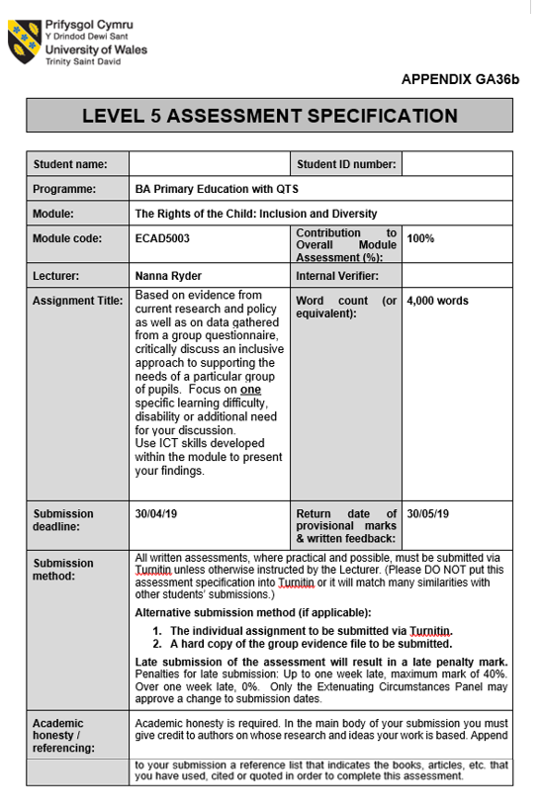
Based on evidence from current research and policy as well as on data gathered from a group questionnaire, critically discuss an inclusive approach to supporting the needs of a particular group of pupils. Focus on one specific learning difficulty, disability or additional need for your discussion. Use ICT skills developed within the module to present your findings.

Introduction
This essay will critically discuss an inclusive approach to supporting the needs of children in poverty. It will take into account current research and policy, as well as data gathered from a group questionnaire; this will be presented in a relevant format for analysis. The essay will use this information to discuss the current support available while also considering barriers to achievement for pupils from impoverished backgrounds. There will also be suggestions for further improvements, to reduce the impact of this wide-ranging issue.

Inclusion of pupils involves much more than the placement of a child or young person in a mainstream or a special school. It requires an inclusive curriculum and measures to improve the awareness of teaching and other staff of inclusive learning and equality issues (Welsh Gov, 2006, p. 19).

It is imperative that we include and support all learners in order to provide an environment conductive to learning. Using Maslow’s hierarchy of needs, we know that humans need psychological security, safety and social belonging in order to achieve self-esteem, only then are they able to fulfil their full potential (Maslow and Town, 2013). The closer they get to this, the higher level of behavioural motivation there will be with an individual. Unfortunately, poverty has a lasting impact on many areas of a child’s life and can limit the chances of them reaching their potential. There is a lot of support and research into providing early intervention and inclusive practice (DFES, 2004); while awareness and skills of staff is at a certain level, there is always more that can be done to improve this.

As with many aspects in teaching, practitioners cannot rest on their laurels when it comes to providing quality support for pupils, there is a need to be aware of the current support and challenges; to be prepared to identify areas that are not working, and try to improve these. Teachers should strive to provide an inclusive approach to all learners they encounter, regardless of any Additional Learning Need (ALN). ALN is a relatively new name to replace the term Special Educational Needs (SEN); this change is due to the Educational Tribunal Act, passed in January 2018 and due to be implemented in September 2020. Guidance follows this in the form of the ALN Code of Practice, which is currently in draft form, subject to minor changes (Snap Cymru, 2019). As these reforms are ongoing, most literature still refers to SEN as follows: ‘children and young people with learning, physical or sensory needs that make it harder to learn than most children of the same age’ (Dewis Cymru, 2019). Although the term is changing to ALN, ‘the definition which the Act uses for ALN is materially the same as the current legal definition of SEN’ (Welsh Gov, 2018, p. 8). When discussing learning needs, we should always put the child before their ability. For example, we should say ‘the child with ADHD’ as opposed to ‘the ADHD child’. As with many things that are improving in our world, a positive change often comes about from the language we use to describe it. As with many aspects of teaching, the child should always come first. Through the language we use, the child can feel more included and this fosters a sense of inclusion in the child; naturally building a confidence in them.

A good indicator that a child comes from poverty is their eligibility for free school meals (FSM) (Welsh Gov, 2016). FSM have been available to those from the poorest households for over one hundred years, however it was only after the 1980 Education Act that it was local authority’s legislative duty for all children ‘whose parents were in receipt of State supplementary benefit or income support’ to provide FSM (Taylor, 2017, p. 31). When looking into statistics about poverty it is also important to consider the various forms of poverty. In doing so, we as practitioners can have a better understanding of the potential pupil impact, and prepare changes to lessen the impact. According to the Joseph Rowntree Foundation (JRF) (2019) there are three levels of poverty (Appendix 1); Jensen (2009) breaks this down further, stating that generally, there are six notable forms of poverty:
- Situational poverty usually a temporary change in situation caused by a change in situation or crisis. Situational poverty can be caused by severe health problems or divorce of parents.
- Generational poverty occurs when at least two generations of family were born into poverty. This can lead on from situational poverty where the family has failed to recover. Often those involved feel hopeless as see no way out.
- Absolute poverty involves a lack of necessaries such as shelter, fresh water, and food. Individuals in this type of poverty often have an emphasis on day-to-day survival.
- Relative poverty refers to families who are unable to meet their society’s average standard of living due to their economic status.
- Urban poverty occurs in areas with a population of at least 50,000 people. Families here have to deal with a complicated mix of chronic and acute stressors (including overcrowding, noise and violence).
- Rural poverty occurs in areas with a population below 50,000. They may experience a lack of job opportunities, transport links, support for disabilities and quality education.

Figure 1.

Figure 1 gave respondents the chance to select one or more answers. Most respondents felt that relative poverty was the most prevalent form effecting the pupils in their class; meaning that the children’s families may be unable to meet the average standard of living. Often following on from generational poverty, which was the second highest answer, showing that the poverty would affect not only the parents and children, but the grandparents also. This can lead to families surviving day-to-day, rather than saving and planning for their futures. As Jensen (2009, p. 45) states, “a childhood spent in poverty often sets the stage for a lifetime of setbacks.” This relates to not only financial, but also emotional and educational setbacks if the child is not supported at home.

Figure 2.

Low socioeconomic status can lead to negative health outcomes, with language development more likely to be negatively affected (Perkins, Finegood and Swain, 2013). This research is supported by the data collected and shown in Figure 2. Where the majority of respondents felt that ‘Languages, Literacy and Communication’ was the one Area of Learning and Experience that was most affected by children who receive FSM. A relatively straightforward way to improve achievement and reduce behavioural difficulties is to have frequent and prolonged family meals (Khan, 2012). When families sit down to talk – families exchange ideas and show an interest in each other – children absorb values, motivation and self-esteem; in short, they will grow into learners that are enthusiastic and attentive; something close to Donaldson’s aim of having ‘ambitious, capable learners’ (2015).

The causes of poverty are wide-ranging and not restricted to; unemployment and low-paid jobs, low levels of skill or education, ineffective benefit systems, high costs of living, discrimination (prevents people gaining good qualifications and restricts access to services), weak relationships (leading to impact on education, social and emotional skills) and abuse, trauma and chaotic lives (JRF, 2019). Following this are the consequences of poverty, such as health and housing problems, perpetrating crimes and drug or alcohol problems. Additionally, there may be family problems, leading to divorce, the rate of which is much higher now than at any time in the past (Frederickson and Cline, 2011). Unfortunately, these consequences can turn into causes and thus develops a circle of poverty that families can struggle to get out of.

As we can see, the potential for poverty and the wide-ranging impact it has, will influence many children in Welsh schools, indeed “there were 4.1 million children living in poverty in the UK in 2016-17. That is 30 per cent of children, or 9 in a classroom of 30” (CPAG, 2019). That is a very alarming statistic and the reason schools and practitioners need to focus on inclusion for these pupils. The responsibility to reduce poverty rates falls on many shoulders, including the government and wider-communities; however, the impact poverty has can often fall on teachers and the school, the first point of contact for many children.

Main Body

The task of researching poverty and devising a questionnaire to investigate further was completed as a group exercise. This was a new and interesting way to approach the research, as previously research had been carried out on an individual basis. Previous experience of working in teams in a more professional role meant that I could enjoy this challenge. Working in a group has benefits as well as negative elements and both elements were experienced during the process. There were some initial group meetings where we all brought ideas and discussed these in depth, debating certain points to reach a conclusion; I left these meetings with a sense of achievement. During other group work exercises, there was not the same level of cohesion and it made for uncomfortable working conditions. These were resolved and I feel we progressed as a team and bonded over these minor failings. At times, I felt I had a good understanding of an element so took the lead; at other times, I took a backseat role, to let other members of the group have a voice. I feel it is important to be pragmatic when working with others and to let all have a say and promote discussion. In this way, all members of a team feel valued and this builds good levels of trust in the group. There were considerable decisions to be made and I was always present for these and tried to give my full input, taking into consideration other’s views.
The research tool of a questionnaire was suggested by university as a good way to collect the data required in a short space of time. There were many factors to consider when devising the questionnaire, such as what the purpose was, what the population and sample would be, what type of data is needed, what type of questions would be asked (Kumar, 2011). Although the participants would be expected to give considered answers, we cannot say the questionnaire would have reliability. In research terms, reliability means that the responses given would be the same or similar every time. Because we allowed participants to provide open answers, the results will not usually be repeatable as individual responses. Conversely, the questionnaire can be seen to be of benefit as it provides qualitative and quantitative data. When sending out emails with links to the questionnaires we sent the emails with a covering script to set out who we were, what our objective was and how the questionnaire would be used. Unfortunately, as Cohen & Manion (2007) point out, one of the downsides to a questionnaire and most forms of data gathering is that it will always be an intrusion into the life of the respondent. This feeling of intrusion by the respondent may manifest itself through a belief that there is an ‘inescapable political dimension’ through our research (Burgess, 1993). Whether directly or indirectly the university could have set us this task in order to gain data for its own purposes.
The main aim of our questionnaire was to develop an understanding of how poverty effects children in education. We worked as a group to research many aspects of poverty, before settling on a more specific area. Through group discussions, we decided that generational poverty, relative and rural poverty were the three most important types that we would encounter in our teaching careers and that we would do best to focus our attention on these. As shown in Figure 1 (page 3) the two areas respondents felt affected children in their classes most were relative and generational poverty, this supported our understanding of poverty in Wales. Respondents felt the third most prevalent type of poverty was urban; this could be down to the locations of the schools who provided feedback. The questionnaire should lead to inductive reasoning, constructing a valid argument by building an understanding of specific instances into a generalized conclusion (Jackson, 2018).
When devising a questionnaire, it is important to try to remain impartial and not to coerce respondents into answering questions in a certain way. As a group, we had discussed the questions and how we would answer these ourselves. This may have been an error as this could lead to less impartiality when devising questions; we may have unconsciously written the questions to lead to a desired outcome. We employed the use of a Likert scale in our questionnaire in order to measure respondent’s attitudes to various aspects of poverty that they would encounter (McLeod, 2008). The data from questions that used a Likert scale would be displayed in a bar chart and summarized by looking at the mode. The questionnaire included some closed questions but the majority were open questions, designed to get participants to consider their responses and provide additional information, which we could not factor in. We also needed to provide respondents with informed consent, so that they know what they are doing and why and how the data will later be used. This leads on to confidentiality and anonymity; something that is not always necessary when using a questionnaire, but something that we provided to our respondents during this study. The university ethics form (2017) was used and helped provide a structured way to ensure that we adhered to the Data Protection Act 2018 (Gov, 2018). As the questionnaires would be sent out to schools and the data would provide statistics on children the group consulted the British Educational Research Association (BERA) guidelines (2018) to ensure the upmost responsibility and transparency and to minimise the risk of any harm arising from undertaking the research. In the nature of the questionnaire, people have the right to withdraw at any time, as the questionnaires were sent via email, people may be less inclined to complete it and more inclined to withdraw, as they would not be dealing face-to-face. A positive of completing the questionnaire online could be that respondents are more inclined to be open and honest in their answers, as long as they feel secure that the answers will be confidential and only used for the purposes intended. I took it upon myself to email the questionnaire to schools from my own email address; I felt the need to get the questionnaire out, in order to receive responses from which to collate information. The group received 15 responses, which was a little lower than expected; we took into account the Easter holiday for schools, which may have influenced the response rate further.

Current research into the statistics of children in poverty highlights some alarming results. As Stats Wales (2019) points out, the percentage of children living in relative income poverty 2015-2016 to 2017-2018 stands at 24%, almost a quarter of all children living in Wales. Although the rates have decreased slightly in the last 24 years, Wales still has one of the highest rates of child poverty in the whole of the UK. Reflected through the current levels of pupils aged 5-15 in Wales eligible for free school meals (FSM) which stands at 64,882. Stats Wales shows that there were 372,440 pupils this age during the same period, meaning the percentage of pupils receiving FSM stood at around 17% in 2017-18 (Stats Wales, 2019). The reasons for the difference in percentages of children in poverty and children receiving FSM are numerous; taking into account children who are home schooled as well as parents who do not want their children to receive FSM as they may feel an embarrassment about this. The questionnaire did not question the percentage of children coming from poverty or receiving FSM only asking for numbers of children. With this in mind, we cannot complete a direct comparison with the Stats Wales data but it can give us a wider understanding of the numbers of pupils involved. Figure 3 shows that 20% of respondents to the questionnaire stated that 1-5 children within their class were receiving FSM with 40% of the responses showing that 6-10 children in their class receive FSM. More alarmingly were the 40% of respondents who stated that 11-15 pupils receive FSM within their class. Average class sizes in primary schools in Wales stand at around 25 pupils (Welsh Gov, 2015); this means that from the responses received our research supports the notion that a high proportion of children are receiving FSM; coming from a background that is in some form of poverty.Figure 3.
Poverty can effect educational attainment through behavioural, emotional and social difficulties (BESD) (Ryder, 2018). BESD was highlighted in feedback received through the questionnaire where it was mentioned as a key indicator of poverty in children in class. As Fredrickson and Cline (2011) state, a child’s behaviour develops through observations of their environment; if behaviour is undesirable then specifics can be identified and the environment that fosters these behaviours can then be adjusted where possible, in order that the child begins to unlearn the negative behaviours. A teacher is always directly responsible for displaying positive behaviour to all children and they should expect and promote the same required behaviours when in contact with a pupil. These professional values in action are supported by Grigg (2015) and Hardy (2018) tying into the Qualified Teacher Status (QTS) standards of S1.4 when they ‘communicate with parents and try to build good behaviour patterns through a mutual understanding of the benefits to the child’. Teachers are also displaying QTS S3.3.1 when they ‘have high expectations and value diversity in order to provide a secure and purposeful learning environment’ (Welsh Gov, 2009). The major barrier to the child experiencing consistent positive behaviour obviously comes when the child goes home; this is something the school cannot control directly. Supporting this practice is Grigg (2015), who notes that good teaching is linked to good behaviour. We need to view the child as inherently good and it is only their behaviour that is bad. A key step in turning this behaviour around seems to be through positive behaviour strategies (SEN, 2019). As poverty is multi-faceted, there will be multiple ways to tackle and improve this issue. One school that was observed has been reported to have many good systems in place to connect the school to the parents, leading to a stronger relationship and more open channels of communication. Some of these initiatives included parents receiving regular information about their child’s progress, a parents association who raised money to improve ICT and reading resources and pupil’s parents were often invited into school to talk about their occupations and hobbies (ESTYN, 2017). Further interventions and inclusive practice was observed during a voluntary visit to the school and placement in a specialist teaching facility solely for pupils with more severe ALN. Here the pupils received beneficial interventions and were given large levels of support. Throughout the school the ALN co-ordinator tracked pupils’ outcomes and progress to ensure that they reached their potential. Parents are regularly involved in reviewing progress and in plans for the next steps in pupil’s learning.

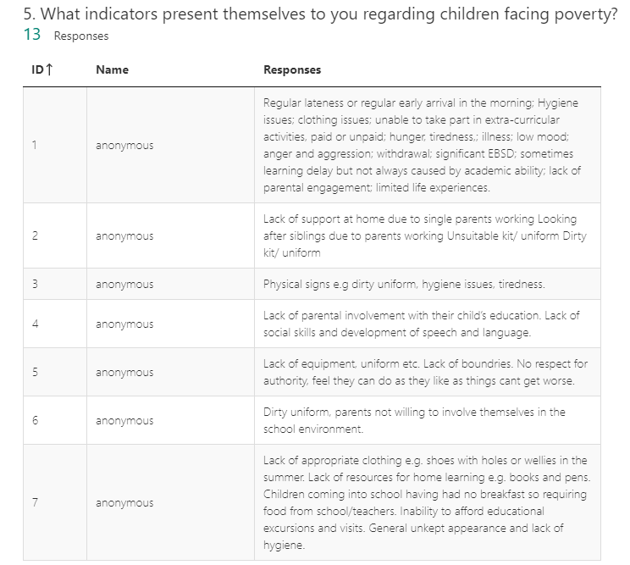
Figure 4.

As shown in Figure 4, question 5 of the questionnaire asked for indicators to poverty. This question highlighted a general consensus that children coming from poorer households can have a lack of equiptment and also a lack of hygiene. From my own observations I have witnessed children with unwashed hair and dirty or tatty clothes. My feelings are that this may not be an issue for them in their own home, when coming to school they may suffer from self-esteem issues as they do not adhere to the social norms of their classmates. This idea of social impact is furthered by Farrell (2009) and Kyriacou (2009) who state that lower socioeconomic backgrounds can lead to negative cognitive development and social class has a higher impact on attainment than either gender or ethnicity. Some solutions to these issues could be achieved by the school offering a laundry service or clothes bank for the pupils. Dunn (2011) writes that in general terms, the teacher should be honest and approachable to pupils and to their parents; in this way the lines of communication will be open to discuss any issues the family may have and from this a beneficial solution can be obtained. The answers to question 5 also highlighted attendance as an indicator of poverty. Kyriacou (2009) goes on to state that families from working class and lower income backgrounds have an ‘group solidarity’ attitude to school where they reject attempts to help them work harder; conversely, pupils from wealthier families view attainment as a challenge and will push themselves to compete against other pupils. These beliefs can be related to generational poverty, whereby beliefs and attitudes to schools and authority manifest themselves over generations. One solution to poor attendence is highlighted in an ESTYN report on a primary school in the City and County of Swansea, noting that “the school actively promotes good attendance, for example through weekley and termly competitions” (ESTYN, 2017. p. 7). It was observed the pupils really engaged with attendence competitions in assembly, although how motivated they were by this at home needs further research to understand fully. Grigg (2015), Hardy (2018), SEN (2019) and Welsh Gov (2009) all support this reward system works well as a whole-school approach and is another example of the promotion of positive behaviour.

Figure 5.

Considering Figure 5 it is worth noting the difference between attainment and achievement. Attainment is the end result; what results the pupil will get, say at the end of KS2. Achievement takes into account the starting point of the pupil and progress they have made along their learning journey (Myatt, 2013). Looking at attainment, Welsh Government (2014) has stated that it feels children from poorer families are not at an acceptable level. This is somewhat supported by the responses to the questionnaire, although the answers were not significant enough to be conclusive. This may be due to the fact they have not witnessed this shortfall for themselves, it could also be that they are not fully aware of all the statistics. There may however be a lack of willing to take responsibility for the failings within the education system, not wanting to accept that some children from deprived backgrounds are failed by the system that is there to support them. This problem may be further compounded by the fact that poverty is to be removed as an ALN from the new ALN Code for Wales (Welsh Gov, 2018).

The ALN Code of Practice 2017 has reduced the number of learning needs in general, stating that poverty will no longer be classed as a form of ALN. The questionnaire asked for our population’s response to this and the answers were very varied with interesting answers (Figure 6). Some respondents told us that they felt poverty should not be seen as an ALN and it is only the children that come from families that are “disengaged” that are effected. That this disengagement is “equally as prevalent in affluent families”. Another respondent supported this, stating that poverty should not be seen as an ALN and that “some of my FSM children are my MAT children”. From these responses, we begin to understand that poverty itself should not be considered as an ALN on its own; however, the consequences of poverty, if they effect the child, should be seen as an ALN. Although poverty will be removed from the ALN Code of Practice, there are many aims to increase the way in which support is offered to learners, through community projects and reach-out programmes based in schools. This coupled with easier access to help and support for learners and more upskilling and support for the education work force will see all learners overcome barriers to learning and help them realise their goals. These aims are supported by the United Nations Convention on the Rights of the Child (United Nations, 1989) and the Salamanca Statement (UNESCO, 1994) which promote inclusion for all pupils, regardless of social backgrounds or any other differences they may have. The importance of children’s rights was made paramount by the Children’s Commissioner for Wales when in 2011 Wales was the first country in the UK to implement the UNCRC’s rights as part of domestic law (Children’s Commissioner for Wales, 2019).
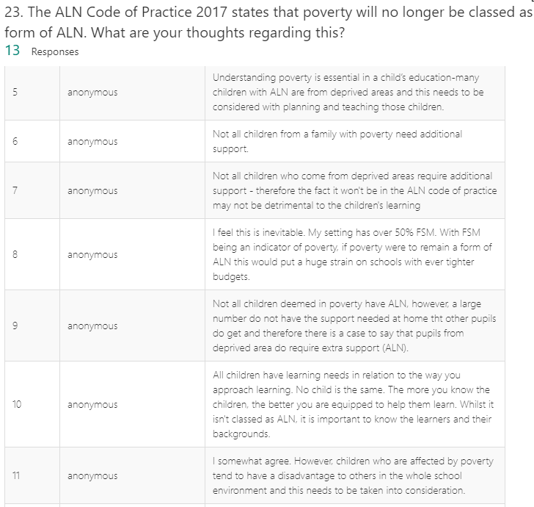Figure 6.
Conclusion

While the causes of poverty are wide-ranging and difficult to solve, the solutions to the problem must be wide-ranging and attack the causes and effects of poverty. The preventative measures should start with the pupil and their home life and expand out to encompass the school community, the community, local services and finally the government. Every individual and service related to a child’s education must work collaboratively to help them reach their potential. Grigg (2015, p. 333) highlights the benefits of a positive home life by stating when parents interest themselves in their child’s learning the attainment levels increased by 15 percent, despite the family’s social standing. The parents role is key in a child’s learning and Welsh Gov (2016) further support this by going on to state that pupils from low-income households would gain most when their parents /carers are actively involved in the learning journey. Again, it is worth noting how important inclusion is in school settings and all learners should receive an education that is inclusive and supportive, regardless of ALN (Snap Cymru, 2019). From personal experience in a school, it was observed how pupils with more severe ALN were integrated into physical education lessons as well as at break times and during assembly. This view was supported by the ESTYN report noting that “Pupils in the specialist teaching facilities take a full part in the life of the school through a very well planned system of integration” (ESTYN, 2017, p. 7). Another key aspect in tackling poverty is ensuring the pupil has the best possible start from an early age. Flying Starts programmes have provided high quality nursery education providing a strong foundation for pupils “ready to learn throughout their life” (Donaldson, 2015. p.28). The prolonged benefits to this positive foundation helps children who have come from poorer households to experience school at an equal level to their classmates (DfES, 2004). Finally, there is the government’s role to consider, this can have a huge impact respect of poverty. Financial support either through direct investment and payments or through cutbacks to vital services such as libraries and outdoor activities. The government are looking to improve the issue is through the Social Services and Well-being act, which took effect on 6th April 2016. The act aims to improve the well-being of people who have ALN and should provide more support for those people who care for others (Social Care Wales, 2017).

Reference List

British Educational Research Association (BERA). Ethical Guidelines for Educational Research. 4th ed, London.
Available at: https://www.bera.ac.uk/wp-content/uploads/2018/06/BERA-Ethical-Guidelines-for-Educational-Research_4thEdn_2018.pdf?noredirect=1
(Accessed: 22/04/2019)

Burgess, R. G. (1993) Biting the hand that feeds you? Educational research for policy and practice. Lewes: Falmer.

Child Poverty Action Group. (2019). Child poverty facts and figures.
Available at: http://www.cpag.org.uk/content/child-poverty-facts-and-figures
(Accessed: 11/04/2019)

Cohen, L. Manion, L. and Morrison, K. (2007). Research Methods in Education. 6th ed. Oxon: Routledge.

Dewis Cymru. (2019). Additional Learning Needs (ALN).
Available at: https://www.dewis.wales/additional-learning-needs-cyp
(Accessed: 12/04/2019)

DFES. (2004). Removing Barriers to Achievement: The Government’s Strategy for SEN.
Available at: https://webarchive.nationalarchives.gov.uk/20130323054333/https://www.education.gov.uk/publications/eOrderingDownload/DfES%200117%20200MIG1994.pdf
(Accessed: 25/04/2019)

Donaldson, G. (2015). Successful Futures. Welsh Government. Cardiff: Crown.
Available at: https://gweddill.gov.wales/docs/dcells/publications/150225-successful-futures-en.pdf
(Accessed: 22/04/2019)

Dunn, D. (2011). How to be an outstanding primary school teacher. London: Bloomsbury.

ESTYN. (2017). A report on Whitestone Primary School. Cardiff: Crown.
Available at: https://www.estyn.gov.wales/sites/default/files/documents/Whitestone%20Primary%20School.pdf
(Accessed: 19/04/2019)

Farrell, M. (2009). Educating special children. London: Routledge.

Frederickson, N. and Cline, T. (2011). Special educational needs, inclusion and diversity. 2nd ed. Maidenhead: McGraw Hill.

Government. (2018). The Data Protection Act.
Available at: https://www.gov.uk/data-protection
(Accessed: 22/04/2019)

Grigg, R. (2015). Becoming an outstanding primary school teacher. 2nd ed. Oxon: Routledge.

Hardy, D. (2018). 8 ways to prevent chronic absenteeism.
Available at: https://www.educationdive.com/news/8-ways-to-prevent-chronic-absenteeism/527794/
(Accessed: 25/04/2019)

Jensen, E. (2009). Teaching with Poverty in Mind: What Being Poor Does to Kids' Brains and What Schools Can Do About It. Alexandria, Va.: Association for Supervision and Curriculum Development.

Joseph Rowntree Foundation. (2019). What is poverty? York.
Available at: https://www.jrf.org.uk/our-work/what-is-poverty
(Accessed: 11/04/2019)

Khan, S. (2012). The one world schoolhouse. New York: Twelve.

Kumar, R. (2011). RESEARCH METHODOLOGY: A step-by-step guide for beginners. 3rd ed. London: SAGE.
Kyriacou, C. (2009). Effective teaching in schools. Cheltenham: Nelson Thornes Ltd.

Maslow, A. and Town, S. (2013). A theory of human motivation. Floyd, Va.: Wilder Publications.

McLeod, S. A. (2008). Likert Scale.
Available at: https://www.simplypsychology.org/likert-scale.html
(Accessed: 25/04/2019)

Myatt, M. (2013). Data for Dummies.
Available at: https://marymyatt.com/blog/2013-10-20/data-for-dummies
(Accessed: 10/04/2019)

Special Educational Needs. (2019). Six ways to manage BESD. SEN Magazine.

Available at: https://senmagazine.co.uk/articles/articles/senarticles/six-ways-to-manage-besd

(Accessed: 10/04/2019)

Snap Cymru. (2019). Proposed changes to the way children and young people’s special educational needs will be identified, assessed and met.
Available at: http://www.snapcymru.org/help-for-families/aln-reform/
(Accessed: 11/04/2019)

Social Care Wales. (2017). Social Services and Well-being (Wales) Act 2014.
Available at: https://socialcare.wales/hub/sswbact
(Accessed: 20/04/2019)

Stats Wales. (2019). Percentage of all individuals, children, working-age adults and pensioners living in relative income poverty for the UK, UK countries and regions of England between 1994-95 to 1996-97 and 2015-16 to 2017-18 (3 year averages of financial years). Welsh Government. Cardiff.
Available at: https://statswales.gov.wales/Catalogue/Community-Safety-and-Social-Inclusion/Poverty/householdbelowaverageincome-by-year
(Accessed: 12/04/2019)

Taylor, C. (2017). The Reliability of Free School Meal Eligibility as a Measure of Socio-Economic Disadvantage: Evidence from the Millennium Cohort Study in Wales. British Journal of Educational Studies. Abingdon: Routledge.

United Nations. (1989). THE SALAMANCA STATEMENT AND FRAMEWORK FOR ACTION ON SPECIAL NEEDS EDUCATION. United Nations. UNESCO.
Available at: http://www.unesco.org/education/pdf/SALAMA_E.PDF
(Accessed: 23/04/2019)

UNICEF. (2019). The United Nations Convention on the Rights of the Child. UNICEF. London.
Available at: https://www.unicef.org.uk/wp-content/uploads/2010/05/UNCRC_united_nations_convention_on_the_rights_of_the_child.pdf
(Accessed: 23/04/2019)

University of Wales Trinity St. David. (2017). Research Ethics & Integrity Code of Practice.
Available at: https://www.uwtsd.ac.uk/media/uwtsd-website/content-assets/documents/research/research-ethics-integrity-code-practice.pdf
(Accessed: 23/04/2019)

Welsh Government, (2015). Average class sizes in maintained primary and secondary schools, and number of qualified teachers in Independent schools, from the January 2014 census. Welsh Government. Cardiff: OGL.

Welsh Government, (2018). Draft Additional Learning Needs Code for Wales. Cardiff: Crown.

Welsh Assembly Government. (2006). Inclusion and Pupil Support. Cardiff: Crown.

Welsh Government. (2016). Inclusion and pupil support. Cardiff: Crown.
Available at: https://gov.wales/sites/default/files/publications/2018-05/guidance-inclusion-and-pupil-support_0.pdf
(Accessed: 23/04/2019)
Welsh Government. (2018). Research Briefing Act Summary: Additional Learning Needs and Education Tribunal (Wales) Act 2018. Cardiff: Crown
Available at: http://www.assembly.wales/research%20documents/18-023/18-23-web-english.pdf
(Accessed: 12/04/2019)

Welsh Government. (2014). Rewriting the future Raising ambition and attainment in Welsh schools. Cardiff: Crown.
Available at: https://gov.wales/sites/default/files/publications/2018-03/rewriting-the-future-raising-ambition-and-attainment-in-welsh-schools.pdf
(Accessed: 25/03/2019)

Welsh Government. (2009). The Qualified Teacher Status Standards Wales 2009.
Available at: https://gweddill.gov.wales/legislation/subordinate/nonsi/educationwales/2009/3220099/?lang=en
(Accessed: 22/04/2019)

Appendix

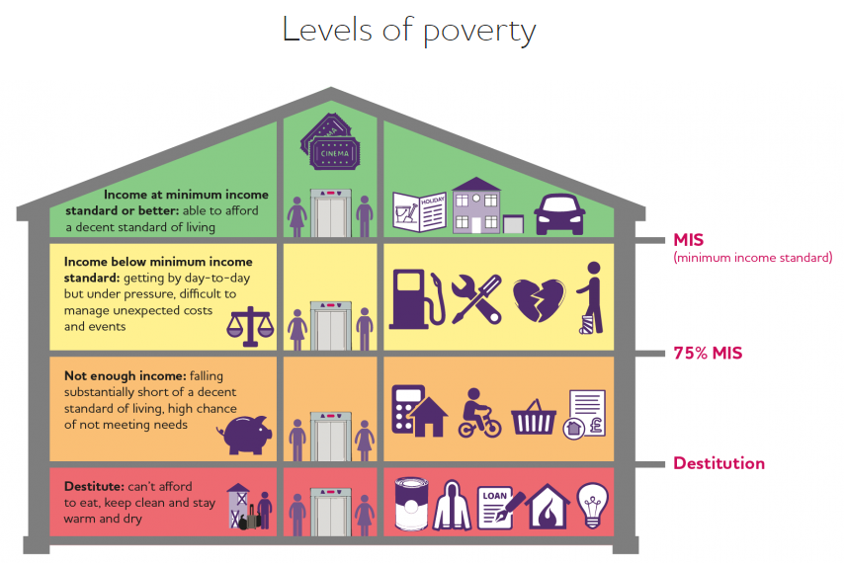
Joseph Rowntree Foundation. (2019). What is poverty? York.
Available at: https://www.jrf.org.uk/our-work/what-is-poverty
(Last Accessed 11/04/2019)

