Change-makers: Creativity and Value Creation

Professions (BMHP5014)

Component 1: poster and written Pitch

Student name: Jamila Zakari

Student number: 2322381

Lecturer’s name: Laila Suran

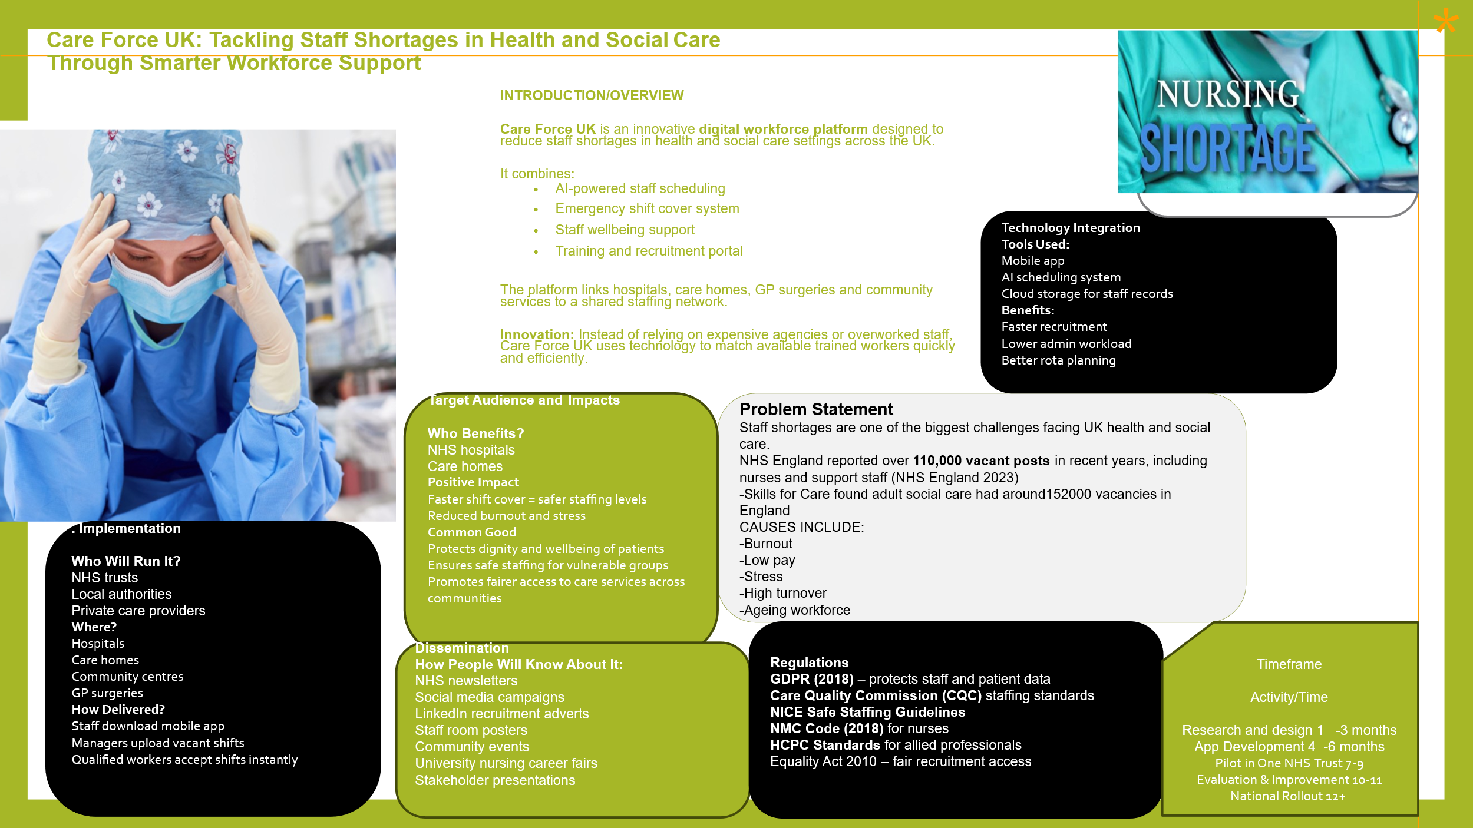

Written Pitch:
CareForce UK – A Digital Solution to Staff Shortages in Health and Social Care

Introduction
CareForce UK is an innovative digital workforce platform designed to reduce persistent staff shortages across the United Kingdom health and social care sector. It responds to one of the most pressing challenges facing modern services: insufficient numbers of qualified workers available to meet increasing patient and service-user demand. Across hospitals, care homes, GP surgeries and community settings, staffing gaps contribute to delayed treatment, reduced quality of care, burnout among employees and increased financial pressure through reliance on agency staff. CareForce UK addresses this issue by connecting providers with qualified professionals through a secure mobile and web-based system that enables rapid shift filling, smarter rota planning and staff wellbeing support. The innovation would benefit patients, service users, healthcare professionals and organisations by improving workforce stability, enhancing care quality and promoting safer, more efficient services. This matters because without sufficient staff, no health or social care system can function effectively.

Background
Staff shortages have become a long-standing structural issue across health and social care in the UK. NHS England reported over 110,000 vacancies across the NHS workforce, affecting nursing, medical, allied health and support roles (NHS England, 2023). In parallel, Skills for Care estimated approximately 152,000 vacant posts within adult social care in England, demonstrating severe recruitment and retention difficulties across residential and domiciliary care services (Skills for Care, 2023).
The causes of workforce shortages are complex and include an ageing workforce, high stress levels, low morale, limited career progression and growing service demand. The COVID-19 pandemic intensified these pressures, leading to emotional exhaustion and increased turnover among frontline workers. The World Health Organization (2022) highlighted that burnout and workforce depletion now present a serious threat to health system resilience across Europe.
Insufficient staffing has direct consequences for patient safety and service quality. NICE (2015) found that safe staffing levels are associated with reduced mortality, fewer medication errors and better patient experiences. In social care settings, understaffing can lead to rushed visits, inconsistent care and reduced dignity for vulnerable individuals.
Government policy has recognised the urgency of workforce reform. The NHS Long Term Plan prioritised retention, flexible working and workforce redesign as essential to future sustainability (NHS England, 2019). Similarly, the Care Act 2014 places legal duties on local authorities to promote wellbeing and ensure quality care provision. However, practical and scalable workforce solutions remain limited, creating a clear opportunity for innovation.

Innovation Description
CareForce UK is a digitally integrated workforce platform that combines recruitment, scheduling, compliance management and staff wellbeing functions into one system. It would be available as both a mobile application and secure web portal, enabling health and social care organisations to fill vacant shifts quickly while supporting long-term workforce planning.
Managers in hospitals, care homes, GP surgeries and community services would upload available shifts in real time. Qualified professionals registered on the platform, such as nurses, healthcare assistants, carers and allied health staff, would receive notifications based on location, availability and skill set. Workers could then accept suitable shifts instantly through the app. This would significantly reduce the delays associated with agency booking systems or manual rota processes.
What distinguishes CareForce UK from existing systems is its preventative and supportive design. Artificial intelligence tools would identify recurring staffing gaps, seasonal trends and high-risk rota periods, enabling organisations to act before shortages become critical. In addition, the platform would contain digital storage for DBS checks, training certificates and professional registrations, reducing administrative burden.
Another innovative feature is its staff wellbeing hub. This would provide access to counselling referrals, stress management resources, mentorship opportunities and continuing professional development modules. Many staffing systems focus solely on filling vacancies; CareForce UK recognises that retention and wellbeing are equally important.
The platform therefore solves multiple interconnected problems: delayed staffing responses, excessive agency costs, administrative inefficiency and poor staff retention. By integrating these solutions into one accessible system, CareForce UK provides a smarter and more sustainable workforce model.

Impact on Health and Social Care
CareForce UK would generate benefits across the whole health and social care system. For patients and service users, improved staffing levels would lead to more timely care, safer treatment environments and better continuity of support. Research demonstrates that adequate staffing is associated with improved clinical outcomes and patient satisfaction (NICE, 2015). For example, if a hospital ward is short of nurses, patients may experience delays in receiving medication, assistance with personal care or discharge planning. By rapidly filling vacant shifts through CareForce UK, patients would receive quicker support, reduced waiting times and safer, more coordinated care.

Older adults living in care homes and people receiving domiciliary care would particularly benefit from greater consistency of carers. Continuity of care supports trust, dignity and emotional wellbeing, especially for individuals living with dementia, disabilities or long-term conditions. Vulnerable groups often experience the greatest harm when services are understaffed.
Healthcare workers would also benefit substantially. Flexible shift access would help staff balance work with caring responsibilities, study or health needs. This may be especially valuable for women, who represent a large proportion of the care workforce, and for workers from ethnically diverse communities who may seek more adaptable employment patterns. Burnout reduction measures and wellbeing support could improve morale and retention.
For organisations, CareForce UK would reduce dependency on costly temporary agency staff. Savings could be reinvested into frontline services, training and employee support. Managers would gain real-time workforce intelligence, allowing evidence-based planning rather than crisis management.
The innovation also promotes the common good. It seeks to create fairer access to care by helping deprived, rural or hard-to-recruit areas source qualified workers more effectively. In doing so, it contributes to health equity and social justice. A workforce system that functions
efficiently benefits not only individual organisations but society as a whole by ensuring that essential care remains safe, accessible and sustainable

Public and Stakeholder Involvement
Successful implementation of CareForce UK would require meaningful involvement from staff, service users and wider stakeholders. Co-production principles would guide development, ensuring that nurses, carers, allied health professionals, patients and families shape the platform design. Their lived experience would help identify barriers, preferred features and usability requirements.
Public engagement could include surveys, focus groups and pilot feedback sessions across hospitals, care homes and community organisations. Trade unions and professional bodies such as the Royal College of Nursing would be consulted regarding fair working practices and staff welfare. Local authorities, integrated care boards and voluntary organisations could also support regional rollout strategies.
Advocacy campaigns through social media, NHS networks and community events would raise awareness and encourage uptake. Involving stakeholders from the outset would strengthen trust, increase adoption rates and ensure the innovation remains responsive to real workforce needs.

Policies, Services and Professional Links
CareForce UK aligns strongly with current UK legislation and policy priorities. The Care Act 2014 requires services to promote wellbeing and maintain quality care, both of which depend on safe staffing levels. The Equality Act 2010 is also relevant, as the platform would promote fair recruitment, equal access to shifts and non-discriminatory workforce practices.
The innovation complements existing services rather than replacing them. It would support NHS trusts, GP practices, community nursing teams, adult social care providers and voluntary sector organisations by strengthening staffing capacity. Integrated Care Systems could use the platform to coordinate workforce resources across regions.
Professional groups including nurses, nursing associates, social workers, occupational therapists and healthcare assistants would all engage with the system. It also aligns with the NMC Code (2018), which emphasises safe practice, prioritising people and preserving professionalism.

Conclusion
CareForce UK is a realistic and timely response to one of the greatest pressures facing modern health and social care: workforce shortages. By combining rapid staffing solutions, predictive technology and wellbeing support, it offers benefits for patients, staff and organisations alike. The platform is feasible, policy-aligned and scalable across multiple settings. Investing in workforce innovation now is essential to protecting the future quality, safety and sustainability of UK care services.

References
Care Act 2014. c.23. London: The Stationery Office.
Equality Act 2010. c.15. London: The Stationery Office.
Health and Care Professions Council (2023) Standards of conduct, performance and ethics. London: HCPC. Available at: https://www.hcpc-uk.org (Accessed: 24 April 2026).
National Institute for Health and Care Excellence (2015) Safe staffing for nursing in adult inpatient wards in acute hospitals. London: NICE. Available at: https://www.nice.org.uk (Accessed: 24 April 2026).
NHS England (2019) The NHS Long Term Plan. London: NHS England. Available at: https://www.longtermplan.nhs.uk (Accessed: 24 April 2026).
NHS England (2023) NHS Vacancy Statistics England. London: NHS England. Available at: https://www.england.nhs.uk (Accessed: 24 April 2026).
Nursing and Midwifery Council (2018) The Code: Professional standards of practice and behaviour for nurses, midwives and nursing associates. London: NMC. Available at: https://www.nmc.org.uk (Accessed: 24 April 2026).
Skills for Care (2023) The state of the adult social care sector and workforce in England. Leeds: Skills for Care. Available at: https://www.skillsforcare.org.uk (Accessed: 24 April 2026).
World Health Organization (2022) Health and care workforce in Europe: Time to act. Copenhagen: WHO Regional Office for Europe. Available at: https://www.who.int (Accessed: 24 April 2026).

