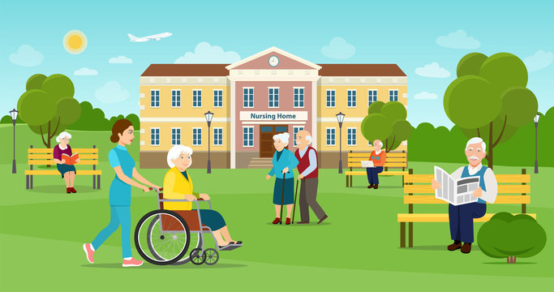
(2509014) LCH4003 AZIDA ZAINOL INTRODUCTION TO PUBLIC HEALTH RESIDENTIAL CARE HOME

The Funding Demands
- Residential care homes are vital for adults who cannot live independently, providing accommodation, personal care, and emotional support and wellbeing, reflecting a modern, rights-based approach to social care.
- Families may face high costs for care, and local authorities often have limited budgets, making it difficult to fund high-quality services.
(The Care Act 2014) (CQC regulations promote person-centred care, dignity),
Challenges in the Residential Care Home
- Workforce Pressures Recruitment problems are common in adult social care. Low pay, high workloads, and emotional demands can lead to staff burnout and turnover.
- Emotional labour is a significant challenge as staff often provide support for residents with complex needs, including dementia or end-of-life care
(The King’s Fund, 2023).
- Funding constraints can impact staffing levels, training, and the quality of the environment, creating tension between financial sustainability and quality of care (The King’s Fund, 2023).

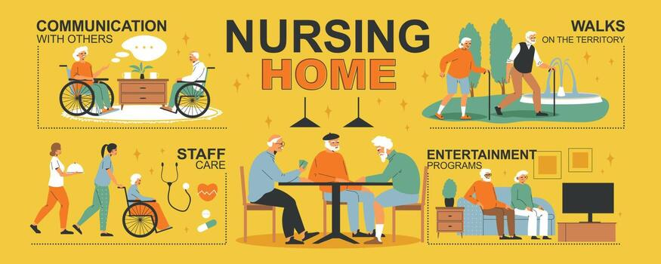
The Brief History
- (1990 – NHS and Community Care Act) The Act promoted moving people out of institutions and into community-based care settings.
- reduced long-term stays in large residential institutions (Legislation.gov.uk, 1990).
- Person-centred care planning: Residential care focuses on the individual’s preferences, history, and cultural needs centred care ensures that residents have choice and control over their lives and care routines This approach aligns with the principle of dignity promoted by the
(Care Act 2014 (SCIE, 2022).

The Current Functioning Service of a Residential Care home
- assistance with daily living (eating, washing, dressing), medication, and social stimulation. They are regulated, requiring staff to support resident dignity, choice, and safety while increasingly partnering with the NHS for enhanced, proactive health care Types of ADLs: National Institutes of Health (NIH) defines ADLs for basic needs (bathing, eating, dressing) vs. IADLs (medication, finances).
- Support Methods: Caregivers should encourage independence where possible, using clear, simple, and patient communication to guide tasks. Methodology: ATrain Education suggests using simple, patient communication to aid with tasks.

What’s a Residential Care Home
- Residential care, which promotes wellbeing as a key principle in adult social care (Department of Health and Social Care, 2014). Wellbeing includes areas such as physical and mental health, personal dignity, control over daily life, participation in work or education, social and economic wellbeing, and protection from abuse or neglect. The Care Quality Commission (CQC) safety, effectiveness, and person-centred care (CQC, 2023 (England is guided by the Care Act 2014)
Neelam Sumundar

Essay for Ambulance service
Module: LCHS4003 INTRODUCTION TO PUBLIC HEALTH

Ambulance Service: Origins, Modern Function, and Impact on Quality of Life
The ambulance service is a vital part of the healthcare system, providing emergency medical treatment, clinical assessment, and transportation for individuals experiencing urgent or life-threatening conditions. In the United Kingdom, ambulance services operate under the National Health Service (NHS), responding to 999 calls and delivering urgent care in both community and hospital settings. Over time, ambulance services have evolved from simple transport providers to highly skilled mobile healthcare units capable of delivering advanced life-saving interventions before patients reach hospital.
The origins of the modern ambulance service can be traced back to the 18th century. During the Napoleonic Wars, Dominique Jean Larrey introduced the concept of “flying ambulances” to transport wounded soldiers rapidly from battlefields to receive medical care. This innovation improved survival rates and laid the foundation for organised pre-hospital emergency care. In the United Kingdom, the St John Ambulance was proved in 1877 and played a significant role in developing first-aid training and patient transport services (Webster, 2002).
Today, ambulance services do far more than transport patients. Paramedics provide rapid clinical assessment, advanced life support, and treatment for conditions such as cardiac arrest and sepsis. Services also support mental health crises and can refer patients to community care when hospital admission is not required (King’s Fund, 2024; NHS England, 2023).
Ambulance services currently face significant challenges. Rising population numbers, increasing long-term health conditions, and workforce shortages have led to increased demand and pressures across the system. Press reports and health performance data show that many key targets, such as response times and emergency department waits, have not been met in recent years (King’s Fund, 2024). Moreover, pressures within hospitals affect ambulance capacity because delays in handovers reduce the number of available crews for new urgent calls (Care Quality Commission, 2024).
Despite these pressures, ambulance services have driven improvements in community care and mobile treatment models. Paramedics are increasingly able to treat patients on scene and reduce unnecessary hospital admissions, thus supporting better patient outcomes and independence (King’s Fund, 2024; NHS England, 2023).In summary, the ambulance service plays a crucial role in improving quality of life by responding to life-threatening emergencies, providing essential pre-hospital care, and supporting patient wellbeing across urgent and emergency care pathways.
Images Links
Care Home Outdoors https://www.google.com/search?sca_esv=9a738b84887eecfa&rlz=1C1GCEA_enGB1202GB1202&udm=2&fbs=ADc_l-aN0CWEZBOHjofHoaMMDiKpaEWjvZ2Py1XXV8d8KvlI3vWUtYx0DZdicpfE1faGYemg2KC4yuMPyQlIvlWqq2AtcdVMJmMDffRprXURy79lwWYbYYV2Zn-_3zemGi58ZoYQT-gc_TefnhK7O6tgh3cJbnRhsfD9J2bnFesALGy1NtfkyaEXUF5U34PYt9QRs96v3tWGXCPutdqk722sMCshCQjZQw&q=care+home+animated&sa=X&ved=2ahUKEwjH_5yTpu2SAxXiW0EAHXmoEVAQtKgLegQIFhAB&biw=1536&bih=845#sv=CAMSVhoyKhBlLUZGMWh2QWUtQkJOM1RNMg5GRjFodkFlLUJCTjNUTToObEhub09FbURLbU1lb00gBCocCgZtb3NhaWMSEGUtRkYxaHZBZS1CQk4zVE0YADABGAcgtvO89wUwAkoIEAIYAiA
Nursing Home Picture https://www.google.com/search?tbnid=W4uFm3SzzGJnwM&tbnh=0&tbnw=0&rlz=1C1GCEA_enGB1202GB1202&sca_esv=9a738b84887eecfa&cs=0&udm=2&tbs=rimg:CVuLhZt0s8xiYaYC5xdU7tJX4AIA&q=care+home+animated&sa=X&ved=2ahUKEwirmKfDv-2SAxWHU0EAHSoBGBUQuIIBegQIThAA&biw=1536&bih=845&dpr=1#sv=CAMSWBoyKhBlLXVyVjBONG42a09uV2tNMg51clYwTjRuNmtPbldrTToOTmd2MFcxVXVyODQ1c00gBCocCgZtb3NhaWMSEGUtdXJWME40bjZrT25Xa00YADABOAAYByDwwPyeCzACSggQAhgCIAIoAg
References (Harvard Style)
1 Care Quality Commission (CQC) (2023) How we regulate and inspect adult social care services. Available at: https://www.cqc.org.uk
2 Department of Health and Social Care (DHSC) (2014) Care Act 2014. London: HMSO.
3 Legislation.gov.uk (1990) NHS and Community Care Act 1990. Available at: https://www.legislation.gov.uk
4 National Institute for Health and Care Excellence (NICE) (2022) People’s experience in adult social care services. London:
5 Social Care Institute for Excellence (SCIE) (2022) Person-centred care guide. London: SCIE.
6 The King’s Fund (2023) Social care in England: Overview. London: The King’s Fund.
7 St John Ambulance (1877) History of st John Ambulance (accessed: 19 February 2026)
8 Health and Social care Professions Council (2023) Standards of paramedic. www.hcpc-uk.org Accessed; 19 February 2026)

