Developing an MS Access Database for coastal tourism management

Lucy Boyt - 2308345
  - Introduction to Web and Database Concepts

Contents
Section A 2
Initial Investigations: 2
1. Database Management System (DBMS) user types. 2
2. Departments that Coastal Tourism Management System (CTMS). 2
Database Design and Implementation: 4
3. Entity Relationship Diagram: 4
4. Relational Database Schema: 4
Application of Database Management System: 5
5. Creating a Database using Microsoft Access: 5
Reports Design 16
6. Creating user-friendly reports within the CTMS. 16
Forms Design, User Interface, and Menus 18
7. Creating Forms within the CTMS: 18
8. Creating user-friendly menus for CTMS. 19
Section B (15 Marks) 21
9. Importance of developing a Database for Coastal Tourism Management in Wales, UK: 21
10. Transitioning from Manual Data Management to a Computerized system. 22

Section A

Initial Investigations:

Database Management System (DBMS) user types.

Users have unique roles and responsibilities when interacting with a Database Management System. Database Administrators oversee the DBMS and ensure that it is optimised for performance while configuring and securing data, managing backups, data modelling, and software updates.

Database Designers develop the database structure and strive for efficient organisation, storage, and retrieval of data. They maintain schemas, write SQL queries, integrate databases into applications, manage data migration, optimise performance, and conduct code testing.

Application Developers design software that interacts with the database and writes SQL queries to manipulate and retrieve data.

End-users such as Tourists and Local Businesses access the database to retrieve and input data, utilising applications, or tools to ensure data accuracy and consistency. The information gathered can assist users in making informed decisions while following data access and usage policies defined by the DMA and the organisation.

Departments that Coastal Tourism Management System (CTMS).

Coastal Getaways, housing diverse departments like Customer Service, Procurement, IT, Marketing/Sales, Management, and Analytics, relies on the Coastal Tourism Management System (CTMS) to meet varied operational needs.

Customer Service teams demand immediate CTMS access for retrieving customer information and managing bookings. Responsibilities encompass maintaining accurate records, addressing inquiries promptly, and logging interactions for future reference and enhancements.

The Procurement department leverages the CTMS for managing contracts, local agreements, and purchase orders, requiring seamless workflow integration. Responsibilities include document generation, collaboration, and ensuring DMS compliance with company and regulatory standards. [1]

IT users seek security features, access control, and encryption for safeguarding IT-related documents. Integration with other IT systems is crucial for data flow, and recovery functionalities are needed to mitigate data loss. IT responsibilities include configuring and maintaining the database, managing access controls, ensuring integration, and troubleshooting technical issues.

The Marketing team utilises the CTMS for centralised content management and employs analytics tools to assess campaign performance. Responsibilities span organising content, managing collateral versions, and evaluating marketing success through analytics tools. Sales users require access to customer-related documents and pricing details, with responsibilities including document generation and maintaining up-to-date customer information.

Management relies on the CTMS for reporting and analytics, storing strategic documents, and ensuring document compliance with legal standards. Responsibilities encompass monitoring DMS usage, making business decisions based on analytics, and storing critical business documents.

The Analytics department requires integration with data sources for business analytics, advanced search capabilities, and visualisation tools for data presentation. Responsibilities include generating insights, creating reports, and developing dashboards to support departmental decision-making.

Database Design and Implementation:

Entity Relationship Diagram [2] :

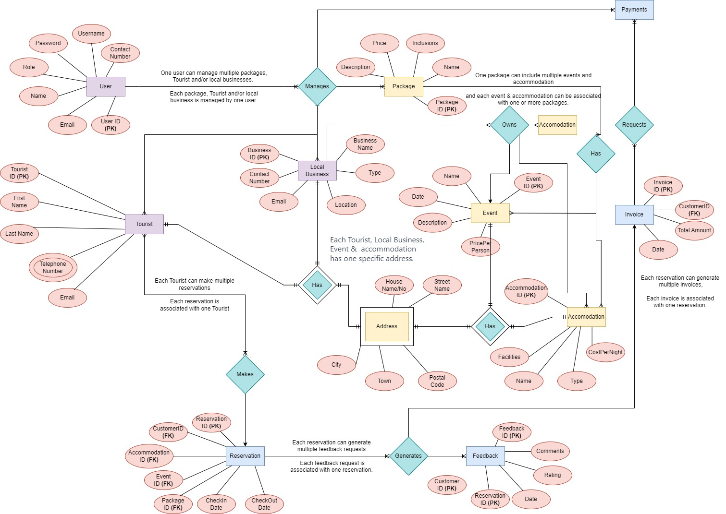

Relational Database Schema:

Application of Database Management System:

Creating a Database using Microsoft Access [3]:

Figure 1 - Accommodation Table – Linked to the LocalBusiness Table
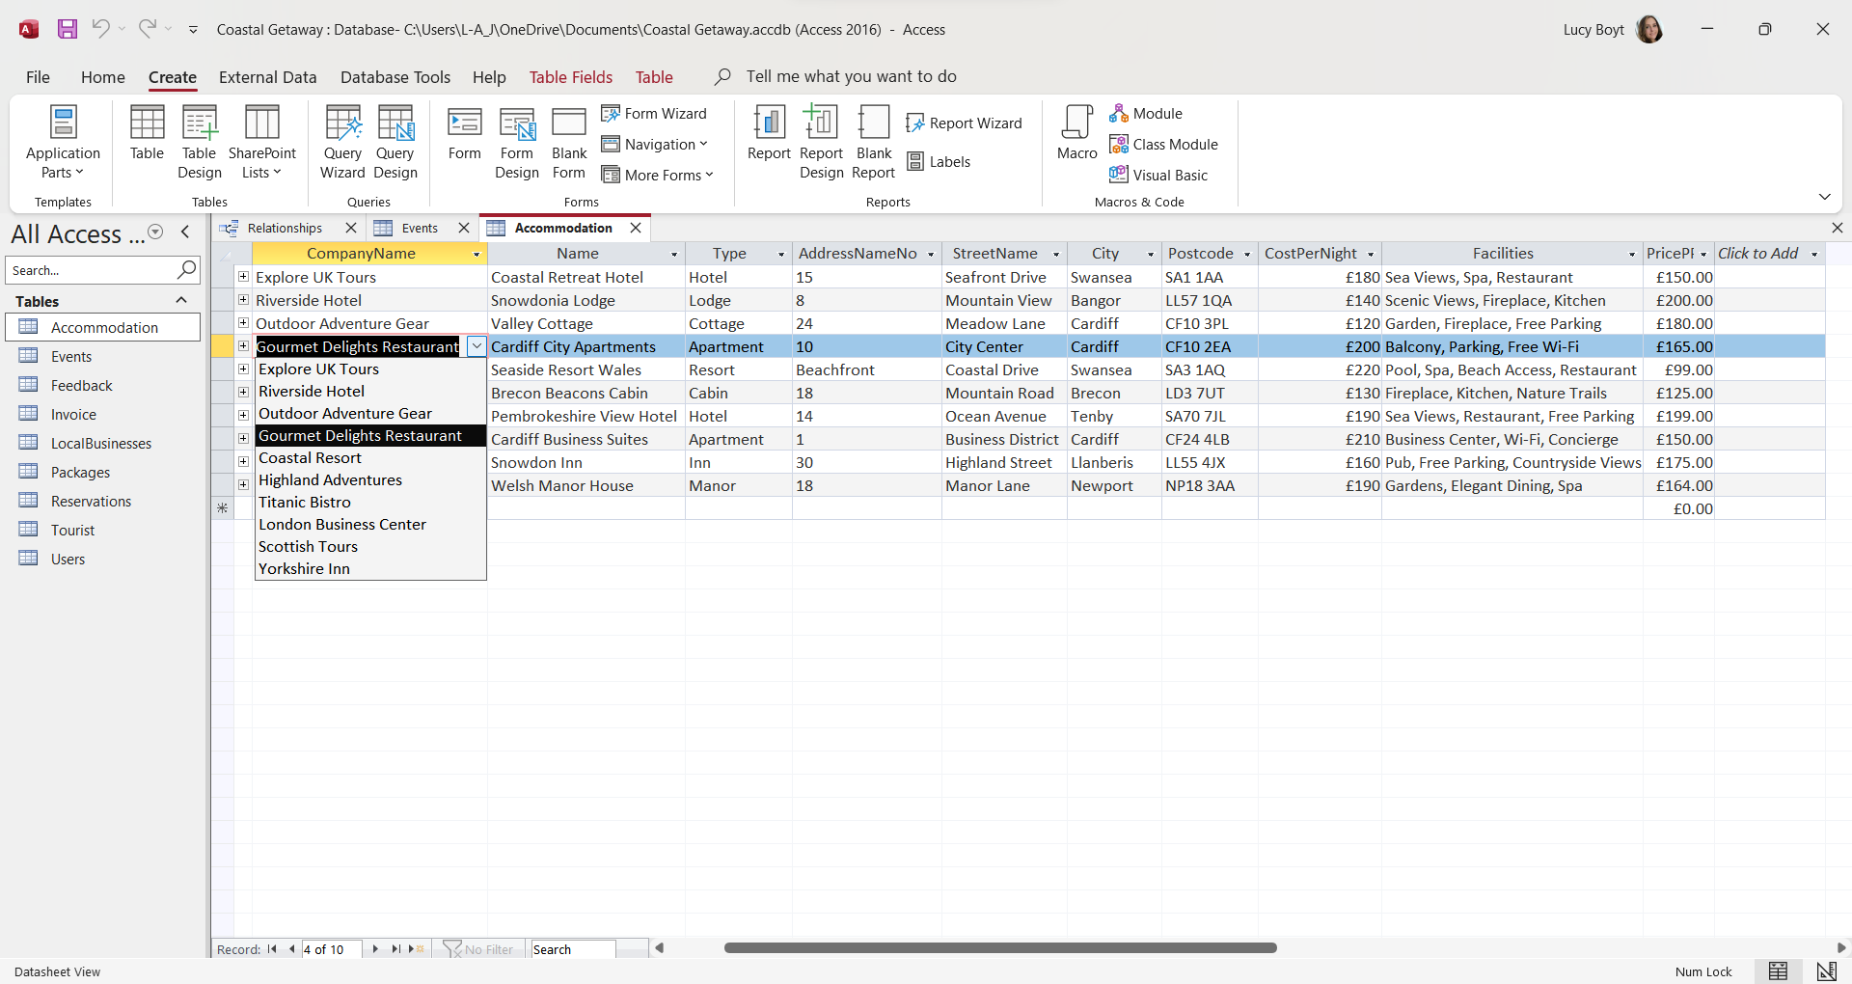

Figure 2 - Accommodation Design View, Primary key set up via AutoNumber with a Format to Include “ACC0” at the start of the auto number. This technique has been used on all AutoNumbers to differentiate the ID’s.
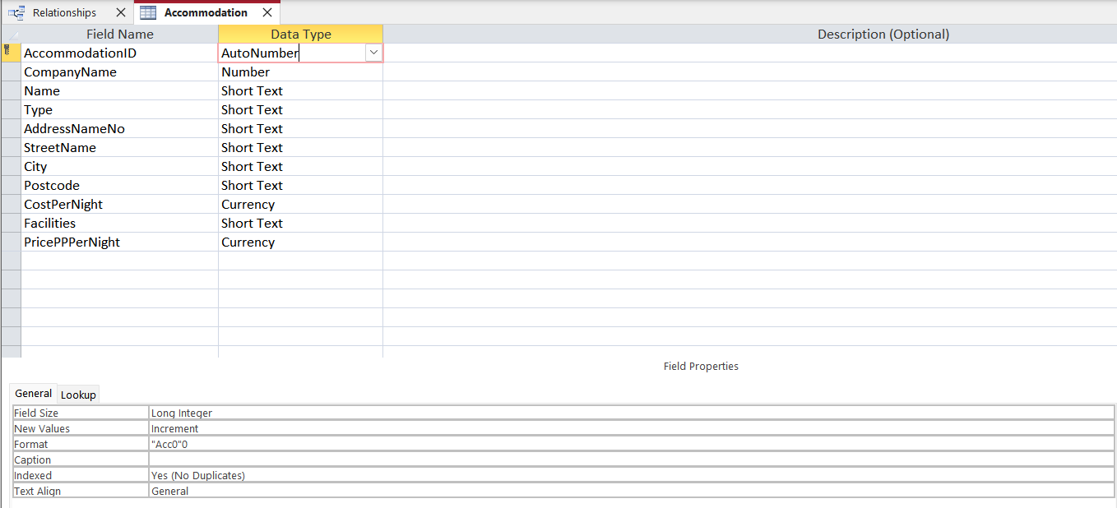

Figure 3 - Accommodation Design View: Showing the Lookup restrictions set for City – Limiting City options to those input.
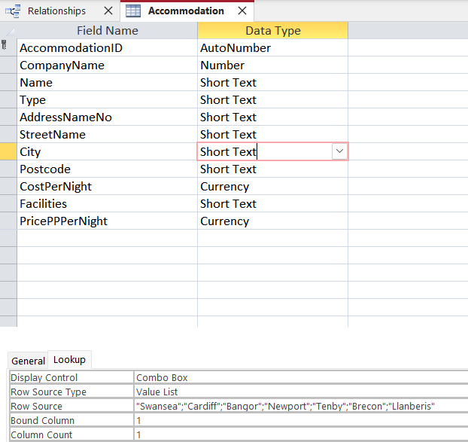

Figure 4 - Accommodation Table showing Input Mask added for Postcode field - this has been applied to all tables where the Attribute Postcode is included.
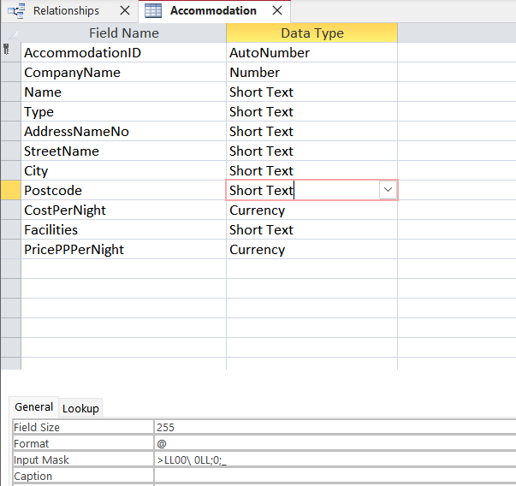

Figure 5 - Events Table - Linked to the LocalBusiness Table
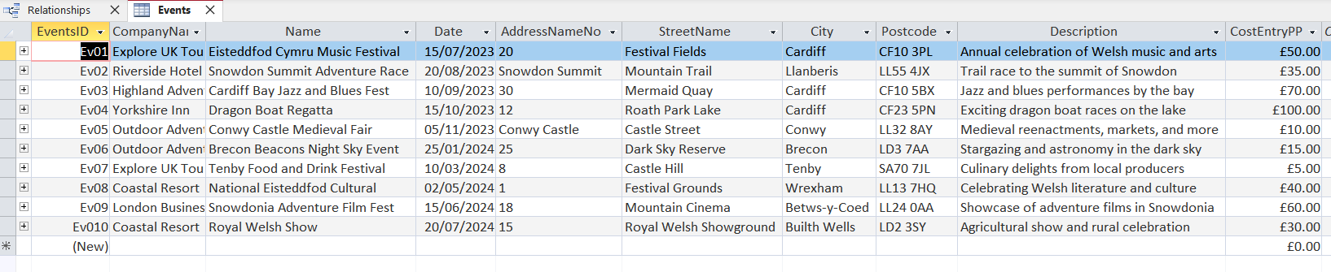

Figure 6 - Events Table from Design View - I have applied an Input mask for a Short Date, Validations have been set to limit the date to today’s date or later. A validation Text has been applied should the user enter a date before today. This field is required.
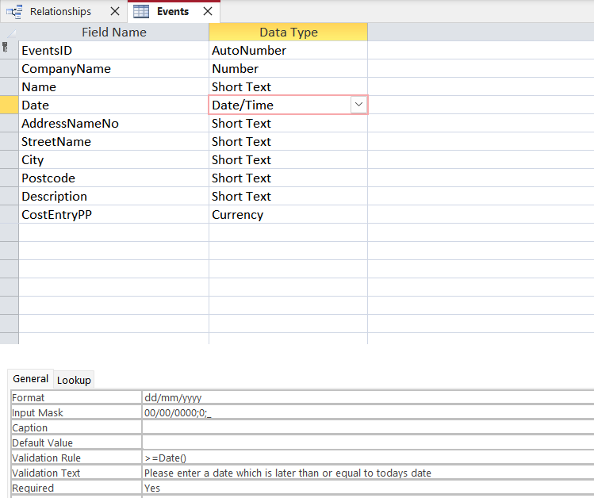

Figure 7 - Feedback Table - Linked to the Customer Table.
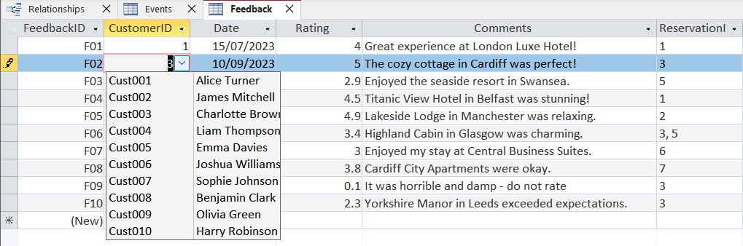
Figure 8 - Feedback Table is also linked to the Reservation ID list - The user can provide feedback for multiple reservations in one comment.
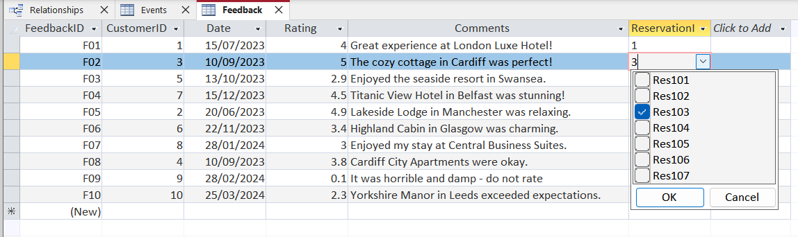
Figure 9- LocalBusiness Table - Linked to the Users Table
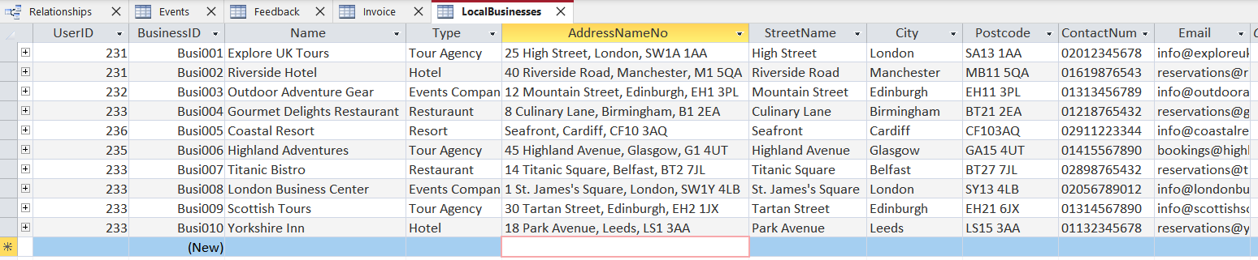

Figure 10 - LocalBusiness Table - Design View. - Contact Numbers utilises the Input Mask to the local format
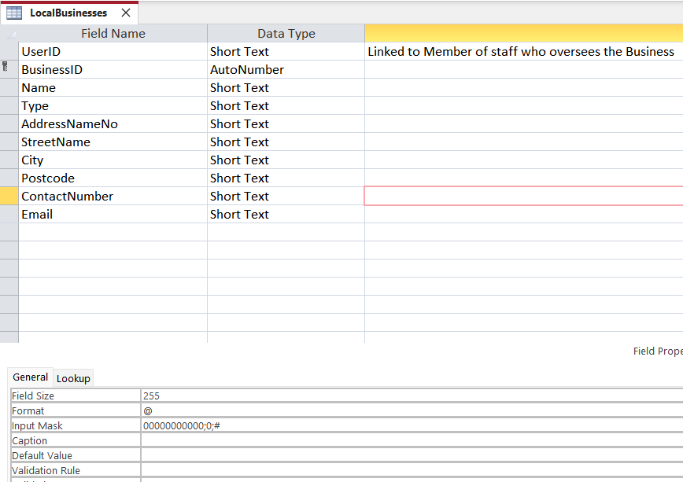

Figure 11 - Local Business Table - Design View - Showing the Validation Rules set for Email - Restricting the field to include an @ followed by “.” - Validation text will be provided should the field not match the validation rule. This technique has been used on all tables where the attribute “Email” appears.
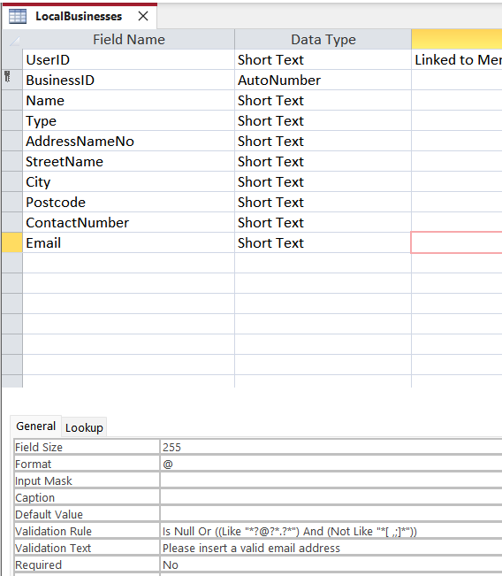

Figure 12 - Packages Table - Linked to the User, Event and Accommodation Tables.
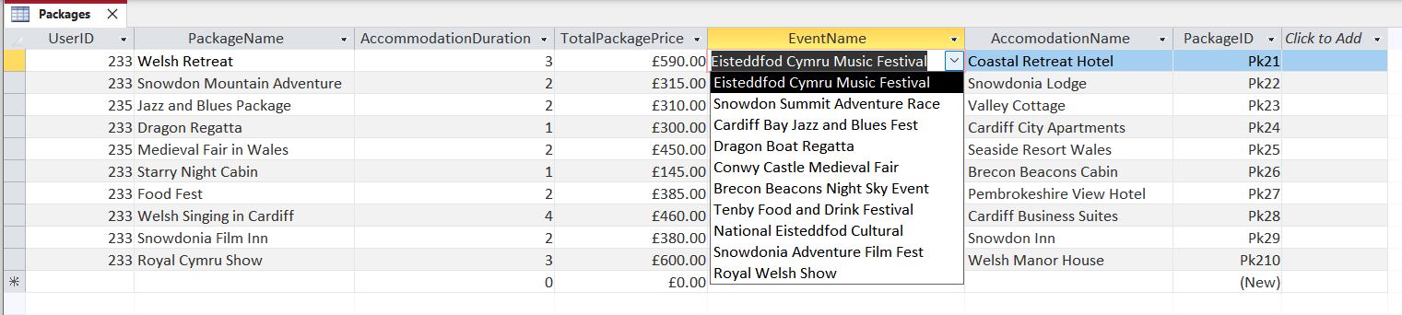

Figure 13 - Packages Table from Design View - Showing the Lookup feature to pull Events from the Events table.
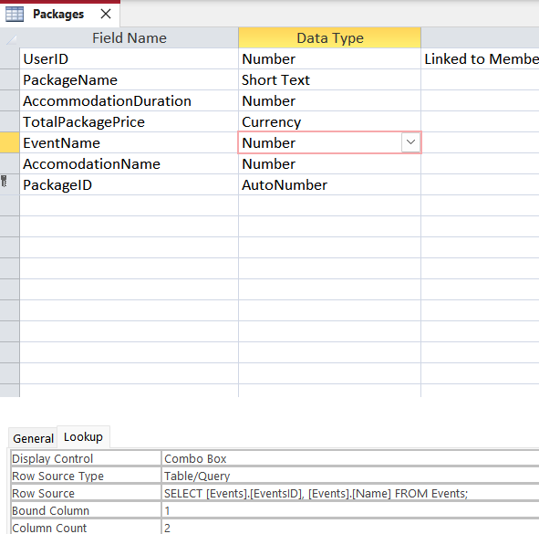

Figure 14 - Packages Table in design view showing the lookup fields for Accommodation to pull from the Accommodation table.
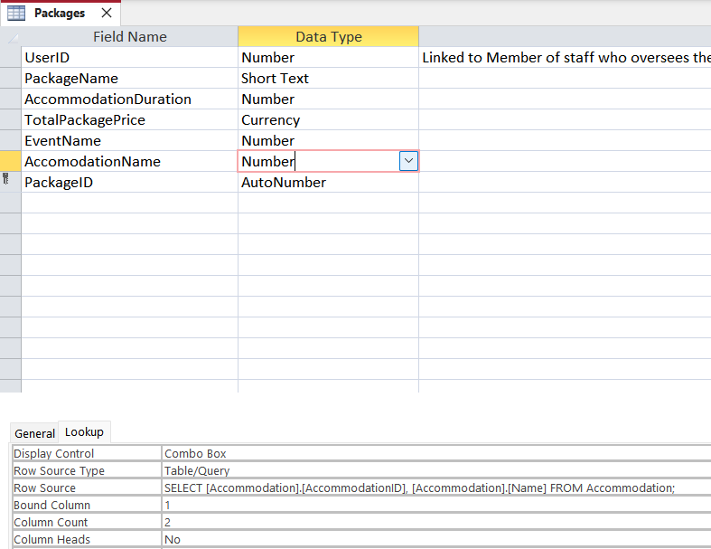
Figure 15 - Reservation Table linked to the package, Customer table.
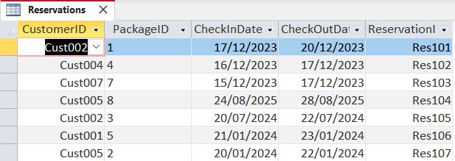
Figure 16 - Reservation Table from Design View - Check in Date Validation rule limits the Check-in date to a period of 01/01/2010 & 25/12/2025 -if the Validation rule is not met, the Validation Text will show.
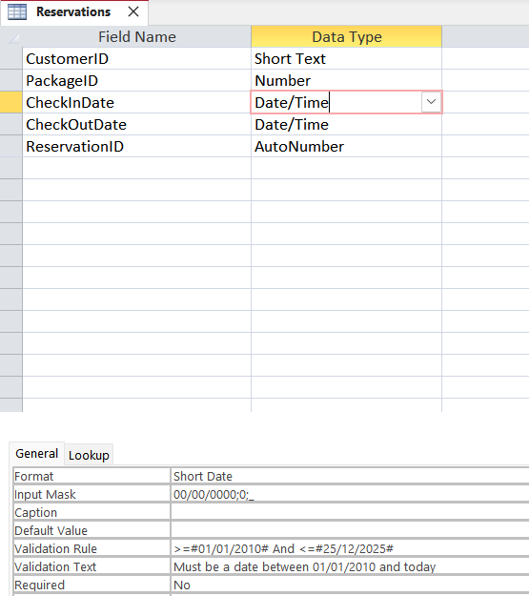
Figure 17 - Reservation Table in Design View showing the CheckOutDate limiting the date to today’s date or later. Validation Text will show should the validation rule not be met.
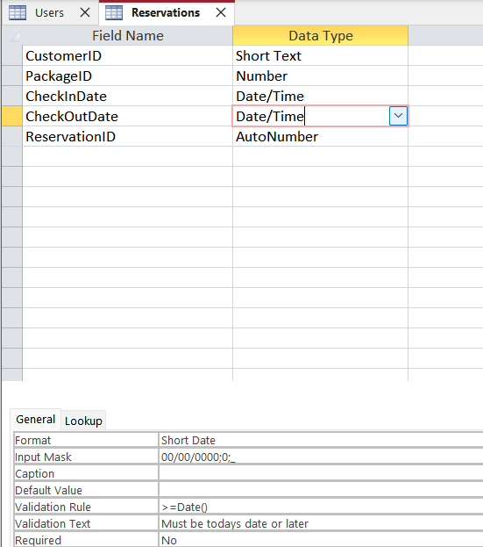
Figure 18 - Tourist Table - Linked to the User Table
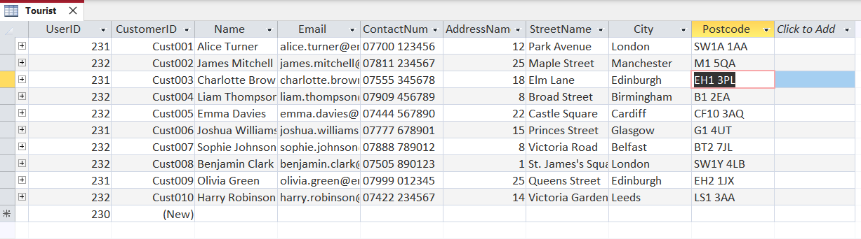
Figure 19 - User Table.
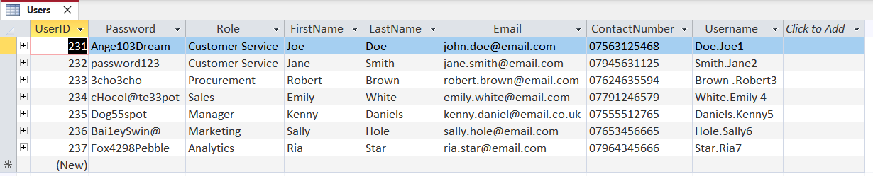
Figure 20 - Users Table from Design Form. Username field is calculated using the User’s Last Name, First Name and User ID to Create a Unique Username.
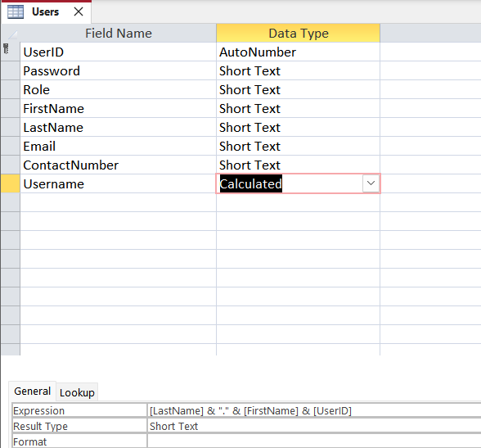

Figure 21- Relationships from Relationship Design Function.
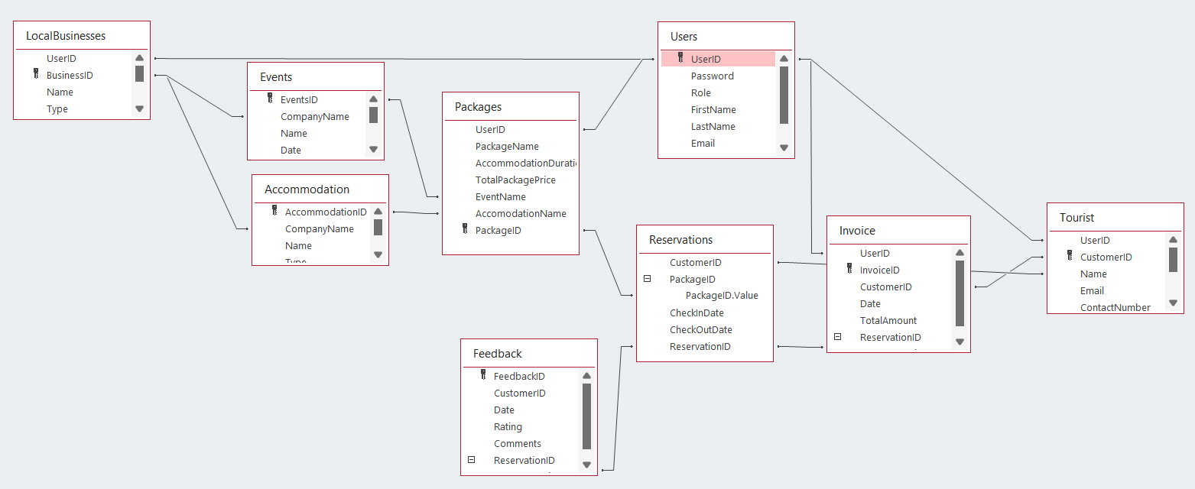

Reports Design

Creating user-friendly reports within the CTMS.

Calculating total revenue for a specific period.

Figure 22 - Total Revenue Report for all Invoices, conditional formatting has been used to separate the higher sales from the lowest.

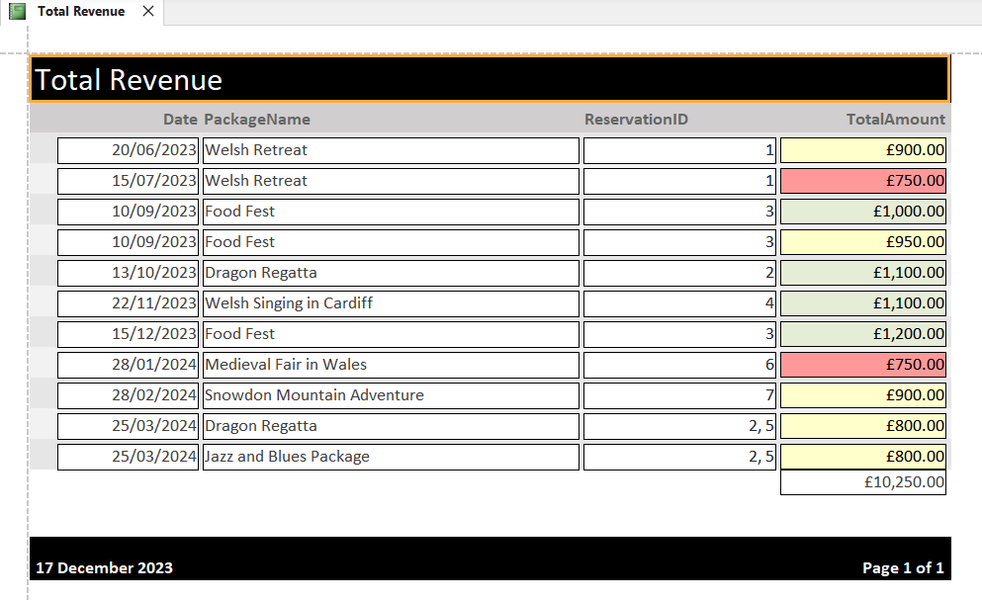
Figure 23 - Total Revenue Table for reservations booked for 2024.
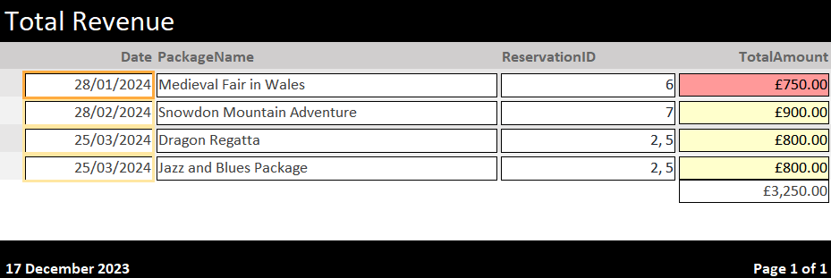

Compiling guest feedback and reviews for Coastal Getaways.

Figure 24 - Guest Feedback Report - Showing Ratings on a Colour Grading.
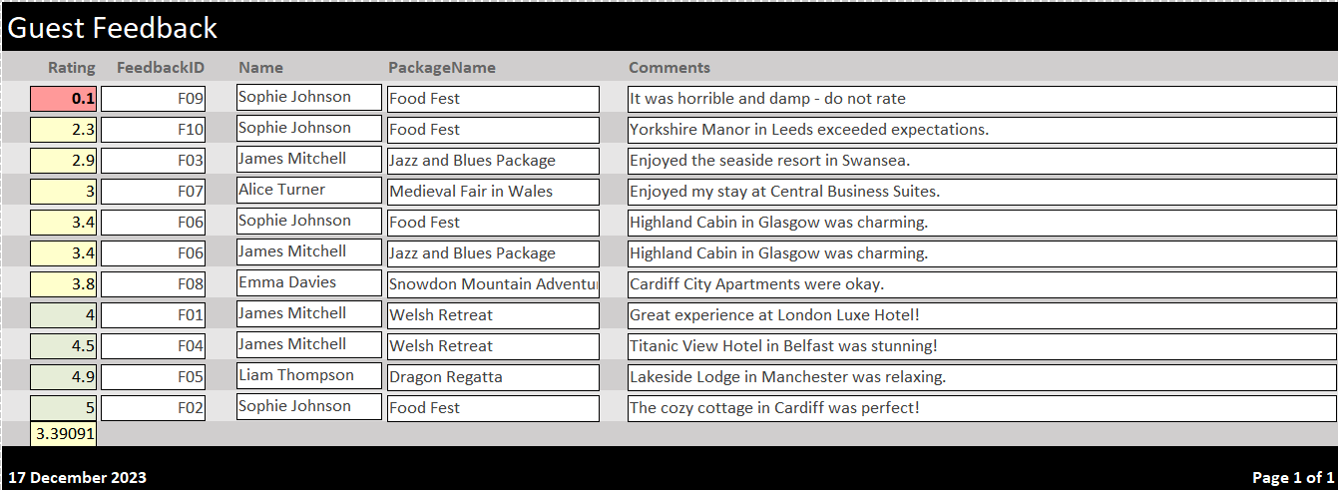

Figure 25 - Guest Feedback Report - Filtered to a Specific Package and rating High to Low.
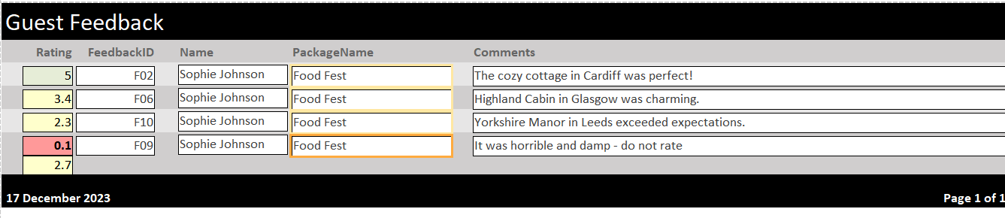

Forms Design, User Interface, and Menus

Creating Forms within the CTMS:
- Reservation form for tourists:
Figure 26 - Reservation Form for Tourists - Tourists need to be registered (separate form available) They can use the Combi box to enter their name, browse the available packages, select the package (Combi-box) and enter in CheckIn/Out Dates.
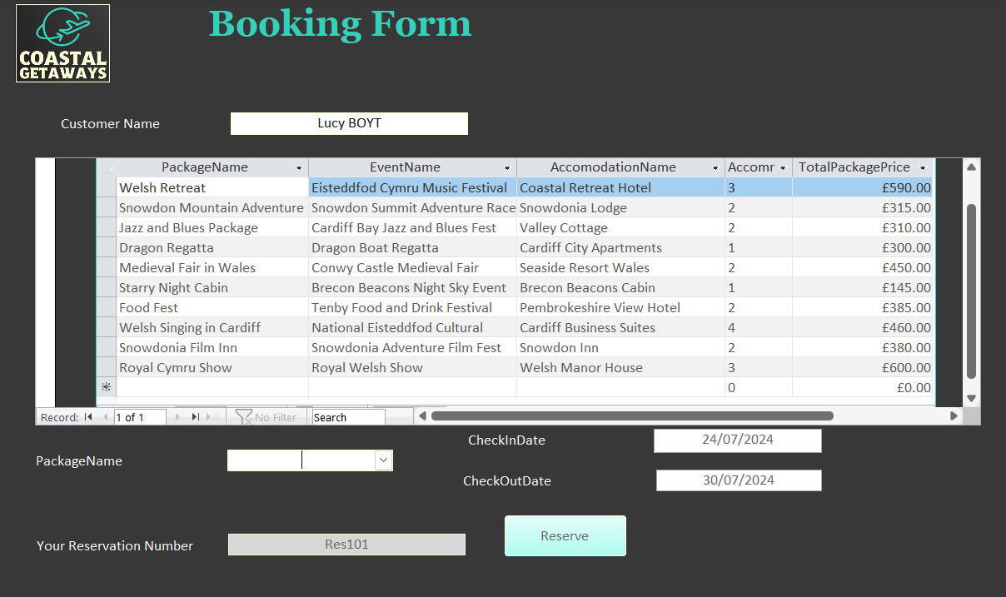
- Create a form that allows event owners to update information about their events.
Figure 27 - Business Selection Page, utilises a Combi-box and Macro'd button. User selects thier business and clicks select.
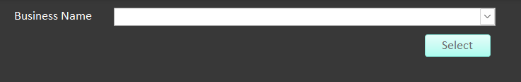

Figure 28 - Select button takes the user to the Owned Events page, Users can then update thier contact details along with the events belonging to the company using the subform.
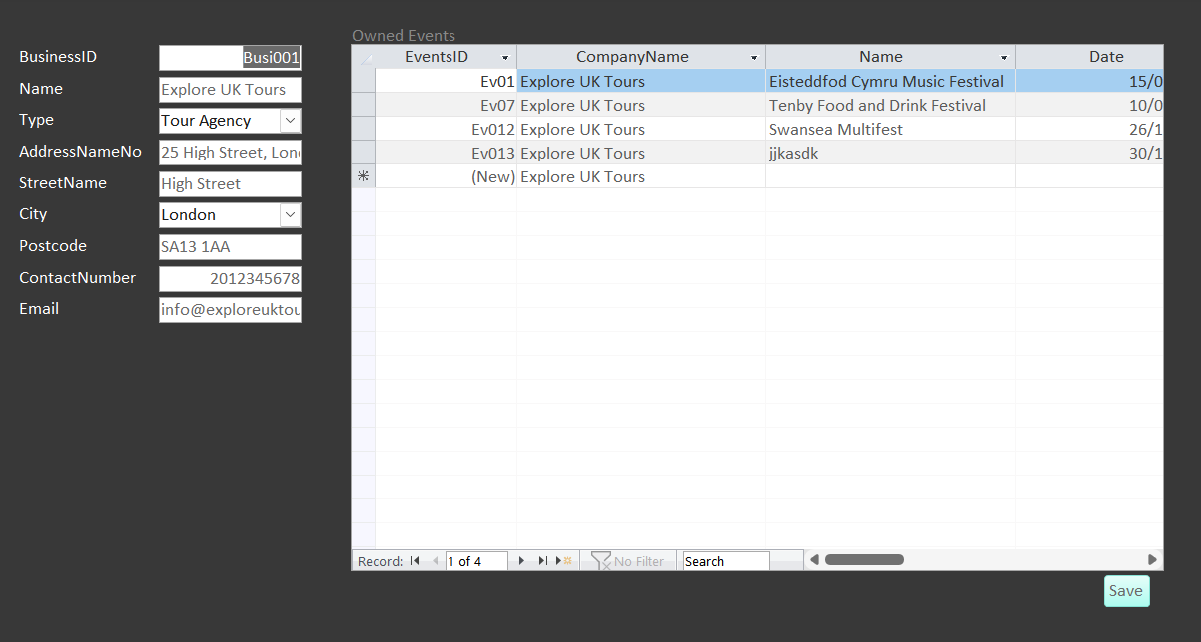

Creating user-friendly menus for CTMS.

- Allows users to navigate the database easily.
- Displays options immediately after opening the database.

Figure 29 - Main Menu - Loads when database is opened.
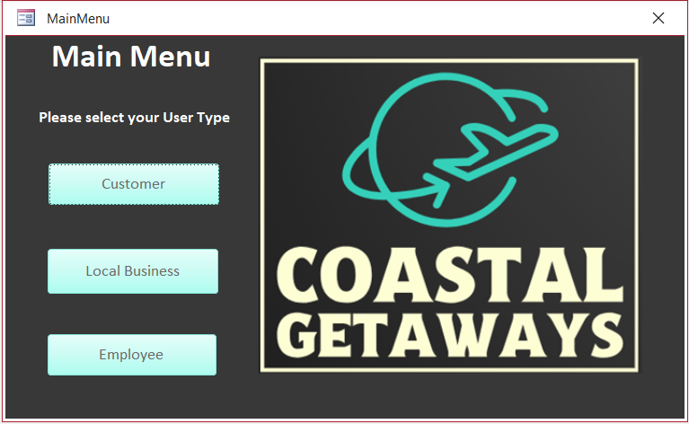

Figure 30 - Customer Nav – providing customer registration forms and the reservation form created above.

Figure 31 - LocalBusiness Nav


Figure 32 – EmployeeNav allowing access to lists of Customers & Local Businesses, the same buttons available to other users along with a customer contact form. Some forms are yet to be created due to time constraints. A Macro has been used to provide the user with a Message box advising to contact their internal IT department.
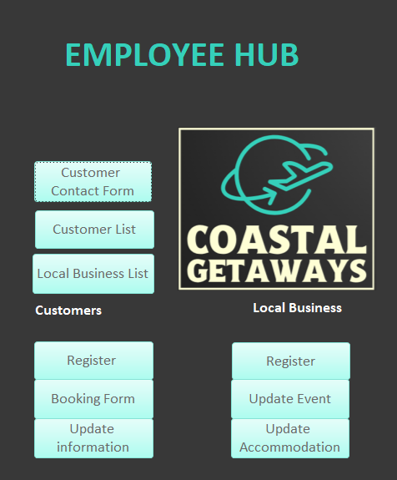

Section B

Importance of developing a Database for Coastal Tourism Management in Wales, UK:

Microsoft Access emerges as a cost-effective and user-friendly tool for small businesses seeking efficient data management. Its compatibility with other Microsoft programs enhances its appeal, providing a budget-friendly solution for businesses without dedicated IT support.

Accessible to non-experts, Microsoft Access allows users to create simple programs and import data easily, ensuring the safety of existing information. The platform's flexibility shines through in its ability to generate custom forms, reports, and queries with minimal effort. It's particularly noteworthy for its user-friendly design, enabling regular users to make complicated queries and professional-looking reports effortlessly.

In the context of coastal tourism management, leveraging a database like Microsoft Access proves invaluable for organizing information related to tourism, accommodations, and activities. The real-time data it provides facilitates informed decision-making, a critical aspect for the success of businesses in the tourism sector.

Furthermore, databases streamline the management of licenses and permits, ensuring compliance with regulations and enhancing the overall efficiency of tourism operations. The organized processes contribute to the smooth functioning of tourism management, fostering a more effective and compliant approach to tasks. [2. 3. 4. 5. 6]

Transitioning from Manual Data Management to a Computerized system. [7. 8. 9. 10]

There are many benefits and disadvantages to using a DBMS. Manual systems often lead to redundant data, which can cause confusion and inefficiencies. A Database Management system can eliminate redundancy through normalisation and data integrity features, promoting accuracy and clarity in the stored data.

There is a risk with manual data entry: the information's reliability can be compromised. A DBMS maintains data consistency with centralised control, which prevents conflicting or contradictory data across the system. Manual systems can also limit how much information can be effectively managed, but a DBMS allows organisations to extract insights and information from the same dataset.

Manual data management can make data sharing and collaboration difficult as documentation can get lost, and the data size may make moving impractical. DBMS allows collaboration features such as sharing data with authorised users, assisting decision-making, and enabling teamwork. More security measures must be taken with manual data systems, making data susceptible to breaches. Within a DBMS, controls and encryption can be used to ensure data security and integrity are maintained.

DBMS platforms can handle large volumes of data without compromising performance. This is an issue the manual system may need help with to ensure that increased data volumes are handled efficiently. DBMS allows quick data retrieval and accessibility, whereas manual systems may delay the same.

With DBMS, multiple users can interact with the system without conflicts; however, if a manual system is being used, users may need to wait for another user to finish with information before reviewing it. Further, manual systems would need reliable backup and recovery mechanisms, such as spare copies of the data, which would cause data security issues and take up a large amount of space. With a DBMS, backup and recovery features are provided to safeguard against lost data or corruption.

Some of the disadvantages of a DBMS include training users on how to use the system, from implementation and maintenance to general office use. More extensive databases may require ample storage space or infrastructure, which can be costly. Creating and acquiring a DBMS will involve a startup cost; therefore, the implementation may seem less attractive to a small business. Data will need to be converted to a computerised system if it still needs to be already, which will incur costs. System failures can significantly impact operations more than a manual system. For example, if the database is retained online and the connection fails, there is no failsafe for the downtime.

References
[1] "Mastering entity data compliance: Business licenses." https://www.wolterskluwer.com/en/expert-insights/mastering-entity-data-compliance-business-licenses (accessed Dec 22,).
[2] "How to use Access," Accessed: Dec 22, 2023, [Online]. Available: http://access.schantz.se/
[3] "Programming Tools - Software applications - Tech Earth", https://techearth.co.in/programming-tools-software-applications/ (accessed Dec 22, 2023).
[4] M. Landry. "Key Benefits of Microsoft Access Database." NHLearningGroup. https://training.nhlearninggroup.com/blog/key-benefits-of-the-microsoft-access-database (accessed Dec 22,).
[5] "Customer Contact Database in Microsoft Access." Computer Learning Zone. https://599cd.com/blog/display-article.asp?ID=1443 (accessed Dec 22,).
[6] A. Moreno, "Improving Productivity for County Clerks with Data Management", Data onDemand™, https://data-ondemand.com/resources/improving-productivity-for-county-clerks-with-data-management/ (accessed Dec 22, 2023).
[7] M. Lynch, "Advantages & Disadvantages of a Computerized Database", The Tech Edvocate, https://www.thetechedvocate.org/advantages-disadvantages-of-a-computerized-database/ (accessed Dec 22, 2023).
[8] S. Writer, "What Are Advantages and Disadvantages of Using a Database?", Reference.com, https://www.reference.com/world-view/advantages-disadvantages-using-database-4277419c4c49f63 (accessed Dec 22, 2023).
[9] T. Connolly and C. Begg,Database systems: a practical approach to design implementation, and management, 6th Ed. Harlow: Pearson Education, 2015.

