Financial Analysis of Microsoft

Jossett Hector
2706750
Managing Financial and Human Resources for Sustainable Business Success (HR7003)
Assessment 2
Ioannis Koutras
University of East London
May 5,2024

Introduction
In this report, a financial analysis of Microsoft’s financial performance was done in detail to determine its financial performance. Microsoft is a global technological company that specialises in computer software, cloud computing services, gaming software and hardware, computer software and other online services worldwide. Microsoft’s business strategy is to keep up with advancements in technology by investing in research and development. Microsoft has a great market positioning as it has little to no threats of substitutes.
In an analysis of Microsoft’s financial statements it was determined that Microsoft have a strong financial position. This is due to an increase in revenue. Microsoft possesses a strong balance sheet due to intelligent working capital and a balanced capital employed.
A financial ratio analysis was done of Microsoft to assess profitability, liquidity and solvency. In 2023, Microsoft had a return on equity of 0.35. This means that for every $1 that Microsoft invests a profit of $0.35 was gained. Microsoft current ROCE is 0.29. Microsoft ROCE has increased over the years. This is indicative that Microsoft has many investment opportunities for investing capital at higher rates and also internally.
Microsoft is a solvent company given the fact that it owns more than it owes. It has a financial gearing of 0.20 which indicates a low risk as it does not rely on funding from external sources. Microsoft also has an interest cover of 4.5 which means that it can pay its interest expense 4.5 times with its current earnings.
Microsoft is also able to fulfil its short-term obligations. The current ratio for Microsoft for the 2023 financial year is 1.79. This is a high current ratio and indicates that Microsoft will be able to meet short term debts which will have a positive impact on return on investment. On the other hand Microsoft has a quick ratio of 1.9 and have an excellent chance of fulfilling its short terms obligations. Microsoft has a good financial position based on comparative analysis of its financial statements along with calculating its liquidity, profitability and solvency ratios.

Methods
To complete this report, I have utilised many academic journals to receive varying viewpoints on the subject. I have read Microsoft’s annual reports to receive a better understanding of their operations and to understand fluctuations int their financial statements. I have also done comparative analysis of Microsoft statements over the years to get a better viewpoint on their operations.

Overview of Microsoft Operations
Microsoft is headquartered in Washington DC and is the largest supplier of computer software in the world it is one of the leading supplier of cloud computing services, gaming and video game software and hardware, computer software and other online services worldwide.
With the prevalence of advancements in technology, Microsoft too has reshaped its operations to keep up with the changing world. Microsoft has reported that the world has “entered a new age of AI that will fundamentally transform productivity for every individual, organization, and industry on earth, and help address some of the world’s most pressing challenges”. (Microsoft, 2023)
Microsoft’s business strategy is geared around generating revenue through licenses and creation of software, selling and designing new software to keep up with the changing world, and through distributing pertinent online marketing to a global customer audience. In addition they offer suite of products and services such as Microsoft Office. (Microsoft, 2023)
SWOT Analysis of Microsoft
Strengths  - Largest technology company worldwide.  - Customer loyalty and retention.  - Vast market reach.  - Stable brand with good financial backing which attract both customers and investors.  - Software are user-friendly and have superior quality standards.  - Constant growth due to investments in new technologies such as Cloud computing and AI. | Opportunities  - Designing more products that are environmentally friendly and recyclable. “In 2021, Microsoft developed a novel mouse which recyclable just like recycling one plastic bottle from the ocean”. (Zhao, 2022)  - Expansion of cloud computing an artificial intelligence business.  - Revamp its smartphone sector.
Weakness  - Edge, Microsoft’s web browser lacks market share. According to W3Counter, Google Chrome has a 68.8% market share while Edge only has 4.7%.  - Microsoft hardware products are not very innovative. For example, Microsoft does not have groundbreaking technology in the computer, tablet or phone market. | Threats  - Microsoft’s Xbox Live game service has been criticised by homosexuals due to the inability to mention homosexuality is gamer’s prefile. (Zhao, 2022)  - There is now a greater focus on portable technologies such as smartphones phones and tablets however, Microsoft’s market share is very small in these segments.  - Cybercrimes are now more prevalent and also customers privacy are sometimes exposed due to crimes, this can have a huge impact on Microsoft’s operations.

Porters Five Forces of Microsoft
Porters Five Forces is used to analyse Microsoft’s market positioning in the technological space.
Bargaining Power of Customers
Customers have great bargaining power as they can impact Microsoft operations according to their changing needs.
Bargaining Power of Suppliers
Microsoft is a global brand is able to source supplies from anywhere in the world. Hence, the bargaining power of suppliers are weak.
Threat of Substitutes
Microsoft is able to retain its customers without threat from substitutes. This is because Microsoft has invested millions in research and development so it is always fulfilling the customers need and thereby building a strong customer base.
The Threat of New Players
Microsoft has little to no threat from new players given that it has built a global empire with strong financial backing. New companies would find it hard to threaten the operations of Microsoft.

Competitive Rivalry
In the technological industry there are huge competitors such as Google and Apple. Hence, Microsoft has rigid policies to keep up with advancements in technology by investing in research and development.

Financial Analysis of Microsoft
A financial analysis was conducted to determine the strengths and weaknesses of the company by assessing the different financial statements.(Appendix A) “A financial statement is an organized collection of data according to logical and conceptual framework”. ( Anitha, 2013)
Comparative Analysis of Microsoft’s Income Statement
A comparative analysis of Microsoft’s financial statements assessed over the 2022 and 2023 financial period studied the financial position in an in depth manner.
It can be determined that revenue in 2023 has been increased by 6.88% compared to 2022. (Appendix B). This increase is due to growth in Intelligent Cloud, Productivity and Business Processes (Microsoft, 2023).
Operating expenses increased in 2023 compare to 2022. This was due to severance packages for employees. (Microsoft, 2023). “Microsoft had to cut 10,000 jobs through the end of the third quarter in 2023”. (Loh,2023) Hence, these employees had to be paid a severance package which has increased their operating expenses.
Net income has decreased by 0.52% in 2023 compared to 2022 due to an increase in tax rates. As reported by Microsoft(2023), tax rate has increased from 13% in 2022 to 19% in 2023 because of a tax break in 2022.
Comparative Analysis of Microsoft’s Balance Sheet
Microsoft possesses a strong balance sheet due to intelligent working capital and a balanced capital employed. Microsoft uses an optimal level of working capital and in 2023, working capital increased by 7.3% (Appendix C). Working capital is to fund the company’s operations, with the aim of creating revenue and profit.
In addition Microsoft has a balanced working capital. In 2023, working capital increased by 14% compare to 2022 (Appendix C). Hence, Microsoft has a balanced mix of both debt and equity funding to maximise the return on capital employed.
Financial Ratios
Financial ratio analysis is used to study Microsoft’s financial position. “Ratio analysis is indispensable part of interpretation of results revealed by the financial statement. It provides users with crucial financial information and points out the areas which require investigation.” (Thomas and Rabiyathulbasariya, 2017)
Profitability Analysis
“The main purpose of establishing a company is to make a profit. In an effort to achieve this goal, it is necessary to have good financial performance management so that optimal profits can be achieved”. (Sunaryo, 2022).
Return on equity
Return on equity is one of the most used analysis to measure the financial performance of businesses. Return on equity (ROE) is a financial ratio that states how much net income is generated per dollar of capital invested. Hence, it gives investors insight on how effectively the company uses capital to gain profit.

Microsoft’s ROE in 2023
ROE= net profit/equity
=72,361,000/206,223,000
= 0.35
This means that for every $1 of Microsoft’s investments made by shareholders, a profit of $0.35 will be gained. In June 2023 the ROE for Microsoft was 0.35 while in June 2022 the ROE was 0.48 which shows a decrease. The higher this ratio, the better because it provides a greater rate of return to shareholders”. (Choiriyah et al., 2021). However, even though there is a decrease in Microsoft’s ROE it’s current value is still good compared to industry ROE which is at 13%.
There are many limitations to ROE. “ROE is calculated after the cost of debt, but before taking into account the cost of its own capital.” (De Wet & Du Toit, 2007). Another limitation is that ROE is a short-term measure of performance and can lead to a company overlooking long term financial opportunities that could increase the value of shares and instead focusing on short-term goals. (Copeland, 2002)
Return on capital employed (ROCE)
Return on capital employed (ROCE) is used by most medium and large companies as the key performance measure to determine total performance as both profit and capital are aggregated. (Whiting,1986) The higher the ROCE the more capable a company is to earn a profit.

Microsoft’s ROCE in 2023
Return on Capital Employed is:
ROCE = operating profit / capital employed.
ROCE= 88,523,000/307,827,000
= 0.29
Microsoft current ROCE is 0.29. This is indicative that Microsoft has many investment opportunities to invest capital at higher rates and also internally.
According to Bishop (1969), the limitation ROCE, is that it cannot be used solely for planning. However, when integrated with financial ratios it becomes a vital component to assist in managerial decisions and reports

Solidity and solvency
Microsoft is a solvent company given the fact that it owns more than it owes
Financial Gearing
Microsoft’s Financial Gearing in 2023
Gearing = long term liabilities / equity
= 41,990,000/206,223,000
=0.20
The financial is calculated for Microsoft to be 0.20 in 2023. The graph below shows the financial gearing of Microsoft over 10 years. According to Netcials (no date), 2023 is one of the less riskiest year for Microsoft given the low financial gearing ratio. A company with a high financial gearing ratio would be more susceptible if the economic declines given that such a company would need to make interest payments and its debt will need to be paid via cash flows, which would also decline in such an economy. Hence, Microsoft’s low financial gearing would protect it from this situation.
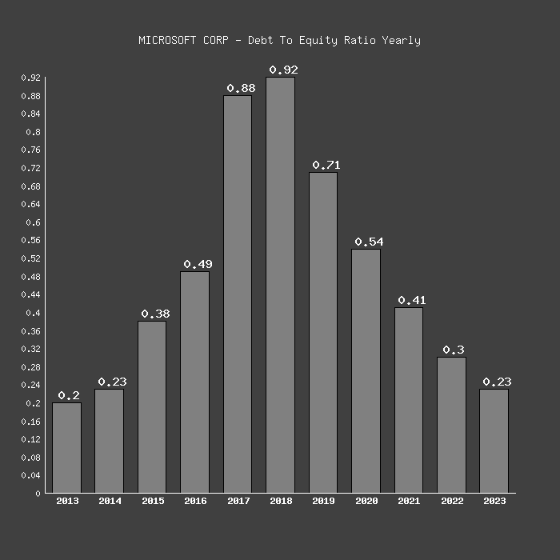
Graph showing Microsoft’s final gearing (2013-2023)- Netcials (no date),
The limitation with financial gearing is that it fluctuates based on the industry. Monopolistic companies can have a high gearing without much impact while others such as those in the technological industry needs a lower gearing due to competition.

Interest Cover
Interest cover ratio signifies the company’s credit value. It specifies the number of times a firm can pay its current interest expenses with its available earnings. “A company with a higher interest cover ratio has a low probability of defaulting on debts”. (Dothan, 2006 cited by (Taebi Noghondari et al., 2011) ).
Microsoft’s Interest Cover in 2023
Interest cover = EBIT/Interest expense
= 89,311,000/19,680.000
=4.5
Hence, Microsoft can pay its interest expense 4.5 times with its current earnings. The limitation is that this ratio cannot be used to compare companies in different sectors as it fluctuates based on industry.

Liquidity Ratios
Corporate liquidity demonstrates the firm’s capability to fulfil its short-term obligations.
Current Ratio
“The current ratio is a ratio to measure the company's ability to pay short-term obligations or debts that are due immediately when billed in their entirety”. (Kasmir, 2017:134 cited in Sunaryo, 2022:1 ).A low current ratio value will indicate that an organisation is unable to meet short term debts which will have a negative impact on return on investment.

Microsoft’s Current ratio in 2023
Current ratio= current assets / current liabilities
= (411, 976,000/205,753,000)
= 1.79
The current ratio for Microsoft for the 2023 financial year is 1.79 This is a high current ratio and indicates that Microsoft will be able to meet short term debts which will have a positive impact on return on investment. This also indicates that Microsoft has more assets than liabilities. “The acceptable current ratio varies from industry to industry. If current liabilities exceed current assets where the current ratio is below 1, then the company may have problems in fulfilling its short-term liabilities”. (Rochim & Ghoniyah2, 2017)
Quick Ratio
Microsoft’s quick ratio in 2023
Quick ratio = (current assets – inventory) / current liabilities
=(411, 976,000-2,500,000)/205,753,000
= 1.99
Quick ratio is one of the tools that are used in financial analysis to measure company liquidity. Theoretically, the higher a company’s quick ratio then the more able it will be to fulfil its short term commitments.
Microsoft has a quick ratio of 1.99 in June 2023. This is a high quick ratio and hence the organisation has an excellent chance of fulfilling its short terms obligations. Given that Microsoft has a high quick ratio, this will be more desirable for investors to want to invest in that organisation, therefore leading to an increase in stock prices. In June 2023, Microsoft stock prices were sold at $ $338.51 however, a year before the stock prices were $ 252.85. Consequently, Microsoft’s quick ratio was 1.99 in June 2023 and was 1.82 in June 2022 which coincided with the fluctuation in stock prices.
In a study conducted by Awan (2014) it was concluded that when quick ratio increased then return on asset (ROA) will decrease, this is inversely proportional. A declining ROA signifies that an organization might have overly invested in assets that have failed to provide enough revenue growth. In regards to Microsoft their quick ratio in June 2023 was 1.99 which was an increase from the 1.82 quick ratio in June 2022. The return on investment in June 2023 was 18% while in June 2022 was 19.8% which corroborates with Awan’s study and reflects the relationship between liquidity and return on assets.
Limitations of liquidity ratios
Liquidity ratios only focuses on liquidity and does not take into account any liabilities that may arise. It also does not focus on the quality of assets and regards all assets as been equal. However, in reality some assets are not able to be converted into cash in the desired time. This types of ratio also ascertains that the higher the ratio, the more ideal however, this can have an impact on company returns.

Conclusion
Microsoft is a global technological company that specialises in computer software cloud computing services, gaming and hardware, computer software and other online services worldwide. Microsoft’s performance is due to strategy of keeping up with technological advancements, market positioning and its user friendly and advanced products. Microsoft has also invested in research and development to ensure it is keeping ahead of the dynamic world and has implemented new systems in cloud computing and artificial intelligence which is now the current computing trend.
The financial analysis of Microsoft has revealed that the company is in a good financial position by studying its profitability, solvency and liquidity ratios. In terms of profitability, Microsoft ROE and ROCE has indicated its operations have yielded a healthy financial position. Even though Microsoft’s return on equity has decreased from 2022, the company has still managed to stay ahead of industry standards which has highlighted to investors that Microsoft have effectively used its capital to gain profits.
Microsoft’s liquidity ratios has reflected the company’s ability to meet short-term obligations. The current ratio and quick ratio are higher than the industry standards and have highlighted that Microsoft is very proficient in managing their current assets. Microsoft’s current ratio indicates that Microsoft has more assets than liabilities which is a positive outlook for investors. If current liabilities exceed current assets where the current ratio is below 1, then the company may have problems in fulfilling its short-term liabilities”. (Rochim & Ghoniyah2, 2017). This is not the case for Microsoft who’s current ratio is 1.79. Microsoft’s quick ratio is 1.99, this makes it more desirable for investors to want to invest in the company and therefore leading to an increase in stock prices. This coincides with Microsoft’s increase in stock prices.

Microsoft is a solvent company and this is reflected in its financial gearing ratio and interest cover. Microsoft is able to manage its long term debts and interest commitments well. Microsoft has a low financial gearing which mitigates risk. In 2023 Microsoft’s financial gearing was 0.20, Microsoft had one of the lowest risk which was a positive for the company. Microsoft’s interest cover ratio indicates the company’s ability to use its earnings to cover its interest earnings which has enhanced its creditworthiness and financial stability.
Apart from its financial position, Microsoft has a strong strategic position and a great market outlook. This has contribute positively to shaping the company and its future. Its continue investments in research and development to meet the dynamic needs of technology plus its environmental friendly and sustainable environments have contributed its financial strength. Microsoft's reputation, global reach, and differentiated activities aids in its development and being successful in the technological sector.
Recommendations
Microsoft needs to remain adaptive and dynamic to meet the needs of the every changing technological industry.
Microsoft must leverage its strengths to delve into other markets such as revamping their smartphone line given the constant need and usage of these devices.
Cybersecurity: Given the prevalence of cybercrimes, Microsoft needs to invest more to prevent these crimes to retain consumers trust.
Create more products that are sustainable and environmentally friendly to meet the changing needs of consumer preferences.

Word count: 2992

References
Awan, M.R. (2014) ‘Impact of liquidity, leverage, inflation on firm profitability an empiricalanalysis of food sector of Pakistan’, IOSR Journal of Business and Management, 16(1), pp. 104–112. doi:10.9790/487x-1617104112.
Bishop, E.B. (1969) ‘R.O.C.E. as a tool for planning and Control’, Long Range Planning, 2(2), pp. 80–87. doi:10.1016/0024-6301(69)90014-4.
Choiriyah, C. et al. (2021) ‘The effect of return on assets, return on equity, net profit margin, earning per share, and operating profit margin on stock prices of banking companies in Indonesia Stock Exchange’, International Journal of Finance Research, 1(2), pp. 103–123. doi:10.47747/ijfr.v1i2.280.
Copeland, T. 2002. ‘Want to create value?’, Strategic Finance. 83(9): 48-54.
De Wet, J.H.V.H. and Du Toit, E. (2007) ‘Return on equity: A popular, but flawed measure of corporate financial performance’, South African Journal of Business Management, 38(1), pp. 59–69. doi:10.4102/sajbm.v38i1.578.
Dr. Donthi Ravinder, & Anitha, M. (2013). Financial Analysis – A Study. IOSR Journal of Economics and Finance, 2(3), 10–22. https://doi.org/10.9790/5933
Joy Thomas , S.Rabiyathulbasariya, J.T. (2017) ‘Measuring financial performance through ratio analysis \"A general study on the ratio analysis tool to trigger out financial performance\"’, International Journal of Accounting and Financial Management Research, 7(6), pp. 37–44. doi:10.24247/ijafmrdec20174.
Loh, M. (2023) Tech giants are laying off thousands of people. here’s how their severance packages stack up., Business Insider. Available at: https://www.businessinsider.com/tech-layoffs-meta-twitter-lyft-stripe-severance-package-compensation-2022-11#microsoft-said-it-would-give-above-market-severance-pay-but-didnt-specify-what-that-meant-3 (Accessed: 30 April 2024).
Market activity market activity(no date) Nasdaq. Available at: https://www.nasdaq.com/market-activity/stocks/msft/financials (Accessed: 05 May 2024).
Microsoft (2023).Annual report 2023. Available at: 2023_Annual_Report.docx (live.com) (Accessed: 30th April 2024).
Netcials All MSFT Reports ➤More Companies ➤ (no date) Microsoft (MSFT) debt to equity ratio (2013-2023) history, Netcials. Available at: https://www.netcials.com/financial-debt-equity-ratio-usa/789019-MICROSOFT-CORP/ (Accessed: 04 May 2024).

Rachmawati, W., Ulya, N. and Karim, A. (2023) ‘Effect of return on assets, return on equity, and current ratio on stock returns’, Economics and Business Solutions Journal, 7(2), p. 73. doi:10.26623/ebsj.v7i2.7383.
Rochim, R. and Ghoniyah2, N. (2017) ‘Analysis on the effect of current ratio, cashflow from operation to debt, firm size and return on equity on stock return’, International Journal of Islamic Business Ethics, 2(3), p. 41. doi:10.30659/ijibe.2.3.41-51.
Sunaryo, D., Nafiuddin, Gentari, R.E. & Adiyanto, Y (2022), "Using Current Ratio Indicator and Total Asset Turnover Approach in Solving Return on Assets Problems with Debtto- Equity Ratio Moderated: Acces la Success’, Calitatea, vol. 23, no. 189, pp. 199-209.

Taebi Noghondari , A., Beytollah, A. and Zeinali , H. (2011) ‘Credit risk I: Structural models with stochastic volatility’, The Effect of Company’s Interest Coverage Ratio on the Structural and Reduced-Form Models in Predicting Credit Derivatives Price, 15(1), pp. 169–188.
With a 13% return on equity, is International Game Technology PLC (NYSE:IGT) A quality stock? (no date) Yahoo! Finance. Available at: https://finance.yahoo.com/news/13-return-equity-international-game-110918070.html (Accessed: 21 April 2024).
Whiting, E. (1986). Return on capital employed. In: A Guide to Business Performance Measurements. Palgrave Macmillan, London. https://doi.org/10.1007/978-1-349-07472-3_18
Web browser market share (no date b) W3Counter. Available at: https://www.w3counter.com/globalstats.php (Accessed: 03 May 2024).
Zhao, B. (2022) ‘Microsoft’s overview and development strategies based on multiple analyses’, BCP Business &amp; Management, 19, pp. 73–77. doi:10.54691/bcpbm.v19i.730.

Appendix A- Microsoft’s Financial Statements

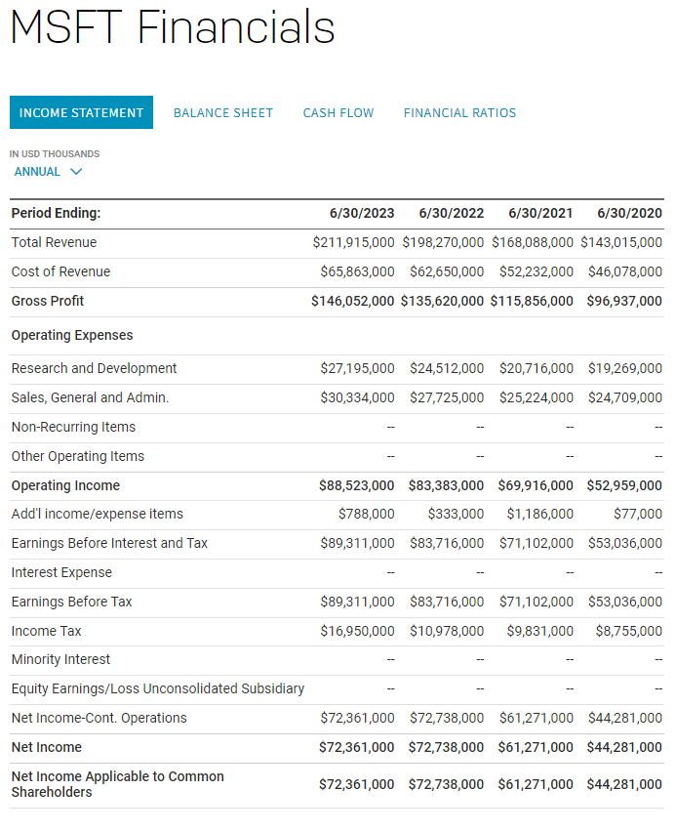

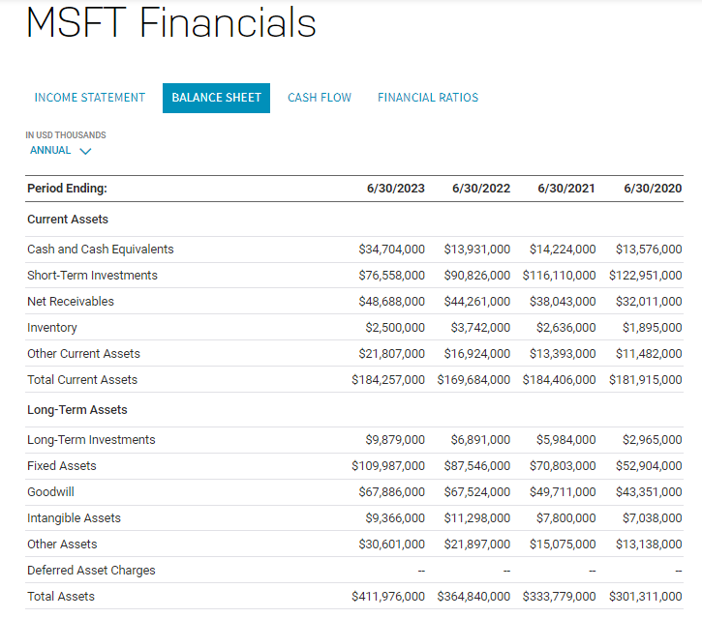
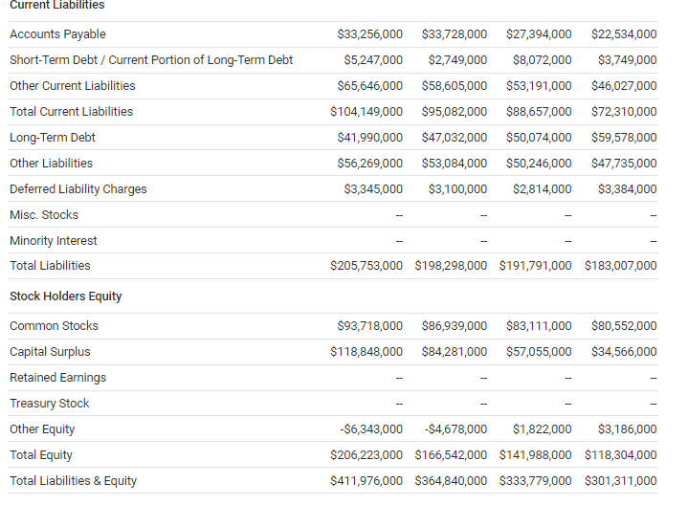

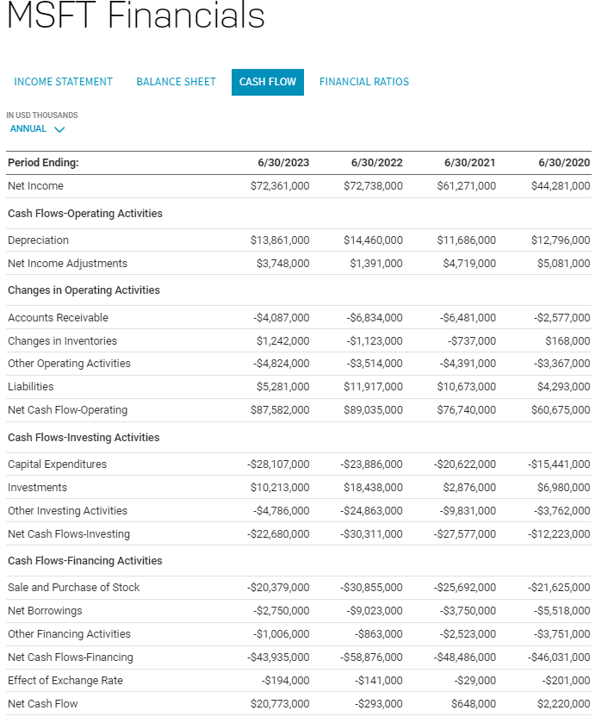

Appendix B- Comparative Analysis of Microsoft’s Income Statement and Balance Sheet

Microsoft’s Income Statement- June 2022 and 2023
Period Ending | 6/30/2023 | 6/30/2022 | Increase (or Decrease) | Percent of Change
Total revenue | 211,915,000 | 198,270,000 | 13,645,000 | 6.88%
Cost of revenue | 65,863,000 | 62,650,000 | 3,213,000 | 5.13%
Gross Profit | 146,052,000 | 135,620,000 | 10,432,000 | 7.69%
Operating Expenses
Research and Development | 27,195,000 | 24,512,000 | 2,683,000 | 10.95%
Sales, General and Admin | 30,334,000 | 27,725,000 | 2,609,000 | 9.41%
Non-Recurring Items
Other Operating Items
Operating Income | 88,523,000 | 83,383,000 | 5,140,000 | 6.16%
Add'I Income/expense items | 788,000 | 333,000 | 455,000 | 136.64%
Earnings Before Interest and Tax | 89,311,000 | 83,716,000 | 5,595,000 | 6.68%
Interest Expense
Earnings Before Tax | 89,311,000 | 83,716,000 | 5,595,000 | 6.68%
Income Tax | 16,950,000 | 10,978,000 | 5,972,000 | 54.40%
Minority Interest
Equity Earnings/Loss Unconsoliated Subsidary
Net Income-Cont. Operations | 72,361,000 | 72,738,000 | -377,000 | -0.52%
Net Income | 72,361,000 | 72,738,000 | -377,000 | -0.52%
Net Income Applicable to Common Shareholers | 72,361,000 | 72,738,000 | -377,000 | -0.52%

Microsoft’s Balance Sheet June 2022 and 2023

Period Ending | 6/30/2023 | 6/30/2022 | Increase (or Decrease) | Percent of Change
Current Assets
Cash and cash equivalents | 34,704,000 | 13,931,000 | 20,773,000 | 149.11%
Short term investments | 76,558,000 | 90,826,000 | -14,268,000 | -15.71%
Net Receivables | 48,688,000 | 44,261,000 | 4,427,000 | 10.00%
Inventory | 2,500,000 | 3,742,000 | -1,242,000 | -33.19%
Other Current Assets | 21,807,000 | 16,924,000 | 4,883,000 | 28.85%
Total Current Assets | 184,257,000 | 169,684,000 | 14,573,000 | 8.59%
Long term Assets |  |  | 0
Long-Term Investments | 9,879,000 | 6,891,000 | 2,988,000 | 43.36%
Fixed Assets | 109,987,000 | 87,546,000 | 22,441,000 | 25.63%
Goodwill | 67,886,000 | 67,524,000 | 362,000 | 0.54%
Intangible Assets | 9,366,000 | 11,298,000 | -1,932,000 | -17.10%
Other Assets | 30,601,000 | 21,897,000 | 8,704,000 | 39.75%
Deferred Asset Change |  |  | 0
Total Asset | 411,976,000 | 364,840,000 | 47,136,000 | 12.92%
Current Liabilities |  |  | 0
Accounts Payable | 33,256,000 | 33,728,000 | -472,000 | -1.40%
Short-term debt/Current Portion of Long-Term Debt | 5,247,000 | 2,749,000 | 2,498,000 | 90.87%
Other Current Liabilities | 65,646,000 | 58,605,000 | 7,041,000 | 12.01%
Total Current Liabilities | 104,149,000 | 95,082,000 | 9,067,000 | 9.54%
Long-Term Debt | 41,990,000 | 47,032,000 | -5,042,000 | -10.72%
Other Liabilties | 56,269,000 | 53,084,000 | 3,185,000 | 6.00%
Deferred Liability | 3,345,000 | 3,100,000 | 245,000 | 7.90%
Misc. Stocks |  |  | 0
Minority Interest |  |  | 0
Total Liabilities |  |  | 0
Stock Holders Equity |  |  | 0
Common Stocks | 93,718,000 | 86,939,000 | 6,779,000 | 7.80%
Capital Surplus | 118,848,000 | 84,281,000 | 34,567,000 | 41.01%
Retained Earnings |  |  | 0
Treasury Stock |  |  | 0
Other Equity | -6,343,000 | -4,678,000 | -1,665,000 | 35.59%
Total Equity | 206,223,000 | 166,542,000 | 39,681,000 | 23.83%
Total Liabilities and Equity | 411,976,000 | 364,840,000 | 47,136,000 | 12.92%

Appendix C- Calculations for working capital and capital employed
Working capital for 2023
184,257,000-104,149,000
= 80,108,000
Working capital for 2022
169,684,000-95,082,000
= 74,602,000
Change in working capital= (5,506,000/74,602,000)*100
=7.3%

Capital employed for 2023= 411,976,000-104,149,000
= 307,827,000
Capital employed for 2022= 364,840,000-95,082,000
= 269,758,000

Change= (38,069,000/269,758,000) *100
= 14%

