(q1) eee referencing &written summary on essential academic and employment skills (350 words

Essential Academic and employment skills.
The importance of essential academic and employment skills and how they can help students and faculty members researchers and lecturer’s discus the differences between the most important skill for getting a job these views are shared the same but viewed differently. There is also going to be a difference in the groups as views shared may not be up for debates.
According to the studies found are that most skills are important to the reign of your success in and out of any workplace weather it’s at home or in the office
Communication and time management are the key to most employers as time keeping problem solving can all get you far in this world. The biggest challenges are finding a good employee or employer who are ready to share that drive and passion for the work they are about to endure; success sometimes has its moments such as its gap year but that just let you prefect of your skills a bit more.
The two greatest concerns of employers today are finding good workers
and training them. The difference between the skills needed on the job and
those possessed by applicants, sometimes called the skills-gap, is of real concern to human resource managers and business owners looking to hire competent employees. While employers would prefer to hire people who are
trained and ready to go to work, they are usually willing to provide the specialized, job-specific training necessary for those lacking such skills that are needed in particular fields.
(1b) submit work [1]

Bibliography

[1] | d. j. p. robinson, “the work place,” p. https://www.middletowncityschools.com/media/user/resources/Information_Grade9_EmployabilitySkills.pdf, 25/062026 september 2001.

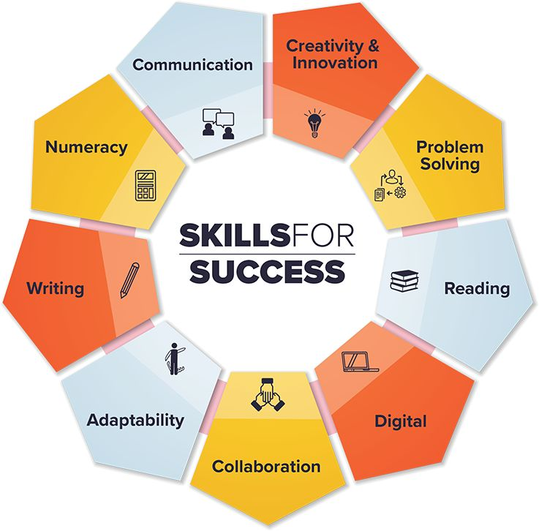

References

[1] | d. j. p. robinson, “the work place,” p. https://www.middletowncityschools.com/media/user/resources/Information_Grade9_EmployabilitySkills.pdf, 25/062026 september 2001.

to the Turnitin link

